Lab03 Report

ANN Analysis:

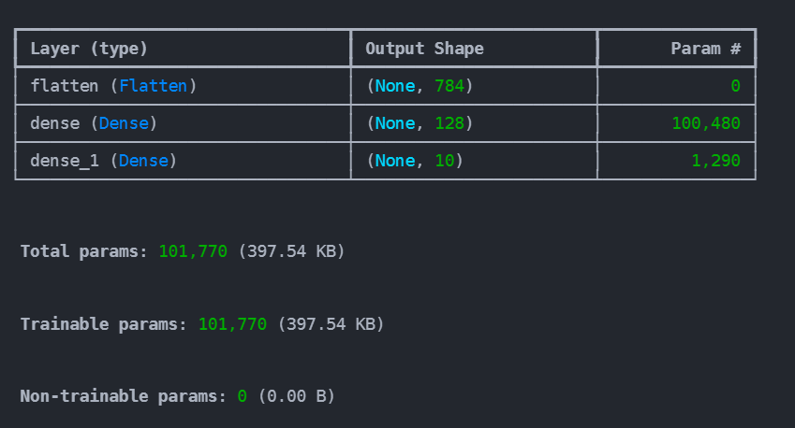
- Architecture:
  - 28x28 Image → 784 Neurons → 128 Neurons → 10 Output

- Metric:
  - Epochs: 6
  - Accuracy: 0.972100019454956
  - Loss: 0.09034173935651779
CNN Analysis:

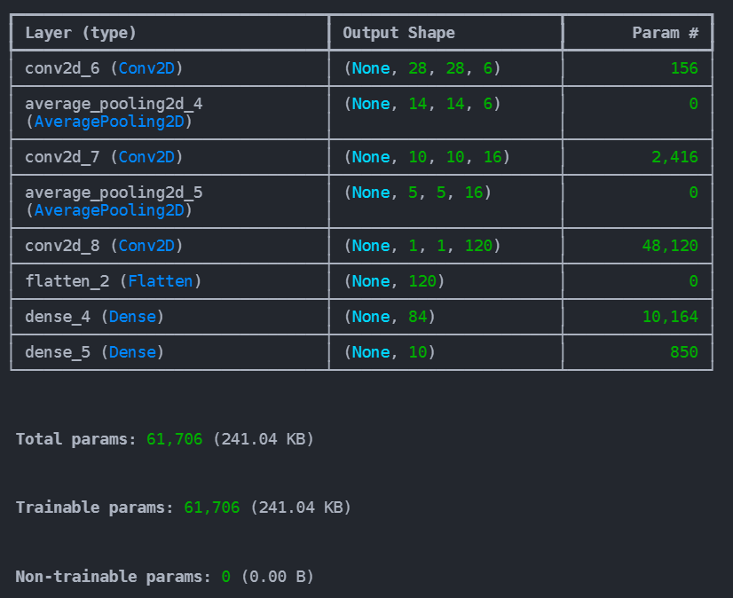
- Architecture:
28x28x1 Image

Convolution

6@5x5 Kernel
Padding 2
Stride 1
tanh
6@28x28

Sampling

2x2 Avg. Pooling
Stride 2
tanh
6@14x14
Convolution

16@5x5 Kernel
Stride 1
tanh
16@10x10

Sampling

2x2 Avg. Pooling
Stride 2
tanh
16@5x5

Convolution

120@5x5 Kernel
Stride 1
tanh
120@1x1
Flatten
120 Neurons
Fully connected

tanh
84 Neurons
Fully connected

softmax
10 Outpus
- Metric:
  - Epochs: 6
  - Accuracy: 98.45%
  - Loss: 0.047294165939092636

