DSP Architecture

Lab Tutor: Arkadiusz Hudzikowski

Laboratory Report 1

Projects initialization and setup

# CUBE IDE

## Project

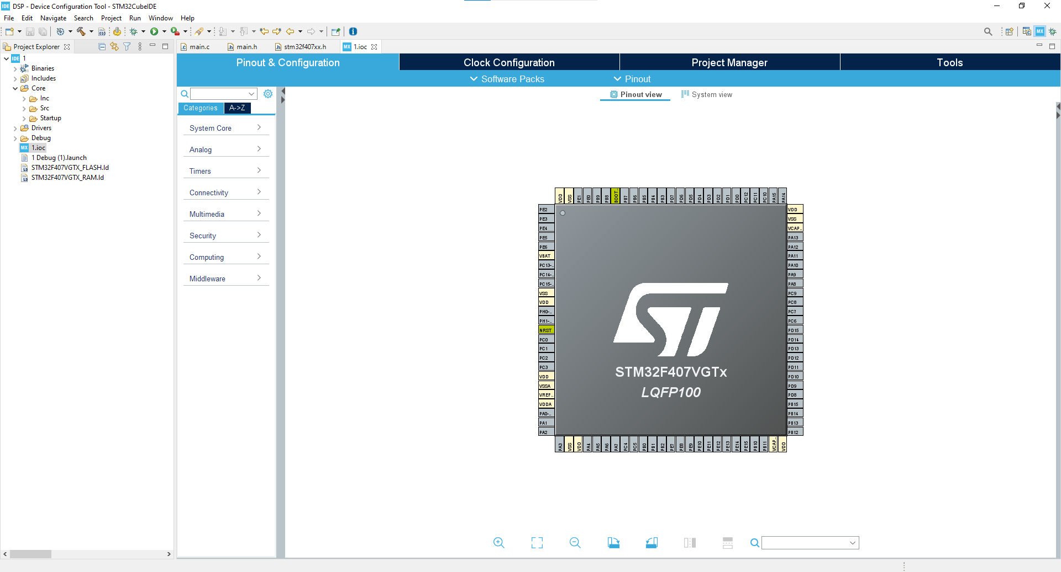

Asdf

## Git integration

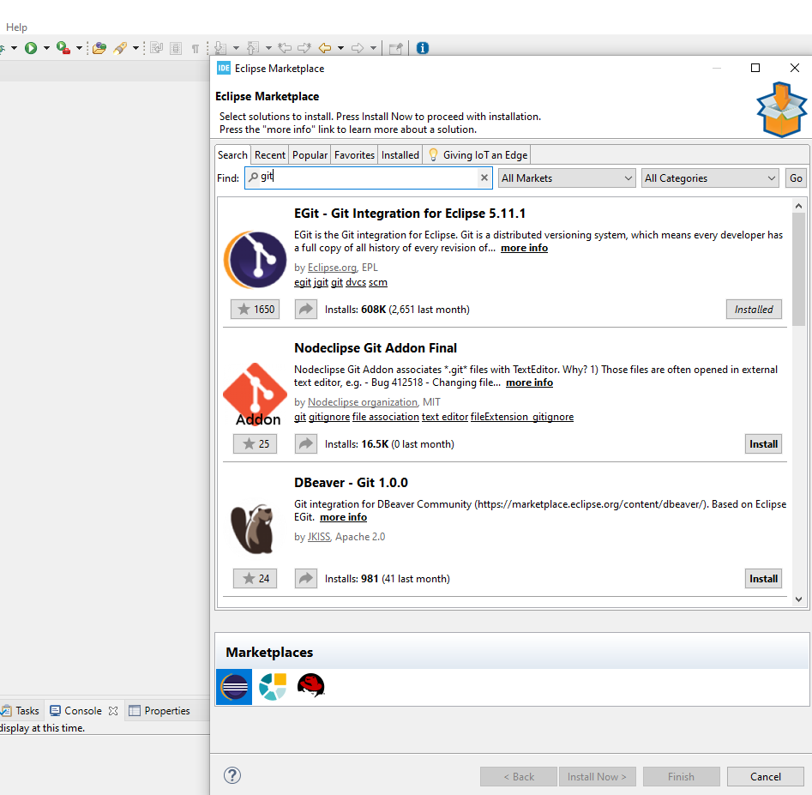

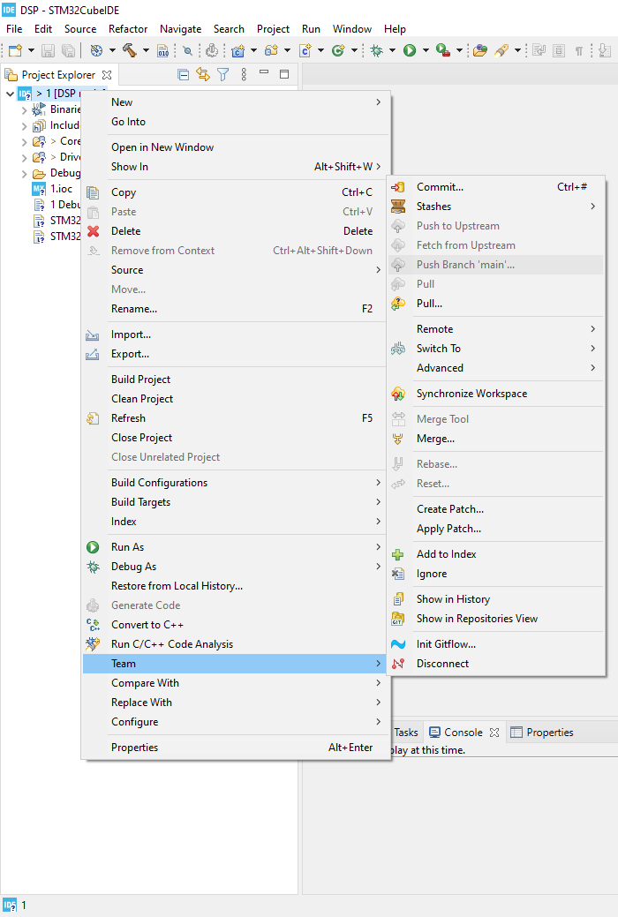

ASDF

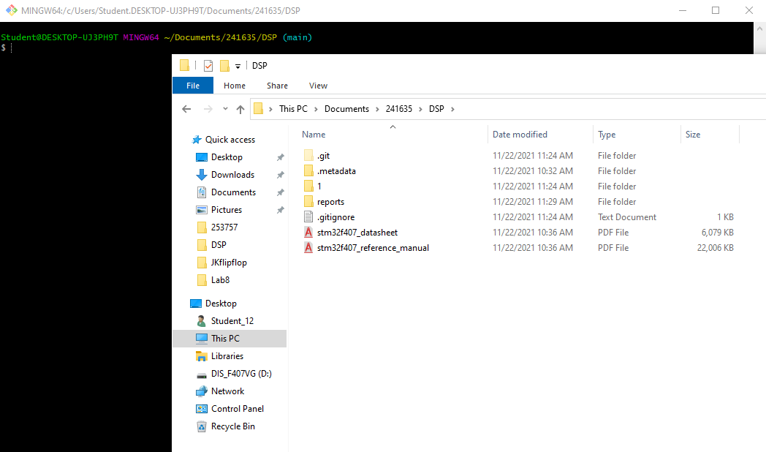

Asdf

# Waweforms

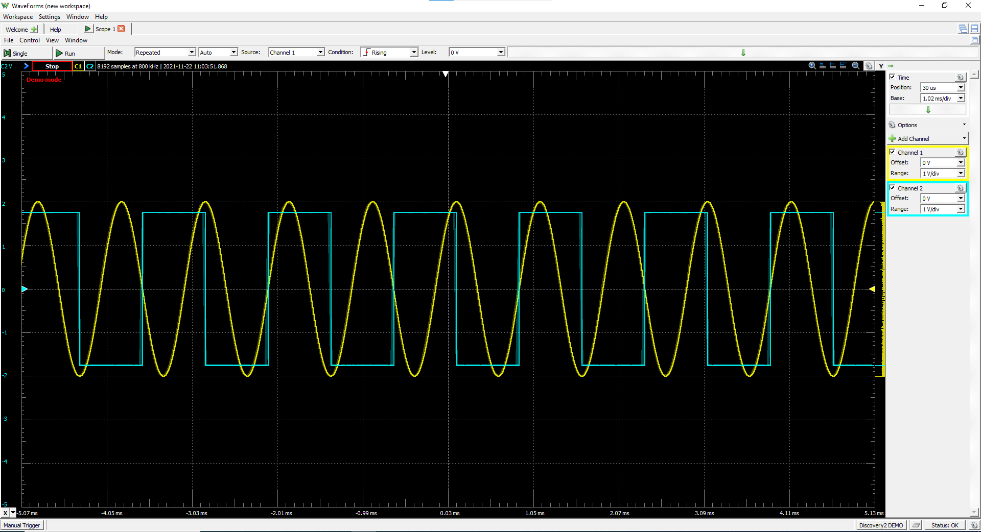

Asdf