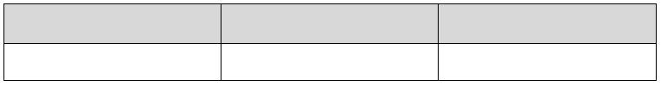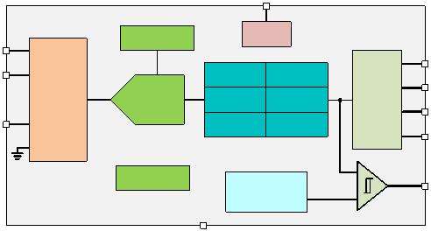INA228-Q1 ZHCSLF8A –JUNE 2020 –REVISED JUNE 2021
INA228-Q1 AEC-Q100、85V、20 位、超精密功率/能量/充电监控器，具有I²C 接
口
1 特性 3 说明
• 符合面向汽车应用的AEC-Q100 标准：  – 温度等级1：–40°C 至+125°C，T_{A}  • 提供功能安全 |  | INA228-Q1 是一款超精密数字功率监控器，配备专为  电流检测应用而设计的 20 位 Δ-Σ ADC。该器件可跨  共模电压支持范围为-0.3V 至+85V 的电阻式分流器感
– 可帮助进行功能安全系统设计的文档  • 高分辨率、20 位Δ-ΣADC  • 电流监控精度：  – 失调电压：±1µV（最大值）  – 温漂：±0.01µV/°C（最大值）  – 增益误差：±0.05%（最大值）  – 增益误差漂移：±20ppm/°C（最大值）  – 共模抑制：154dB（最小值）  • 电源监控精度：  – 0.5% 满量程，–40°C 至+125°C（最大值）  • 能量和充电精度：  – 1.0% 满量程（最大值）  • 快速警报响应：75μs  • 宽共模范围：-0.3 V 至+85 V  • 总线电压感应输入：0 V 至85 V  • 分流器满量程差分范围：  ±163.84mV/±40.96mV  • 输入偏置电流：2.5nA（最大值）  • 温度传感器: ±1°C（25°C 时为最大值） |  | 测元件测量 ±163.84mV 或 ±40.96mV 的满量程差分输  入。  INA228-Q1 报告电流、总线电压、温度功率、能量和  电荷累积，并采用精度为 ±0.5% 的集成振荡器，同时  在后台执行所需的计算。集成的温度传感器用于裸片温  度测量的精度为±1°C，并可用于监测系统环境温度。  INA228-Q1 采用低温漂和增益漂移设计，以使此器件  可用于在制造过程中不进行多温度校准的精密系统。此  外，非常低的失调电压和噪声允许在 mA 至 kA 感测应  用中使用，并在感应分流器元件上提供宽的动态范围而  不会产生显著的功率损耗。该器件的低输入偏置电流允  许使用较大的电流检测电阻器，从而能够提供微安级的  精确电流测量。  该器件允许选择从 50µs 到 4.12ms 的 ADC 转换时间  以及从 1x 到1024x 的采样平均值，这有助于进一步降  低测量数据的噪声。  器件信息⁽¹⁾  器件型号 封装 封装尺寸（标称值）
• 可编程电阻器温度补偿
INA228-Q1 VSSOP (10) 3.00mm × 3.00mm
• 可编程转换时间和平均值计算
• 2.94MHz 高速I²C 接口，具有16 引脚可选地址
• 在2.7V 至5.5V 电源下工作：
(1) ， 如需了解所有可用封装 请参阅数据表末尾的封装选项附录。
– 工作电流：640µA（典型值）
– 关断电流：5µA（最大值）
2 应用
• 汽车电池管理系统
• EV/HEV mA - KA 感测应用
• 直流/直流转换器和功率逆变器
• ADAS 域控制器
VS
Reference
Power
IN+
SCL
IN-
Voltage Current
SDA
20 Bit
ADC
I C 2
MUX
Power Energy
A0
VBUS Charge Temp
A1
 |  | Oscillator |  | Out-of-range  Threshold |  | +  œ
ALERT
GND
简化版方框图
本文档旨在为方便起见，提供有关TI 产品中文版本的信息，以确认产品的概要。有关适用的官方英文版本的最新信息，请访问 www.ti.com，其内容始终优先。TI 不保证翻译的准确性和有效性。在实际设计之前，请务必参考最新版本的英文版本。
English Data Sheet: SLYS022
INA228-Q1
ZHCSLF8A – JUNE 2020 – REVISED JUNE 2021 www.ti.com.cn
Table of Contents
 | 1 特性................................................................................... 1  2 应用................................................................................... 1  3 说明................................................................................... 1  4 Revision History.............................................................. 2  5 Pin Configuration and Functions...................................3  6 Specifications.................................................................. 3  6.1 Absolute Maximum Ratings ....................................... 3  6.2 ESD Ratings .............................................................. 4  6.3 Recommended Operating Conditions ........................4  6.4 Thermal Information ...................................................4  6.5 Electrical Characteristics ............................................5  6.6 Timing Requirements (I²C) ........................................ 7  6.7 Timing Diagram ..........................................................7  6.8 Typical Characteristics................................................8  7 Detailed Description......................................................12  7.1 Overview...................................................................12  7.2 Functional Block Diagram.........................................12  7.3 Feature Description...................................................12 |  | 7.4 Device Functional Modes..........................................18  7.5 Programming............................................................ 19  7.6 Register Maps...........................................................22  8 Application and Implementation..................................33  8.1 Application Information............................................. 33  8.2 Typical Application.................................................... 38  9 Power Supply Recommendations................................42  10 Layout...........................................................................42  10.1 Layout Guidelines................................................... 42  10.2 Layout Example...................................................... 42  11 Device and Documentation Support..........................43  11.1 接收文档更新通知................................................... 43  11.2 支持资源..................................................................43  11.3 Trademarks............................................................. 43  11.4 Electrostatic Discharge Caution..............................43  11.5 术语表..................................................................... 43  12 Mechanical, Packaging, and Orderable  Information.................................................................... 43
4 Revision History
注：以前版本的页码可能与当前版本的页码不同
Changes from Revision * (June 2020) to Revision A (June 2021) Page
• 将数据表状态从“预告信息”更改为：量产数据................................................................................................ 1
• 更新了整个文档中的表格、图和交叉参考的编号格式.........................................................................................1
• 更新了整个文档中的数字和公式，以与商业数据表保持一致.............................................................................. 1
2 Submit Document Feedback Copyright © 2022 Texas Instruments Incorporated
Product Folder Links: INA228-Q1
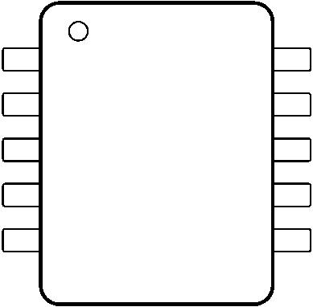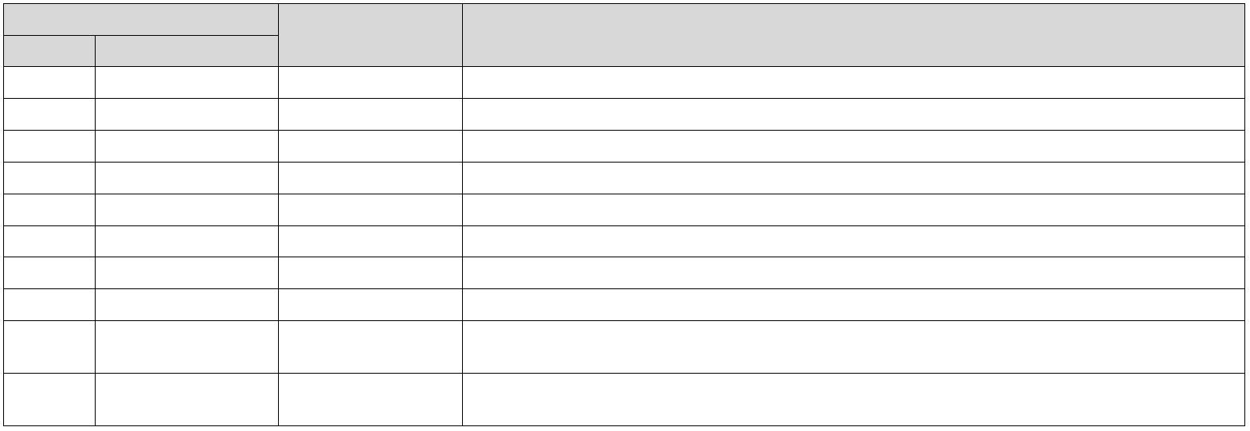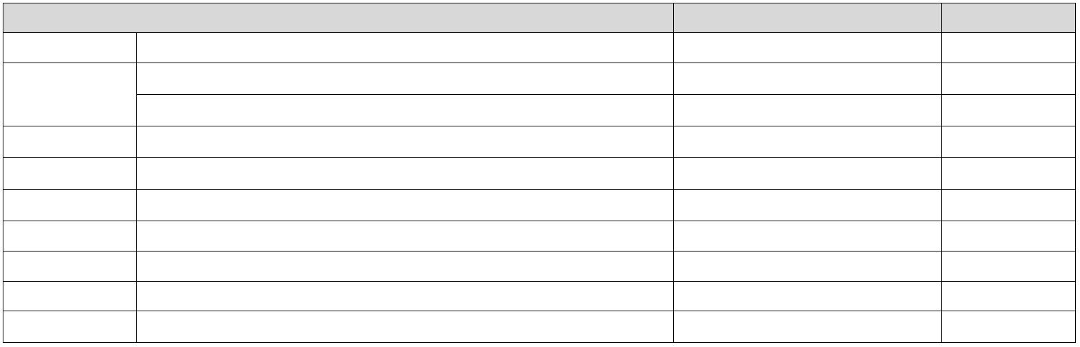www.ti.com.cn |  | INA228-Q1  ZHCSLF8A – JUNE 2020 – REVISED JUNE 2021
5 Pin Configuration and Functions
A1 1 10 IN+
A0 2 9 IN–
ALERT 3 8 VBUS
SDA 4 7 GND
SCL 5 6 VS
Not to scale
图 5-1. DGS Package 10-Pin VSSOP Top View
表 5-1. Pin Functions
 | PIN  NO. NAME |  | TYPE DESCRIPTION
1 A1 Digital input I²C address pin. Connect to GND, SCL, SDA, or VS.
2 A0 Digital input I²C address pin. Connect to GND, SCL, SDA, or VS.
3 ALERT Digital output Open-drain alert output, default state is active low.
4 SDA Digital input/output Open-drain bidirectional I²C data.
5 SCL Digital input I²C clock input.
6 VS Power supply Power supply, 2.7 V to 5.5 V.
7 GND Ground Ground.
8 VBUS Analog input Bus voltage input.
 | 9 IN– Analog input |  | Negative input to the device. For high-side applications, connect to load side of sense resistor. For  low-side applications, connect to ground side of sense resistor.
 | 10 IN+ Analog input |  | Positive input to the device. For high-side applications, connect to power supply side of sense  resistor. For low-side applications, connect to load side of sense resistor.
6 Specifications
6.1 Absolute Maximum Ratings
over operating free-air temperature range (unless otherwise noted)⁽¹⁾
MIN MAX UNIT
V_{S} Supply voltage 6 V
 | V_{IN+}, V_{IN–} ⁽²⁾ |  | Differential (V_{IN+}) – (V_{IN–}) –40 40 V  Common-mode –0.3 85 V
V_{VBUS} –0.3 85 V
V_{ALERT} ALERT –0.3 vs. + 0.3 V
V_{IO} SDA, SCL –0.3 6 V
I_{IN} Input current into any pin 5 mA
I_{OUT} Digital output current 10 mA
T_{J} Junction temperature 150 °C
T_{stg} Storage temperature –65 150 °C
(1) Stresses beyond those listed under Absolute Maximum Rating may cause permanent damage to the device. These are stress ratings
only, which do not imply functional operation of the device at these or any other conditions beyond those indicated under
Recommended Operating Condition. Exposure to absolute-maximum-rated conditions for extended periods may affect device
reliability.
(2) VIN+ and VIN– are the voltages at the IN+ and IN– pins, respectively.
Copyright © 2022 Texas Instruments Incorporated Submit Document Feedback 3
Product Folder Links: INA228-Q1
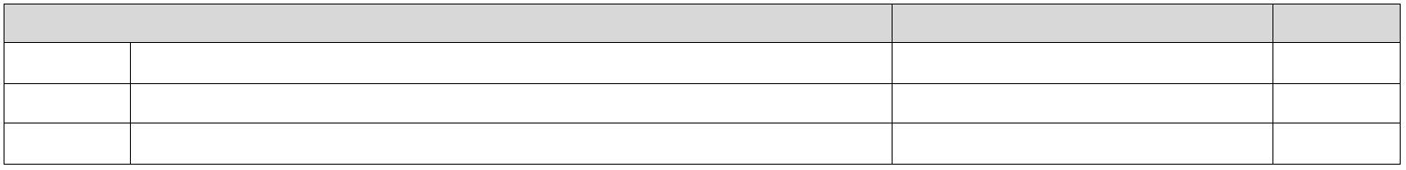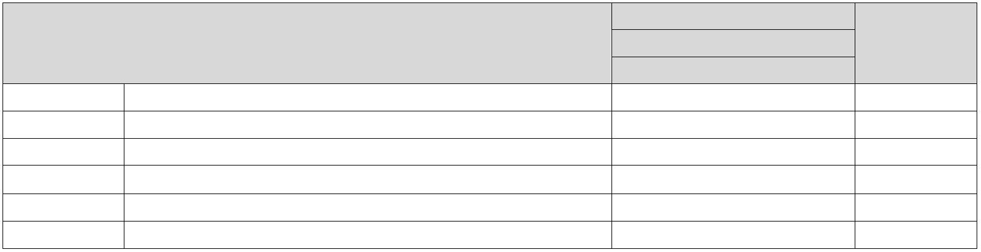INA228-Q1
ZHCSLF8A – JUNE 2020 – REVISED JUNE 2021 www.ti.com.cn
6.2 ESD Ratings
VALUE UNIT
 | V_{(ESD)} Electrostatic discharge |  | Human body model (HBM), per AEC Q100-002, all pins⁽¹⁾ HBM  ESD Classification Level 2  Charged device model (CDM), per AEC Q100-011, all pins CDM  ESD Classification Level C6 |  | ±2000  ±1000 |  | V
(1) AEC Q100-002 indicated that HBM stressing shall be in accordance with the ANSI/ESDA/JEDEC JS-001 specification.
6.3 Recommended Operating Conditions
over operating free-air temperature range (unless otherwise noted)
MIN NOM MAX UNIT
V_{CM} Common-mode input range –0.3 85 V
V_{S} Operating supply range 2.7 5.5 V
T_{A} Ambient temperature –40 125 °C
6.4 Thermal Information
INA228-Q1
THERMAL METRIC⁽¹⁾ DGS UNIT
10 PINS
R_{θJA} Junction-to-ambient thermal resistance 177.6 °C/W
R_{θJC(top)} Junction-to-case (top) thermal resistance 66.4 °C/W
R_{θJB} Junction-to-board thermal resistance 99.5 °C/W
Ψ_{JT} Junction-to-top characterization parameter 9.7 °C/W
Y_{JB} Junction-to-board characterization parameter 97.6 °C/W
R_{θJC(bot)} Junction-to-case (bottom) thermal resistance N/A °C/W
(1) For more information about traditional and new thermal metrics, see the Semiconductor and IC Package Thermal Metrics application
report.
4 Submit Document Feedback Copyright © 2022 Texas Instruments Incorporated
Product Folder Links: INA228-Q1
www.ti.com.cn |  | INA228-Q1  ZHCSLF8A – JUNE 2020 – REVISED JUNE 2021
6.5 Electrical Characteristics
at T_{A} = 25 °C, V_{S} = 3.3 V, V_{SENSE} = V_{IN+} – V_{IN–} = 0 V, V_{CM} = V_{IN–} = 48 V (unless otherwise noted)
PARAMETER TEST CONDITIONS MIN TYP MAX UNIT
INPUT
V_{CM} Common-mode input range T_{A} = –40 °C to +125 °C –0.3 85 V
V_{VBUS} Bus voltage input range 0 85 V
 | CMRR Common-mode rejection |  | –0.3 V < V_{CM} < 85 V, T_{A} = –40 °C to +125  °C |  | 154 170 dB
 | V_{DIFF} Shunt voltage input range |  | T_{A} = –40 °C to +125 °C, ADCRANGE = 0 –163.84 163.84 mV  T_{A} = –40 °C to +125 °C, ADCRANGE = 1 –40.96 40.96 mV
 | V_{os} Shunt offset voltage |  | V_{CM} = 48 V, T_{CT} > 280 µs ±0.3 ±1 µV  V_{CM} = 0 V, T_{CT} > 280 µs ±0.3 ±1 µV
dV_{os}/dT Shunt offset voltage drift T_{A} = –40 °C to +125 °C ±2 ±10 nV/°C
PSRR Shunt offset voltage vs. power supply V_{S} = 2.7 V to 5.5 V, T_{A} = –40 °C to +125 °C ±0.05 ±0.5 µV/V
V_{os_bus} V_{BUS} offset voltage V_{BUS} = 20 mV ±1 ±2.5 mV
dV_{os}/dT V_{BUS} offset voltage drift T_{A} = –40 °C to +125 °C ±4 ±20 µV/°C
PSRR V_{BUS} offset voltage vs. power supply V_{S} = 2.7 V to 5.5 V ±0.25 mV/V
I_{B} Input bias current Either input, IN+ or IN–, V_{CM} = 85 V 0.1 2.5 nA
Z_{VBUS} VBUS pin input impedance Active mode 0.8 1 1.2 MΩ
I_{VBUS} VBUS pin leakage current Shutdown mode, V_{BUS} = 85 V 10 nA
R_{DIFF} Input differential impedance Active mode, V_{IN+} – V_{IN–} < 164 mV 92 kΩ
DC ACCURACY
G_{SERR} Shunt voltage gain error V_{CM} = 24 V ±0.01 ±0.05 %
G_{S_DRFT} Shunt voltage gain error drift ±20 ppm/°C
G_{BERR} V_{BUS} voltage gain error ±0.01 ±0.05 %
G_{B_DRFT} V_{BUS} voltage gain error drift ±20 ppm/°C
P_{TME} Power total measurment error (TME) T_{A} = –40 °C to +125 °C, at full scale ±0.5 %
E_{TME} Energy and charge TME at full scale power ±1 %
ADC resolution 20 Bits
Shunt voltage, ADCRANGE = 0 312.5 nV
 | 1 LSB step size |  | Shunt voltage, ADCRANGE = 1 78.125 nV  Bus voltage 195.3125 µV
Temperature 7.8125 m°C
Conversion time field = 0h 50
Conversion time field = 1h 84
Conversion time field = 2h 150
 | T_{CT} ADC conversion-time⁽¹⁾ |  | Conversion time field = 3h 280  Conversion time field = 4h 540 |  | µs
Conversion time field = 5h 1052
Conversion time field = 6h 2074
Conversion time field = 7h 4120
INL Integral Non-Linearity ±2 m%
DNL Differential Non-Linearity 0.2 LSB
CLOCK SOURCE
F_{OSC} Internal oscillator frequency 1 MHz
 | F_{OSC_TOL} Internal oscillator frequency tolerance |  | T_{A} = 25 °C ±0.5 %  T_{A} = –40 °C to +125 °C ±1 %
Copyright © 2022 Texas Instruments Incorporated Submit Document Feedback 5
Product Folder Links: INA228-Q1
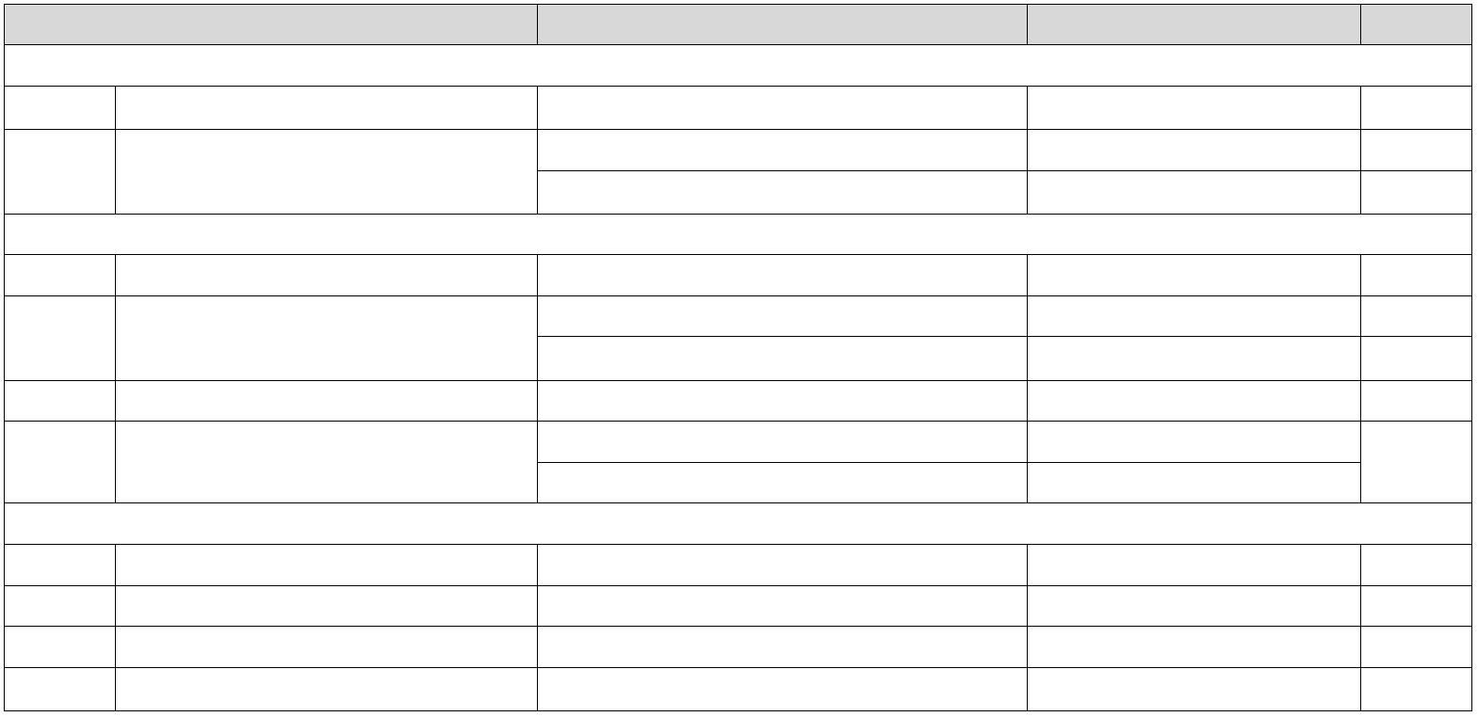INA228-Q1
ZHCSLF8A – JUNE 2020 – REVISED JUNE 2021 www.ti.com.cn
6.5 Electrical Characteristics (continued)
at T_{A} = 25 °C, V_{S} = 3.3 V, V_{SENSE} = V_{IN+} – V_{IN–} = 0 V, V_{CM} = V_{IN–} = 48 V (unless otherwise noted)
PARAMETER TEST CONDITIONS MIN TYP MAX UNIT
TEMPERATURE SENSOR
Measurement range –40 +125 °C
 | Temperature accuracy |  | T_{A} = 25 °C ±0.15 ±1 °C  T_{A} = –40 °C to +125 °C ±0.2 ±2 °C
POWER SUPPLY
V_{S} Supply voltage 2.7 5.5 V
 | I_{Q} Quiescent current |  | V_{SENSE} = 0 V 640 750 µA  V_{SENSE} = 0 V, T_{A} = –40 °C to +125 °C 1.1 mA
I_{QSD} Quiescent current, shutdown Shuntdown mode 2.8 5 µA
 | T_{POR} Device start-up time |  | Power-up (NPOR) 300  From shutdown mode 60 |  | µs
DIGITAL INPUT / OUTPUT
V_{IH} Logic input level, high SDA, SCL 1.2 5.5 V
V_{IL} Logic input level, low GND 0.4 V
V_{OL} Logic output level, low I_{OL} = 3 mA GND 0.4 V
I_{IO_LEAK} Digital leakage input current 0 ≤ V_{IN} ≤ V_{S} –1 1 µA
(1) Subject to oscillator accuracy and drift
6 Submit Document Feedback Copyright © 2022 Texas Instruments Incorporated
Product Folder Links: INA228-Q1
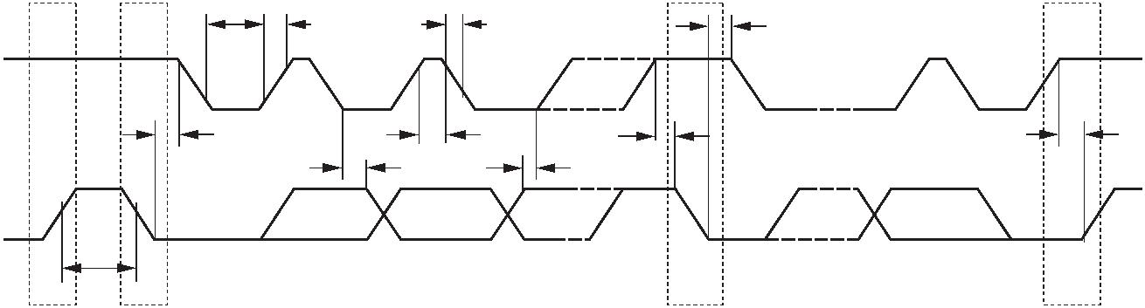www.ti.com.cn |  | INA228-Q1  ZHCSLF8A – JUNE 2020 – REVISED JUNE 2021
6.6 Timing Requirements (I²C)
MIN NOM MAX UNIT
I²C BUS (FAST MODE)
F_{(SCL)} I²C clock frequency 1 400 kHz
t_{(BUF)} Bus free time between STOP and START conditions 600 ns
 | t_{(HDSTA)} |  | Hold time after a repeated START condition. After this period, the first  clock is generated. |  | 100 ns
t_{(SUSTA)} Repeated START condition setup time 100 ns
t_{(SUSTO)} STOP condition setup time 100 ns
t_{(HDDAT)} Data hold time 10 900 ns
t_{(SUDAT)} Data setup time 100 ns
t_{(LOW)} SCL clock low period 1300 ns
t_{(HIGH)} SCL clock high period 600 ns
t_{F} Data fall time 300 ns
t_{F} Clock fall time 300 ns
t_{R} Clock rise time 300 ns
I²C BUS (HIGH-SPEED MODE)
F_{(SCL)} I²C clock frequency 10 2940 kHz
t_{(BUF)} Bus free time between STOP and START conditions 160 ns
 | t_{(HDSTA)} |  | Hold time after a repeated START condition. After this period, the first  clock is generated. |  | 100 ns
t_{(SUSTA)} Repeated START condition setup time 100 ns
t_{(SUSTO)} STOP condition setup time 100 ns
t_{(HDDAT)} Data hold time 10 125 ns
t_{(SUDAT)} Data setup time 20 ns
t_{(LOW)} SCL clock low period 200 ns
t_{(HIGH)} SCL clock high period 60 ns
t_{F} Data fall time 80 ns
t_{F} Clock fall time 40 ns
t_{R} Clock rise time 40 ns
6.7 Timing Diagram
 | t  (LOW) |  | t  R t_{F} t_{(HDSTA)}
SCL
 | t  (HDSTA) |  | t  (HIGH) t_{(SUSTA)} t_{(SUSTO)}
t
(HDDAT) t_{(SUDAT)}
SDA
t
(BUF)
P S S P
图 6-1. I²C Timing Diagram
Copyright © 2022 Texas Instruments Incorporated Submit Document Feedback 7
Product Folder Links: INA228-Q1
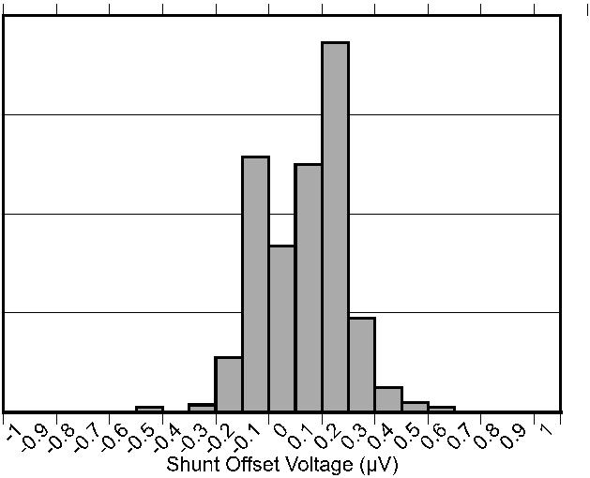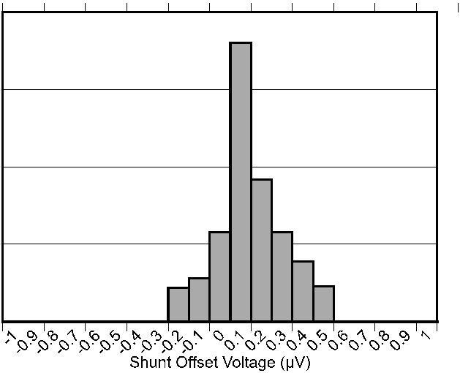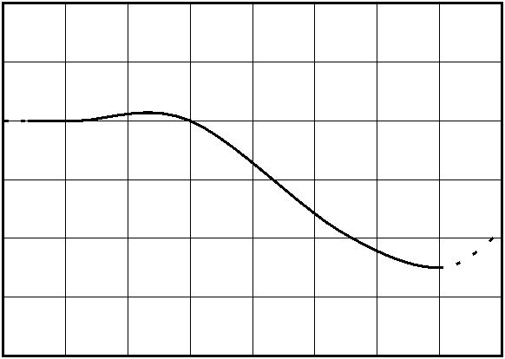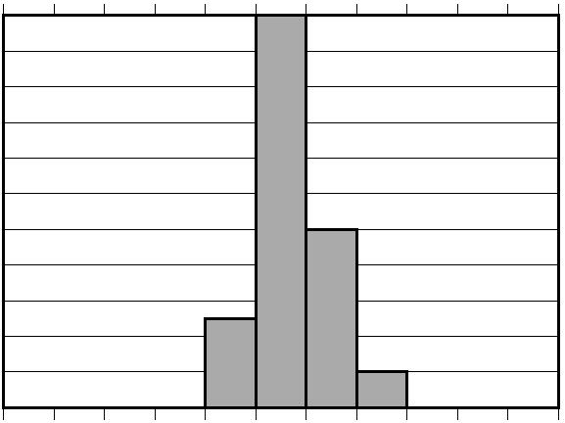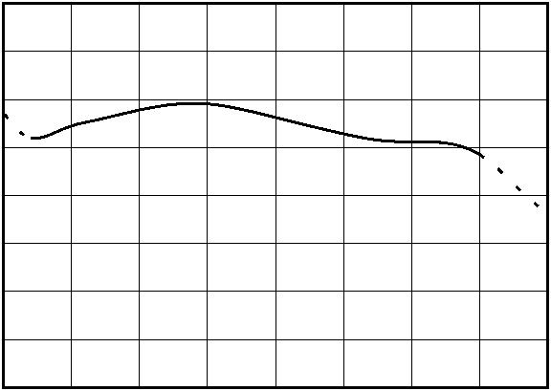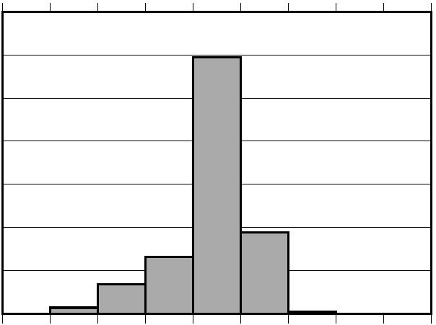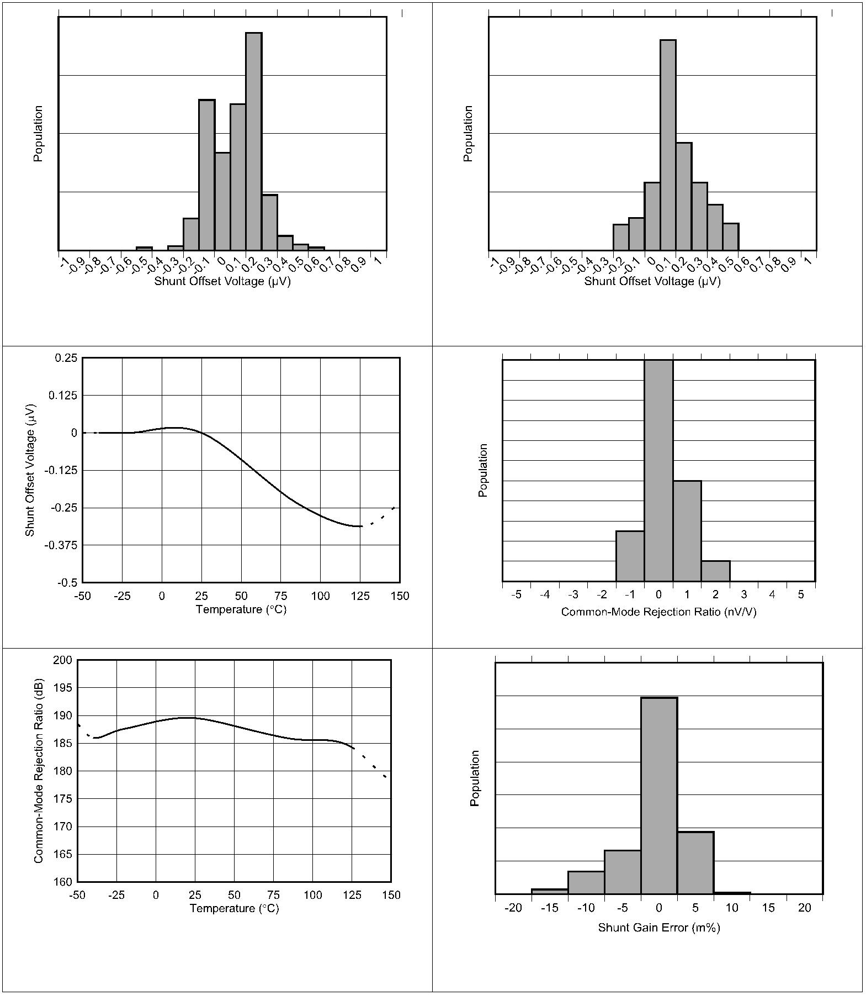INA228-Q1
ZHCSLF8A – JUNE 2020 – REVISED JUNE 2021 www.ti.com.cn
6.8 Typical Characteristics
at T_{A} = 25 °C, V_{VS} = 3.3 V, V_{CM} = 48 V, V_{SENSE} = 0, and V_{VBUS} = 48 V (unless otherwise noted)
V_{CM} = 48 V V_{CM} = 0 V
图 6-2. Shunt Input Offset Voltage Production Distribution 图 6-3. Shunt Input Offset Voltage Production Distribution
图 6-4. Shunt Input Offset Voltage vs. Temperature 图 6-5. Common-Mode Rejection Ratio Production Distribution
图 6-6. Shunt Input Common-Mode Rejection Ratio vs.
Temperature V_{CM} = 24 V
图 6-7. Shunt Input Gain Error Production Distribution
8 Submit Document Feedback Copyright © 2022 Texas Instruments Incorporated
Product Folder Links: INA228-Q1
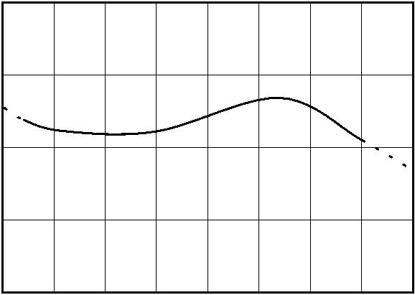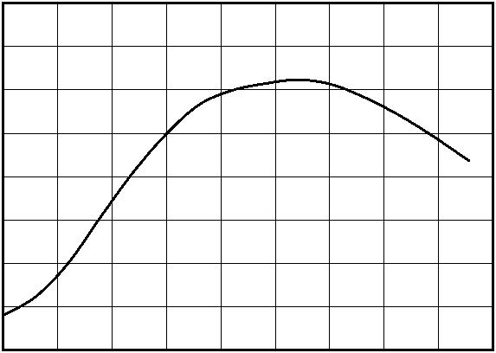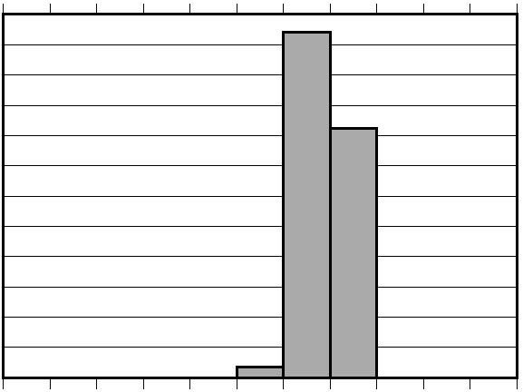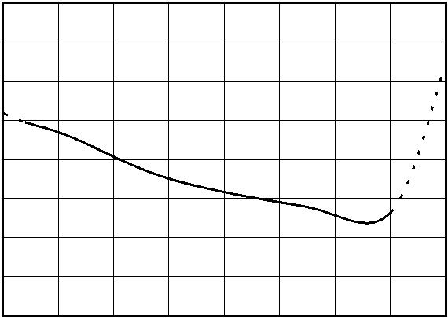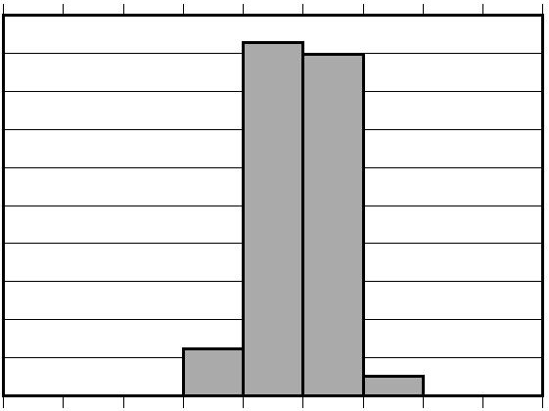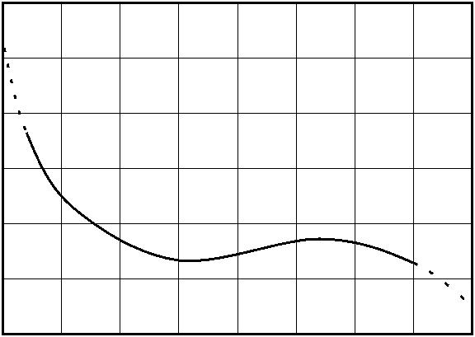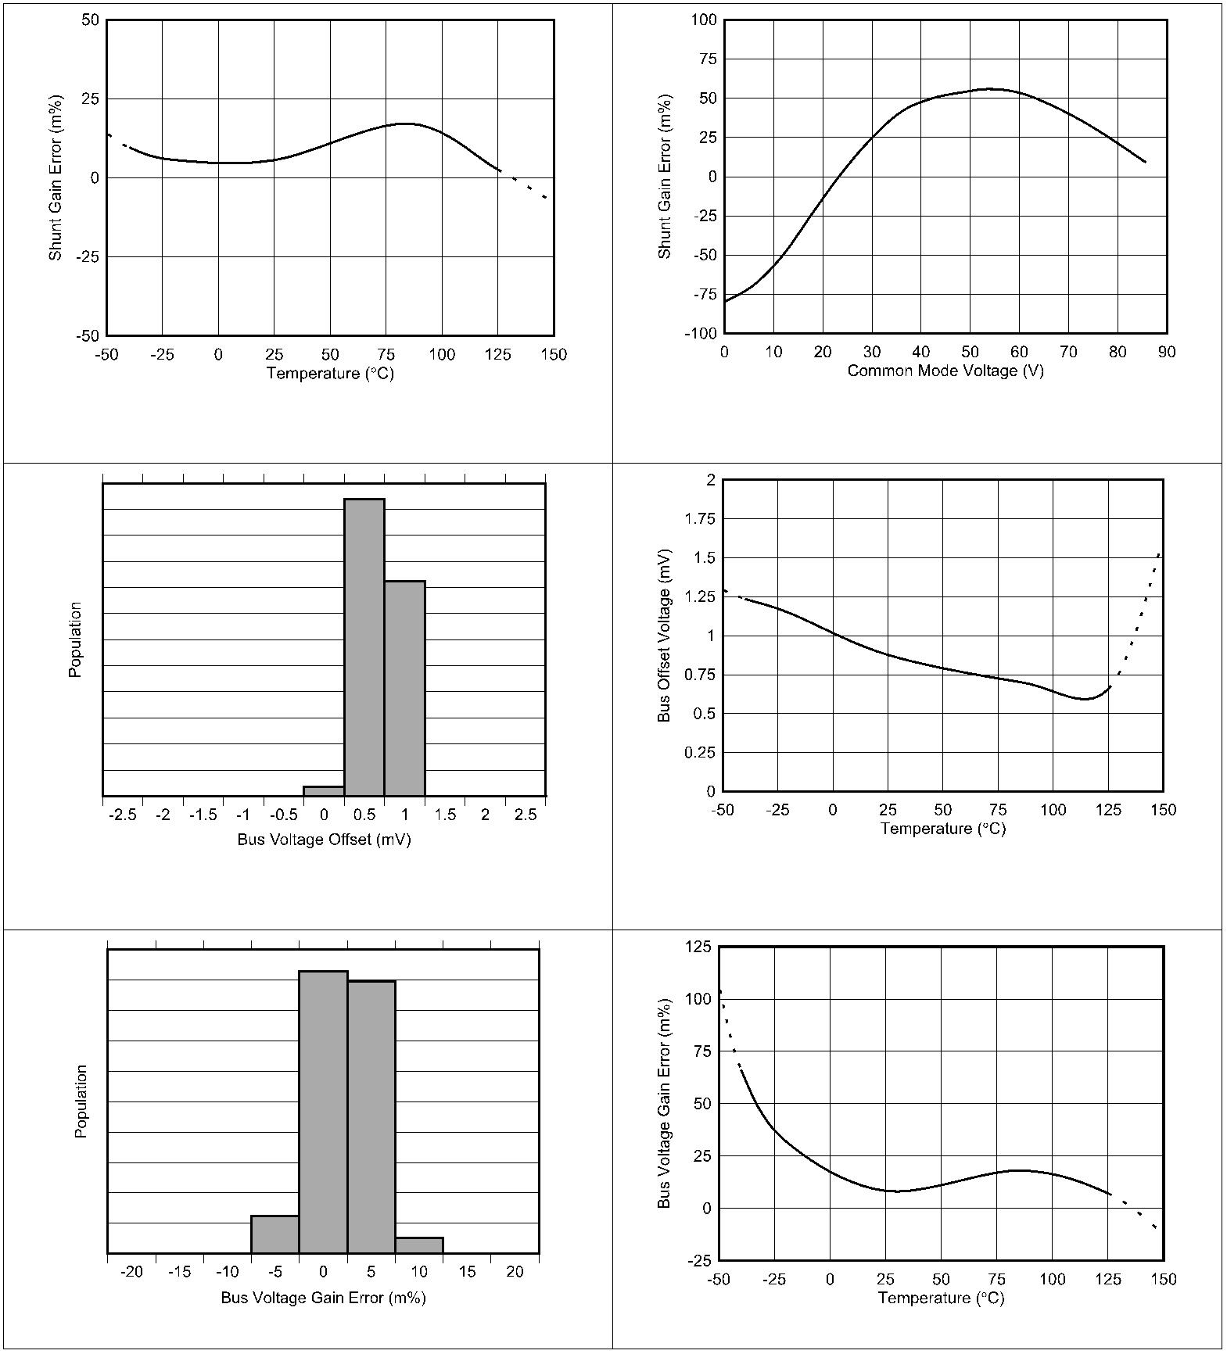www.ti.com.cn |  | INA228-Q1  ZHCSLF8A – JUNE 2020 – REVISED JUNE 2021
6.8 Typical Characteristics (continued)
at T_{A} = 25 °C, V_{VS} = 3.3 V, V_{CM} = 48 V, V_{SENSE} = 0, and V_{VBUS} = 48 V (unless otherwise noted)
 | V_{CM} = 24 V |  | 图 6-9. Shunt Input Gain Error vs. Common-Mode Voltage
图 6-8. Shunt Input Gain Error vs. Temperature
 | V_{VBUS} = 20 mV |  | V_{VBUS} = 20 mV
图 6-11. Bus Input Offset Voltage vs. Temperature
图 6-10. Bus Input Offset Voltage Production Distribution
图 6-12. Bus Input Gain Error Production Distribution 图 6-13. Bus Input Gain Error vs. Temperature
Copyright © 2022 Texas Instruments Incorporated Submit Document Feedback 9
Product Folder Links: INA228-Q1
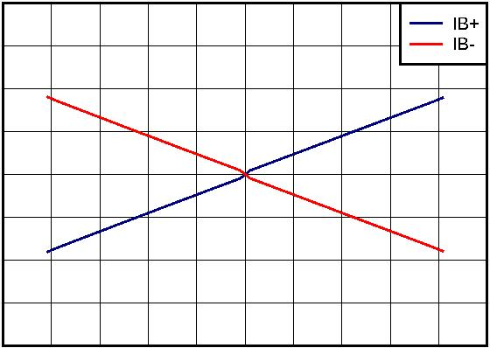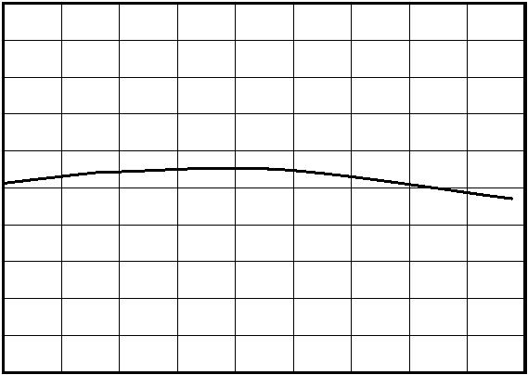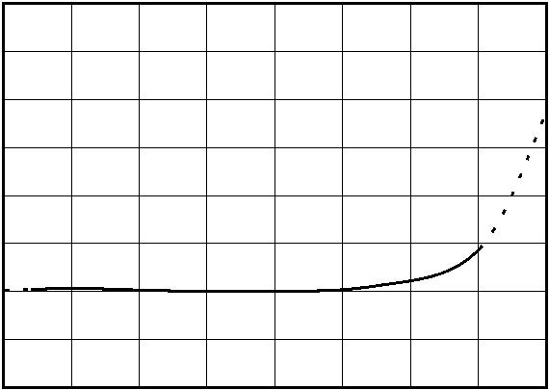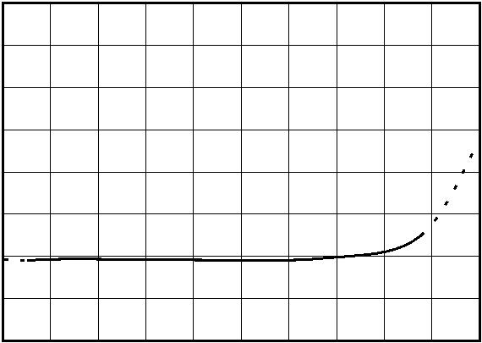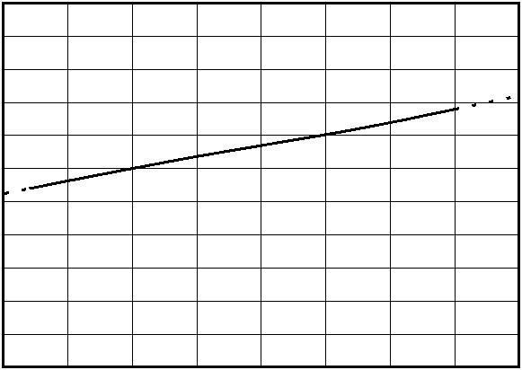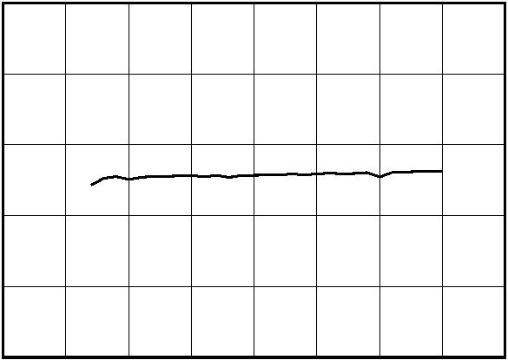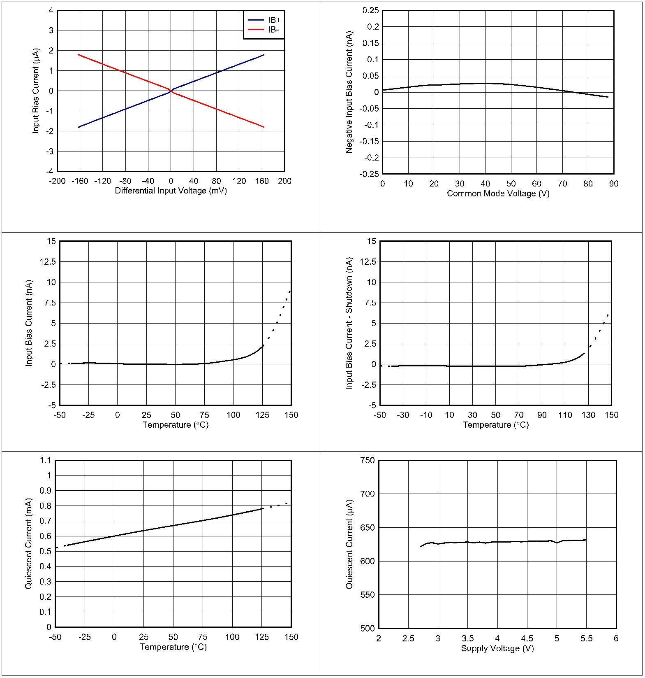INA228-Q1
ZHCSLF8A – JUNE 2020 – REVISED JUNE 2021 www.ti.com.cn
6.8 Typical Characteristics (continued)
at T_{A} = 25 °C, V_{VS} = 3.3 V, V_{CM} = 48 V, V_{SENSE} = 0, and V_{VBUS} = 48 V (unless otherwise noted)
图 6-14. Input Bias Current vs. Differential Input Voltage 图 6-15. Input Bias Current (IB+ or IB–) vs. Common-Mode
Voltage
图 6-16. Input Bias Current vs. Temperature 图 6-17. Input Bias Current vs. Temperature, Shutdown
图 6-18. Active I_{Q} vs. Temperature 图 6-19. Active I_{Q} vs. Supply Voltage
10 Submit Document Feedback Copyright © 2022 Texas Instruments Incorporated
Product Folder Links: INA228-Q1
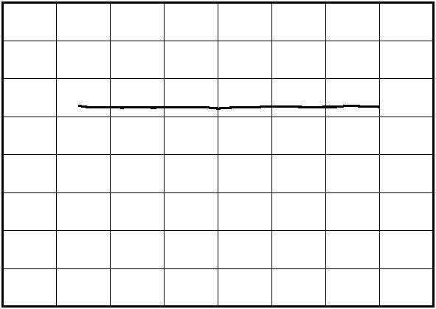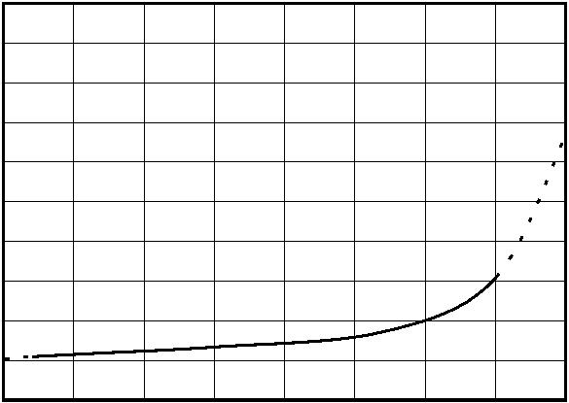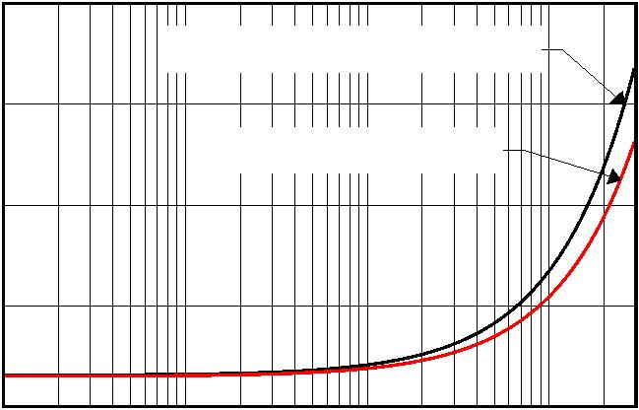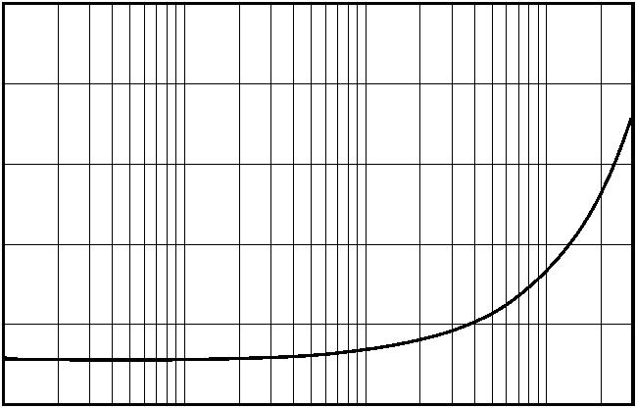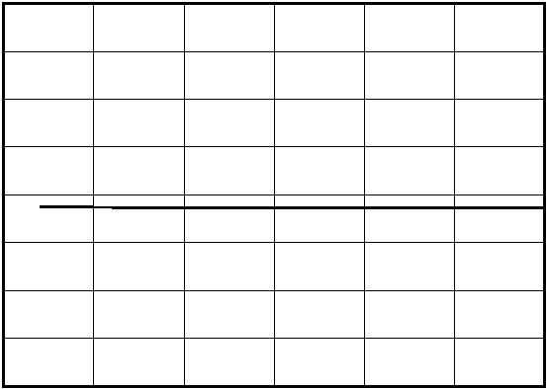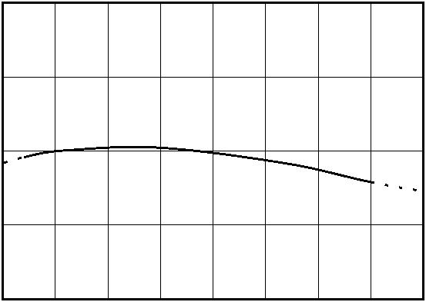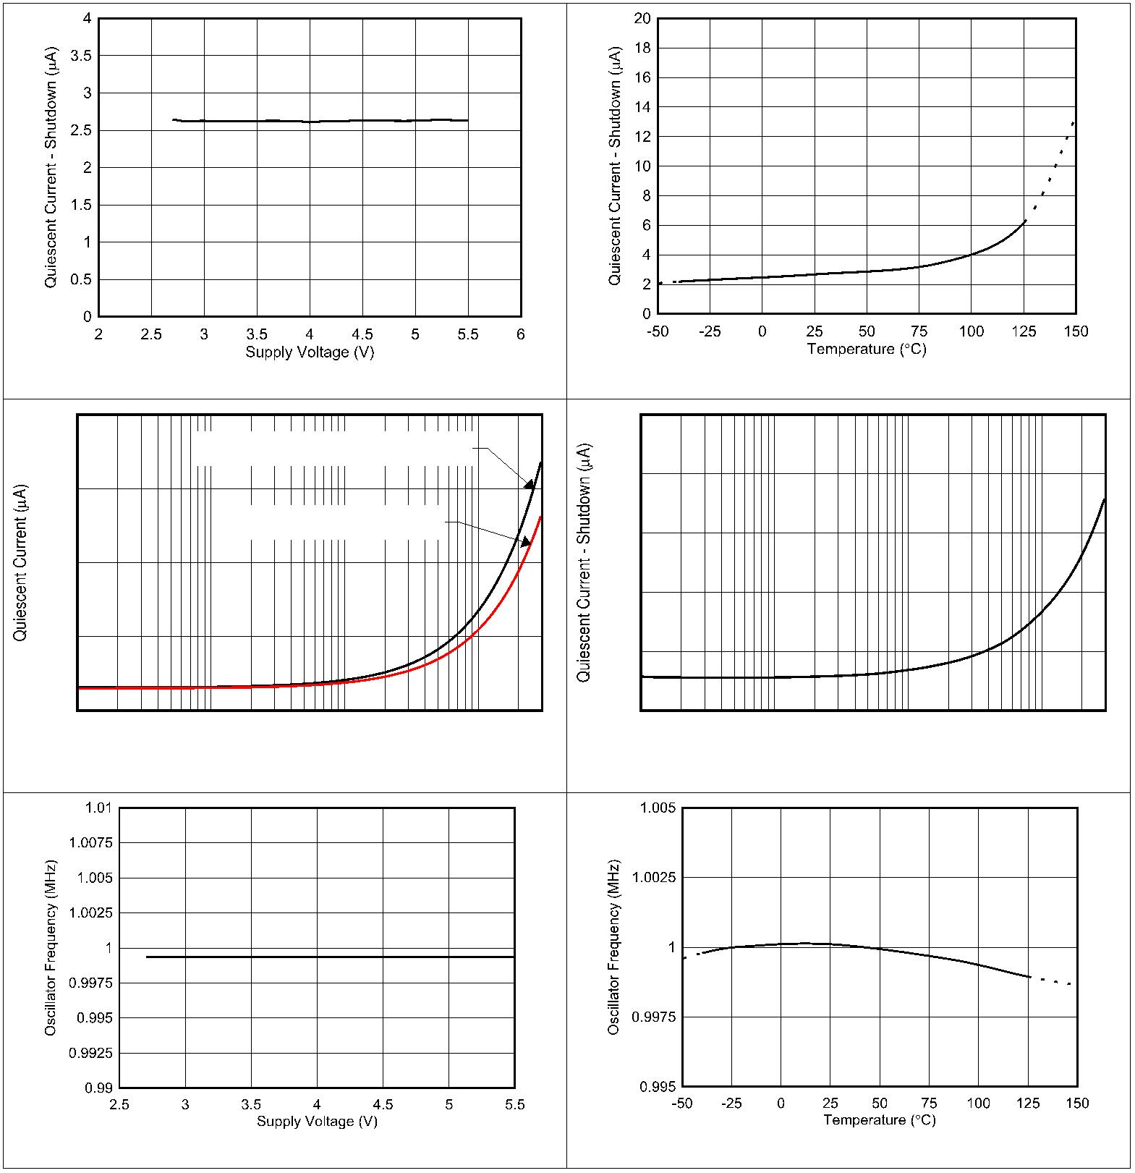www.ti.com.cn |  | INA228-Q1  ZHCSLF8A – JUNE 2020 – REVISED JUNE 2021
6.8 Typical Characteristics (continued)
at T_{A} = 25 °C, V_{VS} = 3.3 V, V_{CM} = 48 V, V_{SENSE} = 0, and V_{VBUS} = 48 V (unless otherwise noted)
图 6-20. Shutdown I_{Q} vs. Supply Voltage 图 6-21. Shutdown I_{Q} vs. Temperature
680 150
Continuous I2C Write Commands
120 660
Idle SDA, Clocking SCL
90
640
60
620
30
 | 600  1 10 100 1000 3000  Frequency (kHz) |  | 0  1 10 100 1000 3000  Frequency (kHz)
图 6-22. Active I_{Q} vs. Clock Frequency 图 6-23. Shutdown I_{Q} vs. Clock Frequency
图 6-24. Internal Clock Frequency vs. Power Supply 图 6-25. Internal Clock Frequency vs. Temperature
Copyright © 2022 Texas Instruments Incorporated Submit Document Feedback 11
Product Folder Links: INA228-Q1
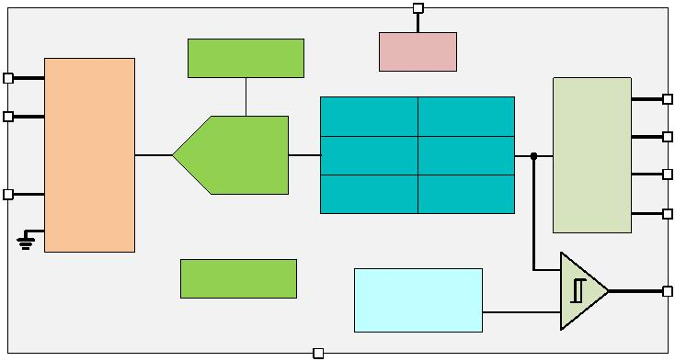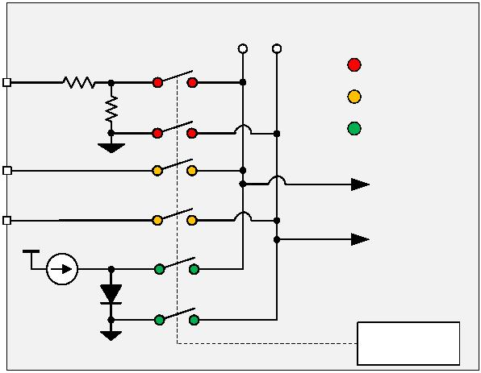INA228-Q1
ZHCSLF8A –JUNE 2020 –REVISED JUNE 2021 www.ti.com.cn
7 Detailed Description
7.1 Overview
The INA228-Q1 device is a digital current sense amplifier with an I²C digital interface. It measures shunt voltage,
bus voltage and internal temperature while calculating current, power, energy and charge necessary for accurate
decision making in precisely controlled systems. Programmable registers allow flexible configuration for
measurement precision as well as continuous or triggered operation. Detailed register information is found in 节
7.6.
7.2 Functional Block Diagram
VS
Reference
Power
IN+
SCL
IN-
Voltage Current
SDA
20 Bit
ADC
MUX
Power Energy
I
2
C
A0
VBUS Charge Temp
A1
+
Oscillator
Out-of-range
Threshold
ALERT œ
GND
7.3 Feature Description
7.3.1 Versatile High Voltage Measurement Capability
The INA228-Q1 operates off a 2.7 V to 5.5 V supply but can measure voltage and current on rails as high as 85
V. The current is measured by sensing the voltage drop across a external shunt resistor at the IN+ and IN–
pins. The input stage of the INA228-Q1 is designed such that the input common-mode voltage can be higher than the device supply voltage, V_{S}. The supported common-mode voltage range at the input pins is –0.3 V to
+85 V, which makes the device well suited for both high-side and low-side current measurements. There are no
special considerations for power-supply sequencing because the common-mode input range and device supply
voltage are independent of each other; therefore, the bus voltage can be present with the supply voltage off, and
vice-versa without damaging the device.
The device also measures the bus supply voltage through the V_{BUS} pin and temperature through the integrated
temperature sensor. The differential shunt voltage is measured between the IN+ and IN– pins, while the bus
voltage is measured with respect to device ground. Monitored bus voltages can range from 0 V to 85 V, while
monitored temperatures can range from -40 ºC to +125 ºC.
Shunt voltage, bus voltage, and temperature measurements are multiplexed internally to a single ADC as shown
in 图7-1.
ADCp ADCn
Bus Voltage V_{BUS}
Shunt Voltage
Internal Temp.
IN+
ADC_IN+
To ADC Input IN-
Vs
ADC_IN-
PTAT Temp.
Sensor
MUX digital
Control
图7-1. High-Voltage Input Multiplexer
12 Submit Document Feedback Copyright © 2022 Texas Instruments Incorporated
Product Folder Links: INA228-Q1
www.ti.com.cn |  | INA228-Q1  ZHCSLF8A – JUNE 2020 – REVISED JUNE 2021
7.3.2 Internal Measurement and Calculation Engine
The current and charge are calculated after a shunt voltage measurement, while the power and energy are
calculated after a bus voltage measurement. Power and energy are calculated based on the previous current
calculation and the latest bus voltage measurement. If the value loaded into the SHUNT_CAL register is zero,
the power, energy and charge values will be reported as zero.
The current, voltage, and temperature values are immediate results when the number of averages is set to one
as shown in 图 7-2. However, when averaging is used, each ADC measurement is an intermediate result which
is stored in the corresponding averaging registers. Following every ADC sample, the newly-calculated values for
current, voltage, and temperature are appended to their corresponding averaging registers until the set number
of averages is achieved. After all of the samples have been measured the average current and voltage is
determined, the power is calculated and the results are loaded to the corresponding output registers where they
can then be read.
The energy and charge values are accumulated for each conversion cycle. Therefore the INA228-Q1 averaging
function is not applied to these.
Calculations for power, charge and energy are performed in the background and do not add to the overall
conversion time.
 | ADC,  Temperature, Current,  Voltage |  | T |  | i v T i v i v i v i v i  T T T T
Power register p1 p2 p3 p4 p5
 | Charge register |  |  | Q₁ =  i₁ x t₁ |  |  |  | Q.. =  i.. x t.. |  |  |  | Q.. =  i.. x t.. |  |  |  | Q.. =  i.. x t.. |  |  |  | Q.. =  i.. x t..
 |  | Energy register |  |  |  | E₁ =  p₁ x t₂ |  |  |  | E.. =  p.. x t.. |  |  |  | E.. =  p.. x t.. |  |  |  | E.. =  p.. x t.. |  |  |  |  | E.. =  p.. x t..
图 7-2. Power, Energy and Charge Calculation Scheme
7.3.3 Low Bias Current
The INA228-Q1 features very low input bias current which provides several benefits. The low input bias current
of the INA228-Q1 reduces the current consumed by the device in both active and shutdown state. Another
benefit of low bias current is that it allows the use of input filters to reject high-frequency noise before the signal
is converted to digital data. In traditional digital current-sense amplifiers, the addition of input filters comes at the
cost of reduced accuracy. However, as a result of the low bias current, the reduction in accuracy due to input
filters is minimized. An additional benefit of low bias current is the ability to use a larger shunt resistor to
accurately sense smaller currents. Use of a larger value for the shunt resistor allows the device to accurately
monitor currents in the sub-mA range.
The bias current in the INA228-Q1 is the smallest when the sensed current is zero. As the current starts to
increase, the differential voltage drop across the shunt resistor increases which results in an increase in the bias
current as shown in 图 6-14.
7.3.4 High-Precision Delta-Sigma ADC
The integrated ADC is a high-performance, low-offset, low-drift, delta-sigma ADC designed to support
bidirectional current flow at the shunt voltage measurement channel. The measured inputs are selected through
the high-voltage input multiplexer to the ADC inputs as shown in 图 7-1. The ADC architecture enables lower
drift measurement across temperature and consistent offset measurements across the common-mode voltage,
temperature, and power supply variations. A low-offset ADC is preferred in current sensing applications to
provide a near 0-V offset voltage that maximizes the useful dynamic range of the system.
Copyright © 2022 Texas Instruments Incorporated Submit Document Feedback 13
Product Folder Links: INA228-Q1
INA228-Q1
ZHCSLF8A – JUNE 2020 – REVISED JUNE 2021 www.ti.com.cn
ADC conversion time for each input can be set independently by the VSHCT, VBUSCT, and VTCT bits in register
ADC_CONFIG, respectively, in the range of 50 µs to 4.12 ms. Furthermore, a sample averaging function in the
range of 1x to 1024x is implemented and can be selected by the AVG bits in ADC_CONFIG register. The sample
conversion time and the averaging are a part of the integrated digital filter described in 节 7.3.4.1.
The INA228-Q1 can measure the shunt voltage, bus voltage, and die temperature, or a combination of any
based on the selected MODE bits setting in the ADC_CONFIG register. This permits selecting modes to convert
only the shunt voltage or bus voltage to further allow the user to configure the monitoring function to fit the
specific application requirements. When no averaging is selected, once an ADC conversion is completed, the
converted values are independently updated in their corresponding registers where they can be read through the
digital interface at the time of conversion end. The conversion time for shunt voltage, bus voltage, and
temperature inputs are set independently from 50 µs to 4.12ms depending on the values programmed in the
ADC_CONFIG register. Enabled measurement inputs are converted sequentially so the total time to convert all
inputs depends on the conversion time for each input and the number of inputs enabled. When averaging is
used, the intermediate values are subsequently stored in an averaging accumulator, and the conversion
sequence repeats until the number of averages is reached. After all of the averaging has been completed, the
final values are updated in the corresponding registers that can then be read. These values remain in the data
output registers until they are replaced by the next fully completed conversion results. In this case, reading the
data output registers does not affect a conversion in progress.
The ADC has two conversion modes—continuous and triggered—set by the MODE bits in ADC_CONFIG
register. In continuous-conversion mode, the ADC will continuously convert the input measurements and update
the output registers as described above in an indefinite loop. In triggered-conversion mode, the ADC will convert
the input measurements as described above, after which the ADC will go into shutdown mode until another
single-shot trigger is generated by writing to the MODE bits. Writing the MODE bits will interrupt and restart
triggered or continuous conversions that are in progress. Although the device can be read at any time, and the
data from the last conversion remains available, the Conversion Ready flag (CNVRF bit in DIAG_ALRT register)
is provided to help coordinate triggered conversions. This bit is set after all conversions and averaging is
completed.
The Conversion Ready flag (CNVRF) clears under these conditions:
• Writing to the ADC_CONFIG register (except for selecting shutdown mode); or
• Reading the DIAG_ALRT Register
While the INA228-Q1 device is used in either one of the conversion modes, a dedicated digital engine is
calculating the current, power, charge and energy values in the background as described in 节 7.3.2. In triggered
mode, the accumulation registers (ENERGY and CHARGE) are invalid, as the device does not keep track of
elapsed time. For applications that need critical measurements in regards to accumulation of time for energy and
charge measurements, the device must be configured to use continuous conversion mode, as the accumulated
results are continuously updated and can provide true system representation of charge and energy consumption
in a system. All of the calculations are performed in the background and do not contribute to conversion time.
For applications that must synchronize with other components in the system, the INA228-Q1 conversion can be
delayed by programming the CONVDLY bits in CONFIG register in the range between 0 (no delay) and 510 ms.
The resolution in programming the conversion delay is 2 ms. The conversion delay is set to 0 by default.
Conversion delay can assist in measurement synchronization when multiple external devices are used for
voltage or current monitoring purposes. In applications where an time aligned voltage and current measurements
are needed, two devices can be used with the current measurement delayed such that the external voltage and
current measurements will occur at approximately the same time. Keep in mind that even though the internal
time base for the ADC is precise, synchronization will be lost over time due to internal and external time base
mismatch.
7.3.4.1 Low Latency Digital Filter
The device integrates a low-pass digital filter that performs both decimation and filtering on the ADC output data,
which helps with noise reduction. The digital filter is automatically adjusted for the different output data rates and
always settles within one conversion cycle. The user has the flexibility to choose different output conversion time
periods T_{CT} from 50 µs to 4.12 ms. With this configuration the first amplitude notch appears at the Nyquist
14 Submit Document Feedback Copyright © 2022 Texas Instruments Incorporated
Product Folder Links: INA228-Q1
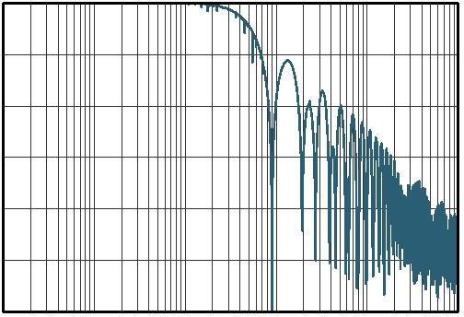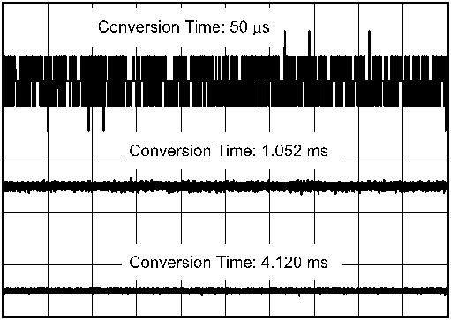www.ti.com.cn |  | INA228-Q1  ZHCSLF8A – JUNE 2020 – REVISED JUNE 2021
frequency of the output signal which is determined by the selected conversion time period and defined as f_{NOTCH}= 1 / (2 x T_{CT}). This means that the filter cut-off frequency will scale proportionally with the data output rate as described. 图 7-3 shows the filter response when the 1.052 ms conversion time period is selected.
0
−10
−20
−30
−40
−50
 | −60 |  | 1 10 100 1k 10k 100k  Frequency (Hz)  G001
Conversion time = 1.052 ms, single
conversion only
图 7-3. ADC Frequency Response
7.3.4.2 Flexible Conversion Times and Averaging
ADC conversion times for shunt voltage, bus voltage and temperature can be set independently from 50 μs to
4.12 ms. The flexibility in conversion time allows for robust operation in a variety of noisy environments. The
device also allows for programmable averaging times from a single conversion all the way to an average of 1024
conversions. The amount of averaging selected applies uniformly to all active measurement inputs. The
ADC_CONFIG register shown in 表 7-6 provides additional details on the supported conversion times and
averaging modes. The INA228-Q1 effective resolution of the ADC can be increased by increasing the conversion
time and increasing the number of averages. 图 7-4 and 图 7-5 shown below illustrate the effect of conversion
time and averaging on a constant input signal.
图 7-4. Noise vs Conversion Time (Averaging = 1)
Copyright © 2022 Texas Instruments Incorporated Submit Document Feedback 15
Product Folder Links: INA228-Q1
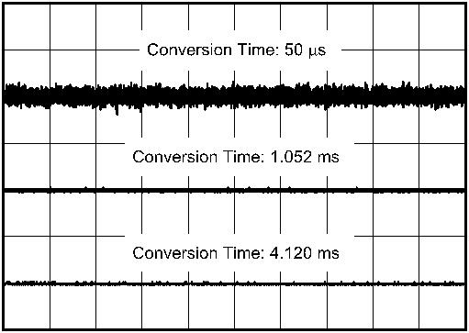INA228-Q1
ZHCSLF8A – JUNE 2020 – REVISED JUNE 2021 www.ti.com.cn
图 7-5. Noise vs. Conversion Time (Averaging = 128)
Settings for the conversion time and number of conversions averaged impact the effective measurement
resolution. For more detailed information on how averaging reduces noise and increases the effective number of
bits (ENOB) see 节 8.1.3.
7.3.5 Shunt Resistor Drift Compensation
The INA228-Q1 device has an internal temperature sensor which can measure die temperature from –40 °C to
+125 °C. The accuracy of the temperature sensor is ±2 °C across the operational temperature range. The
temperature value is stored inside the DIETEMP register and can be read through the digital interface.
The device has the capability to utilize the temperature measurement to compensate for shunt resistor
temperature variance. This feature can be enabled by setting the TEMPCOMP bit in the CONFIG register, while
the SHUNT_TEMPCO is the register that can be programmed to enter the temperature coefficient of the used
shunt. The full scale value of the SHUNT_TEMPCO register is 16384 ppm/°C. The temperature compensation is
referenced to +25 °C . The shunt is always assumed to have a positive temperature coefficient and the
temperature compensation follows 方程式 1:
R_{NOM} x (DIETEMP - 25) x SHUNT_TEMPCO
R_{ADJ} = R_{NOM} +
10
6 (1)
where
• R_{NOM} is the nominal shunt resistance in Ohms at 25 °C.
• DIETEMP is the temperature value in the DIETEMP register in °C.
• SHUNT_TEMPCO is the shunt temperature coefficient in ppm/°C.
When this feature is enabled and correctly programmed, the CURRENT register data is corrected by constantly
monitoring the die temperature and becomes a function of temperature. The effectiveness of the compensation
will depend on how well the resistor and the INA228-Q1 are thermally coupled since the die temperature of the
INA228-Q1 is used for the compensation.
16 Submit Document Feedback Copyright © 2022 Texas Instruments Incorporated
Product Folder Links: INA228-Q1
www.ti.com.cn |  | INA228-Q1  ZHCSLF8A – JUNE 2020 – REVISED JUNE 2021
Note
Warning: If temperature compensation is enabled under some conditions, the calculated current
result may be lower than the actual value. This condition typically occurs when there is a high value of
shunt voltage ( >70% of full range), there is a shunt with high temperature-coefficient value ( >2000
ppm/°C), and there is a high temperature ( >100°C). Consider the example of constant current flowing
through a high temperature coefficient shunt such that at lower temperatures the shunt voltage is in its
upper range. As the temperature increases, the device will correctly report a constant current until the
maximum shunt voltage is reached. As temperature continues to increase after the maximum shunt
voltage is reached, the device will start reporting lower currents. This is because the effective
resistance calculated will continue to increase while the detected shunt voltage will remain constant
due to the voltage exceeding the selected ADC range.
7.3.6 Integrated Precision Oscillator
The internal timebase of the device is provided by an internal oscillator that is trimmed to less than 0.5%
tolerance at room temperature. The precision oscillator is the timing source for ADC conversions, as well as the
time-count used for calculation of energy and charge. The digital filter response varies with conversion time;
therefore, the precise clock ensures filter response and notch frequency consistency across temperature. On
power up, the internal oscillator and ADC take roughly 300 µs to reach <1% error stability. Once the clock
stabilizes, the ADC data output will be accurate to the electrical specifications provided in 节 6.
7.3.7 Multi-Alert Monitoring and Fault Detection
The INA228-Q1 includes a multipurpose, open-drain ALERT output pin that can be used to report multiple
diagnostics or as an indicator that the ADC conversion is complete when the device is operating in both triggered
and continuous conversion mode. The diagnostics listed in 表 7-1 are constantly monitored and can be reported
through the ALERT pin whenever the monitored output value crosses its associated out-of-range threshold.
表 7-1. ALERT Diagnostics Description
 |  | INA228-Q1 DIAGNOSTIC |  | STATUS BIT IN DIAG_ALRT REGISTER  (RO) |  | OUT-OF-RANGE  THRESHOLD  REGISTER (R/W) |  | REGISTER DEFAULT  VALUE
 | Shunt Under Voltage Limit SHNTUL SUVL |  |  |  |  |  |  |  |  |  |  | 0x8000 h  (two's complement)
 | Shunt Over Voltage Limit SHNTOL SOVL |  |  |  |  |  |  |  |  |  |  | 0x7FFF h  (two's complement)
 | Bus Voltage Over-Limit BUSOL BOVL |  |  |  |  |  |  |  |  | 0x7FFF h  (two's complement,  positive values only)
 | Bus Voltage Under-Limit BUSUL BUVL |  |  |  |  |  |  |  |  | 0x0000 h  (two's complement,  positive values only)
 | Temperature Over-Limit TMPOL TEMP_LIMIT |  |  |  |  |  |  |  |  | 0xFFFF h  (two's complement,  positive values only)
 | Power Over-Limit POL PWR_LIMIT |  |  |  |  |  |  |  |  |  |  | 0x7FFF h  (two's complement)
A read of the DIAG_ALRT register is used to determine which diagnostic has triggered the ALERT pin. This
register, shown in 表 7-16, is also used to monitor other associated diagnostics as well as configure some
ALERT pin functions.
• Alert latch enable — In case the ALERT pin is triggered, this function will hold the value of the pin even after
all diagnostic conditions have cleared. A read of the DIAG_ALRT register will reset the status of the ALERT
pin. This function is enabled by setting the ALATCH bit.
• Conversion ready enable — Enables the ALERT pin to assert when an ADC conversion has completed and
output values are ready to be read through the digital interface. This function is enabled by setting the CNVR
Copyright © 2022 Texas Instruments Incorporated Submit Document Feedback 17
Product Folder Links: INA228-Q1
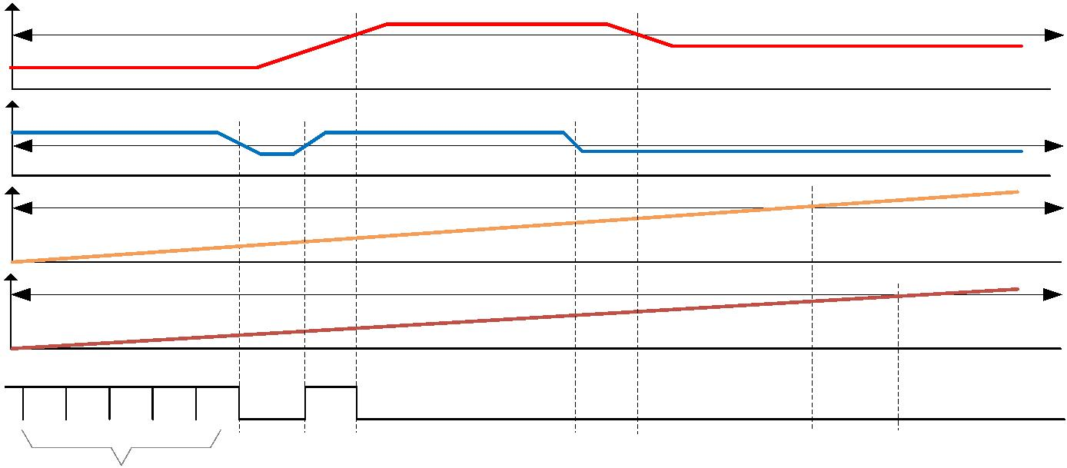INA228-Q1
ZHCSLF8A – JUNE 2020 – REVISED JUNE 2021 www.ti.com.cn
bit. The conversion completed events can also be read through the CNVRF bit regardless of the CNVR bit
setting.
• Alert comparison on averaged output — Allows the out-of-range threshold value to be compared to the
averaged data values produced by the ADC. This helps to additionally remove noise from the output data
when compared to the out-of-range threshold to avoid false alerts due to noise. However, the diagnostic will
be delayed due to the time needed for averaging. This function is enabled by setting the SLOWALERT bit.
• Alert polarity — Allows the device to invert the active state of the ALERT pin. Note that the ALERT pin is an
open-drain output that must be pulled-up by a resistor. The ALERT pin is active-low by default and can be
configured for active high function using the APOL control bit.
Other diagnostic functions that are not reported by the ALERT pin but are available by reading the DIAG_ALRT
register:
• Math overflow — Indicated by the MATHOF bit, reports when an arithmetic operation has caused an internal
register overflow.
• Memory status — Indicated by the MEMSTAT bit, monitors the health of the device non-volatile trim memory.
This bit should always read '1' when the device is operating properly.
• Energy overflow — Indicated by the ENERGYOF bit, reports when the ENERGY register has reached an
overflow state due to data accumulation.
• Charge overflow — Indicated by the CHARGEOF bit, reports when the CHARGE register has reached an
overflow state due to data accumulation.
When the ALERT pin is configured to report the ADC conversion complete event, the ALERT pin becomes a
multipurpose reporting output. 图 7-6 shows an example where the device reports ADC conversion complete
events while the INA228-Q1 device is subject to shunt over voltage (over current) event, bus under voltage
event, over temperature event and over power-limit event.
Shunt Voltage
Shunt Over Voltage Threshold
Bus Voltage
Bus Under Voltage Threshold
Over Temp Threshold
Temperature
Power
Power Over Limit Threshold
 | ALERT  (ALATCH = 0)  (APOL = 0)  (CNVR = 1) |  | - No diag. error -  Conversion Complete  Reported |  | BUV  SET |  | BUV  CLEAR |  | SOV  SET |  | SOV  &  BUV  SET |  | SOV  CLEAR |  | BUV  &  OT  SET |  | BUV  &  OT  &  OP  SET
图 7-6. Multi-Alert Configuration
7.4 Device Functional Modes
7.4.1 Shutdown Mode
In addition to the two conversion modes (continuous and triggered), the device also has a shutdown mode
(selected by the MODE bits in ADC_CONFIG register) that reduces the quiescent current to less than 5 µA and
turns off current into the device inputs, reducing the impact of supply drain when the device is not being used.
The registers of the device can be written to and read from while the device is in shutdown mode. The device
remains in shutdown mode until another triggered conversion command or continuous conversion command is
received.
18 Submit Document Feedback Copyright © 2022 Texas Instruments Incorporated
Product Folder Links: INA228-Q1
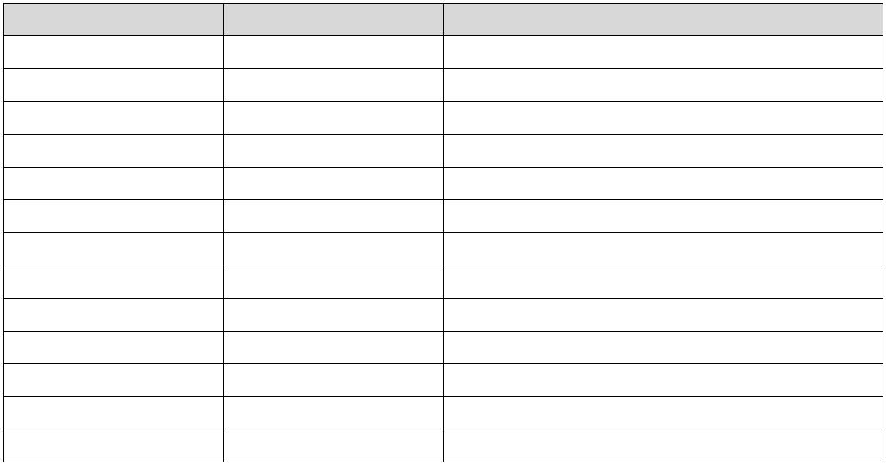www.ti.com.cn |  | INA228-Q1  ZHCSLF8A – JUNE 2020 – REVISED JUNE 2021
The device can be triggered to perform conversions while in shutdown mode. When a conversion is triggered,
the ADC will start conversion; once conversion completes the device will return to the shutdown state.
Note that the shutdown current is specified with an inactive communications bus. Active clock and data activity
will increase the current consumption as a function of the bus frequency as shown in 图 6-23.
7.4.2 Power-On Reset
Power-on reset (POR) is asserted when V_{S} drops below 1.26V (typical) at which all of the registers are reset to
their default values. A manual device reset can be initiated by setting the RST bit in the CONFIG register. The
default power-up register values are shown in the reset column for each register description. Links to the register
descriptions are shown in 节 7.6.
7.5 Programming
7.5.1 I²C Serial Interface
The INA228-Q1 operates only as a secondary device on both the SMBus and I²C interfaces. Connections to the
bus are made through the open-drain SDA and SCL lines. The SDA and SCL pins feature integrated spike
suppression filters and Schmitt triggers to minimize the effects of input spikes and bus noise. Although the
device integrates spike suppression into the digital I/O lines, proper layout techniques help minimize the amount
of coupling into the communication lines. This noise introduction could occur from capacitive coupling signal
edges between the two communication lines themselves or from other switching noise sources present in the
system. Routing traces in parallel with ground in between layers on a printed-circuit board (PCB) typically
reduces the effects of coupling between the communication lines. Shielded communication lines reduce the
possibility of unintended noise coupling into the digital I/O lines that could be incorrectly interpreted as start or
stop commands.
The INA228-Q1 supports the transmission protocol for fast mode (1 kHz to 400 kHz) and high-speed mode (1
kHz to 2.94 MHz). All data bytes are transmitted most significant byte first and follow the SMBus 3.0 transfer
protocol.
To communicate with the INA228-Q1, the main device must first address secondary devices through a
secondary device address byte. The secondary device address byte consists of seven address bits and a
direction bit that indicates whether the action is to be a read or write operation.
The device has two address pins, A0 and A1. 表 7-2 lists the pin logic levels for each of the 16 possible
addresses. The device samples the state of pins A0 and A1 on every bus communication. Establish the pin
states before any activity on the interface occurs. When connecting the SDA pin to either A0 or A1 to set the
device address, additional hold time of 100 ns is needed on the MSB of the I2C address to insure correct device
addressing.
表 7-2. Address Pins and Secondary Device Addresses
A1 A0 Secondary Device Address
GND GND 1000000
GND VS 1000001
GND SDA 1000010
GND SCL 1000011
VS GND 1000100
VS VS 1000101
VS SDA 1000110
VS SCL 1000111
SDA GND 1001000
SDA VS 1001001
SDA SDA 1001010
SDA SCL 1001011
SCL GND 1001100
Copyright © 2022 Texas Instruments Incorporated Submit Document Feedback 19
Product Folder Links: INA228-Q1
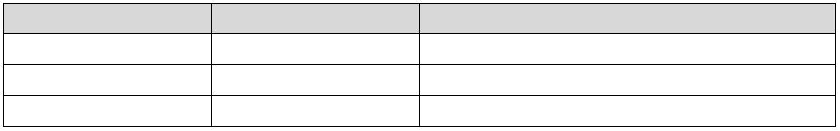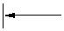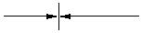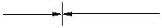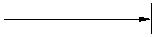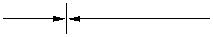INA228-Q1
ZHCSLF8A – JUNE 2020 – REVISED JUNE 2021 www.ti.com.cn
表 7-2. Address Pins and Secondary Device Addresses (continued)
A1 A0 Secondary Device Address
SCL VS 1001101
SCL SDA 1001110
SCL SCL 1001111
7.5.1.1 Writing to and Reading Through the I²C Serial Interface
Accessing a specific register on the INA228-Q1 is accomplished by writing the appropriate value to the register
pointer. Refer to 节 7.6 for a complete list of registers and corresponding addresses. The value for the register
pointer (as shown in 图 7-9) is the first byte transferred after the secondary device address byte with the R/W bit
low. Every write operation to the device requires a value for the register pointer.
Writing to a register begins with the first byte transmitted by the main device. This byte is the secondary device
address, with the R/W bit low. The device then acknowledges receipt of a valid address. The next byte
transmitted by the main device is the address of the register to be accessed. This register address value updates
the register pointer to the desired internal device register. The next two bytes are written to the register
addressed by the register pointer. The device acknowledges receipt of each data byte. The main device may
terminate data transfer by generating a start or stop condition.
When reading from the device, the last value stored in the register pointer by a write operation determines which
register is read during a read operation. To change the register pointer for a read operation, a new value must be
written to the register pointer. This write is accomplished by issuing a secondary device address byte with the R/
W bit low, followed by the register pointer byte. No additional data are required. The main device then generates
a start condition and sends the address byte for the secondary device with the R/W bit high to initiate the read
command. The next byte is transmitted by the secondary device and is the most significant byte of the register
indicated by the register pointer. This byte is followed by an Acknowledge from the main device; then the
secondary device transmits the least significant byte. The main device may or may not acknowledge receipt of
the second data byte. The main device may terminate data transfer by generating a Not-Acknowledge after
receiving any data byte, or generating a start or stop condition. If repeated reads from the same register are
desired, it is not necessary to continually send the register pointer bytes; the device retains the register pointer
value until it is changed by the next write operation.
图 7-7 shows the write operation timing diagram. 图 7-8 shows the read operation timing diagram. These
diagrams are shown for reading/writing to 16 bit registers. Registers with a higher number of bytes will behave
similarly.
Register bytes are sent most-significant byte first, followed by the least significant byte.
 | 1 9 1 9 |  | 1 9 1 9
SCL
SDA 1 0 0 A3 A2 A1 A0 R/W P7 P6 P5 P4 P3 P2 P1 P0 |  |  |  |  |  |  |  |  |  | D15 D14 D13 D12 D11 D10 D9 D8 D7 D6 D5 D4 D3 D2 D1 D0
 | Start By  Controller |  |  | ACK By  Target |  |  |  | ACK By  Target |  |  |  |  |  | ACK By  Target |  |  | ACK By  Target |  |  | Stop By  Controller
 |  | (1)  Frame 1 Two-Wire Target Address Byte |  |  |  | Frame 2 Register Pointer Byte |  |  |  |  |  | Frame 3 Data MSByte Frame 4 Data LSByte
A. The value of the Secondary Device Address byte is determined by the settings of the A0 and A1 pins. Refer to 表 7-2.
B. The device does not support packet error checking (PEC) or perform clock stretching.
图 7-7. Timing Diagram for Write Word Format
20 Submit Document Feedback Copyright © 2022 Texas Instruments Incorporated
Product Folder Links: INA228-Q1
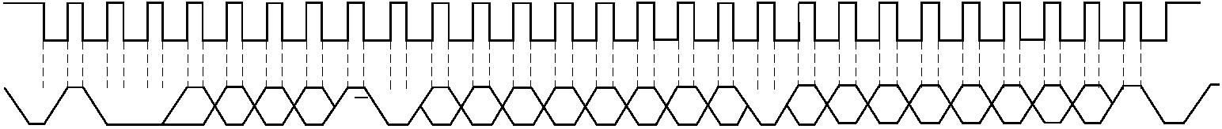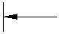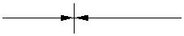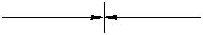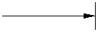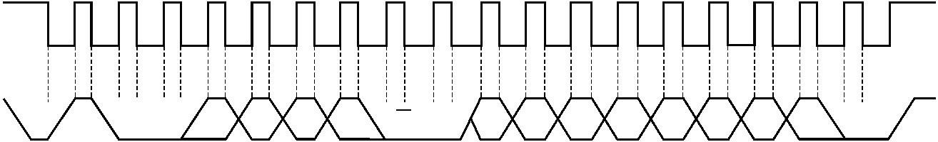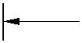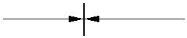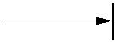 | www.ti.com.cn |  | INA228-Q1  ZHCSLF8A – JUNE 2020 – REVISED JUNE 2021
1 9 1 9 1 9
SCL
SDA |  |  | 1 0 0 A3 A2 A1 A0 R/W D15 D14 D13 D12 D11 D10 D9 D8 |  |  |  |  |  | D7 D6 D5 D4 D3 D2 D1 D0
 | Start By  Controller |  |  |  | ACK By From  Target Target  (1) Frame 2 Data MSByte  (2)  Frame 1 Two-Wire Target Address Byte |  | ACK By  Controller |  |  |  | From  Target  (2)  Frame 3 Data LSByte |  | (3)  No ACK By  Controller |  |  | Stop
A. The value of the Secondary Device Address byte is determined by the settings of the A0 and A1 pins. Refer to 表 7-2.
B. Read data is from the last register pointer location. If a new register is desired, the register pointer must be updated. See 图 7-9.
C. ACK by the main device can also be sent.
D. The device does not support packet error checking (PEC) or perform clock stretching.
图 7-8. Timing Diagram for Read Word Format
1 9 1 9
 | SCL |  | ꢀꢁꢁ
SDA 1 0 0 A3 A2 A1 A0 R/W P7 P6 P5 P4 P3 P2 P1 P0 Stop
 | Start By  Controller |  |  | ACK By  Target |  |  |  |  | ACK By  Target
 |  | (1)  Frame 1 Two-Wire Target Address Byte |  |  |  | Frame 2 Register Pointer Byte
A. The value of the Secondary Device Address Byte is determined by the settings of the A0 and A1 pins. Refer to 表 7-2.
图 7-9. Typical Register Pointer Set
7.5.1.2 High-Speed I²C Mode
When the bus is idle, both the SDA and SCL lines are pulled high by the pullup resistors. The main device
generates a start condition followed by a valid serial byte containing high-speed (HS) main device code
00001XXX. This transmission is made in fast (400 kHz) or standard (100 kHz) (F/S) mode at no more than 400
kHz. The device does not acknowledge the HS main device code, but does recognize it and switches its internal
filters to support 2.94-MHz operation.
The main device then generates a repeated start condition (a repeated start condition has the same timing as
the start condition). After this repeated start condition, the protocol is the same as F/S mode, except that
transmission speeds up to 2.94 MHz are allowed. Instead of using a stop condition, use repeated start
conditions to maintain the bus in HS-mode. A stop condition ends the HS-mode and switches all the internal
filters of the device to support the F/S mode.
7.5.1.3 SMBus Alert Response
The INA228-Q1 is designed to respond to the SMBus Alert Response address. The SMBus Alert Response
provides a quick fault identification for simple secondary devices. When an Alert occurs, the main device can
broadcast the Alert Response secondary device address (0001 100) with the Read/Write bit set high. Following
this Alert Response, any secondary device that generates an alert identifies itself by acknowledging the Alert
Response and sending its address on the bus.
The Alert Response can activate several different slave devices simultaneously, similar to the I²C General Call. If
more than one slave attempts to respond, bus arbitration rules apply. The losing device does not generate an
Acknowledge and continues to hold the Alert line low until that device wins arbitration.
Copyright © 2022 Texas Instruments Incorporated Submit Document Feedback 21
Product Folder Links: INA228-Q1
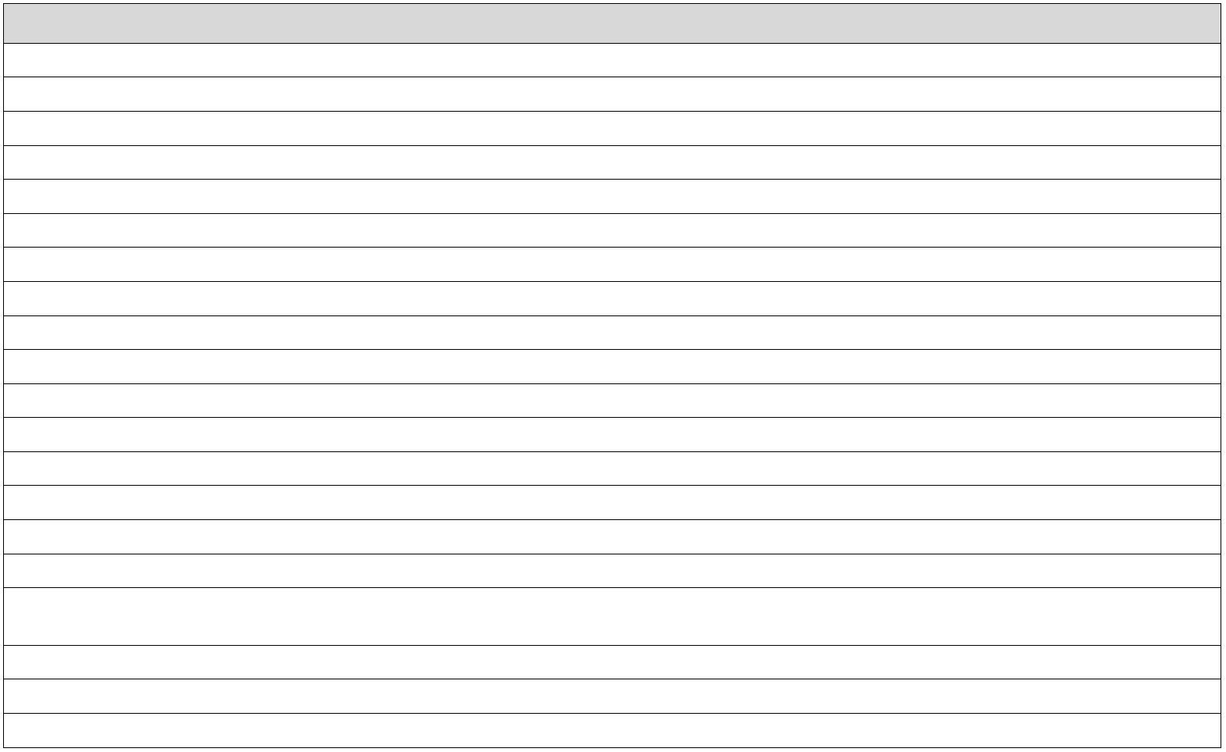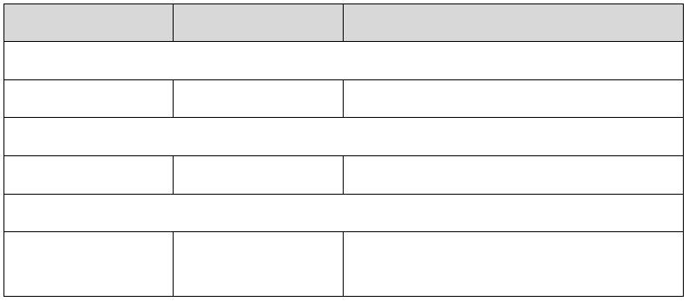INA228-Q1
ZHCSLF8A – JUNE 2020 – REVISED JUNE 2021 www.ti.com.cn
7.6 Register Maps
7.6.1 INA228-Q1 Registers
表 7-3 lists the INA228-Q1 registers. All register locations not listed in 表 7-3 should be considered as reserved locations and the register contents should not be modified.
表 7-3. INA228-Q1 Registers
Address Acronym Register Name Register Size (bits) Section
0h CONFIG Configuration 16 Go
1h ADC_CONFIG ADC Configuration 16 Go
2h SHUNT_CAL Shunt Calibration 16 Go
3h SHUNT_TEMPCO Shunt Temperature Coefficient 16 Go
4h VSHUNT Shunt Voltage Measurement 24 Go
5h VBUS Bus Voltage Measurement 24 Go
6h DIETEMP Temperature Measurement 16 Go
7h CURRENT Current Result 24 Go
8h POWER Power Result 24 Go
9h ENERGY Energy Result 40 Go
Ah CHARGE Charge Result 40 Go
Bh DIAG_ALRT Diagnostic Flags and Alert 16 Go
Ch SOVL Shunt Overvoltage Threshold 16 Go
Dh SUVL Shunt Undervoltage Threshold 16 Go
Eh BOVL Bus Overvoltage Threshold 16 Go
Fh BUVL Bus Undervoltage Threshold 16 Go
 | 10h TEMP_LIMIT Temperature Over-Limit  Threshold |  | 16 Go
11h PWR_LIMIT Power Over-Limit Threshold 16 Go
3Eh MANUFACTURER_ID Manufacturer ID 16 Go
3Fh DEVICE_ID Device ID 16 Go
Complex bit access types are encoded to fit into small table cells. 表 7-4 shows the codes that are used for access types in this section.
表 7-4. INA228-Q1 Access Type Codes
Access Type Code Description
Read Type
R R Read
Write Type
W W Write
Reset or Default Value
-n Value after reset or the default
value
7.6.1.1 Configuration (CONFIG) Register (Address = 0h) [reset = 0h]
The CONFIG register is shown in 表 7-5.
Return to the Summary Table.
22 Submit Document Feedback Copyright © 2022 Texas Instruments Incorporated
Product Folder Links: INA228-Q1
www.ti.com.cn |  | INA228-Q1  ZHCSLF8A – JUNE 2020 – REVISED JUNE 2021
表 7-5. CONFIG Register Field Descriptions
Bit Field Type Reset Description
15 RST R/W 0h Reset Bit. Setting this bit to '1' generates a system reset that is the
same as power-on reset.
Resets all registers to default values. 0h = Normal Operation
1h = System Reset sets registers to default values
This bit self-clears.
14 RSTACC R/W 0h Resets the contents of accumulation registers ENERGY and
CHARGE to 0
0h = Normal Operation
1h = Clears registers to default values for ENERGY and CHARGE
registers
13-6 CONVDLY R/W 0h Sets the Delay for initial ADC conversion in steps of 2 ms.
0h = 0 s
1h = 2 ms
FFh = 510 ms
5 TEMPCOMP R/W 0h Enables temperature compensation of an external shunt
0h = Shunt Temperature Compensation Disabled
1h = Shunt Temperature Compensation Enabled
4 ADCRANGE R/W 0h Shunt full scale range selection across IN+ and IN–.
0h = ±163.84 mV
1h = ± 40.96 mV
3-0 RESERVED R 0h Reserved. Always reads 0.
Copyright © 2022 Texas Instruments Incorporated Submit Document Feedback 23
Product Folder Links: INA228-Q1
INA228-Q1
ZHCSLF8A – JUNE 2020 – REVISED JUNE 2021 www.ti.com.cn
7.6.1.2 ADC Configuration (ADC_CONFIG) Register (Address = 1h) [reset = FB68h]
The ADC_CONFIG register is shown in 表 7-6.
Return to the Summary Table.
表 7-6. ADC_CONFIG Register Field Descriptions
Bit Field Type Reset Description
15-12 MODE R/W Fh The user can set the MODE bits for continuous or triggered mode on
bus voltage, shunt voltage or temperature measurement.
0h = Shutdown
1h = Triggered bus voltage, single shot
2h = Triggered shunt voltage, single shot
3h = Triggered shunt voltage and bus voltage, single shot
4h = Triggered temperature, single shot
5h = Triggered temperature and bus voltage, single shot
6h = Triggered temperature and shunt voltage, single shot
7h = Triggered bus voltage, shunt voltage and temperature, single
shot
8h = Shutdown
9h = Continuous bus voltage only
Ah = Continuous shunt voltage only
Bh = Continuous shunt and bus voltage
Ch = Continuous temperature only
Dh = Continuous bus voltage and temperature
Eh = Continuous temperature and shunt voltage
Fh = Continuous bus voltage, shunt voltage and temperature
11-9 VBUSCT R/W 5h Sets the conversion time of the bus voltage measurement:
0h = 50 µs
1h = 84 µs
2h = 150 µs
3h = 280 µs
4h = 540 µs
5h = 1052 µs
6h = 2074 µs
7h = 4120 µs
8-6 VSHCT R/W 5h Sets the conversion time of the shunt voltage measurement:
0h = 50 µs
1h = 84 µs
2h = 150 µs
3h = 280 µs
4h = 540 µs
5h = 1052 µs
6h = 2074 µs
7h = 4120 µs
5-3 VTCT R/W 5h Sets the conversion time of the temperature measurement:
0h = 50 µs
1h = 84 µs
2h = 150 µs
3h = 280 µs
4h = 540 µs
5h = 1052 µs
6h = 2074 µs
7h = 4120 µs
24 Submit Document Feedback Copyright © 2022 Texas Instruments Incorporated
Product Folder Links: INA228-Q1
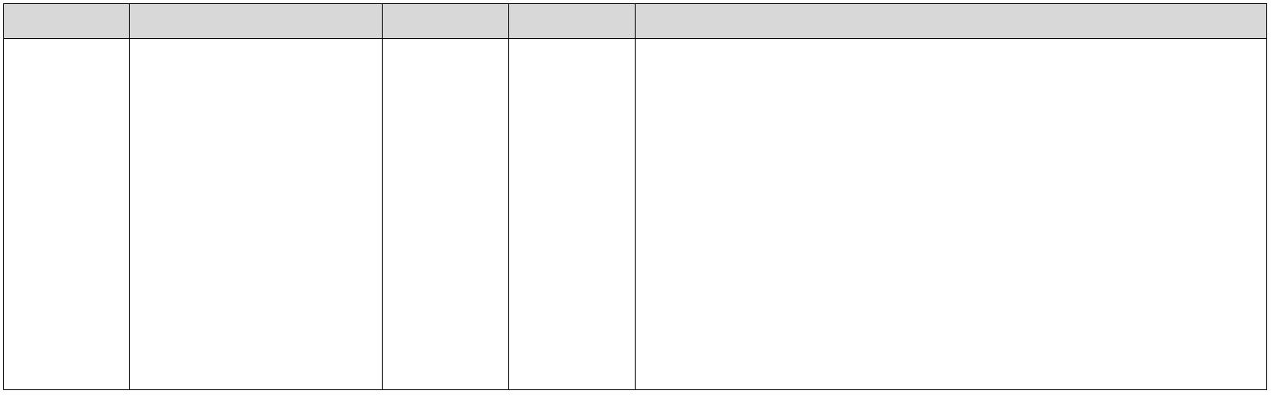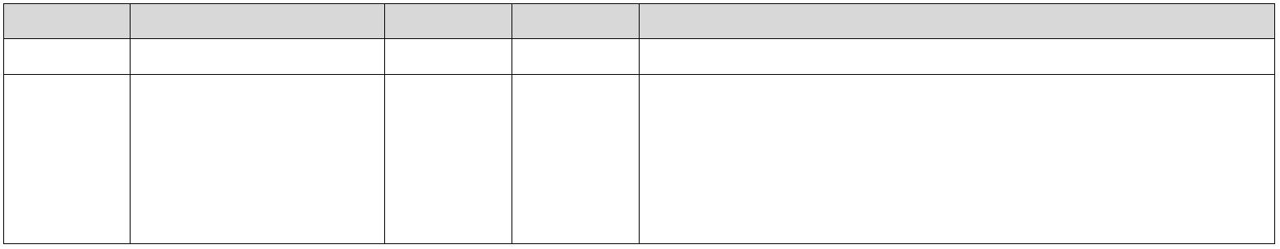www.ti.com.cn |  | INA228-Q1  ZHCSLF8A – JUNE 2020 – REVISED JUNE 2021
表 7-6. ADC_CONFIG Register Field Descriptions (continued)
Bit Field Type Reset Description
2-0 AVG R/W 0h Selects ADC sample averaging count. The averaging setting applies
to all active inputs.
When >0h, the output registers are updated after the averaging has
completed.
0h = 1
1h = 4
2h = 16
3h = 64
4h = 128
5h = 256
6h = 512
7h = 1024
7.6.1.3 Shunt Calibration (SHUNT_CAL) Register (Address = 2h) [reset = 1000h]
The SHUNT_CAL register is shown in 表 7-7.
Return to the Summary Table.
表 7-7. SHUNT_CAL Register Field Descriptions
Bit Field Type Reset Description
15 RESERVED R 0h Reserved. Always reads 0.
14-0 SHUNT_CAL R/W 1000h The register provides the device with a conversion constant value
that represents shunt resistance used to calculate current value in
Amperes.
This also sets the resolution for the CURRENT register. Value calculation under 节 8.1.2.
7.6.1.4 Shunt Temperature Coefficient (SHUNT_TEMPCO) Register (Address = 3h) [reset = 0h]
The SHUNT_TEMPCO register is shown in 表 7-8.
Return to the Summary Table.
表 7-8. SHUNT_TEMPCO Register Field Descriptions
Bit Field Type Reset Description
15-14 RESERVED R 0h Reserved. Always reads 0.
13-0 TEMPCO R/W 0h Temperature coefficient of the shunt for temperature compensation
correction. Calculated with respect to +25 °C.
The full scale value of the register is 16383 ppm/°C.
The 16 bit register provides a resolution of 1ppm/°C/LSB 0h = 0 ppm/°C
3FFFh = 16383 ppm/°C
7.6.1.5 Shunt Voltage Measurement (VSHUNT) Register (Address = 4h) [reset = 0h]
The VSHUNT register is shown in 表 7-9.
Return to the Summary Table.
Copyright © 2022 Texas Instruments Incorporated Submit Document Feedback 25
Product Folder Links: INA228-Q1
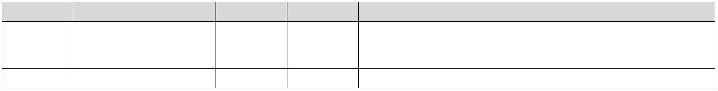INA228-Q1
ZHCSLF8A – JUNE 2020 – REVISED JUNE 2021 www.ti.com.cn
表 7-9. VSHUNT Register Field Descriptions
Bit Field Type Reset Description
23-4 VSHUNT R 0h Differential voltage measured across the shunt output. Two's
complement value. Conversion factor:
312.5 nV/LSB when ADCRANGE = 0
78.125 nV/LSB when ADCRANGE = 1
3-0 RESERVED R 0h Reserved. Always reads 0.
7.6.1.6 Bus Voltage Measurement (VBUS) Register (Address = 5h) [reset = 0h]
The VBUS register is shown in 表 7-10.
Return to the Summary Table.
表 7-10. VBUS Register Field Descriptions
Bit Field Type Reset Description
23-4 VBUS R 0h Bus voltage output. Two's complement value, however always
positive.
Conversion factor: 195.3125 µV/LSB
3-0 RESERVED R 0h Reserved. Always reads 0.
26 Submit Document Feedback Copyright © 2022 Texas Instruments Incorporated
Product Folder Links: INA228-Q1
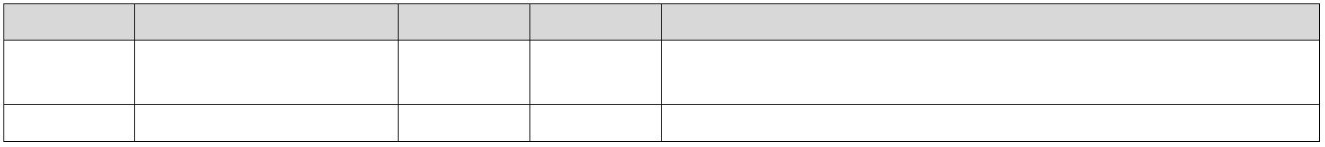www.ti.com.cn |  | INA228-Q1  ZHCSLF8A – JUNE 2020 – REVISED JUNE 2021
7.6.1.7 Temperature Measurement (DIETEMP) Register (Address = 6h) [reset = 0h]
The DIETEMP register is shown in 表 7-11.
Return to the Summary Table.
表 7-11. DIETEMP Register Field Descriptions
Bit Field Type Reset Description
15-0 DIETEMP R 0h Internal die temperature measurement. Two's complement value.
Conversion factor: 7.8125 m°C/LSB
7.6.1.8 Current Result (CURRENT) Register (Address = 7h) [reset = 0h]
The CURRENT register is shown in 表 7-12.
Return to the Summary Table.
表 7-12. CURRENT Register Field Descriptions
Bit Field Type Reset Description
23-4 CURRENT R 0h Calculated current output in Amperes. Two's complement value.
Value description under 节 8.1.2.
3-0 RESERVED R 0h Reserved. Always reads 0.
7.6.1.9 Power Result (POWER) Register (Address = 8h) [reset = 0h]
The POWER register is shown in 表 7-13.
Return to the Summary Table.
表 7-13. POWER Register Field Descriptions
Bit Field Type Reset Description
23-0 POWER R 0h Calculated power output.
Output value in watts.
Unsigned representation. Positive value. Value description under 节 8.1.2.
Copyright © 2022 Texas Instruments Incorporated Submit Document Feedback 27
Product Folder Links: INA228-Q1
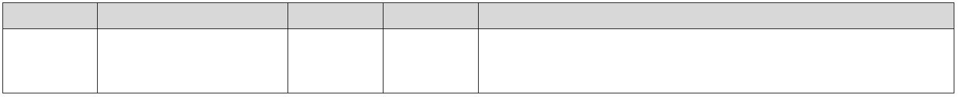INA228-Q1
ZHCSLF8A – JUNE 2020 – REVISED JUNE 2021 www.ti.com.cn
7.6.1.10 Energy Result (ENERGY) Register (Address = 9h) [reset = 0h]
The ENERGY register is shown in 表 7-14.
Return to the Summary Table.
表 7-14. ENERGY Register Field Descriptions
Bit Field Type Reset Description
39-0 ENERGY R 0h Calculated energy output.
Output value is in Joules.Unsigned representation. Positive value.
Value description under 节 8.1.2.
7.6.1.11 Charge Result (CHARGE) Register (Address = Ah) [reset = 0h]
The CHARGE register is shown in 表 7-15.
Return to the Summary Table.
表 7-15. CHARGE Register Field Descriptions
Bit Field Type Reset Description
39-0 CHARGE R 0h Calculated charge output. Output value is in Coulombs.Two's
complement value.
Value description under 节 8.1.2.
7.6.1.12 Diagnostic Flags and Alert (DIAG_ALRT) Register (Address = Bh) [reset = 0001h]
The DIAG_ALRT register is shown in 表 7-16.
Return to the Summary Table.
表 7-16. DIAG_ALRT Register Field Descriptions
Bit Field Type Reset Description
15 ALATCH R/W 0h When the Alert Latch Enable bit is set to Transparent mode, the Alert
pin and Flag bit reset to the idle state when the fault has been
cleared.
When the Alert Latch Enable bit is set to Latch mode, the Alert pin
and Alert Flag bit remain active following a fault until the DIAG_ALRT
Register has been read.
0h = Transparent
1h = Latched
14 CNVR R/W 0h Setting this bit high configures the Alert pin to be asserted when the
Conversion Ready Flag (bit 1) is asserted, indicating that a
conversion cycle has completed.
0h = Disable conversion ready flag on ALERT pin
1h = Enables conversion ready flag on ALERT pin
13 SLOWALERT R/W 0h When enabled, ALERT function is asserted on the completed
averaged value.
This gives the flexibility to delay the ALERT until after the averaged
value.
0h = ALERT comparison on non-averaged (ADC) value
1h = ALERT comparison on averaged value
12 APOL R/W 0h Alert Polarity bit sets the Alert pin polarity.
0h = Normal (Active-low, open-drain)
1h = Inverted (active-high, open-drain )
28 Submit Document Feedback Copyright © 2022 Texas Instruments Incorporated
Product Folder Links: INA228-Q1
www.ti.com.cn |  | INA228-Q1  ZHCSLF8A – JUNE 2020 – REVISED JUNE 2021
表 7-16. DIAG_ALRT Register Field Descriptions (continued)
Bit Field Type Reset Description
11 ENERGYOF R 0h This bit indicates the health of the ENERGY register.
If the 40 bit ENERGY register has overflowed this bit is set to 1.
0h = Normal
1h = Overflow
Clears when the ENERGY register is read.
10 CHARGEOF R 0h This bit indicates the health of the CHARGE register.
If the 40 bit CHARGE register has overflowed this bit is set to 1.
0h = Normal
1h = Overflow
Clears when the CHARGE register is read.
9 MATHOF R 0h This bit is set to 1 if an arithmetic operation resulted in an overflow
error.
It indicates that current and power data may be invalid. 0h = Normal
1h = Overflow
Must be manually cleared by triggering another conversion or by
clearing the accumulators with the RSTACC bit.
8 RESERVED R 0h Reserved. Always read 0.
7 TMPOL R/W 0h This bit is set to 1 if the temperature measurement exceeds the
threshold limit in the temperature over-limit register.
0h = Normal
1h = Over Temp Event
When ALATCH =1 this bit is cleared by reading this register.
6 SHNTOL R/W 0h This bit is set to 1 if the shunt voltage measurement exceeds the
threshold limit in the shunt over-limit register.
0h = Normal
1h = Over Shunt Voltage Event
When ALATCH =1 this bit is cleared by reading this register.
5 SHNTUL R/W 0h This bit is set to 1 if the shunt voltage measurement falls below the
threshold limit in the shunt under-limit register.
0h = Normal
1h = Under Shunt Voltage Event
When ALATCH =1 this bit is cleared by reading this register.
4 BUSOL R/W 0h This bit is set to 1 if the bus voltage measurement exceeds the
threshold limit in the bus over-limit register.
0h = Normal
1h = Bus Over-Limit Event
When ALATCH =1 this bit is cleared by reading this register.
3 BUSUL R/W 0h This bit is set to 1 if the bus voltage measurement falls below the
threshold limit in the bus under-limit register.
0h = Normal
1h = Bus Under-Limit Event
When ALATCH =1 this bit is cleared by reading this register.
2 POL R/W 0h This bit is set to 1 if the power measurement exceeds the threshold
limit in the power limit register.
0h = Normal
1h = Power Over-Limit Event
When ALATCH =1 this bit is cleared by reading this register.
1 CNVRF R/W 0h This bit is set to 1 if the conversion is completed.
0h = Normal
1h = Conversion is complete
When ALATCH =1 this bit is cleared by reading this register or
starting a new triggered conversion.
Copyright © 2022 Texas Instruments Incorporated Submit Document Feedback 29
Product Folder Links: INA228-Q1
INA228-Q1
ZHCSLF8A – JUNE 2020 – REVISED JUNE 2021 www.ti.com.cn
表 7-16. DIAG_ALRT Register Field Descriptions (continued)
Bit Field Type Reset Description
0 MEMSTAT R/W 1h This bit is set to 0 if a checksum error is detected in the device trim
memory space.
0h = Memory Checksum Error
1h = Normal Operation
30 Submit Document Feedback Copyright © 2022 Texas Instruments Incorporated
Product Folder Links: INA228-Q1
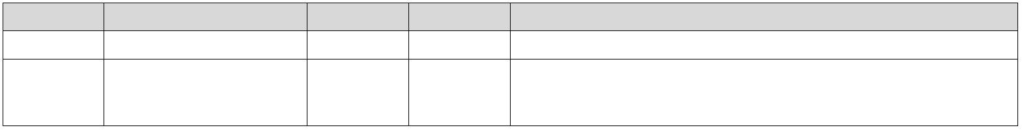www.ti.com.cn |  | INA228-Q1  ZHCSLF8A – JUNE 2020 – REVISED JUNE 2021
7.6.1.13 Shunt Overvoltage Threshold (SOVL) Register (Address = Ch) [reset = 7FFFh]
If negative values are entered in this register, then a shunt voltage measurement of 0 V will trip this alarm. When
using negative values for the shunt under and overvoltage thresholds be aware that the over voltage threshold
must be set to the larger (that is, less negative) of the two values. The SOVL register is shown in 表 7-17.
Return to the Summary Table.
表 7-17. SOVL Register Field Descriptions
Bit Field Type Reset Description
15-0 SOVL R/W 7FFFh Sets the threshold for comparison of the value to detect Shunt
Overvoltage (overcurrent protection). Two's complement value.
Conversion Factor: 5 µV/LSB when ADCRANGE = 0 1.25 µV/LSB when ADCRANGE = 1.
7.6.1.14 Shunt Undervoltage Threshold (SUVL) Register (Address = Dh) [reset = 8000h]
The SUVL register is shown in 表 7-18.
Return to the Summary Table.
表 7-18. SUVL Register Field Descriptions
Bit Field Type Reset Description
15-0 SUVL R/W 8000h Sets the threshold for comparison of the value to detect Shunt
Undervoltage (undercurrent protection). Two's complement value.
Conversion Factor: 5 µV/LSB when ADCRANGE = 0 1.25 µV/LSB when ADCRANGE = 1.
7.6.1.15 Bus Overvoltage Threshold (BOVL) Register (Address = Eh) [reset = 7FFFh]
The BOVL register is shown in 表 7-19.
Return to the Summary Table.
表 7-19. BOVL Register Field Descriptions
Bit Field Type Reset Description
15 Reserved R 0h Reserved. Always reads 0.
14-0 BOVL R/W 7FFFh Sets the threshold for comparison of the value to detect Bus
Overvoltage (overvoltage protection). Unsigned representation,
positive value only. Conversion factor: 3.125 mV/LSB.
7.6.1.16 Bus Undervoltage Threshold (BUVL) Register (Address = Fh) [reset = 0h]
The BUVL register is shown in 表 7-20.
Return to the Summary Table.
表 7-20. BUVL Register Field Descriptions
Bit Field Type Reset Description
15 Reserved R 0h Reserved. Always reads 0.
14-0 BUVL R/W 0h Sets the threshold for comparison of the value to detect Bus
Undervoltage (undervoltage protection). Unsigned representation,
positive value only. Conversion factor: 3.125 mV/LSB.
Copyright © 2022 Texas Instruments Incorporated Submit Document Feedback 31
Product Folder Links: INA228-Q1
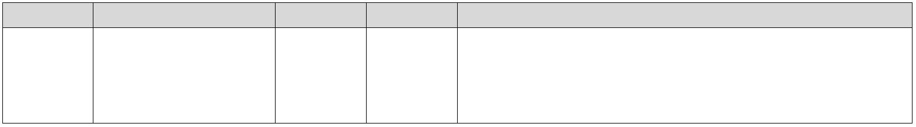INA228-Q1
ZHCSLF8A – JUNE 2020 – REVISED JUNE 2021 www.ti.com.cn
7.6.1.17 Temperature Over-Limit Threshold (TEMP_LIMIT) Register (Address = 10h) [reset = 7FFFh]
The TEMP_LIMIT register is shown in 表 7-21.
Return to the Summary Table.
表 7-21. TEMP_LIMIT Register Field Descriptions
Bit Field Type Reset Description
15-0 TOL R/W 7FFFh Sets the threshold for comparison of the value to detect over
temperature measurements. Two's complement value.
The value entered in this field compares directly against the value from the DIETEMP register to determine if an over temperature condition exists. Conversion factor: 7.8125 m°C/LSB.
7.6.1.18 Power Over-Limit Threshold (PWR_LIMIT) Register (Address = 11h) [reset = FFFFh]
The PWR_LIMIT register is shown in 表 7-22.
Return to the Summary Table.
表 7-22. PWR_LIMIT Register Field Descriptions
Bit Field Type Reset Description
15-0 POL R/W FFFFh Sets the threshold for comparison of the value to detect power over-
limit measurements. Unsigned representation, positive value only.
The value entered in this field compares directly against the value from the POWER register to determine if an over power condition exists. Conversion factor: 256 × Power LSB.
7.6.1.19 Manufacturer ID (MANUFACTURER_ID) Register (Address = 3Eh) [reset = 5449h]
The MANUFACTURER_ID register is shown in 表 7-23.
Return to the Summary Table.
表 7-23. MANUFACTURER_ID Register Field Descriptions
Bit Field Type Reset Description
15-0 MANFID R 5449h Reads back TI in ASCII.
7.6.1.20 Device ID (DEVICE_ID) Register (Address = 3Fh) [reset = 2281h]
The DEVICE_ID register is shown in 表 7-24.
Return to the Summary Table.
表 7-24. DEVICE_ID Register Field Descriptions
Bit Field Type Reset Description
15-4 DIEID R 228h Stores the device identification bits.
3-0 REV_ID R 1h Device revision identification.
32 Submit Document Feedback Copyright © 2022 Texas Instruments Incorporated
Product Folder Links: INA228-Q1
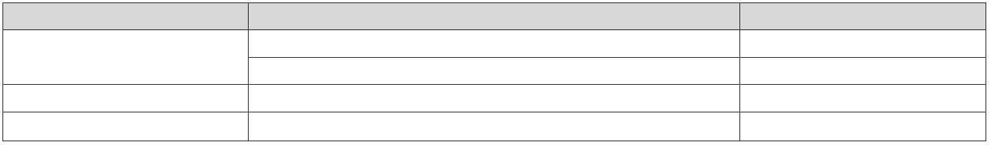www.ti.com.cn |  | INA228-Q1  ZHCSLF8A – JUNE 2020 – REVISED JUNE 2021
8 Application and Implementation
Note
以下应用部分中的信息不属于 TI 器件规格的范围，TI 不担保其准确性和完整性。TI 的客 户应负责确定
器件是否适用于其应用。客户应验证并测试其设计，以确保系统功能。
8.1 Application Information
8.1.1 Device Measurement Range and Resolution
The INA228-Q1 device supports two input ranges for the shunt voltage measurement. The supported full scale
differential input across the IN+ and IN– pins can be either ±163.84 mV or ±40.96 mV depending on the
ADCRANGE bit in CONFIG register. The range for the bus voltage measurement is from 0 V to 85 V. The
internal die temperature sensor range extends from –256 °C to +256 °C but is limited by the package to –40
°C to 125 °C.
表 8-1 provides a description of full scale voltage on shunt, bus, and temperature measurements, along with their
associated step size.
表 8-1. ADC Full Scale Values
PARAMETER FULL SCALE VALUE RESOLUTION
 | Shunt voltage |  | ±163.84 mV (ADCRANGE = 0) 312.5 nV/LSB  ±40.96 mV (ADCRANGE = 1) 78.125 nV/LSB
Bus voltage 0 V to 85 V 195.3125 µV/LSB
Temperature –40 °C to +125 °C 7.8125 m°C/LSB
The device shunt voltage measurements, bus voltage, and temperature measurements can be read through the
VSHUNT, VBUS, and DIETEMP registers, respectively. The digital output in VSHUNT and VBUS registers is 20-
bits. The shunt voltage measurement can be positive or negative due to bidirectional currents in the system;
therefore the data value in VSHUNT can be positive or negative. The VBUS data value is always positive. The
output data can be directly converted into voltage by multiplying the digital value by its respective resolution size.
The digital output in the DIETEMP register is 16-bit and can be directly converted to °C by multiplying by the
above resolution size. This output value can also be positive or negative.
Furthermore, the device provides the flexibility to report calculated current in Amperes, power in Watts, charge in Coulombs and energy in Joules as described in 节 8.1.2.
8.1.2 Current , Power, Energy, and Charge Calculations
For the INA228-Q1 device to report current values in Ampere units, a constant conversion value must be written
in the SHUNT_CAL register that is dependent on the maximum measured current and the shunt resistance used
in the application. The SHUNT_CAL register is calculated based on 方程式 2. The term CURRENT_LSB is the
LSB step size for the CURRENT register where the current in Amperes is stored. The value of CURRENT_LSB
is based on the maximum expected current as shown in 方程式 3, and it directly defines the resolution of the
CURRENT register. While the smallest CURRENT_LSB value yields highest resolution, it is common to select a
higher round-number (no higher than 8x) value for the CURRENT_LSB in order to simplify the conversion of the
CURRENT.
Copyright © 2022 Texas Instruments Incorporated Submit Document Feedback 33
Product Folder Links: INA228-Q1
INA228-Q1
ZHCSLF8A – JUNE 2020 – REVISED JUNE 2021 www.ti.com.cn
The R_{SHUNT} term is the resistance value of the external shunt used to develop the differential voltage across the
IN+ and IN– pins. Use 方程式 2 for ADCRANGE = 0. For ADCRANGE = 1, the value of SHUNT_CAL must be
multiplied by 4.
SHUNT_CAL = 13107.2 x 10
⁶ x CURRENT_LSB x R
SHUNT (2)
where
• 13107.2 x 10⁶ is an internal fixed value used to ensure scaling is maintained properly.
• the value of SHUNT_CAL must be multiplied by 4 for ADCRANGE = 1.
Maximum Expected Current
CURRENT_LSB =
19
2
(3)
Note that the current is calculated following a shunt voltage measurement based on the value set in the
SHUNT_CAL register. If the value loaded into the SHUNT_CAL register is zero, the current value reported
through the CURRENT register is also zero.
After programming the SHUNT_CAL register with the calculated value, the measured current in Amperes can be read from the CURRENT register. The final value is scaled by CURRENT_LSB and calculated in 方程式 4:
Current [A] = CURRENT_LSB x CURRENT (4)
where
• CURRENT is the value read from the CURRENT register
The power value can be read from the POWER register as a 24-bit value and converted to Watts by using 方程
式 5:
Power [W] = 3.2 x CURRENT_LSB x POWER (5)
where
• POWER is the value read from the POWER register.
• CURRENT_LSB is the lsb size of the current calculation as defined by 方程式 3.
The energy value can be read from the ENERGY register as a 40-bit unsigned value in Joules units. The energy value in Joules is converted by using 方程式 6:
Energy [J] = 16 x 3.2 x CURRENT_LSB x ENERGY (6)
34 Submit Document Feedback Copyright © 2022 Texas Instruments Incorporated
Product Folder Links: INA228-Q1
www.ti.com.cn |  | INA228-Q1  ZHCSLF8A – JUNE 2020 – REVISED JUNE 2021
The charge value can be read from the CHARGE register as a 40-bit, two's complement value in Coulombs. The charge value in Coulomb is converted by using 方程式 7:
Charge [C] = CURRENT_LSB x CHARGE (7)
where
• CHARGE is the value read from the CHARGE register.
• CURRENT_LSB is the lsb size of the current calculation as described in 方程式 3.
Upon overflow, the ENERGY and CHARGE registers will roll over and start from zero. The register values can
also be reset at any time by setting the RSTACC bit in the CONFIG register.
For a design example using these equations refer to 节 8.2.2.
8.1.3 ADC Output Data Rate and Noise Performance
The INA228-Q1 noise performance and effective resolution depend on the ADC conversion time. The device
also supports digital averaging which can further help decrease digital noise. The flexibility of the device to select
ADC conversion time and data averaging offers increased signal-to-noise ratio and achieves the highest
dynamic range with lowest offset. The profile of the noise at lower signals levels is dominated by the system
noise that is comprised mainly of 1/f noise or white noise. The INA228-Q1 effective resolution of the ADC can be
increased by increasing the conversion time and increasing the number of averages.
表 8-2 summarizes the output data rate conversion settings supported by the device. The fastest conversion
setting is 50 µs. Typical noise-free resolution is represented as Effective Number of Bits (ENOB) based on
device measured data. The ENOB is calculated based on noise peak-to-peak values, which assures that full
noise distribution is taken into consideration.
表 8-2. INA228-Q1 Noise Performance
 | ADC CONVERSION  TIME PERIOD [µs] |  | OUTPUT SAMPLE  AVERAGING [SAMPLES] |  | OUTPUT SAMPLE PERIOD  [ms] |  | NOISE-FREE ENOB  (±163.84-mV)  (ADCRANGE = 0) |  | NOISE-FREE ENOB  (±40.96-mV)  (ADCRANGE = 1)
50 0.05 12.4 10.4
84 0.084 12.6 10.4
150 0.15 13.3 11.4 280 0.28 13.8 11.8
1
540 0.54 14.2 12.4
1052 1.052 14.5 12.6
2074 2.074 15.3 13.3
4120 4.12 16.0 13.8
50 0.2 13.1 11.4
84 0.336 13.9 11.8
150 0.6 14.3 12.2
280 1.12 14.9 12.8
4
540 2.16 15.1 13.0
1052 4.208 15.8 13.8
2074 8.296 16.1 14.3
4120 16.48 16.5 14.4
Copyright © 2022 Texas Instruments Incorporated Submit Document Feedback 35
Product Folder Links: INA228-Q1
INA228-Q1
ZHCSLF8A – JUNE 2020 – REVISED JUNE 2021 www.ti.com.cn
表 8-2. INA228-Q1 Noise Performance (continued)
 | ADC CONVERSION  TIME PERIOD [µs] |  | OUTPUT SAMPLE  AVERAGING [SAMPLES] |  | OUTPUT SAMPLE PERIOD  [ms] |  | NOISE-FREE ENOB  (±163.84-mV)  (ADCRANGE = 0) |  | NOISE-FREE ENOB  (±40.96-mV)  (ADCRANGE = 1)
50 0.8 13.9 12.3
84 1.344 14.7 12.9
150 2.4 15.1 13.0 280 4.48 15.8 13.7
16
540 8.64 16.3 14.3
1052 16.832 16.5 14.6
2074 33.184 17.1 15.3
4120 65.92 17.7 15.9
50 3.2 15.0 13.3
84 5.376 15.9 13.8
150 9.6 16.4 14.4
280 17.92 16.9 14.5
64
540 34.56 17.7 15.3
1052 67.328 17.7 15.9
2074 132.736 18.1 16.3
4120 263.68 18.7 16.5
50 6.4 15.5 13.4
84 10.752 16.3 14.3
150 19.2 16.9 14.7
280 35.84 17.1 15.2
128
540 69.12 18.1 15.9
1052 134.656 18.1 16.4
2074 265.472 18.7 16.9
4120 527.36 19.7 17.1
50 12.8 15.5 14.4
84 21.504 16.7 14.7
150 38.4 17.4 15.3
280 71.68 17.7 15.7
256
540 138.24 18.7 16.1
1052 269.312 18.7 16.7
2074 530.944 19.7 17.4
4120 1054.72 19.7 17.7
50 25.6 16.7 14.3
84 43 17.4 15.4
150 76.8 17.7 15.5
280 143.36 18.7 16.3
512
540 276.48 18.7 16.5
1052 538.624 19.7 17.4
2074 1061.888 19.7 17.7
4120 2109.44 19.7 18.7
36 Submit Document Feedback Copyright © 2022 Texas Instruments Incorporated
Product Folder Links: INA228-Q1
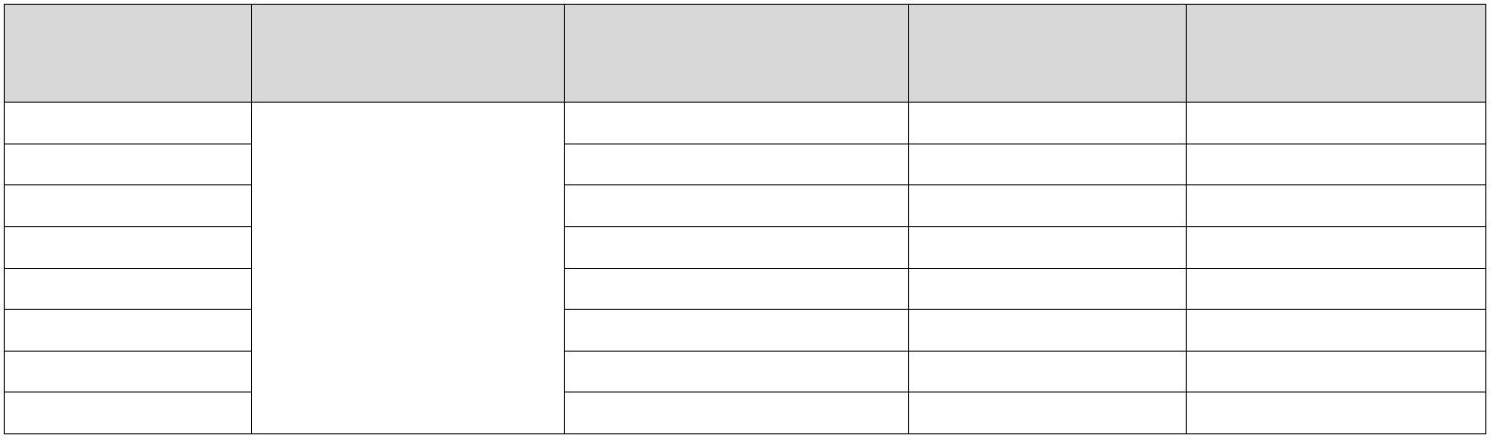www.ti.com.cn |  | INA228-Q1  ZHCSLF8A – JUNE 2020 – REVISED JUNE 2021
表 8-2. INA228-Q1 Noise Performance (continued)
 | ADC CONVERSION  TIME PERIOD [µs] |  | OUTPUT SAMPLE  AVERAGING [SAMPLES] |  | OUTPUT SAMPLE PERIOD  [ms] |  | NOISE-FREE ENOB  (±163.84-mV)  (ADCRANGE = 0) |  | NOISE-FREE ENOB  (±40.96-mV)  (ADCRANGE = 1)
50 51.2 17.1 15.0
84 86.016 17.7 15.9
150 153.6 18.1 16.0 280 286.72 18.7 16.9
1024
540 552.96 19.7 17.1
1052 1077.248 19.7 17.7
2074 2123.776 19.7 18.1
4120 4218.88 20 18.7
8.1.4 Input Filtering Considerations
As previously discussed, INA228-Q1 offers several options for noise filtering by allowing the user to select the
conversion times and number of averages independently in the ADC_CONFIG register. The conversion times
can be set independently for the shunt voltage and bus voltage measurements to allow added flexibility in
monitoring of the power-supply bus.
The internal ADC has good inherent noise rejection; however, the transients that occur at or very close to the
sampling rate harmonics can cause problems. Because these signals are at 1 MHz and higher, they can be
managed by incorporating filtering at the input of the device. Filtering high frequency signals enables the use of
low-value series resistors on the filter with negligible effects on measurement accuracy. For best results, filter
using the lowest possible series resistance (typically 100 Ω or less) and a ceramic capacitor. Recommended
values for this capacitor are between 0.1 µF and 1 µ F. 图 8-1 shows the device with a filter added at the input.
Overload conditions are another consideration for the device inputs. The device inputs are specified to tolerate
±40 V differential across the IN+ and IN– pins. A large differential scenario might be a short to ground on the
load side of the shunt. This type of event can result in full power-supply voltage across the shunt (as long the
power supply or energy storage capacitors support it). Removing a short to ground can result in inductive
kickbacks that could exceed the 40-V differential or 85-V common-mode absolute maximum rating of the device.
Inductive kickback voltages are best controlled by Zener-type transient-absorbing devices (commonly called
transzorbs) combined with sufficient energy storage capacitance. See the Transient Robustness for Current
Shunt Monitors reference design which describes a high-side current shunt monitor used to measure the voltage
developed across a current-sensing resistor when current passes through it.
In applications that do not have large energy storage, electrolytic capacitors on one or both sides of the shunt,
an input overstress condition may result from an excessive dV/dt of the voltage applied to the input. A hard
physical short is the most likely cause of this event. This problem occurs because an excessive dV/dt can
activate the ESD protection in the device in systems where large currents are available. Testing demonstrates
that the addition of 10-Ω resistors in series with each input of the device sufficiently protects the inputs against
this dV/dt failure up to the 40-V maximum differential voltage rating of the device. Selecting these resistors in the
range noted has minimal effect on accuracy.
Copyright © 2022 Texas Instruments Incorporated Submit Document Feedback 37
Product Folder Links: INA228-Q1
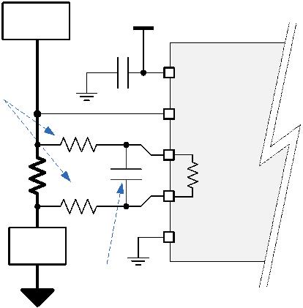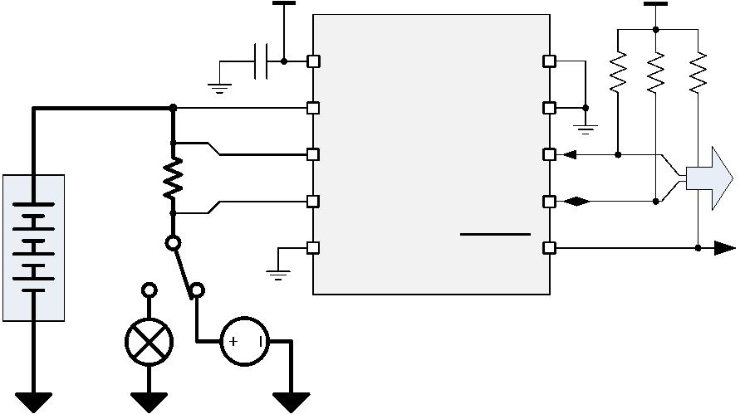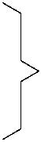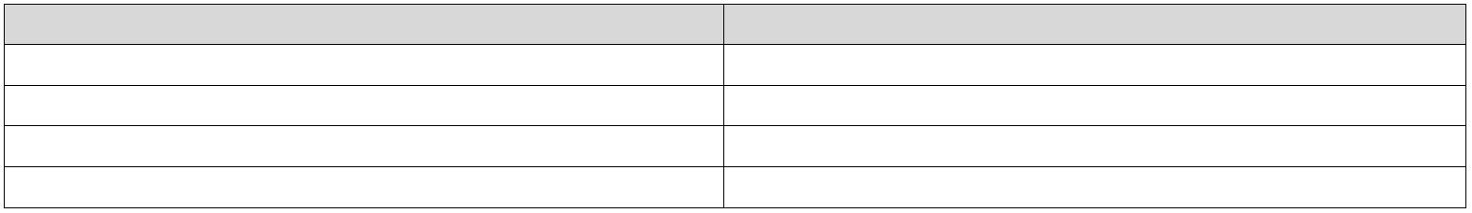INA228-Q1
ZHCSLF8A – JUNE 2020 – REVISED JUNE 2021 www.ti.com.cn
 | Load  Supply |  | V_{S} = 2.7Vœ 5.5V
100 nF
V_{S}
R_{FILTER}
VBUS <100 ꢀ
IN+
 | R_{SHUNT} |  | <100 ꢀ |  | R_{DIFF}
IN-
GND
Load
C_{FILTER}
0.1µF to 1µF
图 8-1. Input Filtering
Do not use values greater than 100 ohms for R_{FILTER}. Doing so will degrade gain error and increase non-
linearity.
8.2 Typical Application
The low offset voltage and low input bias current of the INA228-Q1 allow accurate monitoring of a wide range of
currents. To accurately monitor currents with high resolution, select the value of the shunt resistor so that the
resulting sense voltage is close to the maximum allowable differential input voltage range (either ±163.84 mV or
±40.96 mV, depending on register settings). The circuit for monitoring currents in a high-side configuration is
shown in 图 8-2.
V
_{S} = 2.7Vœ 5.5V V
S
10k 10k 10k
100 nF
V_{S} A0
* VBUS A1
 | 48V  BATT |  | R  SHUNT |  | IN+  SCL  IN- SDA |  |  | I ²C  ²C  I/F
To
MCU
GND ALERT
LOAD
* I²C ADDR: 0x40
CHARGER
GND
图 8-2. INA228-Q1 High-Side Sensing Application Diagram
8.2.1 Design Requirements
The INA228-Q1 measures the voltage developed across a current-sensing resistor (R_{SHUNT}) when current
passes through it. The device also measures the bus supply voltage and calculates power when calibrated. It
also comes with alert capability, where the alert pin can be programmed to respond to a user-defined event or a
conversion ready notification.
The design requirements for the circuit shown in 图 8-2 are listed in 表 8-3.
表 8-3. Design Parameters
DESIGN PARAMETER EXAMPLE VALUE
Power-supply voltage (V_{S}) 5 V
Bus supply rail (V_{CM}) 48 V
Bus supply rail over voltage fault threshold 52 V
Average Current 6 A
38 Submit Document Feedback Copyright © 2022 Texas Instruments Incorporated
Product Folder Links: INA228-Q1
www.ti.com.cn |  | INA228-Q1  ZHCSLF8A – JUNE 2020 – REVISED JUNE 2021
表 8-3. Design Parameters (continued)
DESIGN PARAMETER EXAMPLE VALUE
Overcurrent fault threshold (I_{MAX}) 10 A
ADC Range Selection (V_{SENSE_MAX}) ±163.84 mV
Temperature 25 ºC
Charge Accumulation Period 1 hour
8.2.2 Detailed Design Procedure
8.2.2.1 Select the Shunt Resistor
Using values from 表 8-3, the maximum value of the shunt resistor is calculated based on the value of the
maximum current to be sensed (I_{MAX}) and the maximum allowable sense voltage (V_{SENSE_MAX}) for the chosen
ADC range. When operating at the maximum current, the differential input voltage must not exceed the
maximum full scale range of the device, V_{SENSE_MAX}. Using 方程式 8 for the given design parameters, the
maximum value for R_{SHUNT} is calculated to be 16.38 mΩ. The closest standard resistor value that is smaller than the maximum calculated value is 16.2 mΩ. Also keep in mind that R_{SHUNT} must be able to handle the power
dissipated across it in the maximum load condition.
 | R_{SHUNT} < |  | V_{SENSE_MAX}
I_{MAX} (8)
8.2.2.2 Configure the Device
The first step to program the INA228-Q1 is to properly set the device and ADC configuration registers. On initial
power up the CONFIG and ADC_CONFIG registers are set to the reset values as shown in 表 7-5 and 表 7-6. In
this default power on state the device is set to measured on the ±163.84 mV range with the ADC continuously
converting the shunt voltage, bus voltage, and temperature. If the default power up conditions do not meet the
design requirements, these registers will need to be set properly after each V_{S} power cycle event.
8.2.2.3 Program the Shunt Calibration Register
The shunt calibration register needs to be correctly programmed at each V_{S} power up in order for the device to
properly report any result based on current. The first step in properly setting this register is to calculate the LSB
value for the current by using 方程式 3. Applying this equation with the maximum expected current of 10 A
results in an LSB size of 19.0735 μA. Applying 方程式 2 to the Current_LSB and selected value for the shunt
resistor results in a shunt calibration register setting of 4050d (FD2h). Failure to set the value of the shunt
calibration register will result in a zero value for any result based on current.
8.2.2.4 Set Desired Fault Thresholds
Fault thresholds are set by programming the desired trip threshold into the corresponding fault register. The list
of supported fault registers is shown in 表 7-1. Since the fault limit registers are 16 bits in length, the effective
LSB size for these registers is 16 times greater than the corresponding 20 bit LSB used in calculating returned
values for bus voltage and current.
An over current threshold is set by programming the shunt over voltage limit register (SOVL). The voltage that
needs to be programmed into this register is calculated by multiplying the over current threshold by the shunt
resistor. In this example the over current threshold is 10 A and the value of the current sense resistor is 16.2 mΩ,
which give a shunt voltage limit of 162 mV. Once the shunt voltage limit is known, the value for the shunt over
voltage limit register is calculated by dividing the shunt voltage limit by the shunt voltage LSB size.
In this example, the calculated value of the shunt over voltage limit register is 162 mV / (312.5 nV × 16) =
32400d (7E90h).
An over voltage fault threshold on the bus voltage is set by programming the bus over voltage limit register
(BOVL). In this example the desired over voltage threshold is 52 V. The value that needs to be programmed into
this register is calculated by dividing the target threshold voltage by the bus voltage fault limit LSB value of 3.125
mV. For this example, the target value for the BOVL register is 52 V / (195.3125 μV × 16) = 16640d (4100h).
Copyright © 2022 Texas Instruments Incorporated Submit Document Feedback 39
Product Folder Links: INA228-Q1
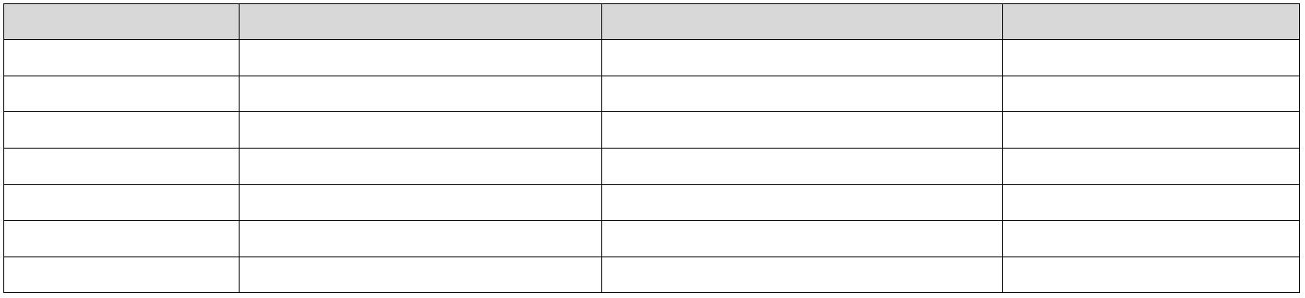INA228-Q1
ZHCSLF8A – JUNE 2020 – REVISED JUNE 2021 www.ti.com.cn
When setting the power over-limit value, the LSB size used to calculate the value needed in the limit registers
will be 256 times greater than the power LSB. This is because the power register is a 24 bits in length while the
power fault limit register is 16 bits.
Values stored in the alert limit registers are set to the default values after V_{S} power cycle events and need to be
reprogrammed each time power is applied.
8.2.2.5 Calculate Returned Values
Parametric values are calculated by multiplying the returned value by the LSB value. 表 8-4 below shows the
returned values for this application example assuming the design requirements shown in 表 8-3.
表 8-4. Calculating Returned Values
PARAMETER Returned Value LSB Value Calculated Value
Shunt voltage (V) 311040d 312.5 nV/LSB 0.0972 V
Current (A) 314572d 10 A/ 2¹⁹ = 19.073486 µA/LSB 6 A
Bus voltage (V) 245760d 195.3125 µV/LSB 48 V
Power (W) 4718604d Current LSB x 3.2 = 61.035156 µW/LSB 288 W
Energy (J) 1061683200d Power LSB x 16 = 976.5625 µJ/LSB 1036800 J
Charge (C) 1132462080d Current LSB = 19.073486 µC/LSB 21600 C
Temperature (°C) 3200d 7.8125 m°C/LSB 25°C
Shunt Voltage, Current, Bus Voltage (positive only), Charge, and Temperature return values in two's complement
format. In two's complement format a negative value in binary is represented by having a 1 in the most
significant bit of the returned value. These values can be converted to decimal by first inverting all the bits and
adding 1 to obtain the unsigned binary value. This value should then be converted to decimal with the negative
sign applied. For example, assume a shunt voltage reading returns 1011 0100 0001 0000 0000. This is a
negative value due to the MSB having a value of one. Inverting the bits and adding one results in 0100 1011
1111 0000 0000 (311040d) which from the shunt voltage example in 表 8-4 correlates to a voltage of 97.2 mV.
Since the returned value was negative the measured shunt voltage value is -97.2 mV.
8.2.3 Application Curves
图 8-3 and 图 8-4 show the ALERT pin response to a bus overvoltage fault with a conversion time of 50 μs,
averaging set to 1, and the SLOWALERT bit set to 0 for bus only conversions. For these scope shots,
persistence was enabled on the ALERT channel to show the variation in the alert response for many sequential
fault events. If the magnitude of the fault is sufficient the ALERT response can be as fast as one quarter of the
ADC conversion time as shown in 图 8-3. For fault conditions that are just exceeding the limit threshold, the
response time for the ALERT pin can vary from approximately 0.5 to 1.5 conversion cycles as shown in 图 8-4.
Variation in the alert response exists because the external fault event is not synchronized to the internal ADC
conversion start. Also the ADC is constantly sampling to get a result, so the response time for fault events
starting from zero will slower than fault events starting from values near the set fault threshold. Since the timing
of the alert can be difficult to predict, applications where the alert timing is critical should assume a alert
response equal to 1.5 times the ADC conversion time for bus voltage or shunt voltage only conversions.
40 Submit Document Feedback Copyright © 2022 Texas Instruments Incorporated
Product Folder Links: INA228-Q1
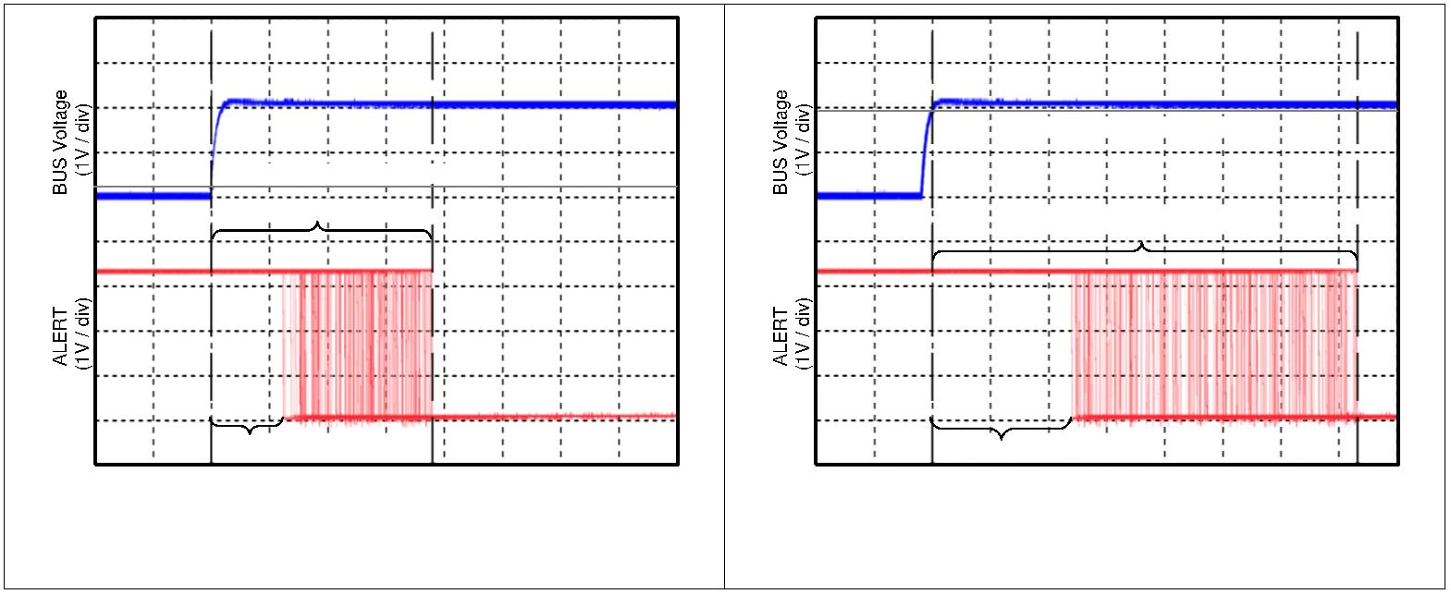www.ti.com.cn |  | INA228-Q1  ZHCSLF8A – JUNE 2020 – REVISED JUNE 2021
Fault Threshold: 1.9 V
Fault Threshold: 0.2 V
Maximum Delay: 37.9 µs
Maximum Delay: 73.2 µs
Minimum Delay: 12.4 µs Minimum Delay: 24 µs
TIME (10 µs / div) TIME (10 µs / div)
 | 图 8-3. Alert Response Time (Sampled Values  Significantly Above Threshold) |  | 图 8-4. Alert Response Time (Sampled Values  Slightly Above Threshold)
Copyright © 2022 Texas Instruments Incorporated Submit Document Feedback 41
Product Folder Links: INA228-Q1
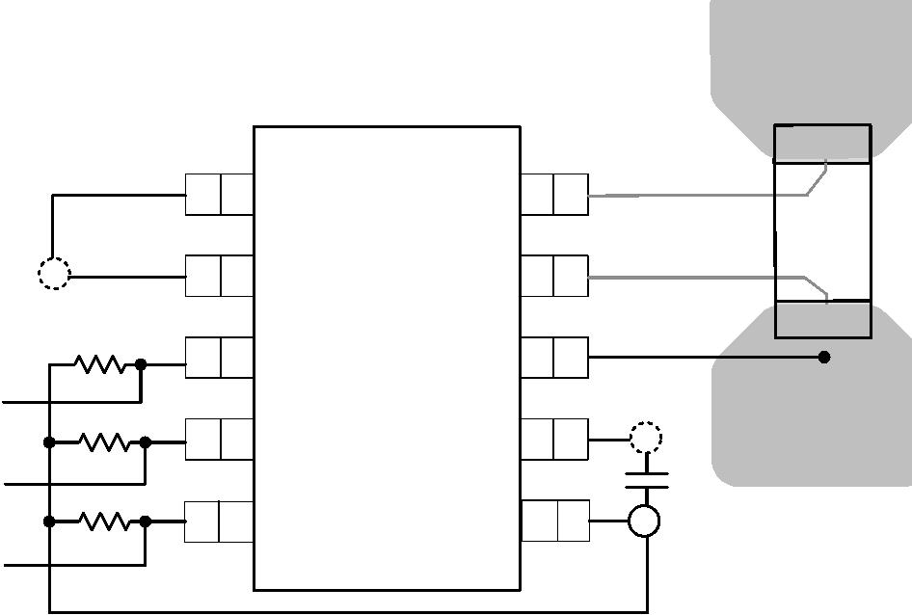INA228-Q1
ZHCSLF8A – JUNE 2020 – REVISED JUNE 2021 www.ti.com.cn
9 Power Supply Recommendations
The input circuitry of the device can accurately measure signals on common-mode voltages beyond its power- supply voltage, V_{S}. For example, the voltage applied to the V_{S} power supply terminal can be 5 V, whereas the
load power-supply voltage being monitored (the common-mode voltage) can be as high as 85 V. Note that the
device can also withstand the full 0 V to 85 V range at the input terminals, regardless of whether the device has
power applied or not. Avoid applications where the GND pin is disconnected while device is actively powered.
Place the required power-supply bypass capacitors as close as possible to the supply and ground terminals of
the device. A typical value for this supply bypass capacitor is 0.1 µ F. Applications with noisy or high-impedance
power supplies may require additional decoupling capacitors to reject power-supply noise.
10 Layout
10.1 Layout Guidelines
Connect the input pins (IN+ and IN–) to the sensing resistor using a Kelvin connection or a 4-wire connection.
This connection technique ensures that only the current-sensing resistor impedance is sensed between the input
pins. Poor routing of the current-sensing resistor commonly results in additional resistance present between the
input pins. Given the very low ohmic value of the current-sensing resistor, any additional high-current carrying
impedance causes significant measurement errors. Place the power-supply bypass capacitor as close as
possible to the supply and ground pins.
10.2 Layout Example
A1 IN+
Sense/Shunt
Resistor
A0 INt
(1)
ALERT VBUS
 | Alert output  (2) |  |  |  | SDA GND
 |  | 2  I C  interface |  |  |  | SCL VS |  |  | Supply bypass  capacitor
Via to Ground Plane
Via to Power Plane
(1) Connect the VBUS pin to the voltage powering the load for load power calculations..
(2) Can be left floating if unused.
图 10-1. INA228-Q1 Layout Example
42 Submit Document Feedback Copyright © 2022 Texas Instruments Incorporated
Product Folder Links: INA228-Q1
www.ti.com.cn |  | INA228-Q1  ZHCSLF8A –JUNE 2020 –REVISED JUNE 2021
11 Device and Documentation Support
11.1 接收文档更新通知
要接收文档更新通知，请导航至 ti.com 上的器件产品文件夹。点击订阅更新 进行注册，即可每周接收产品信息更
改摘要。有关更改的详细信息，请查看任何已修订文档中包含的修订历史记录。
11.2 支持资源
TI E2E™ 支持论坛是工程师的重要参考资料，可直接从专家获得快速、经过验证的解答和设计帮助。搜索现有解
答或提出自己的问题可获得所需的快速设计帮助。
链接的内容由各个贡献者“按原样”提供。这些内容并不构成 TI 技术规范，并且不一定反映 TI 的观点；请参阅
TI 的《使用条款》。
11.3 Trademarks
TI E2E™ is a trademark of Texas Instruments. 所有商标均为其各自所有者的财产。
11.4 Electrostatic Discharge Caution
This integrated circuit can be damaged by ESD. Texas Instruments recommends that all integrated circuits be handled
with appropriate precautions. Failure to observe proper handling and installation procedures can cause damage.
ESD damage can range from subtle performance degradation to complete device failure. Precision integrated circuits may
be more susceptible to damage because very small parametric changes could cause the device not to meet its published
specifications.
11.5 术语表
TI 术语表 本术语表列出并解释了术语、首字母缩略词和定义。
12 Mechanical, Packaging, and Orderable Information
The following pages include mechanical, packaging, and orderable information. This information is the most
current data available for the designated devices. This data is subject to change without notice and revision of
this document. For browser-based versions of this data sheet, refer to the left-hand navigation.
Copyright © 2022 Texas Instruments Incorporated Submit Document Feedback 43
Product Folder Links: INA228-Q1
PACKAGE OPTION ADDENDUM
www.ti.com 9-Nov-2025
PACKAGING INFORMATION
 | Orderable part number Status  (1) |  | Material type  (2) |  | Package | Pins Package qty | Carrier RoHS  (3) |  | Lead finish/  Ball material |  | MSL rating/  Peak reflow |  | Op temp (°C) Part marking  (6)
(4) (5)
INA228AQDGSRQ1 Active Production VSSOP (DGS) | 10 2500 | LARGE T&R Yes SN Level-2-260C-1 YEAR -40 to 125 228Q
INA228AQDGSRQ1.A Active Production VSSOP (DGS) | 10 2500 | LARGE T&R Yes SN Level-2-260C-1 YEAR -40 to 125 228Q
⁽¹⁾ Status: For more details on status, see our product life cycle.
⁽²⁾ Material type: When designated, preproduction parts are prototypes/experimental devices, and are not yet approved or released for full production. Testing and final process, including without limitation quality assurance,
reliability performance testing, and/or process qualification, may not yet be complete, and this item is subject to further changes or possible discontinuation. If available for ordering, purchases will be subject to an additional
waiver at checkout, and are intended for early internal evaluation purposes only. These items are sold without warranties of any kind.
⁽³⁾ RoHS values: Yes, No, RoHS Exempt. See the TI RoHS Statement for additional information and value definition.
⁽⁴⁾ Lead finish/Ball material: Parts may have multiple material finish options. Finish options are separated by a vertical ruled line. Lead finish/Ball material values may wrap to two lines if the finish value exceeds the maximum column width.
⁽⁵⁾ MSL rating/Peak reflow: The moisture sensitivity level ratings and peak solder (reflow) temperatures. In the event that a part has multiple moisture sensitivity ratings, only the lowest level per JEDEC standards is shown. Refer to the shipping label for the actual reflow temperature that will be used to mount the part to the printed circuit board.
⁽⁶⁾ Part marking: There may be an additional marking, which relates to the logo, the lot trace code information, or the environmental category of the part.
Multiple part markings will be inside parentheses. Only one part marking contained in parentheses and separated by a "~" will appear on a part. If a line is indented then it is a continuation of the previous line and the two
combined represent the entire part marking for that device.
Important Information and Disclaimer:The information provided on this page represents TI's knowledge and belief as of the date that it is provided. TI bases its knowledge and belief on information provided by third parties, and
makes no representation or warranty as to the accuracy of such information. Efforts are underway to better integrate information from third parties. TI has taken and continues to take reasonable steps to provide representative
and accurate information but may not have conducted destructive testing or chemical analysis on incoming materials and chemicals. TI and TI suppliers consider certain information to be proprietary, and thus CAS numbers
and other limited information may not be available for release.
In no event shall TI's liability arising out of such information exceed the total purchase price of the TI part(s) at issue in this document sold by TI to Customer on an annual basis.
OTHER QUALIFIED VERSIONS OF INA228-Q1 :
•^{Catalog : INA228}
Addendum-Page 1
PACKAGE OPTION ADDENDUM
www.ti.com 9-Nov-2025
NOTE: Qualified Version Definitions:
•Catalog - TI's standard catalog product
Addendum-Page 2
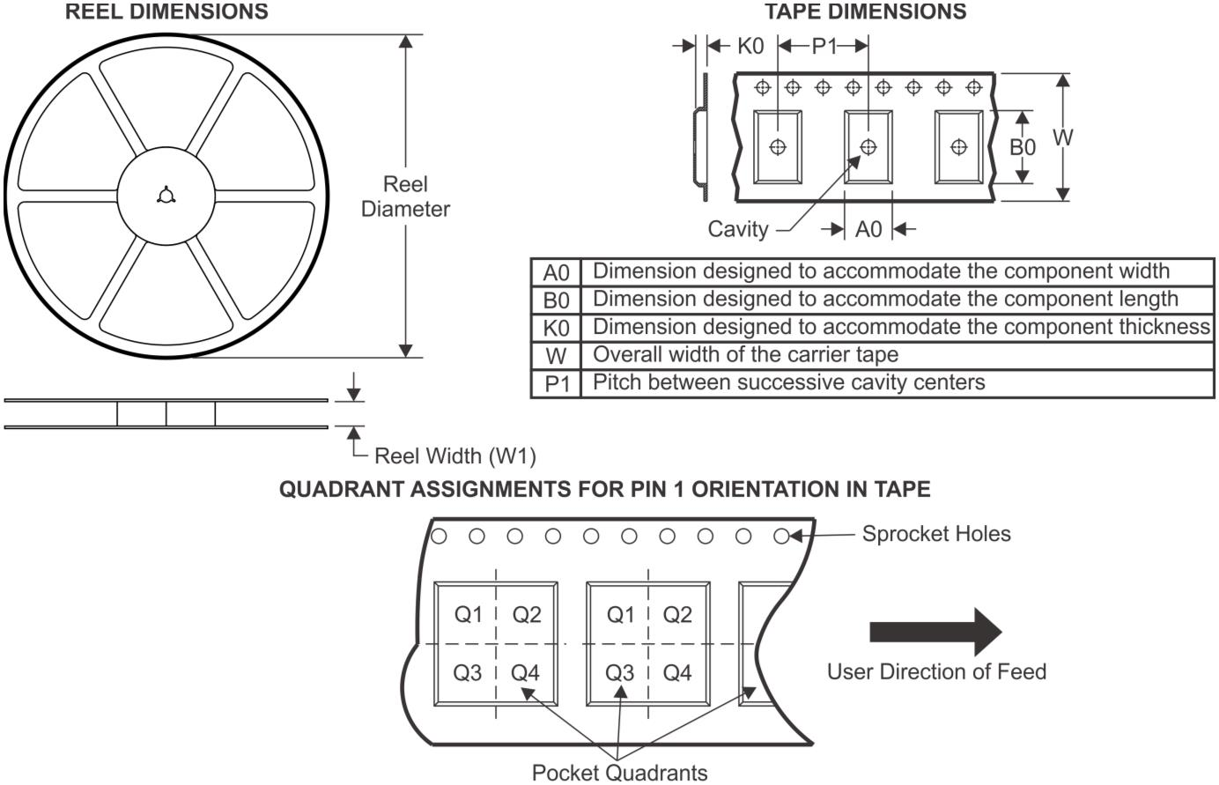PACKAGE MATERIALS INFORMATION
www.ti.com 4-Jul-2021
TAPE AND REEL INFORMATION
*All dimensions are nominal
 | Device Package  Type |  | Package  Drawing |  | Pins SPQ Reel  Diameter  (mm) |  | Reel  Width  W1 (mm) |  | A0  (mm) |  | B0  (mm) |  | K0  (mm) |  | P1  (mm) |  | W  (mm) |  | Pin1  Quadrant
INA228AQDGSRQ1 VSSOP DGS 10 2500 330.0 12.4 5.3 3.4 1.4 8.0 12.0 Q1
Pack Materials-Page 1
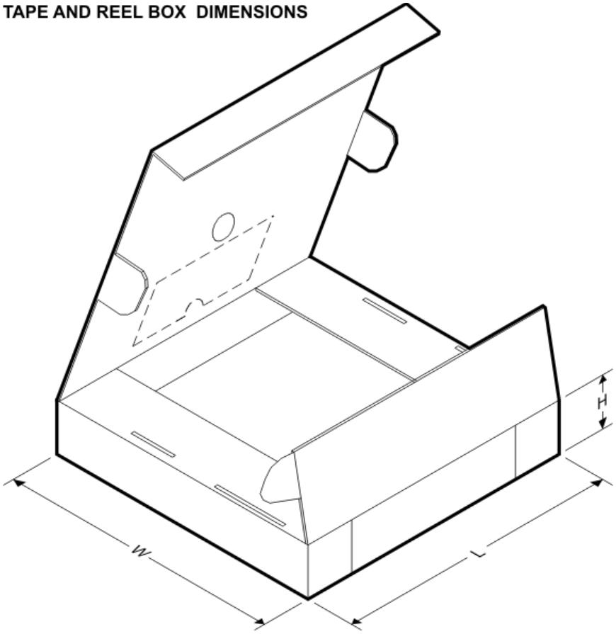PACKAGE MATERIALS INFORMATION
www.ti.com 4-Jul-2021
*All dimensions are nominal
Device Package Type Package Drawing Pins SPQ Length (mm) Width (mm) Height (mm)
INA228AQDGSRQ1 VSSOP DGS 10 2500 366.0 364.0 50.0
Pack Materials-Page 2

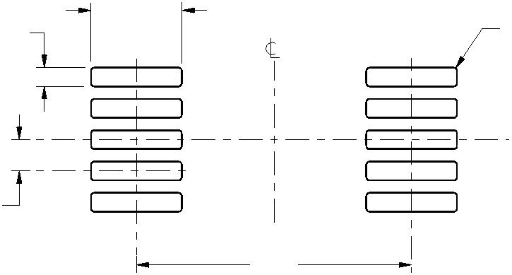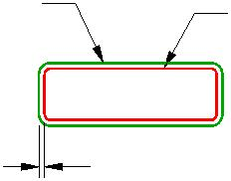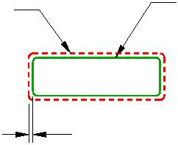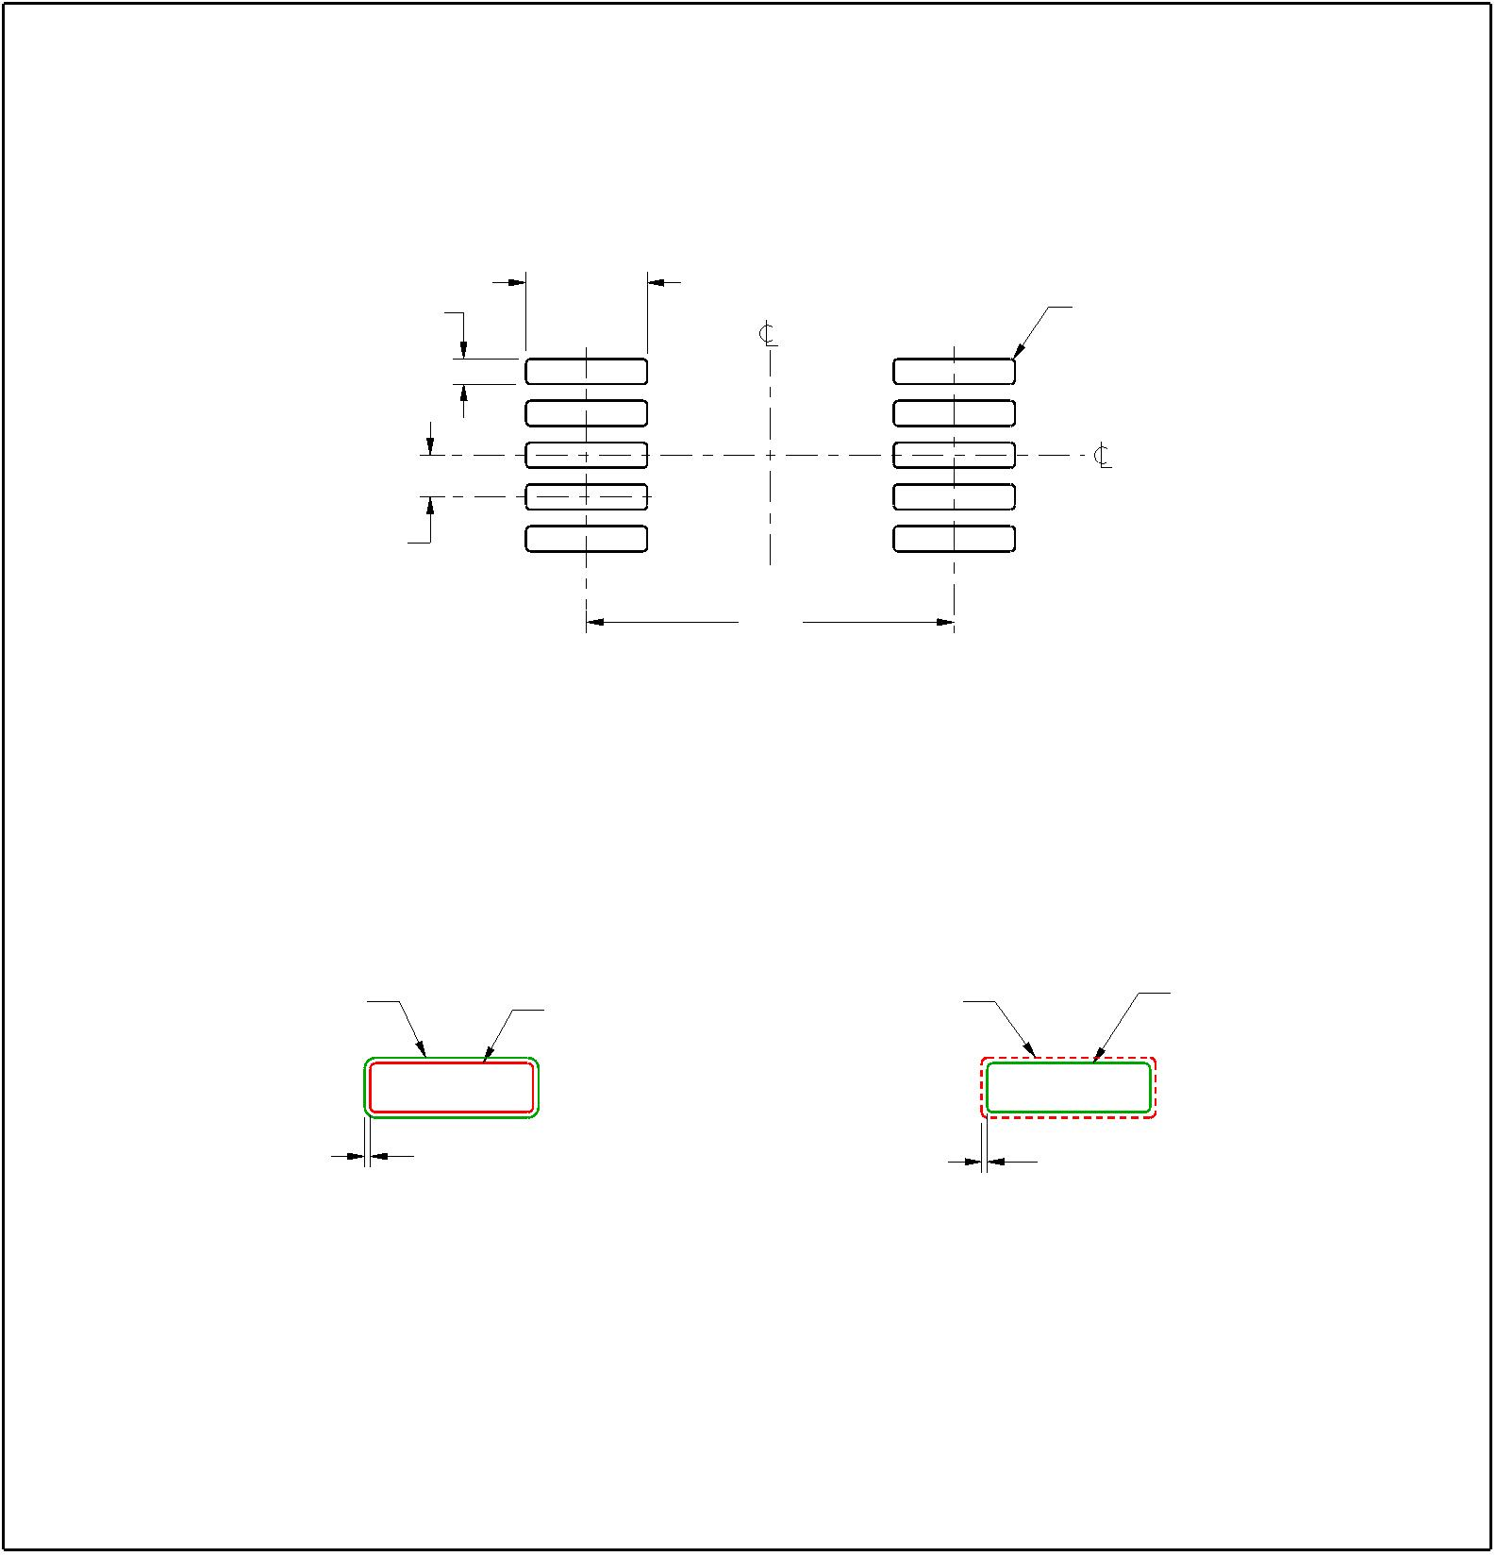EXAMPLE BOARD LAYOUT
DGS0010A
VSSOP - 1.1 mm max height
SMALL OUTLINE PACKAGE
 | 10X (0.3) |  | 1 |  | 10X (1.45) |  | SYMM |  | (R0.05)  TYP
10
SYMM
8X (0.5) 5 6
(4.4)
LAND PATTERN EXAMPLE
SCALE:10X
 | SOLDER MASK  OPENING |  |  |  | METAL |  | METAL UNDER  SOLDER MASK |  |  |  |  |  | SOLDER MASK  OPENING
 |  |  | 0.05 MAX  ALL AROUND |  |  |  |  |  |  |  | 0.05 MIN  ALL AROUND
 |  | NON SOLDER MASK  DEFINED |  |  |  |  |  |  | SOLDER MASK  DEFINED
SOLDER MASK DETAILS
NOT TO SCALE
4221984/A 05/2015
NOTES: (continued)
6. Publication IPC-7351 may have alternate designs.
7. Solder mask tolerances between and around signal pads can vary based on board fabrication site.
www.ti.com
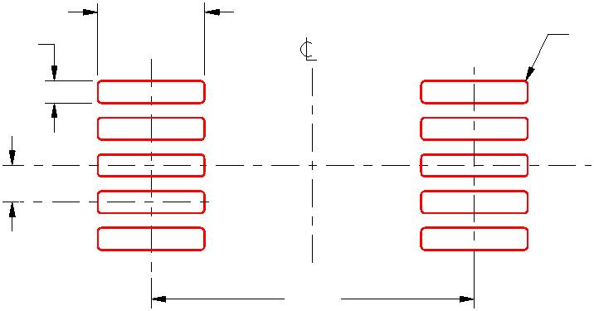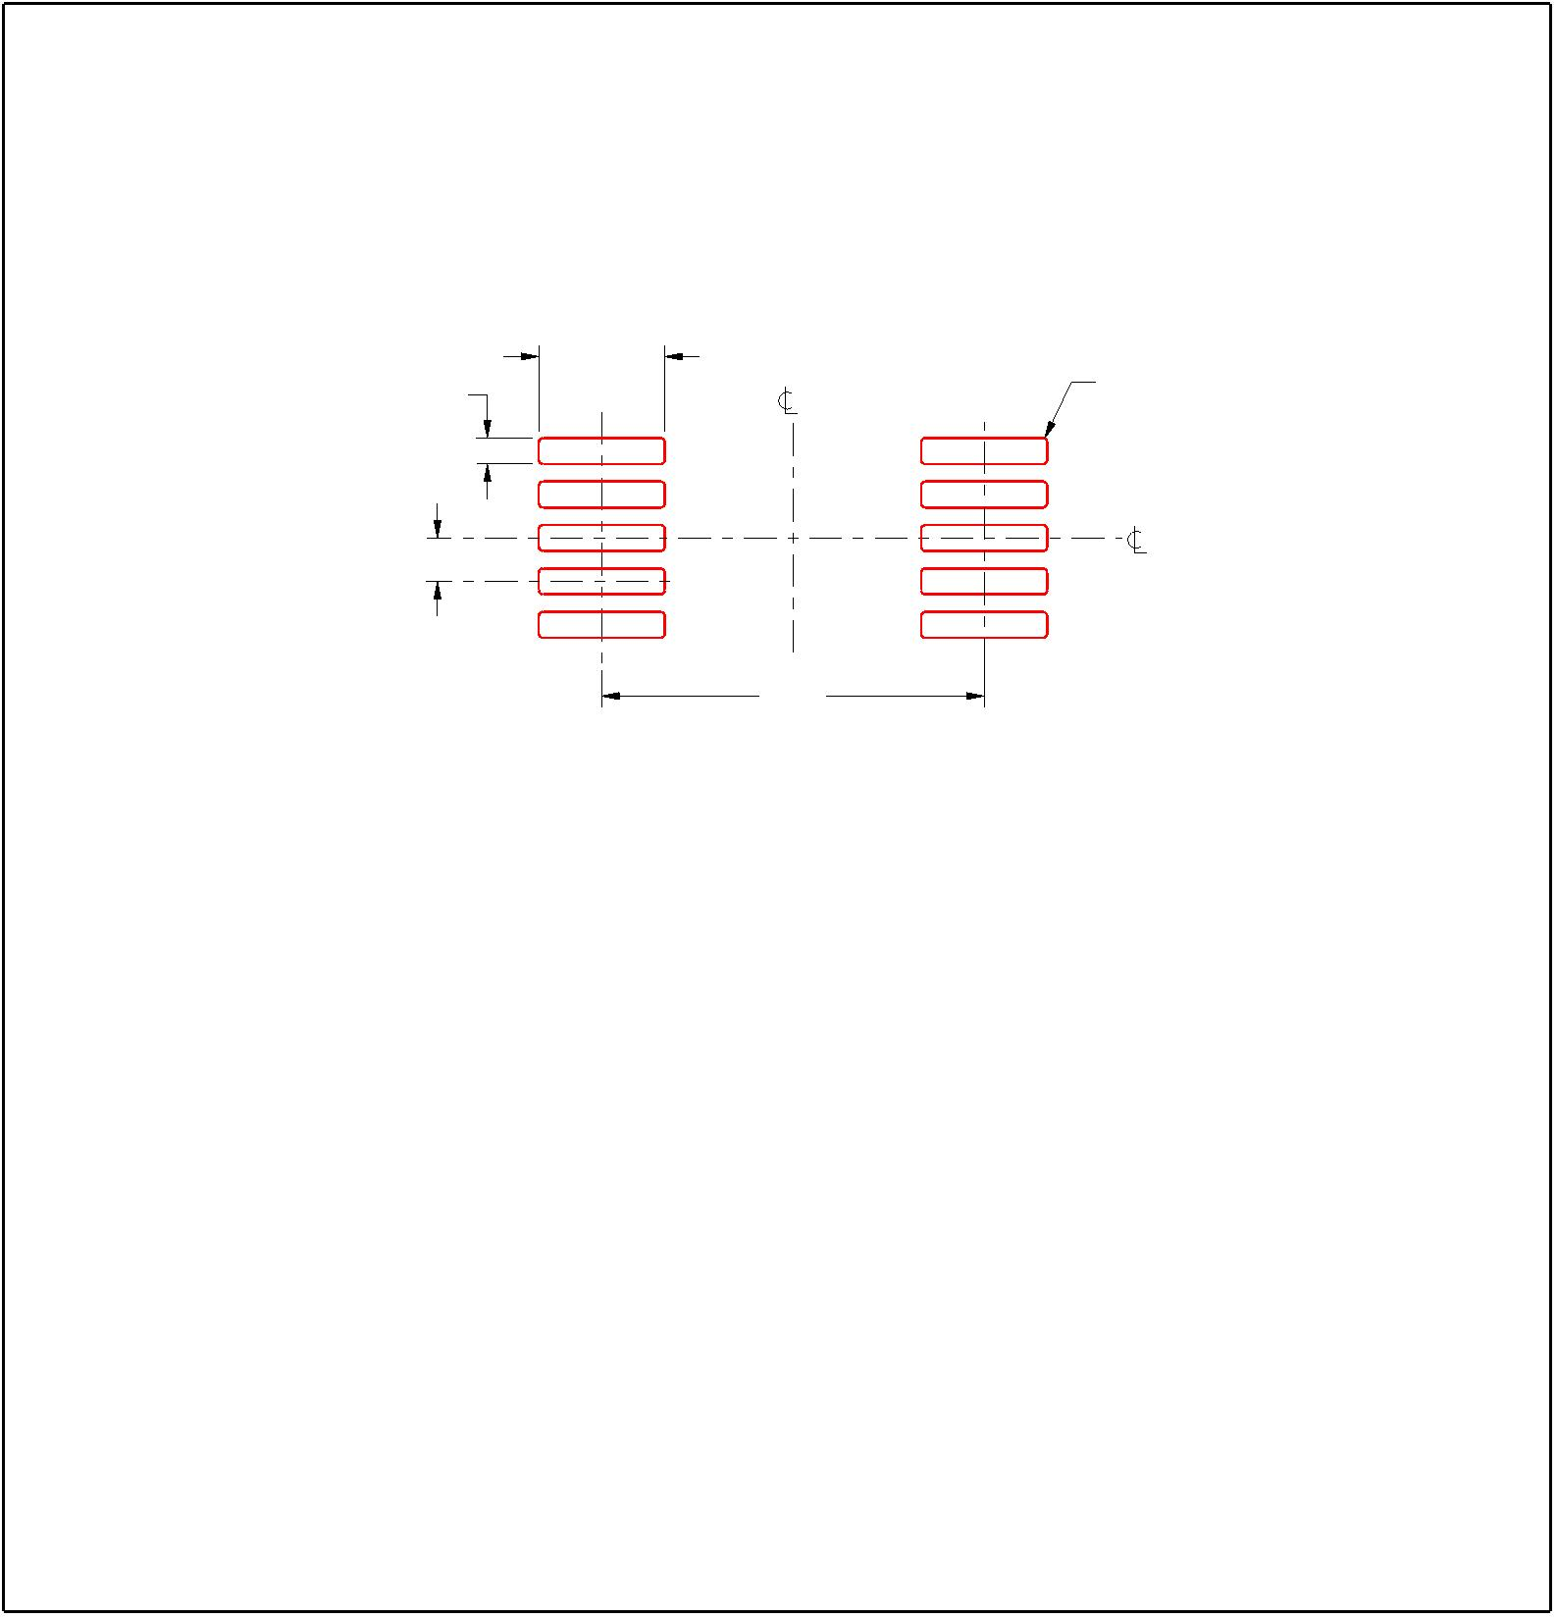EXAMPLE STENCIL DESIGN
DGS0010A
VSSOP - 1.1 mm max height
SMALL OUTLINE PACKAGE
10X (1.45)
SYMM
(R0.05) TYP
10X (0.3)
1
10
SYMM
8X (0.5)
5 6
(4.4)
SOLDER PASTE EXAMPLE
BASED ON 0.125 mm THICK STENCIL
SCALE:10X
4221984/A 05/2015
NOTES: (continued)
8. Laser cutting apertures with trapezoidal walls and rounded corners may offer better paste release. IPC-7525 may have alternate
design recommendations.
9. Board assembly site may have different recommendations for stencil design.
www.ti.com
重要通知和免责声明
TI“按原样”提供技术和可靠性数据（包括数据表）、设计资源（包括参考设计）、应用或其他设计建议、网络工具、安全信息和其他资源，不
保证没有瑕疵且不做出任何明示或暗示的担保，包括但不限于对适销性、与某特定用途的适用性或不侵犯任何第三方知识产权的暗示担保。
这些资源可供使用 TI 产品进行设计的熟练开发人员使用。您将自行承担以下全部责任：(1) 针对您的应用选择合适的 TI 产品，(2) 设计、验
证并测试您的应用，(3) 确保您的应用满足相应标准以及任何其他安全、安保法规或其他要求。
这些资源如有变更，恕不另行通知。TI 授权您仅可将这些资源用于研发本资源所述的 TI 产品的相关应用。严禁以其他方式对这些资源进行复
制或展示。您无权使用任何其他 TI 知识产权或任何第三方知识产权。对于因您对这些资源的使用而对 TI 及其代表造成的任何索赔、损害、
成本、损失和债务，您将全额赔偿，TI 对此概不负责。
TI 提供的产品受 TI 销售条款)、TI 通用质量指南 或 ti.com 上其他适用条款或 TI 产品随附的其他适用条款的约束。TI 提供这些资源并不会扩
展或以其他方式更改 TI 针对 TI 产品发布的适用的担保或担保免责声明。 除非德州仪器 (TI) 明确将某产品指定为定制产品或客户特定产品，
否则其产品均为按确定价格收入目录的标准通用器件。
TI 反对并拒绝您可能提出的任何其他或不同的条款。
IMPORTANT NOTICE
版权所有 © 2025，德州仪器 (TI) 公司
最后更新日期：2025 年 10 月

