7/25/2020

Group Members:

M. Mohsin raza (18b-015-se) -> Documentation handler

Talha ahmed (18b-026-se) -> network designer

hammad khan (18b-102-se) -> component configurator

bilal rehman (18b-017-se) -> Project Planner

Gaming Zone Network

Project

**Project Objectives:**

* Design gaming zone network
* Use OSPF routing configuration

**Overview:**

This gaming zone consists of four gaming rooms and a lobby room, all of them are connected to the main office that is responsible to control these room, all Pcs will be locked unless permission is granted from the control room which will then allow the Pcs to connect to the server

**Network Analysis:**

Network is designed by connecting, Four gaming rooms each consisting of 5 pcs and a sever (which automatically assigns IP) connected to a pt switch, a lobby room consisting of 10 Pcs and a server connected to a 24tt switch and a main control room containing a pc and laptop connected to a pt switch, Using OSPF(Open Shortest Path First) routing configuration.

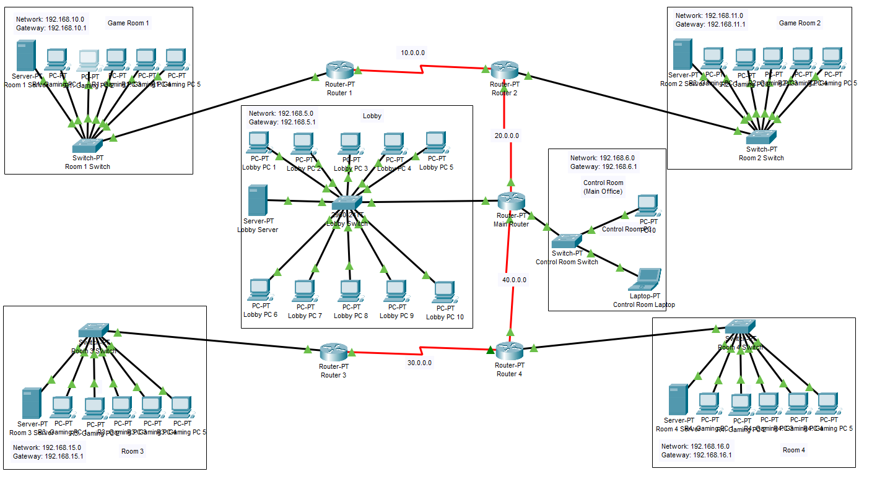Game Room 1:

Network: 192.168.10.0

Gateway: 192.168.10.1

Game Room 2:

Network: 192.168.11.0

Gateway: 192.168.11.1

Game Room 3:

Network: 192.168.15.0

Gateway: 192.168.15.1

Game Room 4:

Network: 192.168.16.0

Gateway: 192.168.16.1

Lobby Room:

Network: 192.168.5.0

Gateway: 192.168.5.1

Control Room:

Network: 192.168.6.0

Gateway: 192.168.6.1

**Future Work:**

In Future this network can be upgraded to a bigger gaming zone system in which PC will be able to manage themselves and will be able to take payment directly from the user to give access, rather than depending on control room operator to manage every single PC in the Zone.

**Design:**



**Capital and operating requirements:**

The estimated cost for 1 gaming Pc will be 100k Rs, that makes 3000k Rs Just for Pc, and including all the server and deployment cost, it can go up to 3100k Rs estimated cost of the whole project.

**Implementation plan:**

Physical (Physical structure), Datalink (Ethernet, Switches) and Network (Packets, IP) layers are implemented in our gaming zone network design

All the devices connected are successfully through LAN, we tried connecting using VLAN in the lobby room through DHCP if worked fine for the very first time, but after we restarted the program, due to different IP generation it couldn’t successfully operate and showed DHPC failed apipa is being used error.

Furthermore, in case of link failure between any room pc and switch only that particular pc will stop operating rest of the network will work fine, In case a room server disconnects and fails to connect to the switch then that particular room will shutdown and in case the main router disconnects then the whole system will have to shutdown excluding the rooms that are not directly connected to the main router.

**Conclusion:**

This network can be used to establish an ordinary gaming zone as it provides all the needs and fullfils all the requirements that a gaming zone must have.

**Refrences:**

<https://community.cisco.com/t5/other-network-architecture/designing-network-for-a-gaming-internet-cafe/td-p/260349>