P a g e | 1



EventHub

**Use Case diagram & Description**

**PRESENTED BY**

M. WALEED

SUPERVISED BY

Dr. ONAIZA MAQBOOL

10th March, 25 version 1.0 Group 15, Case Study 05

**Use Case Diagram:**

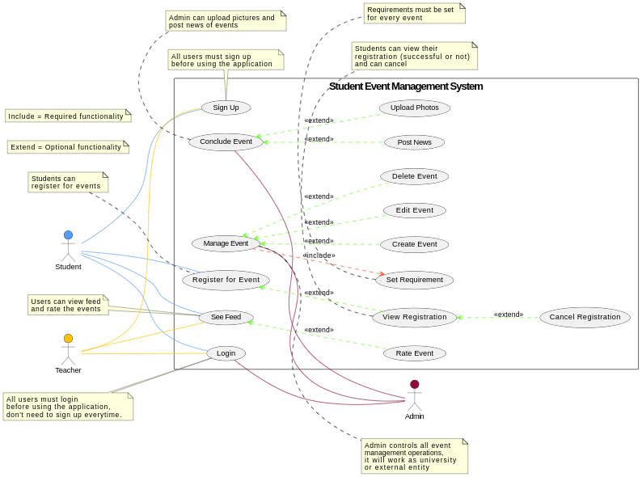

**USECASE DESCRIPTION:**

**BY: M. Waleed**

**Use Case 1: Conclude Event**

**Primary Actor:**

* Admin (Event Organizer)

**Stakeholders and Interests:**

* **Student:**
  + Wants to see event outcomes, news, and photos, and provide feedback.
* **Department:**
  + Wants a record of completed events for documentation and future planning.
* **Event Organizer (Admin):**
  + Wants to officially mark the event as completed and share updates.

**Preconditions:**

* The event must have taken place.
* The admin must be logged into the system.

**Success Guarantee (Postconditions):**

* The event status is updated to "Completed."
* Photos and news are uploaded for students and teachers to view.
* The system allows students and teachers to provide ratings and feedback.

**Inputs:**

* Event ID
* Post-event summary
* Key highlights
* Photos/images
* Event news updates

**Outputs:**

* Event marked as "Completed."
* Uploaded images and news displayed to students and teachers.
* Rating and feedback section enabled for users.

**Main Success Scenario (Basic Flow):**

1. The admin logs into the system.
2. The admin navigates to the event management section.
3. The admin selects the complete event.
4. The system prompts post-event details (summary, key highlights, photos).
5. The admin uploads event news, images, and key outcomes.
6. The system updates the event status to "Completed."
7. The system enables the rating and feedback feature for students and teachers.

**Alternate Scenario (Extensions):**

* **\*a. System Failure at Any Time:**
  + The software saves existing data automatically.
  + When the system is reopened, it resumes from the last step saved.
* **4a. The admin does not have all the post-event details:**
  + The system allows saving progress and updating later.
* **5a. Upload fails due to file size or format issues:**
  + The system notifies the admin and prompts for a compatible file.

**Special Requirements:**

* The application should be developed in **Java**.
* Student registration should be easily visible, using a readable font size (e.g., 12pt).

**Frequency of Occurrence:**

* Nearly continuous.

**Open Issues:**

* Open for feedback to improve the use of case text.
* Consider additional input and output details for better usability.

**Class System Sequence Diagram:**

**BY: M. Waleed**

**Use Case: Conclude Event**

