ICT159

Week 5 | Weekly Assignment | Exercises 3

# Algorithm

1. DECLARE nterm, f_zero = 0, f_one = 0, nvalue, typeCheck : INTEGER
2. typeCheck = INPUT (“Enter the nth-term for F(n): ”, nterm)
3. IF (nterm < 0 || typeCheck == 0) THEN
   1. PRINT(“Enter a positive integer only.”)
   2. RETURN 1
4. PRINT(f_zero)
5. IF (nterm > 0) THEN
   1. PRINT(f_one)
6. FOR i ← 2 TO nterm
   1. nvalue = f_zero + f_one
   2. PRINT(nvalue)
   3. f_one, f_zero = nvalue, f_one
7. NEXT i
8. PRINT(“Value of Fibonacci series at F(n): ”, nterm, nvalue)

**[Flowchart on next page]**

# Flowchart

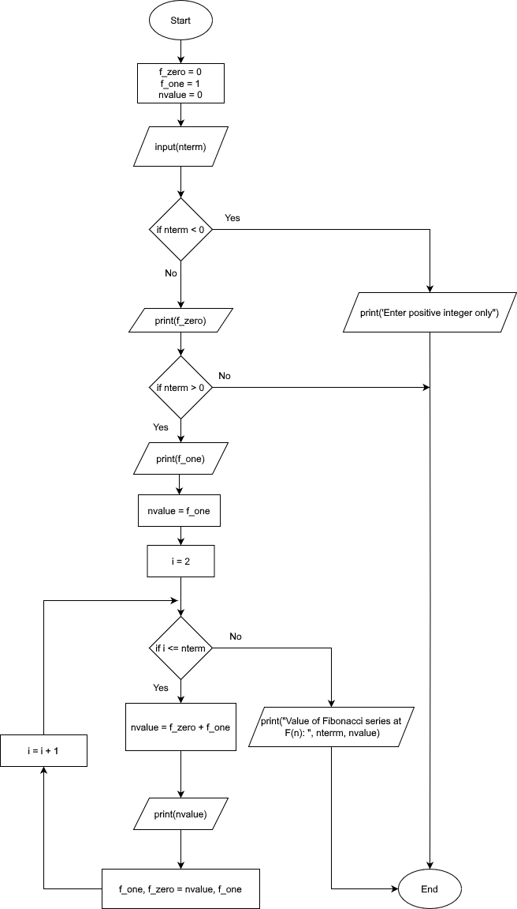

# Test Cases

| **Test #** | **Text Description** | **Inputs** | **Expected Outputs** | **Algorithm Outputs** | **Program Success/Failure** |
| --- | --- | --- | --- | --- | --- |
| 1 | Positive integer | 5 | “Value of Fibonacci series at F(5): 5” | “Value of Fibonacci series at F(5): 5” | Success |
| 2 | Large positive integer | 10 | “Value of Fibonacci series at F(10): 55” | “Value of Fibonacci series at F(10): 55” | Success |
| 3 | Negative integer | -1 | “Enter a positive integer only.” | “Enter a positive integer only.” | Success |
| 4 | string | “abc” | “Enter a positive integer only.” | “Enter a positive integer only.” | Success |
| 5 | Null input | “” | “Enter a positive integer only.” | No output | Failure |
| 6 | Zero | 0 | Value of Fibonacci series at F(0): 0 | Value of Fibonacci series at F(0): 0 | Success |
| 7 | One | 1 | Value of Fibonacci series at F(1): 1 | Value of Fibonacci series at F(1): 1 | Success |

l