**National Textile University, Faisalabad**



**Department of Computer Science**

|  |  |
| --- | --- |
| **Name:** | Muhammad Talha Javed |
| **Class:** | BS Artificial Intelligence |
| **Reg No:** | 22-NTU-CS-1366 |
| **Activity:** | Lab 2 (Home Task) |
| **Course Name:** | Internet of Things |
| **Submitted To:** | Nasir Mehmood |
| **Submission Date:** | 23-FEB-2025 |

**Create a new repo.**

**Clone new repo. To local machine**

**Push a project (NeoPixel Ring Rainbow) to the repo.**

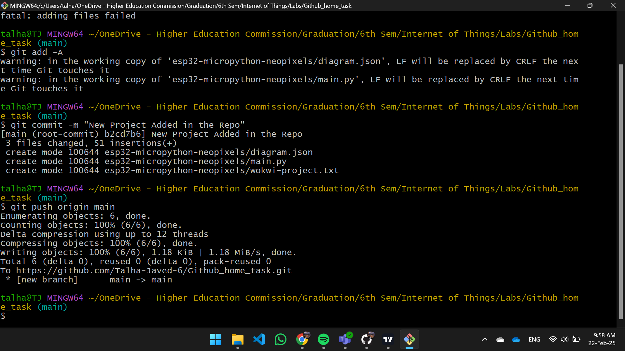

**push a file from a different folder**