Questions 1-10
Listen From Here
Complete the notes below.
Write ONE WORD AND/OR A NUMBER for each answer.

Children’s Engineering Workshops
Tiny Engineers (ages 4-5)
Activities
- Create a cover for an 1 so they can drop it from a height without breaking it.
- Take part in a competition to build the tallest 2 .
- Make a 3 powered by a balloon.
Junior Engineers (ages 6-8)
Activities:
- Build model cars, trucks and 4 and learn how to program them so they can move.
- Take part in a competition to build the longest 5 using card and wood.
- Create a short 6 with special software.
- Build, 7 and program a humanoid robot.
Cost for a five-week block: £50
Held on 8 from 10 am to 11 am
Location
Building 10A, 9 Industrial Estate, Grasford
Plenty of 10 is available.

Questions 11-14
Listen From Here
Choose the correct letter, A, B or C.
11 Stevenson’s was founded in
A1923.
B1924.
C1926.
12 Originally, Stevenson’s manufactured goods for
Athe healthcare industry.
Bthe automotive industry.
Cthe machine tools industry.
13 What does the speaker say about the company premises?
AThe company has recently moved.
BThe company has no plans to move.
CThe company is going to move shortly.
14 The programme for the work experience group includes
Atime to do research.
Bmeetings with a teacher.
Ctalks by staff.

Questions 15-20
Listen From Here
Label the map below.
Write the correct letter, A-J, next to Questions.

Plan of Stevenson’s site
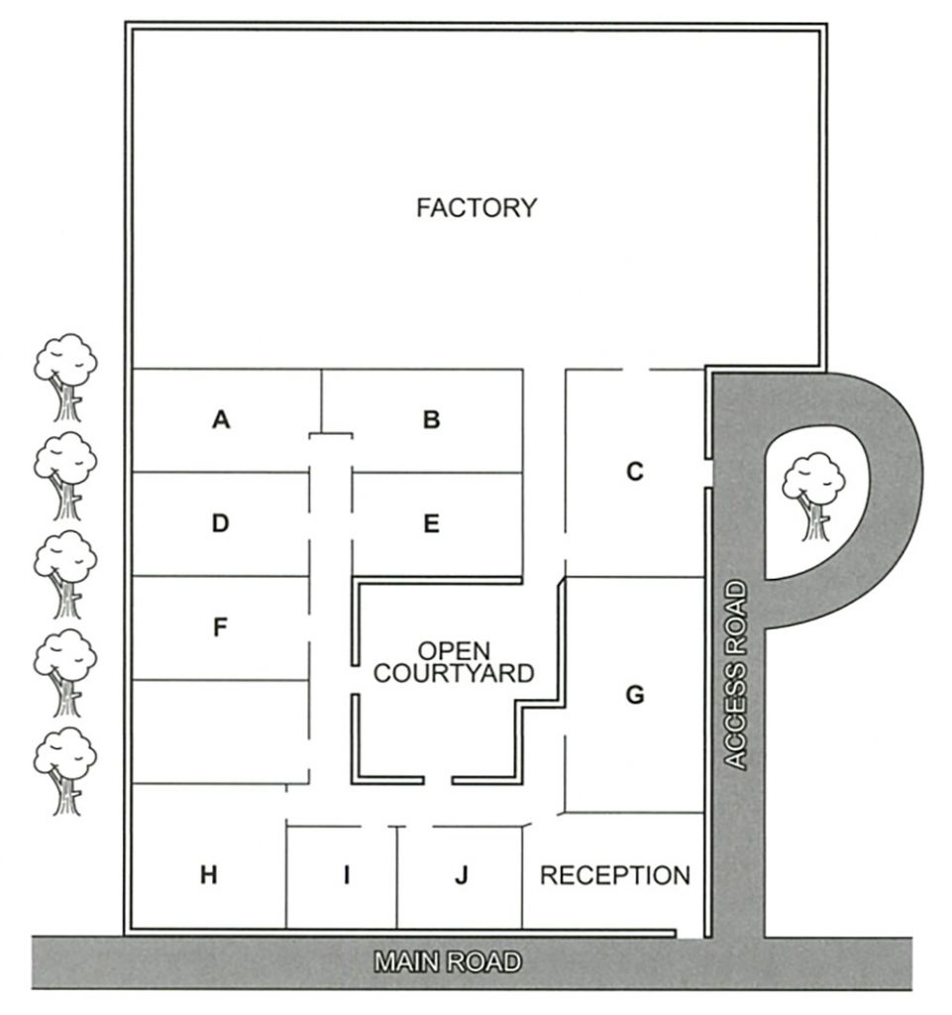
15 coffee room
16 warehouse
17 staff canteen
18 meeting room
19 human resources
20 boardroom

Questions 21-22
Listen From Here
Choose TWO letters, A-E.
21 22 Which TWO parts of the introductory stage to their art projects do Jess and Tom agree were useful?
Athe Bird Park visit
Bthe workshop sessions
Cthe Natural History Museum visit
Dthe projects done in previous years
Ethe handouts with research sources

Questions 23-24
Listen From Here
Choose TWO letters, A-E.
23 24 In which TWO ways do both Jess and Tom decide to change their proposals?
Aby giving a rationale for their action plans
Bby being less specific about the outcome
Cby adding a video diary presentation
Dby providing a timeline and a mind map
Eby making their notes more evaluative

Questions 25-30
Listen From Here
Which personal meaning do the students decide to give to each of the following pictures?
Choose SIX answers from the box and write the correct letter, A-H, next to Questions.

Personal meanings
A a childhood memory
B hope for the future
C fast movement
D a potential threat
E the power of colour
F the continuity of life
G protection of nature
H a confused attitude to nature
Pictures
25 Falcon (Landseer)
26 Fish hawk (Audubon)
27 Kingfisher (van Gogh)
28 Portrait of William Wells
29 Vairumati (Gauguin)
30 Portrait of Giovanni de Medici

Questions 31-40
Listen From Here
Complete the notes below.
Write ONE WORD ONLY for each answer.

Stoicism
Stoicism is still relevant today because of its 31 appeal.
Ancient Stoics
- Stoicism was founded over 2,000 years ago in Greece.
- The Stoics’ ideas are surprisingly well known, despite not being intended for 32
Stoic principles
- Happiness could be achieved by leading a virtuous life.
- Controlling emotions was essential.
- Epictetus said that external events cannot be controlled but the 33 people make in response can be controlled.
- A Stoic is someone who has a different view on experiences which others would consider as 34 .
The influence of Stoicism
- George Washington organised a 35 about Cato to motivate his men.
- The French artist Delacroix was a Stoic.
- Adam Smith’s ideas on 36 were influenced by Stoicism.
- Some of today’s political leaders are inspired by the Stoics.
- Cognitive Behaviour Therapy (CBT)
– the treatment for 37 is based on ideas from Stoicism
– people learn to base their thinking on 38 .
- In business, people benefit from Stoicism by identifying obstacles as 39 .

Relevance of Stoicism
- It requires a lot of 40 but Stoicism can help people to lead a good life.
- It teaches people that having a strong character is more important than anything else.

ANS:
1 egg
2 tower
3 car
4 animals
5 bridge
6 movie, film
7 decorate
8 Wednesdays
9 Fradstone
10 parking
11 3
12 1
13 2
14 3
15 H
16 C
17 G
18 B
19 I
20 A
21 C, E
22 C, E
23 B, E
24 B, E
25 D
26 C
27 A
28 H
29 F
30 G
31 practical
32 publication
33 choices
34 negative
35 play
36 capitalism
37 depression
38 logic
39 opportunity
40 practice, practise

