FAST National University of Computer and Emerging Sciences
Department of Computer Science | Karachi Campus

POCKET PLAN
Personal Finance Management Mobile Application
Software Requirements Specification | Version 2.3

Field | Details
Version | 2.3
Date | 10 May 2026
Team | Team CPS
Course Instructor | Ms. Iqra Fahad
Institution | FAST National University, Karachi

Document Revision History

Version | Author | Date | Description
1.0 | Team CPS | 10 May 2026 | Initial SRS created
2.0 | Team CPS | 10 May 2026 | Updated to reflect actual implementation state — admin portal added, premium model revised to manual payment, API status documented
2.1 | Team CPS | 10 May 2026 | All 15 use case tables added (UC-PP-01 to UC-PP-18), use case rationale note added, Table of Contents added
2.2 | Team CPS | 10 May 2026 | Automatic updatable Table of Contents
2.3 | Team CPS | 10 May 2026 | Problem statement expanded; stakeholders updated;
Table 0.1 — Document Revision History

Table of Contents
Document Revision History 2
1.1 Purpose of Document 7
1.2 Intended Audience 7
1.3 Abbreviations 7
1.4 Document Conventions 8
2.1 Project Background 9
Problem Statement 9
2.2 Project Scope 9
In Scope 9
Not In Scope 10
2.3 Project Objectives 10
User Objectives 10
System Objectives 11
2.4 Stakeholders 11
2.6 System Constraints 11
2.7 Assumptions & Dependencies 12
Assumptions 12
Dependencies 12
3.1 Hardware Interfaces 13
3.2 Software Interfaces 13
3.3 Communications Interfaces 14
3.4 User Interface Requirements 14
3.5 Navigation Flow Diagrams 16
Mobile Application Flow 16
Admin Portal Flow 18
4.1 Functional Hierarchy 19
4.2 API Implementation Status 21
Implemented API Endpoints 21
Models Implemented — API Endpoints Pending 21
4.3 Premium Subscription Tier Comparison 21
4.4 Use Case Diagram 22
Admin Use Case Diagram 22
User Use Case Diagram 23
4.5 Use Case Tables 24
4.4.1 UC-PP-01: User Registration (Two-Step Sign-Up) 24
4.4.2 UC-PP-02: User Sign-In 25
4.4.3 UC-PP-03: Add Transaction 26
4.4.4 UC-PP-04: View and Track Budget 27
4.4.5 UC-PP-05: Admin Reviews Payment and Activates Premium 28
4.4.6 UC-PP-06: View Financial Reports 29
4.4.7 UC-PP-07: Admin Manages Support Ticket 29
4.4.8 UC-PP-08: Google Sign-In 30
4.4.9 UC-PP-09: Forgot Password / Password Reset 31
4.4.10 UC-PP-10: View Transaction History and Search 32
4.4.11 UC-PP-11: Create and Track Savings Goal 33
4.4.12 UC-PP-12: Use AI Financial Chat Assistant 34
4.4.13 UC-PP-13: Manage App Settings and Preferences 35
4.4.14 UC-PP-14: Submit Support Ticket from App 35
4.4.15 UC-PP-15: Subscribe to Premium (Manual Payment Flow) 36
4.4.16 UC-PP-16: Configure Savings Goal Split and Allocation 37
4.4.17 UC-PP-17: Set Savings Goal as Primary or Active 38
4.4.18 UC-PP-18: Switch User Profile 39
4.6 Use Case Coverage Note 40
4.7 Sequence Diagrams 41
Add Transaction 41
Premium Subscription Payment 43
5.1 Performance Requirements 44
5.2 Security Requirements 44
5.3 Reliability Requirements 44
5.4 Usability Requirements 44
5.5 Portability & Scalability 44
5.6 Compliance Requirements 45

List of Tables
The following tables are referenced throughout this document. Page numbers shown are approximate and will update automatically when the document is opened in Microsoft Word.
Table No. | Table Title
Table 0.1 | Document Revision History
Table 1.1 | Abbreviations and Acronyms
Table 2.1 | Project Stakeholders
Table 2.2 | External Dependencies
Table 3.1 | Hardware Interface Requirements
Table 3.2 | Software and Third-Party Service Interfaces
Table 3.3 | User Interface Screen Summary
Table 4.1 | Implemented API Endpoints
Table 4.2 | Backend Models Awaiting API Endpoint Implementation
Table 4.3 | Premium Subscription Feature Comparison — Free vs Monthly vs Yearly
Table 4.4 | Use Case Index — All 18 Use Cases
Table 4.4.1 | UC-PP-01: User Registration (Two-Step Sign-Up)
Table 4.4.2 | UC-PP-02: User Sign-In
Table 4.4.3 | UC-PP-03: Add Transaction
Table 4.4.4 | UC-PP-04: View and Track Budget
Table 4.4.5 | UC-PP-05: Admin Reviews Payment and Activates Premium
Table 4.4.6 | UC-PP-06: View Financial Reports
Table 4.4.7 | UC-PP-07: Admin Manages Support Ticket
Table 4.4.8 | UC-PP-08: Google Sign-In
Table 4.4.9 | UC-PP-09: Forgot Password / Password Reset
Table 4.4.10 | UC-PP-10: View Transaction History and Search
Table 4.4.11 | UC-PP-11: Create and Track Savings Goal
Table 4.4.12 | UC-PP-12: Use AI Financial Chat Assistant
Table 4.4.13 | UC-PP-13: Manage App Settings and Preferences
Table 4.4.14 | UC-PP-14: Submit Support Ticket from App
Table 4.4.15 | UC-PP-15: Subscribe to Premium (Manual Payment Flow)
Table 4.4.16 | UC-PP-16: Configure Savings Goal Split and Allocation
Table 4.4.17 | UC-PP-17: Set Savings Goal as Primary or Active
Table 4.4.18 | UC-PP-18: Switch User Profile

1 | Introduction

1.1 Purpose of Document
This Software Requirements Specification (SRS) describes the complete functional and non-functional requirements for Pocket Plan — a personal finance management mobile application and admin web portal developed as a course project for Agile Software and Project Management at FAST National University, Karachi, under the supervision of Ms. Iqra Fahad.

1.2 Intended Audience
- FAST National University — Ms. Iqra Fahad (Course Instructor)
- Team CPS — Designer, Developer, Tester
- Potential Users — Students, Young Professionals, Freelancers

1.3 Abbreviations

Abbreviation | Full Form
API | Application Programming Interface
AI | Artificial Intelligence
CRUD | Create, Read, Update, Delete
CSV | Comma-Separated Values
FAQ | Frequently Asked Questions
FCM | Firebase Cloud Messaging
HTTPS | Hypertext Transfer Protocol Secure
JSON | JavaScript Object Notation
JWT | JSON Web Token
NFR | Non-Functional Requirement
PDF | Portable Document Format
PIN | Personal Identification Number
PKR | Pakistani Rupee
REST | Representational State Transfer
SDK | Software Development Kit
SRS | Software Requirements Specification
TLS | Transport Layer Security
UI | User Interface
UML | Unified Modeling Language
UX | User Experience
Table 1.1 — Abbreviations and Acronyms

1.4 Document Conventions
- Font Family: Arial
- Heading 1: 16pt Bold | Heading 2: 14pt Bold | Heading 3: 12pt Bold
- Body Text: 11pt | Table Content: 10pt
- Functional requirements prefixed FR- | Non-functional prefixed NFR-
- Use case IDs follow the format UC-PP-XX
- Features marked (planned) exist in UI but are not yet backend-connected
- Features marked (not yet implemented) have no UI or backend in this release

2 | Overall System Description

2.1 Project Background
Pocket Plan is a personal finance management mobile application developed as a course project for Agile Software and Project Management at FAST National University, Karachi. The app targets students, young professionals, and freelancers who need a simple, localized tool to manage daily finances.
Most available budgeting tools are either too complex, not built for the Pakistani market, or require costly subscriptions. Pocket Plan addresses this by providing an intuitive mobile app for logging transactions, planning budgets, tracking savings goals, and accessing an AI-powered financial assistant — all in one place.
The system also includes a web-based Admin Portal developed mid-project, which allows administrators to monitor subscription payments (verified manually via bank transfer screenshot) and manage user support tickets.

Problem Statement
- Users have no single centralized tool to track income, expenses, transfers, and borrow/lend transactions together
- Traditional tracking methods such as pen and paper, notebooks, or spreadsheets are time-consuming, error-prone, and easy to lose — Pocket Plan replaces these with an always-available mobile solution
- Manually recalculating totals, category breakdowns, and savings progress by hand every month is tedious and impractical for most users
- Existing budgeting apps are either too complex, not localized for the Pakistani market, or require costly subscriptions that most students and young professionals cannot justify
- There is no accessible AI-driven financial advisor tailored to the spending patterns of students and young professionals in Pakistan
- Users lack real-time visibility into savings goal progress, budget usage, and monthly financial health in one consolidated place
- Subscription payment verification for premium features requires a manual process — there is no automated payment gateway in the current release
- Administrators have no centralized view of user subscriptions and support requests without a dedicated portal

2.2 Project Scope

In Scope
- User authentication: two-step sign-up (email/password + name/currency), sign-in with email/password and Google, forgot password, sign-out
- Transaction management: add transactions of types Expense, Income, Transfer, and Borrow; select category, amount, date, and optional description; view and search transaction history
- Budget planning: set monthly budget, allocate per-category limits (unlimited), view real-time usage with colour-coded health indicators (Healthy / Watch / Critical / Over Limit), split evenly option
- Savings goals: create named goals with target amount, monthly contribution, primary/active flag; track progress, ETA, and monthly status; split saved money across goals by balanced or custom percentage; choose to direct savings to budget or savings goal; free users limited to 3 goals, premium users unlimited
- Transaction and goals history: unified History screen with tabs for Transactions and Goals, search, and filters
- Reports and analytics: Week / Month / Quarter period selector; total income, total spent, net savings, transaction count; spending trend chart; breakdown views (Category Bars, Pie, Line Trend); AI-powered Insights tab generated via chatbot on demand
- AI Financial Chat Assistant: chat interface with quick prompts, personalized advice based on user data — powers the Insights tab in Reports (Generate button) and direct chat; premium feature; powered by Gemini API (UI complete, not yet implemented)
- Settings: notifications toggle, hide balance toggle, edit profile, update avatar, change password, select currency, change colour theme, app lock (PIN/biometric), biometric login, privacy policy, contact us, help & FAQ, rate the app, switch user profiles, view/manage subscription plan, sign out
- Multiple user profiles: premium users can create and switch between multiple profiles (e.g. Personal, Business); each profile has its own transactions, budget, and savings data
- Premium subscription: three tiers (Free, Monthly PKR 499, Yearly PKR 3,499); activated via manual bank transfer + screenshot; premium features include unlimited savings goals, unlimited accounts, unlimited history, AI chatbot, PDF/CSV export, unlimited category limits, multiple profiles, priority support, early access (yearly only)
- Multiple accounts: premium users can create additional accounts (e.g. Personal, Business, Travel); free users limited to one
- PDF and CSV report export: available to premium users (planned — UI present, not yet implemented)
- Admin Portal (web): dashboard with metrics; Payment Management; Support Tickets with reply functionality
- Real-time currency display using PKR as primary currency (currency selection UI present; live conversion API deferred)

Not In Scope
- Automated payment gateway integration (RevenueCat, Stripe, JazzCash) — deferred to a future release
- iOS deployment — Android only in this release
- Assets and liabilities as a separate module — handled through transaction types (Transfer, Borrow)
- Net worth calculation screen — removed during development
- Live currency conversion API — currency selector UI present but backend conversion deferred
- Offline-first architecture — internet required for sync, chatbot, and admin
- Investment portfolio or stock market tracking
- Tax filing or compliance reporting
- Direct bank account integration or open banking connectivity

2.3 Project Objectives

User Objectives
- Create an account in two steps and sign in using email/password or Google
- Log income, expense, transfer, and borrow transactions with category, amount, date, and notes
- View and search full transaction history filtered by type and time period
- Set a monthly budget with unlimited per-category limits and see real-time colour-coded usage
- Create and track savings goals with ETA, primary/active flags, balanced or percentage-based split allocation, and goals history
- Choose to direct saved money toward a savings goal or back into the budget
- View spending analytics across Week, Month, and Quarter in multiple chart formats
- Access AI-powered Insights in the Reports screen via the Generate button, powered by the Gemini chatbot
- Get personalized financial advice through the AI chat assistant (premium)
- Switch between multiple user profiles (premium)
- Manage app preferences including theme, currency, notifications, balance visibility, security, and subscription plan
- Submit manual payment proof to activate a premium subscription
- Submit support tickets and receive responses from the admin team

System Objectives
- Authenticate users via Firebase Auth with email/password and Google OAuth
- Store and retrieve all transaction, budget, savings, profile, and user data via FastAPI backend and MongoDB
- Calculate and return budget usage, category breakdowns, savings progress, and split allocations in real time
- Deliver AI-powered financial advice and report insights via Gemini API based on user's actual data
- Allow admin to review manual payment screenshots and activate or reject premium subscriptions
- Allow admin to view, filter, and respond to user support tickets
- Enforce free vs premium feature access based on subscription status stored in the database

2.4 Stakeholders

Stakeholder | Role / Interest
Students | Primary user group — daily transaction logging, budget management, savings goals
Young Professionals | Primary user group — expense tracking, multiple accounts and profiles, AI advice
Freelancers | Primary user group — income tracking, savings planning, report exports
Admin | Manages subscription approvals and user support via the web portal
Team CPS | Development team — designer, developer, tester
Ms. Iqra Fahad | Course instructor — evaluates the project and provides academic oversight
FAST National University | Academic institution under which the project is developed; resources, infrastructure, and academic context are provided by the university
Table 2.1 — Project Stakeholders

The mobile app targets Android 8.0 (API level 26) and above. It requires an active internet connection for data sync, chatbot access, and authentication. The backend is a Python FastAPI application hosted on Railway or Render. Data is stored in MongoDB. Firebase Auth handles authentication and Firebase Cloud Messaging handles push notifications.
The Admin Portal is a web application accessible via a browser on desktop. It connects to the same FastAPI backend.
Currency display defaults to PKR. The currency selection UI is present in settings but live conversion is not active in this release.

2.6 System Constraints
- Mobile Framework: React Native — Android deployment only in this release
- Backend: Python FastAPI hosted on Railway or Render (free tier limits apply)
- Database: MongoDB — document-based storage for all user, transaction, budget, savings, profile, and subscription data
- Authentication: Firebase Auth — email/password and Google OAuth
- Notifications: Firebase Cloud Messaging (FCM)
- AI Chatbot: Gemini API — powers both the direct chat and the Reports Insights tab; not yet implemented (UI complete)
- Subscription: Manual bank transfer + screenshot verification by admin; no payment gateway in current release
- PDF/CSV Export: Premium feature planned; UI present but not yet implemented
- Network: Internet connection required for all write operations, chatbot, admin portal, and Insights generation
- Currency: PKR is the primary currency; live conversion API deferred
- Admin Portal: Web application — not a mobile app

2.7 Assumptions & Dependencies

Assumptions
- Users have Android 8.0+ devices with a stable internet connection
- Users will provide accurate transaction data for budgets, goals, and AI advice to be meaningful
- Premium users will submit valid bank transfer screenshots for manual verification
- The Gemini API and Firebase services will maintain sufficient availability during the project lifecycle
- The admin will review payment submissions and support tickets within a reasonable timeframe
- Currency conversion will be implemented in a future release; PKR is sufficient for this release

Dependencies

Dependency | Description
Firebase Auth | Handles all user authentication — unavailability prevents login and sign-up
Firebase Cloud Messaging | Required for push notifications — budget alerts and reminders
MongoDB | Primary database — all user, transaction, budget, savings, profile, and subscription data stored here
FastAPI (Python) | Backend API layer — business logic, Gemini API proxying, admin portal API
Gemini API | Required for AI chatbot and Reports Insights functionality — not yet implemented
Railway / Render | Backend hosting — downtime affects all API availability
Admin manual review | Premium activation depends on admin reviewing payment screenshots — no automation in current release
Table 2.2 — External Dependencies

3 | External Interface Requirements

This section describes how Pocket Plan interfaces with hardware, external software services, communications protocols, and the user interface across both the mobile app and the admin web portal.

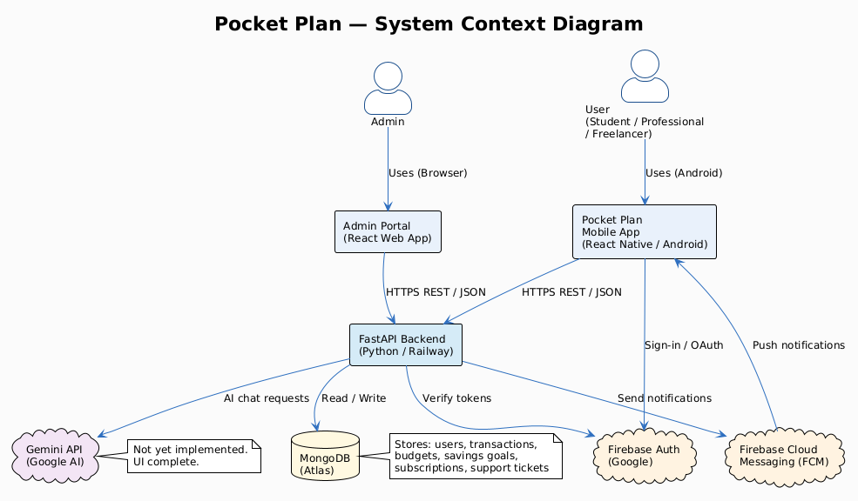

Fig 1. System Context Diagram

3.1 Hardware Interfaces

Component | Specification
Android Device | Android 8.0+ smartphone, minimum 3GB RAM, 1.5GHz processor, 500MB free storage
Biometric Sensor | Fingerprint or face recognition (optional; falls back to PIN if unavailable)
Network Interface | Wi-Fi or mobile data (4G/5G) required for all sync, chatbot, and admin operations
Desktop Browser | Admin Portal requires a modern browser (Chrome, Firefox, Edge) on desktop or laptop
Table 3.1 — Hardware Interface Requirements

3.2 Software Interfaces

Service | Description
Firebase Auth | Handles user authentication — email/password and Google OAuth. SDK-based token exchange.
Firebase Cloud Messaging | Delivers push notifications for budget alerts and reminders. HTTPS REST, service account auth.
MongoDB | Primary document database for all user, transaction, budget, savings, subscription, and ticket data. Accessed via Python motor/pymongo through FastAPI.
FastAPI Backend | Python REST API — handles all business logic, report calculations, admin portal API, and Gemini API proxying. JSON over HTTPS.
Gemini API | Google generative AI API for chatbot functionality. HTTPS REST, API key auth. Not yet implemented — UI complete.
Admin Portal (Web) | React-based web dashboard connecting to FastAPI backend for admin operations.
Table 3.2 — Software and Third-Party Service Interfaces

3.3 Communications Interfaces
- HTTPS (TLS 1.3) — all communication between mobile app, admin portal, and FastAPI backend
- JSON — data exchange format for all API requests and responses
- Firebase SDK — real-time authentication token management and FCM push delivery
- PDF and CSV — report export formats (planned for premium users)

3.4 User Interface Requirements

The table below summarises each screen in the mobile app and admin portal with its key UI elements. Screen wireframes are referenced in the Frontend document attached as Appendix C.

Screen | Key UI Elements
Sign Up | Two-step: Step 1 — email and password fields, Continue button. Step 2 — full name, primary currency selector (defaults to PKR), Back and Create Account buttons
Sign In | Email and password fields, Show toggle, Forgot password link, Sign In button, Continue with Google button, Create account link
Home / Dashboard | Welcome banner with username, total available balance, today's spend, savings rate. Quick Actions: Add Transaction, Budget, Savings Goal. Overview cards: Income, Spent, Saved, Budget Used %. Recent Transactions list. Bottom nav: Home, History, Reports, AI Chat, Settings
Add Transaction | Type selector: Expense, Income, Transfer, Borrow. Expense Category grid (23 categories). Details panel: amount input, date scroll picker, optional description. Save Transaction button
Budget Overview | Budget Planner header: month, days left, Budget / Planned / Remaining. Overview tab: Total Used %, Over Limit count, Critical count. Per-category progress bars with colour coding (Healthy / Watch / Critical / Over Limit)
Budget Allocation | Allocation tab: Monthly Budget input, Split Evenly and Clear Plan buttons. Per-category amount input with used % indicator. Add category chips for unallocated categories
Savings Goal — Overview | Header: target amount, saved amount, ETA. Overview tab: Goal Progress bar, Saved So Far, Remaining. Monthly Progress with health status (On Track / Caution / Delayed). Allocation split options: direct saved money to goal or budget; set split as balanced or custom percentage
Savings Goal — Plan | Plan tab: goal name, total target, monthly saving, start date. Primary / Active toggle. Adjust button. Add Another Goal — gated by premium for users who have reached the 3-goal free limit
History — Transactions | Header: last 3 months flow total, entries count, income, spent. Transactions / Goals tabs. Search bar. Filter chips: All, Expenses, Income, This Week. Monthly grouping
History — Goals | All-time completed count, goal events, on track, attention. Goals tab active. Search bar. Monthly Goal History with status badges (Completed / On Track / Delayed / Adjusted)
Reports | Analytics Hub header: top spend category, savings rate. Reporting Period: Week, Month, Quarter. Total Income, Total Spent, Net Savings, Transactions. Month Spending Trend chart. Breakdown selector: Category Bars, Pie Breakdown, Line Trend, Insights (AI-powered — Generate button triggers Gemini chatbot)
Reports Help | Overlay explaining trend calculation methods (Week / Month / Quarter) and breakdown options (Category Bars, Pie, Line Trend)
AI Chat | AI Money Coach header with Online badge. Chat thread. Quick prompt chips. Text input. Send Message button. Premium-only feature
Settings | App Preferences: Notifications toggle, Hide Balance toggle. Account: Edit Profile, Update Avatar, Change Password, Currency, Change Theme, Switch Profile, Subscription Plan. Security: App Lock, Biometric Login, Privacy Policy. Support: Contact Us, Help & FAQ, Rate the App. Sign Out. Version and team label
Admin — Dashboard | Sidebar: Dashboard, Payments, Support Tickets nav, Logout. Main: Active Users, Monthly Revenue, Total Revenue, Conversion Rate cards. Recent Payments preview. Support Queue preview
Admin — Payment Management | Stats: Total Transactions, Total Amount, Completed Amount, Success Rate. Filter tabs: All, Completed, Pending, Failed. Payment table: User, Amount, Method, Description, Status, Date, Actions
Admin — Support Tickets | Status cards: Open, In Progress, Resolved, Total. Filter dropdowns: Status, Priority. Ticket list with detail and reply panel
Table 3.3 — User Interface Screen Summary

3.5 Navigation Flow Diagrams

Mobile Application Flow

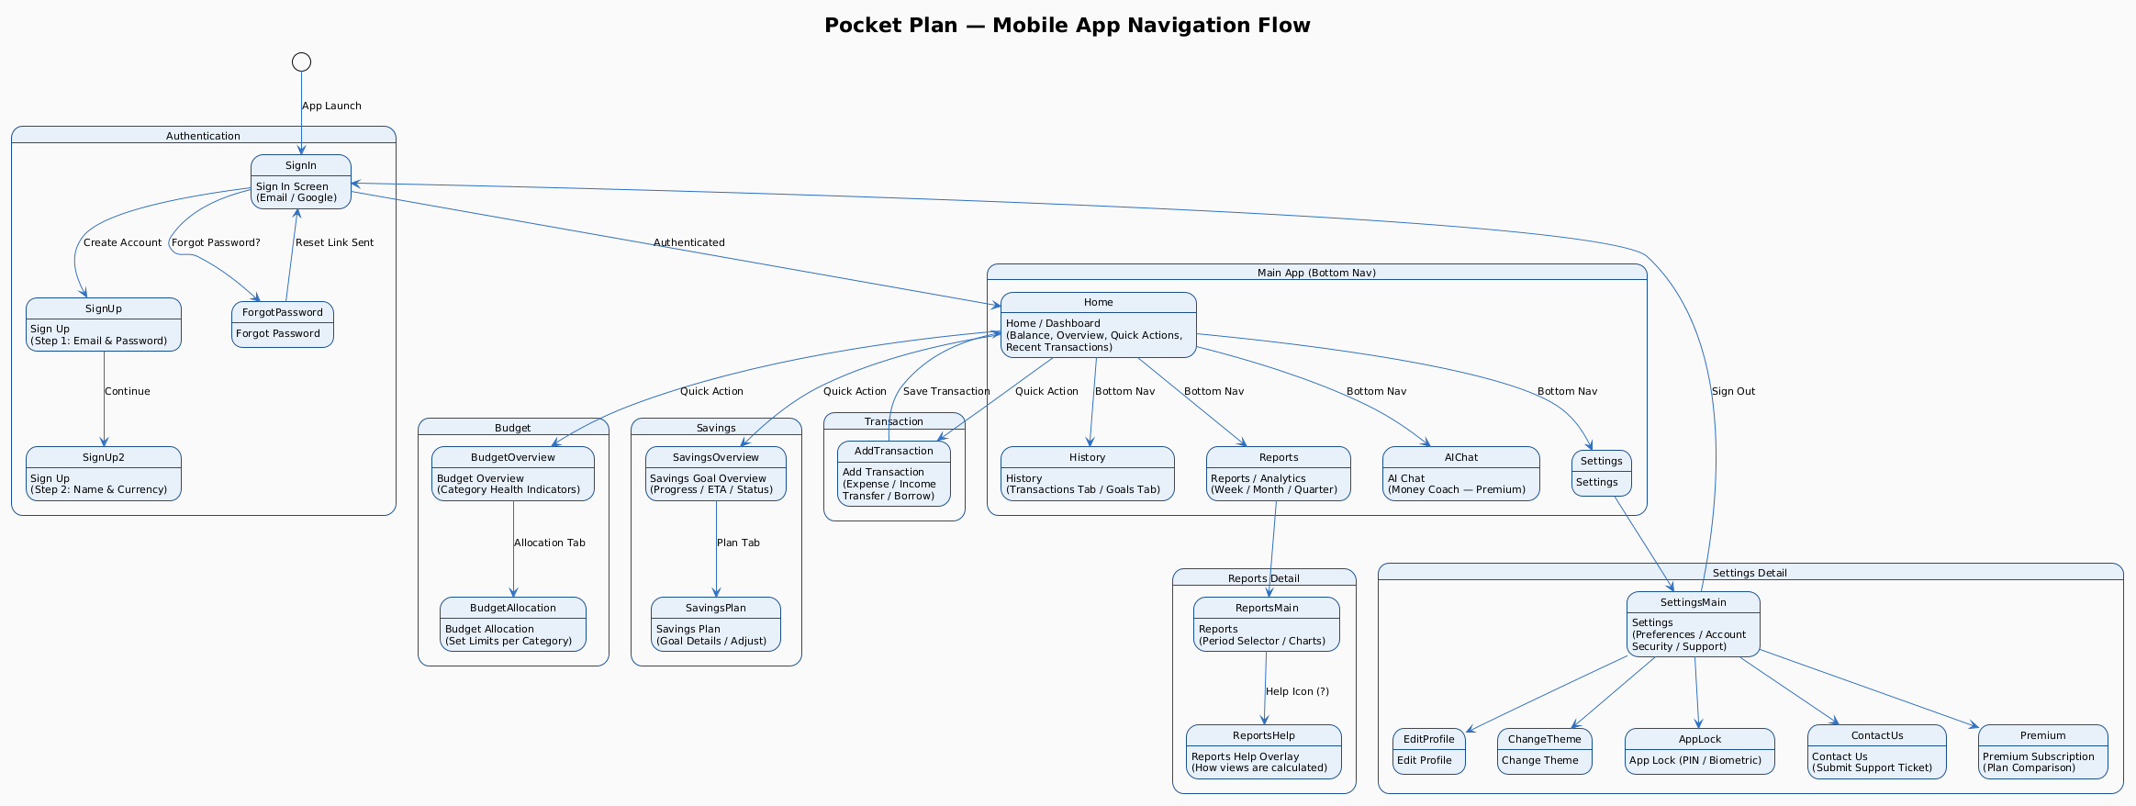

Fig 2.1 Mobile App Navigation Flow (Detailed)

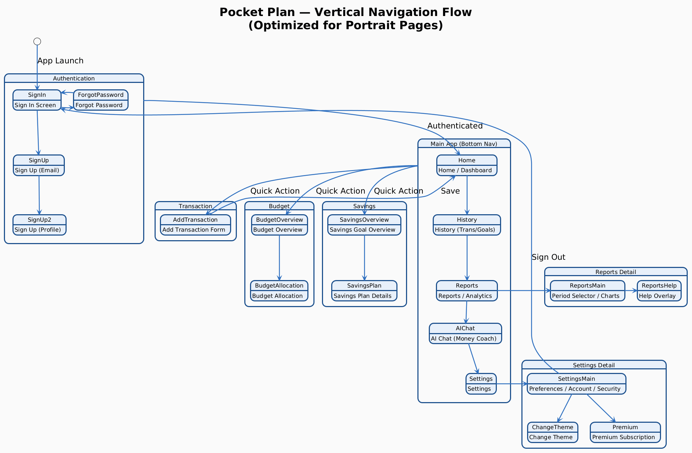

Fig 2.2 Mobile App Navigation Flow (A little easier to understand)

Admin Portal Flow

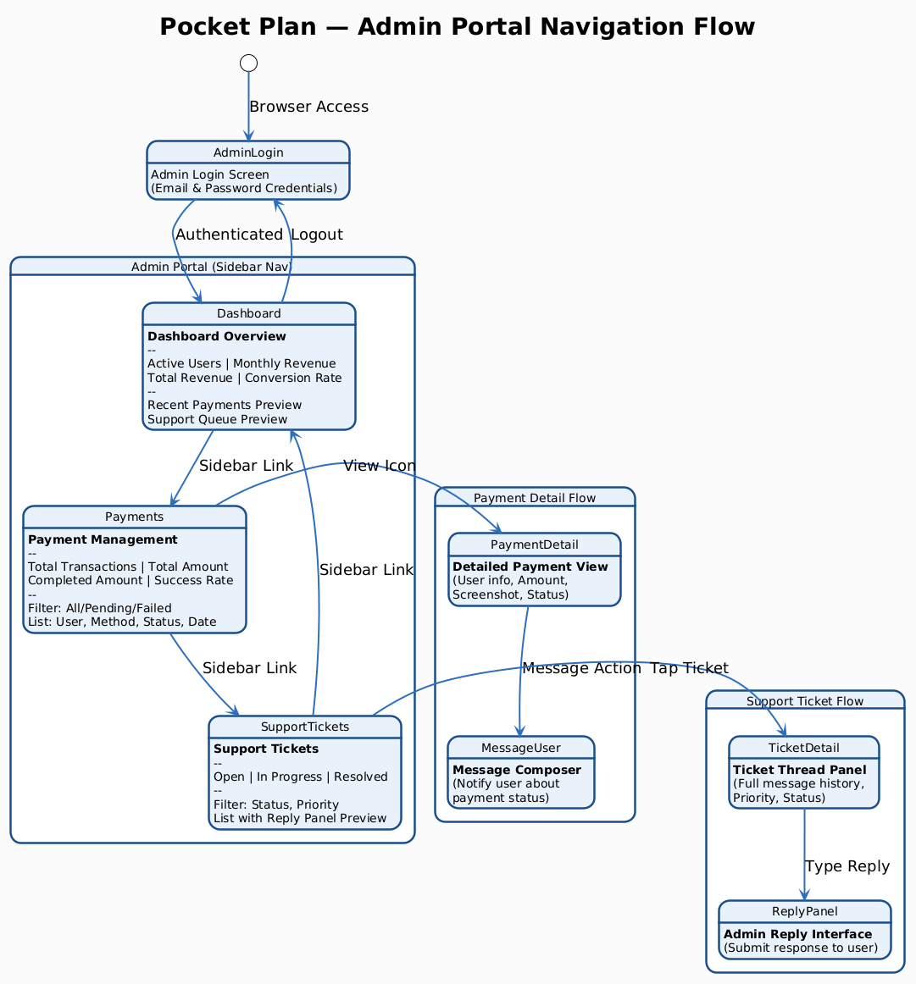

Fig 2.3 Admin Portal Navigation Flow

4 | Functional Requirements

4.1 Functional Hierarchy

1. User Authentication & Onboarding
1.1 Two-Step Email & Password Registration
1.2 Google Sign-In (OAuth)
1.3 Email & Password Sign-In
1.4 Forgot Password / Password Reset via Email
1.5 Sign-Out & Session Termination
1.6 Primary Currency Selection at Sign-Up
2. Transaction Management
2.1 Add Expense Transaction with Category
2.2 Add Income Transaction
2.3 Add Transfer Between Accounts
2.4 Add Borrow Transaction with Contact Name
2.5 Select Category from Predefined Grid (23 categories)
2.6 Enter Amount, Date, and Optional Description
2.7 Save and Persist Transaction to Backend
2.8 View Transaction History with Monthly Grouping
2.9 Search Transactions by Merchant or Category
2.10 Filter Transactions (All / Expenses / Income / This Week)
2.11 View Savings Goals History with Status Badges
3. Budget Planning & Control
3.1 Set Monthly Budget Amount
3.2 Allocate Budget Per Category (Unlimited for All Users)
3.3 Split Budget Evenly Across Categories
3.4 Clear Budget Plan
3.5 View Real-Time Category Usage with Colour Coding
3.6 View Over Limit and Critical Category Counts
3.7 Save Budget Snapshot (temporary — pending full API)
4. Savings Goals
4.1 Create Named Savings Goal with Target and Monthly Contribution
4.2 Set Goal as Primary or Active
4.3 View Goal Progress (Saved, Remaining, ETA)
4.4 View Monthly Progress vs Recommended Contribution
4.5 View Goal Health Status (On Track / Caution / Delayed)
4.6 Split Saved Money Across Goals — Balanced or Custom Percentage
4.7 Choose to Direct Savings to Goal or Back to Budget
4.8 Adjust Savings Plan
4.9 View All-Time Goals History with Status Badges
4.10 Free Users Limited to 3 Savings Goals; Premium Unlimited
5. Reports & Analytics
5.1 Select Reporting Period: Week, Month, or Quarter
5.2 View Total Income, Total Spent, Net Savings, Transaction Count
5.3 View Month Spending Trend (Weekly Averages Bar Chart)
5.4 View Spending Breakdown — Category Bars
5.5 View Spending Breakdown — Pie Chart
5.6 View Spending Breakdown — Line Trend
5.7 Generate AI-Powered Insights via Gemini Chatbot (Generate Button)
5.8 Access Reports Help Overlay
5.9 Export Report as PDF (Premium — planned)
5.10 Export Report as CSV (Premium — planned)
6. AI Financial Chat Assistant
6.1 Send Free-Text Financial Question to AI
6.2 Receive Personalized Advice Based on Actual Spending Data
6.3 Use Quick Prompt Chips for Common Questions
6.4 View Overspending Alerts from AI
6.5 Get Savings Suggestions from AI
6.6 Generate Insights in Reports Screen via Generate Button (Gemini-Powered)
6.7 Chat Feature Restricted to Premium Users (Free: No Access)
7. Settings & User Preferences
7.1 Toggle Budget Alert Notifications
7.2 Toggle Hide Balance (Mask Amounts on Dashboard)
7.3 Edit Profile Name and Email
7.4 Update Avatar (Preset Avatars)
7.5 Change Password
7.6 Select Primary Currency (UI — Conversion Deferred)
7.7 Change App Colour Theme
7.8 Switch User Profile (Premium — Multiple Profiles)
7.9 View and Manage Subscription Plan
7.10 Enable App Lock (PIN or Biometric)
7.11 Enable Biometric Login
7.12 View Privacy Policy
7.13 Contact Us / Submit Support Ticket
7.14 View Help & FAQ
7.15 Rate the App
7.16 Sign Out
8. Multiple User Profiles (Premium)
8.1 Free Users: Single Default Profile
8.2 Premium Users: Create Additional Named Profiles (e.g. Personal, Business)
8.3 Switch Between Profiles from Settings
8.4 Each Profile Has Independent Transactions, Budget, and Savings Data
9. Premium Subscription Management
9.1 View Free vs Monthly vs Yearly Plan Comparison
9.2 Submit Bank Transfer Screenshot as Payment Proof
9.3 Admin Reviews and Approves or Rejects Payment
9.4 Premium Status Activated by Admin in Database
9.5 Enforce Feature Gating Based on Subscription Tier
9.6 Show Premium Badge in Settings When Active
9.7 View and Manage Current Subscription Plan from Settings
9.8 Future: Integration with Automated Payment Gateway
10. Multiple Accounts (Premium)
10.1 Free Users: Single Default Account
10.2 Premium Users: Create Additional Accounts (e.g. Business, Travel)
10.3 Switch Between Accounts
10.4 Budget and Transactions Scoped Per Account
11. Admin Portal
11.1 Admin Login and Authentication
11.2 Dashboard — View Active Users, Monthly Revenue, Total Revenue, Conversion Rate
11.3 Dashboard — View Recent Payments and Support Queue Previews
11.4 Payment Management — View Full Payment List with Filters
11.5 Payment Management — View Payment Detail and Message User
11.6 Support Tickets — View All Tickets with Status and Priority
11.7 Support Tickets — Filter by Status and Priority
11.8 Support Tickets — View Ticket Detail and Reply to User

4.2 API Implementation Status

Implemented API Endpoints

Endpoint | Description
GET /health | Health check — returns system status
GET /health/db | Database connectivity check
POST /transactions | Create a new transaction (expense, income, transfer, borrow, savings)
GET /transactions | Retrieve transactions for a user with pagination
GET /transactions/recent | Retrieve most recent N transactions for a user
GET /transactions/history | Retrieve transaction history for a specified number of months
POST /budgets | Create or update a budget (upsert by user_id + account_id + month + year)
GET /budgets | Retrieve all budgets for a user
GET /budgets/current | Retrieve the current month budget for a specific account
POST /savings-goals | Create a new savings goal
GET /savings-goals | Retrieve all savings goals for a user
PATCH /savings-goals/{goal_id} | Update an existing savings goal
GET /reports/summary | Monthly financial summary including totals, category breakdown, and budget
Table 4.1 — Implemented API Endpoints

Models Implemented — API Endpoints Pending

Model / Area | Scope of Pending Work
User | Registration, login, profile management, password change
UserProfile | Avatar, display name, preferences, multiple profiles per user
Account | Multiple account creation and management (premium)
ChatHistory | AI chatbot message history and Insights generation persistence
Subscription | Premium tier status, activation, manual payment record
Admin endpoints | Payment list, ticket list, ticket reply, subscription approval
Table 4.2 — Backend Models Awaiting API Endpoint Implementation

4.3 Premium Subscription Tier Comparison

Feature | Free | Monthly (PKR 499) | Yearly (PKR 3,499)
Accounts | 1 | Unlimited | Unlimited
User Profiles | 1 | Unlimited | Unlimited
Transaction History | 3 months | Unlimited | Unlimited
Savings Goals | 3 | Unlimited | Unlimited
AI Chatbot & Insights | No | Yes | Yes
PDF / CSV Export | No | Yes | Yes
Category Limits | Unlimited | Unlimited | Unlimited
Priority Support | No | Yes | Yes
Early Access to New Features | No | No | Yes
Table 4.3 — Premium Subscription Feature Comparison — Free vs Monthly vs Yearly

Premium subscription is activated through manual bank transfer. The user submits payment proof (screenshot) through the app. The admin reviews and approves through the Admin Portal Payment Management screen. An automated payment gateway is planned for a future release.

4.4 Use Case Diagram

Admin Use Case Diagram

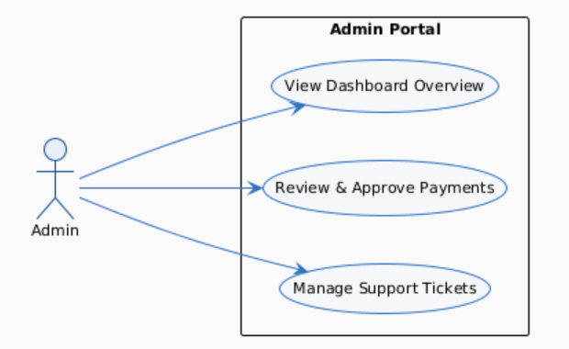

Fig 3.1 Use Case Diagram for Admin

User Use Case Diagram

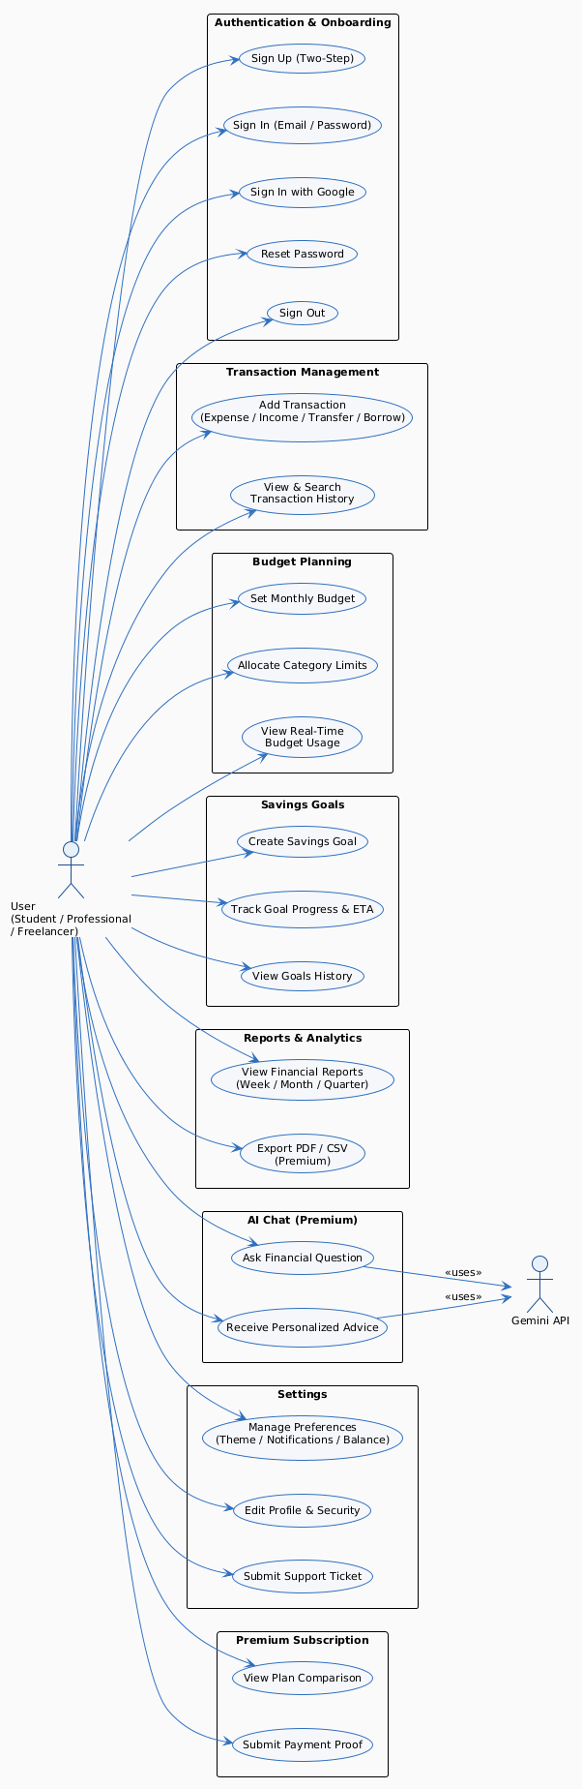
Fig 3.2 Use Case Diagram for User

4.5 Use Case Tables

The following 18 use case tables cover the primary functional flows across all 10 modules of Pocket Plan. Each table includes actor, feature, pre-conditions, step-by-step scenarios with system reactions, alternate scenarios for error and edge cases, post conditions, and cross-references to related use cases.

ID | Feature | Title
UC-PP-01 | User Authentication & Onboarding | User Registration (Two-Step Sign-Up)
UC-PP-02 | User Authentication & Onboarding | User Sign-In
UC-PP-03 | Transaction Management | Add Transaction
UC-PP-04 | Budget Planning & Control | View and Track Budget
UC-PP-05 | Premium Subscription Management | Admin Reviews Payment and Activates Premium
UC-PP-06 | Reports & Analytics | View Financial Reports
UC-PP-07 | Admin Portal | Admin Manages Support Ticket
UC-PP-08 | User Authentication & Onboarding | Google Sign-In
UC-PP-09 | User Authentication & Onboarding | Forgot Password / Password Reset
UC-PP-10 | Transaction Management | View Transaction History and Search
UC-PP-11 | Savings Goals | Create and Track Savings Goal
UC-PP-12 | AI Financial Chat Assistant | Use AI Financial Chat Assistant
UC-PP-13 | Settings & User Preferences | Manage App Settings and Preferences
UC-PP-14 | Settings & User Preferences | Submit Support Ticket from App
UC-PP-15 | Premium Subscription Management | Subscribe to Premium (Manual Payment Flow)
UC-PP-16 | Savings Goals | Configure Savings Goal Split and Allocation
UC-PP-17 | Savings Goals | Set Savings Goal as Primary or Active
UC-PP-18 | Multiple User Profiles (Premium) | Switch User Profile
Table 4.4 — Use Case Index — All 18 Use Cases

4.4.1 UC-PP-01: User Registration (Two-Step Sign-Up)

UC-PP-01 | User Registration (Two-Step Sign-Up)

Use Case ID | UC-PP-01
Actor | New User
Feature | User Authentication & Onboarding
Pre-conditions | - App is installed on an Android device  - User has a valid email address  - Internet connection is available

Scenarios
Step # | Action | System Reaction
1 | User opens the app for the first time | Displays welcome / sign-in screen with Create Account link
2 | User taps Create Account | Displays Step 1 of 2: email and password fields
3 | User enters email and password; taps Continue | Validates email format and password length in real time
4 | Validation passes, Step 2 displayed | Shows full name field and primary currency selector (defaults to PKR)
5 | User enters full name and confirms currency, taps Create Account | Account created via FastAPI backend and Firebase Auth
6 | Account created successfully | User redirected to the Home screen with empty state prompts
Alternate Scenarios
- 3a: Email already registered — inline error: 'An account with this email already exists.'
- 3b: Password under 8 characters — inline error shown, Continue button remains disabled
- 5a: Network unavailable — 'Unable to create account. Check your connection and try again.'
Post Conditions
- User account exists in Firebase Auth and MongoDB
- User is on Home screen
- Session is active
Cross Reference | UC-PP-02: Sign In, UC-PP-03: Google Sign-In
Table 4.4.1 — UC-PP-01: User Registration (Two-Step Sign-Up)

4.4.2 UC-PP-02: User Sign-In

UC-PP-02 | User Sign-In

Use Case ID | UC-PP-02
Actor | Returning User
Feature | User Authentication & Onboarding
Pre-conditions | - User has a registered account  - App is installed

Scenarios
Step # | Action | System Reaction
1 | User opens the app | Sign-In screen displayed
2 | User enters email and password, taps Sign In | Credentials verified against Firebase Auth
3 | Authentication succeeds | Session established; user redirected to Home screen
Alternate Scenarios
- 2a: Incorrect credentials — 'Incorrect email or password. Please try again.'
- 2b: User taps Forgot password? — navigates to password reset flow (UC-PP-09)
- 2c: User taps Continue with Google — see UC-PP-08
Post Conditions
- Active session established
- Home screen loaded with user data
Cross Reference | UC-PP-08: Google Sign-In, UC-PP-09: Password Reset
Table 4.4.2 — UC-PP-02: User Sign-In

4.4.3 UC-PP-03: Add Transaction

UC-PP-03 | Add Transaction

Use Case ID | UC-PP-03
Actor | Authenticated User
Feature | Transaction Management
Pre-conditions | - User is signed in  - At least one account exists

Scenarios
Step # | Action | System Reaction
1 | User taps Add Transaction from Quick Actions | Add Transaction screen displayed with Type selector
2 | User selects transaction type (Expense, Income, Transfer, or Borrow) | Category grid shown for Expense; relevant fields shown for other types
3 | User selects category (Expense only), enters amount and date | Form validates amount is a positive number; date defaults to today
4 | User optionally adds a description, taps Save Transaction | Transaction sent to POST /transactions endpoint
5 | Backend saves transaction | User returned to Home screen; dashboard totals updated
Alternate Scenarios
- 3a: Amount is zero or non-numeric — Save button remains disabled
- 4a: Network unavailable — transaction queued locally and retried on reconnection
- 2a: Type is Borrow — contact name field appears (required)
- 2b: Type is Transfer — to_account_id selector appears (premium users with multiple accounts)
Post Conditions
- Transaction stored in MongoDB
- Dashboard totals recalculated
- Budget usage updated
Cross Reference | UC-PP-10: View Transaction History, UC-PP-04: Budget Overview
Table 4.4.3 — UC-PP-03: Add Transaction

4.4.4 UC-PP-04: View and Track Budget

UC-PP-04 | View and Track Budget

Use Case ID | UC-PP-04
Actor | Authenticated User
Feature | Budget Planning & Control
Pre-conditions | - User is signed in  - At least one transaction has been logged

Scenarios
Step # | Action | System Reaction
1 | User taps Budget from Quick Actions | Budget Planner displayed with current month, days left, Budget / Planned / Remaining
2 | User views Overview tab | Per-category progress bars shown with colour-coded health indicators
3 | User taps Allocation tab | Monthly budget input and per-category fields displayed with current used %
4 | User adjusts category amounts, taps Save Snapshot | Budget saved via POST /budgets endpoint
Alternate Scenarios
- 3a: User taps Split Evenly — budget divided equally across all active categories
- 3b: User taps Clear Plan — all category limits reset to zero
- 2a: A category shows Over Limit (100%+) — displayed in red with Over Limit label
Post Conditions
- Budget stored in MongoDB
- Overview tab reflects updated limits and usage
Cross Reference | UC-PP-03: Add Transaction, UC-PP-06: Reports
Table 4.4.4 — UC-PP-04: View and Track Budget

4.4.5 UC-PP-05: Admin Reviews Payment and Activates Premium

UC-PP-05 | Admin Reviews Payment and Activates Premium

Use Case ID | UC-PP-05
Actor | Admin
Feature | Premium Subscription Management
Pre-conditions | - Admin is logged into the Admin Portal  - User has submitted payment screenshot via the app

Scenarios
Step # | Action | System Reaction
1 | Admin navigates to Payments screen | Payment Management shows full list with filter tabs
2 | Admin locates a Pending entry | Entry shows user name, amount, method, description, date, Pending badge
3 | Admin taps view icon to review payment detail and screenshot | Payment detail view opens
4 | Admin verifies transfer amount and screenshot are valid | Admin can message user if needed
5 | Admin updates subscription status to Completed | User's premium tier activated in MongoDB
6 | User's app reflects premium on next load | Premium badge shown in Settings; premium features unlocked
Alternate Scenarios
- 3a: Screenshot invalid or amount incorrect — Admin marks as Failed and messages the user
- 4a: Admin needs more info — messages user through the portal message action
Post Conditions
- Subscription status updated in MongoDB
- User has access to premium features
- Payment record shows Completed
Cross Reference | UC-PP-15: Subscribe to Premium, UC-PP-07: Admin Manages Support Ticket
Table 4.4.5 — UC-PP-05: Admin Reviews Payment and Activates Premium

4.4.6 UC-PP-06: View Financial Reports

UC-PP-06 | View Financial Reports

Use Case ID | UC-PP-06
Actor | Authenticated User
Feature | Reports & Analytics
Pre-conditions | - User is signed in  - At least one transaction exists for the selected period

Scenarios
Step # | Action | System Reaction
1 | User navigates to Reports via bottom nav | Analytics Hub displayed, defaults to Month view
2 | System fetches data from GET /reports/summary | Total Income, Spent, Net Savings, Transaction Count displayed
3 | Month Spending Trend chart rendered with weekly averages | 4-week bar chart shown
4 | User selects breakdown type (Category Bars, Pie, Line Trend, or Insights) | Selected chart rendered; for Insights user taps Generate button
5 | If Insights selected — user taps Generate | Gemini API called with user's financial data; AI-generated insight displayed
6 | User taps help icon (?) in top right | Reports Help overlay opens explaining how each view is calculated
Alternate Scenarios
- 2a: No data for selected period — 'No transactions found for this period.'
- 5a: Gemini API unavailable — 'Insights unavailable. Please try again later.'
- 6a: Free user taps Export — premium upgrade prompt shown
Post Conditions
- User has a visual breakdown of finances
- AI Insights generated and displayed if requested
Cross Reference | UC-PP-03: Add Transaction, UC-PP-15: Premium Subscription, UC-PP-12: AI Chat
Table 4.4.6 — UC-PP-06: View Financial Reports

4.4.7 UC-PP-07: Admin Manages Support Ticket

UC-PP-07 | Admin Manages Support Ticket

Use Case ID | UC-PP-07
Actor | Admin
Feature | Admin Portal
Pre-conditions | - Admin is logged into the Admin Portal  - At least one support ticket exists

Scenarios
Step # | Action | System Reaction
1 | Admin navigates to Support Tickets | Ticket list displayed with status counts: Open, In Progress, Resolved, Total
2 | Admin filters by Status or Priority | List updates to matching tickets
3 | Admin taps a ticket | Ticket detail panel opens on right with full message thread
4 | Admin types a reply and submits | Reply sent to user; ticket status updated to In-Progress
5 | Issue resolved — Admin marks ticket as Resolved | Ticket status badge updated to Resolved
Alternate Scenarios
- 3a: No tickets match the selected filter — 'No tickets found for this filter.'
- 4a: Network error during reply — error shown, admin can retry
Post Conditions
- Ticket status updated
- User notified of admin response
- Ticket appears in Resolved list when closed
Cross Reference | UC-PP-05: Admin Reviews Payment, UC-PP-14: Submit Support Ticket
Table 4.4.7 — UC-PP-07: Admin Manages Support Ticket

4.4.8 UC-PP-08: Google Sign-In

UC-PP-08 | Google Sign-In

Use Case ID | UC-PP-08
Actor | New or Returning User
Feature | User Authentication & Onboarding
Pre-conditions | - App is installed on an Android device  - User has a Google account  - Internet connection is available

Scenarios
Step # | Action | System Reaction
1 | User taps Continue with Google on the Sign-In screen | App initiates Google OAuth flow
2 | Google account picker displayed | User selects their Google account
3 | User grants permission | Google returns OAuth token to the app
4 | App sends token to FastAPI backend | Backend verifies token with Firebase Auth
5 | Account created or matched in the system | User redirected to Home screen
Alternate Scenarios
- 3a: User cancels the Google account picker — returned to Sign-In screen, no error shown
- 4a: Token verification fails — 'Sign-in failed. Please try again or use email and password.'
- 4b: Network unavailable — 'Unable to sign in. Check your connection and try again.'
Post Conditions
- Active session established
- User on Home screen
- Account exists in Firebase Auth and MongoDB
Cross Reference | UC-PP-02: Email Sign-In, UC-PP-01: Registration
Table 4.4.8 — UC-PP-08: Google Sign-In

4.4.9 UC-PP-09: Forgot Password / Password Reset

UC-PP-09 | Forgot Password / Password Reset

Use Case ID | UC-PP-09
Actor | Registered User
Feature | User Authentication & Onboarding
Pre-conditions | - User has a registered email/password account  - Internet connection is available

Scenarios
Step # | Action | System Reaction
1 | User taps Forgot password? on the Sign-In screen | Password reset screen or prompt displayed
2 | User enters their registered email address | Email format validated in real time
3 | User submits the form | Firebase Auth sends a password reset link to the email
4 | User opens the reset link in their email | Password reset page opens
5 | User enters and confirms a new password | Password strength validated
6 | User submits new password | Password updated in Firebase Auth; success message shown
7 | User returns to Sign-In screen | Signs in with the new password
Alternate Scenarios
- 2a: Email is not registered — 'No account found with this email address.'
- 3a: Network unavailable — 'Unable to send reset email. Check your connection.'
- 5a: New password is under 8 characters — inline error shown, form cannot submit
- 5b: Passwords do not match — 'Passwords do not match. Please try again.'
- 4a: Reset link has expired (after 24 hours) — 'This link has expired. Please request a new password reset.'
Post Conditions
- Password updated in Firebase Auth
- User can sign in with the new password
- Reset link becomes invalid after use
Cross Reference | UC-PP-02: User Sign-In
Table 4.4.9 — UC-PP-09: Forgot Password / Password Reset

4.4.10 UC-PP-10: View Transaction History and Search

UC-PP-10 | View Transaction History and Search

Use Case ID | UC-PP-10
Actor | Authenticated User
Feature | Transaction Management
Pre-conditions | - User is signed in  - At least one transaction has been logged

Scenarios
Step # | Action | System Reaction
1 | User taps History in the bottom navigation bar | History screen displayed with header showing last 3 months total, entries, income, and spent
2 | Transactions tab is active by default | Monthly Transaction History shown, grouped by month with date headers
3 | User types in the search bar | Results filter in real time to match merchant name or category
4 | User taps a filter chip (Expenses, Income, or This Week) | Transaction list updates to show only matching entries
5 | User taps Goals tab | View switches to Savings Goals History showing goal events grouped by month with status badges
Alternate Scenarios
- 3a: No transactions match the search query — 'No transactions found for this search.'
- 4a: No transactions match the selected filter — 'No transactions for this filter.'
- 1a: Free user scrolls past 3 months of history — premium upgrade prompt displayed
Post Conditions
- User has reviewed their transaction or goals history
- Search and filter state is maintained while on the screen
Cross Reference | UC-PP-03: Add Transaction, UC-PP-06: View Reports
Table 4.4.10 — UC-PP-10: View Transaction History and Search

4.4.11 UC-PP-11: Create and Track Savings Goal

UC-PP-11 | Create and Track Savings Goal

Use Case ID | UC-PP-11
Actor | Authenticated User
Feature | Savings Goals
Pre-conditions | - User is signed in  - User navigates to the Savings Goal screen via Quick Actions on Home

Scenarios
Step # | Action | System Reaction
1 | User taps Savings Goal from Home Quick Actions | Savings Goal screen displayed showing current goal overview if one exists
2 | User taps Plan tab then taps to create a new goal | Goal creation form displayed: goal name, target amount, monthly contribution, start date
3 | User fills in all fields and saves | Goal sent to POST /savings-goals endpoint and saved to MongoDB
4 | User views Overview tab | Goal Progress bar shown with saved amount, remaining amount, and ETA in months
5 | System calculates monthly progress status | Status badge shown: On Track, Caution, or Delayed based on current contribution vs recommended
6 | User views all-time goals history by tapping History → Goals tab | All goal events listed with status badges (Completed, On Track, Delayed, Adjusted)
Alternate Scenarios
- 2a: Free user already has 3 active goals and taps Add Another Goal — premium upgrade prompt shown with Premium badge
- 3a: Target amount is zero or missing — form cannot submit
- 3b: Network unavailable — 'Unable to save goal. Check your connection and try again.'
- 5a: Current monthly contribution is below recommended — status shown as Caution with the gap displayed
Post Conditions
- Savings goal stored in MongoDB
- Goal progress visible on Overview tab
- ETA calculated and displayed
Cross Reference | UC-PP-03: Add Transaction (savings transaction type), UC-PP-10: Transaction History — Goals tab
Table 4.4.11 — UC-PP-11: Create and Track Savings Goal

4.4.12 UC-PP-12: Use AI Financial Chat Assistant

UC-PP-12 | Use AI Financial Chat Assistant

Use Case ID | UC-PP-12
Actor | Authenticated Premium User
Feature | AI Financial Chat Assistant
Pre-conditions | - User is signed in  - User has an active premium subscription  - Internet connection is available  - Gemini API is accessible

Scenarios
Step # | Action | System Reaction
1 | User taps AI Chat in the bottom navigation bar | AI Money Coach screen displayed with Online status badge
2 | User taps a quick prompt chip or types a question in the input field | Input text displayed in the chat thread as a user message
3 | App sends user message and relevant financial context to FastAPI backend | Backend proxies request to Gemini API with user's spending and budget data
4 | Gemini API generates a personalized response | Response streamed back to app and displayed as an assistant message
5 | User reads the advice and continues the conversation or closes the screen | Chat thread retains messages for the session
Alternate Scenarios
- 1a: Free user taps AI Chat — message shown: 'AI Chat is a premium feature. Upgrade to access your AI Money Coach.'
- 4a: Gemini API is unavailable — 'AI assistant is temporarily unavailable. Please try again later.'
- 4b: Response takes longer than 10 seconds — loading indicator shown with message 'Thinking...'
- 3a: User has no transactions logged — AI response notes there is insufficient data for personalized advice
Post Conditions
- User has received personalized financial advice
- Chat session history maintained during the session
- No response is stored permanently in this release (Chat History model pending)
Cross Reference | UC-PP-05: Premium Subscription, UC-PP-06: View Reports
Table 4.4.12 — UC-PP-12: Use AI Financial Chat Assistant

4.4.13 UC-PP-13: Manage App Settings and Preferences

UC-PP-13 | Manage App Settings and Preferences

Use Case ID | UC-PP-13
Actor | Authenticated User
Feature | Settings & User Preferences
Pre-conditions | - User is signed in  - User navigates to Settings via bottom navigation bar

Scenarios
Step # | Action | System Reaction
1 | User taps Settings in the bottom navigation bar | Settings screen displayed with App Preferences, Account, Security, and Support sections
2 | User toggles Notifications on or off | Notification preference updated immediately; budget alerts and reminders enabled or disabled accordingly
3 | User toggles Hide Balance on or off | All monetary amounts on the dashboard masked with asterisks when enabled; revealed when disabled
4 | User taps Change Theme | Colour theme selector shown; user selects a theme; app appearance updates immediately
5 | User taps App Lock | App lock setup flow shown; user sets a PIN or enables biometric lock
6 | User taps Edit Profile | Profile edit form shown; user updates name or email and saves
Alternate Scenarios
- 5a: Device does not support biometrics — Biometric Login option is greyed out; only PIN lock available
- 6a: New email is already registered to another account — 'This email is already in use.'
- 6b: Email change requires re-authentication — user prompted to enter current password before proceeding
- 4a: User selects a theme — change is applied immediately without requiring app restart
Post Conditions
- User preferences saved to database
- App appearance and behaviour reflect updated settings
- App lock is active if configured
Cross Reference | UC-PP-14: Submit Support Ticket, UC-PP-15: Premium Subscription
Table 4.4.13 — UC-PP-13: Manage App Settings and Preferences

4.4.14 UC-PP-14: Submit Support Ticket from App

UC-PP-14 | Submit Support Ticket from App

Use Case ID | UC-PP-14
Actor | Authenticated User
Feature | Settings & User Preferences
Pre-conditions | - User is signed in  - User navigates to Settings → Contact Us

Scenarios
Step # | Action | System Reaction
1 | User taps Contact Us in the Settings Support section | Support ticket form or chat interface displayed
2 | User describes their issue and submits | Ticket created in the system with status Open and default priority
3 | System confirms ticket submission | Confirmation message shown: 'Your message has been received. Our team will get back to you shortly.'
4 | Admin views the ticket in the Admin Portal Support Tickets screen | Ticket appears in the Open queue with the user's name and message count
5 | Admin replies to the ticket | User receives a notification or can view the reply through the Contact Us screen
Alternate Scenarios
- 2a: Issue description is empty — form cannot be submitted; inline error shown
- 2b: Network unavailable — 'Unable to submit ticket. Check your connection and try again.'
- 5a: Admin has not yet replied — ticket remains in Open status visible to admin
Post Conditions
- Support ticket created in MongoDB with Open status
- Admin can view and respond in the Admin Portal
- User has a record of the submission
Cross Reference | UC-PP-07: Admin Manages Support Ticket
Table 4.4.14 — UC-PP-14: Submit Support Ticket from App

4.4.15 UC-PP-15: Subscribe to Premium (Manual Payment Flow)

UC-PP-15 | Subscribe to Premium (Manual Payment Flow)

Use Case ID | UC-PP-15
Actor | Authenticated User
Feature | Premium Subscription Management
Pre-conditions | - User is signed in  - User is currently on the Free tier  - User has access to the bank account details for payment

Scenarios
Step # | Action | System Reaction
1 | User taps a locked premium feature or navigates to subscription screen | Premium plan comparison screen displayed showing Free, Monthly (PKR 499), and Yearly (PKR 3,499) tiers with feature comparison table
2 | User selects Monthly or Yearly plan | Payment instructions displayed: bank account number and required reference (user email or ID)
3 | User makes the bank transfer using their banking app | Transfer completed outside the app
4 | User returns to the app and submits a screenshot of the transfer as proof | Screenshot uploaded and payment record created with Pending status
5 | Admin receives the submission in Payment Management screen | Admin reviews the screenshot and amount against the selected plan
6 | Admin approves the payment | Subscription status in MongoDB updated to active; user's premium tier activated
7 | User's app reflects premium status on next load or refresh | Premium badge shown in Settings; previously locked features now accessible
Alternate Scenarios
- 6a: Admin rejects the payment (incorrect amount or invalid screenshot) — payment marked as Failed; admin messages user through portal
- 4a: Screenshot upload fails due to network error — 'Upload failed. Please try again.'
- 1a: User already has an active premium subscription — current plan details shown with expiry date
- 6b: Future release — payment will be processed automatically via a payment gateway; admin approval will not be required
Post Conditions
- Payment record exists in MongoDB with Completed status
- User has access to all premium features for the selected plan duration
- Admin has a full audit trail of the payment submission and approval
Cross Reference | UC-PP-05: Admin Reviews Payment, UC-PP-12: AI Chat (premium), UC-PP-11: Savings Goals (premium)
Table 4.4.15 — UC-PP-15: Subscribe to Premium (Manual Payment Flow)

4.4.16 UC-PP-16: Configure Savings Goal Split and Allocation

UC-PP-16 | Configure Savings Goal Split and Allocation

Use Case ID | UC-PP-16
Actor | Authenticated User
Feature | Savings Goals
Pre-conditions | - User is signed in  - At least one savings goal exists  - User navigates to the Savings Goal screen

Scenarios
Step # | Action | System Reaction
1 | User opens the Savings Goal screen and views the Overview tab | Goal Progress, Monthly Progress, and health status displayed
2 | User taps the split/allocation option on the savings overview | Allocation panel shown with two options: direct savings to Goal or back to Budget
3 | User selects Goal — then chooses split method: Balanced or Custom Percentage | If Balanced: saved amount divided equally across all active goals. If Custom: user enters a percentage for each goal
4 | User confirms the allocation settings | Settings saved to the goal record in MongoDB via PATCH /savings-goals/{goal_id}
5 | System recalculates how monthly savings are distributed across goals | Updated split reflected in the goal overview
Alternate Scenarios
- 3a: Custom percentages do not sum to 100% — inline error: 'Percentages must total 100%. Please adjust.'
- 2a: User selects Budget — saved money is directed back into the monthly budget pool instead of the savings goal
- 4a: Network unavailable — 'Unable to save allocation settings. Check your connection.'
- 3b: User has only one active goal — Balanced and Custom options both allocate 100% to that goal
Post Conditions
- Allocation settings saved to MongoDB
- Future savings distributions follow the configured split
- Goal overview reflects updated allocation logic
Cross Reference | UC-PP-11: Create and Track Savings Goal, UC-PP-04: View and Track Budget
Table 4.4.16 — UC-PP-16: Configure Savings Goal Split and Allocation

4.4.17 UC-PP-17: Set Savings Goal as Primary or Active

UC-PP-17 | Set Savings Goal as Primary or Active

Use Case ID | UC-PP-17
Actor | Authenticated User
Feature | Savings Goals
Pre-conditions | - User is signed in  - At least one savings goal exists  - User navigates to the Savings Goal Plan tab

Scenarios
Step # | Action | System Reaction
1 | User opens the Savings Goal screen and taps the Plan tab | Savings Plan card shown with goal name, target, monthly saving, start date
2 | User taps Adjust on the plan card | Goal edit options displayed including Primary toggle and Active toggle
3 | User enables the Primary toggle on their chosen goal | Goal marked as Primary — used as the default savings target across the app
4 | User enables or disables the Active toggle | Active goals receive savings contributions; inactive goals are paused
5 | User saves changes | Updated goal flags sent to PATCH /savings-goals/{goal_id}
Alternate Scenarios
- 3a: User tries to set a second goal as Primary — previous Primary is automatically unset; only one Primary goal allowed at a time
- 4a: User deactivates all goals — system shows a warning: 'No active savings goals. Savings will not be tracked.'
- 5a: Network unavailable — 'Unable to update goal settings. Please try again.'
Post Conditions
- Goal flags (primary, active) updated in MongoDB
- App uses Primary goal as default reference across dashboard and reports
- Inactive goals do not receive contributions until reactivated
Cross Reference | UC-PP-11: Create and Track Savings Goal, UC-PP-16: Configure Savings Goal Split
Table 4.4.17 — UC-PP-17: Set Savings Goal as Primary or Active

4.4.18 UC-PP-18: Switch User Profile

UC-PP-18 | Switch User Profile

Use Case ID | UC-PP-18
Actor | Authenticated Premium User
Feature | Multiple User Profiles (Premium)
Pre-conditions | - User is signed in  - User has an active premium subscription  - At least one additional profile has been created  - User navigates to Settings

Scenarios
Step # | Action | System Reaction
1 | User opens Settings and taps Switch Profile | Profile selector shown listing all available profiles (e.g. Personal, Business)
2 | User selects a different profile | System loads data for the selected profile — transactions, budget, savings goals scoped to that profile
3 | Home screen refreshed with the selected profile's data | Profile name shown in the welcome banner; all financial data reflects the selected profile
Alternate Scenarios
- 1a: Free user taps Switch Profile — message shown: 'Multiple profiles is a premium feature. Upgrade to create and switch profiles.'
- 1b: User has only one profile — 'You only have one profile. Create a new profile to switch.'
- 2a: Network unavailable during profile switch — 'Unable to load profile. Check your connection.'
Post Conditions
- Selected profile is active
- All app screens (Home, History, Budget, Reports) show data scoped to the selected profile
- Previous profile data is preserved and accessible by switching back
Cross Reference | UC-PP-15: Subscribe to Premium, UC-PP-13: Manage Settings
Table 4.4.18 — UC-PP-18: Switch User Profile

4.6 Use Case Coverage Note

Note on Use Case Scope
This SRS includes 15 use cases (UC-PP-01 to UC-PP-18) covering all 10 functional modules of Pocket Plan. These were selected to represent the primary, most complex, and highest-risk interactions in the system. Not every possible user action has a dedicated use case table. The following categories of interactions were intentionally excluded to avoid redundancy and keep the document at a practical length for a course project:
- Trivial single-action flows — such as Sign Out, Update Avatar, View Privacy Policy, Rate the App, and Help & FAQ. These involve no business logic, no alternate scenarios of significance, and no system decision-making. They are fully covered by the functional hierarchy in Section 4.1.
- CRUD sub-operations already implied by existing use cases — for example, Edit Transaction and Delete Transaction are direct extensions of UC-PP-03 (Add Transaction) and follow identical pre-conditions, validation rules, and error handling. A separate use case table would add no new information.
- Admin login — the Admin Portal authentication flow mirrors the standard user sign-in pattern (UC-PP-02) and does not involve any distinct system behaviour specific to Pocket Plan's domain.
- Settings sub-actions covered within UC-PP-13 — individual settings such as Change Password, Update Avatar, and Currency Selection are captured as alternate steps within UC-PP-13 (Manage App Settings and Preferences) rather than in separate tables.
- Future features not yet implemented — PDF/CSV export (planned) and automated payment gateway integration are noted in the functional hierarchy and scope sections but do not have use case tables since the flows are not yet defined or testable in this release.
This approach is consistent with standard agile SRS practice, where use cases focus on flows that involve meaningful decision points, error handling, actor-system interaction, and business rules — not mechanical UI actions.

4.7 Sequence Diagrams

Add Transaction
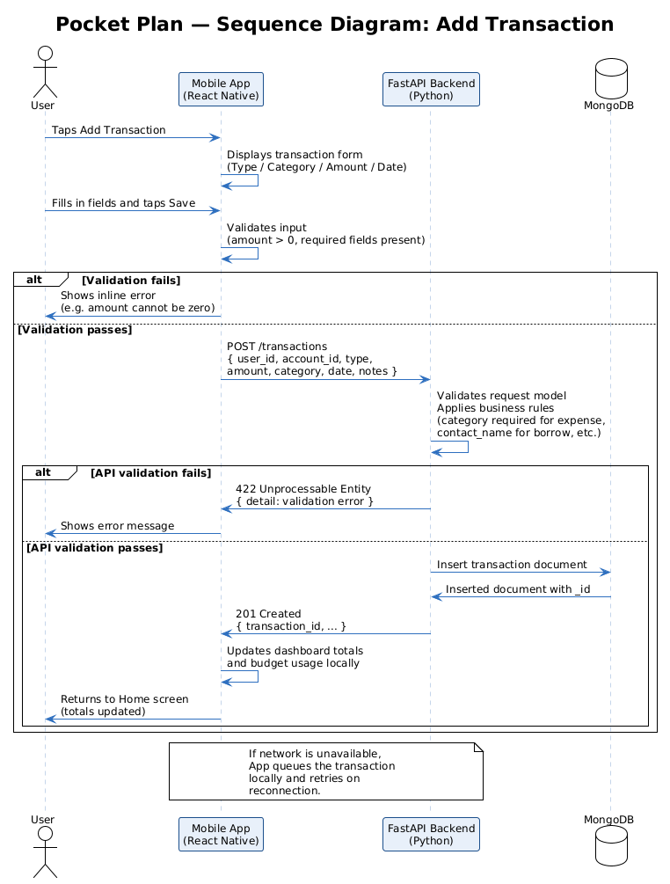

Fig 4.1 Sequence Diagram for Adding Transaction

Premium Subscription Payment

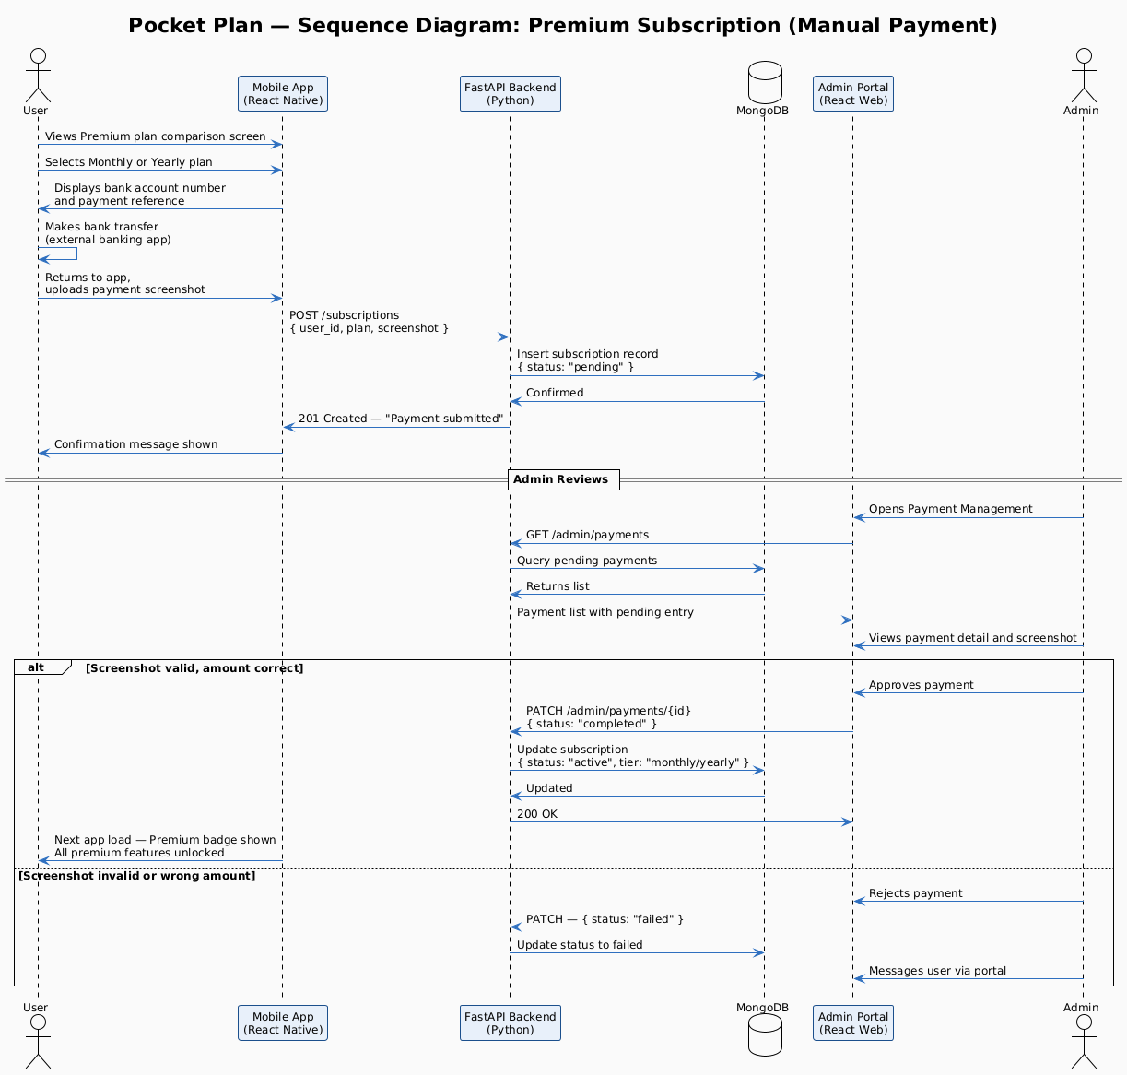

Fig 4.2 Sequence Diagram for Purchasing Premium Subscription

5 | Non-Functional Requirements

5.1 Performance Requirements
- Home screen must load and display user data within 3 seconds on a standard mobile data connection
- Transaction save (POST /transactions) must complete within 2 seconds under normal network conditions
- Report screen with charts must render within 3 seconds of navigation
- Budget overview with category progress bars must update immediately after a transaction is saved
- AI Insights generation (Gemini API) must return a response within 10 seconds of the Generate button being tapped
- Admin portal pages must load within 3 seconds on a desktop browser with a stable connection

5.2 Security Requirements
- All data transmitted between app, admin portal, and backend must use HTTPS (TLS 1.3)
- Firebase Auth JWT tokens must be used for session management with appropriate expiration
- MongoDB access restricted to authenticated backend service only — no direct client access
- User passwords managed entirely by Firebase Auth — no plaintext passwords stored
- App Lock (PIN or biometric) must engage automatically when the app is moved to background
- Balance amounts can be hidden via the Hide Balance toggle — masked as asterisks on dashboard
- Admin portal must require admin credentials — no public routes
- Payment screenshots stored securely and accessible only to admin

5.3 Reliability Requirements
- Failed transaction writes must be queued locally and retried automatically when connectivity returns
- The app must display previously loaded dashboard data when offline rather than showing a blank error screen
- Chatbot and Insights API failures must show a user-friendly message without crashing the app
- Budget snapshot save must provide clear feedback on success or failure
- Admin portal must gracefully handle API errors and display error states rather than blank pages

5.4 Usability Requirements
- All primary user actions (add transaction, view budget, view reports, open chat) must be reachable within 2 taps from Home
- All error messages must be specific and tell the user what to do next
- Minimum touch target size for all interactive elements is 44x44 pixels
- Minimum body text size is 14pt for readability on small screens
- Budget health communicated through both colour and text label — not colour alone
- Reports Help overlay must explain how each chart type is calculated in plain language
- New users must be able to log their first transaction within 3 minutes without external help

5.5 Portability & Scalability
- The mobile app must run on Android 8.0 (API level 26) and all subsequent versions
- The app must adapt to screen sizes from 5 to 6.8 inches without layout breaking
- The Admin Portal must be accessible on modern desktop browsers (Chrome, Firefox, Edge)
- The FastAPI backend must be deployable on Railway or Render without manual server configuration

5.6 Compliance Requirements
- A Privacy Policy must be accessible from the Settings screen within the app
- User data must not be shared with third parties without explicit consent
- Users must have the ability to permanently delete their account and all associated data
- Manual payment verification must include a clear record of submission and approval for audit
- Premium subscription pricing must be displayed clearly before the user submits payment

6 | References

Firebase Authentication — Google Firebase, 2024. https://firebase.google.com/docs/auth
Firebase Cloud Messaging — Google Firebase, 2024. https://firebase.google.com/docs/cloud-messaging
Gemini API Documentation — Google AI for Developers, 2024. https://ai.google.dev/docs
React Native Documentation — Meta Open Source, 2024. https://reactnative.dev/docs/getting-started
FastAPI Documentation — Tiangolo, 2024. https://fastapi.tiangolo.com
MongoDB Documentation — MongoDB Inc., 2024. https://www.mongodb.com/docs
Railway Deployment — Railway, 2024. https://docs.railway.app
Material Design 3 — Google Design, 2024. https://m3.material.io

7 | Appendices

The following appendices contain supporting material referenced in this document.
- Appendix A — Themes & Epics Register (PocketPlan_Themes.docx, PocketPlan_Epics.docx)
- Appendix B — User Stories & Acceptance Criteria (PocketPlan_UserStories.docx)
- Appendix C — Frontend Screen Wireframes (Frontend.docx)
- Appendix D — Work Breakdown Structure (Work_Breakdown_Structure.docx)
- Appendix E — Change Report (PocketPlan_ChangeReport.docx)

