Exercise 2

Multiple Alignments of genes and proteins
and their use in Phylogeny

- Codon Bias

As you know there is redundancy in translation with multiple codons for the same amino acid.
But not all codons are used equally! This is called codon bias - an organism may use more of certain codons.

Start by using Google images to view a Codon Table. In this table you will note how several codon sequences encode the same amino acid. Notice that it is usually the 3rd position. This is 3rd position redundancy.

We will look at species-specific codon bias at http://www.kazusa.or.jp/codon/ . This site allows you to look at the codon base composition in a large number of organisms, both their nuclear and mitochondrial DNA. You can use it to investigate codon bias in the sequence X77778. This is the cellobiohydrolase gene.

To check for codon bias, look at codon usage in the 3rd position redundant amino acids. To do this, you need to paste the simple DNA sequence (edit out the numbering and amino acid codes) into the countcodon program (bottom of the Codon Usage page).

Write your analysis on the Answer sheet

(b) Protein sequence analysis for motifs or features

ScanProsite is a database of motifs or signatures of protein families. Often they are used as tools for the prediction of protein function.

ScanProsite at http://ca.expasy.org/tools/scanprosite/ permits you to paste in either a sequence or a Swiss-Prot protein sequence code, and scan it against the PROSITE database of protein motifs of known function. This is the function on the left-hand side of the screen (the right-hand side will check a motif for you).

Scan human uridine synthase by typing pyr5_human into the code box, then hitting the “Start the scan" button. Use the default settings and exclude motifs with a high probability of occurrence. What two motifs does it find?

(c) Manual sequence alignment

Manual alignment is when you manipulate a number of sequences in order to match up homologous sequences. This can be done on paper or in a text file.

Find and download the protein sequences NP_001182468, NP_001104521, NP_064362 in FASTA format. You can put them all in a single file in MSWord or Notepad or you can paste each one into the alignment programme.

We will use CLUSTAL to initially generate a multiple alignment and then try to modify it by hand. Go to CLUSTAL-OMEGA http:/www.ebi.ac.uk/Tools/msa/clustalo/and paste in the FASTA files. It will help if you truncate the protein names to short descriptors such as SEQ1, SEQ2… Use the defaults and run the alignment.

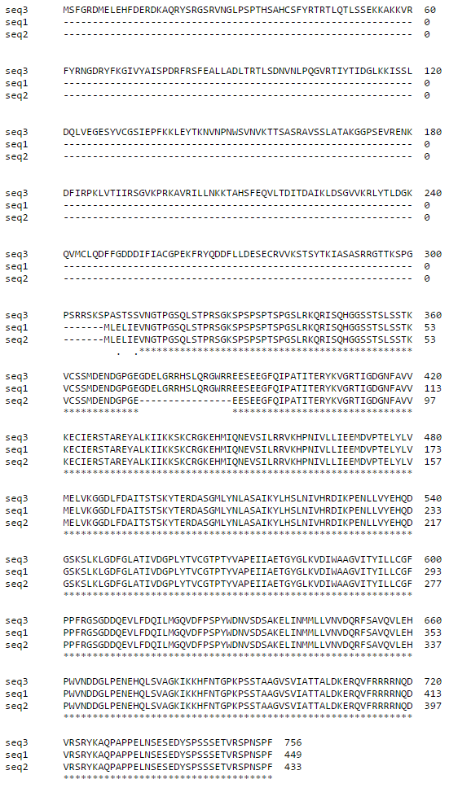
Download the alignment file and open in Notepad. Note the small gap in the middle sequence. Try deleting it. Note that it displaces the entire alignment and hence is difficult to do manually. Something that we can do manually is to remove the ends when there is no alignment. Remove the long amino terminus end of the third sequence so that all three sequences start at the same place. Notice that even this puts some of the alignment off.
