Lab Manual



Course: BI-402

Bioinformatics Software Development

Term: Fall 2020, Class: BSBI-2017

Submitted By:

TALHA NAEEM 2017-BI-005

(Name) (Roll. No.)

Submitted To:

**Ms. Mehwish Mehmood**

**Department Of Bioinformatics**

**Sir Syed University Of Engineering and Technology**

**University Road Karachi - 75300**

<http://www.ssuet.edu.pk>

Table of content

|  |  |  |  |  |
| --- | --- | --- | --- | --- |
| S.no | Lab No | Task | Sig. | Remarks |
| 1 | 1 | **Creating Gantt Chart & PERT Chart Using MS Project** |  |  |
|  |  |  |  |  |
|  |  |  |  |  |
|  |  |  |  |  |
|  |  |  |  |  |
|  |  |  |  |  |
|  |  |  |  |  |
|  |  |  |  |  |
|  |  |  |  |  |
|  |  |  |  |  |
|  |  |  |  |  |
|  |  |  |  |  |
|  |  |  |  |  |
|  |  |  |  |  |

**LAB 1**

**Creating Gantt Chart & PERT Chart Using MS Project**

**GANTT CHART**

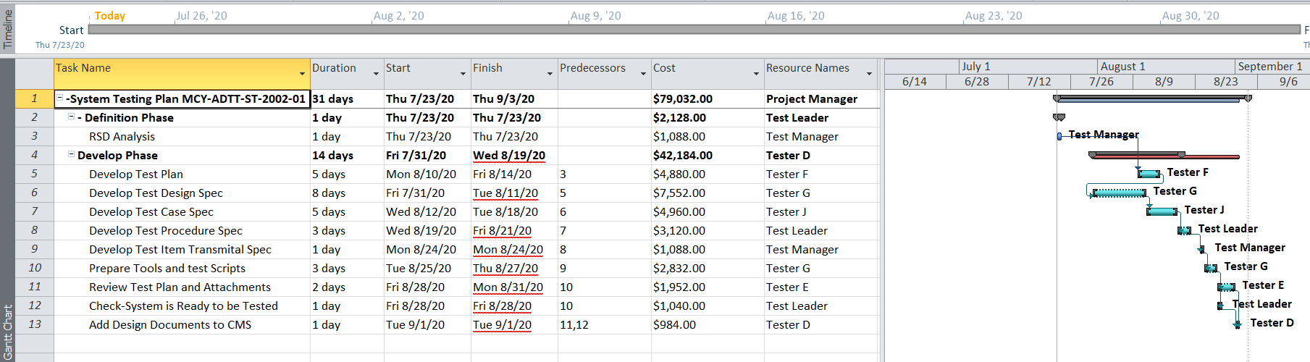

**RESOURCE SHEET**

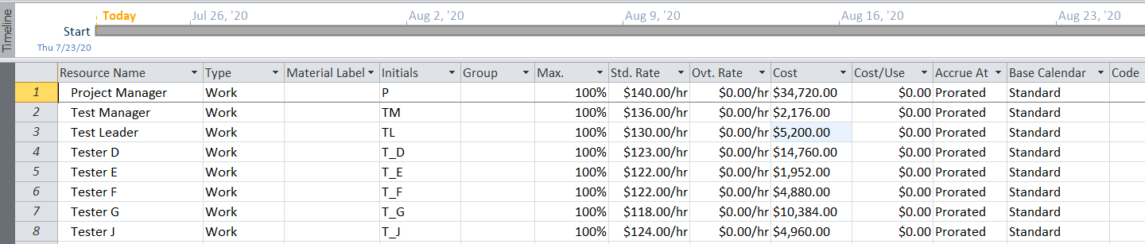

**NETWORK DIAGRAM**

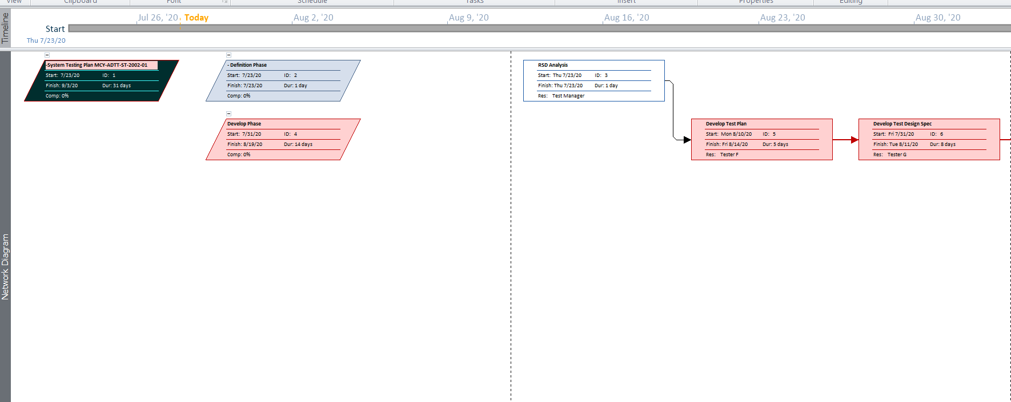

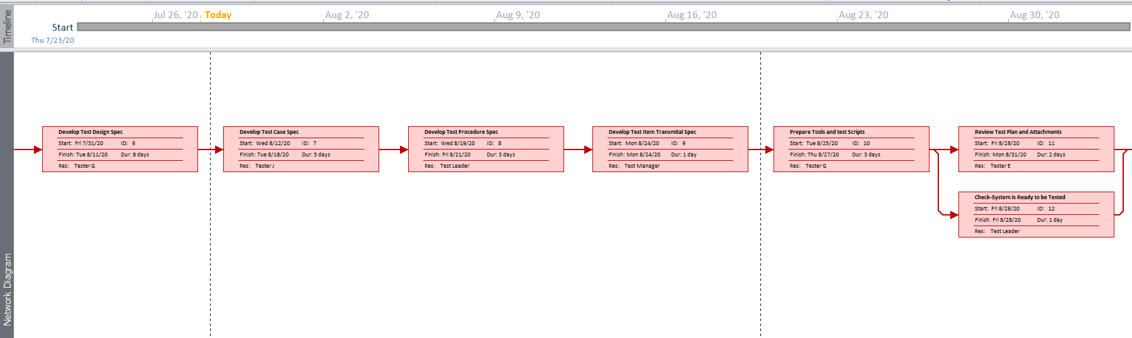

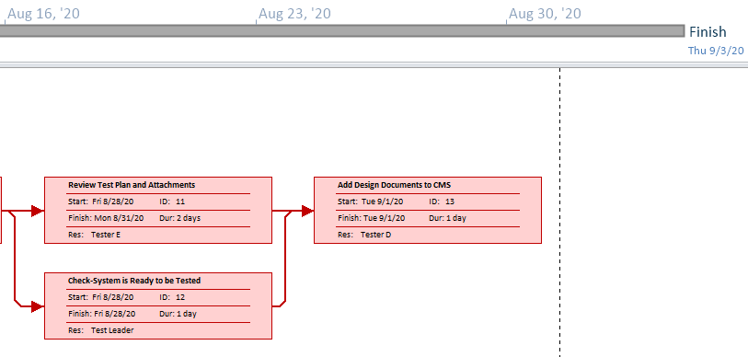

**TASK 1**

**FYP GANTT CHART**

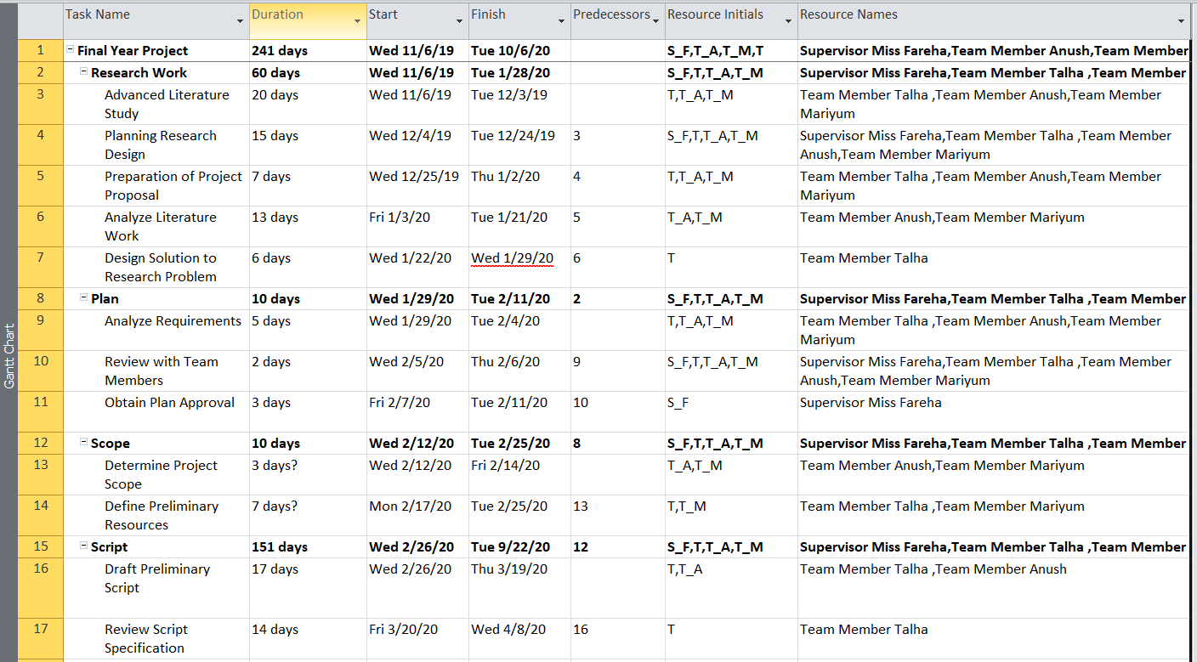

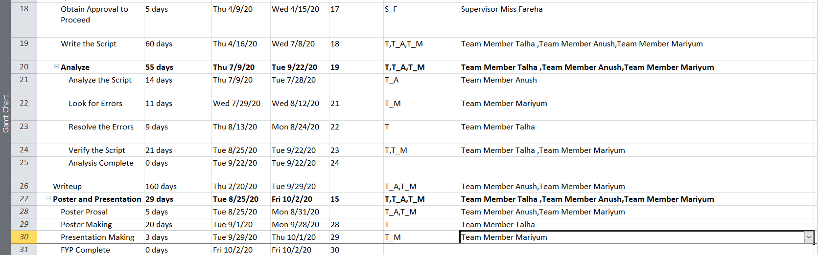

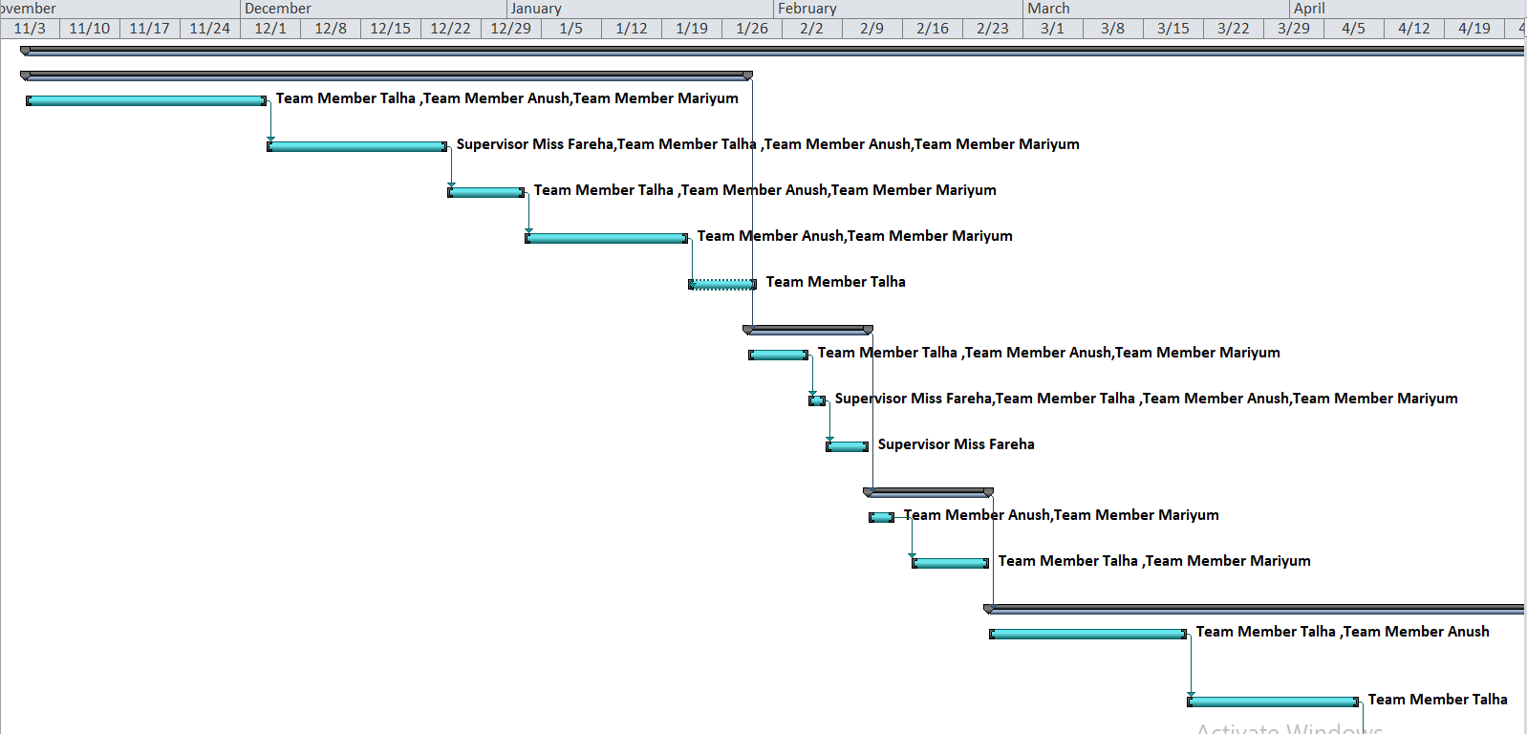

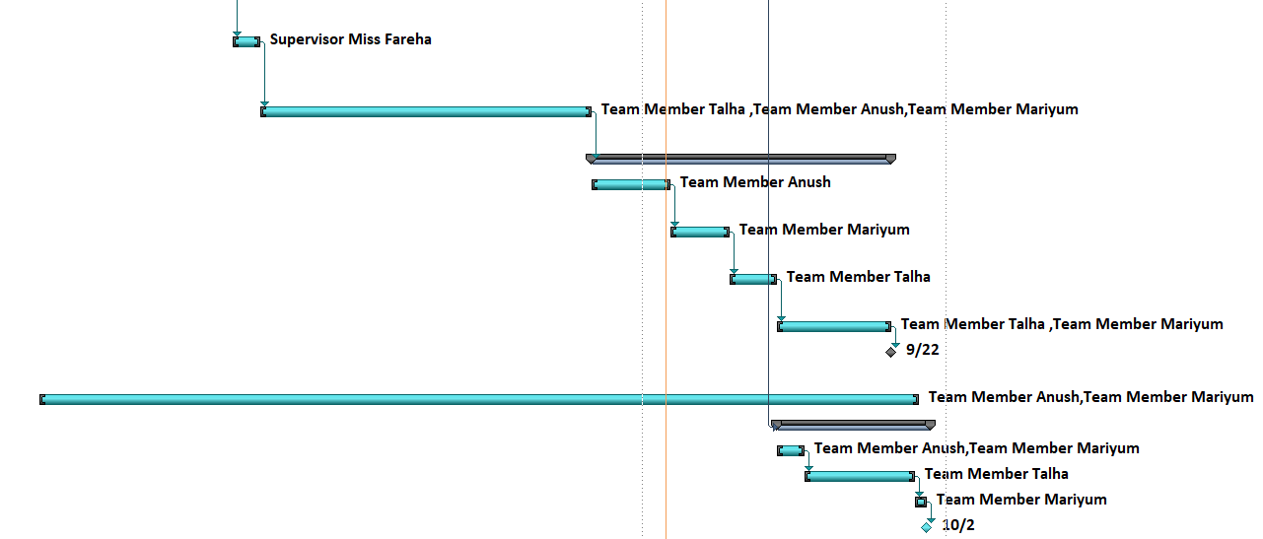

**FYP RESOURCE SHEET**

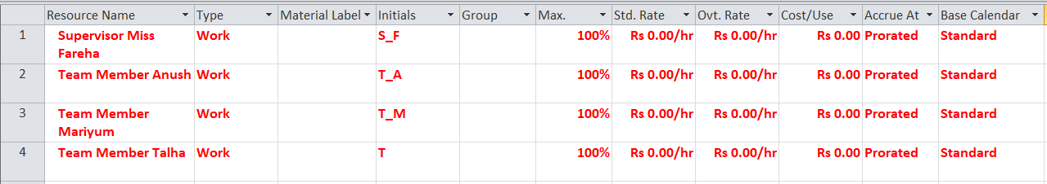

**FYP NETWORK DIAGRAM**

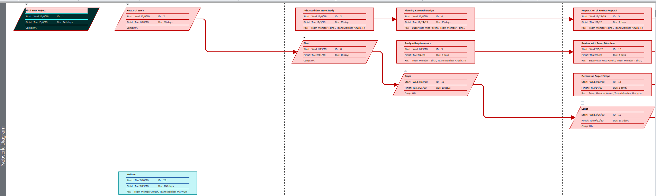

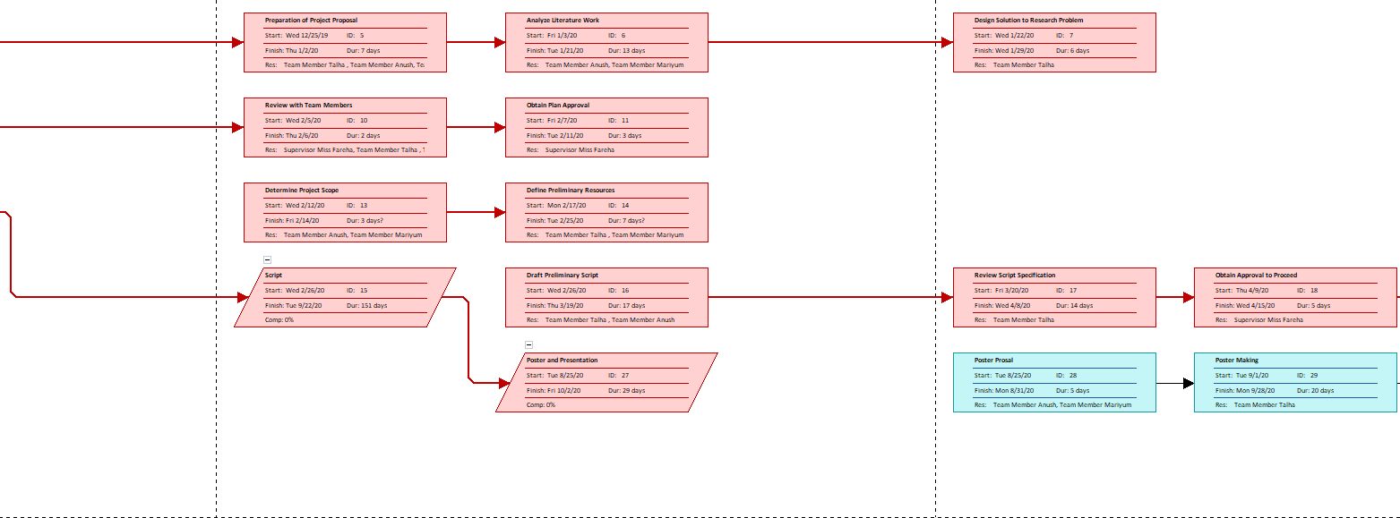

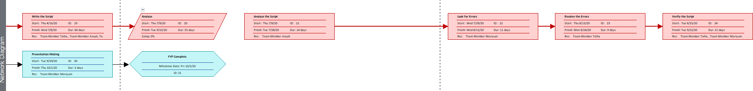

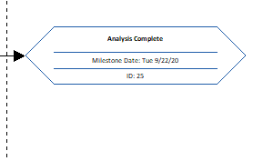

**TASK 2**

**HOSPITAL GANTT CHART**

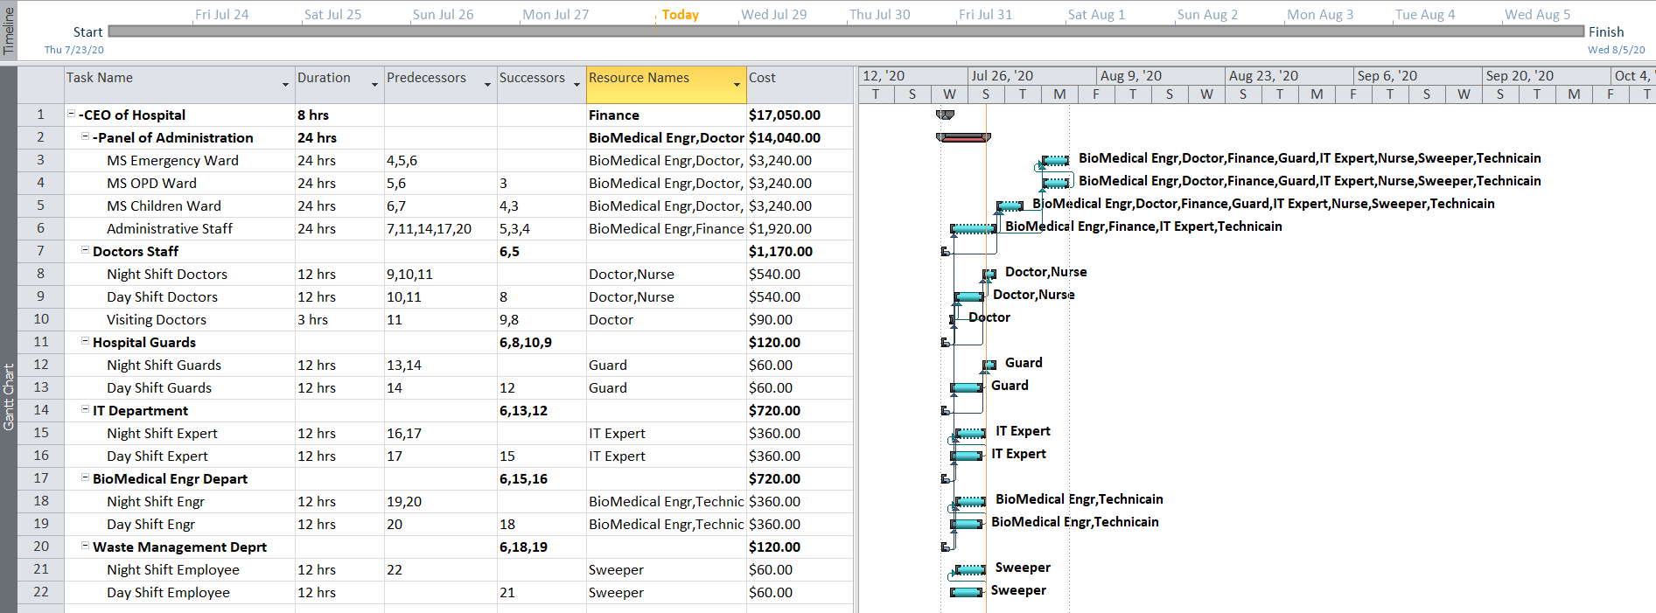

**HOSPITAL RESOURCE SHEET**

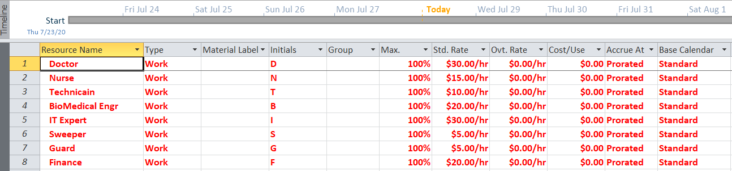

**HOSPITAL NETWORK DIAGRAM**

