**LAB 2**

**Python Programming 2**

1. Write a Python script that uses a dictionary to store information about a person you know. Store their first name, last name, age, and the city in which they live. You should have keys such as first_name, last_name, age, and city. Print each piece of information stored in your dictionary.

**(a)**

**SOURCE CODE:**

dict={'FName':'Kaif', 'Lname':'Naeem','Age':'7','City':'RYK'}

for i in  dict:

    print((i),dict[i])

**OUTPUT:**

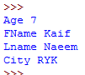

**(b)**

**SOURCE CODE:**

dict={'FName':['Talha','Kaif','Asif','Raza'],'LName':['Naeem','Naeem','Ali','Khan'],  
      'Age':[24,7,22,10],'City':['Karachi','RYK','Karachi','Lahore']}  
for key,value in dict.items():  
    print('Key: ',key)  
    print('Value: ',value)

**OUTPUT:**

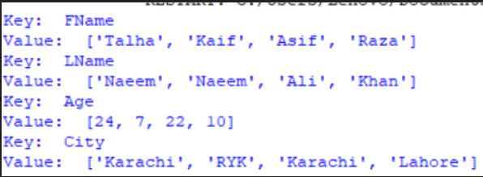

1. A buffet-style restaurant offers only five basic foods. Think of five simple foods, and store them in a tuple.

* Use a for loop to print each food the restaurant offers.
* Try to modify one of the items, and make sure that Python rejects the change.

**SOURCE CODE:**

resurt=('AfghaniRice','MuttonKarahi','BeefKarahi','Kabab','Chappli')

for i in resurt:

print(i)

resurt[0]= 'Pulao'

for i in resurt:

print(resurt)

**OUTPUT:**

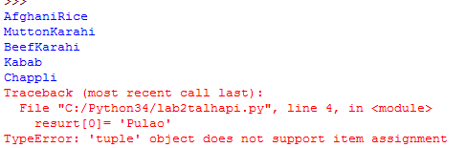

1. If you could invite anyone, living or deceased, to dinner, who would you invite? Make a list that includes at least three people you’d like to invite to dinner. Then use your list to print a message to each person, inviting them to dinner.

**SOURCE CODE:**

ft=['Kaif','Asif','Raza']

for i in ft:

print(i,'I you’d like to invite to dinner.')

**OUTPUT:**

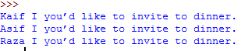

1. **Changing Guest List:** You just heard that one of your guests can’t make the dinner, so you need to send out a new set of invitations. You’ll have to think of someone else to invite.

* Modify your list, replacing the name of the guest who can’t make it with the name of the new person you are inviting.
* Print a second set of invitation messages, one for each person who is still in your list.

**SOURCE CODE:**

ft=['Kaif','Asif','Raza']  
print(ft)  
for i in ft:  
    print(i,'I you’d like to invite to dinner.')  
print('You just heard that one of your guests can’t make the dinner')  
ft[2]= 'Nawab'  
print(ft)  
for j in ft:  
    print(j,'I you’d like to invite to dinner.')

**OUTPUT:**

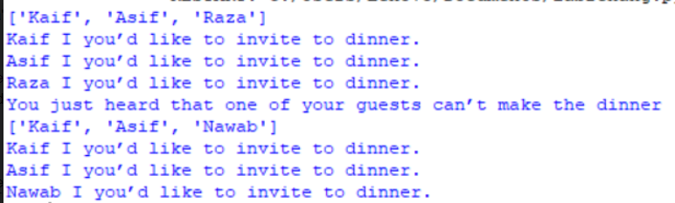

1. Write the following 2 functions: **def ComputeOddSum(num): defComputeEvenSum(num:**

The function **ComputeOddSum** find the sum of all odd numbers less than num. The function **ComputeEvenSum** find the sum of all even numbers less than num.

**SOURCE CODE:**

ft=[1,2,3,4,5,6,7,8,9]

print(ft)

def oddsum(n):

return n * (n + 0)

n=4

print("sum of first", n,"odd number is: ",oddsum(n))

def evensum(n):

return n * (n + 1)

n=4

print("sum of first", n,"even number is: ",evensum(n))

**OUTPUT:**

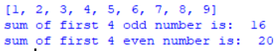

1. Write a recursive function to get sum of all number from 1 up to give number. Example N = 5 Result must be sum (1+2+3+4+5) =15.

**SOURCE CODE:**

def recu(n):

sum=0

while(n>0):

sum=sum+(n%10)

n=int(n/10)

return(sum)

n=752

print('Sum is: ',recu(n))

**OUTPUT:**

