**LAB 1**

**Exercise 1:** Write a program that needs to ask the user for her or his email address in the format *firstnam*[*e.lastname@bahria.edu.pk*](mailto:lastname@bahria.edu.pk)OR *firstname*[*.lastname@gmail.com*](mailto:lastname@gmail.com). The application takes as input this email address, parses the email and replies to the user with first name, last name and host name.

**SOURCE CODE:**

email = "khalid.amin@ssuet.edu.pk"

FName = email[0:6]

print(FName)

LName = email[7:11]

print(LName)

FName = email[11:]

print(HName)

**OUTPUT:**

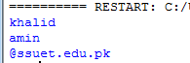

**Exercise 2:** Write a program that calculates the user’s body mass index (BMI) and categorizes it asunderweight, normal, overweight, or obese, based on the table from the United States Centers for Disease Control.

**SOURCE CODE:**

mass = int(input('Enter your weight in whole pounds: '))

height = int(input('Enter your height in whole pounds: '))

BMI = (mass/(height**2)) * 703

print("You have a BMI of",BMI,'and your weight status is')

if BMI <=18.5:

print("Underweight")

elif BMI >=18.5 and BMI<=24.9:

print("Normal")

elif BMI >=20.5 and BMI<=29.9:

print("Overweight")

elif BMI >=30.0:

print("Obese")

**OUTPUT:**

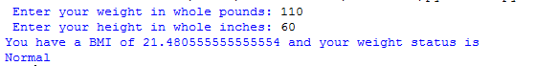

**Exercise 3:** Write a program to compute quotient and remainder of a number without using division ('/')

operator and modulo ('%') operator.

**SOURCE CODE:**

num=int(input('Enter numerator: '))

deno=int(input('Enter dumenator: '))

i=0

while num>=deno:

num-=deno

i=i+1

print("Quotient: ",i)

print("Remainder: ",num)

**OUTPUT:**

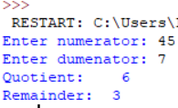

**Exercise 4:** Blood types are important for blood transfusion. The blood types must be matched since if not matched properly, the recipient’s blood can form clots and these can lead to heart attacks, embolisms and strokes.

**SOURCE CODE:**

ai = 'y'

while ai == 'y':

blood = input("Enter Blood Type: ")

if blood == 'O-':

print("it can Receive: O- ")

print("it can donate to: O-,O+,A-,A+,B-,B+,AB-,AB+ ")

elif blood == 'O+':

print("it can Receive: O-,O+ ")

print("it can donate to: O+,A-,A+,B-,B+,AB-,AB+ ")

elif blood == 'A-':

print("it can Receive: O-,A- ")

print("it can donate to: A-,A+,B-,B+,AB-,AB+ ")

elif blood == 'A+':

print("it can Receive: O-,O+,A-,A+ ")

print("it can donate to: A+,B-,B+,AB-,AB+ ")

elif blood == 'B-':

print("it can Receive: O-,B- ")

print("it can donate to: B-,B+,AB-,AB+ ")

elif blood == 'B+':

print("it can Receive: O-,O+,B-,B+ ")

print("it can donate to: B+,AB-,AB+ ")

elif blood == 'AB-':

print("it can Receive: O-,A-,B-,AB- ")

print("it can donate to: O+,A+,B+,AB+ ")

elif blood == 'AB+':

print("it can Receive: O-,O+,A-,A+,B-,B+,AB-,AB+ ")

print("it can donate to: A+,B-,B+,AB-,AB+ ")

else:

print("it cannot be donate")

ft = input("Do you want another blood y/n?")

if ft == 'n':

print(exit())

**OUTPUT:**

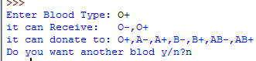

**Exercise 5:** Write a program to take an array and find the number of occurrences each number had.

**SOURCE CODE:**

arr = [10,19,5,1,7,14,0,7,5]

for i in range (9):

print(arr[i])

for j in arr:

print('*',end=' ')

print(collections.Counter(arr[0]))

**OUTPUT:**



**Exercise 6:** Given the following array, display its data graphically by plotting each numeric value as a bar of asterisks (**\***) as shown in the diagram.

**SOURCE CODE:**

arr = [10,19,5,1,7,14,0,7,5]

for i in range (8):

a=''

for j in range(arr[i]):

a=a+'*'

print(arr[i], a)

**OUTPUT:**

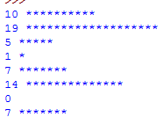

**Exercise 7:** Design then implement a Python program that will produce its transpose and print it along with the original one.

**SOURCE CODE:**

A =([2,0,4,2,6,3],

[9,9,1,0,4,1],

[7,1,2,3,7,4],

[2,2,2,7,1,6],

[1,5,8,7,4,1])

print(A)

result =[[A[j][i] for j in range(len(A))] for i in range(len(A[0]))]

for r in result:

print(r)

**OUTPUT:**

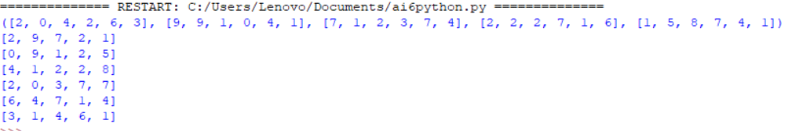

**Exercise 8(a):** Write a script that take user input for a number then adds 3 to that number.Then multiplies the result by 2, subtract 4, then again adds 3, then print the result.

**SOURCE CODE:**

a=int(input('Enter Value '))

b=a+3

c=b*2

d=c-4

e=d+3

print(b)

print(c)

print(d)

print('Answer ',e)

**OUTPUT:**

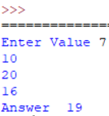

**(b)** Write a script that takes input as radius then calculate area of circle. (hint: A= πr²).

**SOURCE CODE:**

r=int(input(' Enter a Radius '))

b=3.14

A = b*(r**2)

print(b)

print("Radius of a Circle ",A)

**OUTPUT:**

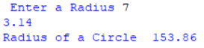

**(c)** Write a Python script that asks users for their favourite color. Create the following output (assuming blue is the chosen color) (hint: use ‘+’ and ‘*’)

**SOURCE CODE:**

print('Green'*10)

print('Green'+" "+'Green')

print('Green'*10)

**OUTPUT:**

