Lab Manual



Course: BI-402

Bioinformatics Software Development

Term: Fall 2020, Class: BSBI-2017

Submitted By:

TALHA NAEEM 2017-BI-005

(Name) (Roll. No.)

Submitted To:

**Ms. Mehwish Mehmood**

**Department Of Bioinformatics**

**Sir Syed University Of Engineering and Technology**

**University Road Karachi - 75300**

<http://www.ssuet.edu.pk>

Table of content

|  |  |  |  |  |
| --- | --- | --- | --- | --- |
| S.no | Lab No | Task | Sig. | Remarks |
| 1 | 1 | **Creating Gantt Chart & PERT Chart Using MS Project** |  |  |
| 2 | 2 | **Introduction to UML (Unified Modeling Language) Diagram and Modeling use case diagram using visual paradigm** |  |  |
| 3 | 3 | **Creating Sequence Diagram using Visual Paradigm Software** |  |  |
| 4 | 4 | **Web Development Framework Using**  **“Dreamweaver CS 5”** |  |  |
| 5 | 5 | **Introduction to CSS** |  |  |
| 6 | 6 | **More About CSS and Designing a Website** |  |  |
| 7 | 7 | **Introduction of Java Script and Form Validation with Java Script** |  |  |
| 8 | 8 | **Introduction of Server Side Scripting** |  |  |
| 9 | 9 | **Server Site Scripting on MY SQL and Database (Authentication)** |  |  |
| **10** | **10** | **Web Development – View Record** |  |  |
| 11 | 11 | **Web Development – Edit Record** |  |  |
|  |  |  |  |  |

**LAB 11**

**Web Development – Edit Record**

**VIEW SOURCE CODE**

<?php

include("coni.php");

?>

<!doctype html>

<html>

<head>

<meta charset="utf-8">

<title>Untitled Document</title>

</head>

<body>

<center style="color: green;">

<?php

if(isset($_GET['success'])){

$success = $_GET['success'];

echo $success;

}

?>

</center>

<table border="1" cellpadding="5" align="center">

<caption><h3>View All Employee Records</h3></caption>

<tr style="background-color: yellow;">

<th>S.No</th>

<th>Employee Id</th>

<th>Employee Name</th>

<th>Father Name</th>

<th>Designation</th>

<th>Salary</th>

<th>Organization</th>

<th>Delete</th>

<th>Update</th>

</tr>

<?php

$query = "SELECT * FROM employee";

$result = mysqli_query($con, $query);

$i=0;

while($row = mysqli_fetch_array($result))

{

$id = ++$i;

$emp = $row['emp_id'];

$name = $row['emp_name'];

$fname = $row['father_name'];

$designation = $row['emp_designation'];

$salary = $row['emp_salary'];

$organization = $row['emp_organization'];

echo '<tr> ';

echo '<td>'. $id.'</td>';

echo '<td>'. $emp.'</td>';

echo '<td>'. $name.'</td>';

echo '<td>'. $fname.'</td>';

echo '<td>'. $designation.'</td>';

echo '<td>'. $salary.'</td>';

echo '<td>'. $organization.'</td>';

echo '<td><a href="#">'. "Delete".'</td>';

echo '<td>'.'<a href= "update.php">'."Update".'</td>';

} ?>

</table>

</body>

</html>

**UPDATE SOURCE CODE**

<!doctype html>

<?php

include("coni.php");

session_start();

if(isset($_POST['submit']))

{

$emp=$_POST['emp_id'];

$name=$_POST['emp_name'];

$fname=$_POST['father_name'];

$designation=$_POST['emp_designation'];

$salary=$_POST['emp_salary'];

$organization=$_POST['emp_organization'];

$query="UPDATE employee SET emp_name='$name',father_name = '$fname',emp_designation='$designation',

emp_salary='$salary',emp_organization= '$organization' where emp_id = '$emp' ";

$result=mysqli_query($con,$query);

if($result){

echo "<script>window.open('viewemp.php?success=A record has updated successfully','_self')</script>";

}

else

{

echo "Operation Failure please re-attempt";

}}

?>

**EMPLOYEE TABLE**

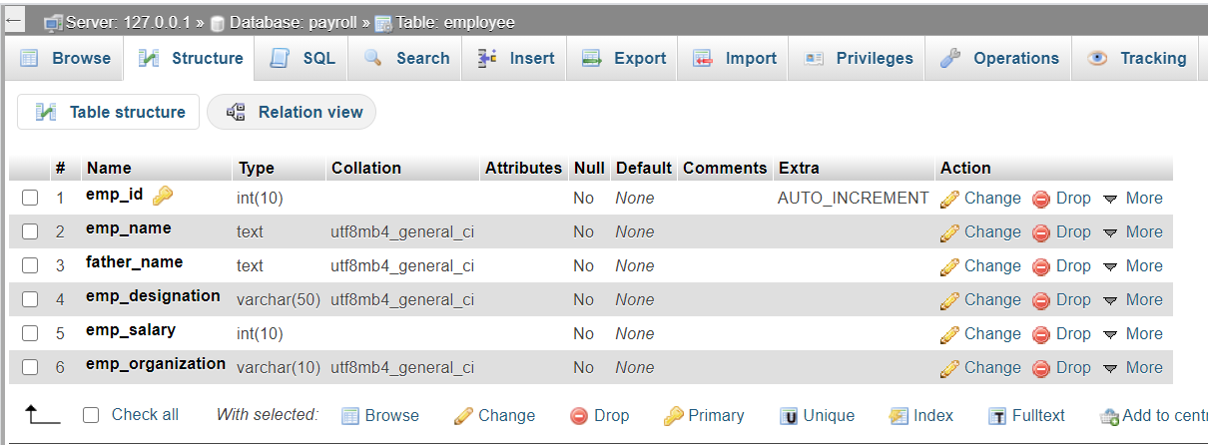

**EMPLOYEE TABLE VALUES**

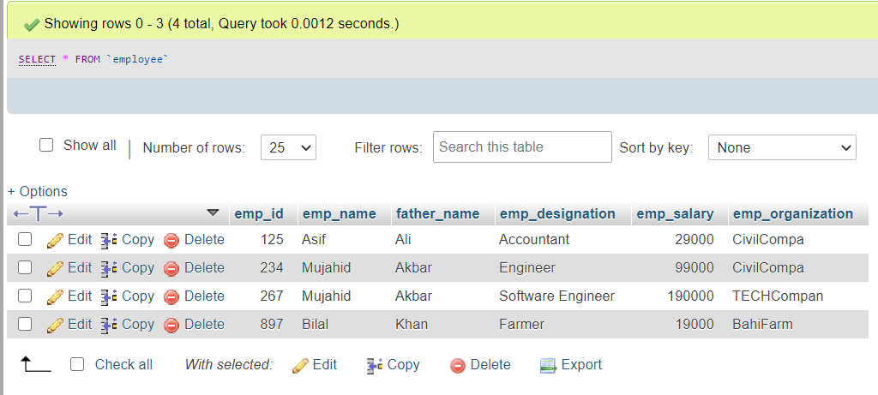

**EMPLOYEE RECORDS IN PHP BROWSER**

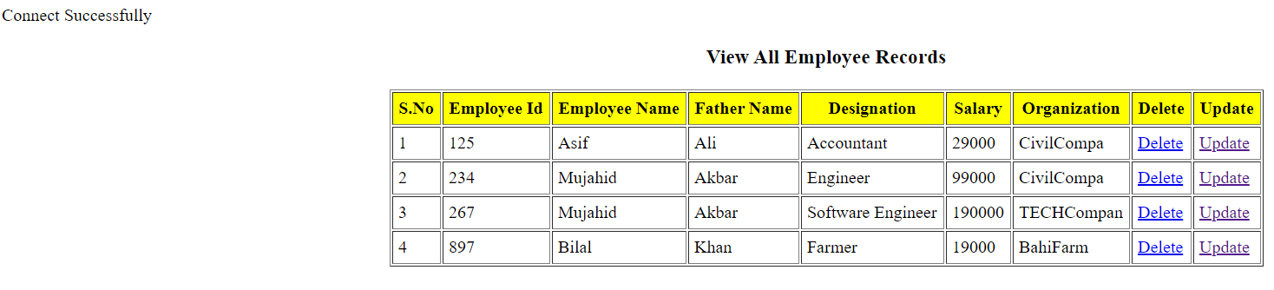

**UPDATE EMPLOYEE ID QUERY**

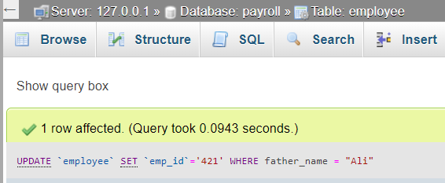

**OUTPUT UPDATE EMPLOYEE ID**

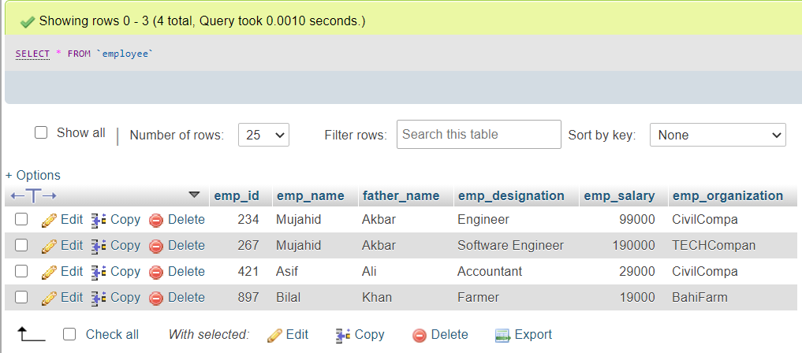

**OUTPUT UPDATE EMPLOYEE ID IN PHP BROWSER**

