Lab Manual



Course: BI-402

Bioinformatics Software Development

Term: Fall 2020, Class: BSBI-2017

Submitted By:

TALHA NAEEM 2017-BI-005

(Name) (Roll. No.)

Submitted To:

**Ms. Mehwish Mehmood**

**Department Of Bioinformatics**

**Sir Syed University Of Engineering and Technology**

**University Road Karachi - 75300**

<http://www.ssuet.edu.pk>

Table of content

|  |  |  |  |  |
| --- | --- | --- | --- | --- |
| S.no | Lab No | Task | Sig. | Remarks |
| 1 | 1 | **Creating Gantt Chart & PERT Chart Using MS Project** |  |  |
| 2 | 2 | **Introduction to UML (Unified Modeling Language) Diagram and Modeling use case diagram using visual paradigm** |  |  |
| 3 | 3 | **Creating Sequence Diagram using Visual Paradigm Software** |  |  |
| 4 | 4 | **Web Development Framework Using**  **“Dreamweaver CS 5”** |  |  |
| 5 | 5 | **Introduction to CSS** |  |  |
| 6 | 6 | **More About CSS and Designing a Website** |  |  |
| 7 | 7 | **Introduction of Java Script and Form Validation with Java Script** |  |  |
| 8 | 8 | **Introduction of Server Side Scripting** |  |  |
| 9 | 9 | **Server Site Scripting on MY SQL and Database (Authentication)** |  |  |
| **10** | **10** | **Web Development – View Record** |  |  |
| 11 | 11 | **Web Development – Edit Record** |  |  |
| 12 | 12 | **Web Development – Insert & Delete Record** |  |  |

**LAB 12**

**Web Development – Insert & Delete Record**

**Registration SOURCE CODE**

<!doctype html>

<html lang="en">

<head>

<meta charset="utf-8">

<title>Update Employee Records</title>

</head>

<body>

<div>

<form method="post" action="insert.php">

<table width="300" border="0" align="center" cellpadding="5">

<tr>

<th bgcolor="yellow" colspan="2">Employee Registration Form</th>

</tr>

<tr bgcolor="lightgray">

<td align="right">Employee ID</td>

<td><input type="text" name="EmpID" required value=""</td><tr bgcolor="lightgray">

<td align="right">Employee Name</td>

<td><input type="text" name="EName" required value=""</td><tr bgcolor="lightgray">

<td align="right">Father Name</td>

<td><input type="text" name="FName" required value=""</td><tr bgcolor="lightgray">

<td align="right">Designation</td>

<td><input type="text" name="EDesig" required value=""</td><tr bgcolor="lightgray">

<td align="right">Salary</td>

<td><input type="text" name="ESalary" required value=""</td><tr bgcolor="lightgray">

<td align="right">Organization</td>

<td><input type="text" name="EOrg" required value=""</td><tr bgcolor="lightgray"><tr><tr>

<td align="right"></td>

<td><input type="submit" name="submit" value="Submit"></td>

</tr>

</table>

</form>

</div>

</body>

</html>

**OUTPUT**

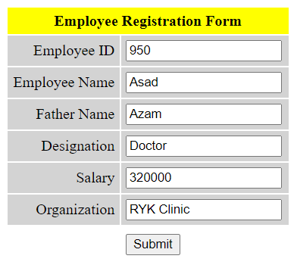

**INSERT SOURCE CODE**

<?php

session_start();

$con = mysqli_connect("localhost", "root", "", "payroll");

if(!$con){

die("Database connection has failed" . mysqli_error());

}

else

{$id = $_POST['EmpID'];

$name = $_POST['EName'];

$fname = $_POST['FName'];

$designation = $_POST['EDesig'];

$salary = $_POST['ESalary'];

$organization = $_POST['EOrg'];

$sql="INSERT INTO employee (emp_id,emp_name,father_name,emp_designation,emp_salary,emp_organization) VALUES ( 'Sid','$name', '$fname', '$designation', '$salary','$organization'); ";

$result=mysqli_query($con,$sql);

if($result)

{

echo "You have successfully insert record";

}

else

{

echo "Operation Failure please re-attempt";

}

}

**OUTPUT**

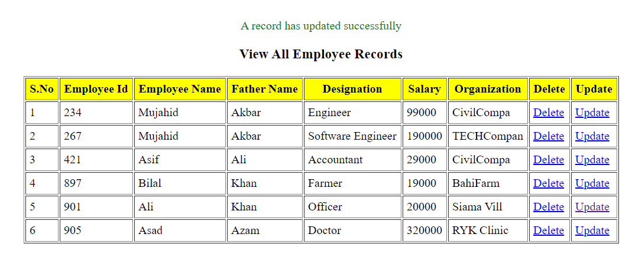

**DELETE SOURCE CODE**

<?php

session_start();

$con = mysqli_connect("localhost", "root", "", "payroll");

if(!$con){

die("Database connection has failed" . mysqli_error());

}

else

{

$eid = $_GET['empid'];

$sql="DELETE from employee where emp_id='$eid'";

$result=mysqli_query($con,$sql);

if($result)

{

echo "You have successfully delete record";

}

else

{

echo "Operation Failure please re-attempt";

}

}

**OUTPUT**

