Lab Manual



Course: BI-402

Bioinformatics Software Development

Term: Fall 2020, Class: BSBI-2017

Submitted By:

SYEDA ANUSH FATIMA 2017-BI-004

(Name) (Roll. No.)

Submitted To:

**Ms. Mehwish Mehmood**

**Department Of Bioinformatics**

**Sir Syed University Of Engineering and Technology**

**University Road Karachi - 75300**

<http://www.ssuet.edu.pk>

Table of content

|  |  |  |  |  |
| --- | --- | --- | --- | --- |
| S.no | Lab No | Task | Sig. | Remarks |
| 1 | 1 | **Creating Gantt Chart & PERT Chart Using MS Project** |  |  |
| 2 | 2 | **Introduction to UML (Unified Modeling Language) Diagram and Modeling use case diagram using visual paradigm** |  |  |
| 3 | 3 | **Creating Sequence Diagram using Visual Paradigm Software** |  |  |
| 4 | 4 | **Web Development Framework Using**  **“Dreamweaver CS 5”** |  |  |
| 5 | 5 | **Introduction to CSS** |  |  |
| 6 | 6 | **More About CSS and Designing a Website** |  |  |
|  |  |  |  |  |
|  |  |  |  |  |
|  |  |  |  |  |
|  |  |  |  |  |
|  |  |  |  |  |
|  |  |  |  |  |

**Lab 6**

**More About CSS and Designing a Website**

**Exercise:**

1. Create website for online shopping system.

**SOURCE CODE**

<!doctype html>

<html>

<head>

<meta charset="utf-8">

<title>Untitled Document</title>

<link type="text/css" href="info.css" rel="stylesheet" />

<link rel="stylesheet" href="https://fontawesome.com/v4.7.0/icon/mobile">

<link href="https://fonts.googleapis.com/css2?family=Josefin+Sans:wght@500&display=swap" rel="stylesheet">

</head>

<body>

<div class="menu">

<h2>ETIHAD Electronics Shop</h2>

<ul>

<li><a href="inf.html">Contacts</a></li>

<li><a href="hom.html">Home Appliances</a></li>

<li><a href="gen.html">Generators</a></li>

<li><a href="mob.html">Mobiles</a></li>

<li><a href="cmp.html">Computers</a></li></li>

<br><br><br><br><br><br><br><br><br><br>

</ul>

</div>

<div class="ft">

<ul>

<h4>Trust. Quality. Relaibility</h4>

<h1>A Place where all brands available</h1>

<h4> “Genius is one percent inspiration and ninety-nine percent perspiration.” </h4> <br>

</ul>

</div>

<center><a href="#" class="mt">Terms & Conditions</a></center>

</body>

</html>

**EXTERNEL SHEET CODE**

.menu ul li{

width:200px;height: 30px;background-color:chartreuse;font-size: 20px;float: right;border:thick;text-transform: uppercase;list-style: none;padding: 7px;border: double;text-align:center;text-decoration: none;}

.mt{text-align:center;width:120px;height: 10px;padding: 7px;border: double;background-color:chartreuse;text-transform: uppercase;font-weight: 20px;text-decoration: none;

}

.mt:hover{color:aliceblue;float: right;

}

.menu h2{background-color:burlywood;text-align: center;margin-top: 2px;border: 3px solid #EB5151;padding: 7px;width: 407px;height: 30px;float: left;font-weight:20px;border: double;text-transform: uppercase;}

.ft h1,h4{font-size: 30px; font-weight: 30px; text-align:center;text-transform: uppercase; text-transform: uppercase;text-shadow: 3px 2px aliceblue}

.menu ul li:hover{ background-color:aliceblue; color: antiquewhite;float: right;

}

body{background-image: url("file:///C:/Users/Lenovo/Downloads/elctronic.PNG");background-repeat:no-repeat;background-size: cover;height: 2200}

**OUTPUT**

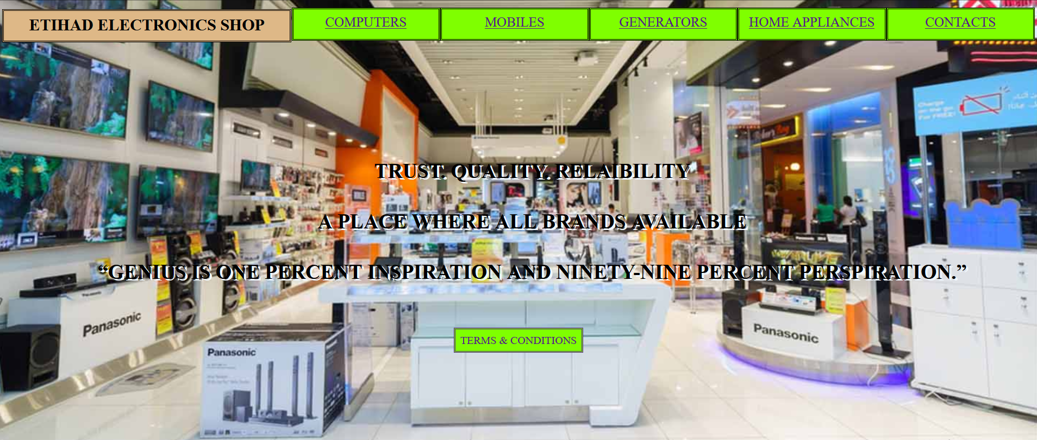

**COMPUTER PAGE CODE**

<!doctype html>

<html>

<head>

<meta charset="utf-8">

<title>Untitled Document</title>

</head>

<style>

body{background-color:lightseagreen}

h1{background-color:cadetblue;font-family: Cambria, "Hoefler Text", "Liberation Serif", Times, "Times New Roman", "serif"; text-align: center;text-transform:uppercase;border-color: chocolate;border: double;border-width:medium}

ul{

list-style: none;}

.menubar ul li{

background:#3AF846; font-size: 24px;float:right;text-align: center;border:thick;height: 40px; width: 200px;border:1px solid green;line-height: 40px;text-align: center;color:darkcyan;font-weight: 180px;font-family: Baskerville, "Palatino Linotype", Palatino, "Century Schoolbook L", "Times New Roman", "serif";text-transform: uppercase

}

.child1{

width:140px;font-size: 16px;

height:50px;padding: 2px;

background-color: deeppink;text-transform: uppercase;

position:absolute;text-align: center;margin: 1px;

left:0;

}

.child2{

width:140px;

height:50px;text-transform: uppercase;font-size: 16px;

background-color: red;text-align: center;

position: absolute;padding: 2px;margin: 1px;

right: 0

}

.child3{

width:120px;

height:50px;text-transform: uppercase;

background-color: royalblue;text-align: center;

position: absolute;padding: 2px;margin: 1px;font-size: 16px;

bottom: 0;

left:0

}

.child4{

width:140px;

height:50px;text-transform: uppercase;

background-color: royalblue;text-align: center;

position: absolute;padding: 2px;margin: 1px;

bottom: 0;font-size: 16px;

right:0

}

</style>

<body>

</div>

<div class="father">

<div class="child1">A Place where all brands are available</div>

<div class="child2">The Place of Quality</div>

<div class="child3">The Place of Trust</div>

<div class="child4">Customers Choice is our Choice</div>

</div><br><br>

<h1>PC and Laptops </h1>

<div class="menubar">

<ul>

<li>Toshiba</li>

<li>Lenovo</li>

<li>DELL</li>

<li>HP</li>

<li>Samsung</li>

<li>Mac</li>

</ul>

</div>

</body>

</html>

**OUTPUT**

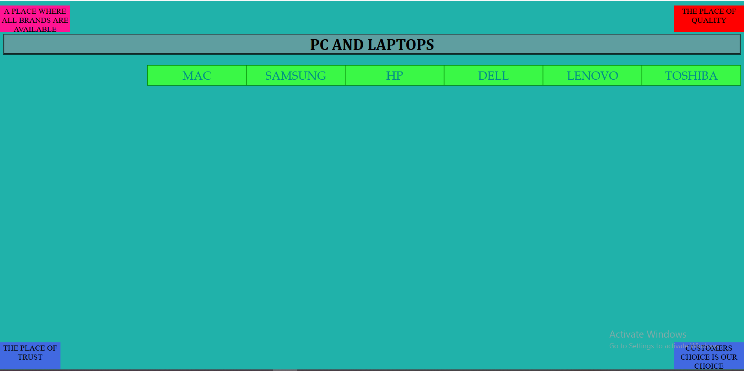

**MOBILES PAGE CODE**

<!doctype html>

<html>

<head>

<meta charset="utf-8">

<title>Untitled Document</title>

</head>

<style>

body{background-color:lightseagreen}

h1{background-color:cadetblue;font-family: Cambria, "Hoefler Text", "Liberation Serif", Times, "Times New Roman", "serif"; text-align: center;text-transform:uppercase;border-color: chocolate;border: double;border-width:medium}

ul{

list-style: none;}

.menubar ul li{

background:#3AF846; font-size: 24px;float:right;text-align: center;border:thick;height: 40px; width: 200px;border:1px solid green;line-height: 40px;text-align: center;color:darkcyan;font-weight: 180px;font-family: Baskerville, "Palatino Linotype", Palatino, "Century Schoolbook L", "Times New Roman", "serif";text-transform: uppercase

}

.child1{

width:140px;font-size: 16px;

height:50px;padding: 2px;

background-color: deeppink;text-transform: uppercase;

position:absolute;text-align: center;margin: 1px;

left:0;

}

.child2{

width:140px;

height:50px;text-transform: uppercase;font-size: 16px;

background-color: red;text-align: center;

position: absolute;padding: 2px;margin: 1px;

right: 0

}

.child3{

width:120px;

height:50px;text-transform: uppercase;

background-color: royalblue;text-align: center;

position: absolute;padding: 2px;margin: 1px;font-size: 16px;

bottom: 0;

left:0

}

.child4{

width:140px;

height:50px;text-transform: uppercase;

background-color: royalblue;text-align: center;

position: absolute;padding: 2px;margin: 1px;

bottom: 0;font-size: 16px;

right:0

}

</style>

<body>

</div>

<div class="father">

<div class="child1">A Place where all brands are available</div>

<div class="child2">The Place of Quality</div>

<div class="child3">The Place of Trust</div>

<div class="child4">Customers Choice is our Choice</div>

</div><br><br>

<h1>Mobiles And TABS</h1>

<div class="menubar">

<ul>

<li>Real me</li>

<li>Techno</li>

<li>Infinix</li>

<li>Xiaomi</li>

<li>OPPO</li>

<li>Samsung</li>

<li>IPhone</li>

</ul>

</div>

</body>

</html>

**OUTPUT**

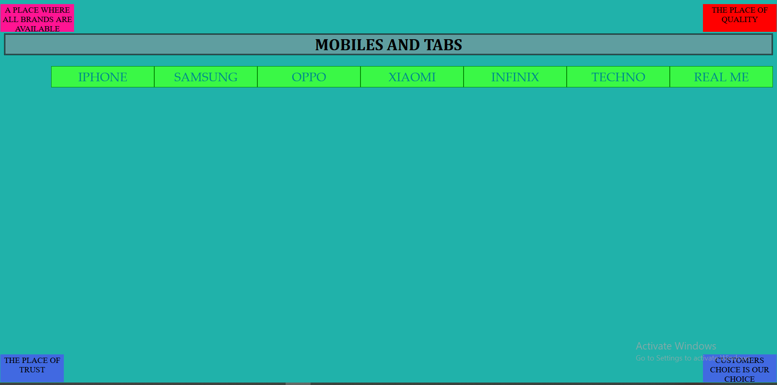

**GENERATORS PAGE CODE**

<!doctype html>

<html>

<head>

<meta charset="utf-8">

<title>Untitled Document</title>

</head>

<title>Untitled Document</title>

</head>

<style>

body{background-color:lightseagreen}

h1{background-color:cadetblue;font-family: Cambria, "Hoefler Text", "Liberation Serif", Times, "Times New Roman", "serif"; text-align: center;text-transform:uppercase;border-color: chocolate;border: double;border-width:medium}

ul{

list-style: none;}

.menubar ul li{

background:#3AF846; font-size: 24px;float:right;text-align: center;border:thick;height: 40px; width: 200px;border:1px solid green;line-height: 40px;text-align: center;color:darkcyan;font-weight: 180px;font-family: Baskerville, "Palatino Linotype", Palatino, "Century Schoolbook L", "Times New Roman", "serif";text-transform: uppercase

}

.child1{

width:140px;font-size: 16px;

height:50px;padding: 2px;

background-color: deeppink;text-transform: uppercase;

position:absolute;text-align: center;margin: 1px;

left:0;

}

.child2{

width:140px;

height:50px;text-transform: uppercase;font-size: 16px;

background-color: red;text-align: center;

position: absolute;padding: 2px;margin: 1px;

right: 0

}

.child3{

width:120px;

height:50px;text-transform: uppercase;

background-color: royalblue;text-align: center;

position: absolute;padding: 2px;margin: 1px;font-size: 16px;

bottom: 0;

left:0

}

.child4{

width:140px;

height:50px;text-transform: uppercase;

background-color: royalblue;text-align: center;

position: absolute;padding: 2px;margin: 1px;

bottom: 0;font-size: 16px;

right:0

}

</style>

<body>

</div>

<div class="father">

<div class="child1">A Place where all brands are available</div>

<div class="child2">The Place of Quality</div>

<div class="child3">The Place of Trust</div>

<div class="child4">Customers Choice is our Choice</div>

</div><br><br>s

<h1>Generators </h1>

<div class="menubar">

<ul>

<li>China Brands</li>

<li>Honda</li>

<li>Hyundai</li>

<li>Kawasaki</li>

<li>Yamaha</li>

</body>

</html>

**OUTPUT**

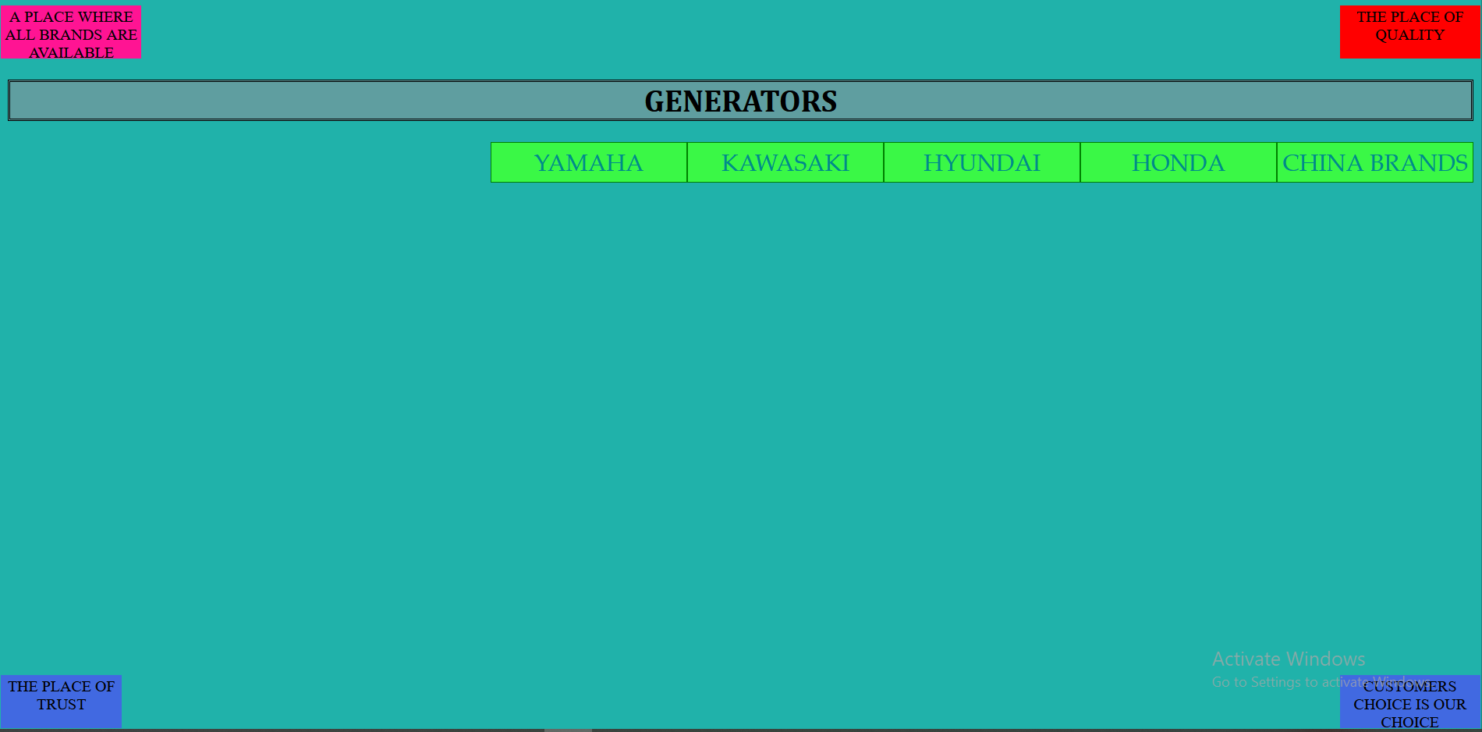

**HOME APPLIANCES PAGE CODE**

<!doctype html>

<html>

<head>

<meta charset="utf-8">

<title>Untitled Document</title>

</head>

<style>

body{background-color:lightseagreen}

h1{background-color:cadetblue;font-family: Cambria, "Hoefler Text", "Liberation Serif", Times, "Times New Roman", "serif"; text-align: center;text-transform:uppercase;border-color: chocolate;border: double;border-width:medium}

ul{

list-style: none;}

.menubar ul li{

background:#3AF846; font-size: 20px;float:right;text-align: center;border:thick;height: 40px; width: 280px;border:1px solid green;line-height: 40px;text-align: center;color:darkcyan;font-weight: 160px;font-family: Baskerville, "Palatino Linotype", Palatino, "Century Schoolbook L", "Times New Roman", "serif";text-transform: uppercase

}

.child1{

width:140px;font-size: 16px;

height:50px;padding: 2px;

background-color: deeppink;text-transform: uppercase;

position:absolute;text-align: center;margin: 1px;

left:0;

}

.child2{

width:140px;

height:50px;text-transform: uppercase;font-size: 16px;

background-color: red;text-align: center;

position: absolute;padding: 2px;margin: 1px;

right: 0

}

.child3{

width:120px;

height:50px;text-transform: uppercase;

background-color: royalblue;text-align: center;

position: absolute;padding: 2px;margin: 1px;font-size: 16px;

bottom: 0;

left:0

}

.child4{

width:140px;

height:50px;text-transform: uppercase;

background-color: royalblue;text-align: center;

position: absolute;padding: 2px;margin: 1px;

bottom: 0;font-size: 16px;

right:0

}

</style>

<body>

</div>

<div class="father">

<div class="child1">A Place where all brands are available</div>

<div class="child2">The Place of Quality</div>

<div class="child3">The Place of Trust</div>

<div class="child4">Customers Choice is our Choice</div>

</div><br><br>

<h1>Home appliances </h1>

<div class="menubar">

<ul>

<li>Fans</li>

<li>Decoration Items</li>

<li>TV</li>

<li>Microovens</li>

<li>Geasers</li>

<li>Heaters</li>

<li>Irons</li>

<li>Washing Machines</li>

<li>AC & Air Coolers</li>

<li>Refrigenerators</li>

</ul>

</div>

</body>

</html>

**OUTPUT**

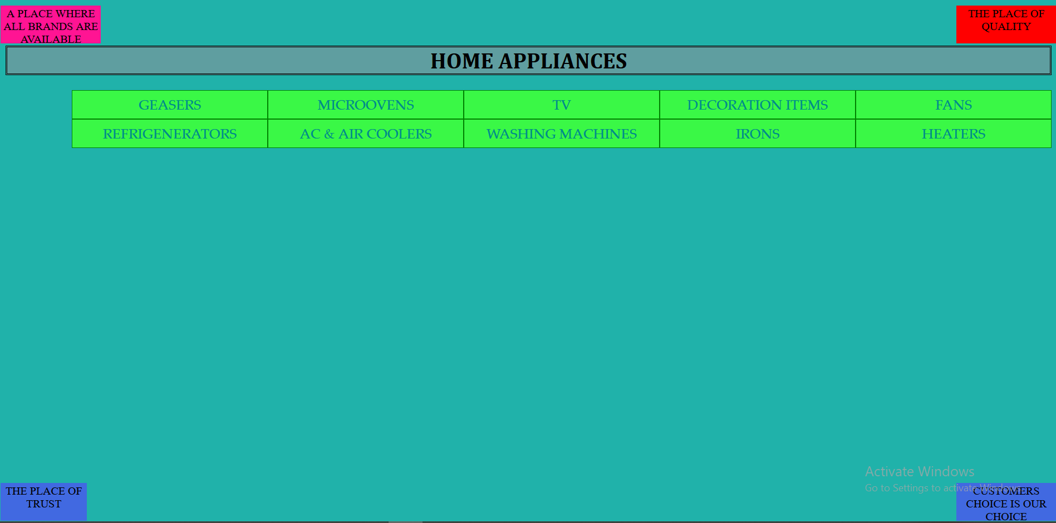

**INFORMATION PAGE CODE**

<!doctype html>

<html>

<head>

<meta charset="utf-8">

<title>Untitled Document</title>

</head>

<style>

body{background-color:lightseagreen}

h1{background-color:cadetblue;font-family: Cambria, "Hoefler Text", "Liberation Serif", Times, "Times New Roman", "serif"; text-align: center;text-transform:uppercase;border-color: chocolate;border: double;border-width:medium}

ul{

list-style: none;}

.menubar ul li{

background:#3AF846; font-size: 24px;float:right;text-align: center;border:thick;height: 40px; width: 220px;border:1px solid green;line-height: 40px;font-size: right;text-align: center;color:darkcyan;font-weight: 200px;font-family: Baskerville, "Palatino Linotype", Palatino, "Century Schoolbook L", "Times New Roman", "serif"

}

.child1{

width:140px;font-size: 16px;

height:50px;padding: 2px;

background-color: deeppink;text-transform: uppercase;

position:absolute;text-align: center;margin: 1px;

left:0;

}

.child2{

width:140px;

height:50px;text-transform: uppercase;font-size: 16px;

background-color: red;text-align: center;

position: absolute;padding: 2px;margin: 1px;

right: 0

}

.child3{

width:120px;

height:50px;text-transform: uppercase;

background-color: royalblue;text-align: center;

position: absolute;padding: 2px;margin: 1px;font-size: 16px;

bottom: 0;

left:0

}

.child4{

width:140px;

height:50px;text-transform: uppercase;

background-color: royalblue;text-align: center;

position: absolute;padding: 2px;margin: 1px;

bottom: 0;font-size: 16px;

right:0

}

</style>

<body>

</div>

<div class="father">

<div class="child1">A Place where all brands are available</div>

<div class="child2">The Place of Quality</div>

<div class="child3">The Place of Trust</div>

<div class="child4">Customers Choice is our Choice</div>

</div><br><br>

<h1>Information</h1>

<div class="menubar">

<ul>

<li>Company Address</li>

<li>Fax</li>

<li>Telephone Number</li>

<li>Email</li>

</ul>

</body>

</html>

**OUTPUT**

