Lab Manual



Course: BI-402

Bioinformatics Software Development

Term: Fall 2020, Class: BSBI-2017

Submitted By:

TALHA NAEEM 2017-BI-004

(Name) (Roll. No.)

Submitted To:

**Ms. Mehwish Mehmood**

**Department Of Bioinformatics**

**Sir Syed University Of Engineering and Technology**

**University Road Karachi - 75300**

<http://www.ssuet.edu.pk>

Table of content

|  |  |  |  |  |
| --- | --- | --- | --- | --- |
| S.no | Lab No | Task | Sig. | Remarks |
| 1 | 1 | **Creating Gantt Chart & PERT Chart Using MS Project** |  |  |
| 2 | 2 | **Introduction to UML (Unified Modeling Language) Diagram and Modeling use case diagram using visual paradigm** |  |  |
| 3 | 3 | **Creating Sequence Diagram using Visual Paradigm Software** |  |  |
| 4 | 4 | **Web Development Framework Using**  **“Dreamweaver CS 5”** |  |  |
| 5 | 5 | **Introduction to CSS** |  |  |
| 6 | 6 | **More About CSS and Designing a Website** |  |  |
| 7 | 7 | **Introduction of Java Script and Form Validation with Java Script** |  |  |
|  |  |  |  |  |
|  |  |  |  |  |
|  |  |  |  |  |
|  |  |  |  |  |
|  |  |  |  |  |

**LAB 7**

**Introduction of Java Script and Form Validation with Java Script**

**Exercise**

1. Design a proper interface of a calculator using Html , CSS and javaScript.Enhance the given example in the given manual and create a scientific calculator using Math object. That must include following operations.

Square root of a number , logarithm , trignomatric functions, quadratic eqation, square of a number cube of a number.(Hint: use math class e.g. var a= Math.pow(2,3))

**SOURCE CODE**

<!DOCTYPE html>

<html>

<head>

<title>Page Title</title>

<body>

<html>

<head>

<title></title>

</head>

<style type="text/css">

* {

padding: 0;

margin: 5px;

text-align: center;

}

body {

background-color:#ff9933;

}

.calculator {

width: 350px;

height: 320px;

background-color: #c0c0c0;

box-shadow: 0px 0px 0px 10px #666;

border: 5px solid black;

border-radius: 10px;

}

#display {

width: 320px;

height: 40px;

text-align: right;

background-color: black;

border: 3px solid white;

font-size: 18px;

left: 2px;

top: 2px;

color: #7fff00;

}

.btnTop{

color: white;

background-color: #6f6f6f;

font-size: 14px;

margin: auto;

width: 50px;

height: 25px;

}

.btnNum {

color: white;

background-color: black;

font-size: 14px;

margin: auto;

width: 50px;

height: 25px;

}

.btnMath {

color: white;

background-color: #ff4561;

font-size: 14px;

margin: auto;

width: 50px;

height: 25px;

}

.btnOpps {

color: white;

background-color: #ff9933;

font-size: 14px;

margin: auto;

width: 50px;

height: 25px;

}

.h1{color: lightgreen;font-size: 14px;margin: auto;width: 50px;height: 25px;}

</style>

<body>

<form name="sci-calc">

<table class="calculator" cellspacing="0" cellpadding="1">

<tr>

<td colspan="5"><input id="display" name="display" value="0" size="28" maxlength="25"></td>

</tr>

<tr>

<h1>SCIENTIFIC CALCULATOR</h1><br><br><center>

<td><input type="button" class="btnTop" name="btnTop" value="C" onclick="this.form.display.value= 0 "></td>

<td><input type="button" class="btnTop" name="btnTop" value="DEL" onclick="deleteChar(this.form.display)"></td>

<td><input type="button" class="btnTop" name="btnTop" value="&#46;" onclick="addChar(this.form.display, '&#46;')"></td>

<td><input type="button" class="btnOpps" name="btnOpps" value="&#960;" onclick="addChar(this.form.display,'3.14159265359')"></td>

<td><input type="button" class="btnMath" name="btnMath" value="%" onclick=" percent(this.form.display)"></td>

</tr>

<tr>

<td><input type="button" class="btnNum" name="btnNum" value="7" onclick="addChar(this.form.display, '7')"></td>

<td><input type="button" class="btnNum" name="btnNum" value="8" onclick="addChar(this.form.display, '8')"></td>

<td><input type="button" class="btnNum" name="btnNum" value="9" onclick="addChar(this.form.display, '9')"></td>

<td><input type="button" class="btnOpps" name="btnOpps" value="x&#94;" onclick="if(checkNum(this.form.display.value)) { exp(this.form) }"></td>

<td><input type="button" class="btnMath" name="btnMath" value="/" onclick="addChar(this.form.display, '/')"></td>

<tr>

<td><input type="button" class="btnNum" name="btnNum" value="4" onclick="addChar(this.form.display, '4')"></td>

<td><input type="button" class="btnNum" name="btnNum" value="5" onclick="addChar(this.form.display, '5')"></td>

<td><input type="button" class="btnNum" name="btnNum" value="6" onclick="addChar(this.form.display, '6')"></td>

<td><input type="button" class="btnOpps" name="btnOpps" value="ln" onclick="if(checkNum(this.form.display.value)) { ln(this.form) }"></td>

<td><input type="button" class="btnMath" name="btnMath" value="*" onclick="addChar(this.form.display, '*')"></td>

</tr>

<tr>

<td><input type="button" class="btnNum" name="btnNum" value="1" onclick="addChar(this.form.display, '1')"></td>

<td><input type="button" class="btnNum" name="btnNum" value="2" onclick="addChar(this.form.display, '2')"></td>

<td><input type="button" class="btnNum" name="btnNum" value="3" onclick="addChar(this.form.display, '3')"></td>

<td><input type="button" class="btnOpps" name="btnOpps" value="&radic;" onclick="if(checkNum(this.form.display.value)) { sqrt(this.form) }"></td>

<td><input type="button" class="btnMath" name="btnMath" value="-" onclick="addChar(this.form.display, '-')"></td>

</tr>

<tr>

<td><input type="button" class="btnNum" name="btnNum" value="0" onclick="addChar(this.form.display, '0')"></td>

<td><input type="button" class="btnNum" name="btnNum" value="=" onclick="if(checkNum(this.form.display.value)) { compute(this.form) }"></td>

<td><input type="button" class="btnOpps" name="btnOpps" value="e" onclick="addChar(this.form.display,'2.7182818285')"></td>

<td><input type="button" class="btnOpps" name="btnOpps" value="x&#50;" onclick="if(checkNum(this.form.display.value)) { square(this.form) }"></td>

<td><input type="button" class="btnMath" name="btnMath" value="+" onclick="addChar(this.form.display, '+')"></td>

</tr>

<tr>

<td><input type="button" class="btnMath" name="btnMath" value="(" onclick="addChar(this.form.display, '(')"></td>

<td><input type="button" class="btnMath" name="btnMath" value=")" onclick="addChar(this.form.display,')')"></td>

<td><input type="button" class="btnMath" name="btnMath" value="cos" onclick="if(checkNum(this.form.display.value)) { cos(this.form) }"></td>

<td><input type="button" class="btnMath" name="btnMath" value="sin" onclick="if(checkNum(this.form.display.value)) { sin(this.form) }"></td>

<td><input type="button" class="btnMath" name="btnMath" value="tan" onclick="if(checkNum(this.form.display.value)) { tan(this.form) }"></td>

</tr>

</tabel>

</form>

</body>

<script>

function addChar(input, character) {

if(input.value == null || input.value == "0")

input.value = character

else

input.value += character

}

function cos(form) {

form.display.value = Math.cos(form.display.value);

}

function sin(form) {

form.display.value = Math.sin(form.display.value);

}

function tan(form) {

form.display.value = Math.tan(form.display.value);

}

function sqrt(form) {

form.display.value = Math.sqrt(form.display.value);

}

function e(form) {

form.display.value = Math.e(form.display.value);

}

function ln(form) {

form.display.value = Math.log(form.display.value);

}

function exp(form) {

form.display.value = Math.exp(form.display.value);

}

function deleteChar(input) {

input.value = input.value.substring(0, input.value.length - 1)

}

var val = 0.0;

function percent(input) {

val = input.value;

input.value = input.value + "%";

}

function changeSign(input) {

if(input.value.substring(0, 1) == "-")

input.value = input.value.substring(1, input.value.length)

else

input.value = "-" + input.value

}

function compute(form) {

form.display.value = eval(form.display.value);

}

function square(form) {

form.display.value = eval(form.display.value) * eval(form.display.value)

}

function checkNum(str) {

for (var i = 0; i < str.length; i++) {

var ch = str.charAt(i);

if (ch < "0" || ch > "9") {

if (ch != "/" && ch != "*" && ch != "+" && ch != "-" && ch != "."

&& ch != "(" && ch!= ")" && ch != "%") {

alert("invalid entry!")

return false

}

}

}

return true

}</center>

</script>

</body>

</html>

**OUTPUT**

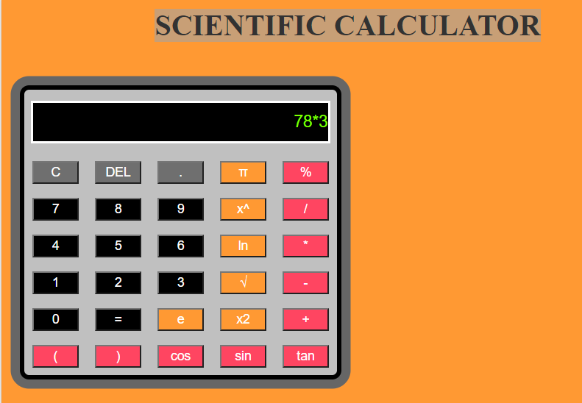

1. Develop, test and validate Sign up Form that collects the following information from the user : last name , first name ,user id, password, confirm password, age(restricted to be greater than 17).You must have event handlers for the form elements that collect this information. These handlers must check the input data for correctness. Message in alert windows must be produced when errors are detected.

**SOURCE CODE**

</body>

</html>

<!DOCTYPE html>

<html>

<head>

<title>Page Title</title>

<!DOCTYPE html>

<html>

<head>

<title>Page Title</title>

<script>

function validation()

{

var us=document.getElementById("name").value;

var ps=document.getElementById("pas").value;

var cps=document.getElementById("cpas").value;

var email=document.getElementById("Em").value;

var re=RegExp("[a-z][0-9]@hotmail|gmail|yahoo|outlook).(com|net.org)","g");

if(us"=="){

document.getElementById("Fname").innerHTML="**Please fill User Name";

return false;}

else if(us.length<=6){

document.getElementById("Fname").innerHTML="**User Name must contain at least 6 characters";

return false;}

if(ps==""){

document.getElementById("pass").innerHTML="**Please fill Password";

return false;}

if(ps!=cps){

document.getElementById("cpass").innerHTML="**Password Not Matched";

return false;}

if(!Em.test(email){

document.getElementById("Email").innerHTML="**Incorrect Email Address";

return false;}

else{

alert('Done'){

return true;}

}

</script>

<body>

<br>

<center><h1>LOGIN FORM</h1></center>

<center><form name="myform" onSubmit="return validation()">

User Name: <input type="text" value="" size="20" id="name"> <span id="Fname"></span><br><br>

Password: <input type="password" value="" size="20" id="pas"> <span id="pass"></span><br><br>

Confirm Password: <input type="password" value="" size="20" id="cpas"> <span id="cpass"></span><br><br>

Email: <input type="text" value="" size="20" id="Em"> <span id="Email"></span><br><br>

Male: <input type="radio" name="gender" value="Male">

Female: <input type="radio" name="gender" value="Female"><br><br>

<label>Country:</label>

<select name="Country">

<option value ="Country1">Pakistan</option>

<option value ="Country2">Afghanistan</option>

<option value ="Country3">Turkey</option>

<option value ="Country4">Saudi Arab</option></select><br><br>

<input type="submit" value ="SUBMIT" ></center>

</form>

</body>

</html>

**OUTPUT:**

