Lab Manual



Course: BI-402

Bioinformatics Software Development

Term: Fall 2020, Class: BSBI-2017

Submitted By:

TALHA NAEEM 2017-BI-005

(Name) (Roll. No.)

Submitted To:

**Ms. Mehwish Mehmood**

**Department Of Bioinformatics**

**Sir Syed University Of Engineering and Technology**

**University Road Karachi - 75300**

<http://www.ssuet.edu.pk>

Table of content

|  |  |  |  |  |
| --- | --- | --- | --- | --- |
| S.no | Lab No | Task | Sig. | Remarks |
| 1 | 1 | **Creating Gantt Chart & PERT Chart Using MS Project** |  |  |
| 2 | 2 | **Introduction to UML (Unified Modeling Language) Diagram and Modeling use case diagram using visual paradigm** |  |  |
| 3 | 3 | **Creating Sequence Diagram using Visual Paradigm Software** |  |  |
| 4 | 4 | **Web Development Framework Using**  **“Dreamweaver CS 5”** |  |  |
| 5 | 5 | **Introduction to CSS** |  |  |
| 6 | 6 | **More About CSS and Designing a Website** |  |  |
| 7 | 7 | **Introduction of Java Script and Form Validation with Java Script** |  |  |
| 8 | 8 | **Introduction of Server Side Scripting** |  |  |
| 9 | 9 | **Server Site Scripting on MY SQL and Database (Authentication)** |  |  |
|  |  |  |  |  |
|  |  |  |  |  |
|  |  |  |  |  |

**LAB 9**

**Server Site Scripting on MY SQL and Database (Authentication)**

**Exercise**

1) Create a MySQL database “payroll Management System” having a table name “Employee”. The Employee table have following fields:

emp_id auto_increment int(10) primary key

emp_name text(30)

father_name text(30)

emp_designation varchar(50)

emp_salary int(10)

emp_organization varchar(10)

**payroll manage database**

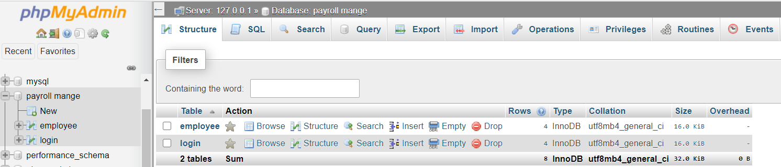

**employee table**

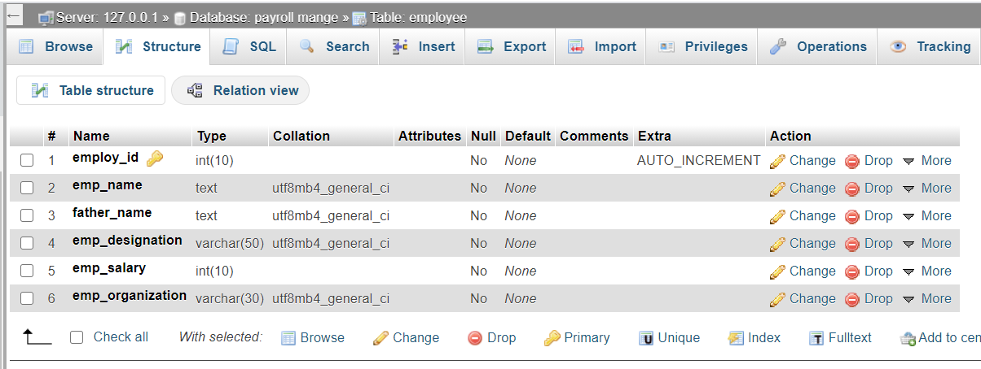

**employee data**

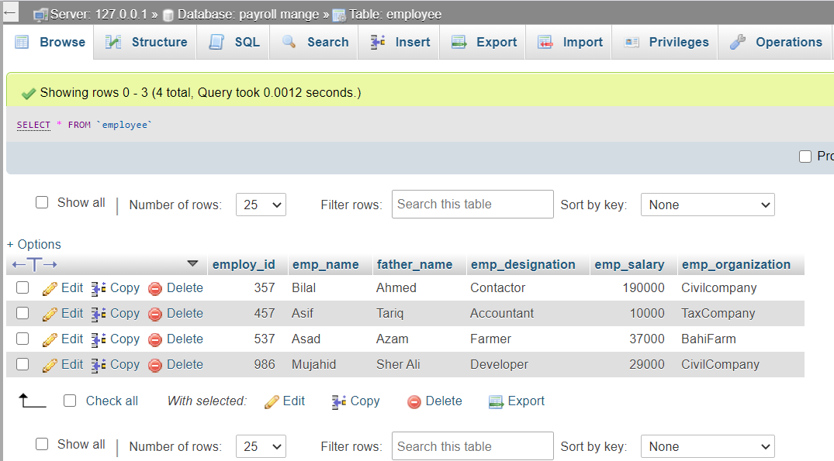

**login table**

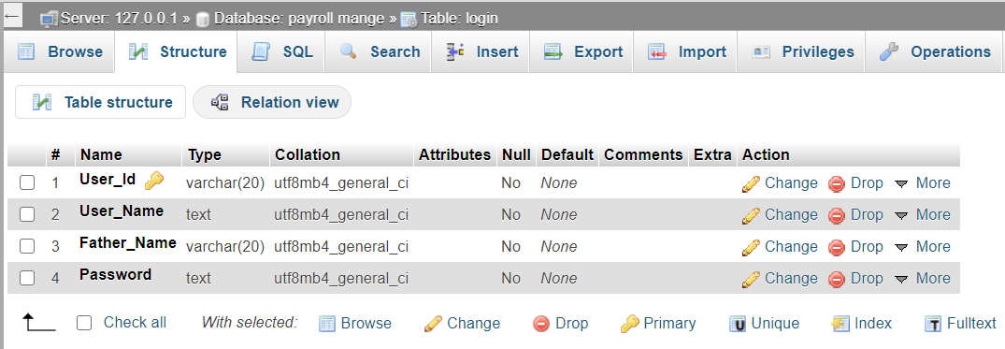

**login data**

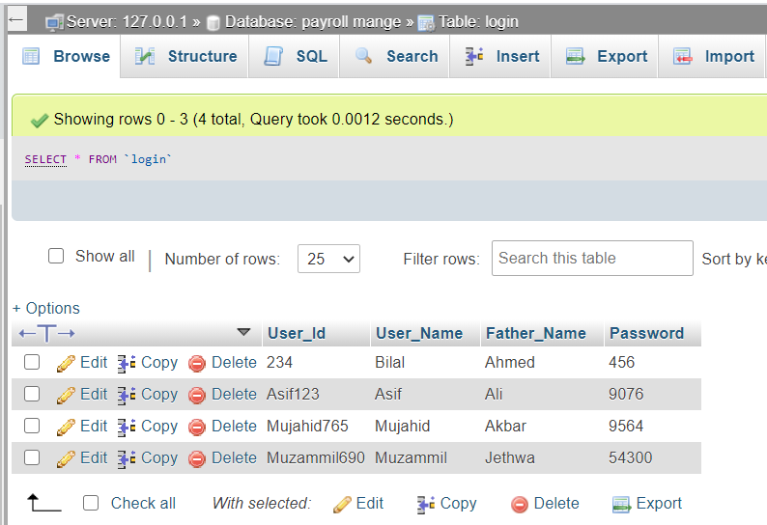

**Exercise**

### **Create Database Connection File In PHP(Connection.php)**

**SOURCE CODE**

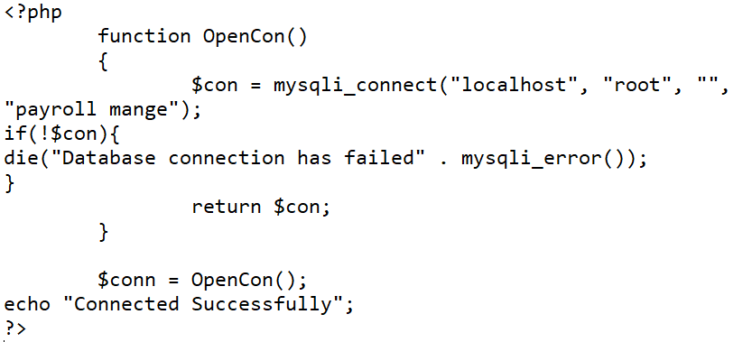

**OUTPUT**

