

DEPARTMENT OF COMPUTER SCIENCE AND ENGINEERING

Course: CSE 391
Name: Talha Ridwan
ID: 24341161
Email: talha.ridwan@g.bracu.ac.bd
Project Title: To understand the technology

Project Features:
By the end of this course, implemented features:
- Login system
- Dark Mode
- Search for recipes with available ingredients
- Search for random recipes with a button
- Store favorite recipes, look up on how to cook them
- History of usage
- Search and store meal plan data
Screenshots:

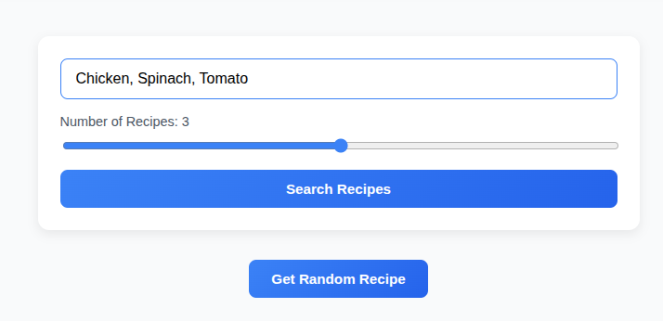
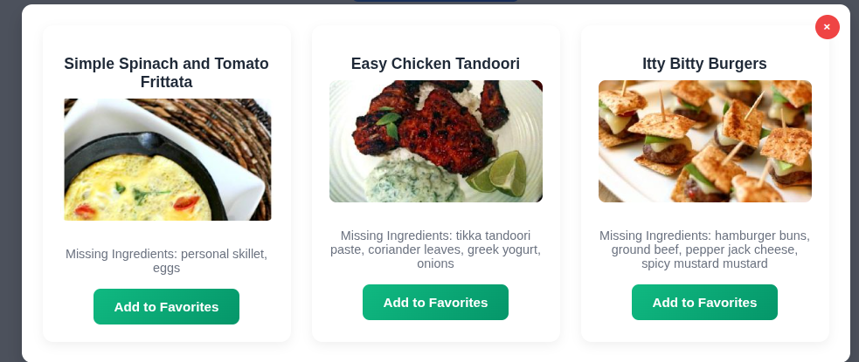

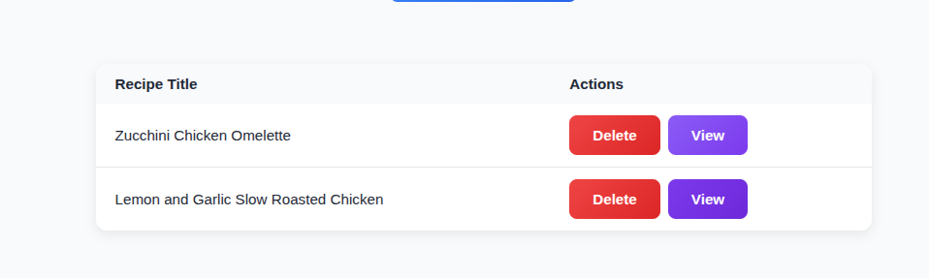

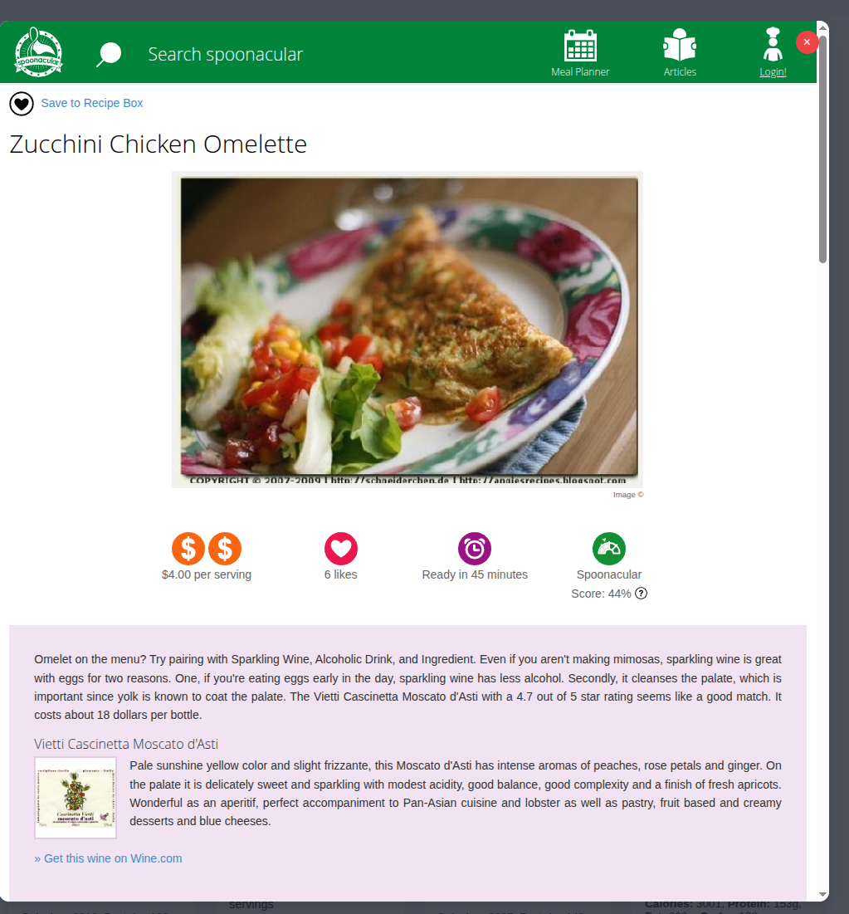
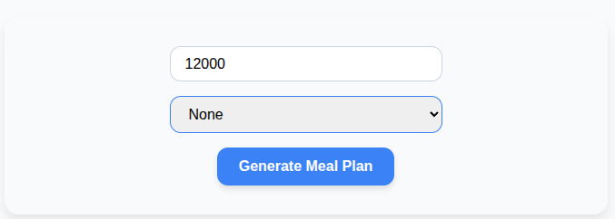

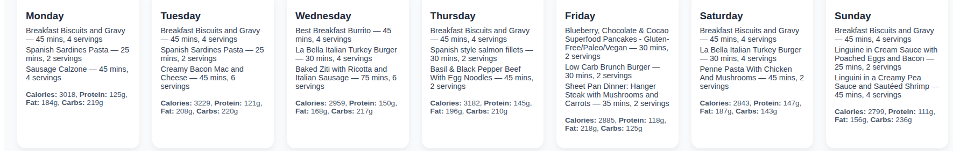
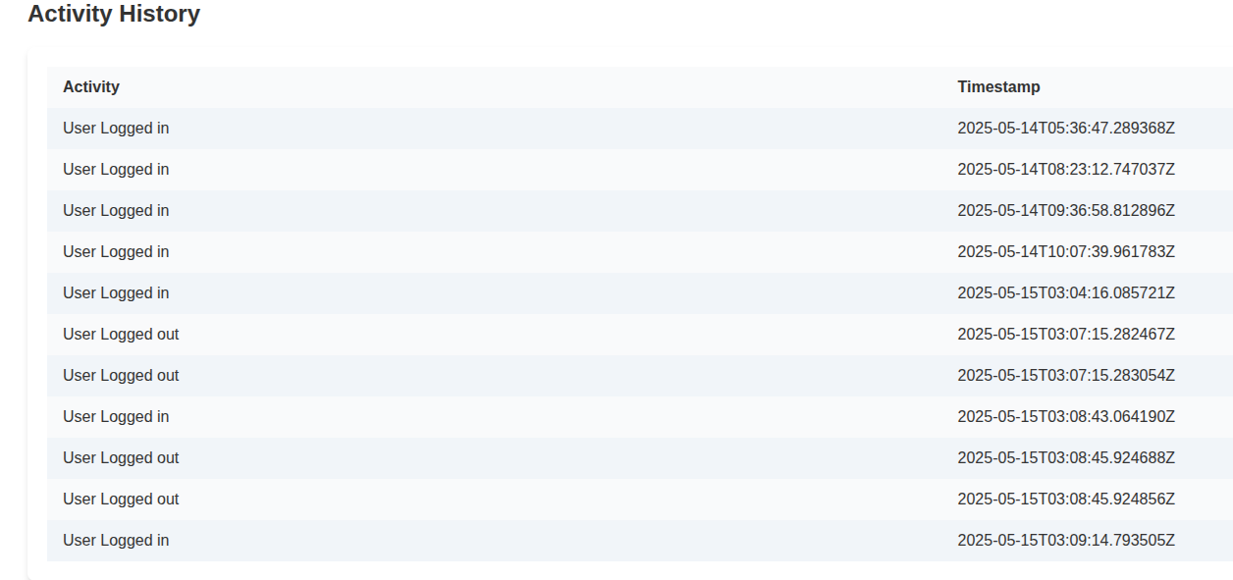
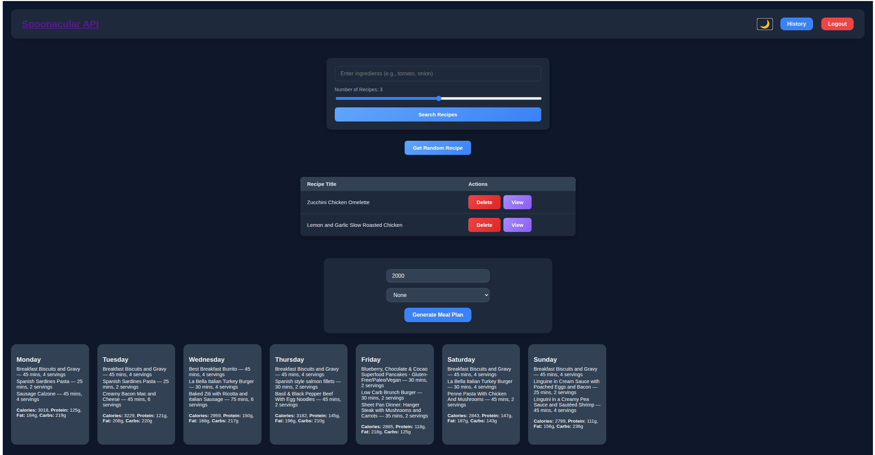

Online Resources used:
a) Reference:
- W3schools.com website
- Youtube videos: https://www.youtube.com/watch?v=c-QsfbznSXI&t=5491s

Future Enhancements:
Following enhancement can be added to the current system which will improve the system.
- Better UI
- Shopping List
- More information about recipe
- Better logging

