REPORT

Title: Credit Card Fault Detection

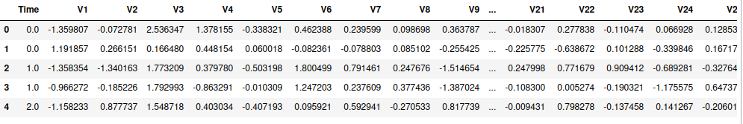
Task:
In this project, we are going to use the credit card history dataset from the kaggle website. he problem is actually to detect the defaulter. Criminals use certain typical practices which help us detect them. Like in this case, if someone is using his own credit card, then he’ll be using it in a certain pattern (same way as used in past). But if someone steal it, then the transaction pattern changes a lot because of the reason that the thief will definitely try to make as much transactions as possible before it gets blocked. This change in transaction behaviour will help the credit card fraud detection model to predict that it is very much possible that the card is not in the owner’s hand, so the credit card company will get notified about this mysterious behaviour and the card will be temporarily suspended until confirmation.

Related Work:
This task has great history, many efficient proposals were given to solve the task using isolated forest algorithm, clustering etc. but the main focus is still to gain the highest accuracy because this is a real sensitive task and customer’s trust is at sake. So the goal always remain to gain closest to 100% accuracy. We will try to solve the same problem with regression and neural networks with a hope to achieve much promising results.

Approach:
We are going to perform data mining techniques i-e logistic regression and neural network technique to our dataset. We divide our dataset in two different portions i-e train dataset and test dataset. Then using the train dataset, we train our both models to become capable to better predict that a given transaction is a fraudulent transaction or normal transaction. Then we will test our model using the test dataset to keep on track that our model is learning efficiently or not.
Then, we will compare the accuracy of both the models and select the one which gives the best prediction accuracy. we can also use both models together in the ensemble learning and improve the total accuracy.

For logistic regression,we will be dividing our dataset into two parts i-e training part and testing part. We have took the training part to be 80% and the testing part limits only to 20% (preprocessing).
we trained model m1 with our specified training data i-e X_train and Y_train
m1 = LogisticRegression()
m1.fit(X_train, Y_train)

For neural networks, splitting the dataset into three parts for training, test and validation datasets (preprocessing).
We have used keras library for the model learning.
Attached pic is a segment of code to give a better picture of architecture of neural network structure.
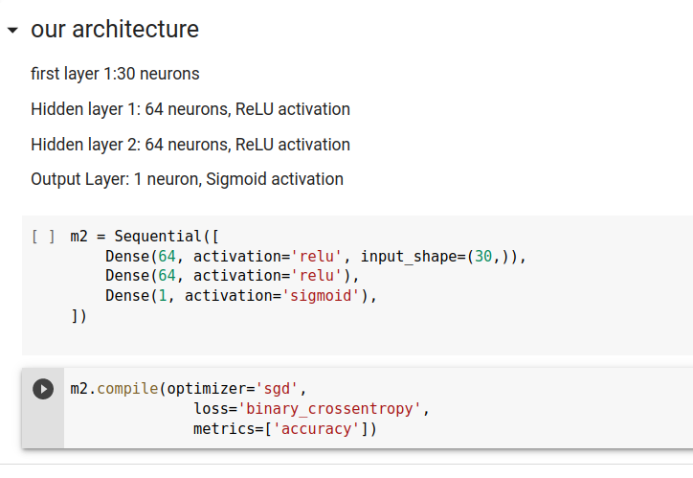
All libraries used in the project are,
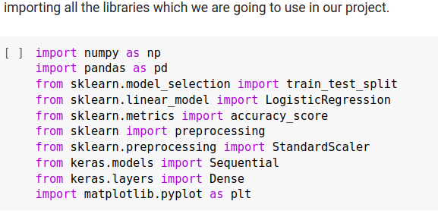

Dataset:
We have chose the dataset of credit card fraud detection from kaggle websote and the link is provided :https://www.kaggle.com/datasets/mlg-ulb/creditcardfraud.
As we can see, the dataset is highly imbalanced, we have a total non defaulters records = 284315 and total defaulters records are only = 492. The dataset is highly unbalanced, so we have to make the number of records same for both the classes
The defaulter class has only 492 records, so we have to reduce the non defaulters class dataset to 492 by randomly taking a sample.

Preliminary Results:
1- Logestic Regression:
The accuracy we are getting is around somewhat more than 92% on the testset and around 94% on the training set. Which means that fortunately our model is not underfit either is it overfit.
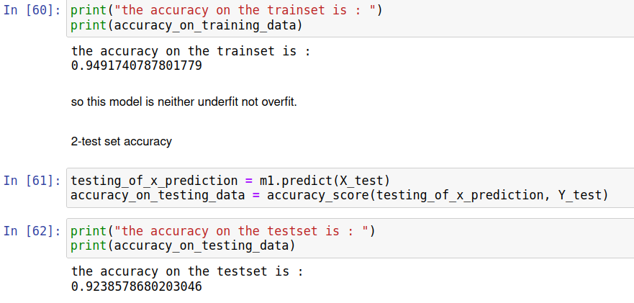
2- Neural Networks:
Now, we try another model based on the technique of neural networks to check if this model could solve our problem in a better way or not.
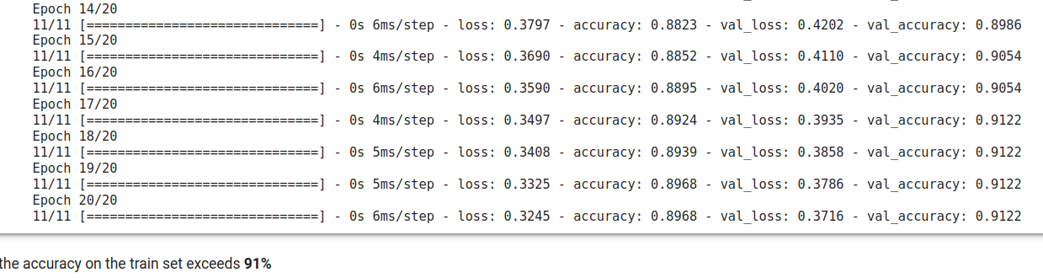
As we see, the model kept training and the accuracy kept increasing and the loss kept decreasing as also shown in the below graph.
The accuracy on the test set came to be around 93% which seems to be good but not as much as our first logistic regression model. Both the models are giving accuracy of more than 90% but the model m1 i-e logistic regression model is giving much higher prediction than the neural network model.

