Similar Game- Strategic Tic Tac Toe:

<https://www.coolmathgames.com/0-strategic-tic-tac-toe>

Features:

* Tutorial
* Slightly different rules- cannot move back to taken grid
* Preview of next move as reminder (turned on and off)
* Undo function
* Changing symbol for character
* Does not have true multiplayer, only has co-op
* Style very cartoonish/childish
* How to play button in all screens
* Cannot select difficulty of AI

Variants:

* Timed mode- cannot exceed given amount of time or opponent wins

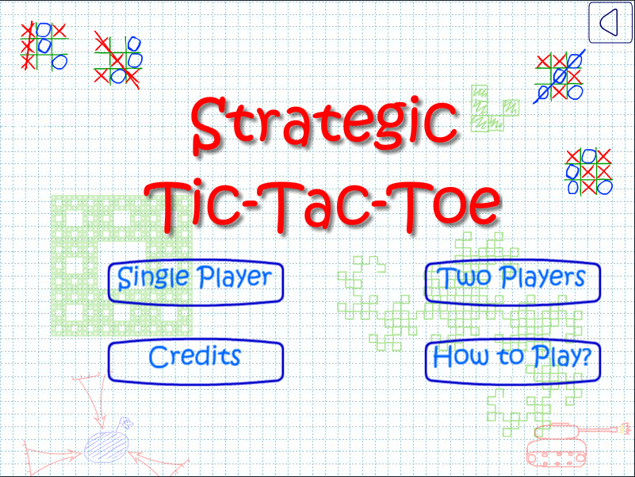I have researched a number of similar games, one of which is ‘strategic tic tac toe’. This game was found on a games website for children, and is created for that audience. Because of this, it makes use of a theme, and look well suited for children- cartoonish and full of different colour. However, I am planning on creating a more simplistic theme that reflects the age of the end user: 15-25.

This game also includes a tutorial/help button on every screen so that players are reminded of how to play, and includes a tutorial whenever a new game is started. I think this is crucial to the gameplay, since this game is very complex and new players as well as old can become confused regarding the rules. Ultimate tic tac toe is not a very popular game and different variations of it have slightly different rules, so it is extremely important that my game includes an extremely accessible tutorial section. However, I would not force the user to sit through a tutorial at the start of every game, but I would allow the user to decide when or if they want to view the tutorial.

In order to reduce the amount of

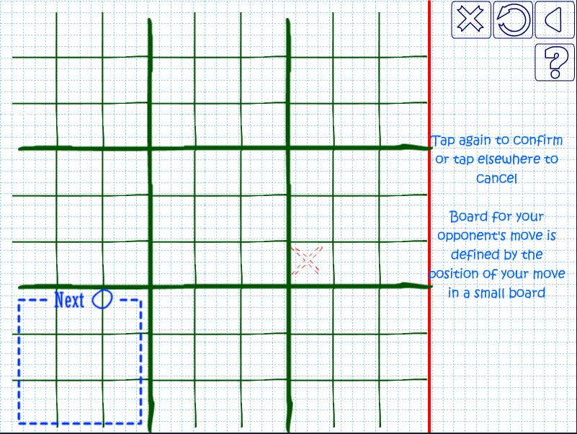Visible features: ‘?’ help button, preview of move result, confirmation of move.

This game also has the ability to play co-op however cannot be played in online multiplayer.

I would also implement a timed mode, since this game generally takes a large amount of time to complete.

Use template for documentation

In analysis look at human solutions and algorithms for the AI to solve the problem – speculate.

<https://en.wikipedia.org/wiki/Ultimate_tic-tac-toe>

<https://en.wikipedia.org/wiki/Minimax>

<https://en.wikipedia.org/wiki/Artificial_intelligence>

<https://www.baeldung.com/java-minimax-algorithm>

<https://medium.freecodecamp.org/how-to-make-your-tic-tac-toe-game-unbeatable-by-using-the-minimax-algorithm-9d690bad4b37>