MUHAMMAD TALHA  AI AUTOMATION ENGINEER / n8n SPECIALIST / PYTHON DEVELOPER | KARACHI, PAKISTAN  Email | GitHub
m.talha.kamran.pk@gmail.com • github.com/Talha-dev27
PROFESSIONAL PROFILE
AI Automation Engineer and Python developer who builds practical, connected systems for business workflows. Experienced in n8n orchestration, AI-assisted lead research, workflow integrations, REST APIs, and structured data handoffs. Focused on turning repeatable manual tasks into clear, maintainable processes using Python, external services, and automation tools.
TECHNICAL CAPABILITIES
AI WORKFLOWS & AUTOMATION  n8n, AI agents, workflow design, lead qualification | BACKEND ENGINEERING  Python, FastAPI, Flask, Django, REST API design
INTEGRATIONS & DATA  Third-party APIs, web scraping, Google Sheets, databases | DEVELOPER TOOLS  Git, GitHub, Docker, cloud services, AWS familiarity
WEB TECHNOLOGIES  HTML, CSS, full-stack application development | BUSINESS APPLICATIONS  Lead generation, workflow optimization, email marketing
PROFESSIONAL EXPERIENCE
Independent AI Automation Engineer | Self-employed · Remote
- Design and build n8n workflows that connect data discovery, AI-assisted processing, validation, and outputs across multiple services.
- Develop Python-based REST APIs and integration logic using FastAPI and Flask to support automation and backend workflows.
- Create lead research and qualification pipelines that combine website data, rule-based filters, and AI tools to organize prospects.
- Troubleshoot integrations and deployment issues; use Git, GitHub, Docker, and cloud tools to support iterative delivery.
SELECTED PROJECTS
Lead Radar AI — Lead discovery and qualification workflow
n8n · APIs · Website analysis · Google Sheets
- Built an automated process to find businesses, inspect their online presence, and assess potential service fit.
- Structured and filtered lead records before sending them to Google Sheets for follow-up and review; published the project on GitHub.
Studify — Full-stack web application project
Worked on a web application involving Vercel deployment, Supabase authentication, and frontend integration.
EDUCATION & PROFESSIONAL DEVELOPMENT
Cambridge O Level | Focus areas: Computer Science, Mathematics, Physics
Coursework: Python Programming (Basic to Advanced) · AI Automation Mastery Course · Email Marketing Specialist Course

PROJECT BRIEF / SELECTED ENGINEERING WORK
Lead Radar AI
A modular approach to discovering, evaluating, and organizing potential business leads with n8n, web data, AI tools, and Google Sheets.
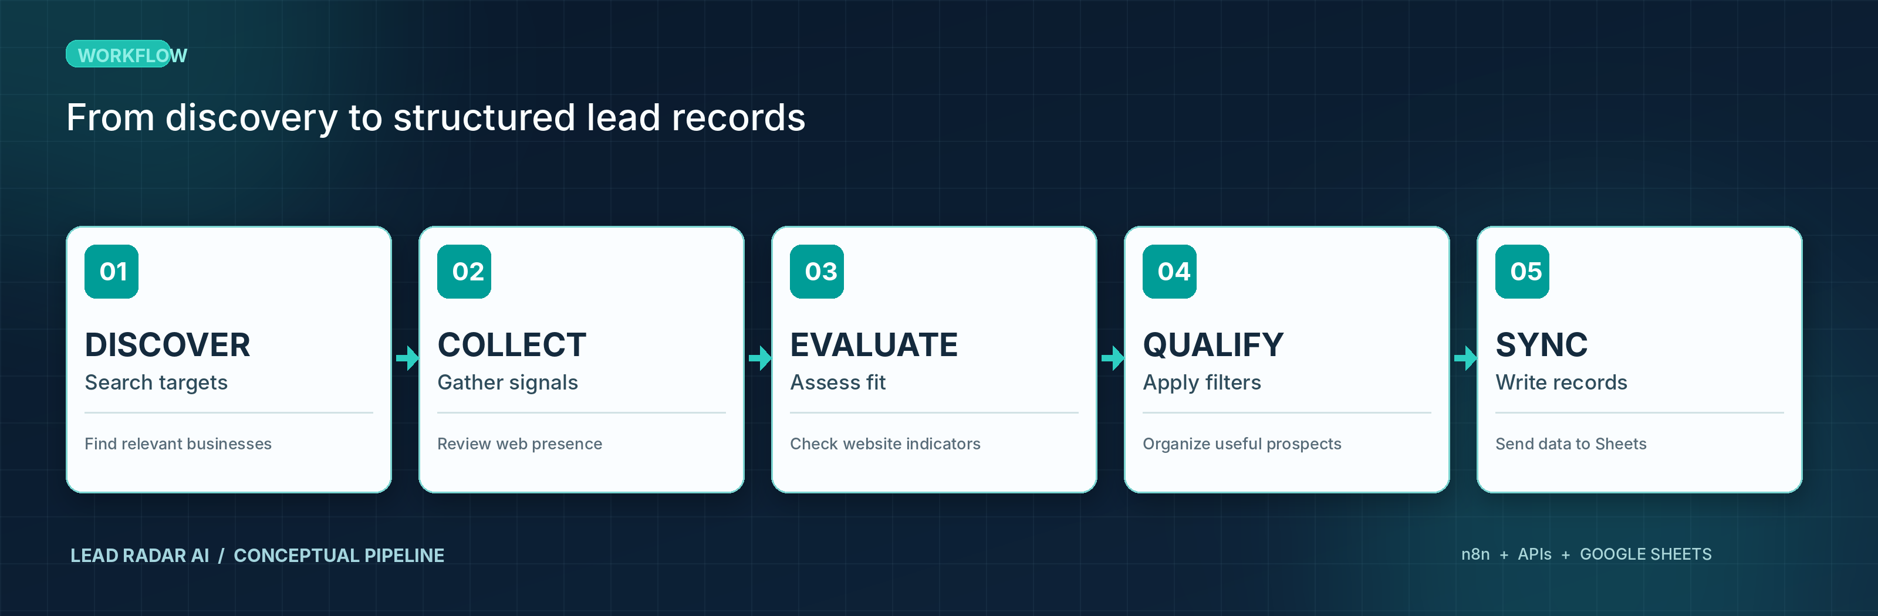
Conceptual diagram based on the described workflow; not an application screenshot.
WORKFLOW BREAKDOWN
01 / Discovery | Search for relevant businesses within a target market or service category.
02 / Collection | Gather public website and online-presence information for each candidate.
03 / Evaluation | Review website signals against the requirements of the intended service.
04 / Qualification | Apply automated filtering and AI-assisted analysis to prioritize useful leads.
05 / Output | Save consistent, structured records to Google Sheets for review and follow-up.
ENGINEERING PRINCIPLES
Modular workflow stages  Separate discovery, validation, qualification, and output for easier troubleshooting. | Structured information  Keep lead data readable and consistent for downstream review or outreach.
Integration-minded design  Use API connections to link specialized tools without unnecessary duplication. | Reviewable automation  Make it possible to inspect the data produced by automated decisions.
Portfolio reference github.com/Talha-dev27 • Available for AI automation, backend API, and integration projects.

