**New Jersey Institute of Technology**

**Senior Capstone Seminar**

**Spring, 2023**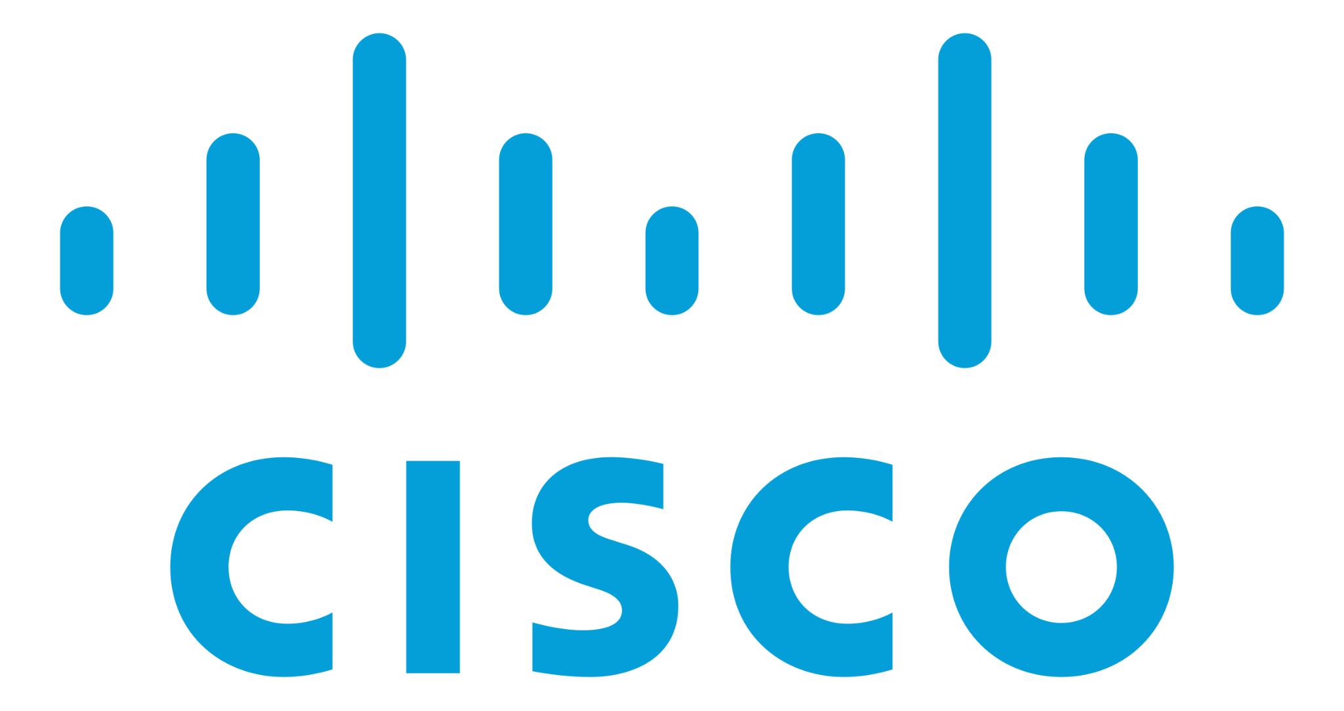

**SMALL BUSINESS NETWORK ARCHITECTURE WITH GUEST ACCESS**

**FINAL DOCUMENTATION**

**Professor Eljabiri Osama**

**Team Members:**

**Matthew Cabrera**

**Mohammad Khan**

**Kevin Elia - Project Manager**

**TABLE OF CONTENT:**

**Pg**

**1. Introduction(Written By Matthew Cabrera): 2**

**2. Project Management(Written By Matthew Cabrera): 5**

**3. Define(Written By Mohammad Khan): 8**

**4. Design(Written By Kevin Elia): 10**

**5. Resources/Citation/Bibliography: 17**

# 

# **1. PROJECT INTRODUCTION**

**1.1. ABSTRACT.**

This is the final document of Team 3 of the Cisco teams in the IT 491-102 Tuesday night section. The following will entail a detailed and in depth overview of our Senior Capstone Cisco Packet Tracer project, a *Small Business Network Architecture with Guest Access*. The goal of this packet tracer project is to design a network for a small company that will suit its business and growth expansion as needed.

These following students are the ones that make up Team 3 and are responsible for the creation of the packet tracer: Kevin Elia, Matthew Cabrera, and Mohammad Khan. These students are all from the New Jersey Institute of Technology and have created the packet tracer using their knowledge from Cisco’s Network Academy courses, previous NJIT courses, and extensive research. This document will explain in meticulous detail of the process to create the finalized version of our packet tracer that was showcased for the final presentation.

The packet tracer was created in the span of 12 weeks and went through multiple iterations during this extensive process. Weekly SCRUM meetings, Trello workspace, and other forms of contact were used to help complete this packet tracer project within the semester. Deadlines, deliverables, and milestones were also implemented to keep morale high and track progress throughout this semester as well. The identifications of risks, stakeholders, and other reasonable factors helped narrow down the focus and scope of the project in order to be completed yet still implement desirable features and functionality.

**1.2. BACKGROUND.**

Cisco project examples were uploaded on the week of February 12th, 2023 and it was then where our group decided to settle on a project and expand upon it for approval with Professor Eljabiri Osama. The group had a meeting and briefly discussed all of the projects presented to us, any original ideas for projects, and other alternatives that could help guarantee that our project proposal would be approved within the week.

The project we settled on and got approved for was for a small business network architecture with guest access to the network. This network would feature guest access for 60+ users and have features such as scalability, basic security, and strong connectivity. Our project also includes features we learned from Cisco’s network academy such as VLANs, SSH access, and static routes. Some other features are ISP failovers, implementing AAA security, WLAN controllers, domain controllers, and adding options for network equipment based on company needs to show the flexibility of the network topology.

**1.3 PROBLEM DEFINITION**

A small start up business is in the market that is set to have tremendous growth within the coming years. They have branches in Atlantic City, NJ, Newark, NJ, and headquarters in New York City. They have an unstable and unreliable network in all three branches that have difficulty communicating with each other due to slow speeds and network failures. The company is also hiring new employees in all branches and are currently running out of room and equipment to support their fast growing company.

We have been assigned with the task to create a network that can support the company based on their business needs. Since the company is a small start-up business, they do not have the budget currently for the best high end equipment. The network topology must consider all and any risks and factors that the business may encounter, and be within a reasonable budget since the company is to see profit growth very soon.

**1.4 GLOSSARY**

* **Cisco Packet Tracer**: Virtual Environment Software that allows for networks to be created and configured
* **Trello Board**: Software that allows for team management of our project’s timeline and progress. Can assign tasks to individuals and label assignments completed.
* **SSH**: Secure Shell is a protocol that allows for secure network communication
* **Static Routes**: Fixed and explicitly defined paths of communications configured by an administrator that tells packets its source and destination.

**1.5 ITERATION/REVISION UPDATES**

**REVERSE CHRONOLOGICAL ORDER:**

**Final:** [FinalProject-4-21-2023-Rev4.pkt](https://cdn.discordapp.com/attachments/1070427045835837525/1099337386116251658/FinalProject-4-21-2023-Rev4.pkt)

[FinalProject-4-21-2023-Rev3.pkt](https://cdn.discordapp.com/attachments/1070427045835837525/1099099165197353011/FinalProject-4-21-2023-Rev3.pkt)

**Midterm:** [FinalProject-4-21-2023.pkt](https://cdn.discordapp.com/attachments/1070427045835837525/1098973355606016021/FinalProject-4-21-2023.pkt)

[FinalProject-4-2-2023.pkt](https://cdn.discordapp.com/attachments/1070427045835837525/1092230495108071454/FinalProject-4-2-2023.pkt)

**First:** [FinalProject-4-1-2023.pkt](https://cdn.discordapp.com/attachments/1070427045835837525/1092049370070917160/FinalProject-4-1-2023.pkt)

**2. PROJECT MANAGEMENT**

**2.1 TASK ANALYSIS**

After the approval of the groups packet tracer project proposal, Cisco Team 3 decided to establish weekly SCRUM meetings, the use of Trello for progress tracking, and a GANTT chart as well. Now with a solidified project on hand, we took the time to determine the requirements needed for the Small Business we were creating a network topology for. We decided the work evenly and assigned tasks to each other to ensure that the project will be completed.

**2.2 ROLES**

**Kevin Elia(PM) - NYC HQ**

**Matthew Cabrera - Newark Branch**

**Mohammad Khan - Atlantic City Branch**

All members were assigned a network branch to work on. Team created functioning scripts that would help each other set up proper VLANS, static routes, connectivity, and other requirements for a fully functioning network. Our work was broken down into milestones with certain features and deliverables required to be completed within each milestone throughout the semester.

We used Trello, as mentioned above, to assign tasks to each member of the team. By the time of the final, a timeline was created to see the progress we made throughout the semester of when objectives, deliverables, and milestones were completed. The entirety of the project took roughly 10 weeks to complete, including spring break which was used as time to also work on the project.

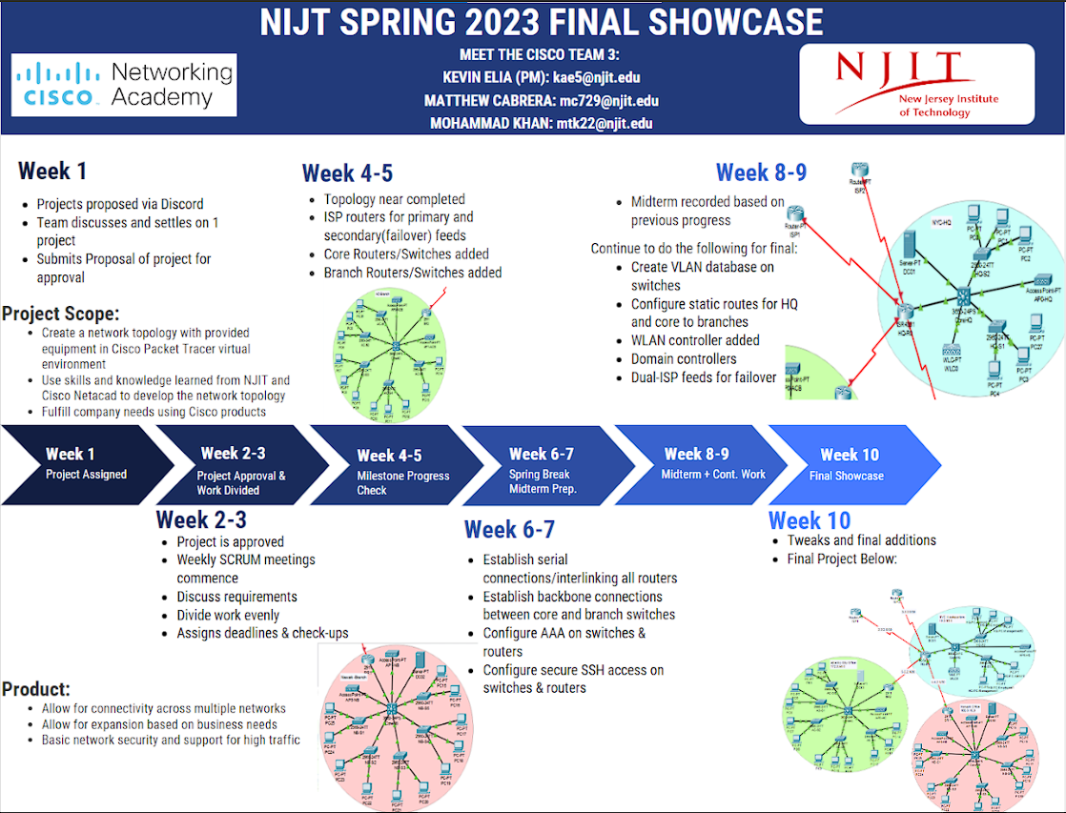

**Timeline & Electronic/Digital Poster**

**2.3 WBS/GANTT**

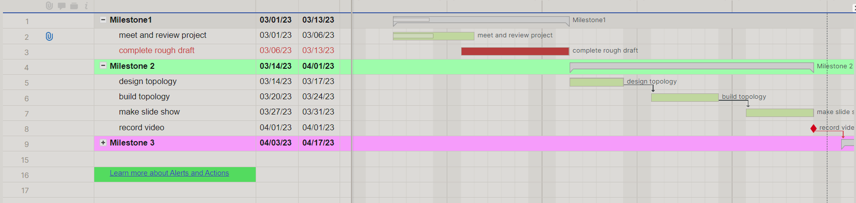

**2.4 RISK IDENTIFICATION AND MANAGEMENT**

| Risk | Possibility | Cause | Effect | Fix |
| --- | --- | --- | --- | --- |
| Time Conflicts | Medium-High | Schedules/Emergencies | Stalls Development | Discord/Trello Board |
| Withdrawal | Medium | Unknown Factors, Emergencies, Work Load | Weakened Team Morale  Workload Growth & Small Team | Trello Board Cards  Team Assistance |
| Network Failure | High | Misconfiguration, Poor Cabling, etc | High Traffic, Low-No Connectivity | Redundancy |

The first risk is time conflicts. The possibility of this risk happening was highly likely and could happen on multiple occasions throughout the semesters. College student schedules may conflict with each other because of outside factors such as family, work, and emergencies. Therefore, the effect that this first risk could have on the team and the Cisco Packet Tracer project is that it will stall development. The way we intended to remedy this risk was the use of online communication through Discord and Trello Board.

The second risk is class withdrawal. This was a likely event to happen because of the prior reasons mentioned above. The effect this could have on the team and project is that it could weaken the team morale with losing a team member and increase the difficulty of the project by causing more work for the remaining team members. The way we intended to fix this was also through online communication to keep everyone up to date and help them when needed.

The last risk is a network failure within the packet tracer which could be caused by misconfigurations, a bug, or any limited capabilities within Cisco Packet Tracer itself. The effect that this could have on the project is that it will prevent it from being fully completed as intended. The way to fix this was through online research, troubleshooting, or removing features.

**3.** **DEFINE**

**3.1 STAKEHOLDERS**

The network we built and designed is a type of network infrastructure that allows temporary or limited access to non-employees, such as clients, vendors or other visitors. This network architecture is designed to provide a secure and reliable connection for both internal and external users while maintaining the confidentiality and integrity of sensitive data. There are various stakeholders that can benefit from our product.

Our main focus is on small business owners. These business owners are responsible for providing the necessary resources and budget to establish and maintain a network for their business. Employees,clients and guests are also considered to be stakeholders in this scenario as well. We had developed a very cost effective and reliable way to have the network communicate. This is why we believe most businesses would benefit from us and our product.

**3.2 REQUIREMENTS GATHERING**

The requirements for this project was for us to utilize our time and learning material. We had divided up work and met through using trello and discord. We also had Gnatt charts showing our weekly sprints. We also utilized the NetAcad sources from the course and previous hands-on projects we took as well. We also took into consideration things such as risks we may deal with. Such as classes being in the way of this project, losing team members and network failures such as misconfigurations and poor cabling.

**3.3 PROJECT SCOPE**

The Scope of this project is for us to design the network to meet the business performance requirements, as well as providing a reliable and scalable infrastructure. That can accommodate future growth requirements. Our main goal is to provide an affordable , reliable and secure network to anyone whether it's your business or home.

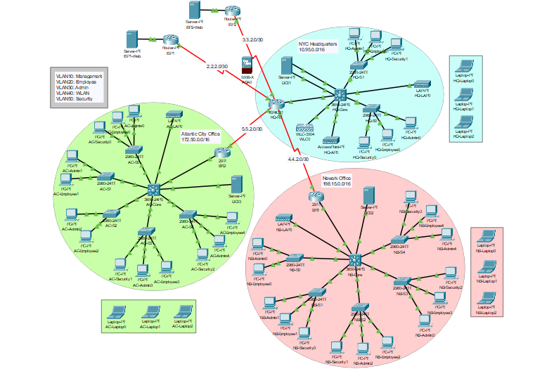

**3.4 Extra Credit FDD AND USE CASE DIAGRAMS**

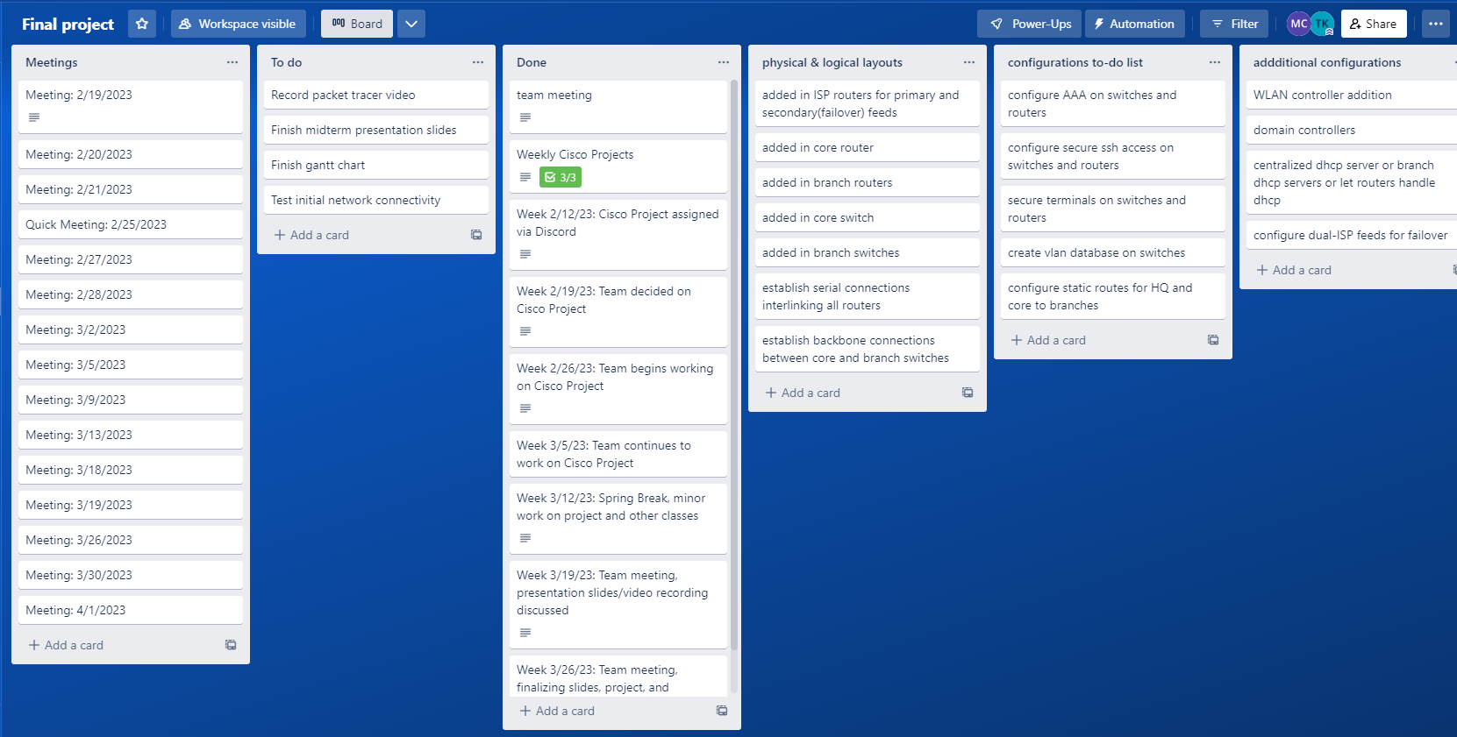



**4. DESIGN**

**4.1 ER**

The fully functioning simulated network model that we currently have was based around a basic ER model that would help us adhere to the main desired result, while also giving us the ability to expand upon or modify the original design. When creating large scale networks like these, especially ones with multiple branch locations and remote networks, it is very easy to get lost among all of the different subnets, VLANs, port assignments, configuration files, and additional features. Having a high-level diagram or model to refer to is a must.

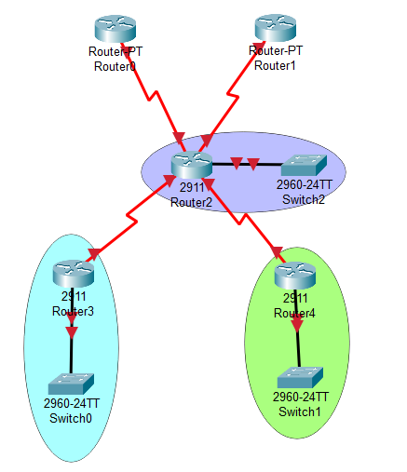

The breakdown of our ER model can be transposed into a very simple network flow concept. Starting from top to bottom, at the top level we have our dual connections from our Internet Providers. Having a failover ISP for Internet connection redundancy and HA(high availability) services was something that we wanted as a core feature of our network model, and since this was going to be a brand new network, having two Internet feeds installed from the get-go would be much easier to implement than starting with a single feed and then having the secondary installed later down the line over pre-existing infrastructure.

The second level involves our core router and the core switch. The core router essentially serves as the brainstem of the entire network, as it facilitates network traffic from both upstream and downstream, as well as Intranet. The third and last level involves the two branch routers that manage traffic to and from the remote networks communicating directly with the core router, which is located in the HQ location.

This basic ER model represents the backbone or the skeleton of the entire network. Regardless of any additional switches, or APs, or end devices that are added to the network, or any additional modifications, this core design will not change.

**4.2 CLASS**

Throughout the semester we had to complete many hands-on projects assigned to us during the Cisco Netacad duration. With a bit of additional research on the side for some extra functionality, we wanted to incorporate most, if not all of the concepts we learned during the hands-on projects into our final network simulation, and we accomplished this with great success. Some of the main hands-on projects involved locking down and securing routers, switches, and wireless controllers, configuring wireless networks, configuring static routes to establish connections between remote networks, creating and configuring custom subnets and VLAN assignments, working with dual-stack functionality supporting both IPv4 and IPv6, and implementing port security on all network appliances. Our team has incorporated all of these features and functions in our final network model.

**4.3 NETWORK DIAGRAMS**

**Network:**

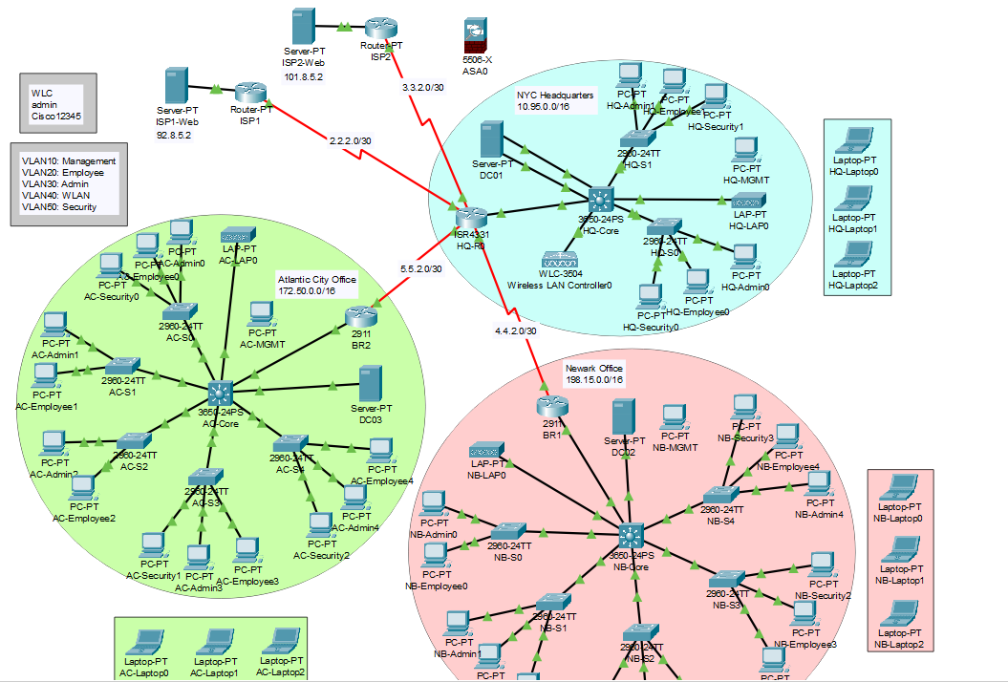

**HQ:**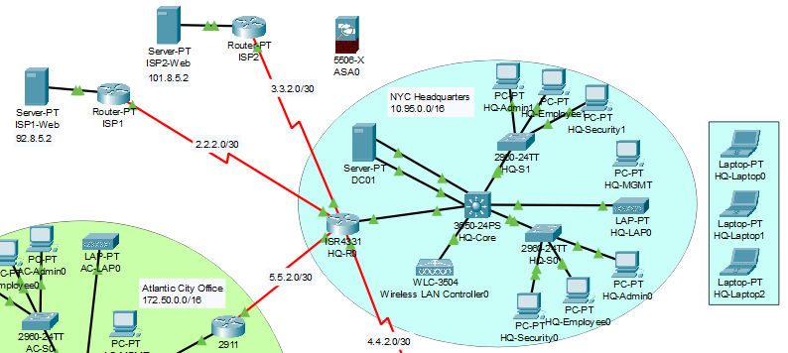

**Newark:**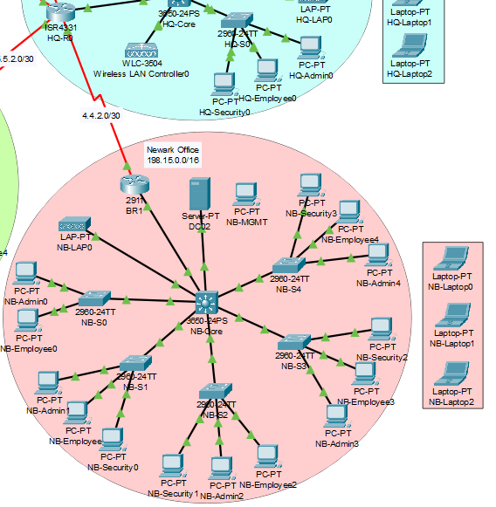

**Atlantic City:**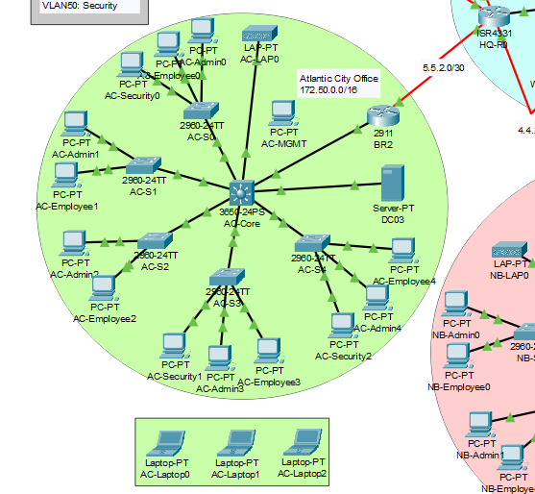

**4.4 IMPLEMENTATION DETAILS**

During initial implementation, we came across the inevitable issue of finding an efficient way to be able to collaborate on the project. Because no real tool exists that would allow us to work in Packet Tracer simultaneously or be able to push configuration updates to a master file, we came up with the solution of essentially splitting the main network model into three divisions, three separate networks consisting of a HQ network, and two branch networks. Splitting it up this way allowed us to effectively work on the project simultaneously, then we would all come together during our SCRUM meetings and share all of the changes with each other in order to apply changes to an offline master file.

Splitting up the networks into branch locations also turned out to be a great way to allow us to implement one of the most important concepts we learned during the Cisco Netacad, which was configuring and managing default and local static routes. Static routing is an integral part of networking, and arguably one of the most important aspects. Static routing is what allows remote networks to communicate with each other, as well as what allows inter-VLAN connections to be configured.

**Resources**

*Cisco Networking Academy builds it Skills & Education for Future Careers*. Networking Academy. (2023, March 13). Retrieved May 3, 2023, from https://www.netacad.com/