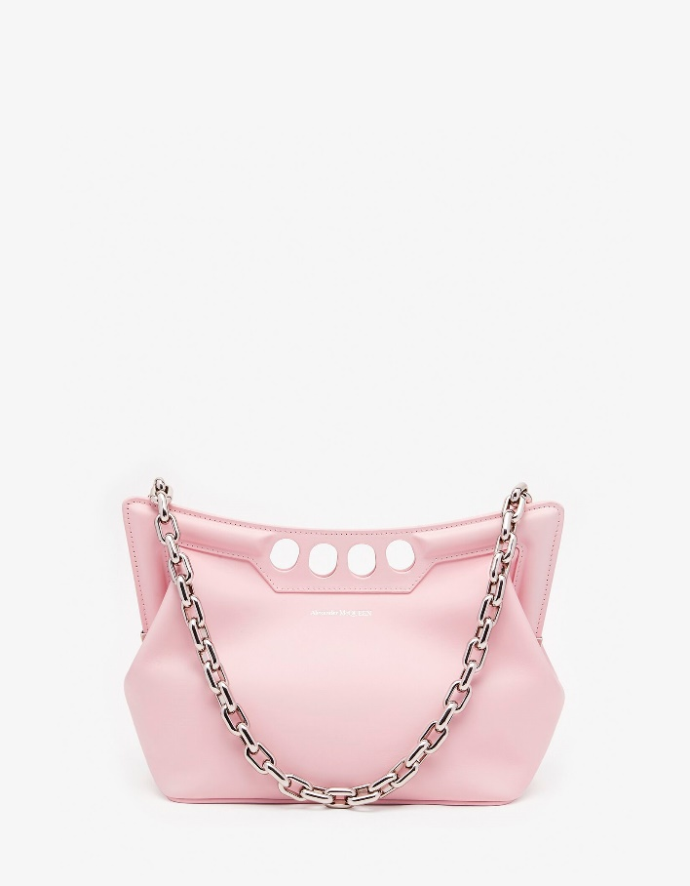

Women's The Peak Bag Small in New Pink

#### $2000.0

### **Product details**

* Strap drop: 30 cm / 11.8 inches
* Dimensions: 28 x 20 x 11 cm / 11 x 7.8 x 4.3 inches
* 100% Calf Leather
* Magnetic fastening
* Fixed chain strap
* Brass hardware with antique silver finishing
* Contrasting suede lining