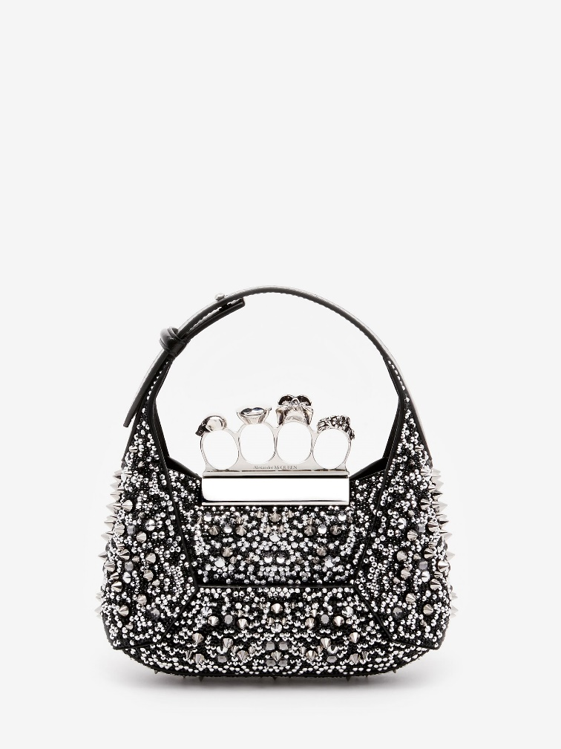

The Jewelled Hobo Mini Bag in Black

#### $2200.0

### **Product details**

* Dimensions: 20 x 12 x 8 cm / 7.8 x 4.7 x 3.1 inches
* 100% Calf Leather
* Silver-finished handle adorned with Swarovski-encrusted rings
* Magnetic fastening
* Detachable chain strap
* Brass hardware with antique silver finishing
* Leather lining