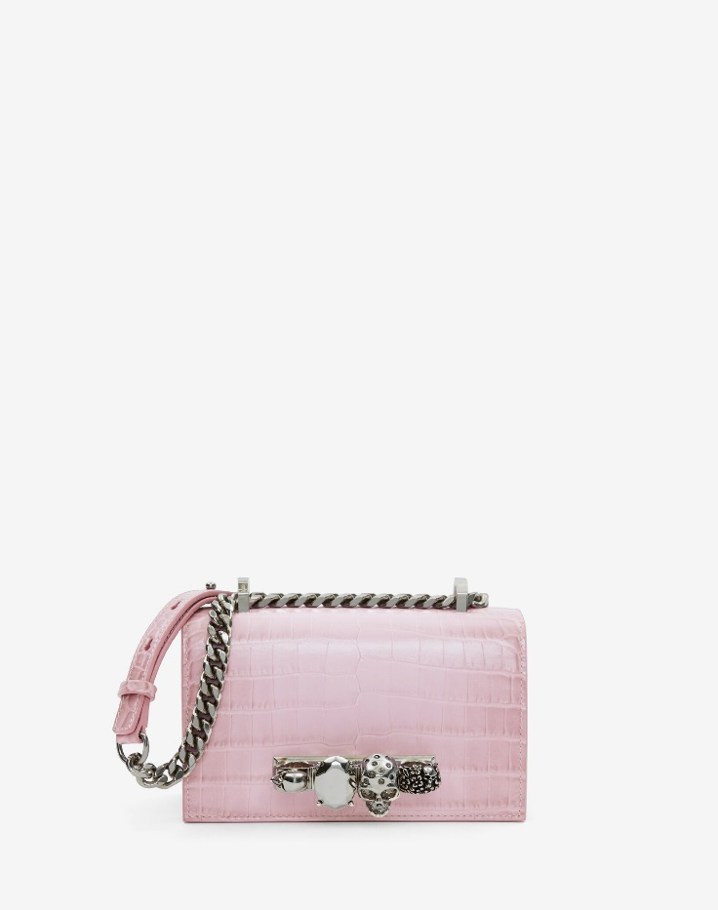

Women's Mini Jewelled Satchel in Antique Pink

#### $1500.0

### **Product details**

* Dimensions: 17.5 x 9.5 x 4cm / 6.8 x 3.7 x 1.5 inches
* Strap drop: 55cm / 21.6 inches
* 100% Calf Leather
* Silver four-ring embellishment encrusted with Swarovski crystals
* One main compartment and one card slot
* Adjustable leather and chain strap
* Brass hardware with antique silver finishing