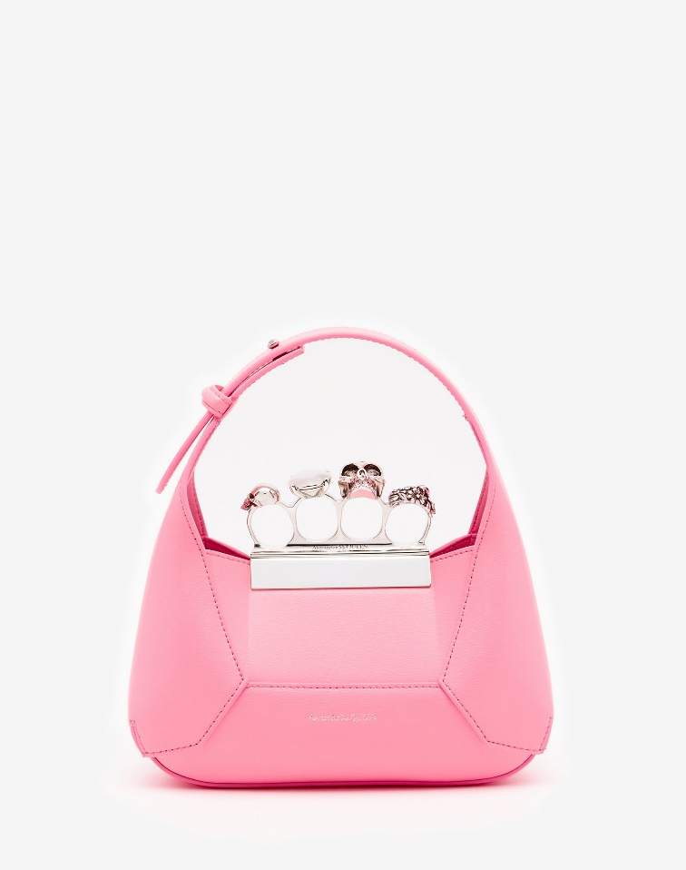

Women's The Jewelled Hobo Mini Bag in Psychedelic Pink

#### $2500.0

### **Product details**

* Dimensions: 20 x 12 x 8 cm / 7.8 x 4.7 x 3.1 inches
* Strap drop: 52 cm / 20.4 inches
* 100% Calf Leather
* Magnetic fastening
* Detachable chain strap
* Tonal liningp
* Brass hardware with antique silver finishing