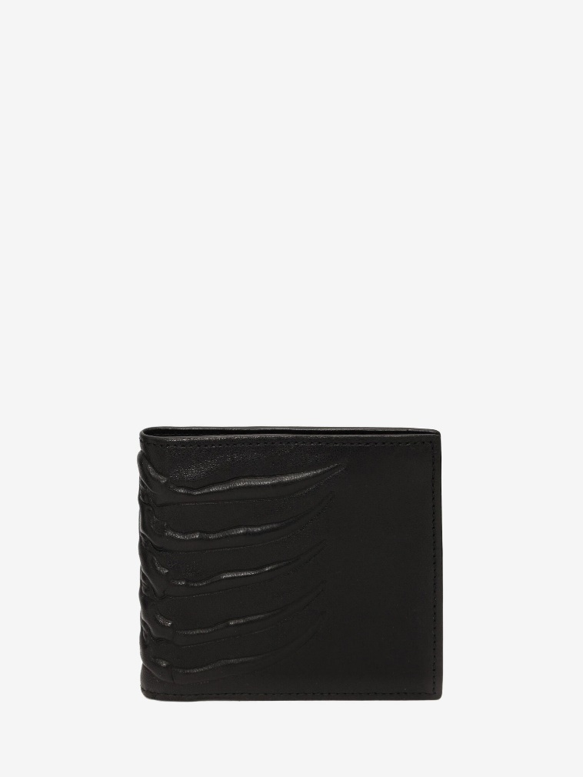

Men's Leather Billfold Wallet in Black

#### $499.0

### **Product details**

* 100% Mutton Sking
* Dimensions: 11 x 10 x 1,5 cm / 4.3 x 3.9 x 0.5 inches
* Black soft lambskin billfold wallet
* 8-slot card compartment and notes section.