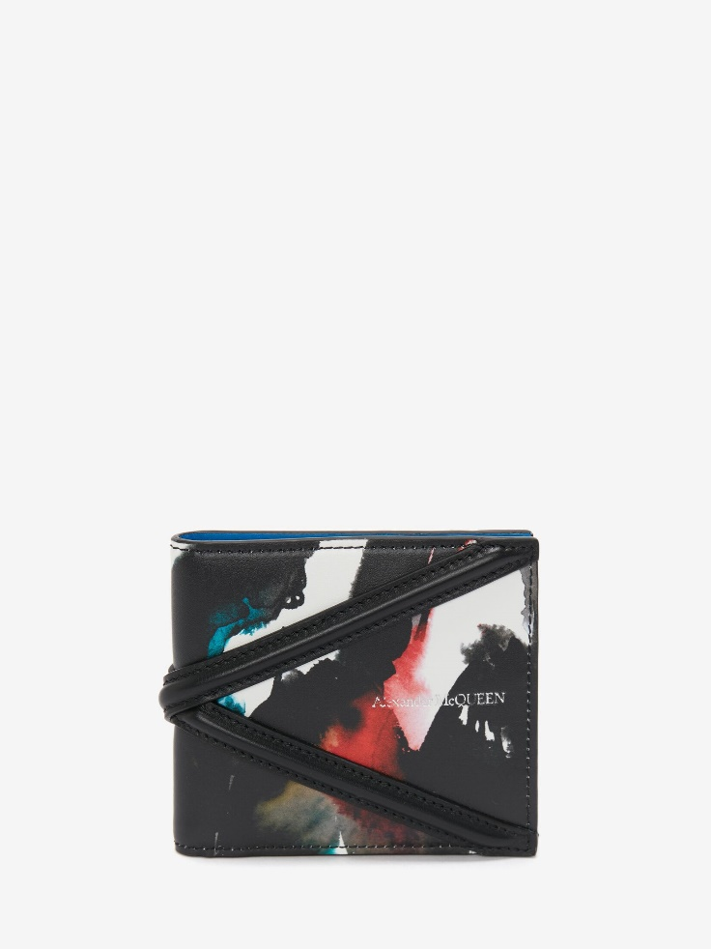

Men's Watercolor Graffiti The Harness Billfold Wallet in Multicolor

#### $599.0

### **Product details**

* Multicolored calf leather billfold wallet featuring
* all-over Watercolor Graffiti print and black harness detailing
* 100% Calf Leather
* The wallet has eight card slots, two flat pockets and two bill

compartments.

* Finished with an Alexander McQueen signature.