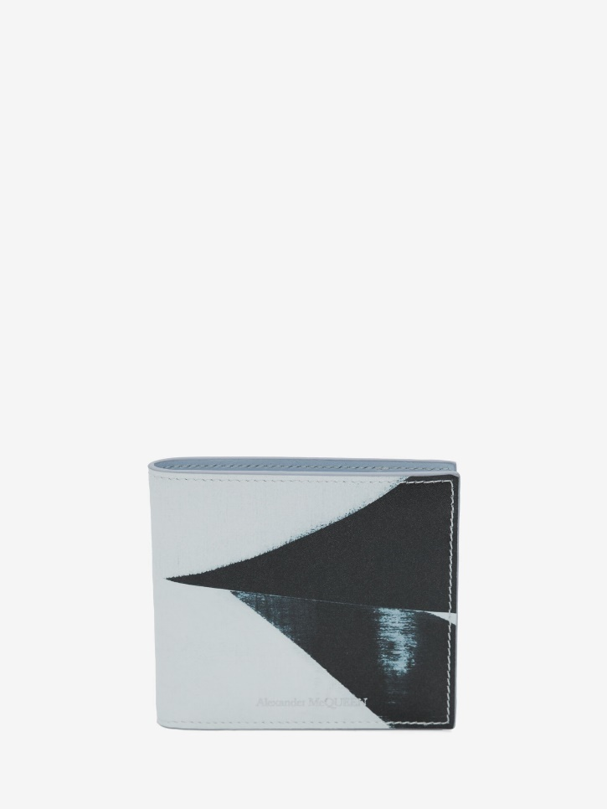

Men's Brushstroke Billfold Wallet in Black/white

#### $299.0

### **Product details**

* 100% Calf Leather
* Dimensions: 11.5 x 9.5 x 1.5cm / 4.5 x 3.7 x 0.5 inches
* Eight card slots
* Two bill compartments.
* Black and white leather billfold wallet featuring
* all-over Brushstroke print
* Lined with contrasting spring blue leather. Alexander McQueen tonal

Signature.