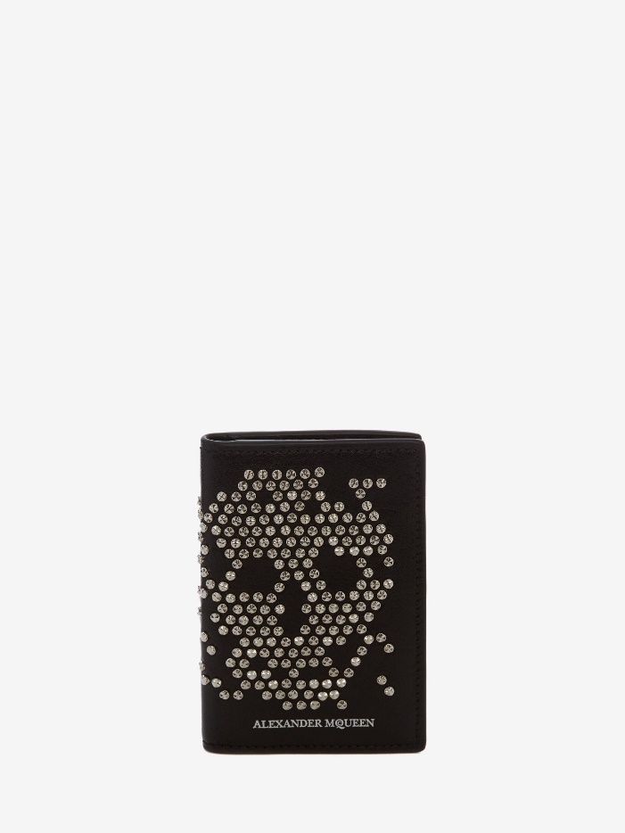

Men's Brushstroke Billfold Wallet in Black/white

#### $599.0

### **Product details**

* 100% Calfskin
* Dimensions: 7 x 11 x 0,8 cm / 2.7 x 4.3 x 0.3 inches
* Black calf leather pocket organizer with an exploded skull made of

hammered studs

* Two bill compartments.
* It features three credit card slots and three flat pockets.
* White printed Alexander McQueen signature on the front.