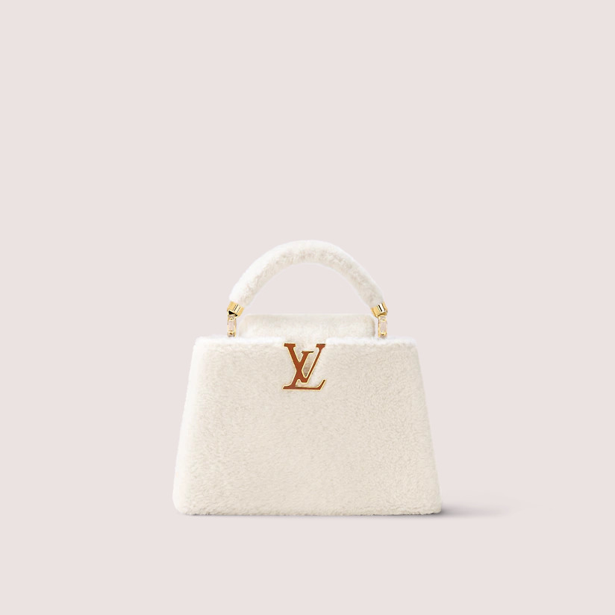

This reference is either

Made in

France, Spain, Italy or in the US.

#### $2999.0

### **Product details**

* White
* Shearling and Taurillon-leather trim
* Gold-color and enamel hardware
* Double carry style: flap inside or outside
* Compartmented interior with zipped pocket
* Strap: Removable, not adjustable
* Strap Drop: 54.0 cm