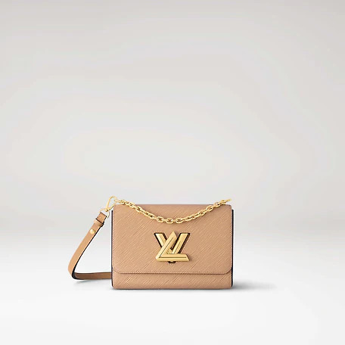

This reference is either

Made in

France, Spain, Italy or in the US.

#### $1199.0

### **Product details**

* Camel Light Brown
* Epi grained cowhide leather
* Epi cowhide-leather trim
* Smooth cowhide leather lining
* Gold-color hardware
* Transforming signature LV Twist lock
* 1 interior flat back pocket