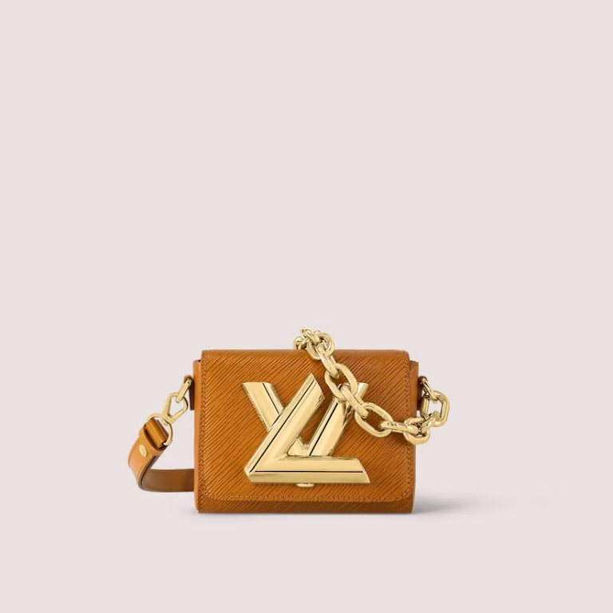

This reference is either

Made in

France, Spain, Italy or in the US.

#### $1999.0

### **Product details**

* Gold Miel Brown
* Epi cowhide leather
* Gold-color hardware
* Large inside pocket
* Flap closure with decorative LV Twist lock (not functional)
* Strap Drop Max.: 51.5 cm
* Chain Drop: 23.0 cm