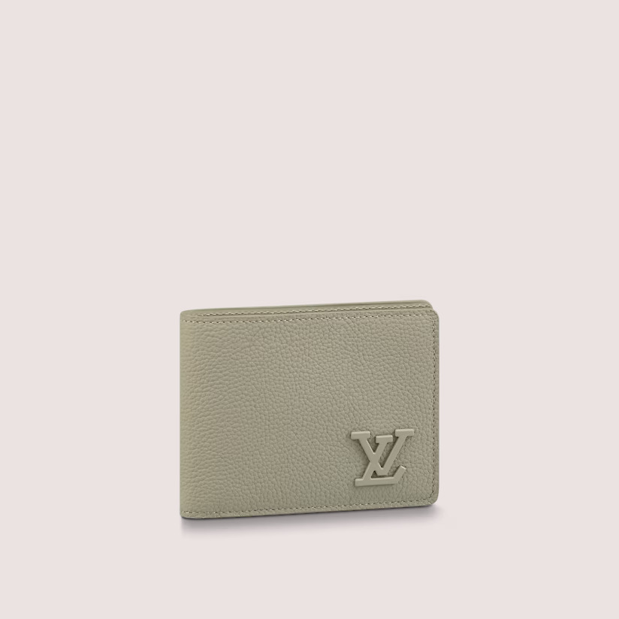

This reference is either

Made in

France, Spain, Italy or in the US.

#### $699.0

### **Product details**

* Cowhide leather
* Cowhide-leather trim
* 3 card slots
* 2 inside pockets
* 2 compartments for bills and tickets
* 2 side slots for receipts