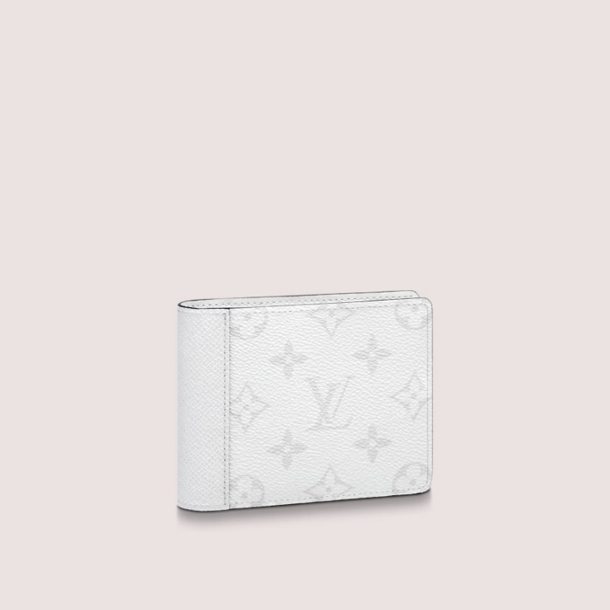

This reference is either

Made in

France, Spain, Italy or in the US.

#### $999.0

### **Product details**

* Optic White
* Monogram coated canvas and Taiga cowhide leather
* Cowhide-leather lining
* Palladium-color hardware
* 3 card slots
* 2 inside pockets