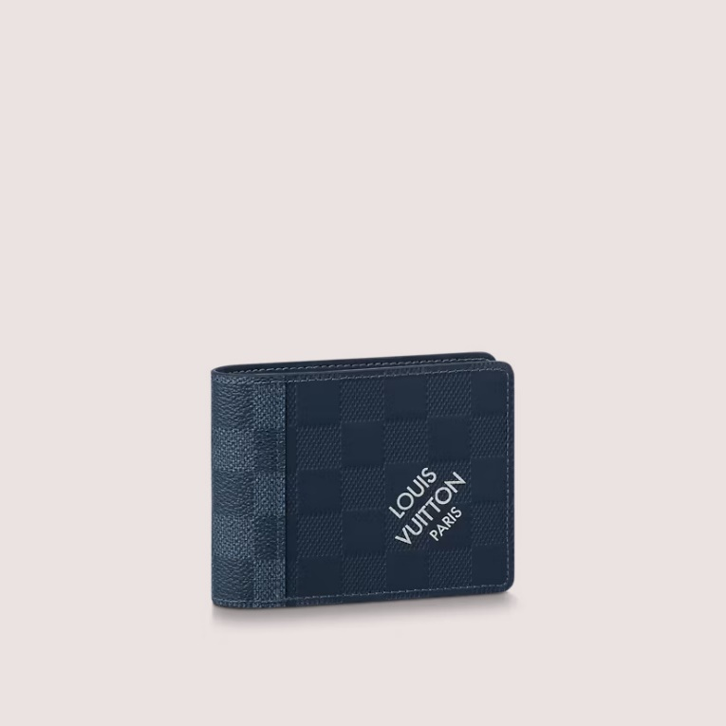

This reference is either

Made in

France, Spain, Italy or in the US.

#### $ 899.0

### **Product details**

* Blue Sapphire
* Damier Infini cowhide leather and Damier Graphite coated canvas
* Cowhide-leather lining
* 8 card slots
* 3 card slots
* Bill compartment