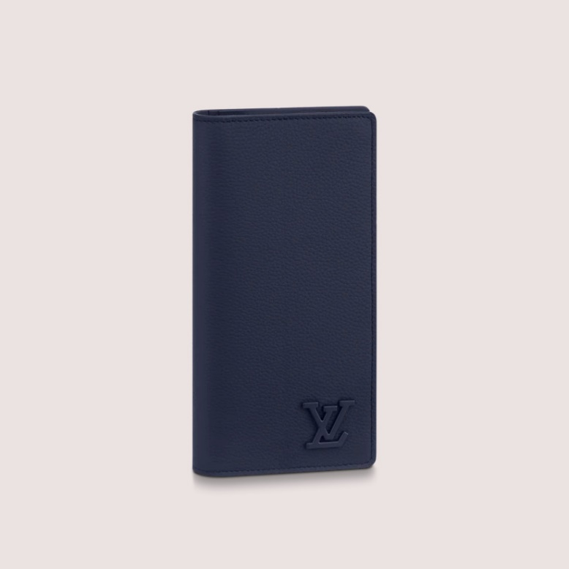

This reference is either

Made in

France, Spain, Italy or in the US.

#### $ 1190.0

### **Product details**

* Navy Blue
* LV Aerogram cowhide leather
* Signature initials in tone-on-tone metal
* 16 credit card slots
* ID or business card slot
* 4 inside flat compartments for bills and tickets
* Large zipped coin compartment