

|  |  |
| --- | --- |
| Facial Emotion Recognition |  |
|  |  |



|  |  |  |
| --- | --- | --- |
|  |  |  |
|  | *Abstract* Gartner predicts that by 2022, 10% of [personal devices will have emotion AI capabilities](https://www.gartner.com/en/newsroom/press-releases/2018-03-20-gartner-highlights-10-uses-for-ai-powered-smartphones), either on-device or via [cloud services](https://www.gartner.com/smarterwithgartner/understand-the-cloud-spectrum/), up from less than 1% in 2018. In order to enhance the interaction between smart devices and humans, it is essential for the smart devices to get to know about the human’s nature and behavior. To contribute to this cause, facial emotion recognition has proven vital as it predicts the mood and emotion of a person. So, we have designed a facial emotion recognition system that predicts the emotion of a person based on their facial expressions and features from their face images. Our system targets anger, fear, happiness, neutral, sadness and surprise classes with accuracy of 69.98% and loss of 85.59% by detecting the face from the image and then extracting the emotion. |  |



# *Introduction and Background*

These days, a growing number of intelligent systems use emotion detection models to enhance their communication with people. This is significant because it enables the systems to modify their replies and behavioral patterns in reaction to the human's emotions, improving the relationship. Thus, this leads to our project that is Facial Emotion Recognition, which has its applications in video gaming, medical diagnosis, education, autonomous cars industry etc., After recognizing the importance of emotion recognition, many people have contributed in this domain. This research article (Jiang n.d.) proposes the approach where Gabor feature is taken as input where Gabor wavelength changes would lead to extraction of ROI feature leading to feature mapping processing. The results would be fed in the feature fusion model and channel attention model. The second contributor (Arora 2022) proposes ECNN (Enhanced Convolution Neural Network) with feature extraction using holistic, hybrid approach with geo-metric based and template technique.

Coming to our approach, we have proposed a DCNN model with 6 convolution layers, 2 dense layers along with dropout layers, batch normalization and max pooling, to which images are fed in after being preprocessed. We have combined the system of facial emotion recognition with face detection techniques for more usability (combination which is proposed by us), targeting 6 classes i.e., of anger, fear, happiness, neutral, sadness and surprise.

|  |  |  |
| --- | --- | --- |
|  |  |  |
|  | Motivation We, humans, are recognizing facial expressions and detecting emotions for ages. But making use of these gestures for business benefits and service improvement is new. Though recognizing faces and detecting emotions with technology are not easy tasks; the advent of facial recognition and emotion detection systems has made it possible (Modawal, 2022). Emotion detection technology can help the product industry understand the real emotions of clients when they try a product. Companies can arrange a product testing session, record it and analyze it to detect and asses the facial emotions that arise during the session. Facial Emotion Recognition is an instinctive impression of an individual's psychological state, which contains rich profound data, and is one of the main types of relational correspondence. It very well may be utilized in different fields, including brain research and assess personality traits in interviews. As a celebrity in old China, Zeng Guofan's insight includes facial emotion recognition strategies. His book Bing Jian sums up eight strategies on the most proficient method to recognize individuals, particularly how to pick the right one (Jiang n.d.). | |

# Results:



The epoch’s history shows that accuracy gradually increases and achieves ~70% accuracy on both training and validation dataset. Also, ReduceLROnPlateau is called whenever the accuracy plateaus.

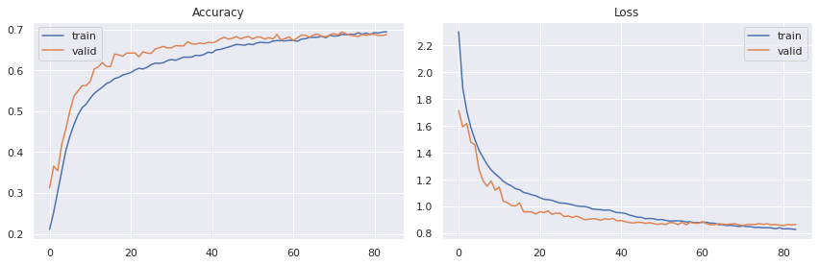

Plotting the distribution of training and validation metrics:

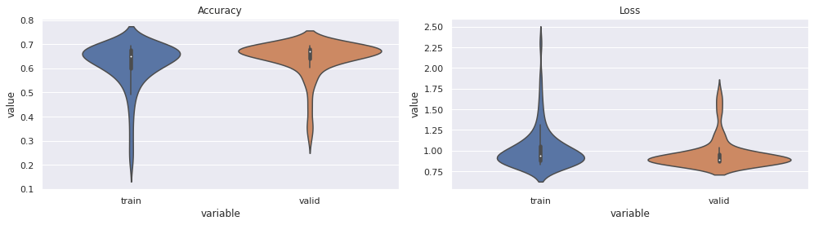

# References

Arora, Tarun Kumar. "Optimal Facial Feature Based Emotional Recognition Using Deep Learning Algorithm." *Computational Intelligence and Neuroscience,* 2022.

Jiang, Yizhang. "Facial Expression Emotion Recognition Model Integrating Philosophy and Machine Learning Theory." n.d.

Modawal, A. (2022). Know the benefits of facial recognition and emotion detection tools.