**COMSATS University Islamabad,   
Park Road, Chak Shahzad, Islamabad Pakistan**

SOFTWARE DESIGN DESCRIPTION   
(SDD DOCUMENT)

for

**GharPey**  
Version 1.0

***By***

**Muhammad Abdullah CIIT/FA16-BSE-057/ISB**

**Shahzaib Munawar CIIT/ FA16- BSE-047/ISB**

**Malik Abdullah CIIT/ FA16- BSE-101/ISB**

***Supervisor*Mr. M Rashid Mukhtar**

*Bachelor of Science in Computer Science (2016-2020)*

Table of Contents

1. Introduction 1

2. Design methodology and software process model 1

3. System overview 1

3.1 Architectural design 2

3.2 Process flow/Representation 3

4. Design Models 9

4.1 Class Diagram 9

4.2 Sequence Diagram 10

4.2.1 Request Order 10

4.2.2 Request Service 11

4.2.3 Support Ticket 12

4.2.4 Payment 13

5. Data design 14

5.1 Data dictionary 15

5.1.1 ADMINS: 15

5.1.2 MODERATORS: 15

5.1.3 BUYERS: 15

5.1.4 PRODUCT: 16

5.1.5 PRODUCT_CATEGORIES 16

5.1.6 QUESTIONS: 17

5.1.7 ANSWERS: 17

5.1.8 PRODUCT_TAG: 17

5.1.9 PRODUCT_REVIEWS: 18

5.1.10 PRODUCT_ORDER: 18

5.1.11 ORDERS: 18

5.1.12 CITIES: 19

5.1.13 STATES: 19

5.1.14 COUNTRIES: 19

5.1.15 CITY_ARES: 20

5.1.16 SELLERS: 20

5.1.17 SUPPORT_TICKETS: 21

5.1.18 SUPPORT_TICKET_MESSAGES: 21

5.1.19 TRANSACTIONS: 21

5.1.20 SERVICES: 22

5.1.21 SERVICE_CATEGORIES: 22

5.1.22 SERVICE_SELLER: 23

5.1.23 SELLER_SELLER_REVIEWS: 23

5.1.24 SERVICE_QUESTIONS: 23

5.1.25 SERVICE_REQUESTS: 24

5.1.26 SERVICE_REQUEST_ANSWERS: 24

5.1.27 SERVICE_REQUEST_INVOICE_DETAILS: 24

5.1.28 SERVICE_REQUEST_QUOTES: 25

5.1.29 SERVICE_REQUEST_INVOICES: 25

5.1.30 SERVICE_QUESTION_CHOICE: 25

5.1.31 SERVICE_REQUEST_ANSWER_TEXT_MULTILINES: 26

5.1.32 SERVICE_REQUEST_ANSWER_CHOICES: 26

5.1.33 SERVICE_REQUEST_ANSWER_DATES: 26

5.1.34 SERVICE_REQUEST_ANSWER_TEXTS: 26

5.1.35 SERVICE_REQUEST_ANSWER_DATE_TIMES: 26

5.1.36 SERVICE_REQUEST_ANSWER_FILES: 27

5.1.37 SERVICE_REQUEST_ANSWER_TIMES: 27

5.1.38 SERVICE_REQUEST_ANSWER_BOOLEANS: 27

6. Algorithm & Implementation 28

6.1 Seller’s Registration: 28

6.2 Order Product: 29

6.3 Order Service: 29

6.4 Create Quotation/Invoice for Service Request (Seller): 29

6.5 Pay Invoice for Service Request (Buyer): 30

6.6 Add New Moderator as Admin: 30

6.7 Edit Moderator as Admin: 30

7. Software requirements traceability matrix 31

8. Human interface design 32

8.1 Screen images 32

8.1.1 Screen Home Web 32

8.1.2 Screen Products Search Web 33

8.1.3 Screen Checkout Web 34

8.1.4 Screen Cart Web 35

8.1.5 Screen Settings Web 36

8.1.6 Screen Home Mobile 37

8.2 Screen objects and actions 38

8.2.1 Screen Home Web 38

8.2.2 Screen Products Search Web 38

8.2.3 Screen Checkout Web 38

8.2.4 Screen Cart Web 38

8.2.5 Screen Settings Web 38

8.2.6 Screen Home Mobile 38

Revision History

|  |  |  |  |
| --- | --- | --- | --- |
| **Name** | **Date** | **Reason for changes** | **Version** |
|  |  |  |  |
|  |  |  |  |

**Application Evaluation History**

|  |  |
| --- | --- |
| **Comments (by committee)**  **\*include the ones given at scope time both in doc and presentation** | **Action Taken** |
|  |  |
|  |  |

Supervised by

<Supervisor’s Name>

Signature______________

# Introduction

This project proposal document is intended to describe the system's scope. This document also contains statement of problems and proposed solution, modules, related system analysis, tools and technology, and system benefits.

The proposed system is an initiative to empower hardworking and skilled women by providing them with a market appraisal platform to sell their products and services. Our mission is to increase economic opportunity in Pakistan. The proposed system consists of a web and an android application.

# Design methodology and software process model

Incremental model is selected because this model make risk management easy as risky pieces are handled during the iterations and as our system requirements are clearly understood. The model generates working software quickly and early during the software life cycle and it is easier to test and debug. Move over, it is flexible and less expensive to change requirements and scope.

# System overview

There are a huge number of hardworking women in Pakistan who work at home or any workplace making products that they are unable to display and sell on some huge audience platform. Similarly, talented women lack opportunities to deliver local services like Bridal Makeup etc. Whether it's a doorstep service or the service they provide from home/workplace, the issue continues in either way. The proposed system aimed at helping those hardworking talented women by offering a platform to sell their products and services at much lower cost and with less understanding.

The proposed system will allow and encourage the Pakistani women to use digital marketplace and showcase their skills and talent in well-secured manner through this platform. This platform will allow seller to create a shop as her brand, add products on it and sell them. Besides products, sellers can also provide system-defined services that could be either the doorstep service or the home / workplace service they provide Sellers can manage their store portfolios and maintain reputation through buyer reviews to survive the digital market platform. This system allows sellers to create live sessions and increase the visibility of their products to the public. Sellers can keep track of all orders and payments and enjoy popular local payment methods.

## Architectural design

## Process flow/Representation

**Administrator:**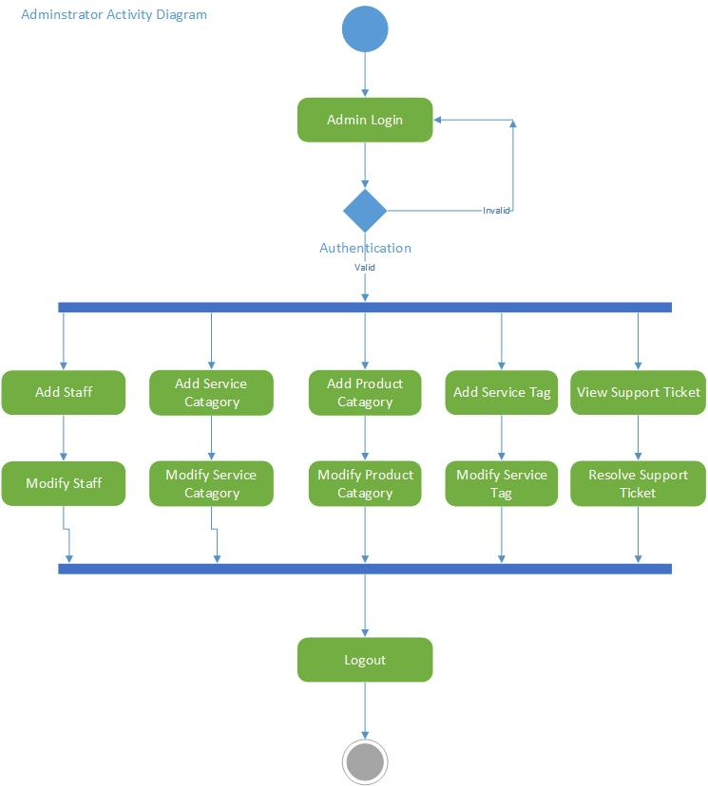

**Moderator:**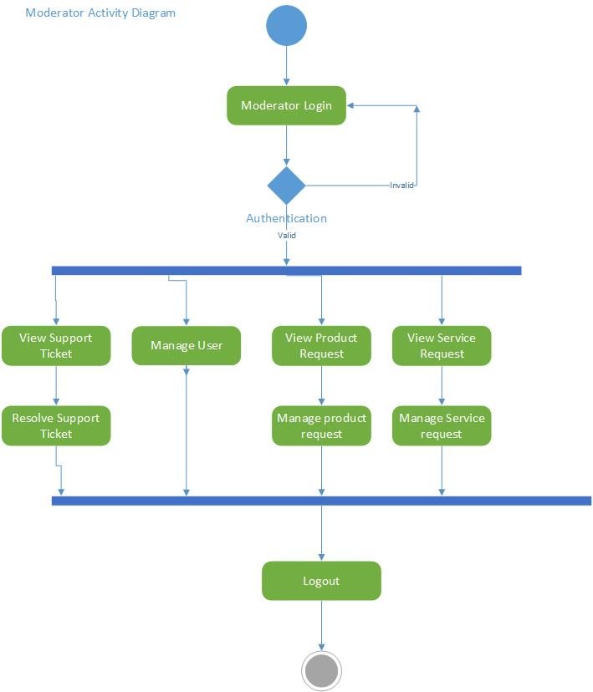

**Seller:**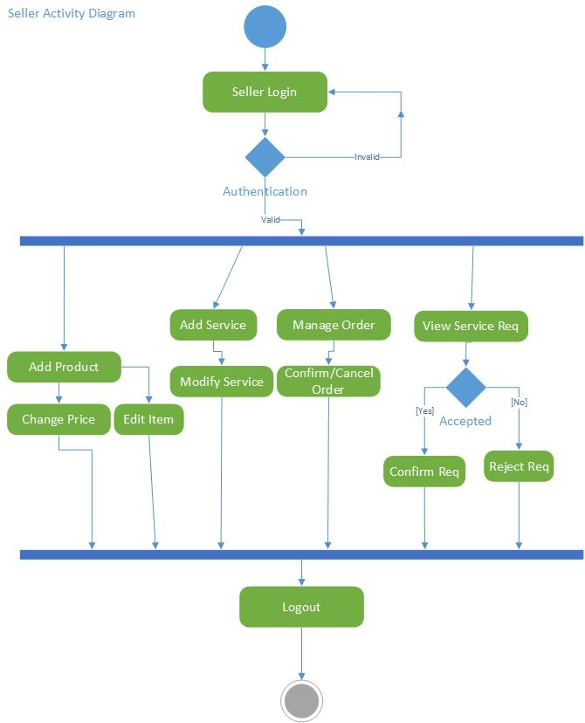

**Service:**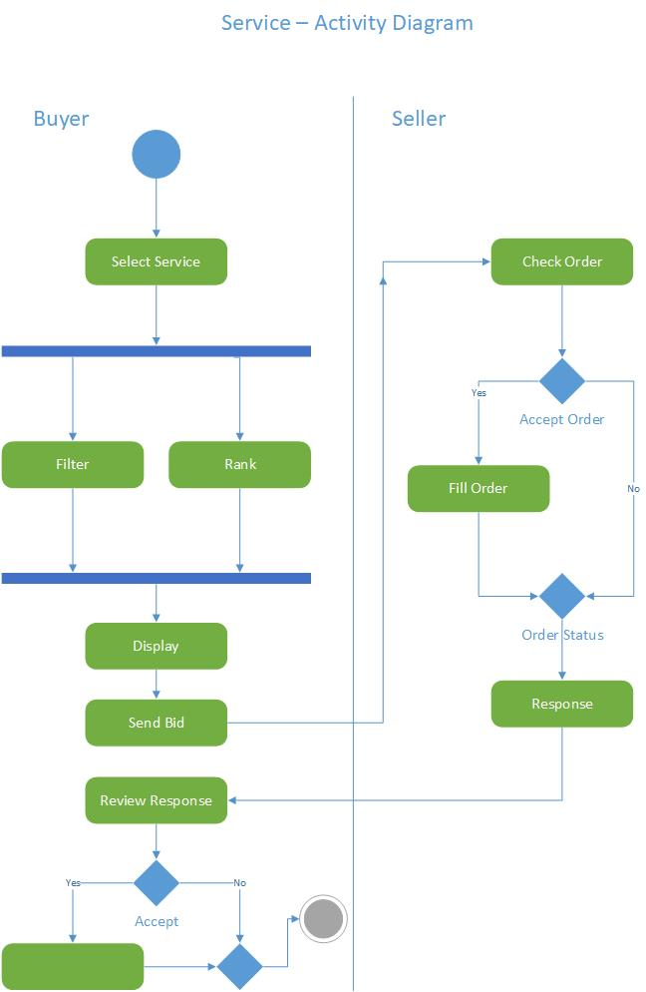

**Buyer:**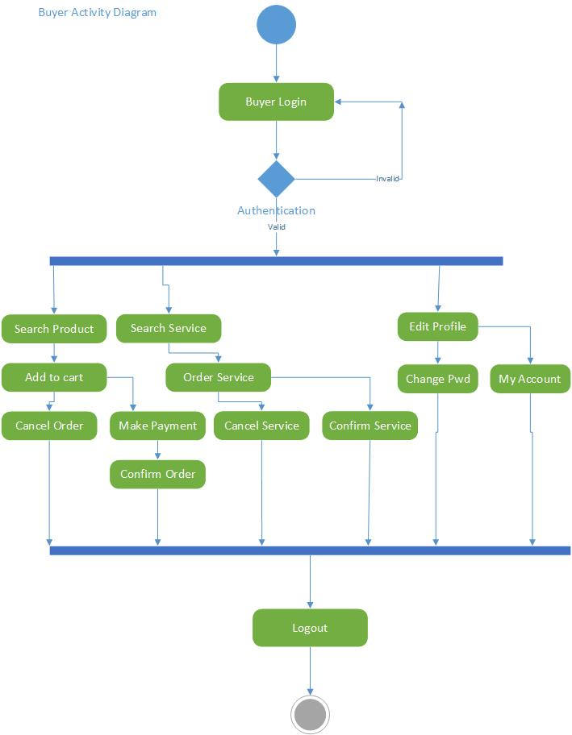

**Online Shopping:**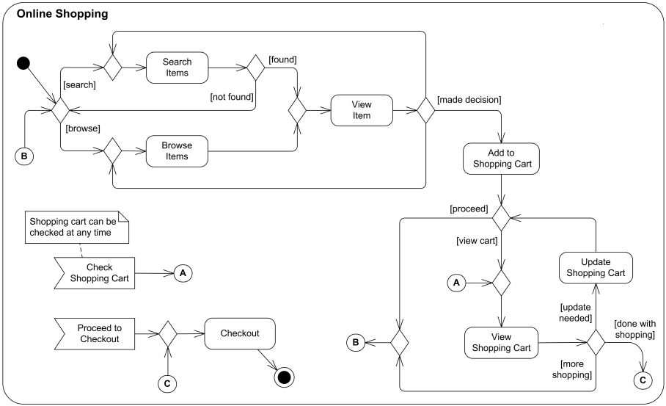

**Process Order:**

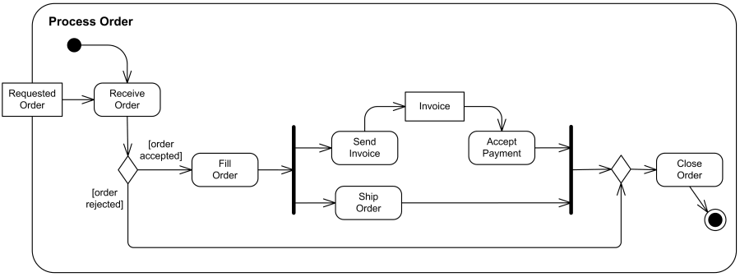

# Design Models

## Class Diagram

## Sequence Diagram

### Request Order

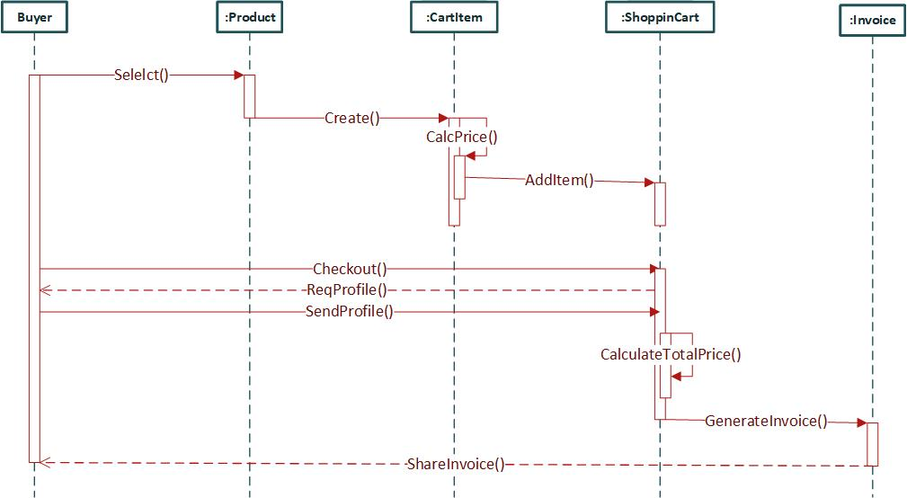

### Request Service

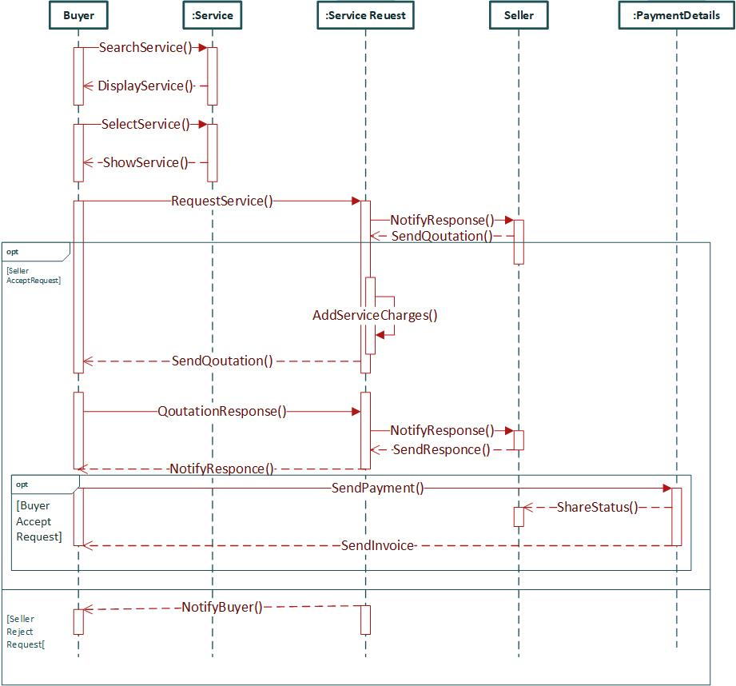

### Support Ticket

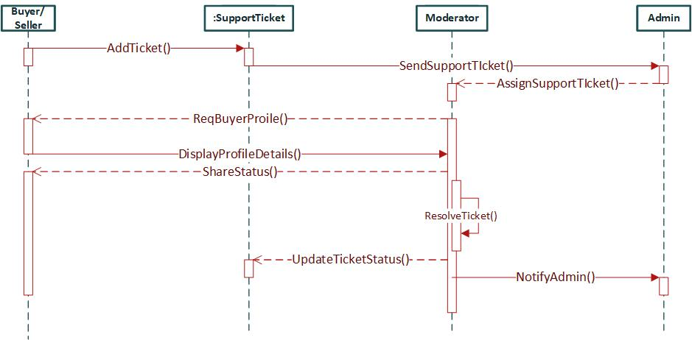

### Payment

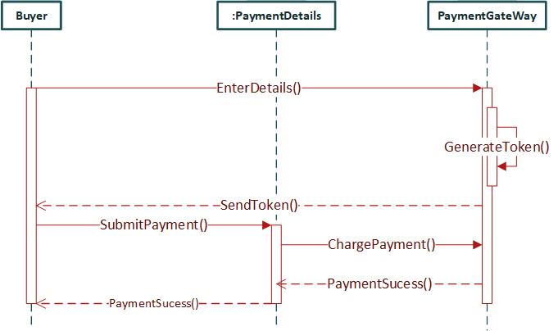

# Data design

**[ERD Attached]**

## Data dictionary

### ADMINS:

|  |  |  |
| --- | --- | --- |
| **Fields** | **Data Type** | **Size** |
| Id | BIGINT | 20 |
| Name | VARCHAR | 255 |
| Phone | VARCHAR | 255 |
| Email | VARCHAR | 255 |
| Email_verified_at | TIMESTAMP |  |
| password | VARCHAR | 255 |
| Remember_token | VARCHAR | 100 |
| Created_at | TIMESTAMP |  |
| Updated_at | TIMESTAMP |  |

### MODERATORS:

|  |  |  |
| --- | --- | --- |
| **Fields** | **Data Type** | **Size** |
| Id | BIGINT | 20 |
| Name | VARCHAR | 255 |
| Phone | VARCHAR | 255 |
| Address | VARCHAR | 255 |
| Email | VARCHER | 255 |
| Location_id | INT | 10 |
| Email_verified_at | TIMESTAMP |  |
| password | VARCHAR | 255 |
| Remember_token | VARCHAR | 100 |
| Created_at | TIMESTAMP |  |
| Updated_at | TIMESTAMP |  |

### BUYERS:

|  |  |  |
| --- | --- | --- |
| **Fields** | **Data Type** | **Size** |
| Id | BIGINT | 20 |
| Email | VARCHAR | 255 |
| Name | VARCHAR | 255 |
| Phone | VARCHAR | 255 |
| Address | VARCHAR | 255 |
| Location_id | BIGINT | 10 |
| Email_verified_at | TIMESTAMP |  |
| password | VARCHAR | 255 |
| Remember_token | VARCHAR | 100 |
| Created_at | TIMESTAMP |  |
| Updated_at | TIMESTAMP |  |

### PRODUCT:

|  |  |  |
| --- | --- | --- |
| **Fields** | **Data Type** | **Size** |
| Id | BIGINT | 20 |
| seller_id | BIGINT | 20 |
| category_id | BIGINT | 20 |
| Name | VARCHAR | 255 |
| Slug | VARCHAR | 255 |
| Featured_image | VARCHAR | 255 |
| Description | TEXT |  |
| Price | Decimal | (16,2) |
| Created_at | TIMESTAMP |  |
| Updated_at | TIMESTAMP |  |

### PRODUCT_CATEGORIES

|  |  |  |
| --- | --- | --- |
| **Fields** | **Data Type** | **Size** |
| Id | BIGINT | 20 |
| Name | VARCHAR | 255 |
| Slug | VARCHAR | 255 |
| Featured_image | VARCHAR | 255 |
| Created_at | TIMESTAMP |  |
| Updated_at | TIMESTAMP |  |

### QUESTIONS:

|  |  |  |
| --- | --- | --- |
| **Fields** | **Data Type** | **Size** |
| Id | BIGINT | 20 |
| Buyer_id | BIGINT | 20 |
| Question-title | TEXT | 255 |
| question_id | BIGINT | 20 |
| Question_description | TEXT | 10 |
| item_type | Varcher | 255 |
| Created_at | TIMESTAMP |  |
| Updated_at | TIMESTAMP |  |

### ANSWERS:

|  |  |  |
| --- | --- | --- |
| **Fields** | **Data Type** | **Size** |
| Id | BIGINT | 20 |
| question_id | BIGINT | 20 |
| Answer_title | TEXT | 255 |
| Answer_description | TEXT | 20 |
| Created_at | TIMESTAMP |  |
| Updated_at | TIMESTAMP |  |

### PRODUCT_TAG:

|  |  |  |
| --- | --- | --- |
| **Fields** | **Data Type** | **Size** |
| Id | BIGINT | 20 |
| Name | VARCHAR | 255 |
| Tag_id | BIGINT | 20 |
| Created_at | TIMESTAMP |  |
| Updated_at | TIMESTAMP |  |

### PRODUCT_REVIEWS:

|  |  |  |
| --- | --- | --- |
| **Fields** | **Data Type** | **Size** |
| Id | BIGINT | 20 |
| product_id | BIGINT | 20 |
| Product_order_ID | BIGINT | 20 |
| question_id | BIGINT | 20 |
| Review | TEXT |  |
| Rating | SMALLINT | 5 |
| Created_at | TIMESTAMP |  |
| Updated_at | TIMESTAMP |  |

### PRODUCT_ORDER:

|  |  |  |
| --- | --- | --- |
| **Fields** | **Data Type** | **Size** |
| Id | BIGINT | 20 |
| Order_id | BIGINT | 20 |
| Product-id | BIGINT | 20 |
| Product_price | DECIMAL | (12,4) |
| Created_at | TIMESTAMP |  |
| Updated_at | TIMESTAMP |  |

### ORDERS:

|  |  |  |
| --- | --- | --- |
| **Fields** | **Data Type** | **Size** |
| Id | BIGINT | 20 |
| Buyer_id | BIGINT | 20 |
| Shipping_address | VARCHAR | 255 |
| Shipping_location_id | BIGINT | 20 |
| Charge_id | VARCHAR | 255 |
| Note | MEDIUMTEXT |  |
| Paid_at | TIMESTAMP |  |
| Completed_at | TIMESTAMP |  |
| Created_at | TIMESTAMP |  |
| Updated_at | TIMESTAMP |  |

### CITIES:

|  |  |  |
| --- | --- | --- |
| **Fields** | **Data Type** | **Size** |
| Id | BIGINT | 20 |
| Name | VARCHAR | 255 |
| city_id | INT | 10 |
| Zip | VARCHER | 255 |
| Created_at | TIMESTAMP |  |
| Updated_at | TIMESTAMP |  |

### STATES:

|  |  |  |
| --- | --- | --- |
| **Fields** | **Data Type** | **Size** |
| Id | BIGINT | 20 |
| Name | VARCHAR | 255 |
| Country_id | INT | 10 |
| Created_at | TIMESTAMP |  |
| Updated_at | TIMESTAMP |  |

### COUNTRIES:

|  |  |  |
| --- | --- | --- |
| **Fields** | **Data Type** | **Size** |
| Id | BIGINT | 20 |
| Name | VARCHAR | 255 |
| Created_at | TIMESTAMP |  |
| Updated_at | TIMESTAMP |  |

### CITY_ARES:

|  |  |  |
| --- | --- | --- |
| **Fields** | **Data Type** | **Size** |
| Id | BIGINT | 20 |
| Name | VARCHAR | 255 |
| City_id | INT | 10 |
| ZIP | VARCHAR | 255 |
| Created_at | TIMESTAMP |  |
| Updated_at | TIMESTAMP |  |

### SELLERS:

|  |  |  |
| --- | --- | --- |
| **Fields** | **Data Type** | **Size** |
| Id | BIGINT | 20 |
| Name | VARCHAR | 255 |
| Phone | VARCHAR | 255 |
| Return_address | VARCHAR | 255 |
| Email | VARCHER | 255 |
| Approved_at | INT | 10 |
| Email_verified_at | TIMESTAMP |  |
| Verification_code | VARCHAR | 255 |
| Phone_verified_at | TIMESTAMP |  |
| Cnic | VARCHAR | 255 |
| Warehouse_address | VARCHAR | 255 |
| Warehouse_location_id | BIGINT | 20 |
| password | VARCHAR | 255 |
| Remember_token | VARCHAR | 100 |
| Return_location_id | BIGINT | 20 |
| Business_address | VARCHAR | 255 |
| Business_location_id | BIGINT | 20 |
| Created_at | TIMESTAMP |  |
| Updated_at | TIMESTAMP |  |

### SUPPORT_TICKETS:

|  |  |  |
| --- | --- | --- |
| **Fields** | **Data Type** | **Size** |
| Id | BIGINT | 20 |
| User_id | BIGINT | 20 |
| User_type | BOGINT | 20 |
| Moderator_id | BIGINT | 20 |
| Moderator_type | VARCHAR | 255 |
| Resolved_at | TIMESTAMP |  |
| Created_at | TIMESTAMP |  |
| Updated_at | TIMESTAMP |  |

### SUPPORT_TICKET_MESSAGES:

|  |  |  |
| --- | --- | --- |
| **Fields** | **Data Type** | **Size** |
| Id | BIGINT | 20 |
| Support_ticket_id | BIGINT | 20 |
| Title | VARCHAR | 255 |
| Message | MEDIUMTEXT |  |
| Created_at | TIMESTAMP |  |
| Updated_at | TIMESTAMP |  |

### TRANSACTIONS:

|  |  |  |
| --- | --- | --- |
| **Fields** | **Data Type** | **Size** |
| Id | BIGINT | 20 |
| user_id | BIGINT | 20 |
| User_type | VARCHAR | 255 |
| reference_id | BIGINT | 20 |
| Reference_type | VARCHAR | 255 |
| Type | ENUM |  |
| Amount | DECIMALS |  |
| Balance | DECIMALS |  |
| Note | TEXT |  |
| Created_at | TIMESTAMP |  |
| Updated_at | TIMESTAMP |  |

### SERVICES:

|  |  |  |
| --- | --- | --- |
| **Fields** | **Data Type** | **Size** |
| Id | BIGINT | 20 |
| category_id | BIGINT | 20 |
| Name | VARCHAR | 255 |
| featured_image_id | VARCHAR | 255 |
| slug | VARCHAR | 255 |
| Description | MEDIUMTEXT |  |
| Created_at | TIMESTAMP |  |
| Updated_at | TIMESTAMP |  |

### SERVICE_CATEGORIES:

|  |  |  |
| --- | --- | --- |
| **Fields** | **Data Type** | **Size** |
| Id | BIGINT | 20 |
| Name | VARCHAR | 255 |
| featured_image_id | VARCHAR | 255 |
| slug | VARCHAR | 255 |
| Created_at | TIMESTAMP |  |
| Updated_at | TIMESTAMP |  |

### SERVICE_SELLER:

|  |  |  |
| --- | --- | --- |
| **Fields** | **Data Type** | **Size** |
| Id | BIGINT | 20 |
| service_id | BIGINT | 20 |
| Seller_id | BIGINT | 20 |
| Price | DECIMAL | (16,4) |
| Description | MEDIUMTEXT |  |
| Created_at | TIMESTAMP |  |
| Updated_at | TIMESTAMP |  |

### SELLER_SELLER_REVIEWS:

|  |  |  |
| --- | --- | --- |
| **Fields** | **Data Type** | **Size** |
| Id | BIGINT | 20 |
| Service_seller_id | BIGINT | 20 |
| Service_request_id | BIGINT | 20 |
| Buyer_id | BIGINT | 20 |
| Review | TEXT |  |
| Rating | SMALLINT | 5 |
| Created_at | TIMESTAMP |  |
| Updated_at | TIMESTAMP |  |

### SERVICE_QUESTIONS:

|  |  |  |
| --- | --- | --- |
| **Fields** | **Data Type** | **Size** |
| Id | BIGINT | 20 |
| service_id | BIGINT | 20 |
| Seller_serrvice_id | BIGINT | 20 |
| Name | VARCHAR | 255 |
| Type | ENUM |  |
| Question | TEXT | 10 |
| Is_locked | TINYINT | 1 |
| Is_required | TINYINT | 1 |
| Auth_rule | VARCHAR | 255 |
| item_type | Varcher | 255 |
| Created_at | TIMESTAMP |  |
| Updated_at | TIMESTAMP |  |

### SERVICE_REQUESTS:

|  |  |  |
| --- | --- | --- |
| **Fields** | **Data Type** | **Size** |
| Id | BIGINT | 20 |
| Service_seller_id | BIGINT | 20 |
| buyer_id | BIGINT | 20 |
| Location_id | BIGINT | 20 |
| Completed_at | TIMESTAMP |  |
| Created_at | TIMESTAMP |  |
| Updated_at | TIMESTAMP |  |

### SERVICE_REQUEST_ANSWERS:

|  |  |  |
| --- | --- | --- |
| **Fields** | **Data Type** | **Size** |
| Id | BIGINT | 20 |
| request _id | BIGINT | 20 |
| question_id | BIGINT | 20 |
| Answer_id | BIGINT | 20 |
| Answer_type | VARCHAR | 255 |
| Created_at | TIMESTAMP |  |
| Updated_at | TIMESTAMP |  |

### SERVICE_REQUEST_INVOICE_DETAILS:

|  |  |  |
| --- | --- | --- |
| **Fields** | **Data Type** | **Size** |
| Id | BIGINT | 20 |
| request _id | BIGINT | 20 |
| Detail | Text |  |
| COST | DECIMAL | (8,2) |
| Quantity | INT | 11 |
| Created_at | TIMESTAMP |  |
| Updated_at | TIMESTAMP |  |

### SERVICE_REQUEST_QUOTES:

|  |  |  |
| --- | --- | --- |
| **Fields** | **Data Type** | **Size** |
| Id | BIGINT | 20 |
| request _id | BIGINT | 20 |
| Quote | DECIMAL | (8,2) |
| Type | ENUM |  |
| Note | MEDIUMTEXT |  |
| Created_at | TIMESTAMP |  |
| Updated_at | TIMESTAMP |  |

### SERVICE_REQUEST_INVOICES:

|  |  |  |
| --- | --- | --- |
| **Fields** | **Data Type** | **Size** |
| Id | BIGINT | 20 |
| request _id | BIGINT | 20 |
| charge_id | BIGINT | 20 |
| Description | MEDIUMTEXT |  |
| Paid_at | TIMESTAMP |  |
| Created_at | TIMESTAMP |  |
| Updated_at | TIMESTAMP |  |

### SERVICE_QUESTION_CHOICE:

|  |  |  |
| --- | --- | --- |
| **Fields** | **Data Type** | **Size** |
| Id | BIGINT | 20 |
| question_id | BIGINT | 20 |
| Choice | VARCHAR | 255 |
| Created_at | TIMESTAMP |  |
| Updated_at | TIMESTAMP |  |

### SERVICE_REQUEST_ANSWER_TEXT_MULTILINES:

|  |  |  |
| --- | --- | --- |
| **Fields** | **Data Type** | **Size** |
| Id | BIGINT | 20 |
| Answer | TEXT |  |

### SERVICE_REQUEST_ANSWER_CHOICES:

|  |  |  |
| --- | --- | --- |
| **Fields** | **Data Type** | **Size** |
| Id | BIGINT | 20 |
| Choice_id | BIGINT | 20 |

### SERVICE_REQUEST_ANSWER_DATES:

|  |  |  |
| --- | --- | --- |
| **Fields** | **Data Type** | **Size** |
| Id | BIGINT | 20 |
| Answer | DATE |  |

### SERVICE_REQUEST_ANSWER_TEXTS:

|  |  |  |
| --- | --- | --- |
| **Fields** | **Data Type** | **Size** |
| Id | BIGINT | 20 |
| Answer | VARCHAR | 255 |

### SERVICE_REQUEST_ANSWER_DATE_TIMES:

|  |  |  |
| --- | --- | --- |
| **Fields** | **Data Type** | **Size** |
| Id | BIGINT | 20 |
| Answer | DATETIME |  |

### SERVICE_REQUEST_ANSWER_FILES:

|  |  |  |
| --- | --- | --- |
| **Fields** | **Data Type** | **Size** |
| Id | BIGINT | 20 |
| File_path | VARCHAR | 255 |
| File_type | VARCHAR | 255 |

### SERVICE_REQUEST_ANSWER_TIMES:

|  |  |  |
| --- | --- | --- |
| **Fields** | **Data Type** | **Size** |
| Id | BIGINT | 20 |
| Answer | TIME |  |

### SERVICE_REQUEST_ANSWER_BOOLEANS:

|  |  |  |
| --- | --- | --- |
| **Fields** | **Data Type** | **Size** |
| Id | BIGINT | 20 |
| Answer | TINYINT | 1 |

# Algorithm & Implementation

## Seller’s Registration:

Display Registration form.

Validate Registration form on submission.

If (validation-successful)

Store seller’s information in database

Set approval to false.

Set phone verification to false.

Set email verification to false.

Send email to seller’s provided email address.

Open Email Verification Link

If (valid-verification-link)

Set seller’s email to verified

Show Success message of email verification

Show Phone Form Page

Validate Phone form on submission.

If (valid-phone-number)

Send Phone Verification Code

Show Phone Verification Page

Validate Verification Code on submission

If(valid-verification-code)

Set seller’s phone to verified

Show Address Form

Validate Addresses on submission

If (valid-addresses)

Update Addresses of seller

Show Approval Status Page

Else

Show Error Message

Else

Show Error Message

Else

Show Error Message

Else

Show Error Message

Else

Show Error Message

## Order Product:

Display “Products”.

Add Product Items to Cart

Display Cart Page when click on Cart button

Display Checkout page when click on Checkout button

Display Payment Methods

Display Payment Page of selected payment method

Validate Payment Information on Submission.

If (validation-successful)

Charge Payment

Store Product Orders Information in Database

Notify Seller of Order

Show Success Message

Else

Show Error Message

## Order Service:

Display “Services”.

Display Service Page when Select Service

Display all Sellers for the service

Display Questions Form for Selected Service

Validate Questions Inputs on Submission.

If (validation-successful)

Create Service Request in database

Notify Seller

Show Success Message to wait for quotation

Else

Show Error Message

## Create Quotation/Invoice for Service Request (Seller):

Display “Service Requests”.

Display ServiceRequest Page when Select Service Request

Display Answers for Selected Service Request

Display Invoice/Quote Form

Validate Invoice Inputs on Submission.

If (validation-successful)

Create Invoice for Service Request in database

Notify Buyer

Show Success Message

Else

Show Error Message

## Pay Invoice for Service Request (Buyer):

Display “Service Requests”.

Display ServiceRequest Page when Select Service Request

Display Invoices for Service Request

Display Payment Form when select Unpaid Invoice

Display Payment Methods

Display Payment Page of selected payment method

Validate Payment Information on Submission.

If (validation-successful)

Charge Payment

Store Payment Information in Database for Service Request

Notify Seller of Payment

Show Success Message of successful order placement.

Else

Show Error Message

## Add New Moderator as Admin:

Display “Add Moderator” form.

Validate form on submission.

If (validation-successful)

Store moderator’s information in database

Send welcome email to moderator’s email address along with their password.

Show Success Message

Else

Show Error Message

## Edit Moderator as Admin:

Display “Edit Moderator” form.

Validate form on submission.

If (validation-successful)

Update moderator’s information in database

Show Success Message

Else

Show Error Message

# Software requirements traceability matrix

Table 1 Requirements Traceability Matrix

|  |  |  |  |
| --- | --- | --- | --- |
| **Req. Number** | **Ref. Item** | **Design Component** | **Component Items** |
| FR001-FR014 | Class Diagram | Person | Register(), Login(), |
| FR021-FR026,  FR031-FR034 | Class Diagram | Person | UpdateProfile() |
| FR312-FR320 | Class Diagram | Admin | ApproveSeller() |
| FR107-FR124 | Class Diagram | Moderator, SupportTicket | TakeSupportTickets(), ResolveSupportTicket() |
| FR045-FR051 | Class Diagram | Moderator | ApproveProduct() |
| FR066-FR073 | Class Diagram | Moderator | ApproveService() |
| FR001-FR014 | Class Diagram | Seller | VerifyPhone(), VerifyEmail() |
| FR045-FR055 | Class Diagram | Seller | AddProduct(), ModifyProduct() |
| FR066-FR076 | Class Diagram | Seller | AddService(), ModifyService() |
| FR149-FR152 | Class Diagram | Buyer | RequestSerivce(), |
| FR199-FR204 | Class Diagram | Buyer | SearchProduct() |
| FR147-FR148 | Class Diagram | Buyer | SearchService() |
| FR126-FR138 | Class Diagram | Buyer | Checkout() |
| FR252-FR269 | Class Diagram | ProductCategory | CreateCategory(), ModifyCategory() |
| FR272-FR289 | Class Diagram | ServiceCategory | CreateCategory(), ModifyCategory() |
| FR292-FR310 | Class Diagram | Tags | CreateTag(), ModifyTag(), |
| FR141-FR142 | Class Diagram | Service | DisplayService(), GetServiceReviews() |
| FR199-FR200 | Class Diagram | Product | DisplayProducts(), GetProductDetails(), |
| FR133-FR-135 | Class Diagram | Order, ShippingInfo | PlaceOrder(),UpdateShippingInfo() |
| FR136-FR-137 | Class Diagram | PaymentGateway | PaymentRequest(), PaymentResponse() |

# Human interface design

## Screen images

### Screen Home Web

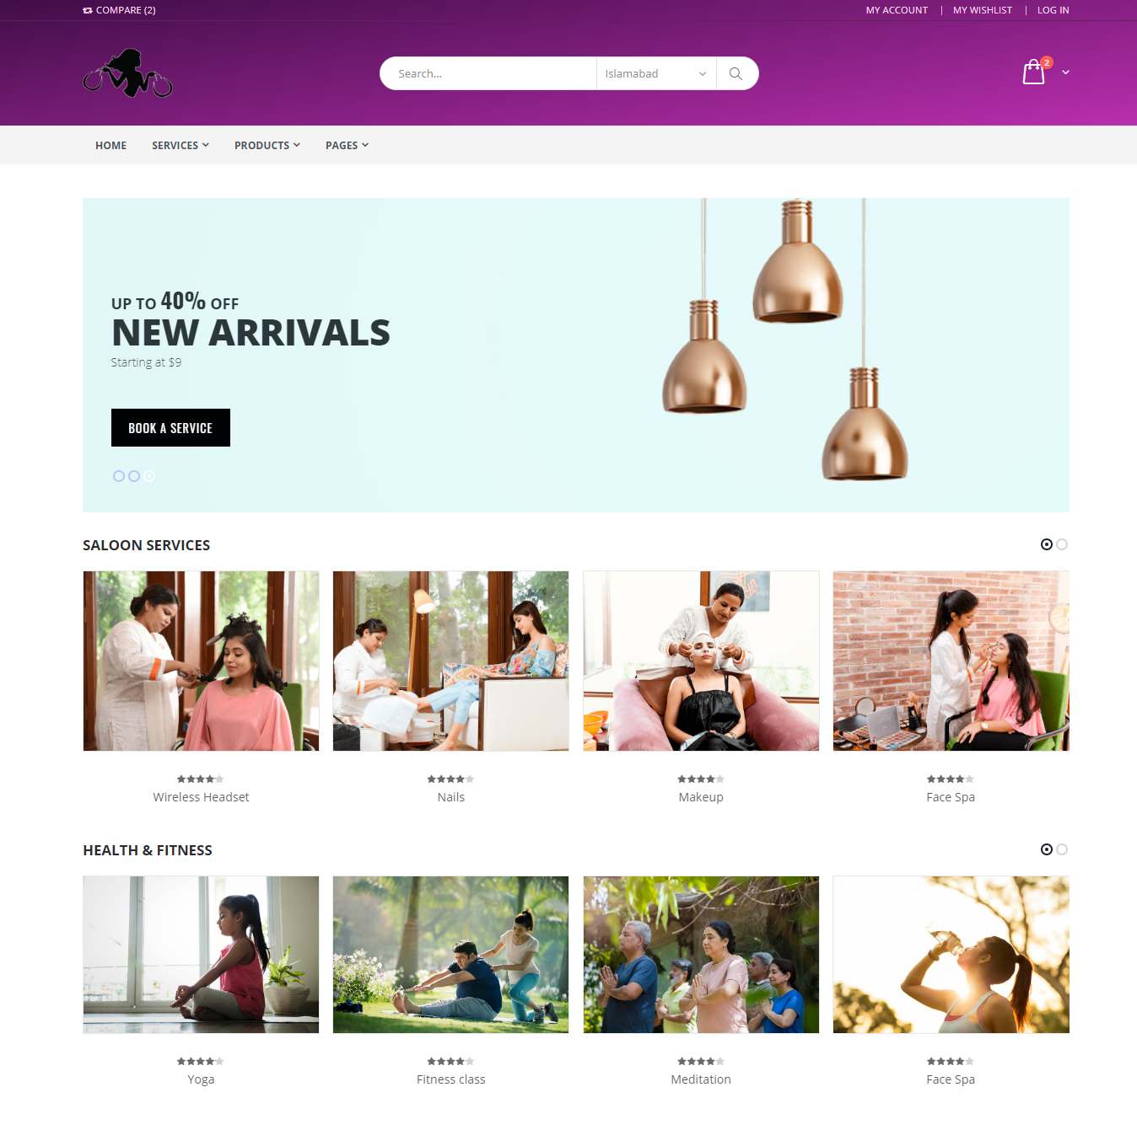

### Screen Products Search Web

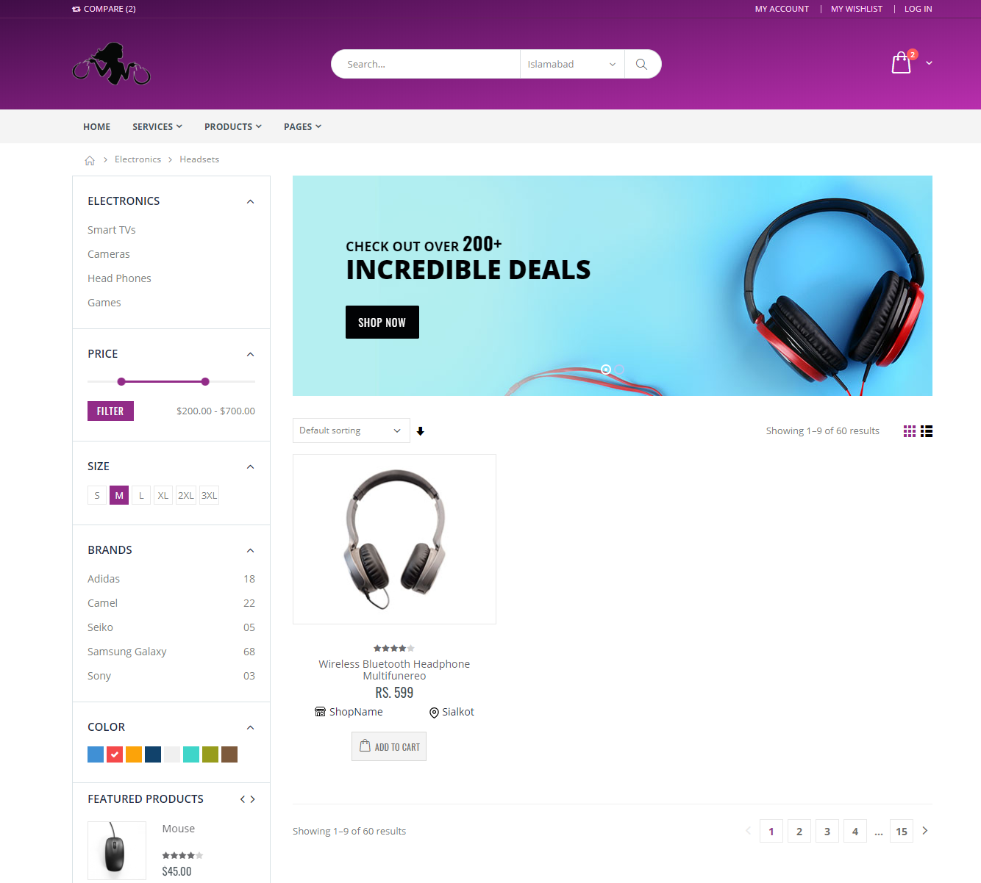

### Screen Checkout Web

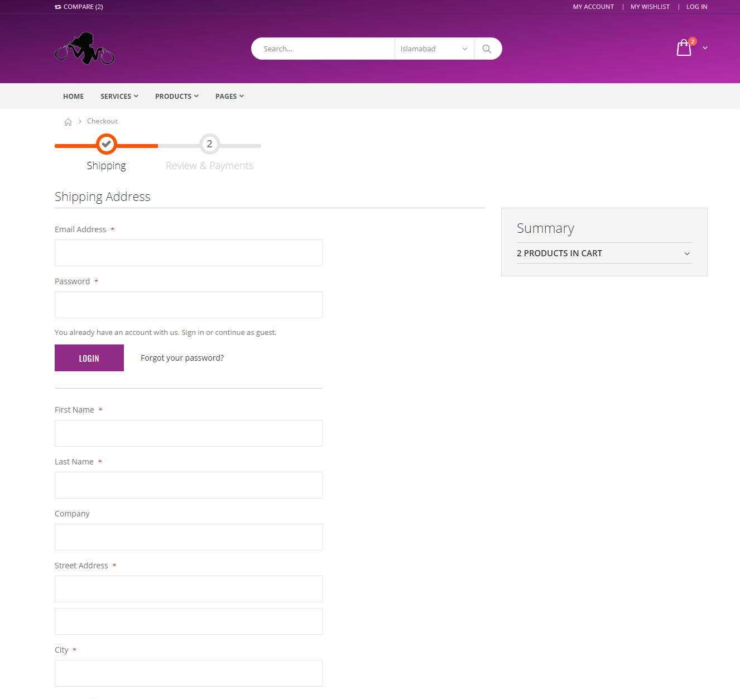

### Screen Cart Web

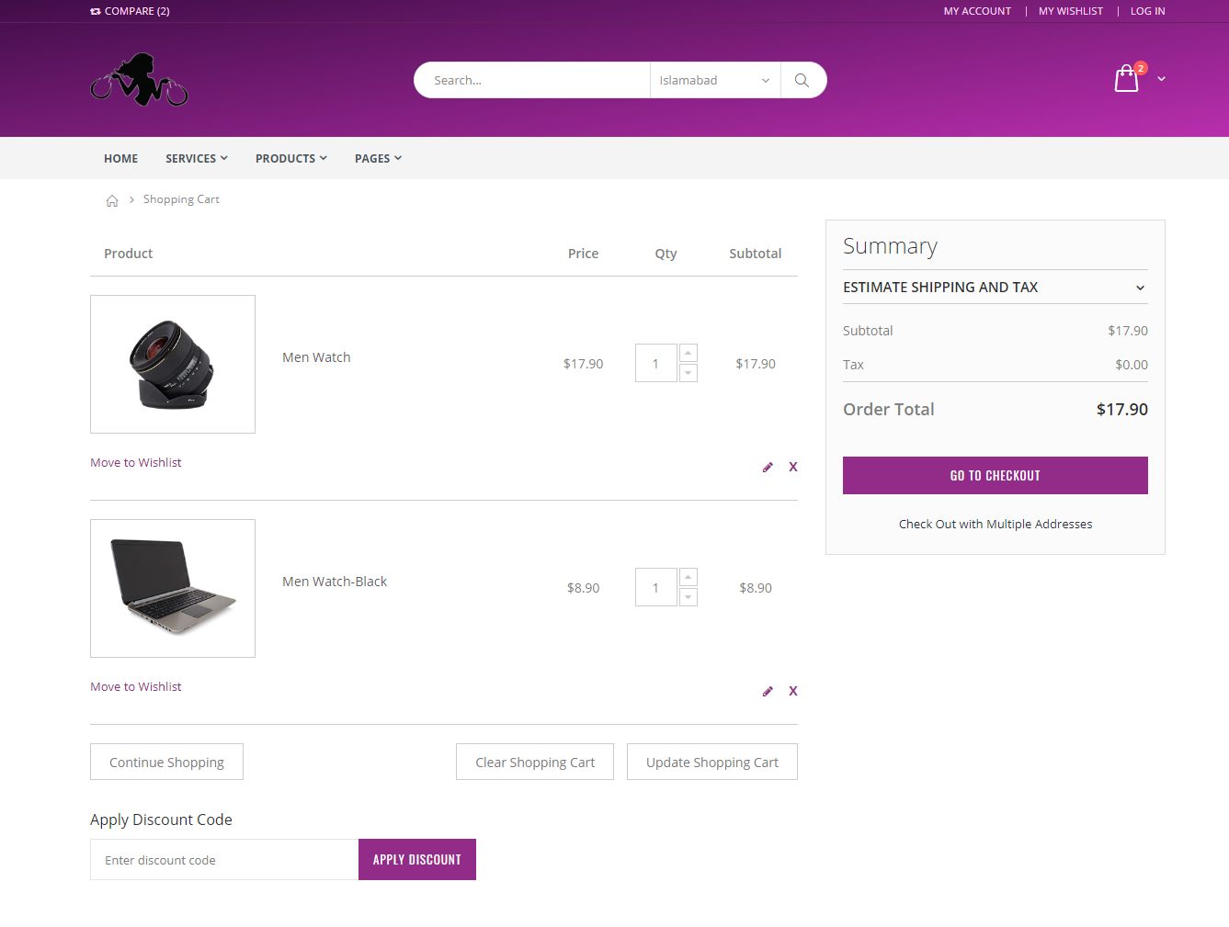

### Screen Settings Web

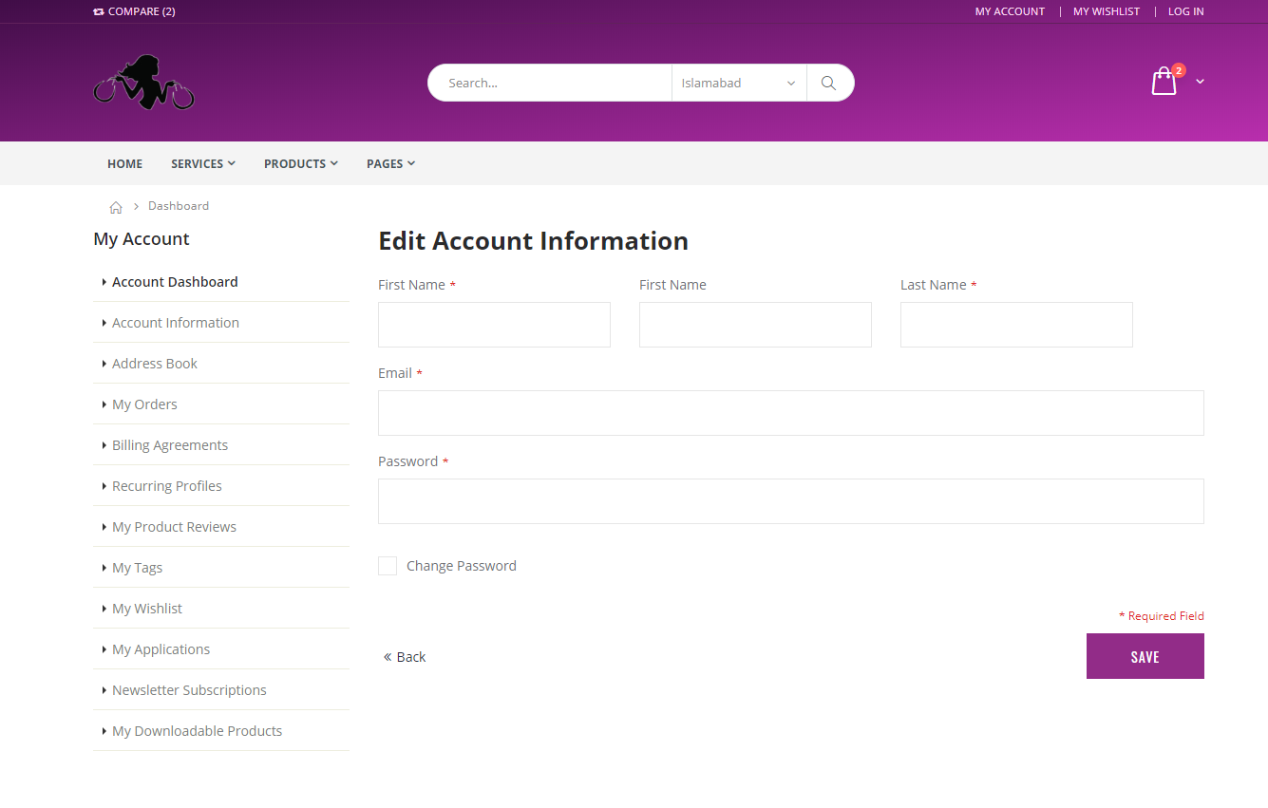

### Screen Home Mobile

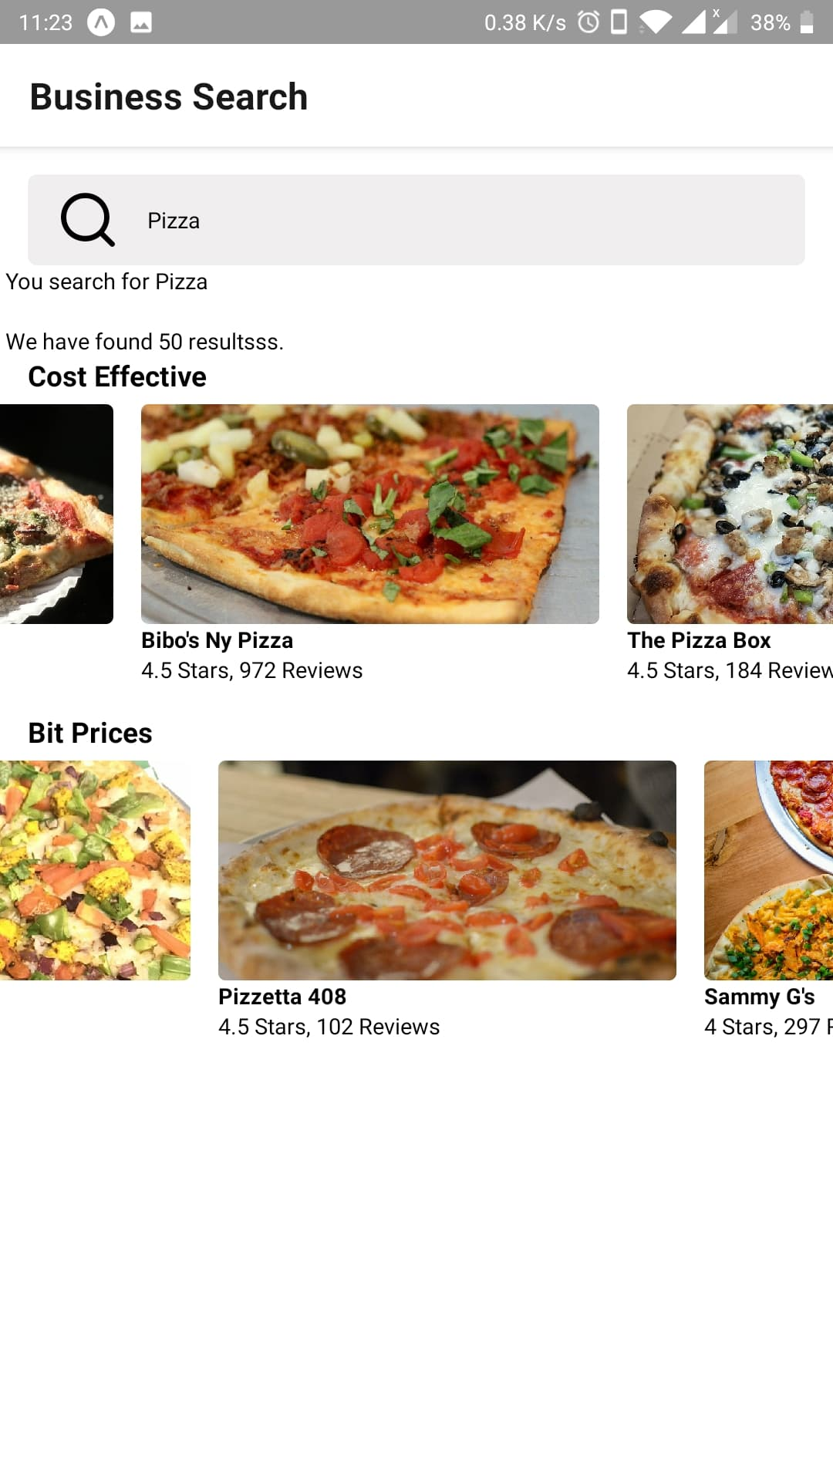

## Screen objects and actions

### Screen Home Web

This is main screen of web application. It will be accessible to all users. It will display the top products and services to users.

### Screen Products Search Web

This is page have search and filters form for products. This page shows products from queried inputs.

### Screen Checkout Web

This page show payment methods and payment forms to user after they proceed from cart.

### Screen Cart Web

This page shows all product items to user that they have added in their cart. This page is used to review products and finalize order.

### Screen Settings Web

This is settings page for user. A user must be logged in to access this page. This page can be used to update profile information like name and address Info.

### Screen Home Mobile

This is main screen of mobile application. It is accessible to all users. It displays the top products to users.