­­

**COMSATS University Islamabad,   
Park Road, Chak Shahzad, Islamabad Pakistan**

Project Proposal  
(SCOPE DOCUMENT)

for

**GharPey**  
Version 1.0

***By***

**Muhammad Abdullah CIIT/FA16-BSE-057/ISB**

**Shahzaib Munawar CIIT/ FA16- BSE-047/ISB**

**Malik Abdullah CIIT/ FA16- BSE-101/ISB**

***Supervisor***  
**Mr. M Rashid Mukhtar**

*Bachelor of Science in Software Engineering (2016-2020)*

|  |  |  |
| --- | --- | --- |
| **No.** | **Comment** | **Action** |
|  |  |  |
|  |  |  |
|  |  |  |
|  |  |  |
|  |  |  |
|  |  |  |

**SCOPE DOCUMENT REVSION HISTORY**

**Supervisor Signature**

**Date: _________________**

Table of Contents

1. Introduction 4

2. Problem Statement 4

3. Problem Solution for Proposed System 4

4. Related System Analysis/Literature Review 5

5. Advantages/Benefits of Proposed System 5

6. Scope 5

7. Modules 6

7.1 Module 1: User Management 6

7.1.1 Admin 6

7.1.2 Moderator 6

7.1.3 Buyer 6

7.1.4 Seller 6

7.2 Module 2: Shop Management 6

7.3 Module 3: Product Management 6

7.3.1 Order Management 6

7.3.2 Inventory 6

7.3.3 Reviews 7

7.3.4 Wishlist 7

7.3.5 Cart 7

7.4 Module 4: Service Management 7

7.4.1 Service Request Management 7

7.4.2 Reviews 7

7.5 Module 5: Payment Gateways 7

7.5.1 Products 7

7.5.2 Services 7

7.5.3 Memberships 7

7.6 Module 6: Shipping & Delivery Management 7

7.7 Module 7: Finance Management 8

7.8 Module 8: Reports & Analytics 8

7.9 Module 9: Products & Services Q&As 8

7.10 Module 10: Notifications 8

7.11 Module 11: Live Streaming 8

7.12 Module 12: Seller Memberships 8

7.12.1 Free Seller 8

7.12.2 Pro Seller 8

8. System Limitations/Constraints 9

9. Software Process Methodology 9

10. Tools and Technologies 10

11. Project Stakeholders and Roles 11

12. Team Members Individual Tasks/Work Division 11

13. Data Gathering Approach 11

14. Concepts 12

15. Gantt chart 13

16. Mockups 14

17. Conclusion 21

18. References 21

19. Plagiarism Report 21

**Project Category:**

**A-**Desktop Application/Information System **B-**Web Application/Web Application based Information System  **C-** Problem Solving and Artificial Intelligence  **D-**Simulation and Modeling ** E-** Smartphone Application  **F-** Smartphone Game  **G-** Networks  **H-** Image Processing



****Other (specify category) ______________________

.

# Introduction

This project proposal document is intended to describe the system's scope. This document also contains statement of problems and proposed solution, modules, related system analysis, tools and technology, and system benefits.

The proposed system is an initiative to empower hardworking and skilled women by providing them with a market appraisal platform to sell their products and services. Our mission is to increase economic opportunity in Pakistan. The proposed system consists of a web and an android application.

# Problem Statement

Women play a central role in family, community and social development in Pakistan, as elsewhere in the developing world. However, women often remain invisible and unheard. Women more

than men must balance the complexities of surviving in extreme poverty, yet these women are excluded from debate because they lack confidence and absence mobility.

There are a huge number of hardworking women in Pakistan who work at home or any workplace making products that they are unable to display and sell on some huge audience platform. Even if they want to promote their products, it's only going to cost them a lot and it requires a lot of understanding as well. These products are, of course, limited to their nearby places. Similarly, talented women lack opportunities to deliver local services like Bridal Makeup etc. Whether it's a doorstep service or the service they provide from home/workplace, the issue continues in either way.

So, there is a need of a system that aimed at helping those hardworking talented women by offering a platform to sell their products and services at much lower cost and with less understanding. Some issues have been discussed in some apps, but these issues are not being effectively resolved.

# Problem Solution for Proposed System

An android and web application are to be developed which will help hardworking talented women to sell their products and local services anywhere in Pakistan. The proposed system allows female seller to create her personal shop as a brand and upload her work products and services that were unheard and unseen before. In order to survive the digital market platform, sellers can handle their shop portfolios and retain reputation by buyers’ reviews. This allows the system to boost the economic opportunities and women empowerment in Pakistan.

Buyers, on the other hand, are looking for products and services in different shops and can buy a product or take a service from anywhere in Pakistan. Buyers can get a doorstep service or a service at the Buyer's workplace. The proposed system will provide local gateway payment that eases the local Buyers.

# Related System Analysis/Literature Review

|  |  |  |
| --- | --- | --- |
| **Application Name** | **Weakness** | **Proposed Project Solution** |
| Urban Clap | * Only offer services * Operate only in India * Don’t offer Products * Generic platform for everyone * Not focused towards women empowerment. | * Offer services. * Offer product. * Easy user experience (UX) for local user. * Provide security for sellers (women). * Focused towards women empowerment. |
| Super Taskers | * Don’t offer products. * Not focused towards women empowerment. * Don’t offer live video streaming | * Offers Products. * Mobile App * Focused towards women empowerment. * Offer live video for user engagement. |
| Gharpar.co | * Only offer services * Old and slow website * Less security * Don’t have proper support * Don’t offer online payment gateways | * Offers Services. * Focused towards women empowerment. * Offer local payments methods. * Mobile app |

Table 1: Related System Analysis with proposed project solution

# Advantages/Benefits of Proposed System

* Support of Local Payment Gateways.
* Allow offering products for sale.
* Allow offering services.
* Security for Sellers (Female).
* Focused towards women empowerment.
* Providing built in marketing tool like a live session for pro sellers.
* Mobile Application for buyers

# Scope

There are a huge number of hardworking women in Pakistan who work at home or any workplace making products that they are unable to display and sell on some huge audience platform. Similarly, talented women lack opportunities to deliver local services like Bridal Makeup etc. Whether it's a doorstep service or the service they provide from home/workplace, the issue continues in either way. The proposed system aimed at helping those hardworking talented women by offering a platform to sell their products and services at much lower cost and with less understanding.

The proposed system will allow and encourage the Pakistani women to use digital marketplace and showcase their skills and talent in well-secured manner through this platform. This platform will allow seller to create a shop as her brand, add products on it and sell them. Besides products, sellers can also provide system-defined services that could be either the doorstep service or the home / workplace service they provide Sellers can manage their store portfolios and maintain reputation through buyer reviews to survive the digital market platform. This system allows sellers to create live sessions and increase the visibility of their products to the public. Sellers can keep track of all orders and payments and enjoy popular local payment methods.

# Modules

## Module 1: User Management

Admin, Support staff, Sellers and Buyers will be able to login and use forget password. Buyers and Sellers can also register.

Buyers can also use mobile application to register and login.

### Admin

Admin have all permissions in admin portal. They will be able to manage support tickets product categories, service categories and moderators. They will also be able to ban buyers and sellers.

### Moderator

Moderator manage support tickets of sellers and buyers and resolve them in system. They have all permissions permitted by admin in the admin portal of the system.

### Buyer

The buyer can purchase products and services on system. Buyer can view their order history, review products and services, and ask questions on products and services.

Buyer will be required to verify their email for registration.

### Seller

Seller have permissions to manage products, services, portfolios, finance and Q&As of their account. Seller will be able to create a shop which acts as brand.

Seller will be required to verify their email, mobile and CNIC for registration.

## Module 2: Shop Management

System will allow sellers to create and manage their shop. Shop will work as seller profile in system where listing of their products and services will be shown.

## Module 3: Product Management

System will allow sellers to create products from the seller portal. Sellers will enter product information such as name, description, category, tags, weight, dimensions and inventory.

After approval of products from administration, these products will be displayed on main website and allow buyers to buy these products.

System will also allow admin and moderators to approve or block products from admin section.

### Order Management

System will allow buyers to place orders of products. Sellers will be able to manage the product orders from their portal. Seller will be able to confirm the products orders and notify buyer about status through system.

### Inventory

System will allow sellers to manage product inventory from seller portal and limit buyers to order within available stock limits.

### Reviews

System will allow sellers to give reviews on completed product and service orders. Reviews can be 1 to 5 stars along with short message and will be displayed along specified products and services.

### Wishlist

Buyer will be able to add products and services to their Wishlist. This list will be used to personalize user experience on site. It will also be used to send notifications to buyers about related promotions and discounts.

### Cart

System will allow buyers to add products to cart. Cart will be saved with user session. Buyers will be able to manage cart items such as removing item and quantity of items on cart page.

## Module 4: Service Management

System will allow sellers to offer services by selecting services defined by admin. System will allow buyers to use/hire these services. System will also allow admin and support staff to manage services and set predefined questions for services.

### Service Request Management

System allow buyers to request services. System will allow sellers to manage the service requests from their portal and manage invoices of service requests. System will notify buyer using email notifications when seller accept service request and create invoices.

### Reviews

System will allow buyers to give reviews on completed service orders. Reviews can be 1 to 5 stars and will be displayed along specified services.

## Module 5: Payment Gateways

### Products

System will allow buyers to pay for products with Debit Card, Easy Paisa and Cash on Delivery.

### Services

System will allow buyers to pay for service invoices with Debit Card and Easy Paisa.

### Memberships

System will allow sellers to pay for memberships with Credit Card, Debit Card and Easy Paisa.

## Module 6: Shipping & Delivery Management

System will use “TCS” APIs to estimate delivery costs and deliveries. Buyer will be notified on every status change of delivery like “Ready to send”, “Delivery Start”, “Reached your area” and “Delivery completed”.

## Module 7: Finance Management

System will have balance system for sellers. All revenue generated by completed product and service requests will be added in sellers balance. Seller will be able to define payment methods for withdraw. Sellers will be paid by system after reaching defined threshold amount periodically.

Only bank account transaction is offered for withdraw as payment method for now. And these will be handled manually by administration.

## Module 8: Reports & Analytics

Seller will be able to see reports on system about revenues generated by orders in form of time-based line charts. System will also show detailed charts on no of orders and give analytics about trending and popular products of shop to seller.

## Module 9: Products & Services Q&As

Buyers will be able to ask questions on products and services which will be publicly shown on specified product or service page.

Sellers will be able to respond to those questions from their portal.

## Module 10: Notifications

System will handle two types of notifications. One is email notifications and second is in-system notifications. These notifications will be generated on event base like new order creation, delivery status updates, support ticket responses, review responses, Q&As responses, etc.

## Module 11: Live Streaming

Allow the seller to do live video streaming, to promote their products and services. This feature is limited to pro users only. Live streaming will only be available on web application and not on mobile application.

## Module 12: Seller Memberships

System will offer two types of memberships for sellers. Sellers will be able to pay for membership monthly through integrated payment gateways and it doesn’t include cash payment.

### Free Seller

All new buyers will be on “Free Seller” membership by default. This membership allows sellers to create their shop and sell their products and services on our system. Free Seller will also have limits how much orders they can receive.

### Pro Seller

“Pro Seller” membership will offer all features from “Free Seller” membership. This membership will also allow to take unlimited orders and live video feature.

Moreover, pro sellers will be awarded a “Pro” badge, which will prioritize their products and services listings to buyers.

# System Limitations/Constraints

* Proposed system offers limited options (Easy Paisa, Debit Card) of payment methods. System can be improved in future updates to support more local payment methods.
* Proposed system will only provide mobile application for buyers.
* Proposed system will use Hybrid Mobile Application Platforms for mobile application which has significant performance tradeoffs.
* Proposed system is intended for female sellers.

# Software Process Methodology

Incremental model is selected because this model make risk management easy as risky pieces are handled during the iterations and as our system requirements are clearly understood. The model generates working software quickly and early during the software life cycle and it is easier to test and debug. Move over, it is flexible and less expensive to change requirements and scope.

# Tools and Technologies

|  |  |  |  |
| --- | --- | --- | --- |
| **Tools**  **And**  **Technologies** | **Tools** | **Version** | **Rationale** |
| Trello | - | For tasks assignments and team management |
| Slack | - | Team collaboration and real time messaging |
| MySQL Workbench | 8 | DBMS |
| IntelliJ PHPStorm | 2019 | IDE for Web Development |
| MS Office | 365 | Documentation and Presentations |
| Adobe XD | CC6 | Mockups Creation |
| Git | 2.2 | Version Control Software |
| SendGrid | - | Manage Emails |
| Twilio | - | Programmable SMS |
| **Technology** | **Version** | **Rationale** |
| MySQL | 2016 | Query Language |
| PHP | 7.3 | Programming Language |
| Laravel | 6 | PHP Web Framework |
| Html | 5 | Web Development |
| JavaScript | 9 | Programming Language |
| CSS | 4 | Web Design |
| React Native | 0.6 | Mobile Application Framework |
| Redis | 5 | In-memory key-value database |

Table 2: Tools and Technologies for Proposed Project

# Project Stakeholders and Roles

|  |  |
| --- | --- |
| **Project Sponsor** | COMSATS University, Islamabad  COMSATS University is a public university in Pakistan. It is a multi-campus university with its principal seat located in Islamabad. |
| **Stakeholder** | **Team Members**  **Shahzaib Munawar**   * **Role:** Documentarist, Frontend Developer, Mobile App Developer, Graphic Designer   **Muhammad Abdullah**   * **Role:** Documentarist, Backend Developer   **Malik Muhammad Abdullah Naeem**   * **Role:** Documentarist, Backend Developer, Mobile App Developer   **Project Supervisor:** Mr. M Rashid Mukhtar  **Final Year Project Committee:** Evaluation of project |

Table 2: Project Stakeholders for Proposed Project

# Team Members Individual Tasks/Work Division

|  |  |  |
| --- | --- | --- |
| **Student Name** | **Student Registration Number** | **Responsibility/ Modules** |
| Muhammad Abdullah | FA16-BSE-057 | **Backend & API Development:**  Module 1: User Management.  Module 3: Product Management.  Module 5: Payment Gateways.  Module 12: Seller Memberships. |
| Shahzaib Munawar | FA16-BSE-047 | **Frontend & Mobile Development:**  Module 9: Product & services Q&As.  Module 10: Notifications.  Module 8: Reports & Analytics.  Module 7 Finance Management.  Module 11: Live Streaming. |
| Malik Abdullah | FA16-BSE-101 | **Backend & API Development:**  Module 2: Shop Management.  Module 5: Payment Gateways.  Module 4: Service Management.  Module 6: Shipping and delivery management. |

Table 3: Team Member Work Division for Proposed Project

# Data Gathering Approach

The information and requirement gathering approaches that will be used during the proposed project are meetings for requirements of industrial stake holders, brainstorming with the team members and the supervisor, survey and related system analysis.

# Concepts

1. **Web Development**

This will teach us the core concepts of web development including frontend designing to backend development and building websites using frameworks.

1. **Mobile App Development**

This concept will us core concept of developing a mobile application. Mobile app development is a process by which mobile app is developed for mobile applications.

1. **UI/UX designing**

This concept will teach is to how to develop the design interface and develop user experience. UX refers to the user experience that emphasis on how something works when user interact with it.

1. **Database**

This concept will teach database management, creating and managing complex database structures and building web and mobile application using the database.

1. **APIs implementation**

An application program interface (API) is a set of routines, protocols, and tools for building software applications. Basically, an API specifies how software components should interact. Additionally, APIs are used when programming graphical user interface (GUI) components.

1. **Hybrid Mobile App development**

This concept will teach us to develop hybrid applications. Hybrid applications allow developers to write code once and use it in multiple platforms. e.g. Android and iOS.

1. **React Native**

This concept will teach us to learn React Native. React Native is an open-source mobile application framework created by Facebook. It is used to develop applications for Android, iOS, Web by enabling developers to use React along with native platform capabilities.

1. **Data visualization**   
   This Concept will teach us the science behind data visualization that how raw and huge amount of data can be visually display in the organized and structured manner to perform intelligent decision.
2. **Video Streaming**  
   This concept will teach us to create live real time video streaming platform and integrate it with the website.
3. **Economy of product development**This concept will teach us the economy of product development and developing a product with high revenue generating business model.

# Gantt chart

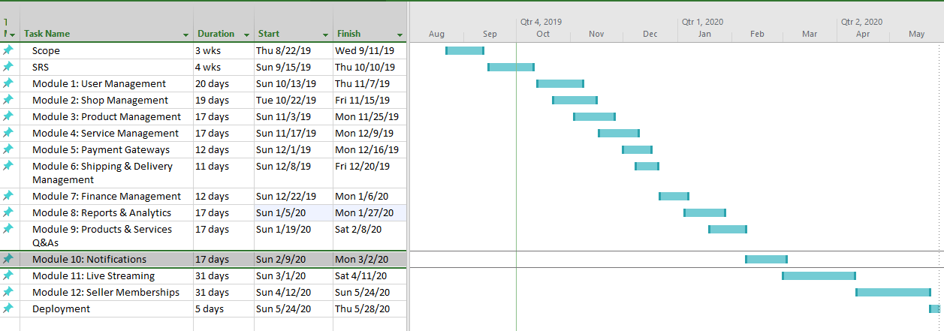

# Mockups

Home Page.

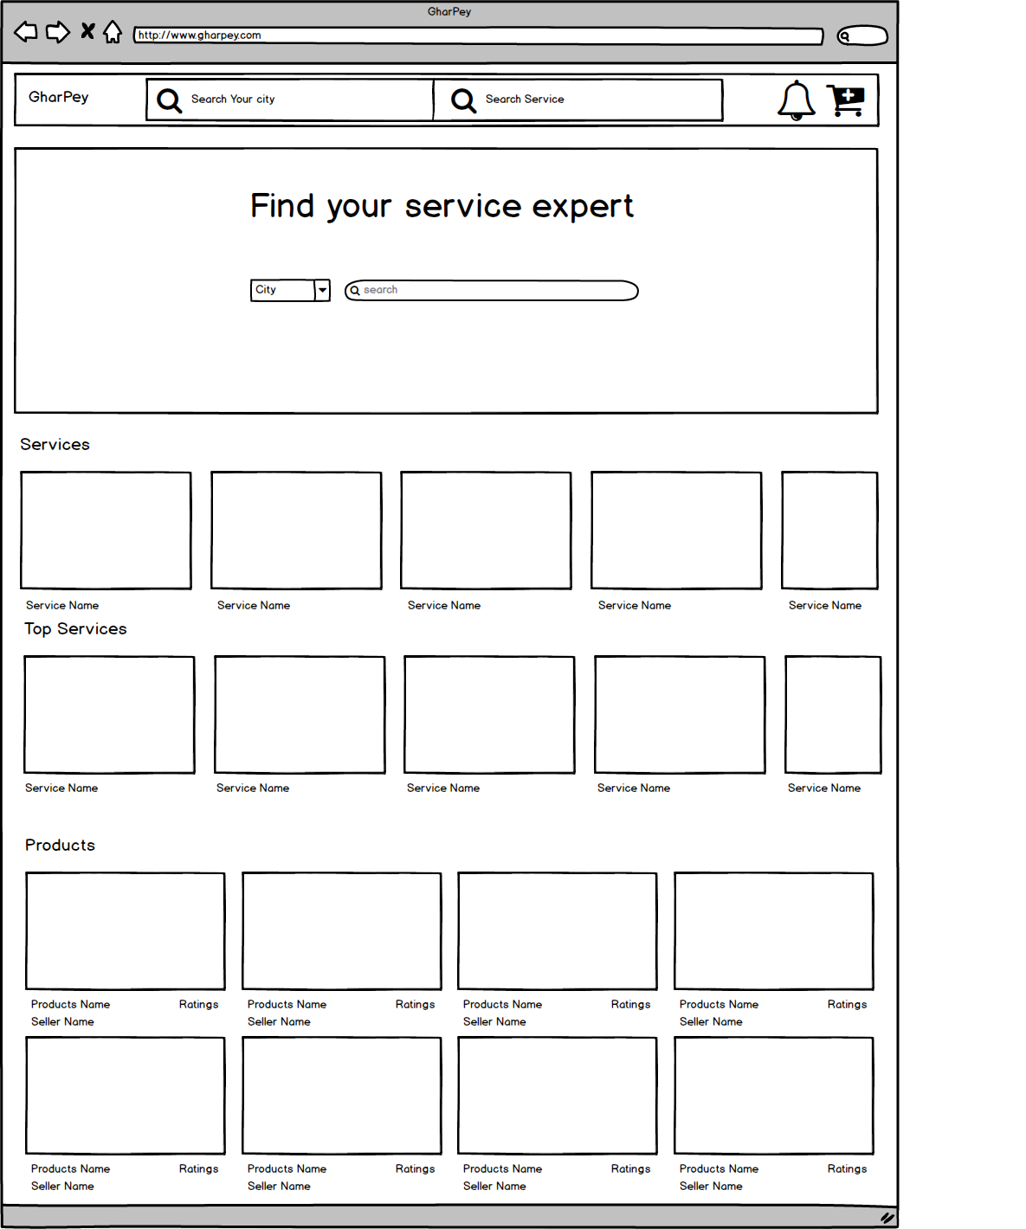

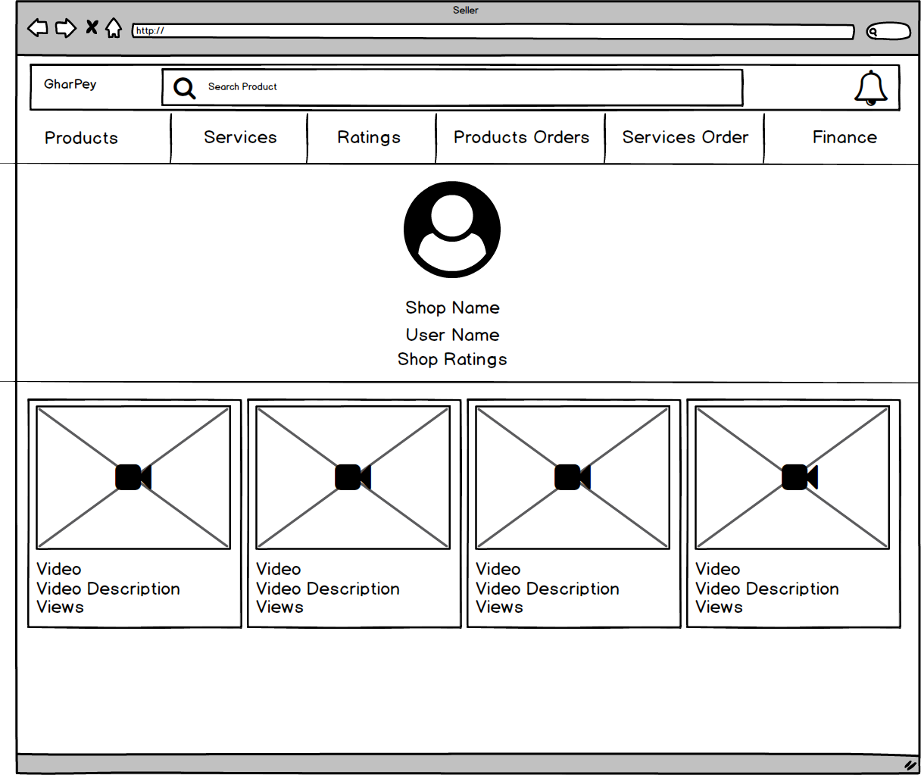Main Page (Sellers)

Service Main Page (Buyer)

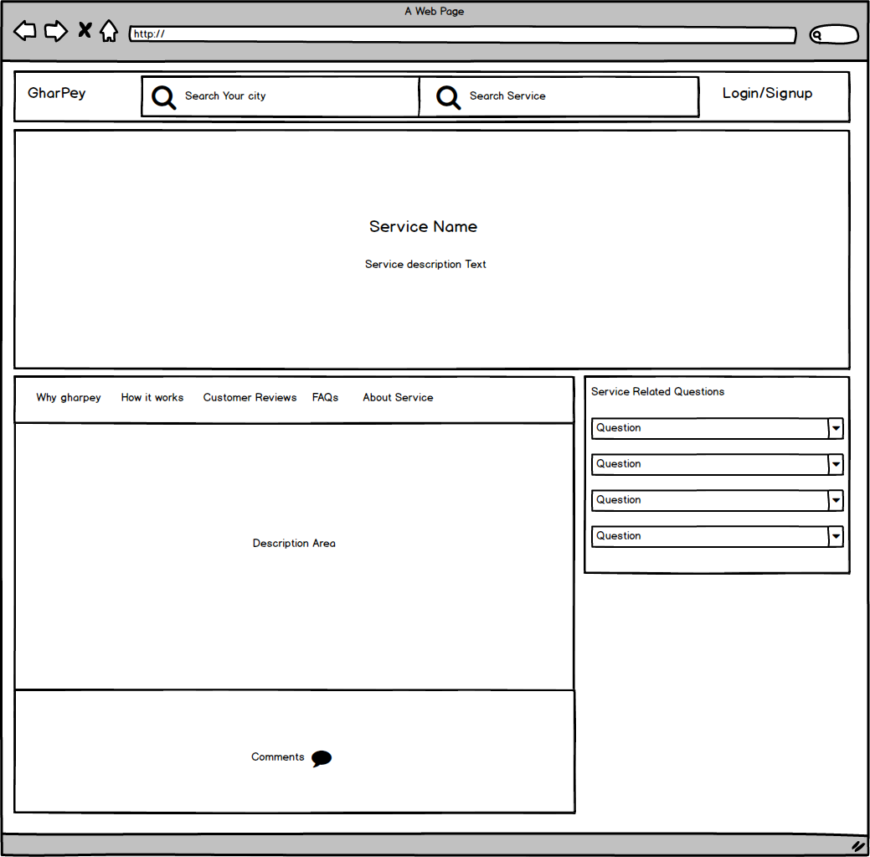

Service-related Questions (Buyer)

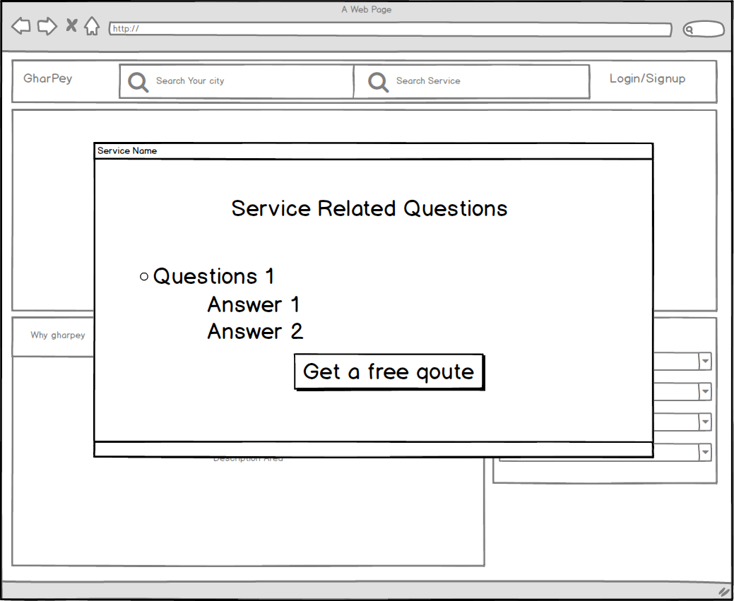

Products main page

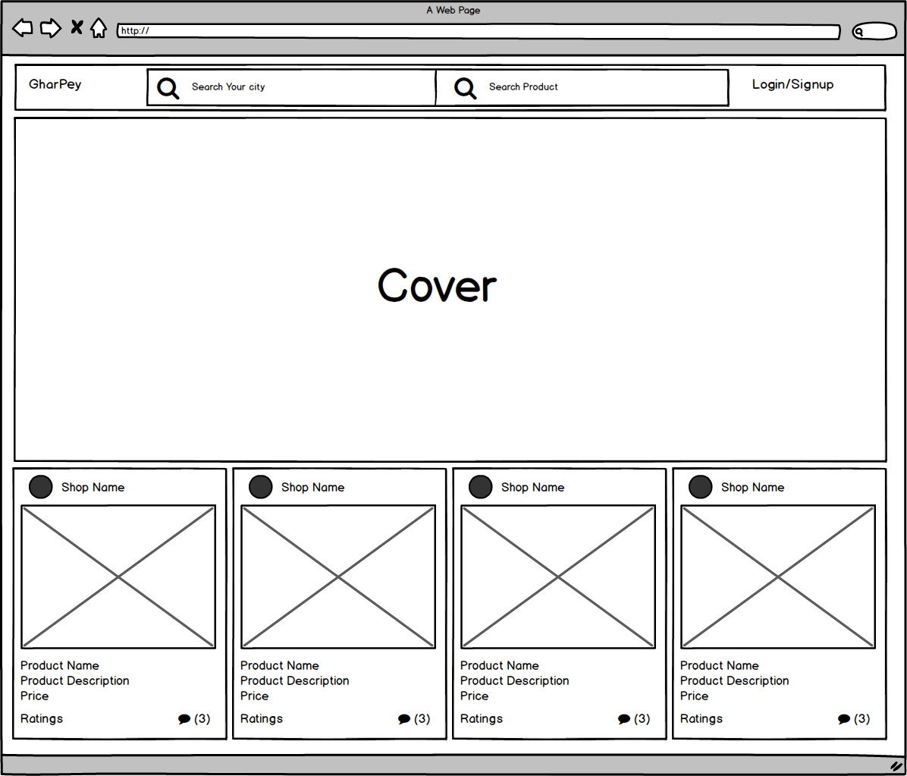

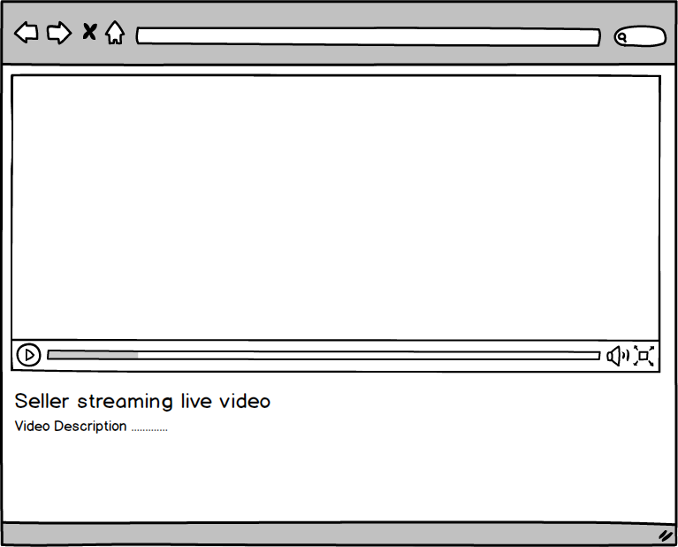Live Streaming (Buyer)

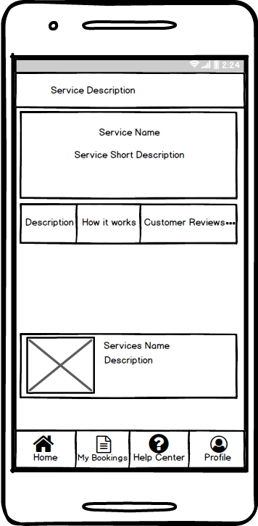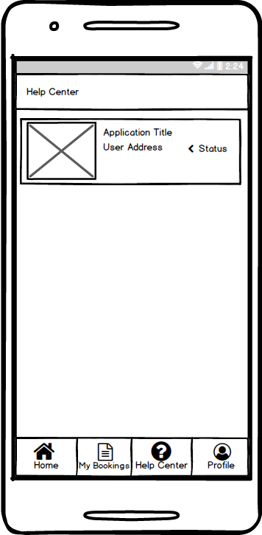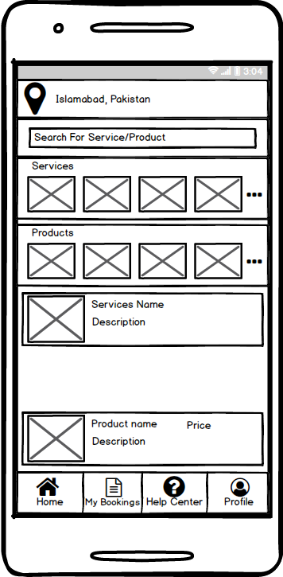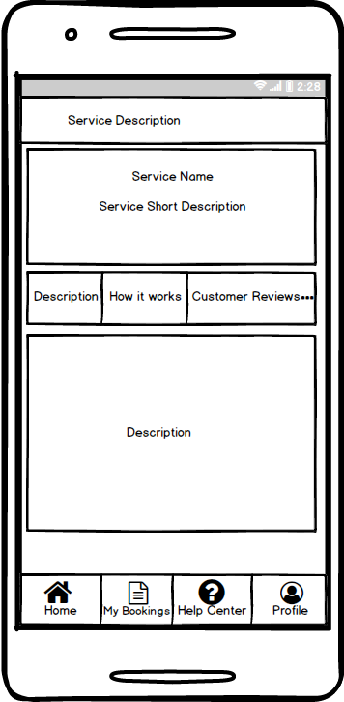

# Conclusion

The proposed system will be an android and web application which will help hardworking talented women to sell their products and local services anywhere in Pakistan. The proposed system allows female seller to create her personal shop as a brand and upload her work products and services that were unheard and unseen before. Buyer will be able to explore and buy the products from mobile and web application. System will provide support for cash on delivery and online payment methods for customer convenience.

# References

* COMSATS University: <https://en.wikipedia.org/wiki/COMSATS_University_Islamabad>
* PHP: <https://www.php.net/>
* Laravel: [https://laravel.com](https://laravel.com/)
* jQuery: <https://jquery.com/>
* React Native: https://facebook.github.io/react-native/

# Plagiarism Report