**COMSATS University Islamabad (CUI)**

**Project Proposal**

**(Scope Document)**

**For**

**Smart Construction Manager**

Version 1.0

***By***

**Talha Ejaz CU/SP18-BCS-161/ISB**

**Waleed Butt CU/SP18-BCS-170/ISB**

***Supervisor*Dr. Ashfaq Hussain Farooqi**

*Bachelor of Science in Computer Science (2018-2022)*

**SCOPE DOCUMENT REVSION HISTORY**

|  |  |  |
| --- | --- | --- |
| **No.** | **Comment** | **Action** |
| 1 | ‘Modules are clear and Well defined. Can Proceed for next step’ – Dr Basit Raza | N/A |
| 2 | ‘Project idea is ok. All the modules are properly explained ‘– Mr. Zulfiqar Ali | N/A |
| 3 | ‘Add some major modules other than management systems’ – Mr. Tehseen Riaz Abbasi | Modules Added |
| 4 | ‘Replace the “targeted project” with your project name in tables’ caption.’ – Mr. Tehseen Riaz Abbasi | “targeted project” replaced with project name in tables’ caption. |
| 5 | ‘There is a difference between functionality and advantages, you have written too functionality of the system in advantages section, please correct it.’ – Mr. Tehseen Riaz Abbasi | Functionality and advantages section updated |
| 6 | ‘The modules are not written with logical and technical flow, rather students tried to add modules without proper flow, understanding the system needs and boundaries.’ – Mr. Tehseen Riaz Abbasi | Modules added with the flow |
| 7 | ‘Modules needs to refine, redefine, and improved.’ – Mr. Tehseen Riaz Abbasi | Modules refined, redefined, and improved. |
| 8 | ‘Revise concept section. Explain it.’ – Mr. Tehseen Riaz Abbasi | Concept section revised. |
| 9 | ‘Milestones for the Gantt chart needs revision, so revise your Gantt chart. Format is also not correct.’ – Mr. Tehseen Riaz Abbasi | Gantt Chart revised |
| 10 | ‘Mockup images quality is not good, redesign them.’ – Mr. Tehseen Riaz Abbasi | Mockup images quality improved and redesigned. |
| 11 | ‘The screenshot of plagiarism report is missing.’ – Mr. Tehseen Riaz Abbasi | Plagiarism report added |

**Supervisor Signature:**

**Date:**

**Table of Contents**

Abstract iii

1 Introduction 1

2 Problem Statement 1

3 Problem Solution for the Proposed System 2

4 Related System Analysis/Literature Review 3

5 Advantages/Benefits of Proposed System 3

6 Project Scope 4

7 Modules 6

7.1 Module 1: Basics 6

7.2 Module 2: Buy and Sell 6

7.3 Module 3: Search (Audio and Text) 6

7.3.1 Sub-Module 1: Speech to Text 6

7.4 Module 4: Chat Box 6

7.5 Module 5: Recommendations Tab 7

7.6 Module 6: Map Making (3D Modeling) 7

7.7 Module 7: House Decor (Augmented Reality) (Mobile Only) 7

7.8 Module 8: Application Requests 7

7.9 Module 9: Requests Management (Web Only) 8

8 System Limitations/Constraints 8

9 Software Process and Design Methodology 8

10 Tools and Technologies 9

11 Project Stakeholders and Roles 10

12 Team Members Individual Tasks/Work Division 10

13 Data Gathering Approach 10

14 Concepts 11

15 Gantt Chart 12

16 Mockups 12

17 Conclusion 14

18 References 14

19 Plagiarism Report 14

**Project Category:**

* **B-**Web Application/Web Application based Information System.
* **E-** Smartphone Application

# Abstract

To develop a One Window Solution for the construction process of housing in the state and keeping in view the incumbent government’s housing and construction policies & packages to minimize the time & effort for the construction process and ensure transparency. This solution also addresses unexpected turn of events in the fiscal policies caused by the global pandemic (COVID-19). It also ensures the safety of people regarding the SOPs. Smart Construction Manager is an all-rounder application addressing basic house construction needs.

# Introduction

The different government as well as private bodies of the state are moving towards automation. The technological reforms provide an easier access to public to avail their services. The records of an individual can be accessed in a few seconds as the NADRA databases have been regularized, the physical existence of records is minimal.

Similarly, the process of communication has been eased with the advancement of telecommunications, currently there are 5 major telecom companies authorized by PTA.

The records of Active Taxpayers in Pakistan can be viewed on the FBR website which once used to be a tedious task.

Reforms in the private sectors have also took a turn for more better, efficient, and easier access. The private & the private – limited companies function on the national as well as international scope due to the technological advancements.

The banking sector comprising both public and private banks have the whole dependency on a 24-hour active functioning system.

The government organizations such as the development authorities of different cities have introduced the concepts of One-window operations to streamline the working process, our project is providing faster and easier access to this operation.

# Problem Statement

The process of construction starts with owning the piece of land. The ownership of plot can be achieved by buying the land directly from development authority. Or the land ownership can be transferred from one person to the other. People look for property dealers who then search for the land as per user requirements. When they find the required land, they buy it and move towards construction. [1]

After you have the land, you must apply to the respective development authority for the approval of map for the construction site. The procedure of approval involves applying to the development authority then wait for response. You may have to wait for weeks because the process in most development authorities is manual. You must physically submit handwritten application. When your application is accepted you then submit the required documents. Then you have the approval for the construction.

The construction procedure starts with hiring people for different tasks. People may hire a single construction company which will do all the work of construction until the construction is complete. Some may prefer hiring labors themselves. Either way, searching for workers is time consuming. And sometimes the people hired for work may not perform well or the hirer may not pay them well.

During the construction, development authorities keep sending their employees to keep in check the construction procedure. They verify the items used for constructions are of good quality. And they also keep in check that if the approved map provided in the start is followed. They also charge money for each visit. And provide confirmation if the procedure is smooth. These confirmations are later required to register the constructed site by your name.

After the construction is done, people will need the daily utility services. These services are generally acquired from government bodies. These can be electricity connections, Sui Gas connections and Water Connections etc. When people apply for these connections, they again must physically visit the respective offices to submit their applications. Also, it is not compulsory for people to apply here after construction. People can apply during construction just after land approval.

# Problem Solution for the Proposed System

Smart Construction Manager will provide user the interface to search for the land in their respected areas. People who want to sell the land can post them adds and then the buyer can contact them. User can also hire a property dealer through our app and ask him to search for the land.

After users have the ownership of the land, they can apply to their respective development authorities for map approval. For this, we must apply to the respective development authority. User will have option to submit this application through app. After that they can continue with the submission of physical documents.

When the construction process starts, users will now have the option to hire people for different tasks. User can hire construction companies through our application. Or the user can hire labor directly. User will also have the option to buy equipment for construction through our application. These items can be Cement, Bricks and Other construction materials.

During the construction, we are supposed to inform development authorities to come at the construction site and verify the process. This must be two- or three-times during construction at different stages. We can request the development authorities through our application. Also, we will see the confirmation and progress on our app.

After the construction is done or after the land is approved, people can send request to government institutions for utility services.

# Related System Analysis/Literature Review

Table 1: Related System Analysis with Smart Construction Manager Solution

|  |  |  |
| --- | --- | --- |
| **Application Name** | **Weakness** | **Proposed Project Solution** |
| * Zameen.com | * Does not deal with government bodies. * Outsourced labor is required. [2] | * Deals effectively with government bodies through separate portals. * Labor can be hired through the application |
| * Graana.com | * Dedicated Solely for real estate. * Utility services not provided [3] | * Multi-purpose provides real estate, contractors, labors, builders. * Utility Services included. |
| * LDA (Lahore Development Authority) Insaaf Portal | * Limited for Lahore City [4] | * Scalable to multiple development authorities |

# Advantages/Benefits of Proposed System

* Land Possession process which is usually a lengthy and hectic process will be done online and easily.
* Transparent and effective construction process will be ensured.
* Land Grabbing will be minimal.
* Communication with the Govt bodies will be a click away.
* Records will be digitized so users can view any information at any time.
* People for different services like contractors, architect, labors will be hired.
* 3D modelling & Augmented Reality will allow the architect to view a comprehensive and real-time design of the property
* Users will get active recommendations for hiring services.

# Project Scope

System will provide a one window application and act as agent of communication between construction companies, user, and government bodies. The user will provide the required information to the system the system will authenticate the user. User will submit request to respective organization (depending upon the location of project) & The construction company. The authorities and the industries will accept the request. Design and Layout will be sent by user. After review authorities and industries will generate the response.

Government Organizations & Construction companies:

* User will be provided an interface for Government organizations & companies.
* User will submit request to respective organization (depending upon the location of project) & The construction company.
* The authorities and the industries will accept the request.
* Design and Layout will be sent by user.
* After review authorities and industries will generate the response.

Overseas Pakistani & Construction companies:

* The overseas Pakistani can have access to the same utilities as a local Pakistani.
* His registration will be done through his ONIC (Overseas National Identity Card)
* He can strike a deal with any construction company of his choosing, however, to ensure transparency a local relative might also be registered to handle the project physically.
* The process will be same as mentioned above.

Foreign Pakistani & Development authority:

* Registration
* Application for design approval
* Blueprint
* Get Updates
* Design Approval

Foreign Pakistani & Utility Services:

* Registration for the service
* Send Location
* Service availability
* Approval

Local Pakistani & Utility Services:

* Registration for the service
* Send Location
* Service availability
* Approval

Local Pakistani & Construction companies:

* Registration process will be same as heading 5.1.
* NIC will be used for registration here.
* Further process same as 5.2

Local Pakistani & Development authority:

* Registration
* Application for design approval
* Blueprint
* Get Updates
* Design Approval

Owner and Builders:

* Owners can hire builders through the portal.
* Contract will be formed.
* Payment

Builders and Labor:

* Builders can hire their own labor or outsource the project.
* The different kinds of labor in the construction process h will be hired.
* The construction process will be followed by the builders.

Incase owner wants to fire the builder he has to submit the subsidy to the company depending upon the duration builders were hired.

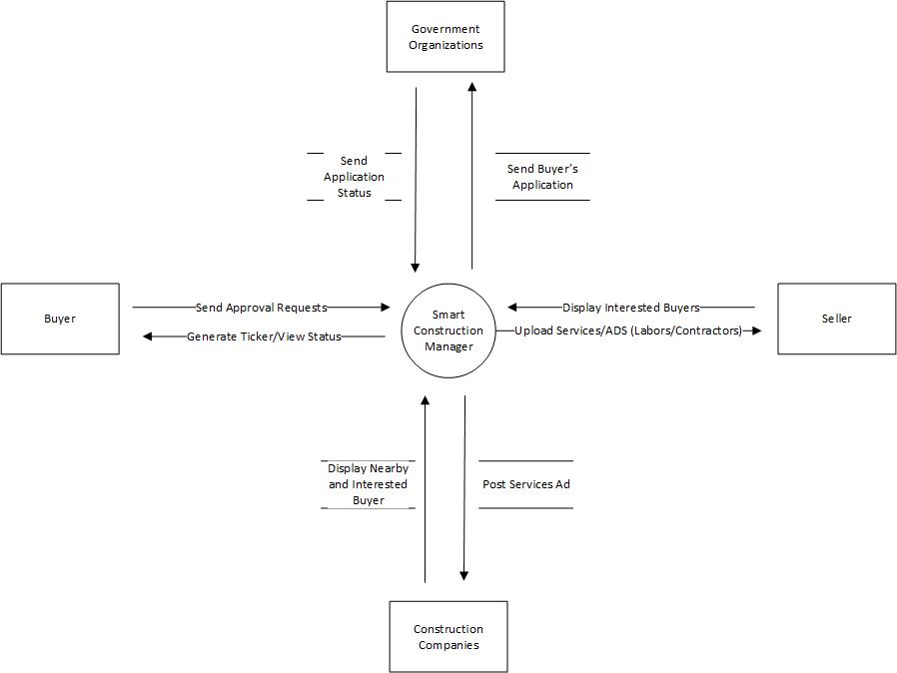

Figure 1: Context Diagram of the Smart Construction Manager.

# Modules

## Module 1: Basics

This module provides basic features to the user. These are

* Login
* Signup
* Forget Password
* Update Profile
* Update Email
* Update Password
* Profile Privacy
* Help & Support
* Remove Account
* App Settings
* Notifications and Subscriptions

## Module 2: Buy and Sell

This module implements the functionality to manage ad posting. User may post any ad regarding the services or items they are selling.

* Post an Add: User can post add of items or services they want to sell.
* Edit Add.
* Delete Add.
* View Add
* View History
* Clear History
* Favorite Add

## Module 3: Search (Audio and Text)

* Search Adds: User can search items or services they require.
* Filter Search Results
* Search Based on Location
* Search Based on category
* Sort search results
  + By Name
  + By Price
* Pagination
* Suggestions

### Sub-Module 1: Speech to Text

* User will have the functionality to search by speaking
* User will click on mic button and start speaking
* User’s audio will be converted to text and displayed on box

## Module 4: Chat Box

* A chat box feature will be implemented in the Smart Construction Manager to ensure smooth communication between the patron and the client.
* User can send text, images, audio, video and files.
* User can share location
* User can share link with previews.

## Module 5: Recommendations Tab

* This section will display user nearby adds and services based on user’s interests.
* User’s interests will be decided by the viewed and favorite ads.

## Module 6: Map Making (3D Modeling)

* User will have the functionality to select the 3D model for construction site.
* User will see various types and designs in 3D of homes.
* User can select from previously made models.
* User can than decide the model.
* User may search among models.
* User can send the models in chat to architect who will return the design in proper format for development authorities.

## Module 7: House Decor (Augmented Reality) (Mobile Only)

* This module will help user in designing and decorating their house.
* User can add 3D objects and place them in real-time environment to see what the house will look like.
* User can place table, chairs, sofas and carpets etc. in virtual world to visualize before finally ordering luggage.

## Module 8: Application Requests

* User interacts with government and official authorities consistently through the construction process.
* SCM will provide user the functionality to send applications and required documents to respective bodies.
* This will reduce the user’s effort to physically visiting authorities.
* User will receive updates on the application request.
* User can cancel the request at any time.
* **Request Verification**
  + User can make one request against one construction site.
* **Request Types**
  + Apply for land transfers and Ownerships to development authorities
  + Apply for Land Approval to development authorities
  + Apply for Land Grabbing Case to DC.
  + Apply for Utility Services to Government

## Module 9: Requests Management (Web Only)

* This module deals with the admin portal provided to the official authorities where they can manage the requests sent by users. The portal will have two major actors. Admin and Employee.
* Both Admin and Employee cannot create accounts
* Admin will be provided a default account and then admin will provide the accounts to its employee
* Both Admin and Employee must update login information after first sign in.
* They may update their profiles later again.
* Some unique features for both actors are
* **Admin**
  + Admin can see and manage the employees working.
  + Only Admin will have authority to create an account for employee.
  + Only Admin can remove employee account
* **Employee**
  + Manage requests.
  + Send requestee updates on application
  + Approve/Disapprove and Terminate Request
  + Employee can search requests from requests list.
  + Download/View requirements sent by user in request.

# System Limitations/Constraints

* Attested documents cannot be submitted which are essential for the process.
* Requires internet connection for buy and sell.
* Locally available only.

# Software Process and Design Methodology

We will be following Modified Waterfall process methodology. Modified Waterfall enables the phases to overlap when needed. Design Methodology will be Component Based Software Engineering.

Planning

Basic goals and objectives to be achieved through the project are defined in this phase.

Requirement Analysis

We gather the requirement through questionnaires and forms. Then we consult our supervisor regarding the requirement. If he approves it, we then move to designing.

Design

We design the frontend using graphical tools like Adobe Photoshop. Then according to our frontend, we will design flow of backend using Microsoft Visio.

Coding

We will implement our design using JavaScript and its libraries like React, Express and React Native. We will be following component approach in our project.

Testing

Testing will be taken out in different stages. We will test the major functionalities of each module. Then we will improve our minor functional requirements as we go. We will provide test cases against each use case to ensure smooth working of Smart Construction Manager.

Documentation

We will pen down everything related to our project using Microsoft Word. And create a beautiful presentation along with it.

# Tools and Technologies

Table 2: Tools and Technologies for Smart Construction Manager

|  |  |  |  |
| --- | --- | --- | --- |
| **Tools**  **And**  **Technologies** | **Tools** | **Version** | **Rationale** |
| MS Visual Studio Code | 2019 | IDE |
| Adobe Photoshop | CSC 6 | Design Work |
| MS Word | 2019 | Documentation |
| MS Power Point | 2019 | Presentation |
| Web Storm | 2020 | IDE |
| PyCharm | 2020 | IDE |
| Android Studio | 2020 | IDE |
| Adobe XD | 2020 | UI UX Design |
| Pencil | 2.0.5 | Mockups Creation |
| **Technology** | **Version** | **Rationale** |
| MongoDB | Updated | DBMS |
| ExpressJS | 4.17.1 | back end web framework |
| React | 17 | Front End Web Framework |
| Node.js | 12.0 | JS Runtime Environment |
| React Native | 0.62 | Hybrid Mobile Development |
| JavaScript | 2020 | Programming Language |
| Bootstrap | 4 | CSS styling Framework |
| Three.js | 2020 | JS Library to create 3d models |
| Python | 3.8 | Programming Language |
| TensorFlow | 2.1 | Python Library for ML |
| Scikit-Learn | 0.24.1 | Python Library for ML |
| ViroReact | 2.17.0 | Open Source developer platform to integrate AR in React Native |

# Project Stakeholders and Roles

Talha Ejaz will be dealing with the management systems at the development authorities and government sectors, 3D modeling and AR. While Waleed Butt will be dealing with modules 1 to 4 which involve Machine Learning, Chat Box, Search and Buying and selling platform. Dr. Ashfaq Farooqi will be our guide in the process.

Table 3: Project Stakeholders for Smart Construction Manager

|  |  |
| --- | --- |
| **Project Sponsor** | ***COMSATS University Islamabad*** |
| **Stakeholder** | * Talha Ejaz * Waleed But * Project Supervisor Name: Dr. Ashfaq Hussain Farooqi * Final Year Project Committee: Evaluation of project |

# Team Members Individual Tasks/Work Division

Table 4: Team Member Work Division for Smart Construction Manager

|  |  |  |
| --- | --- | --- |
| **Student Name** | **Student Registration Number** | **Responsibility/ Modules** |
| * ***Talha Ejaz*** | * ***SP18-BCS-161*** | * ***(Module6-Module9)*** |
| * ***Waleed Butt*** | * ***SP18-BCS-170*** | * ***(Module1-Module5)*** |

# Data Gathering Approach

We will use techniques like interviews and questionnaires through Google forms to grasp the general requirements for the construction process. First approach the domain expert to thoroughly understand the functionality of this proposed system. Preparing basic prototypes and using documentation techniques like use cases and class diagrams for the further discussions in the interviews. Then we will do group discussions for brainstorming.

# Concepts

Following concepts will be learned and implemented in the project Smart Construction Manager.

Web Development

We will implement the web-based portal and management system for administrative authorities and ads posting using MERN stack development. Which includes using MongoDB as Database Management system, ExpressJS as for routing, React for frontend and NodeJS as backend runtime environment. The programming language required will be JavaScript.

Mobile Application Development

React Native is a framework for JavaScript programming language. The mobile apps will be developed using React Native. The hybrid application will run on IOS and Android mobile smartphones only. Using React Native we can update and make changes to both versions of app from single coding channel.

Machine Learning

Naïve Bayes algorithm will be used to filter result as relevant or irrelevant to user. The user behavior will be recorded which will help in training the application to show user recommendations based on user’s interests. The algorithm will be a real-time feedback loop that tailors search results and recommendations to each user according to user’s interest.

API Integration

We will be using REST APIs for chatting. They will allow user to share text, audio, image and video messages. ViroReact API will be used in AR implementation. We will also use Googl’s location API to share locations in chat.

Speech to Text

We will also be focusing on implementing the speech to text algorithm .

3D Modeling

ThreeJS will be used to design 3D models for the homes. We will be learning how to integrate ThreeJS models in the application.

# Gantt Chart

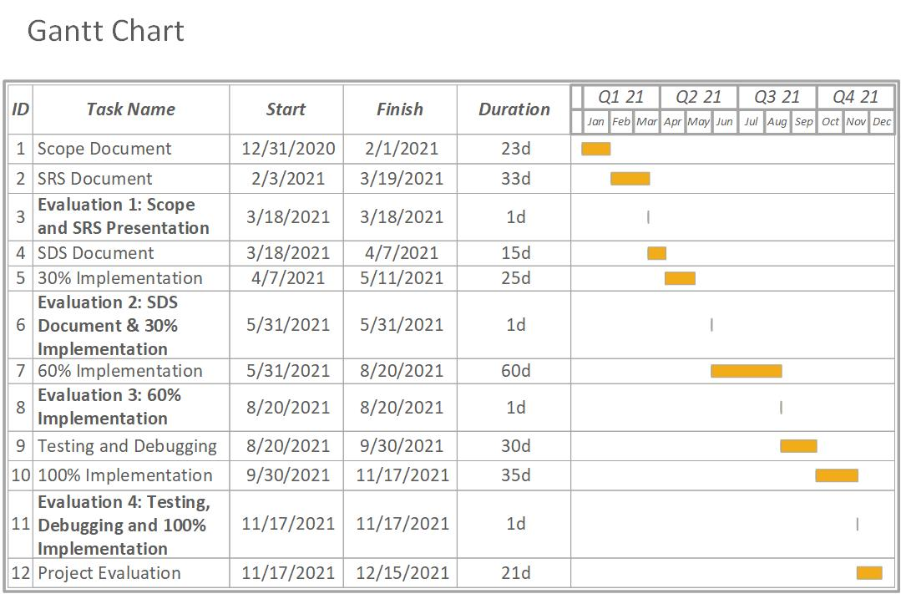

Figure 2: Gantt Chart of Smart Construction Manager

# Mockups

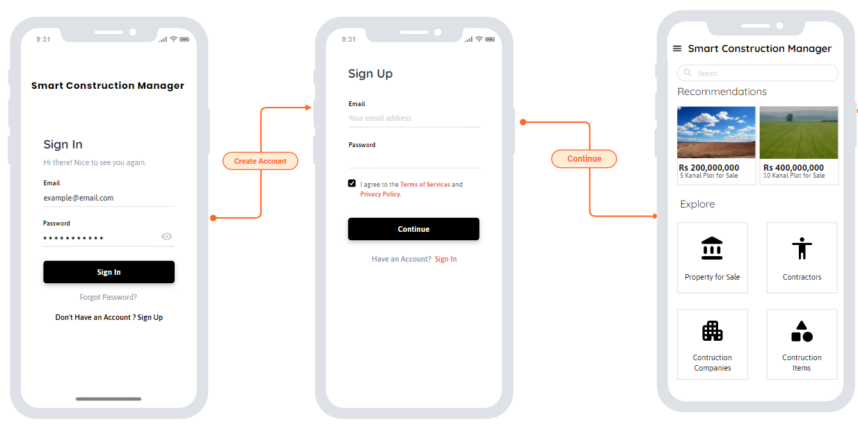

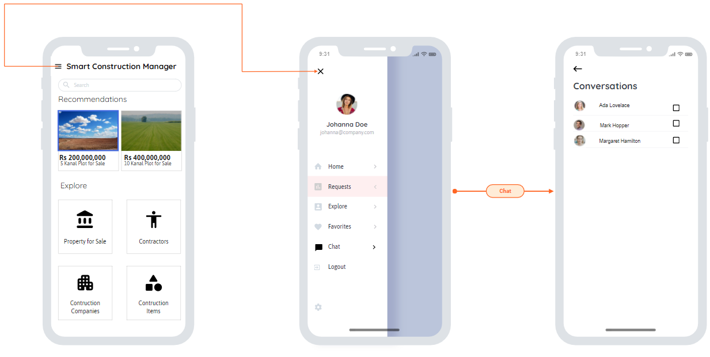

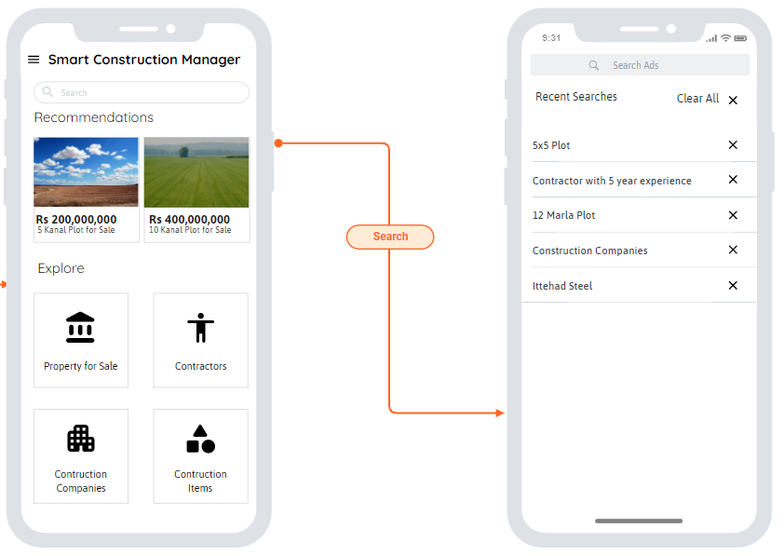

# Conclusion

Smart Construction Manager will aid the public with ease in process of construction. Endogenous and exogenous factors affecting the efficiency and transparency between government institutions and service providers will be ensured. The extensive research and practical implementation of Smart Construction Manager will provide us with the experience of Mobile and Web Application development, a general idea about one window application and its implications.

# References

|  |  |
| --- | --- |
| [1] | CDA, "FAQs - CDA," CDA, [Online]. Available: http://www.cda.gov.pk/resource_center/faqs.asp#faq1. |
| [2] | Zameen, "Zameen Blog," 2021. [Online]. Available: https://www.zameen.com/blog/. |
| [3] | Graana, "Pakistan's Smartest Property Portal," Graana, [Online]. Available: https://www.graana.com/. |
| [4] | LDA, "Lahore Developement Authority," LDA, [Online]. Available: https://www.lda.gop.pk/page.php?p=TmpReg==. |

# Plagiarism Report

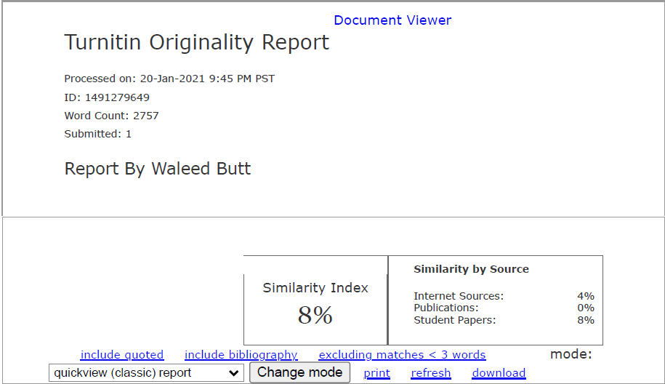

Figure 3: Plagiarism Report from Turnitin