# Introduction

This is the SRS (Software Specification) document for our project Smart Construction Manager. The document briefly explains the working and description of the project. The document contains the Use Cases against specified modules. The Functional and Non-Functional s are also elicited in the document. The UML diagrams and Class diagrams explain the flow of the application. Moreover, user interfaces describe the working of application for the end user.

## Purpose

Smart Construction Manager is a One Window Solution for the construction process of housing in the state. Keeping in view the incumbent government’s housing and construction policies & packages to minimize the time & effort for the construction process and ensure transparency. This solution also addresses unexpected turn of events in the fiscal policies caused by the global pandemic (COVID-19). It also ensures the safety of people regarding the SOPs. Smart Construction Manager is an all-rounder application addressing basic house construction needs.

## Scope and Modules

System will provide a one window application and act as agent of communication between construction companies, user, and government bodies. The provide the required information to the system the system will authenticate the user. submit request to respective organization (depending upon the location of project) & The construction company. The authorities and the industries will accept the request. Design and Layout will be sent by user. After review authorities and industries will generate the response.

### Modules

**First module** buys and sell, user can buy land and other construction equipment posted by other users for sale. **Second module** deals with user searching and provides functionality to search by talking. **Third module** is user chatting with other users. **Fourth module** shows user recommendations on home page. **Fifth module** helps user decide the map for construction site. And **sixth module** will be for designing and decorating house with AR. **Seventh module** deals with the user sending application requests to government bodies for various procedures. **Eight module** provides admin portal to government bodies to manage user requests.

# Overall Description

The government organizations such as the development authorities of different cities have introduced the concepts of One-window operations to streamline the working process, our project is providing faster and easier access to this operation.

## Product Perspective

Smart Construction Manager is designed to ease the entire process of construction. The product is an alternate to growing market of construction site. Mostly websites like Zameen.com and Graana.com offer the buy and sell functionality. Smart Construction Manager will help user to communicate with government bodies too.

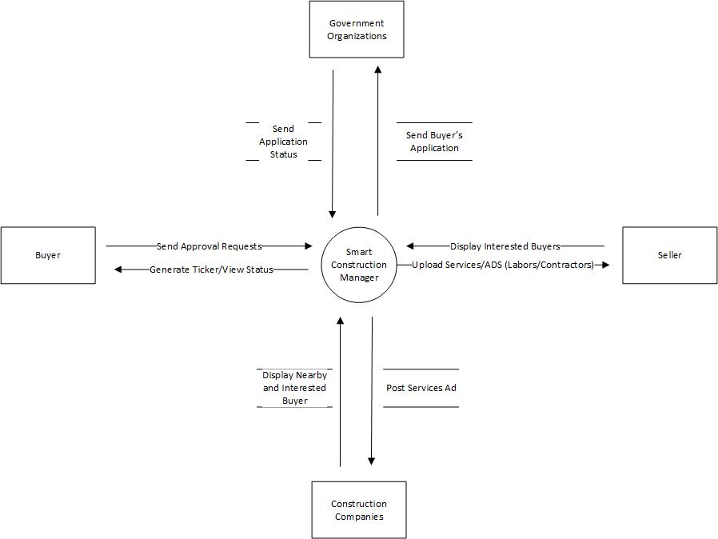

Figure 1: Context Diagram of Targeted Project

## Operating Environment

***OE-1:*** *The System shall operate correctly with the following web browsers: Firefox versions 80 through own wards; Google Chrome (all versions); and Apple Safari versions 10.0 and above.*

***OE-*2:** *The Minimum Smart Phone OS is 6.0 for Android and IOS 9 for iPhones.*

***OE-3:*** *The Application will be available for Residence of Islamabad, Pakistan. In future, we will be upscaling to be used country wide.*

# Design and Implementation Constraints

*CO-1: The system shall use the current corporate standard MongoDB database engine*

*CO-2: The system shall use ExpressJS as Web Backend and ReactJS as Web Frontend Framework*

*CO-3: The system shall use React Native for Smart Phone Development (Android and IOS).*

# Identifying Technique

The s for the project will be gathered using Interviews and online Google Forms.

## Use Case Diagram

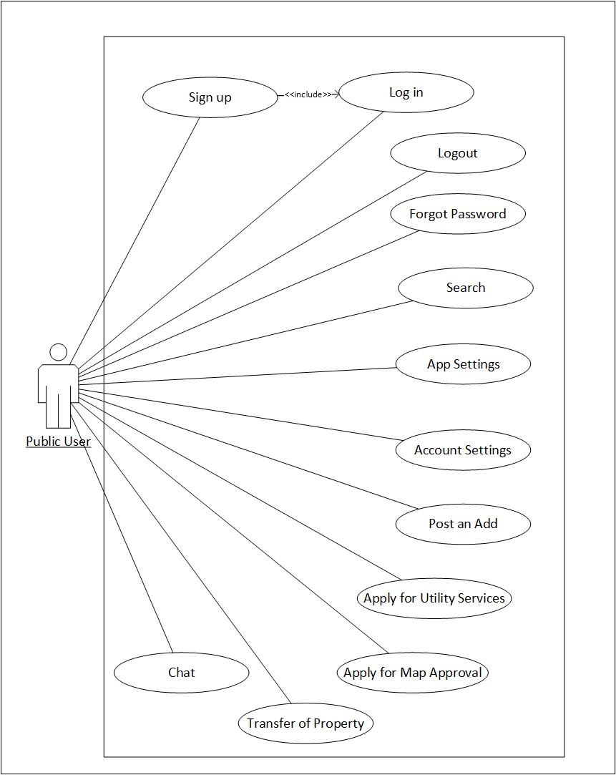

Figure 1: Use Case Diagram Showing Actions of User from Home Screen

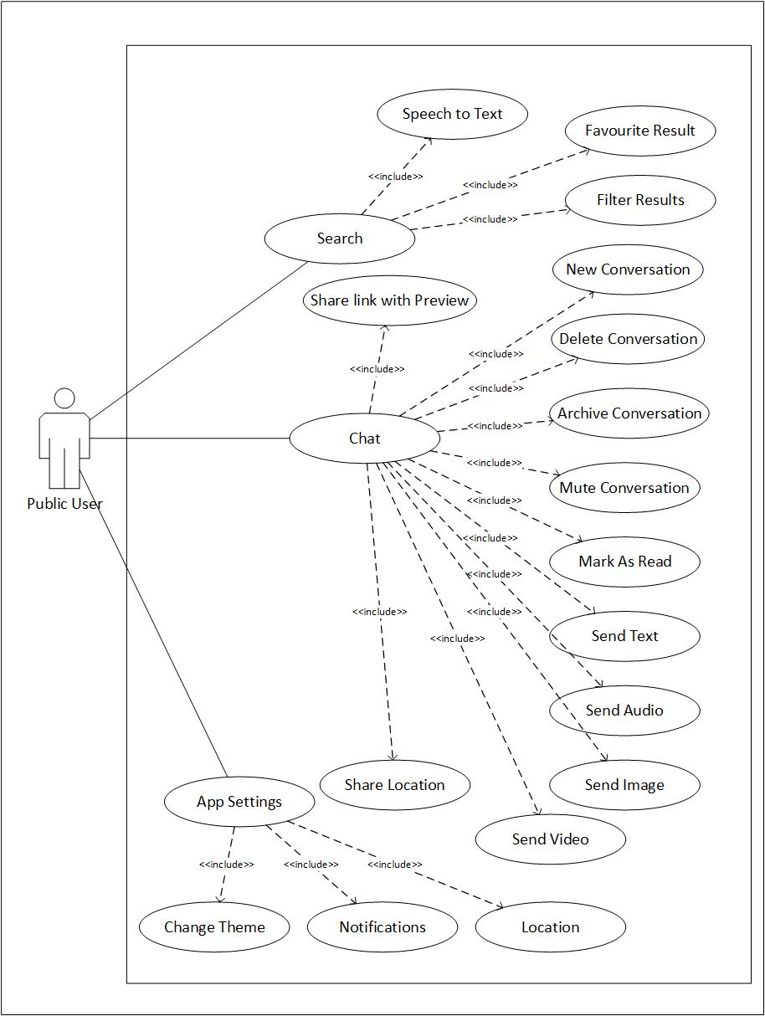

Figure 2: User Interface with Basic App Features

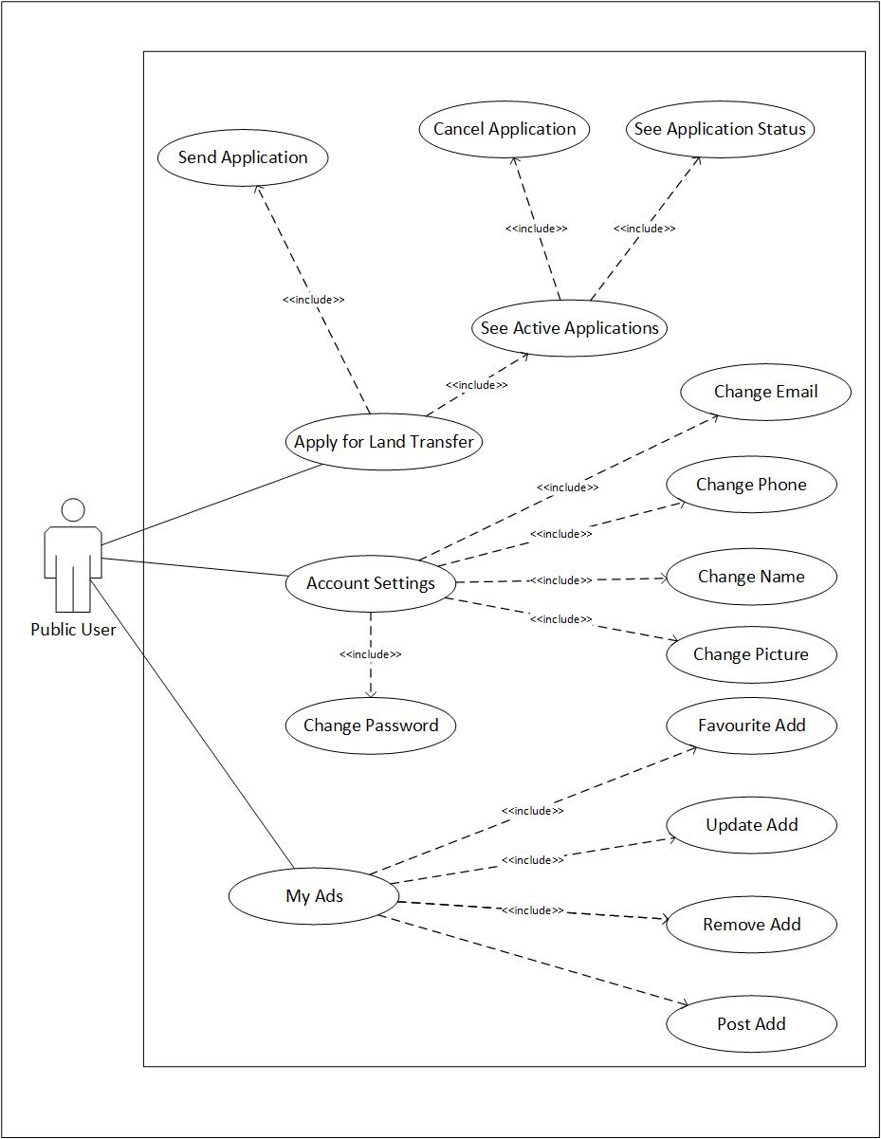

Figure 3: Use Case Diagram Explaining Activities of User

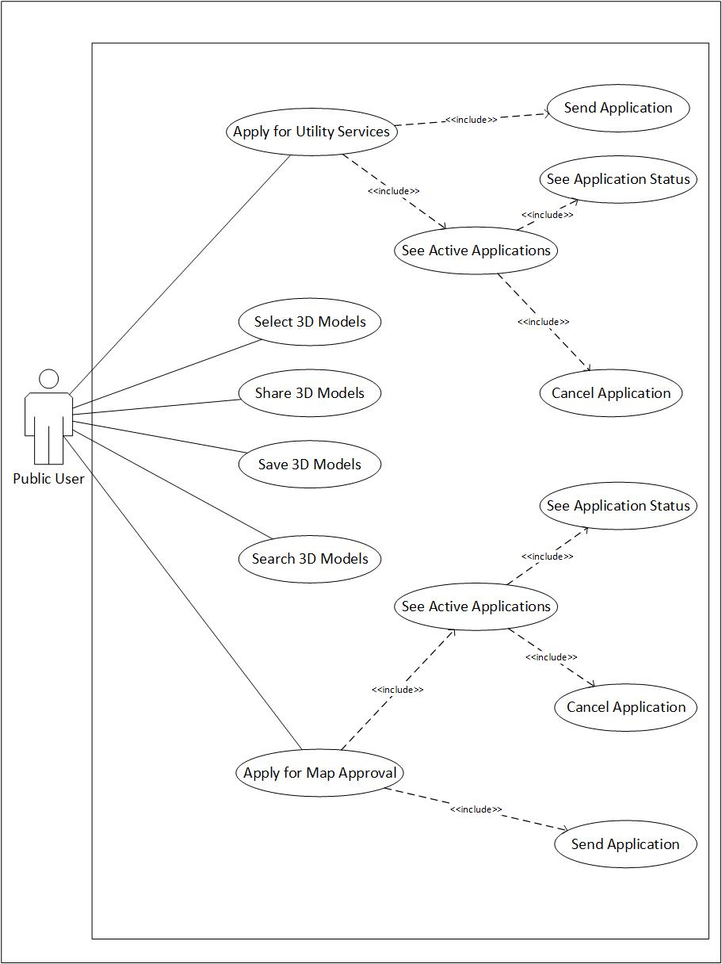

Figure 4: Use Case Diagram Showing Application Procedure with Official Authorities

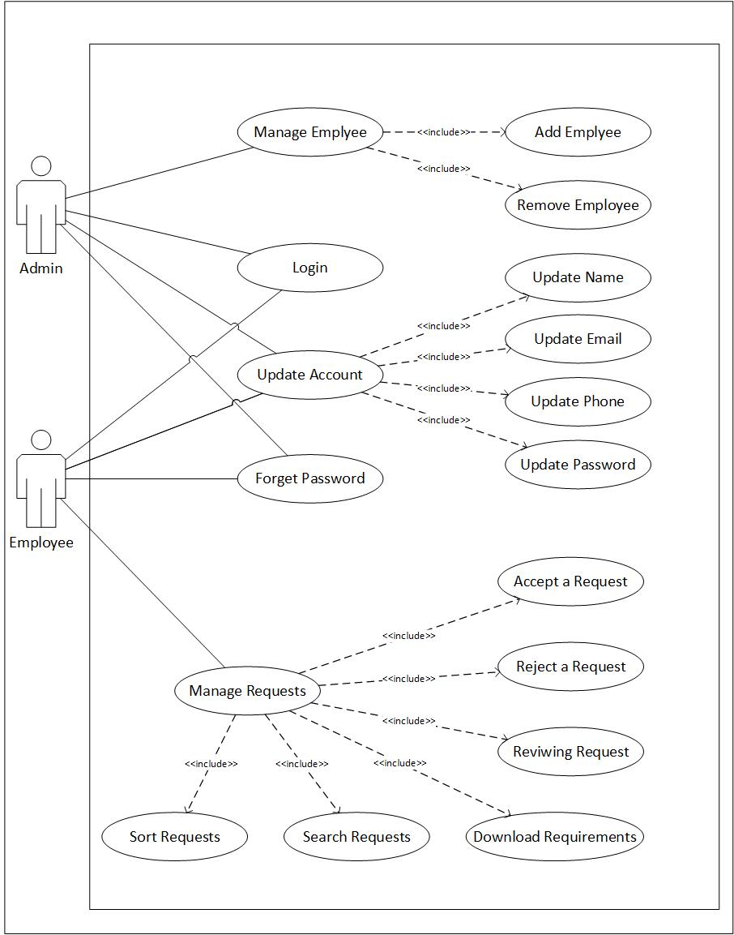

Figure 5: Use Case Diagram Explaining Activities of Admin

## Use Case Description

**Module 1: Basics**

|  |  |
| --- | --- |
| **M1-UC1** | Sign up (Mobile) |
| **M1-UC2** | Sign up (Web) |
| **M1-UC3** | Log in (Mobile) |
| **M1-UC4** | Log in (Web) |
| **M1-UC5** | Forget Password (Mobile) |
| **M1-UC6** | Forget Password (Web) |
| **M1-UC7** | Update Profile (Mobile) |
| **M1-UC8** | Update Profile (Web) |
| **M1-UC9** | Profile Privacy (Web) |
| **M1-UC10** | Profile Privacy (Mobile) |
| **M1-UC11** | Help & Support |
| **M1-UC12** | Remove Account (Mobile) |
| **M1-UC13** | Remove Account (Web) |
| **M1-UC14** | App Settings (Mobile) |
| **M1-UC15** | App Settings (Web) |
| **M1-UC16** | Notifications (Web) |
| **M1-UC17** | Notifications (Mobile) |
| **M1-UC18** | Subscriptions |

**Module 2: Buy and Sell**

|  |  |
| --- | --- |
| **M2-UC1** | Post Add (Web) |
| **M2-UC2** | Post Add (Mobile) |
| **M2-UC3** | Edit Add (Web) |
| **M2-UC4** | Edit Add (Mobile) |
| **M2-UC5** | Delete Add (Web) |
| **M2-UC6** | Delete Add (Mobile) |
| **M2-UC7** | View Add (Web) |
| **M2-UC8** | View Add (Mobile) |
| **M2-UC9** | History (Web) |
| **M2-UC10** | History (Mobile) |
| **M2-UC11** | Favorite Add (Web) |
| **M2-UC12** | Favorite Add (Mobile) |

**Module 3: Search**

|  |  |
| --- | --- |
| **M3-UC1** | Search by Text (Web) |
| **M3-UC2** | Search by Text (Mobile) |
| **M3-UC3** | Search by Audio (Web) |
| **M3-UC4** | Search by Audio (Mobile) |
| **M3-UC5** | Filters (Web) |
| **M3-UC6** | Filters (Mobile) |
| **M3-UC7** | Suggestions (Web) |
| **M3-UC8** | Suggestions (Mobile) |

**Module 4: Chat**

|  |  |
| --- | --- |
| **M4-UC1** | New Conversation (Web) |
| **M4-UC2** | New Conversation (Mobile) |
| **M4-UC3** | Delete Conversation (Web) |
| **M4-UC4** | Delete Conversation (Mobile) |
| **M4-UC5** | Archive Conversation (Web) |
| **M4-UC6** | Archive Conversation (Mobile) |
| **M4-UC7** | See Archived Conversation (Web) |
| **M4-UC8** | See Archived Conversation (Mobile) |
| **M4-UC9** | Send Text (Web) |
| **M4-UC10** | Send Text (Mobile) |
| **M4-UC11** | Send File (Web) |
| **M4-UC12** | Send File (Mobile) |
| **M4-UC13** | Send Location (Mobile) |
| **M4-UC14** | Send Location (Web) |
| **M4-UC15** | Send a Link (Web) |
| **M4-UC16** | Send a Link (Mobile) |
| **M4-UC17** | Delete Message (Web) |
| **M4-UC18** | Delete Message (Mobile) |
| **M4-UC19** | Delete for All (Web) |
| **M4-UC20** | Delete for All (Mobile) |

**Module 5: Recommendations Tab**

|  |  |
| --- | --- |
| **M5-UC1** | Process Recommendation (Web) |
| **M5-UC2** | Process Recommendation (Mobile) |
| **M5-UC3** | Show Recommendation (Web) |
| **M5-UC4** | Show Recommendation (Mobile) |
| **M5-UC5** | Take Feedback (Web) |
| **M5-UC6** | Take Feedback (Mobile) |

**Module 6: Map Making (3D Modeling)**

|  |  |
| --- | --- |
| **M6-UC1** | Pre-Built Models |
| **M6-UC2** | Show Model (Web) |
| **M6-UC3** | Show Model (Mobile) |
| **M6-UC4** | Save Model (Web) |
| **M6-UC5** | Save Model (Mobile) |
| **M6-UC6** | Share Model (Web) |
| **M6-UC7** | Share Model (Mobile) |

**Module 7: House Décor (AR)**

|  |  |
| --- | --- |
| **M7-UC1** | Show Objects |
| **M7-UC2** | Select Objects |
| **M7-UC3** | Move Objects |
| **M7-UC4** | Resize Objects |
| **M7-UC5** | Place Objects |
| **M7-UC6** | Rotate Objects |
| **M7-UC7** | Remove Objects |

**Module 8: Application Request**

|  |  |
| --- | --- |
| **M8-UC1** | New Application (Web) |
| **M8-UC2** | New Application (Mobile) |
| **M8-UC3** | Verify Application (Web) |
| **M8-UC4** | Verify Application (Mobile) |
| **M8-UC5** | Manage Application (Web) |
| **M8-UC6** | Manage Application (Mobile) |
| **M8-UC7** | View Application (Web) |
| **M8-UC8** | View Application (Mobile) |
| **M8-UC9** | Cancel Application (Web) |
| **M8-UC10** | Cancel Application (Mobile) |
| **M8-UC11** | Receive Update (Web) |
| **M8-UC12** | Receive Update (Mobile) |
| **M8-UC13** | Re-submit (Web) |
| **M8-UC14** | Re-submit (Mobile) |

**Module 9: Requests Management**

|  |  |
| --- | --- |
| **M9-UC1** | Create Admin Account |
| **M9-UC2** | First Login |
| **M9-UC3** | Login |
| **M9-UC4** | Forget Password |
| **M9-UC5** | Update Profile |
| **M9-UC6** | Add Employee |
| **M9-UC7** | Employee role |
| **M9-UC8** | Remove Employee |
| **M9-UC9** | View Request |
| **M9-UC10** | Download/View Attachments |
| **M9-UC11** | Update Request |
| **M9-UC12** | Terminate Request |

### Module 1: Basics

Following are Tabular Use Cases for Module 1

1: Sign up (Mobile).

|  |  |
| --- | --- |
|  | M1-UC1 |
|  | Sign up (Mobile) |
|  | Primary Actor: User |
|  | be able to create account for SCM. |
|  | Click on the “Sign up” button |
|  | High |
|  | PRE-1. User has Valid Email. |
|  | N/A |
|  | 1. click on Sign up Button 2. enter email 3. enter password 4. confirm password 5. User’s Email will be verified via OTP 6. enter OTP received on email 7. add profile information 8. click continue to save data |
|  | N/A |
|  | 1. If email is invalid see a prompt message “Enter Valid Email” 2. If password does not meet minimum s “Password must have minimum 8 characters, digits, alphabet and special character” 3. User enters invalid OTP “Prompt Message saying Enter Valid OTP” |
|  | POST-1. be registered |
|  | N/A |
|  | User has an email and can speak English |

2: Sign up (Web).

|  |  |
| --- | --- |
|  | M1-UC2 |
|  | Sign up (Web) |
|  | Primary Actor: User |
|  | be able to create account for SCM. |
|  | Click on the “Sign up” button |
|  | High |
|  | PRE-1. User has Valid Email. |
|  | N/A |
|  | 1. click on Sign up Button 2. enter email 3. enter password 4. confirm password 5. User’s Email will be verified via OTP 6. enter OTP received on email 7. add profile information 8. click continue to save data |
|  | N/A |
|  | 1. If email is invalid see a prompt message “Enter Valid Email” 2. If password does not meet minimum s “Password must have minimum 8 characters, digits, alphabet and special character” 3. User enters invalid OTP “Prompt Message saying Enter Valid OTP” |
|  | POST-1. be registered |
|  | N/A |
|  | User has an email and can speak English |

3: Log in (Mobile).

|  |  |
| --- | --- |
|  | M1-UC3 |
|  | Log in (Mobile) |
|  | Primary Actor: User |
|  | be able to login into SCM account. |
|  | Click on the “Log in” button |
|  | High |
|  | PRE-1. User has Created Account. |
|  | M1-UC1 |
|  | 1. click on Log in Button 2. enter email 3. enter password 4. click Login to continue |
|  | N/A |
|  | 1. If email is invalid see a prompt message “Enter Valid Email” 2. If password does not meet minimum s “Password must have minimum 8 characters, digits, alphabet and special character” 3. User email and password does not match the records “Invalid Email or Password’ will prompt. |
|  | POST-1. be Logged in. |
|  | N/A |
|  | User has an email and can speak English |

4: Log in (Web).

|  |  |
| --- | --- |
|  | M1-UC4 |
|  | Log in (Web) |
|  | Primary Actor: User |
|  | be able to login into SCM account. |
|  | Click on the “Log in” button |
|  | High |
|  | PRE-1. User has Created Account. |
|  | M1-UC2 |
|  | 1. click on Log in Button 2. enter email 3. enter password 4. click Login to continue |
|  | N/A |
|  | 1. If email is invalid see a prompt message “Enter Valid Email” 2. If password does not meet minimum s “Password must have minimum 8 characters, digits, alphabet and special character” 3. User email and password does not match the records “Invalid Email or Password’ will prompt. |
|  | POST-1. be Logged in. |
|  | N/A |
|  | User has an email and can speak English |

5: Forget Password (Mobile).

|  |  |
| --- | --- |
|  | M1-UC5 |
|  | Forget Password (Mobile) |
|  | Primary Actor: User |
|  | be able to login into SCM account after setting new password. |
|  | Click on the “Forget Password” button |
|  | High |
|  | PRE-1. User has Created Account. |
|  | M1-UC1 |
|  | 1. click on ‘Forget Password’ Button 2. enter email 3. OTP will be sent to User’s email 4. OTP 5. enter new password 6. confirm password 7. click Confirm to continue |
|  | N/A |
|  | 1. If email is invalid see a prompt message “Enter Valid Email” 2. If password does not meet minimum s “Password must have minimum 8 characters, digits, alphabet and special character” |
|  | POST-1. User’s password will be updated |
|  | N/A |
|  | User has an email and can speak English |

6: Forget Password (Web).

|  |  |
| --- | --- |
|  | M1-UC6 |
|  | Forget Password (Web) |
|  | Primary Actor: User |
|  | be able to login into SCM account after setting new password. |
|  | Click on the “Forget Password” button |
|  | High |
|  | PRE-1. User has Created Account. |
|  | M1-UC2 |
|  | 1. click on ‘Forget Password’ Button 2. enter email 3. OTP will be sent to User’s email 4. OTP 5. enter new password 6. confirm password 7. click Confirm to continue |
|  | N/A |
|  | 1. If email is invalid see a prompt message “Enter Valid Email” 2. If password does not meet minimum s “Password must have minimum 8 characters, digits, alphabet and special character” |
|  | POST-1. User’s password will be updated |
|  | N/A |
|  | User has an email and can speak English |

7: Update Profile (Mobile).

|  |  |
| --- | --- |
|  | M1-UC7 |
|  | Update Profile (Mobile) |
|  | Primary Actor: User |
|  | be able to change profile info. |
|  | Click on the “Update Profile” button |
|  | Medium |
|  | PRE-1. User has Created Account. |
|  | M1-UC1, M1-UC3 |
|  | 1. click on ‘Update Profile’ Button 2. change the fields to be updated 3. click Confirm to continue |
|  | N/A |
|  | 1. If email is invalid see a prompt message “Enter Valid Email” 2. If password does not meet minimum s “Password must have minimum 8 characters, digits, alphabet and special character” |
|  | POST-1. User’s profile info will be changed. |
|  | N/A |
|  | User has an email and can speak English |

8: Update Profile (Web).

|  |  |
| --- | --- |
|  | M1-UC8 |
|  | Update Profile (Web) |
|  | Primary Actor: User |
|  | be able to change profile info. |
|  | Click on the “Update Profile” button |
|  | Medium |
|  | PRE-1. User has Created Account. |
|  | M1-UC2, M1-UC4 |
|  | 1. click on ‘Update Profile’ Button 2. change the fields to be updated 3. click Confirm to continue |
|  | N/A |
|  | 1. If email is invalid see a prompt message “Enter Valid Email” 2. If password does not meet minimum s “Password must have minimum 8 characters, digits, alphabet and special character” |
|  | POST-1. User’s profile info will be changed. |
|  | N/A |
|  | User has an email and can speak English |

9: Profile Privacy (Mobile).

|  |  |
| --- | --- |
|  | M1-UC9 |
|  | Profile Privacy (Mobile) |
|  | Primary Actor: User |
|  | be able to change profile privacy. |
|  | Click on the “Profile Privacy” button |
|  | Medium |
|  | PRE-1. User has Created Account. |
|  | M1-UC1, M1-UC3 |
|  | 1. click on ‘Profile Privacy’ Button 2. see dropdown ahead of each profile info 3. User may select public or private. 4. The privacy of such field will be updated on dropdown change |
|  | N/A |
|  | N/A |
|  | POST-1. User’s profile privacy will be changed. |
|  | N/A |
|  | User has knowledge about privacy meanings. |

10: Profile Privacy (Web).

|  |  |
| --- | --- |
|  | M1-UC10 |
|  | Profile Privacy (Web) |
|  | Primary Actor: User |
|  | be able to change profile privacy. |
|  | Click on the “Profile Privacy” button |
|  | Medium |
|  | PRE-1. User has Created Account. |
|  | M1-UC1, M1-UC3 |
|  | 1. click on ‘Profile Privacy’ Button 2. see dropdown ahead of each profile info 3. User may select public or private. 4. The privacy of such field will be updated on dropdown change |
|  | N/A |
|  | N/A |
|  | POST-1. User’s profile privacy will be changed. |
|  | N/A |
|  | User has knowledge about privacy meanings. |

11: Help & Support.

|  |  |
| --- | --- |
|  | M1-UC11 |
|  | Help & Support |
|  | Primary Actor: User  Secondary Actor: SCM |
|  | be able to get help from SCM. |
|  | Click on the “Help & Support” button |
|  | Low |
|  | N/A. |
|  | N/A |
|  | 1. click on ‘Help Support’ Button 2. be redirected to a webpage with help menu 3. navigate in help page as per 4. If User does not find help, user may email at email provided in footer of help page |
|  | N/A |
|  | N/A |
|  | POST-1. User’s profile privacy will be changed. |
|  | N/A |
|  | User has knowledge about privacy meanings. |

12: Remove Account (Mobile).

|  |  |
| --- | --- |
|  | M1-UC12 |
|  | Remove Account (Mobile) |
|  | Primary Actor: User |
|  | be able to Remove Account. |
|  | Click on the “Delete Account” button |
|  | Medium |
|  | PRE-1: User has created account. |
|  | M1-UC1, M1-UC3 |
|  | 1. click on ‘Delete Account’ Button 2. OTP will be sent user’s email. 3. enter OTP from email. 4. enter Password 5. confirm account deletion. |
|  | N/A |
|  | 1. If password does not meet minimum s “Password must have minimum 8 characters, digits, alphabet and special character” 2. User enters invalid OTP “Prompt Message saying Enter Valid OTP” |
|  | POST-1. User’s profile will be removed. |
|  | N/A |
|  | User has knowledge about account removal.  User knows that the process is irreversible. |

13: Remove Account (Web).

|  |  |
| --- | --- |
|  | M1-UC13 |
|  | Remove Account (Web) |
|  | Primary Actor: User |
|  | be able to Remove Account. |
|  | Click on the “Delete Account” button |
|  | Medium |
|  | PRE-1: User has created account. |
|  | M1-UC2, M1-UC4 |
|  | 1. click on ‘Delete Account’ Button 2. OTP will be sent user’s email. 3. enter OTP from email. 4. enter Password 5. confirm account deletion. |
|  | N/A |
|  | 1. If password does not meet minimum s “Password must have minimum 8 characters, digits, alphabet and special character” 2. User enters invalid OTP “Prompt Message saying Enter Valid OTP” |
|  | POST-1. User’s profile will be removed. |
|  | N/A |
|  | User has knowledge about account removal.  User knows that the process is irreversible. |

14: App Settings (Mobile).

|  |  |
| --- | --- |
|  | M1-UC14 |
|  | App Settings (Mobile) |
|  | Primary Actor: User |
|  | be able to Change Application Settings. |
|  | Click on the “Settings” button |
|  | Medium |
|  | N/A. |
|  | N/A |
|  | 1. click on ‘Settings’ Button 2. User may change app theme (Follow System, Dark or Light). 3. User may Logout. 4. User may change current location. |
|  | N/A |
|  | 1. If user does not have GPS on then prompt message will appear “Turn on GPS to get current location” |
|  | POST-1. User’s account will be logged out.  POST-2. User’s theme will be changed.  POST-3. User’s location will be changed. |
|  | N/A |
|  | User has knowledge about location and themes. |

15: App Settings (Web).

|  |  |
| --- | --- |
|  | M1-UC15 |
|  | App Settings (Web) |
|  | Primary Actor: User |
|  | be able to Change Application Settings. |
|  | Click on the “Settings” button |
|  | Medium |
|  | N/A. |
|  | N/A |
|  | 1. click on ‘Settings’ Button 2. User may change app theme (Follow System, Dark or Light). 3. User may Logout. 4. User may change current location. |
|  | N/A |
|  | 1. If user does not have GPS on then prompt message will appear “Turn on GPS to get current location” |
|  | POST-1. User’s account will be logged out.  POST-2. User’s theme will be changed.  POST-3. User’s location will be changed. |
|  | N/A |
|  | User has knowledge about location and themes. |

16: Notifications (Mobile).

|  |  |
| --- | --- |
|  | M1-UC16 |
|  | Notifications (Mobile) |
|  | Primary Actor: User |
|  | be able to Change Notifications Settings. |
|  | Click on the “Notifications” button |
|  | Medium |
|  | N/A. |
|  | N/A |
|  | 1. click on ‘Notifications Settings’ Button 2. User may toggle all notifications off. 3. User may toggle messaging notification 4. User may toggle ADs notification |
|  | N/A |
|  | 1. If user does not have GPS on then prompt message will appear “Turn on GPS to get current location” |
|  | POST-1. User’s account will be logged out.  POST-2. User’s theme will be changed.  POST-3. User’s location will be changed. |
|  | N/A |
|  | User has knowledge about location and themes. |

17: Notifications (Web).

|  |  |
| --- | --- |
|  | M1-UC17 |
|  | Notifications (Web) |
|  | Primary Actor: User |
|  | be able to Change Notifications Settings. |
|  | Click on the “Notifications” button |
|  | Medium |
|  | N/A. |
|  | N/A |
|  | 1. click on ‘Notifications Settings’ Button 2. User may toggle all notifications off. 3. User may toggle messaging notification 4. User may toggle ADs notification |
|  | N/A |
|  | 1. If user does not have GPS on then prompt message will appear “Turn on GPS to get current location” |
|  | POST-1. User’s account will be logged out.  POST-2. User’s theme will be changed.  POST-3. User’s location will be changed. |
|  | N/A |
|  | User has knowledge about location and themes. |

18: Subscription.

|  |  |
| --- | --- |
|  | M1-UC18 |
|  | Subscription. |
|  | Primary Actor: User  Secondary Actor: SCM |
|  | be able to Subscribe to Newsletter. |
|  | Click on the “Subscribe” button |
|  | Medium |
|  | N/A. |
|  | N/A |
|  | 1. enter email on text field 2. press subscribe button. |
|  | N/A |
|  | 1. If user does not have GPS on then prompt message will appear “Turn on GPS to get current location” |
|  | POST-1. User’s account will be logged out.  POST-2. User’s theme will be changed.  POST-3. User’s location will be changed. |
|  | N/A |
|  | User has knowledge about location and themes. |

19: Post ad (Web).

|  |  |
| --- | --- |
|  | M2-UC1 |
|  | Post ad (Web) |
|  | Primary Actor: User |
|  | be able to post ad |
|  | Click on the “Post ad” button |
|  | Medium |
|  | PRE-1. User has logged in the account. |
|  | M1-UC2, M1-UC4 |
|  | 1. click on the post ad button 2. select the ad category 3. enter ad description 4. enter service price 5. enter service location 6. press ‘post’ button |
|  | N/A |
|  | 9a. if user doesn’t fill all the fields   1. Prompt message will appear “please enter all fields” |
|  | POST-1. be able to post an ad |
|  | N/A |
|  | User has an active internet connection.  User has installed the application.  User has an account. |

20: Post ad (Mobile).

|  |  |
| --- | --- |
|  | M2-UC2 |
|  | Post ad (Mobile) |
|  | Primary Actor: User |
|  | be able to post ad |
|  | Click on the “Post ad” button |
|  | Medium |
|  | PRE-1. User has logged in the account. |
|  | M1-UC1, M1-UC3 |
|  | 1. click on the post ad button 2. select the ad category 3. enter ad description 4. enter service price 5. enter service location 6. press ‘post’ button |
|  | N/A |
|  | 9a. if user doesn’t fill all the fields   1. Prompt message will appear “please enter all fields” |
|  | POST-1. be able to post an ad |
|  | N/A |
|  | User has an active internet connection.  User has installed the application.  User has an account. |

21: Edit ad (Web).

|  |  |
| --- | --- |
|  | M2-UC3 |
|  | Edit ad |
|  | Primary Actor: User Secondary Actor: Smart Construction Manager |
|  | be able to Edit an ad |
|  | Click on the “Edit ad” button |
|  | Medium |
|  | PRE-1. User has logged in the account. |
|  | M1-UC2, M1-UC4 |
|  | 1. select my adds button 2. click on the edit ad button 3. select the desired posted ad 4. click ok button |
|  | N/A |
|  | 2a if user doesn’t select the desired ad   1. Prompt message will appear “please select the desired ad” |
|  | POST-1. be able to delete an ad |
|  | N/A |
|  | User has an active internet connection.  User has installed the application.  User has an account. |

22: Edit ad (Mobile).

|  |  |
| --- | --- |
|  | M2-UC-4 |
|  | Edit ad |
|  | Primary Actor: User Secondary Actor: Smart Construction Manager |
|  | be able to Edit an ad |
|  | Click on the “Edit ad” button |
|  | Medium |
|  | PRE-1. User has logged in the account. |
|  | M1-UC1, M1-UC3 |
|  | 1. select my adds button 2. click on the edit ad button 3. select the desired posted ad 4. click ok button |
|  | N/A |
|  | 2a if user doesn’t select the desired ad   1. Prompt message will appear “please select the desired ad” |
|  | POST-1. be able to delete an ad |
|  | N/A |
|  | User has an active internet connection.  User has installed the application.  User has an account. |

23: Delete ad (Web).

|  |  |
| --- | --- |
|  | M2-UC5 |
|  | Delete ad |
|  | Primary Actor: User Secondary Actor: Smart Construction Manager |
|  | be able to Delete an ad |
|  | Click on the “Delete ad” button |
|  | Medium |
|  | PRE-1. User has logged in the account. |
|  | M1-UC2, M1-UC4 |
|  | 1. select my adds button 2. click on the delete ad button 3. select the desired posted ad 4. click ok button |
|  | N/A |
|  | 2a if user doesn’t select the desired ad   1. Prompt message will appear “please select the desired ad” |
|  | POST-1. be able to delete an ad |
|  | N/A |
|  | User has an active internet connection.  User has installed the application.  User has an account. |

24: Delete ad (Mobile).

|  |  |
| --- | --- |
|  | M2-UC6 |
|  | Delete ad |
|  | Primary Actor: User Secondary Actor: Smart Construction Manager |
|  | be able to Delete an ad |
|  | Click on the “Delete ad” button |
|  | Medium |
|  | PRE-1. User has logged in the account. |
|  | M1-UC1, M1-UC3 |
|  | 1. select my adds button 2. click on the delete ad button 3. select the desired posted ad 4. click ok button |
|  | N/A |
|  | 2a if user doesn’t select the desired ad   1. Prompt message will appear “please select the desired ad” |
|  | POST-1. be able to delete an ad |
|  | N/A |
|  | User has an active internet connection.  User has installed the application.  User has an account. |

25: View ad (Web).

|  |  |
| --- | --- |
|  | M2-UC7 |
|  | View ad |
|  | Primary Actor: User Secondary Actor: Smart Construction Manager |
|  | be able to View a posted ad |
|  | Click on the “View ad” button |
|  | Medium |
|  | PRE-1. User has logged in the account. |
|  | M1-UC2, M1-UC4 |
|  | 1. click on the ad button 2. see the ad 3. Add will be saved to view history |
|  | N/A |
|  | 2a if user doesn’t select the desired ad   1. Prompt message will appear “please select the desired ad” |
|  | POST-1. be able to view a desired ad. |
|  | N/A |
|  | User has an active internet connection.  User has installed the application.  User has an account. |

26: View ad (Mobile).

|  |  |
| --- | --- |
|  | M2-UC8 |
|  | View ad (Mobile) |
|  | Primary Actor: User Secondary Actor: Smart Construction Manager |
|  | be able to View a posted ad |
|  | Click on the “View ad” button |
|  | Medium |
|  | PRE-1. User has logged in the account. |
|  | M1-UC1, M1-UC3 |
|  | 1. click on the ad button 2. see the ad 3. Add will be saved to view history |
|  | N/A |
|  | 2a if user doesn’t select the desired ad   1. Prompt message will appear “please select the desired ad” |
|  | POST-1. be able to view a desired ad. |
|  | N/A |
|  | User has an active internet connection.  User has installed the application.  User has an account. |

27: History (Web).

|  |  |
| --- | --- |
|  | M2-UC9 |
|  | History (Web) |
|  | Primary Actor: User Secondary Actor: Smart Construction Manager |
|  | be able to manage a viewed ad history |
|  | Click on the “View ads history” button |
|  | Medium |
|  | PRE-1. User has logged in the account. |
|  | M1-UC2, M1-UC4 |
|  | 1. click on the history button 2. see all the ads viewed 3. User can turn off history 4. User can clear history |
|  | N/A |
|  | N/A |
|  | POST-1. be able to view history. |
|  | N/A |
|  | User has an active internet connection.  User has installed the application.  User has an account. |

28: History (Mobile).

|  |  |
| --- | --- |
|  | M2-UC10 |
|  | History (Mobile) |
|  | Primary Actor: User Secondary Actor: Smart Construction Manager |
|  | be able to manage a viewed ad history |
|  | Click on the “View ads history” button |
|  | Medium |
|  | PRE-1. User has logged in the account. |
|  | M1-UC1, M1-UC3 |
|  | 1. click on the history button 2. see all the ads viewed 3. User can turn off history 4. User can clear history |
|  | N/A |
|  | N/A |
|  | POST-1. be able to view history. |
|  | N/A |
|  | User has an active internet connection.  User has installed the application.  User has an account. |

29: Favorite Ad (Web).

|  |  |
| --- | --- |
|  | M2-UC11 |
|  | Favorite Ad (Web) |
|  | Primary Actor: User |
|  | be able to Favorite Ad and manage them |
|  | Click on the “Heart” icon on any ad |
|  | Medium |
|  | PRE-1. User has logged in the account. |
|  | M1-UC2, M1-UC4 |
|  | 1. click on the add to view 2. User press heart icon on add. 3. User can manage favorites in favorites list 4. User can clear favorites |
|  | N/A |
|  | N/A |
|  | POST-1. be able to view history. |
|  | N/A |
|  | User has an active internet connection.  User has installed the application.  User has an account. |

30: Favorite Ad (Mobile).

|  |  |
| --- | --- |
|  | M2-UC12 |
|  | Favorite Ad (Mobile) |
|  | Primary Actor: User |
|  | be able to Favorite Ad and manage them |
|  | Click on the “Heart” icon on any ad |
|  | Medium |
|  | PRE-1. User has logged in the account. |
|  | M1-UC2, M1-UC4 |
|  | 1. click on the add to view 2. User press heart icon on add. 3. User can manage favorites in favorites list 4. User can clear favorites |
|  | N/A |
|  | N/A |
|  | POST-1. be able to view history. |
|  | N/A |
|  | User has an active internet connection.  User has installed the application.  User has an account. |

31: Search by Text (Web).

|  |  |
| --- | --- |
|  | M3-UC1 |
|  | Search by Text (Web) |
|  | Primary Actor: User |
|  | be able to Search Ad |
|  | Click on the “Search” Bar. |
|  | High |
|  | N/A. |
|  | N/A |
|  | 1. User visits SCM website. 2. click on search bar 3. User types the text they want to search. 4. see list of relevant results |
|  | N/A |
|  | N/A |
|  | POST-1. be ads relevant to text typed. |
|  | N/A |
|  | User can speak English. |

32: Search by Text (Mobile).

|  |  |
| --- | --- |
|  | M3-UC2 |
|  | Search by Text (Mobile) |
|  | Primary Actor: User |
|  | be able to Search Ad |
|  | Click on the “Search” Bar. |
|  | High |
|  | N/A. |
|  | N/A |
|  | 1. User visits SCM website. 2. click on search bar 3. User types the text they want to search. 4. see list of relevant results |
|  | N/A |
|  | N/A |
|  | POST-1. be ads relevant to text typed. |
|  | N/A |
|  | User can speak English. |

33: Search by Audio (Web).

|  |  |
| --- | --- |
|  | M3-UC3 |
|  | Search by Audio (Web) |
|  | Primary Actor: User |
|  | be able to Search Ad |
|  | Click on the “Search” Bar. |
|  | High |
|  | N/A. |
|  | N/A |
|  | 1. User visits SCM website. 2. click on search bar 3. User presses speaker icon and starts speaking 4. Speech is converted to text and displayed on search bar. 5. see list of search results |
|  | N/A |
|  | N/A |
|  | POST-1. be ads relevant to text typed. |
|  | N/A |
|  | User can speak English. |

34: Search by Audio (Mobile).

|  |  |
| --- | --- |
|  | M3-UC4 |
|  | Search by Audio (Mobile) |
|  | Primary Actor: User |
|  | be able to Search Ad |
|  | Click on the “Search” Bar. |
|  | High |
|  | N/A. |
|  | N/A |
|  | 1. User visits SCM website. 2. click on search bar 3. User presses speaker icon and starts speaking 4. Speech is converted to text and displayed on search bar. 5. see list of search results |
|  | N/A |
|  | N/A |
|  | POST-1. be ads relevant to text typed. |
|  | N/A |
|  | User can speak English. |

35: Filters (Web).

|  |  |
| --- | --- |
|  | M3-UC5 |
|  | Filters (Web) |
|  | Primary Actor: User |
|  | be able to Filter Search results |
|  | Click on the “Filter” Button. |
|  | High |
|  | N/A. |
|  | N/A |
|  | 1. User visits SCM website. 2. click on filter button. 3. User checks the fields user want to be displayed. 4. see list of filtered search results |
|  | N/A |
|  | N/A |
|  | POST-1. see ads relevant to text typed. |
|  | N/A |
|  | User can speak English. |

36: Filters (Mobile).

|  |  |
| --- | --- |
|  | M3-UC6 |
|  | Filters (Mobile) |
|  | Primary Actor: User |
|  | be able to Filter Search results |
|  | Click on the “Filter” Button. |
|  | High |
|  | N/A. |
|  | N/A |
|  | 1. User visits SCM website. 2. click on filter button. 3. User checks the fields user want to be displayed. 4. see list of filtered search results |
|  | N/A |
|  | N/A |
|  | POST-1. see ads relevant to text typed. |
|  | N/A |
|  | User can speak English. |

37: Suggestions (Web).

|  |  |
| --- | --- |
|  | M3-UC7 |
|  | Suggestions (Web) |
|  | Primary Actor: User |
|  | be able to see search suggestions before typing. |
|  | Click on the “Search” Bar. |
|  | High |
|  | PRE-1: User has entered something on text area. |
|  | N/A |
|  | 1. User visits SCM website. 2. click on Search button. 3. User types on text field. 4. see list of search suggestions in dropdown below search bar. |
|  | N/A |
|  | N/A |
|  | POST-1. see ads relevant to text typed. |
|  | N/A |
|  | User can speak English. |

38: Suggestions (Mobile).

|  |  |
| --- | --- |
|  | M3-UC8 |
|  | Suggestions (Mobile) |
|  | Primary Actor: User |
|  | be able to see search suggestions before typing. |
|  | Click on the “Search” Bar. |
|  | High |
|  | PRE-1: User has entered something on text area. |
|  | N/A |
|  | 1. User visits SCM website. 2. click on Search button. 3. User types on text field. 4. see list of search suggestions in dropdown below search bar. |
|  | N/A |
|  | N/A |
|  | POST-1. see ads relevant to text typed. |
|  | N/A |
|  | User can speak English. |

39: New Conversation (Web).

|  |  |
| --- | --- |
|  | M4-UC1 |
|  | New Conversation (Web) |
|  | Primary Actor: User |
|  | be able to start a chat with another user. |
|  | Click on the “+” icon in chat menu. |
|  | High |
|  | PRE-1: User has logged in. |
|  | M1-UC2, M1-UC4 |
|  | 1. click on + button. 2. enter name of recipient. 3. User selects the recipient from searched results 4. User types text in text area and starts chatting. |
|  | 1. User views an add 2. User press chat button in the add 3. New Conversation is started with the user who posted the ad |
|  | 1. If user enters the name that does not belong to any SCM account see prompt message “No results found” |
|  | POST-1. be able to send message to another user. |
|  | N/A |
|  | User can navigate to chat menu. |

40: New Conversation (Mobile).

|  |  |
| --- | --- |
|  | M4-UC2 |
|  | New Conversation (Mobile) |
|  | Primary Actor: User |
|  | be able to start a chat with another user. |
|  | Click on the “+” icon in chat menu. |
|  | High |
|  | PRE-1: User has logged in. |
|  | M1-UC1, M1-UC3 |
|  | 1. click on + button. 2. enter name of recipient. 3. User selects the recipient from searched results 4. User types text in text area and starts chatting. |
|  | 1. User views an add 2. User press chat button in the add 3. New Conversation is started with the user who posted the ad |
|  | 1. If user enters the name that does not belong to any SCM account see prompt message “No results found” |
|  | POST-1. be able to send message to another user. |
|  | N/A |
|  | User can navigate to chat menu. |

41: Delete Conversation (Web).

|  |  |
| --- | --- |
|  | M4-UC3 |
|  | Delete Conversation (Web) |
|  | Primary Actor: User |
|  | be able to delete a chat. |
|  | Press and hold the conversation |
|  | High |
|  | PRE-1: User has logged in. |
|  | M1-UC1, M1-UC3, M4-UC1 |
|  | 1. click and hold the conversation. 2. press delete button. 3. A confirmation dialog box appears 4. User presses ok to delete the chat |
|  | N/A |
|  | N/A |
|  | POST-1. User’s conversation will be deleted. |
|  | N/A |
|  | User can navigate to chat menu. |

42: Delete Conversation (Mobile).

|  |  |
| --- | --- |
|  | M4-UC4 |
|  | Delete Conversation (Mobile) |
|  | Primary Actor: User |
|  | be able to delete a chat. |
|  | Press and hold the conversation. |
|  | High |
|  | PRE-1: User has logged in. |
|  | M1-UC2, M1-UC4, M4-UC2 |
|  | 1. click and hold the conversation. 2. press delete button. 3. A confirmation dialog box appears 4. User presses ok to delete the chat |
|  | N/A |
|  | N/A |
|  | POST-1. User’s conversation will be deleted. |
|  | N/A |
|  | User can navigate to chat menu. |

43: Archive Conversation (Web).

|  |  |
| --- | --- |
|  | M4-UC5 |
|  | Archive Conversation (Web) |
|  | Primary Actor: User |
|  | be able to archive a chat. |
|  | Press and hold the conversation |
|  | High |
|  | PRE-1: User has logged in. |
|  | M1-UC1, M1-UC3, M4-UC1 |
|  | 1. click and hold the conversation. 2. press archive button. 3. A confirmation dialog box appears 4. User presses ok to delete the chat |
|  | N/A |
|  | N/A |
|  | POST-1. User’s conversation will be archived. |
|  | N/A |
|  | User can navigate to chat menu. |

44: Archive Conversation (Mobile).

|  |  |
| --- | --- |
|  | M4-UC6 |
|  | Archive Conversation (Mobile) |
|  | Primary Actor: User |
|  | be able to archive a chat. |
|  | Press and hold the conversation |
|  | High |
|  | PRE-1: User has logged in. |
|  | M1-UC2, M1-UC4, M4-UC2 |
|  | 1. click and hold the conversation. 2. press archive button. 3. A confirmation dialog box appears 4. User presses ok to delete the chat |
|  | N/A |
|  | N/A |
|  | POST-1. User’s conversation will be archive. |
|  | N/A |
|  | User can navigate to chat menu. |

45: See Archive Conversation (Web).

|  |  |
| --- | --- |
|  | M4-UC7 |
|  | See Archive Conversation (Web) |
|  | Primary Actor: User |
|  | be able to see archived a chat. |
|  | Press ‘Archive’ button in end of chat list |
|  | High |
|  | PRE-1: User has logged in. |
|  | M1-UC1, M1-UC3, M4-UC1, M4-UC5 |
|  | 1. scroll to the bottom of chats. 2. press archive button. 3. see archived chats |
|  | N/A |
|  | N/A |
|  | POST-1. User’s conversation will be archive. |
|  | N/A |
|  | User can navigate to chat menu. |

46: See Archive Conversation (Mobile).

|  |  |
| --- | --- |
|  | M4-UC8 |
|  | See Archive Conversation (Mobile) |
|  | Primary Actor: User |
|  | be able to see archived a chat. |
|  | Press ‘Archive’ button in end of chat list |
|  | High |
|  | PRE-1: User has logged in. |
|  | M1-UC2, M1-UC4, M4-UC2, M4-UC6 |
|  | 1. scroll to the bottom of chats. 2. press archive button. 3. see archived chats |
|  | N/A |
|  | N/A |
|  | POST-1. User’s conversation will be archive. |
|  | N/A |
|  | User can navigate to chat menu. |

47: Send Text (Web).

|  |  |
| --- | --- |
|  | M4-UC9 |
|  | Send Text (Web) |
|  | Primary Actor: User |
|  | be able to send text message. |
|  | Press ‘Send button. |
|  | High |
|  | PRE-1: User has logged in. |
|  | M1-UC1, M1-UC3, M4-UC1 |
|  | 1. select conversation from list. 2. enter text in provided text field. 3. press send button. |
|  | 1. User selects chat button from ad. 2. be redirected to the conversation 3. enter text in provided text field. 4. press send button. |
|  | If user is not connected to the internet prompt message will appear “Cannot send message! Connect to the internet please” |
|  | POST-1. User’s message will be sent. |
|  | N/A |
|  | User can navigate to chat menu. |

48: Send Text (Mobile).

|  |  |
| --- | --- |
|  | M4-UC10 |
|  | Send Text (Mobile) |
|  | Primary Actor: User |
|  | be able to send text message. |
|  | Press ‘Send button. |
|  | High |
|  | PRE-1: User has logged in. |
|  | M1-UC2, M1-UC4, M4-UC2 |
|  | 1. select conversation from list. 2. enter text in provided text field. 3. press send button. |
|  | 1. User selects chat button from ad. 2. be redirected to the conversation 3. enter text in provided text field. 4. press send button. |
|  | If user is not connected to the internet prompt message will appear “Cannot send message! Connect to the internet please” |
|  | POST-1. User’s message will be sent. |
|  | N/A |
|  | User can navigate to chat menu. |

49: Send File (Web).

|  |  |
| --- | --- |
|  | M4-UC11 |
|  | Send File (Web) |
|  | Primary Actor: User |
|  | be able to send file in message. |
|  | Press ‘Send’ button. |
|  | High |
|  | PRE-1: User has logged in. |
|  | M1-UC1, M1-UC3, M4-UC1 |
|  | 1. select conversation from list. 2. select attach file. 3. see option to select image/audio/video/file 4. select file from the device 5. press send button. |
|  | 1. User selects chat button from ad. 2. be redirected to the conversation 3. select attach file. 4. see option to select image/audio/video/file 5. select file from the device 6. press send button. |
|  | If user is not connected to the internet prompt message will appear “Cannot send message! Connect to the internet please” |
|  | POST-1. User’s message will be sent. |
|  | N/A |
|  | User can navigate to chat menu.  User has a file in the system. |

50: Send File (Mobile).

|  |  |
| --- | --- |
|  | M4-UC12 |
|  | Send File (Mobile) |
|  | Primary Actor: User |
|  | be able to send file in message. |
|  | Press ‘Send’ button. |
|  | High |
|  | PRE-1: User has logged in. |
|  | M1-UC1, M1-UC3, M4-UC1 |
|  | 1. select conversation from list. 2. select attach file. 3. see option to select image/audio/video/file 4. select file from the device 5. press send button. |
|  | 1. User selects chat button from ad. 2. be redirected to the conversation 3. select attach file. 4. see option to select image/audio/video/file 5. select file from the device 6. press send button. |
|  | If user is not connected to the internet prompt message will appear “Cannot send message! Connect to the internet please” |
|  | POST-1. User’s message will be sent. |
|  | N/A |
|  | User can navigate to chat menu.  User has a file in the system. |

51: Send File (Web).

|  |  |
| --- | --- |
|  | M4-UC11 |
|  | Send File (Web) |
|  | Primary Actor: User |
|  | be able to send file in message. |
|  | Press ‘Send’ button. |
|  | High |
|  | PRE-1: User has logged in. |
|  | M1-UC1, M1-UC3, M4-UC1 |
|  | 1. select conversation from list. 2. select attach file. 3. see option to select image/audio/video/file 4. select file from the device 5. press send button. |
|  | 1. User selects chat button from ad. 2. be redirected to the conversation 3. select attach file. 4. see option to select image/audio/video/file 5. select file from the device 6. press send button. |
|  | If user is not connected to the internet prompt message will appear “Cannot send message! Connect to the internet please” |
|  | POST-1. User’s message will be sent. |
|  | N/A |
|  | User can navigate to chat menu.  User has a file in the system. |

52: Send File (Mobile).

|  |  |
| --- | --- |
|  | M4-UC12 |
|  | Send File (Mobile) |
|  | Primary Actor: User |
|  | be able to send file in message. |
|  | Press ‘Send’ button. |
|  | High |
|  | PRE-1: User has logged in. |
|  | M1-UC2, M1-UC4, M4-UC2 |
|  | 1. select conversation from list. 2. select attach file. 3. see option to select image/audio/video/file 4. select file from the device 5. press send button. |
|  | 1. User selects chat button from ad. 2. be redirected to the conversation 3. select attach file. 4. see option to select image/audio/video/file 5. select file from the device 6. press send button. |
|  | If user is not connected to the internet prompt message will appear “Cannot send message! Connect to the internet please” |
|  | POST-1. User’s message will be sent. |
|  | N/A |
|  | User can navigate to chat menu.  User has a file in the system. |

53: Send Location (Web).

|  |  |
| --- | --- |
|  | M4-UC13 |
|  | Send Location (Web) |
|  | Primary Actor: User |
|  | be able to send location in message. |
|  | Press ‘Send’ button. |
|  | High |
|  | PRE-1: User has logged in. |
|  | M1-UC2, M1-UC4, M4-UC2 |
|  | 1. select conversation from list. 2. select location icon. 3. see a map. 4. User may drop pin or select current location. 5. press send button. |
|  | 1. User selects chat button from ad. 2. be redirected to the conversation 3. select location icon. 4. see a map. 5. User may drop pin or select current location. 6. press send button. |
|  | 1. If user is not connected to the internet prompt message will appear “Cannot send message! Connect to the internet please” 2. If user has not turned GPS on prompt message will appear “Turn on GPS’ |
|  | POST-1. User’s location will be sent. |
|  | N/A |
|  | User can navigate to chat menu.  User has maps installed. |

54: Send Location (Mobile).

|  |  |
| --- | --- |
|  | M4-UC14 |
|  | Send Location (Mobile) |
|  | Primary Actor: User |
|  | be able to send location in message. |
|  | Press ‘Send’ button. |
|  | High |
|  | PRE-1: User has logged in. |
|  | M1-UC1, M1-UC3, M4-UC1 |
|  | 1. select conversation from list. 2. select location icon. 3. see a map. 4. User may drop pin or select current location. 5. press send button. |
|  | 1. User selects chat button from ad. 2. be redirected to the conversation 3. select location icon. 4. see a map. 5. User may drop pin or select current location. 6. press send button. |
|  | 1. If user is not connected to the internet prompt message will appear “Cannot send message! Connect to the internet please” 2. If user has not turned GPS on prompt message will appear “Turn on GPS’ |
|  | POST-1. User’s location will be sent. |
|  | N/A |
|  | User can navigate to chat menu.  User has maps installed. |

55: Send Link (Web).

|  |  |
| --- | --- |
|  | M4-UC15 |
|  | Send Link (Web) |
|  | Primary Actor: User |
|  | be able to send link with preview in message. |
|  | Press ‘Send’ button. |
|  | High |
|  | PRE-1: User has logged in. |
|  | M1-UC2, M1-UC4, M4-UC1 |
|  | 1. select conversation from list. 2. paste link. 3. see a link preview. 4. press send button. |
|  | 1. User selects chat button from ad. 2. be redirected to the conversation 3. paste link. 4. see a link preview. 5. press send button. |
|  | 1. If user is not connected to the internet prompt message will appear “Cannot send message! Connect to the internet please” 2. And Link preview will not appear |
|  | POST-1. User’s location will be sent. |
|  | N/A |
|  | User can navigate to chat menu. |

56: Send Link (Mobile).

|  |  |
| --- | --- |
|  | M4-UC16 |
|  | Send Link (Mobile) |
|  | Primary Actor: User |
|  | be able to send link with preview in message. |
|  | Press ‘Send’ button. |
|  | High |
|  | PRE-1: User has logged in. |
|  | M1-UC1, M1-UC3, M4-UC2 |
|  | 1. select conversation from list. 2. paste link. 3. see a link preview. 4. press send button. |
|  | 1. User selects chat button from ad. 2. be redirected to the conversation 3. paste link. 4. see a link preview. 5. press send button. |
|  | 1. If user is not connected to the internet prompt message will appear “Cannot send message! Connect to the internet please” 2. And Link preview will not appear |
|  | POST-1. User’s location will be sent. |
|  | N/A |
|  | User can navigate to chat menu. |

57: Delete Message (Web).

|  |  |
| --- | --- |
|  | M4-UC17 |
|  | Delete Message (Web) |
|  | Primary Actor: User |
|  | be able to delete message from conversation. |
|  | Press and hold a message in conversation. |
|  | High |
|  | PRE-1: User has logged in.  PRE-2: User has started a conversation  PRE-3: User has sent a message |
|  | M1-UC2, M1-UC4, M4-UC1 |
|  | 1. select conversation from list. 2. press and hold a message. 3. select delete. 4. press ok to confirm deletion. |
|  | 1. User selects chat button from ad. 2. be redirected to the conversation 3. press and hold a message. 4. select delete. 5. press ok to confirm deletion |
|  | 1. If user is not connected to the internet prompt message will appear “Cannot send message! Connect to the internet please” |
|  | POST-1. Message will be cleared form conversation. |
|  | N/A |
|  | User can navigate to chat menu. |

58: Delete Message (Mobile).

|  |  |
| --- | --- |
|  | M4-UC18 |
|  | Delete Message (Mobile) |
|  | Primary Actor: User |
|  | be able to delete message from conversation. |
|  | Press and hold a message in conversation. |
|  | High |
|  | PRE-1: User has logged in.  PRE-2: User has started a conversation  PRE-3: User has sent a message |
|  | M1-UC1, M1-UC3, M4-UC2 |
|  | 1. select conversation from list. 2. press and hold a message. 3. select delete. 4. press ok to confirm deletion. |
|  | 1. User selects chat button from ad. 2. be redirected to the conversation 3. press and hold a message. 4. select delete. 5. press ok to confirm deletion |
|  | 1. If user is not connected to the internet prompt message will appear “Cannot send message! Connect to the internet please” |
|  | POST-1. Message will be cleared form conversation. |
|  | N/A |
|  | User can navigate to chat menu. |

59: Delete for All (Web).

|  |  |
| --- | --- |
|  | M4-UC19 |
|  | Delete for All (Web) |
|  | Primary Actor: User |
|  | be able to delete message for recipient’s conversation also. |
|  | Press and hold a message in conversation. |
|  | High |
|  | PRE-1: User has logged in.  PRE-2: User has started a conversation  PRE-3: User has sent a message |
|  | M1-UC2, M1-UC4, M4-UC1 |
|  | 1. select conversation from list. 2. press and hold a message. 3. select delete. 4. press ok to all to confirm deletion. |
|  | 1. User selects chat button from ad. 2. be redirected to the conversation 3. press and hold a message. 4. select delete. 5. press ok to all to confirm deletion |
|  | 1. If user is not connected to the internet prompt message will appear “Cannot send message! Connect to the internet please” |
|  | POST-1. Message will be cleared form conversation.  POST-2. Message will be cleared form recipient’s conversation. |
|  | N/A |
|  | User can navigate to chat menu. |

60: Delete for All (Mobile).

|  |  |
| --- | --- |
|  | M4-UC20 |
|  | Delete for All (Mobile) |
|  | Primary Actor: User |
|  | be able to delete message for recipient’s conversation also. |
|  | Press and hold a message in conversation. |
|  | High |
|  | PRE-1: User has logged in.  PRE-2: User has started a conversation  PRE-3: User has sent a message |
|  | M1-UC2, M1-UC4, M4-UC1 |
|  | 1. select conversation from list. 2. press and hold a message. 3. select delete. 4. press ok to all to confirm deletion. |
|  | 1. User selects chat button from ad. 2. be redirected to the conversation 3. press and hold a message. 4. select delete. 5. press ok to all to confirm deletion |
|  | 1. If user is not connected to the internet prompt message will appear “Cannot send message! Connect to the internet please” |
|  | POST-1. Message will be cleared form conversation.  POST-2. Message will be cleared form recipient’s conversation. |
|  | N/A |
|  | User can navigate to chat menu. |

61: Process Recommendations (Web).

|  |  |
| --- | --- |
|  | M5-UC1 |
|  | Process Recommendations (Web) |
|  | Primary Actor: SCM |
|  | SCM will take user’s history and feedback to fetch relevant posts for user. |
|  | User login and opening home page. |
|  | High |
|  | PRE-1: User has logged in.  PRE-2: User has viewed ads  PRE-3: User has favorited ads  PRE-4: User has searched. |
|  | M2-UC7, M2-UC-9, M2-UC11 |
|  | 1. login into app. 2. SCM will take user’s data. 3. SCM will process data. 4. SCM will improve model to match user’s . |
|  | N/A |
|  | 1. If user does not have any data recommendations tab will not appear |
|  | POST-1. SCM will be ready to identify item as relevant or irrelevant. |
|  | N/A |
|  | User wants relevant content. |

62: Process Recommendations (Mobile).

|  |  |
| --- | --- |
|  | M5-UC2 |
|  | Process Recommendations (Mobile) |
|  | Primary Actor: SCM |
|  | SCM will take user’s history and feedback to fetch relevant posts for user. |
|  | User login and opening home page. |
|  | High |
|  | PRE-1: User has logged in.  PRE-2: User has viewed ads  PRE-3: User has favorited ads  PRE-4: User has searched. |
|  | M2-UC8, M2-UC-10, M2-UC12 |
|  | 1. login into app. 2. SCM will take user’s data. 3. SCM will process data. 4. SCM will improve model to match user’s . |
|  | N/A |
|  | 1. If user does not have any data recommendations tab will not appear |
|  | POST-1. SCM will be ready to identify item as relevant or irrelevant. |
|  | N/A |
|  | User wants relevant content. |

63: Show Recommendations (Web).

|  |  |
| --- | --- |
|  | M5-UC3 |
|  | Show Recommendations (Web) |
|  | Primary Actor: SCM |
|  | SCM will show user relevant posts. |
|  | User login and opening home page. |
|  | High |
|  | PRE-1: User has logged in.  PRE-2: User has viewed ads  PRE-3: User has favorited ads  PRE-4: User has searched. |
|  | M2-UC7, M2-UC-9, M2-UC11, M5-UC1 |
|  | 1. SCM will show user recommendations 2. click on recommendations button to see more recommendations |
|  | N/A |
|  | 1. If user does not have any data recommendations tab will not appear |
|  | POST-1. see relevant content. |
|  | N/A |
|  | User wants relevant content. |

64: Show Recommendations (Mobile).

|  |  |
| --- | --- |
|  | M5-UC4 |
|  | Show Recommendations (Mobile) |
|  | Primary Actor: SCM |
|  | SCM will show user relevant posts. |
|  | User login and opening home page. |
|  | High |
|  | PRE-1: User has logged in.  PRE-2: User has viewed ads  PRE-3: User has favorited ads  PRE-4: User has searched. |
|  | M2-UC8, M2-UC-10, M2-UC12, M5-UC2 |
|  | 1. SCM will show user recommendations 2. click on recommendations button to see more recommendations |
|  | N/A |
|  | 1. If user does not have any data recommendations tab will not appear |
|  | POST-1. see relevant content. |
|  | N/A |
|  | User wants relevant content. |

65: Take Feedback (Web).

|  |  |
| --- | --- |
|  | M5-UC5 |
|  | Take Feedback (Web) |
|  | Primary Actor: User |
|  | select recommended post as relevant or irrelevant. |
|  | User login and opening home page. |
|  | High |
|  | PRE-1: User has logged in.  PRE-2: User has viewed ads  PRE-3: User has favorited ads  PRE-4: User has searched. |
|  | M2-UC7, M2-UC-9, M2-UC11, M5-UC1 |
|  | 1. SCM will show user recommendations 2. select recommendations 3. select relevant or irrelevant from the dropdown. 4. SCM will not recommend that content again |
|  | N/A |
|  | 1. If user does not have any data recommendations tab will not appear |
|  | POST-1. SCM will adapt towards user’s behavior |
|  | N/A |
|  | User wants relevant content. |

66: Take Feedback (Mobile).

|  |  |
| --- | --- |
|  | M5-UC6 |
|  | Take Feedback (Mobile) |
|  | Primary Actor: User |
|  | select recommended post as relevant or irrelevant. |
|  | User login and opening home page. |
|  | High |
|  | PRE-1: User has logged in.  PRE-2: User has viewed ads  PRE-3: User has favorited ads  PRE-4: User has searched. |
|  | M2-UC8, M2-UC-10, M2-UC12, M5-UC2 |
|  | 1. SCM will show user recommendations 2. select recommendations 3. select relevant or irrelevant from the dropdown. 4. SCM will not recommend that content again |
|  | N/A |
|  | 1. If user does not have any data recommendations tab will not appear |
|  | POST-1. SCM will adapt towards user’s behavior |
|  | N/A |
|  | User wants relevant content. |

67: Pre-Built Models.

|  |  |
| --- | --- |
|  | M6-UC1 |
|  | Pre-Built Models |
|  | Primary Actor: SCM  Secondary Actor: User |
|  | SCM will provide user the pre-built designs of homes in application. |
|  | User clicks on ‘models’ button |
|  | High |
|  | PRE-1: User has logged in.  . |
|  | N/A |
|  | 1. SCM will provide user multiple designs of homes 2. see these designs by pressing models’ button 3. see list of models with their short description |
|  | N/A |
|  | 1. If user does not have internet the model will not be downloaded and see error |
|  | POST-1. have full experience of viewing 3D Object |
|  | N/A |
|  | User wants maps for construction site. |

68: Show Model (Web).

|  |  |
| --- | --- |
|  | M6-UC2 |
|  | Show Model (Web) |
|  | Primary Actor: User |
|  | User can see the 3D model. |
|  | User clicks on Model |
|  | High |
|  | PRE-1: User has visited the |
|  | M6-UC1 |
|  | 1. click on the model 2. see the model. 3. User can rotate the model. 4. have full three-dimensional experience of model. |
|  | N/A |
|  | 1. If user does not have internet the model will not be downloaded and see error message “Connect to internet to download model first time.” |
|  | POST-1. have full experience of viewing 3D Object |
|  | N/A |
|  | User wants maps for construction site. |

69: Show Model (Mobile).

|  |  |
| --- | --- |
|  | M6-UC3 |
|  | Show Model (Model) |
|  | Primary Actor: User |
|  | User can see the 3D model. |
|  | User clicks on Model |
|  | High |
|  | PRE-1: User has visited the |
|  | M6-UC1 |
|  | 1. click on the model 2. see the model. 3. User can rotate the model. 4. have full three-dimensional experience of model. |
|  | N/A |
|  | 1. If user does not have internet the model will not be downloaded and see error message “Connect to internet to download model first time.” |
|  | POST-1. have full experience of viewing 3D Object |
|  | N/A |
|  | User wants maps for construction site. |

70: Save Model (Web).

|  |  |
| --- | --- |
|  | M6-UC4 |
|  | Save Model (Web) |
|  | Primary Actor: User |
|  | User can save the 3D model. |
|  | User clicks on ‘Save Model’ button |
|  | High |
|  | PRE-1: User is in models’ menu |
|  | M1-UC2, M1-UC4, M6-UC1, M6-UC2 |
|  | 1. click on the model list 2. press the save model button |
|  | 1. User is viewing the model 2. User presses save button |
|  | 1. If user does not have enough storage popup message will appear” saving model to library but cannot be downloaded’ |
|  | POST-1. have full experience of viewing 3D Object  POST-2. 3D Model will be saved to user’s library |
|  | N/A |
|  | User wants maps for construction site. |

71: Save Model (Mobile).

|  |  |
| --- | --- |
|  | M6-UC5 |
|  | Save Model (Mobile) |
|  | Primary Actor: User |
|  | User can save the 3D model. |
|  | User clicks on ‘Save Model’ button |
|  | High |
|  | PRE-1: User is in models’ menu |
|  | M1-UC1, M1-UC3, M6-UC2, M6-UC3 |
|  | 1. click on the model list 2. press the save model button |
|  | 1. User is viewing the model 2. User presses save button |
|  | 1. If user does not have enough storage popup message will appear” saving model to library but cannot be downloaded’ |
|  | POST-1. have full experience of viewing 3D Object  POST-2. 3D Model will be saved to user’s library |
|  | N/A |
|  | User wants maps for construction site. |

72: Share Model (Web).

|  |  |
| --- | --- |
|  | M6-UC6 |
|  | Share Model (Web). |
|  | Primary Actor: User |
|  | User can share the 3D model. |
|  | User clicks on ‘Share’ button |
|  | High |
|  | PRE-1: User is in models’ menu |
|  | M1-UC1, M1-UC3, M6-UC2, M6-UC3 |
|  | 1. click on the model list 2. press the share model button |
|  | 1. User is viewing the model 2. User presses share button |
|  | 1. If user does not have enough storage popup message will appear” saving model to library but cannot be downloaded’ |
|  | POST-1. have full experience of viewing 3D Object  POST-2. 3D Model will be shared. |
|  | N/A |
|  | User wants maps for construction site. |

73: Share Model (Mobile).

|  |  |
| --- | --- |
|  | M6-UC7 |
|  | Share Model (Mobile). |
|  | Primary Actor: User |
|  | User can share the 3D model. |
|  | User clicks on ‘Share’ button |
|  | High |
|  | PRE-1: User is in models’ menu |
|  | M1-UC1, M1-UC3, M6-UC2, M6-UC3 |
|  | 1. click on the model list 2. press the share model button |
|  | 1. User is viewing the model 2. User presses share button |
|  | 1. If user does not have enough storage popup message will appear” saving model to library but cannot be downloaded’ |
|  | POST-1. have full experience of viewing 3D Object  POST-2. 3D Model will be shared. |
|  | N/A |
|  | User wants maps for construction site. |

74: Show Objects.

|  |  |
| --- | --- |
|  | M7-UC1 |
|  | Show Objects. |
|  | Primary Actor: User |
|  | User can see the list of possible objects to be placed. |
|  | User clicks on ‘Objects’ button |
|  | High |
|  | PRE-1: User is in Décor menu |
|  | N/A |
|  | 1. click on the AR Menu 2. see the list of possible objects |
|  | N/A |
|  | 1. If user’s device does not support AR prompt message will appear “Device not supported” |
|  | POST-1. have full experience of AR.  POST-2. be able to virtually décor house before buying things. |
|  | N/A |
|  | User wants to décor house virtually. |

75: Select Objects.

|  |  |
| --- | --- |
|  | M7-UC2 |
|  | Select Objects. |
|  | Primary Actor: User |
|  | User can select the object from list. |
|  | User clicks on ‘Object’ |
|  | High |
|  | PRE-1: User is in Décor menu |
|  | M7-UC1 |
|  | 1. click on object 2. Object will be placed to virtual world |
|  | N/A |
|  | 1. If user’s device does not support AR prompt message will appear “Device not supported” |
|  | POST-1. have full experience of AR.  POST-2. be able to virtually décor house before buying things. |
|  | N/A |
|  | User wants to décor house virtually. |

76: Move Objects.

|  |  |
| --- | --- |
|  | M7-UC3 |
|  | Move Objects. |
|  | Primary Actor: User |
|  | User can move the object in virtual world. |
|  | User drags on screen, User moves phone |
|  | High |
|  | PRE-1: User is in Décor menu |
|  | M7-UC1, M7-UC2 |
|  | 1. press and hold the object 2. drag the object to move it in the virtual world 3. Moving Phone will also move the object. |
|  | N/A |
|  | 1. If user’s device does not support AR prompt message will appear “Device not supported” |
|  | POST-1. have full experience of AR.  POST-2. be able to virtually décor house before buying things. |
|  | N/A |
|  | User wants to décor house virtually. |

77: Resize Objects.

|  |  |
| --- | --- |
|  | M7-UC4 |
|  | Resize Objects. |
|  | Primary Actor: User |
|  | User can change the size of the object in virtual world. |
|  | User pinches on the object |
|  | High |
|  | PRE-1: User is in Décor menu |
|  | M7-UC1, M7-UC2 |
|  | 1. pinch on the object 2. Object size will increase Moving Phone will also move the object. |
|  | N/A |
|  | 1. If user’s device does not support AR prompt message will appear “Device not supported” |
|  | POST-1. have full experience of AR.  POST-2. be able to virtually décor house before buying things. |
|  | N/A |
|  | User wants to décor house virtually. |

78: Place Objects.

|  |  |
| --- | --- |
|  | M7-UC5 |
|  | Place Objects. |
|  | Primary Actor: User |
|  | User can fix the position of the object in virtual world. |
|  | select ‘Place’ button |
|  | High |
|  | PRE-1: User is in Décor menu |
|  | M7-UC1, M7-UC2, M7-UC4 |
|  | 1. select ‘Place’ button 2. Object will remain fixed in the virtual world. |
|  | N/A |
|  | 1. If user’s device does not support AR prompt message will appear “Device not supported” |
|  | POST-1. have full experience of AR.  POST-2. be able to virtually décor house before buying things. |
|  | N/A |
|  | User wants to décor house virtually. |

79: Rotate Objects.

|  |  |
| --- | --- |
|  | M7-UC6 |
|  | Rotate Objects. |
|  | Primary Actor: User |
|  | User can rotate the object in virtual world. |
|  | User presses “rotate” icon on object. |
|  | High |
|  | PRE-1: User is in Décor menu |
|  | M7-UC1, M7-UC2 |
|  | 1. press and hold object on virtual world 2. press and hold rotate button 3. swipe on screen to rotate object. 4. Object will be rotated in the virtual world. |
|  | N/A |
|  | 1. If user’s device does not support AR prompt message will appear “Device not supported” |
|  | POST-1. have full experience of AR.  POST-2. be able to virtually décor house before buying things. |
|  | N/A |
|  | User wants to décor house virtually. |

80: Remove Objects.

|  |  |
| --- | --- |
|  | M7-UC7 |
|  | Remove Objects. |
|  | Primary Actor: User |
|  | User can remove the object from virtual world. |
|  | User presses “remove” button. |
|  | High |
|  | PRE-1: User is in Décor menu |
|  | M7-UC1, M7-UC2 |
|  | 1. press and hold object on virtual world 2. press remove button 3. Object will be removed from the virtual world. |
|  | N/A |
|  | 1. If user’s device does not support AR prompt message will appear “Device not supported” |
|  | POST-1. have full experience of AR.  POST-2. be able to virtually décor house before buying things. |
|  | N/A |
|  | User wants to décor house virtually. |

81: New Application (Web).

|  |  |
| --- | --- |
|  | M8-UC1 |
|  | New Application (Web) |
|  | Primary Actor: User |
|  | User can send application to government authorities. |
|  | User presses “+” button. |
|  | High |
|  | PRE-1: User is logged in  PRE-2: User is in Application Menu |
|  | M1-UC2, M1-UC4, |
|  | 1. press ‘+’ button 2. be asked to select government body 3. be given a form to fill w.r.t to the authority 4. attach the required documents in pdf or image format 5. press send button |
|  | N/A |
|  | 1. If user enters invalid CNIC prompt message will appear “Enter Valid CNIC’ 2. If user enters invalid Email prompt message will appear “Enter Valid Email’ 3. If user enters invalid Phone prompt message will appear “Enter Valid Phone’ 4. If user does not attach s error message will appear saying “Attach required documents’ |
|  | POST-1. User’s application will be sent to verification phase.  POST-2. immediately get response if the application was submitted. |
|  | N/A |
|  | User owns the property. |

82: New Application (Mobile).

|  |  |
| --- | --- |
|  | M8-UC2 |
|  | New Application (Mobile) |
|  | Primary Actor: User |
|  | User can send application to government authorities. |
|  | User presses “+” button. |
|  | High |
|  | PRE-1: User is logged in  PRE-2: User is in Application Menu |
|  | M1-UC1, M1-UC3 |
|  | 1. press ‘+’ button 2. be asked to select government body 3. be given a form to fill w.r.t to the authority 4. attach the required documents in pdf or image format 5. press send button |
|  | N/A |
|  | 1. If user enters invalid CNIC prompt message will appear “Enter Valid CNIC’ 2. If user enters invalid Email prompt message will appear “Enter Valid Email’ 3. If user enters invalid Phone prompt message will appear “Enter Valid Phone’ 4. If user does not attach s error message will appear saying “Attach required documents’ |
|  | POST-1. User’s application will be sent to verification phase.  POST-2. immediately get response if the application was submitted. |
|  | N/A |
|  | User owns the property. |

83: Verify Application (Web).

|  |  |
| --- | --- |
|  | M8-UC3 |
|  | Verify Application (Web) |
|  | Primary Actor: SCM  Secondary Actor: User |
|  | User’s application will be verified before sending. |
|  | User presses “Send” button. |
|  | High |
|  | PRE-1: User is logged in  PRE-2: User sent the application |
|  | M1-UC2, M1-UC4, M8-UC1 |
|  | 1. press ‘Send’ button 2. SCM verifies if there is any other application for same address. One address can have only one application. 3. SCM verifies if the applications against CNIC are not more than five. 4. SCM informs user if the application is sent to respective authority or not. |
|  | N/A |
|  | 1. If a request has been made for same address prompt message will appear “One application request against this address has already been made. Complete previous request to request more.’ 2. If five requests have been made with same CNIC prompt message will appear “this CNIC has already made five requests. Complete previous requests to request more.’ |
|  | POST-1. User’s application will be sent to government body.  POST-2. immediately get response if the application was submitted. |
|  | N/A |
|  | User owns the property. |

84: Verify Application (Mobile).

|  |  |
| --- | --- |
|  | M8-UC4 |
|  | Verify Application (Mobile) |
|  | Primary Actor: SCM  Secondary Actor: User |
|  | User’s application will be verified before sending. |
|  | User presses “Send” button. |
|  | High |
|  | PRE-1: User is logged in  PRE-2: User sent the application |
|  | M1-UC1, M1-UC3, M8-UC2 |
|  | 1. press ‘Send’ button 2. SCM verifies if there is any other application for same address. One address can have only one application. 3. SCM verifies if the applications against CNIC are not more than five. 4. SCM informs user if the application is sent to respective authority or not. |
|  | N/A |
|  | 1. If a request has been made for same address prompt message will appear “One application request against this address has already been made. Complete previous request to request more.’ 2. If five requests have been made with same CNIC prompt message will appear “this CNIC has already made five requests. Complete previous requests to request more.’ |
|  | POST-1. User’s application will be sent to government body.  POST-2. immediately get response if the application was submitted. |
|  | N/A |
|  | User owns the property. |

85: Manage Application (Web).

|  |  |
| --- | --- |
|  | M8-UC5 |
|  | Manage Application (Web) |
|  | Primary Actor: User |
|  | see list of applications. |
|  | User presses “Manage Applications” button. |
|  | High |
|  | PRE-1: User is logged in |
|  | M1-UC2, M1-UC4 |
|  | 1. press ‘Manage Applications’ button 2. see a list of applications. 3. Applications will be grouped according to their status (Active, Completed, Rejected etc.) |
|  | N/A |
|  | 1. If user has not made any applications requests “no application requests” will appear instead of the list. |
|  | POST-1. be able to see application request history.  POST-2. be able to manage applications. |
|  | N/A |
|  | User owns the property. |

86: Manage Application (Mobile).

|  |  |
| --- | --- |
|  | M8-UC6 |
|  | Manage Application (Mobile) |
|  | Primary Actor: User |
|  | see list of applications. |
|  | User presses “Manage Applications” button. |
|  | High |
|  | PRE-1: User is logged in |
|  | M1-UC1, M1-UC3 |
|  | 1. press ‘Manage Applications’ button 2. see a list of applications. 3. Applications will be grouped according to their status (Active, Completed, Rejected etc.) |
|  | N/A |
|  | 1. If user has not made any applications requests “no application requests” will appear instead of the list. |
|  | POST-1. be able to see application request history.  POST-2. be able to manage applications. |
|  | N/A |
|  | User owns the property. |

87: View Application (Web).

|  |  |
| --- | --- |
|  | M8-UC7 |
|  | View Application (Web) |
|  | Primary Actor: User |
|  | see detail of application. |
|  | User clicks on applications from list. |
|  | High |
|  | PRE-1: User is logged in  PRE-2: User has made application request |
|  | M1-UC2, M1-UC4, M8-UC1, M8-UC3, M8-UC5 |
|  | 1. click on application. 2. see application detail. |
|  | N/A |
|  | N/A |
|  | POST-1. be able to see application history.  POST-2. be able to cancel application.  POST-3. be able to resubmit application. |
|  | N/A |
|  | User owns the property. |

88: View Application (Mobile).

|  |  |
| --- | --- |
|  | M8-UC8 |
|  | View Application (Mobile) |
|  | Primary Actor: User |
|  | see detail of application. |
|  | User clicks on applications from list. |
|  | High |
|  | PRE-1: User is logged in  PRE-2: User has made application request |
|  | M1-UC1, M1-UC3, M8-UC2, M8-UC4, M8-UC6 |
|  | 1. click on application. 2. see application detail. |
|  | N/A |
|  | N/A |
|  | POST-1. be able to see application history.  POST-2. be able to cancel application.  POST-3. be able to resubmit application. |
|  | N/A |
|  | User owns the property. |

89: Cancel Application (Web).

|  |  |
| --- | --- |
|  | M8-UC9 |
|  | Cancel Application (Web) |
|  | Primary Actor: User |
|  | be able to cancel application request made |
|  | User clicks on ‘Cancel’ button |
|  | High |
|  | PRE-1: User is logged in  PRE-2: User has made application request |
|  | M1-UC2, M1-UC4, M8-UC1, M8-UC3, M8-UC5, M8-UC7 |
|  | 1. click on application. 2. click ‘Cancel Button’ |
|  | 1. click on Manage Application. 2. press ‘x’ button on application. |
|  | 1. If application is complete ‘cancel’ button will not appear. |
|  | POST-1. Application will be canceled. |
|  | N/A |
|  | User owns the property. |

90: Cancel Application (Mobile).

|  |  |
| --- | --- |
|  | M8-UC10 |
|  | Cancel Application (Mobile) |
|  | Primary Actor: User |
|  | be able to cancel application request made |
|  | User clicks on ‘Cancel’ button |
|  | High |
|  | PRE-1: User is logged in  PRE-2: User has made application request |
|  | M1-UC1, M1-UC3, M8-UC2, M8-UC4, M8-UC6, M8-UC8 |
|  | 1. click on application. 2. click ‘Cancel Button’ |
|  | 1. click on Manage Application. 2. press ‘x’ button on application. |
|  | 1. If application is complete ‘cancel’ button will not appear. |
|  | POST-1. Application will be canceled |
|  | N/A |
|  | User owns the property. |

91: Receive Update (Web).

|  |  |
| --- | --- |
|  | M8-UC11 |
|  | Receive Update (Web) |
|  | Primary Actor: SCM  Secondary Actor: User |
|  | be able to receive application update. |
|  | SCM receives response from admin. |
|  | High |
|  | PRE-1: User is logged in  PRE-2: User has made application request |
|  | M1-UC2, M1-UC4, M8-UC1, M8-UC3 |
|  | 1. SCM will run background service to receive update from government authorities. 2. SCM will notify user of update. 3. click on notification to see the update. |
|  | N/A |
|  | 1. If user has turned off notification’s not see notification of update. |
|  | POST-1. see updated response. |
|  | N/A |
|  | User owns the property. |

92: Receive Update (Mobile).

|  |  |
| --- | --- |
|  | M8-UC12 |
|  | Receive Update (Mobile) |
|  | Primary Actor: SCM  Secondary Actor: User |
|  | be able to receive application update. |
|  | SCM receives response from admin. |
|  | High |
|  | PRE-1: User is logged in  PRE-2: User has made application request |
|  | M1-UC1, M1-UC3, M8-UC2, M8-UC4 |
|  | 1. SCM will run background service to receive update from government authorities. 2. SCM will notify user of update. 3. click on notification to see the update. |
|  | N/A |
|  | 1. If user has turned off notification’s not see notification of update. |
|  | POST-1. see updated response. |
|  | N/A |
|  | User owns the property. |

93: Re-submit (Web).

|  |  |
| --- | --- |
|  | M8-UC13 |
|  | Re-submit (Web) |
|  | Primary Actor: User |
|  | be able to resubmit application. |
|  | User clicks RI-submit’ button |
|  | High |
|  | PRE-1: User is logged in  PRE-2: User has made application request |
|  | M1-UC2, M1-UC4, M8-UC1, M8-UC3, M8-UC5, M8-UC7, M8-UC11 |
|  | 1. User clicks on Re-submit button 2. User fix the application form as per admin . 3. User press submit button. |
|  | N/A |
|  | 1. If user enters invalid CNIC prompt message will appear “Enter Valid CNIC’ 2. If user enters invalid Email prompt message will appear “Enter Valid Email’ 3. If user enters invalid Phone prompt message will appear “Enter Valid Phone’ 4. If user does not attach s error message will appear saying “Attach required documents’ |
|  | POST-1. send updated application. |
|  | N/A |
|  | User owns the property. |

94: Re-submit (Mobile).

|  |  |
| --- | --- |
|  | M8-UC14 |
|  | Re-submit (Mobile) |
|  | Primary Actor: User |
|  | be able to resubmit application. |
|  | User clicks ‘Re-submit’ button |
|  | High |
|  | PRE-1: User is logged in  PRE-2: User has made application request |
|  | M1-UC2, M1-UC4, M8-UC1, M8-UC3, M8-UC5, M8-UC7, M8-UC11 |
|  | 1. User clicks on Re-submit button 2. User fix the application form as per admin . 3. User press submit button. |
|  | N/A |
|  | 1. If user enters invalid CNIC prompt message will appear “Enter Valid CNIC’ 2. If user enters invalid Email prompt message will appear “Enter Valid Email’ 3. If user enters invalid Phone prompt message will appear “Enter Valid Phone’ 4. If user does not attach s error message will appear saying “Attach required documents’ |
|  | POST-1. send updated application. |
|  | N/A |
|  | User owns the property. |

### Module 9: Requests Management

Following are the tabular use cases for module 9 requests management

95: Create Admin Account.

|  |  |
| --- | --- |
|  | M9-UC1 |
|  | Create Admin Account |
|  | Primary Actor: SCM  Secondary Actor: Admin |
|  | SCM will provide Admin account for managing employees in department |
|  | System is deployed |
|  | High |
|  | N/A |
|  | N/A |
|  | 1. SCM will provide an admin account to manage organization 2. Account will have a default username and password |
|  | N/A |
|  | 1. If admin enters invalid username prompt message will appear “Enter Valid Username’ 2. If user enters invalid password prompt message will appear “Enter Valid Password’ |
|  | POST-1. Admin will be able to login with provided email and password for first time. |
|  | N/A |
|  | Admin knows default username and password |

96: First Login.

|  |  |
| --- | --- |
|  | M9-UC2 |
|  | First Login |
|  | Primary Actor: Admin, Employee |
|  | Actor will login with default username and password and change |
|  | Actor presses “login” button. |
|  | High |
|  | PRE-1: Actor has visited the portal |
|  | M9-UC1 |
|  | 1. Actor Enters default username and password. 2. Actor sets new password. 3. Actor confirms new password. 4. Actor presses save changes. |
|  | N/A |
|  | 1. If Actor enters invalid username prompt message will appear “Enter Valid Username’ 2. If Actor enters invalid password prompt message will appear “Enter Valid Password’ 3. If password does not match the password prompt message will appear “Password must have 8 characters including digits, alphabets and special character” |
|  | POST-1. Admin will be able to login with new password. |
|  | N/A |
|  | Actors know the username and password. |

97: Login.

|  |  |
| --- | --- |
|  | M9-UC3 |
|  | Login |
|  | Primary Actor: Admin, Employee |
|  | Actor will be able to login. |
|  | Actor presses “login” button. |
|  | High |
|  | PRE-1: Actor has visited the portal  PRE-2: Actor has logged in before |
|  | M9-UC1, M9-UC2 |
|  | 1. Actor enters username. 2. Actor enters password. 3. Actor presses log in. |
|  | N/A |
|  | 1. If Actor enters invalid username prompt message will appear “Enter Valid Username’ 2. If Actor enters invalid password prompt message will appear “Enter Valid Password’ |
|  | POST-1. Admin will be able to manage employee.  POST-2. Employee will be able to manage requests. |
|  | N/A |
|  | Actors know the username and password. |

98: Forget Password.

|  |  |
| --- | --- |
|  | M9-UC4 |
|  | Forget Password |
|  | Primary Actor: Admin, Employee |
|  | Actor will be able reset password. |
|  | Actor presses “Forget Password” button. |
|  | High |
|  | PRE-1: Actor has visited the portal  PRE-2: Actor has logged in before |
|  | M9-UC1, M9-UC2 |
|  | 1. Actor presses Forget Password. 2. Actor enters OTP received on email. 3. Actor enters new password. 4. Actor confirms new password. 5. Actor presses save changes |
|  | N/A |
|  | 1. If Actor enters invalid email prompt message will appear “Enter Valid Email” 2. If Actor enters invalid OTP prompt message will appear “Enter Valid OTP” 3. If password does not match the password prompt message will appear “Password must have 8 characters including digits, alphabets and special character” |
|  | POST-1. Actor will be able to login with new password. |
|  | N/A |
|  | Actors has the working email |

99: Update Profile.

|  |  |
| --- | --- |
|  | M9-UC5 |
|  | Update Profile |
|  | Primary Actor: Admin, Employee |
|  | Actor will be able to update profile. |
|  | Actor presses “Update Profile” button. |
|  | High |
|  | PRE-1: Actor has visited the portal  PRE-2: Actor has logged in before |
|  | M9-UC1, M9-UC2 |
|  | 1. Actor presses Update Profile. 2. Actor changed the information they want to change. 3. Actor presses save changes |
|  | N/A |
|  | 1. If Actor enters invalid email prompt message will appear “Enter Valid Email” 2. If password does not match the password prompt message will appear “Password must have 8 characters including digits, alphabets and special character” |
|  | POST-1. Actor will be able to Update Profile. |
|  | N/A |
|  | Actors has logged in. |

100: Add Employee.

|  |  |
| --- | --- |
|  | M9-UC6 |
|  | Add Employee |
|  | Primary Actor: Admin |
|  | Admin will be click on Add Employee to add employee. |
|  | Admin presses “Add Employee” button. |
|  | High |
|  | PRE-1: Admin has visited the portal  PRE-2: Admin has logged in before |
|  | M9-UC1, M9-UC2 |
|  | 1. Admin presses Manage Employee. 2. Admin will see List of Employee 3. Admin selects Add Employee 4. Admin enters employee’s email 5. Admin selects employee role 6. Admin presses submit to add employee |
|  | N/A |
|  | 1. If Employees are not added “No Employee Added” will be seen instead of the list |
|  | POST-1. Employee will be able to login with username provided and default password |
|  | N/A |
|  | Actors knows his employees. |

101: Employee Role.

|  |  |
| --- | --- |
|  | M9-UC7 |
|  | Employee Role |
|  | Primary Actor: Admin |
|  | Admin will be click on Manage Employee. |
|  | Admin changes role from dropdown. |
|  | High |
|  | PRE-1: Admin has visited the portal  PRE-2: Admin has logged in before  PER-3: Admin has created employee account. |
|  | M9-UC1, M9-UC2, M9-UC6 |
|  | 1. Admin presses Manage Employee. 2. Admin will see List of Employee 3. Admin will change Employee role from dropdown |
|  | N/A |
|  | 1. If Employees are not added “No Employee Added” will be seen instead of the list |
|  | POST-1. Admin will be able to manage employee. |
|  | N/A |
|  | Actors knows his employees. |

102: Remove Employee.

|  |  |
| --- | --- |
|  | M9-UC8 |
|  | Remove Employee |
|  | Primary Actor: Admin |
|  | Admin will click on Manage Employee to Remove Employee. |
|  | Admin will be pressing ‘x’ button |
|  | High |
|  | PRE-1: Admin has visited the portal  PRE-2: Admin has logged in before  PER-3: Admin has created employee account. |
|  | M9-UC1, M9-UC2, M9-UC6 |
|  | 1. Admin presses Manage Employee. 2. Admin will see List of Employee 3. Admin will press ‘x’ button. |
|  | N/A |
|  | 1. If Employees are not added “No Employee Added” will be seen instead of the list |
|  | POST-1. Admin will be able to manage employee. |
|  | N/A |
|  | Actors knows his employees. |

103: View Request.

|  |  |
| --- | --- |
|  | M9-UC9 |
|  | View Request |
|  | Primary Actor: Employee |
|  | Employee will see the requests details. |
|  | Employee will press request from the list. |
|  | High |
|  | PRE-1: Employee has visited the portal  PRE-2: Employee has logged in before  PER-3: User has sent request. |
|  | M9-UC2, M9-UC3 |
|  | 1. Employee presses Manage Requests. 2. Employee will see List of Requests. 3. Employee clicks on request. |
|  | N/A |
|  | 1. If Requests are not received “No Requests” will be seen instead of the requests list |
|  | POST-1. Employee will be able to see the request detail. |
|  | N/A |
|  | Actors knows his employees. |

104: Download/View Attachments.

|  |  |
| --- | --- |
|  | M9-UC10 |
|  | Download/View Attachments |
|  | Primary Actor: Employee |
|  | Employee will be able to Download/View Attachments sent by user with request. |
|  | Employee ‘Download/View Attachments’ button. |
|  | High |
|  | PRE-1: Employee has visited the portal  PRE-2: Employee has logged in before  PER-3: User has sent request. |
|  | M9-UC2, M9-UC3 |
|  | 1. Employee presses Download/View Attachments. 2. Attachments Open 3. Employee presses download button. 4. Employee selects download location. 5. Employee clicks save to save attachments. |
|  | N/A |
|  | 1. If Requests are not received “No Requests” will be seen instead of the requests list |
|  | POST-1. Request verification process will start. |
|  | N/A |
|  | Actors knows his employees. |

105: Update Request.

|  |  |
| --- | --- |
|  | M9-UC11 |
|  | Update Request |
|  | Primary Actor: Employee |
|  | Employee will send user the update on requests. |
|  | Employee ‘Send Update’ button. |
|  | High |
|  | PRE-1: Employee has visited the portal  PRE-2: Employee has logged in before  PER-3: User has sent request. |
|  | M9-UC2, M9-UC3 |
|  | 1. Employee changes request status. 2. Employee types update message. 3. Employee clicks on send update. |
|  | N/A |
|  | 1. If Requests are not received “No Requests” will be seen instead of the requests list |
|  | POST-1. Request update will be sent to user. |
|  | N/A |
|  | Actors knows his employees. |

106: Terminate Request.

|  |  |
| --- | --- |
|  | M9-UC12 |
|  | Terminate Request |
|  | Primary Actor: Employee |
|  | Employee will terminate the requests. |
|  | Employee ‘Terminate Request’ button. |
|  | High |
|  | PRE-1: Employee has visited the portal  PRE-2: Employee has logged in before  PER-3: User has sent request. |
|  | M9-UC2, M9-UC3 |
|  | 1. Employee changes status (Accepted/Rejected). 2. Employee terminates request. 3. Employee clicks on send update. |
|  | N/A |
|  | 1. If Requests are not received “No Requests” will be seen instead of the requests list |
|  | POST-1. Request update will be sent to user. |
|  | N/A |
|  | Actors knows his employees. |

# Functional s

M1-UC1: Description of FR-1.1.1

|  |  |
| --- | --- |
|  | FR-1.1.1 |
|  | Enter Email |
|  | The enter his email in the given input field. |
|  | Student |
|  | Email is required to register the user. |
|  | N/A |
|  | N/A |
|  | High |

M1-UC1: Description of FR-1.1.2

|  |  |
| --- | --- |
|  | FR-1.1.2 |
|  | Enter Password |
|  | The enter his password in the given input field. |
|  | Student |
|  | Password is required to register the user. |
|  | N/A |
|  | FR-1.1.1 |
|  | High |

M1-UC1: Description of FR-1.1.3

|  |  |
| --- | --- |
|  | FR-1.1.3 |
|  | Send OTP |
|  | OTP will be sent on user’s email. |
|  | Student |
|  | OTP is required to verify working email. |
|  | N/A |
|  | FR-1.1.1, FR-1.1.2 |
|  | High |

M1-UC1: Description of FR-1.1.4

|  |  |
| --- | --- |
|  | FR-1.1.4 |
|  | Enter OTP |
|  | The enter OTP in given input field. |
|  | Student |
|  | OTP is required to register the user. |
|  | N/A |
|  | FR-1.1.1, FR-1.1.2, FR-1.1.3 |
|  | High |

M1-UC1: Description of FR-1.1.5

|  |  |
| --- | --- |
|  | FR-1.1.5 |
|  | Enter Profile Info |
|  | The enter his name in the given input field. |
|  | Student |
|  | Name is required to register the user. |
|  | N/A |
|  | FR-1.1.1, FR-1.1.2, FR-1.1.3, FR-1.1.4 |
|  | High |

M1-UC2: Description of FR-1.2.1

|  |  |
| --- | --- |
|  | FR-1.2.1 |
|  | Enter Email |
|  | The enter his email in the given input field. |
|  | Student |
|  | Email is required to register the user. |
|  | N/A |
|  | N/A |
|  | High |

M1-UC2: Description of FR-1.2.2

|  |  |
| --- | --- |
|  | FR-1.2.2 |
|  | Enter Password |
|  | The enter his password in the given input field. |
|  | Student |
|  | Password is required to register the user. |
|  | N/A |
|  | FR-1.2.1 |
|  | High |

M1-UC2: Description of FR-1.2.3

|  |  |
| --- | --- |
|  | FR-1.2.3 |
|  | Send OTP |
|  | OTP will be sent on user’s email. |
|  | Student |
|  | OTP is required to verify working email. |
|  | N/A |
|  | FR-1.2.1, FR-1.2.2 |
|  | High |

M1-UC2: Description of FR-1.2.4

|  |  |
| --- | --- |
|  | FR-1.2.4 |
|  | Enter OTP |
|  | The enter OTP in given input field. |
|  | Student |
|  | OTP is required to register the user. |
|  | N/A |
|  | FR-1.2.1, FR-1.2.2, FR-1.2.3 |
|  | High |

M1-UC2: Description of FR-1.2.5

|  |  |
| --- | --- |
|  | FR-1.2.5 |
|  | Enter Profile Info |
|  | The enter his name in the given input field. |
|  | Student |
|  | Name is required to register the user. |
|  | N/A |
|  | FR-1.2.1, FR-1.2.2, FR-1.2.3, FR-1.2.4 |
|  | High |

M1-UC3: Description of FR-1.3.1

|  |  |
| --- | --- |
|  | FR-1.3.1 |
|  | Enter Email |
|  | The enter his email in the given input field. |
|  | Student |
|  | Email is required to login the user. |
|  | N/A |
|  | N/A |
|  | High |

M1-UC3: Description of FR-1.3.2

|  |  |
| --- | --- |
|  | FR-1.3.2 |
|  | Enter Password |
|  | The enter his password in the given input field. |
|  | Student |
|  | Password is required to login the user. |
|  | N/A |
|  | FR-1.3.2 |
|  | High |

M1-UC4: Description of FR-1.4.1

|  |  |
| --- | --- |
|  | FR-1.4.1 |
|  | Enter Email |
|  | The enter his email in the given input field. |
|  | Student |
|  | Email is required to login the user. |
|  | N/A |
|  | N/A |
|  | High |

M1-UC4: Description of FR-1.4.2

|  |  |
| --- | --- |
|  | FR-1.4.2 |
|  | Enter Password |
|  | The enter his password in the given input field. |
|  | Student |
|  | Password is required to login the user. |
|  | N/A |
|  | FR-1.4.1 |
|  | High |

M1-UC5: Description of FR-1.5.1

|  |  |
| --- | --- |
|  | FR-1.5.1 |
|  | Enter Email |
|  | The enter his email in the given input field. |
|  | Student |
|  | Email is required to reset user password. |
|  | N/A |
|  | N/A |
|  | High |

M1-UC5: Description of FR-1.5.2

|  |  |
| --- | --- |
|  | FR-1.5.2 |
|  | Send OTP |
|  | OTP will be sent on user’s email. |
|  | Student |
|  | OTP is required to verify email. |
|  | N/A |
|  | FR-1.5.1 |
|  | High |

M1-UC5: Description of FR-1.5.3

|  |  |
| --- | --- |
|  | FR-1.5.3 |
|  | Enter OTP |
|  | The enter OTP in given input field. |
|  | Student |
|  | OTP is required to register the user. |
|  | N/A |
|  | FR-1.5.1, FR-1.5.2 |
|  | High |

M1-UC5: Description of FR-1.5.4

|  |  |
| --- | --- |
|  | FR-1.5.4 |
|  | Enter New Password |
|  | The enter his new password in the given input field. |
|  | Student |
|  | Password is required to login next time. |
|  | N/A |
|  | FR-1.5.1, FR-1.5.2, FR-1.5.3 |
|  | High |

M1-UC5: Description of FR-1.5.5

|  |  |
| --- | --- |
|  | FR-1.5.5 |
|  | Confirm New Password |
|  | The enter his new password again in the given input field. |
|  | Student |
|  | Password is required to login next time. |
|  | N/A |
|  | FR-1.5.1, FR-1.5.2, FR-1.5.3, FR-1.5.4 |
|  | High |

M1-UC6: Description of FR-1.6.1

|  |  |
| --- | --- |
|  | FR-1.6.1 |
|  | Enter Email |
|  | The enter his email in the given input field. |
|  | Student |
|  | Email is required to reset user password. |
|  | N/A |
|  | N/A |
|  | High |

M1-UC6: Description of FR-1.6.2

|  |  |
| --- | --- |
|  | FR-1.6.2 |
|  | Send OTP |
|  | OTP will be sent on user’s email. |
|  | Student |
|  | OTP is required to verify email. |
|  | FR-1.6.1 |
|  | N/A |
|  | High |

M1-UC6: Description of FR-1.6.3

|  |  |
| --- | --- |
|  | FR-1.6.3 |
|  | Enter OTP |
|  | The enter OTP in given input field. |
|  | Student |
|  | OTP is required to register the user. |
|  | N/A |
|  | FR-1.6.1, FR-1.6.2 |
|  | High |

M1-UC6: Description of FR-1.6.4

|  |  |
| --- | --- |
|  | FR-1.6.4 |
|  | Enter New Password |
|  | The enter his new password in the given input field. |
|  | Student |
|  | Password is required to login next time. |
|  | N/A |
|  | FR-1.6.1, FR-1.6.2, FR-1.6.3 |
|  | High |

M1-UC6: Description of FR-1.6.5

|  |  |
| --- | --- |
|  | FR-1.6.5 |
|  | Confirm New Password |
|  | The enter his new password again in the given input field. |
|  | Student |
|  | Password is required to login next time. |
|  | N/A |
|  | FR-1.6.1, FR-1.6.2, FR-1.6.3, FR-1.6.4 |
|  | High |

M1-UC7: Description of FR-1.7.1

|  |  |
| --- | --- |
|  | FR-1.7.1 |
|  | Update Profile |
|  | The enter his new information in the given input fields. And press submit |
|  | Student |
|  | New Information is required to change profile. |
|  | N/A |
|  | N/A |
|  | Medium |

M1-UC8: Description of FR-1.8.1

|  |  |
| --- | --- |
|  | FR-1.8.1 |
|  | Update Profile |
|  | The enter his new information in the given input fields. And press submit |
|  | Student |
|  | New Information is required to change profile. |
|  | N/A |
|  | N/A |
|  | Medium |

M1-UC9: Description of FR-1.9.1

|  |  |
| --- | --- |
|  | FR-1.9.1 |
|  | Profile Privacy |
|  | The select privacy for all profile info from drop down provided. |
|  | Student |
|  | Profile privacy decides what information will be visible to public. |
|  | N/A |
|  | N/A |
|  | Medium |

M1-UC9: Description of FR-1.9.2

|  |  |
| --- | --- |
|  | FR-1.9.2 |
|  | Email Privacy |
|  | The select privacy for email from drop down provided. |
|  | Student |
|  | Email privacy decides whether it will be visible to public. |
|  | N/A |
|  | FR-1.9.1 |
|  | Medium |

M1-UC9: Description of FR-1.9.3

|  |  |
| --- | --- |
|  | FR-1.9.3 |
|  | Phone Privacy |
|  | The select privacy for phone from drop down provided. |
|  | Student |
|  | Phone privacy decides whether it will be visible to public. |
|  | N/A |
|  | FR-1.9.1, FR-1.9.2 |
|  | Medium |

M1-UC9: Description of FR-1.9.4

|  |  |
| --- | --- |
|  | FR-1.9.4 |
|  | Picture Privacy |
|  | The select privacy for picture from drop down provided. |
|  | Student |
|  | Picture privacy decides whether it will be visible to public. |
|  | N/A |
|  | FR-1.9.1, FR-1.9.2, FR-1.9.3 |
|  | Medium |

M1-UC10: Description of FR-1.10.1

|  |  |
| --- | --- |
|  | FR-1.10.1 |
|  | Profile Privacy |
|  | The select privacy for all profile info from drop down provided. |
|  | Student |
|  | Profile privacy decides what information will be visible to public. |
|  | N/A |
|  | N/A |
|  | Medium |

M1-UC10: Description of FR-1.10.2

|  |  |
| --- | --- |
|  | FR-1.10.2 |
|  | Email Privacy |
|  | The select privacy for email from drop down provided. |
|  | Student |
|  | Email privacy decides whether it will be visible to public. |
|  | N/A |
|  | FR-1.10.1 |
|  | Medium |

M1-UC10: Description of FR-1.10.3

|  |  |
| --- | --- |
|  | FR-1.10.3 |
|  | Phone Privacy |
|  | The select privacy for phone from drop down provided. |
|  | Student |
|  | Phone privacy decides whether it will be visible to public. |
|  | N/A |
|  | FR-1.10.1, FR-1.10.2 |
|  | Medium |

M1-UC10: Description of FR-1.10.4

|  |  |
| --- | --- |
|  | FR-1.10.4 |
|  | Picture Privacy |
|  | The select privacy for picture from drop down provided. |
|  | Student |
|  | Picture privacy decides whether it will be visible to public. |
|  | N/A |
|  | FR-1.10.1, FR-1.10.2, FR-1.10.3 |
|  | Medium |

M1-UC11: Description of FR-1.11.1

|  |  |
| --- | --- |
|  | FR-1.11.1 |
|  | Help |
|  | The select help & support. |
|  | Student |
|  | Help & Support page will help user. |
|  | N/A |
|  | N/A |
|  | Low |

M1-UC11: Description of FR-1.11.2

|  |  |
| --- | --- |
|  | FR-1.11.2 |
|  | Account Help |
|  | The select Account help from help & support page. |
|  | Student |
|  | Account Help will help user in account related matters. |
|  | N/A |
|  | FR-1.11.1 |
|  | Low |

M1-UC11: Description of FR-1.11.3

|  |  |
| --- | --- |
|  | FR-1.11.3 |
|  | Application Help |
|  | The select Application help from help & support page. |
|  | Student |
|  | Application Help will help user in app usage. |
|  | N/A |
|  | FR-1.11.1, FR-1.11.2 |
|  | Low |

M1-UC12: Description of FR-1.12.1

|  |  |
| --- | --- |
|  | FR-1.12.1 |
|  | Remove Account |
|  | The select Remove Account button to remove account. |
|  | Student |
|  | Remove account provides user impurity that their data is no more with us as they have decided to leave our app. |
|  | N/A |
|  | N/A |
|  | Low |

M1-UC12: Description of FR-1.12.2

|  |  |
| --- | --- |
|  | FR-1.12.2 |
|  | Enter OTP |
|  | The enter OTP received via email in provided text field. |
|  | Student |
|  | The OTP adds the security layer to ensure user trying to remove account is same as the one creating it. |
|  | N/A |
|  | FR-1.12.1 |
|  | High |

M1-UC12: Description of FR-1.12.3

|  |  |
| --- | --- |
|  | FR-1.12.3 |
|  | Enter Password |
|  | The enter Password in provided text field. |
|  | Student |
|  | The Password adds the security layer to ensure user trying to remove account is same as the one creating it. |
|  | N/A |
|  | FR-1.12.1, FR-1.12.2 |
|  | High |

M1-UC13: Description of FR-1.13.1

|  |  |
| --- | --- |
|  | FR-1.13.1 |
|  | Remove Account |
|  | The select Remove Account button to remove account. |
|  | Student |
|  | Remove account provides user impurity that their data is no more with us as they have decided to leave our app. |
|  | N/A |
|  | N/A |
|  | Low |

M1-UC13: Description of FR-1.13.2

|  |  |
| --- | --- |
|  | FR-1.13.2 |
|  | Enter OTP |
|  | The enter OTP received via email in provided text field. |
|  | Student |
|  | The OTP adds the security layer to ensure user trying to remove account is same as the one creating it. |
|  | N/A |
|  | FR-1.13.1 |
|  | High |

M1-UC13: Description of FR-1.13.3

|  |  |
| --- | --- |
|  | FR-1.13.3 |
|  | Enter Password |
|  | The enter Password in provided text field. |
|  | Student |
|  | The Password adds the security layer to ensure user trying to remove account is same as the one creating it. |
|  | N/A |
|  | FR-1.13.1, FR-1.13.2 |
|  | High |

M1-UC14: Description of FR-1.14.1

|  |  |
| --- | --- |
|  | FR-1.14.1 |
|  | Settings |
|  | The select Settings button from side menu. |
|  | Student |
|  | have the functionality to change application settings to match user’s needs. |
|  | N/A |
|  | N/A |
|  | Medium |

M1-UC14: Description of FR-1.14.2

|  |  |
| --- | --- |
|  | FR-1.14.2 |
|  | Change Location |
|  | The Enter new location in text field. |
|  | Student |
|  | have the functionality to change application settings to match user’s needs. |
|  | N/A |
|  | FR-1.14.1 |
|  | Medium |

M1-UC14: Description of FR-1.14.3

|  |  |
| --- | --- |
|  | FR-1.14.3 |
|  | Current Location |
|  | The select current location button. |
|  | Student |
|  | have the functionality to change application settings to match user’s needs. |
|  | N/A |
|  | FR-1.14.1 |
|  | Medium |

M1-UC14: Description of FR-1.14.4

|  |  |
| --- | --- |
|  | FR-1.14.4 |
|  | Change Theme |
|  | The select theme option from dropdown. |
|  | Student |
|  | have the functionality to change application settings to match user’s needs. |
|  | N/A |
|  | FR-1.14.1 |
|  | Medium |

M1-UC14: Description of FR-1.14.5

|  |  |
| --- | --- |
|  | FR-1.14.5 |
|  | Logout |
|  | The user account will be logged out. |
|  | Student |
|  | have the functionality to change application settings to match user’s needs. |
|  | N/A |
|  | FR-1.14.1 |
|  | Medium |

M1-UC15: Description of FR-1.15.1

|  |  |
| --- | --- |
|  | FR-1.15.1 |
|  | Settings |
|  | The select Settings button from side menu. |
|  | Student |
|  | have the functionality to change application settings to match user’s needs. |
|  | N/A |
|  | N/A |
|  | Medium |

M1-UC15: Description of FR-1.15.2

|  |  |
| --- | --- |
|  | FR-1.15.2 |
|  | Change Location |
|  | The Enter new location in text field. |
|  | Student |
|  | have the functionality to change application settings to match user’s needs. |
|  | N/A |
|  | FR-1.15.1 |
|  | Medium |

M1-UC15: Description of FR-1.15.3

|  |  |
| --- | --- |
|  | FR-1.15.3 |
|  | Current Location |
|  | The select current location button. |
|  | Student |
|  | have the functionality to change application settings to match user’s needs. |
|  | N/A |
|  | FR-1.15.1 |
|  | Medium |

M1-UC15: Description of FR-1.15.4

|  |  |
| --- | --- |
|  | FR-1.15.4 |
|  | Change Theme |
|  | The select theme option from dropdown. |
|  | Student |
|  | have the functionality to change application settings to match user’s needs. |
|  | N/A |
|  | FR-1.15.1 |
|  | Medium |

M1-UC15: Description of FR-1.15.5

|  |  |
| --- | --- |
|  | FR-1.15.5 |
|  | Logout |
|  | The user account will be logged out. |
|  | Student |
|  | have the functionality to change application settings to match user’s needs. |
|  | N/A |
|  | FR-1.15.1 |
|  | Medium |

M1-UC16: Description of FR-1.16.1

|  |  |
| --- | --- |
|  | FR-1.16.1 |
|  | Notifications |
|  | The toggle all notifications as on or off. |
|  | Student |
|  | have the functionality to change application settings to match user’s needs. |
|  | N/A |
|  | N/A |
|  | Medium |

M1-UC16: Description of FR-1.16.2

|  |  |
| --- | --- |
|  | FR-1.16.2 |
|  | Message Notifications |
|  | The toggle messaging notifications as on or off. |
|  | Student |
|  | have the functionality to change application settings to match user’s needs. |
|  | N/A |
|  | N/A |
|  | Medium |

M1-UC16: Description of FR-1.16.3

|  |  |
| --- | --- |
|  | FR-1.16.3 |
|  | Ads Notifications |
|  | The toggle Ads notifications as on or off. |
|  | Student |
|  | have the functionality to change application settings to match user’s needs. |
|  | N/A |
|  | N/A |
|  | Medium |

M1-UC17: Description of FR-1.17.1

|  |  |
| --- | --- |
|  | FR-1.17.1 |
|  | Notifications |
|  | The toggle all notifications as on or off. |
|  | Student |
|  | have the functionality to change application settings to match user’s needs. |
|  | N/A |
|  | N/A |
|  | Medium |

M1-UC17: Description of FR-1.17.2

|  |  |
| --- | --- |
|  | FR-1.17.2 |
|  | Message Notifications |
|  | The toggle messaging notifications as on or off. |
|  | Student |
|  | have the functionality to change application settings to match user’s needs. |
|  | N/A |
|  | N/A |
|  | Medium |

M1-UC17: Description of FR-1.17.3

|  |  |
| --- | --- |
|  | FR-1.17.3 |
|  | Ads Notifications |
|  | The toggle Ads notifications as on or off. |
|  | Student |
|  | have the functionality to change application settings to match user’s needs. |
|  | N/A |
|  | N/A |
|  | Medium |

M1-UC18: Description of FR-1.18.1

|  |  |
| --- | --- |
|  | FR-1.18.1 |
|  | Subscribe |
|  | The subscribe to Newsletter. |
|  | Student |
|  | receive latest updates on SCM. |
|  | N/A |
|  | N/A |
|  | Medium |

M2-UC1: Description of FR-2.1.1

|  |  |
| --- | --- |
|  | FR-2.1.1 |
|  | Post Add |
|  | Click on the post add button. |
|  | Student |
|  | This is necessary to post an add. |
|  | N/A |
|  | N/A |
|  | High |

M2-UC1: Description of FR-2.1.2

|  |  |
| --- | --- |
|  | FR-2.1.2 |
|  | Select Add Category |
|  | Click on the category dropdown. |
|  | Student |
|  | This is necessary to post an add. |
|  | N/A |
|  | N/A |
|  | High |

M2-UC1: Description of FR-2.1.3

|  |  |
| --- | --- |
|  | FR-2.1.3 |
|  | Enter Add Description |
|  | Enter details about add in Textbox. |
|  | Student |
|  | This is necessary to post an add. |
|  | N/A |
|  | N/A |
|  | High |

M2-UC1: Description of FR-2.1.4

|  |  |
| --- | --- |
|  | FR-2.1.4 |
|  | Enter Price |
|  | Enter price in text field. |
|  | Student |
|  | This is necessary to post an add. |
|  | N/A |
|  | N/A |
|  | High |

M2-UC1: Description of FR-2.1.5

|  |  |
| --- | --- |
|  | FR-2.1.5 |
|  | Enter Location |
|  | Enter location where you add is located in location field. |
|  | Student |
|  | This is necessary to post an add. |
|  | N/A |
|  | N/A |
|  | High |

M2-UC1: Description of FR-2.1.6

|  |  |
| --- | --- |
|  | FR-1.3.6 |
|  | Click Post Button |
|  | Press Post Button to post the final add. |
|  | Student |
|  | This is necessary to post an add. |
|  | N/A |
|  | N/A |
|  | High |

M2-UC2: Description of FR-2.2.1

|  |  |
| --- | --- |
|  | FR-2.2.1 |
|  | Post Add |
|  | Click on the post add button. |
|  | Student |
|  | This is necessary to post an add. |
|  | N/A |
|  | N/A |
|  | High |

M2-UC2: Description of FR-2.2.2

|  |  |
| --- | --- |
|  | FR-2.2.2 |
|  | Select Add Category |
|  | Click on the category dropdown. |
|  | Student |
|  | This is necessary to post an add. |
|  | N/A |
|  | N/A |
|  | High |

M2-UC2: Description of FR-2.2.3

|  |  |
| --- | --- |
|  | FR-2.2.3 |
|  | Enter Add Description |
|  | Enter details about add in Textbox. |
|  | Student |
|  | This is necessary to post an add. |
|  | N/A |
|  | N/A |
|  | High |

M2-UC2: Description of FR-2.2.4

|  |  |
| --- | --- |
|  | FR-2.2.4 |
|  | Enter Price |
|  | Enter price in text field. |
|  | Student |
|  | This is necessary to post an add. |
|  | N/A |
|  | N/A |
|  | High |

M2-UC2: Description of FR-2.2.5

|  |  |
| --- | --- |
|  | FR-2.2.5 |
|  | Enter Location |
|  | Enter location where you add is located in location field. |
|  | Student |
|  | This is necessary to post an add. |
|  | N/A |
|  | N/A |
|  | High |

M2-UC2: Description of FR-2.2.6

|  |  |
| --- | --- |
|  | FR-1.2.6 |
|  | Click Post Button |
|  | Press Post Button to post the final add. |
|  | Student |
|  | This is necessary to post an add. |
|  | N/A |
|  | N/A |
|  | High |

M2-UC3: Description of FR-2.3.1

|  |  |
| --- | --- |
|  | FR-2.3.1 |
|  | Edit Add |
|  | change the fields to be updated. |
|  | Student |
|  | This is there to provide user functionality to manage ads. |
|  | N/A |
|  | N/A |
|  | High |

M2-UC4: Description of FR-2.4.1

|  |  |
| --- | --- |
|  | FR-2.4.1 |
|  | Edit Add |
|  | change the fields to be updated. |
|  | Student |
|  | This is there to provide user functionality to manage ads. |
|  | N/A |
|  | N/A |
|  | High |

M2-UC5: Description of FR-2.5.1

|  |  |
| --- | --- |
|  | FR-2.5.1 |
|  | Delete Add |
|  | press delete button in the ads list. |
|  | Student |
|  | This is there to provide user functionality to manage ads. |
|  | N/A |
|  | N/A |
|  | High |

M2-UC6: Description of FR-2.6.1

|  |  |
| --- | --- |
|  | FR-2.5.1 |
|  | Delete Add |
|  | press delete button in the ads list. |
|  | Student |
|  | This is there to provide user functionality to manage ads. |
|  | N/A |
|  | N/A |
|  | High |

M2-UC7: Description of FR-2.7.1

|  |  |
| --- | --- |
|  | FR-2.7.1 |
|  | View Add |
|  | User can view add details by clicking add short description box. |
|  | Student |
|  | This is there to provide user the detailed information of ad. |
|  | N/A |
|  | N/A |
|  | High |

M2-UC7: Description of FR-2.7.2

|  |  |
| --- | --- |
|  | FR-2.7.2 |
|  | Close Add |
|  | User can close add details by clicking cross button or back button. |
|  | Student |
|  | This is there to provide user ease in navigation. |
|  | N/A |
|  | N/A |
|  | High |

M2-UC8: Description of FR-2.8.1

|  |  |
| --- | --- |
|  | FR-2.8.1 |
|  | View Add |
|  | User can view add details by clicking add short description box. |
|  | Student |
|  | This is there to provide user the detailed information of ad. |
|  | N/A |
|  | N/A |
|  | High |

M2-UC7: Description of FR-2.8.2

|  |  |
| --- | --- |
|  | FR-2.8.2 |
|  | Close Add |
|  | User can close add details by clicking cross button or back button. |
|  | Student |
|  | This is there to provide user ease in navigation. |
|  | N/A |
|  | N/A |
|  | High |

M2-UC9: Description of FR-2.9.1

|  |  |
| --- | --- |
|  | FR-2.9.1 |
|  | History |
|  | User can see ads history in list by clicking history. |
|  | Student |
|  | This is there to provide user ease in searching history. |
|  | N/A |
|  | N/A |
|  | High |

M2-UC9: Description of FR-2.9.2

|  |  |
| --- | --- |
|  | FR-2.9.2 |
|  | Clear All |
|  | User can clear ads history in list by clicking clear all. |
|  | Student |
|  | This is there to provide user ease in managing history. |
|  | N/A |
|  | N/A |
|  | High |

M2-UC9: Description of FR-2.9.3

|  |  |
| --- | --- |
|  | FR-2.9.3 |
|  | Remove |
|  | User can remove specific ad from history. |
|  | Student |
|  | This is there to provide user ease in managing history. |
|  | N/A |
|  | N/A |
|  | High |

M2-UC9: Description of FR-2.9.4

|  |  |
| --- | --- |
|  | FR-2.9.4 |
|  | Toggle History |
|  | User can see toggle between saving or not saving ads history. |
|  | Student |
|  | This is there to provide user ease in searching history. |
|  | N/A |
|  | N/A |
|  | High |

M2-UC10: Description of FR-2.10.1

|  |  |
| --- | --- |
|  | FR-2.10.1 |
|  | History |
|  | User can see ads history in list by clicking history. |
|  | Student |
|  | This is there to provide user ease in searching history. |
|  | N/A |
|  | N/A |
|  | High |

M2-UC10: Description of FR-2.10.2

|  |  |
| --- | --- |
|  | FR-2.10.2 |
|  | Clear All |
|  | User can clear ads history in list by clicking clear all. |
|  | Student |
|  | This is there to provide user ease in managing history. |
|  | N/A |
|  | N/A |
|  | High |

M2-UC10: Description of FR-2.10.3

|  |  |
| --- | --- |
|  | FR-2.10.3 |
|  | Remove |
|  | User can remove specific ad from history. |
|  | Student |
|  | This is there to provide user ease in managing history. |
|  | N/A |
|  | N/A |
|  | High |

M2-UC10: Description of FR-2.10.4

|  |  |
| --- | --- |
|  | FR-2.10.4 |
|  | Toggle History |
|  | User can see toggle between saving or not saving ads history. |
|  | Student |
|  | This is there to provide user ease in searching history. |
|  | N/A |
|  | N/A |
|  | High |

M2-UC11: Description of FR-2.11.1

|  |  |
| --- | --- |
|  | FR-2.11.1 |
|  | Favorite Add |
|  | click heart icon to favorite an add. |
|  | Student |
|  | This is there to provide user ease in saving ads. |
|  | N/A |
|  | N/A |
|  | High |

M2-UC11: Description of FR-2.11.2

|  |  |
| --- | --- |
|  | FR-2.11.2 |
|  | Favorites |
|  | User can see ads favorited in list by clicking favorites. |
|  | Student |
|  | This is there to provide user ease in searching history. |
|  | N/A |
|  | N/A |
|  | High |

M2-UC11: Description of FR-2.11.3

|  |  |
| --- | --- |
|  | FR-2.11.3 |
|  | Clear All |
|  | User can clear favorite ads in list by clicking clear all. |
|  | Student |
|  | This is there to provide user ease in managing history. |
|  | N/A |
|  | N/A |
|  | High |

M2-UC11: Description of FR-2.11.4

|  |  |
| --- | --- |
|  | FR-2.11.4 |
|  | Remove |
|  | User can remove specific ad from favorites. |
|  | Student |
|  | This is there to provide user ease in managing history. |
|  | N/A |
|  | N/A |
|  | High |

M2-UC12: Description of FR-2.12.1

|  |  |
| --- | --- |
|  | FR-2.12.1 |
|  | Favorite Add |
|  | click heart icon to favorite an add. |
|  | Student |
|  | This is there to provide user ease in saving ads. |
|  | N/A |
|  | N/A |
|  | High |

M2-UC12: Description of FR-2.12.2

|  |  |
| --- | --- |
|  | FR-2.12.2 |
|  | Favorites |
|  | User can see ads favorited in list by clicking favorites. |
|  | Student |
|  | This is there to provide user ease in searching history. |
|  | N/A |
|  | N/A |
|  | High |

M2-UC12: Description of FR-2.12.3

|  |  |
| --- | --- |
|  | FR-2.12.3 |
|  | Clear All |
|  | User can clear favorite ads in list by clicking clear all. |
|  | Student |
|  | This is there to provide user ease in managing history. |
|  | N/A |
|  | N/A |
|  | High |

M2-UC12: Description of FR-2.11.4

|  |  |
| --- | --- |
|  | FR-2.12.4 |
|  | Remove |
|  | User can remove specific ad from favorites. |
|  | Student |
|  | This is there to provide user ease in managing history. |
|  | N/A |
|  | N/A |
|  | High |

M3-UC1: Description of FR-3.1.1

|  |  |
| --- | --- |
|  | FR-3.1.1 |
|  | Search Bar |
|  | click on search bar to start searching. |
|  | Student |
|  | This is there to provide user ease in searching. |
|  | N/A |
|  | N/A |
|  | High |

M3-UC1: Description of FR-3.1.2

|  |  |
| --- | --- |
|  | FR-3.1.2 |
|  | Text Field |
|  | enter query in text field on search bar to start searching. |
|  | Student |
|  | This is there to provide user ease in searching. |
|  | N/A |
|  | FR-3.1.1 |
|  | High |

M3-UC2: Description of FR-3.2.1

|  |  |
| --- | --- |
|  | FR-3.2.1 |
|  | Search Bar |
|  | click on search bar to start searching. |
|  | Student |
|  | This is there to provide user ease in searching. |
|  | N/A |
|  | N/A |
|  | High |

M3-UC2: Description of FR-3.2.2

|  |  |
| --- | --- |
|  | FR-3.2.2 |
|  | Text Field |
|  | enter query in text field on search bar to start searching. |
|  | Student |
|  | This is there to provide user ease in searching. |
|  | N/A |
|  | FR-3.3.1 |
|  | High |

M3-UC3: Description of FR-3.3.1

|  |  |
| --- | --- |
|  | FR-3.3.1 |
|  | Search Bar Icon |
|  | click audio icon on search bar and start speaking. |
|  | Student |
|  | This is there to provide user ease in searching. |
|  | N/A |
|  | N/A |
|  | High |

M3-UC3: Description of FR-3.3.2

|  |  |
| --- | --- |
|  | FR-3.3.2 |
|  | Text Field |
|  | User’s speech will be converted to text and will be shown on search bar. |
|  | Student |
|  | This is there to provide user ease in searching. |
|  | N/A |
|  | FR-3.3.1 |
|  | High |

M3-UC4: Description of FR-3.4.1

|  |  |
| --- | --- |
|  | FR-3.4.1 |
|  | Search Bar Icon |
|  | click audio icon on search bar and start speaking. |
|  | Student |
|  | This is there to provide user ease in searching. |
|  | N/A |
|  | N/A |
|  | High |

M3-UC4: Description of FR-3.4.2

|  |  |
| --- | --- |
|  | FR-3.4.2 |
|  | Text Field |
|  | User’s speech will be converted to text and will be shown on search bar. |
|  | Student |
|  | This is there to provide user ease in searching. |
|  | N/A |
|  | FR-3.4.1 |
|  | High |

M3-UC4: Description of FR-3.4.2

|  |  |
| --- | --- |
|  | FR-3.4.2 |
|  | Text Field |
|  | User’s speech will be converted to text and will be shown on search bar. |
|  | Student |
|  | This is there to provide user ease in searching. |
|  | N/A |
|  | FR-3.4.1 |
|  | High |

M3-UC5: Description of FR-3.5.1

|  |  |
| --- | --- |
|  | FR-3.5.1 |
|  | Filters |
|  | click on Filters button to open filter options. |
|  | Student |
|  | This is there to provide user ease in searching. |
|  | N/A |
|  | N/A |
|  | High |

M3-UC5: Description of FR-3.5.2

|  |  |
| --- | --- |
|  | FR-3.5.2 |
|  | Slide Price Range |
|  | slide on slider provided to adjust price range. |
|  | Student |
|  | This is there to provide user ease in searching. |
|  | N/A |
|  | N/A |
|  | High |

M3-UC5: Description of FR-3.5.3

|  |  |
| --- | --- |
|  | FR-3.5.3 |
|  | Select Location |
|  | select location from dropdown. |
|  | Student |
|  | This is there to provide user ease in searching. |
|  | N/A |
|  | N/A |
|  | High |

M3-UC5: Description of FR-3.5.4

|  |  |
| --- | --- |
|  | FR-3.5.4 |
|  | Specify Category |
|  | check the categories user wants to see. |
|  | Student |
|  | This is there to provide user ease in searching. |
|  | N/A |
|  | N/A |
|  | High |

M3-UC6: Description of FR-3.6.1

|  |  |
| --- | --- |
|  | FR-3.6.1 |
|  | Filters |
|  | click on Filters button to open filter options. |
|  | Student |
|  | This is there to provide user ease in searching. |
|  | N/A |
|  | N/A |
|  | High |

M3-UC6: Description of FR-3.6.2

|  |  |
| --- | --- |
|  | FR-3.6.2 |
|  | Slide Price Range |
|  | slide on slider provided to adjust price range. |
|  | Student |
|  | This is there to provide user ease in searching. |
|  | N/A |
|  | N/A |
|  | High |

M3-UC6: Description of FR-3.6.3

|  |  |
| --- | --- |
|  | FR-3.6.3 |
|  | Select Location |
|  | select location from dropdown. |
|  | Student |
|  | This is there to provide user ease in searching. |
|  | N/A |
|  | N/A |
|  | High |

M3-UC7: Description of FR-3.7.1

|  |  |
| --- | --- |
|  | FR-3.7.1 |
|  | Suggestions |
|  | type on the text field in search bar. |
|  | Student |
|  | This is there to provide user ease in searching. |
|  | N/A |
|  | N/A |
|  | High |

M3-UC7: Description of FR-3.7.2

|  |  |
| --- | --- |
|  | FR-3.7.2 |
|  | Generate Suggestions |
|  | Text data from user’s search bar will be taken and used to fetch similar data from database. Then similar suggestions will be shown below search bar |
|  | Student |
|  | This is there to provide user ease in searching. |
|  | N/A |
|  | N/A |
|  | High |

M3-UC8: Description of FR-3.8.1

|  |  |
| --- | --- |
|  | FR-3.8.1 |
|  | Suggestions |
|  | type on the text field in search bar. |
|  | Student |
|  | This is there to provide user ease in searching. |
|  | N/A |
|  | N/A |
|  | High |

M3-UC8: Description of FR-3.8.2

|  |  |
| --- | --- |
|  | FR-3.8.2 |
|  | Generate Suggestions |
|  | Text data from user’s search bar will be taken and used to fetch similar data from database. Then similar suggestions will be shown below search bar |
|  | Student |
|  | This is there to provide user ease in searching. |
|  | N/A |
|  | N/A |
|  | High |

M4-UC1: Description of FR-4.1.1

|  |  |
| --- | --- |
|  | FR-4.1.1 |
|  | New Conversation |
|  | User clicks on the ‘+’ button |
|  | Student |
|  | This is necessary to start a conversation. |
|  | N/A |
|  | N/A |
|  | High |

M4-UC1: Description of FR-4.1.2

|  |  |
| --- | --- |
|  | FR-4.1.2 |
|  | Search Recipient |
|  | User types recipient’s name in the text field provided. |
|  | Student |
|  | This is necessary to start a conversation. |
|  | N/A |
|  | FR-4.1.1 |
|  | High |

M4-UC1: Description of FR-4.1.3

|  |  |
| --- | --- |
|  | FR-4.1.3 |
|  | Select Recipient |
|  | User selects recipient from searched results. |
|  | Student |
|  | This is necessary to start a conversation. |
|  | N/A |
|  | FR-4.1.1, FR-4.1.2 |
|  | High |

M4-UC1: Description of FR-4.1.4

|  |  |
| --- | --- |
|  | FR-4.1.4 |
|  | Chat |
|  | User selects chat button from the viewing ad. |
|  | Student |
|  | This is necessary to start a conversation. |
|  | N/A |
|  | FR-4.1.1, FR-4.1.2 |
|  | High |

M4-UC2: Description of FR-4.2.1

|  |  |
| --- | --- |
|  | FR-4.2.1 |
|  | New Conversation |
|  | User clicks on the ‘+’ button |
|  | Student |
|  | This is necessary to start a conversation. |
|  | N/A |
|  | N/A |
|  | High |

M4-UC2: Description of FR-4.2.2

|  |  |
| --- | --- |
|  | FR-4.2.2 |
|  | Search Recipient |
|  | User types recipient’s name in the text field provided. |
|  | Student |
|  | This is necessary to start a conversation. |
|  | N/A |
|  | FR-4.2.1 |
|  | High |

M4-UC2: Description of FR-4.2.3

|  |  |
| --- | --- |
|  | FR-4.2.3 |
|  | Select Recipient |
|  | User selects recipient from searched results. |
|  | Student |
|  | This is necessary to start a conversation. |
|  | N/A |
|  | FR-4.2.1, FR-4.2.2 |
|  | High |

M4-UC2: Description of FR-4.2.4

|  |  |
| --- | --- |
|  | FR-4.2.4 |
|  | Chat |
|  | User selects chat button from the viewing ad. |
|  | Student |
|  | This is necessary to start a conversation. |
|  | N/A |
|  | FR-4.1.1, FR-4.1.2 |
|  | High |

M4-UC3: Description of FR-4.3.1

|  |  |
| --- | --- |
|  | FR-4.3.1 |
|  | Delete Chat |
|  | User selects delete button which appears after holding the chat for some time. |
|  | Student |
|  | This is necessary to delete a conversation. |
|  | N/A |
|  | N/A |
|  | High |

M4-UC4: Description of FR-4.4.1

|  |  |
| --- | --- |
|  | FR-4.4.1 |
|  | Delete Chat |
|  | User selects delete button which appears after holding the chat for some time. |
|  | Student |
|  | This is necessary to delete a conversation. |
|  | N/A |
|  | N/A |
|  | High |

M4-UC5: Description of FR-4.5.1

|  |  |
| --- | --- |
|  | FR-4.5.1 |
|  | Archive Chat |
|  | User selects archive button which appears after holding the chat for some time. |
|  | Student |
|  | This is necessary to archive a conversation. |
|  | N/A |
|  | N/A |
|  | High |

M4-UC6: Description of FR-4.6.1

|  |  |
| --- | --- |
|  | FR-4.6.1 |
|  | Archive Chat |
|  | User selects archive button which appears after holding the chat for some time. |
|  | Student |
|  | This is necessary to archive a conversation. |
|  | N/A |
|  | N/A |
|  | High |

M4-UC7: Description of FR-4.7.1

|  |  |
| --- | --- |
|  | FR-4.7.1 |
|  | See Archive Conversation |
|  | User selects archive button which appears in the end of chat list. |
|  | Student |
|  | This is necessary to see archived conversation. |
|  | N/A |
|  | N/A |
|  | High |

M4-UC9: Description of FR-4.8.1

|  |  |
| --- | --- |
|  | FR-4.8.1 |
|  | See Archive Conversation |
|  | User selects archive button which appears in the end of chat list. |
|  | Student |
|  | This is necessary to see archived conversation. |
|  | N/A |
|  | N/A |
|  | High |

M4-UC9: Description of FR-4.9.1

|  |  |
| --- | --- |
|  | FR-4.9.1 |
|  | Send Text |
|  | User types text on text field provided. |
|  | Student |
|  | This is necessary to send a text message. |
|  | N/A |
|  | N/A |
|  | High |

M4-UC10: Description of FR-4.10.1

|  |  |
| --- | --- |
|  | FR-4.10.1 |
|  | Send Text |
|  | User types text on text field provided. |
|  | Student |
|  | This is necessary to send a text message. |
|  | N/A |
|  | N/A |
|  | High |

M4-UC11: Description of FR-4.11.1

|  |  |
| --- | --- |
|  | FR-4.11.1 |
|  | Send File |
|  | User selects send file from the ‘attach’ button. |
|  | Student |
|  | This is necessary to send a file message. |
|  | N/A |
|  | N/A |
|  | High |

M4-UC11: Description of FR-4.11.2

|  |  |
| --- | --- |
|  | FR-4.11.2 |
|  | Select File type |
|  | User selects file type from the popup. |
|  | Student |
|  | This is necessary to send a file message. |
|  | N/A |
|  | N/A |
|  | High |

M4-UC11: Description of FR-4.11.3

|  |  |
| --- | --- |
|  | FR-4.11.3 |
|  | Send Image |
|  | User selects Image from the device storage. |
|  | Student |
|  | This is necessary to send a file message. |
|  | N/A |
|  | N/A |
|  | High |

M4-UC11: Description of FR-4.11.4

|  |  |
| --- | --- |
|  | FR-4.11.4 |
|  | Camera |
|  | User selects Camera and takes the picture/video. |
|  | Student |
|  | This is necessary to send a file message. |
|  | N/A |
|  | N/A |
|  | High |

M4-UC11: Description of FR-4.11.5

|  |  |
| --- | --- |
|  | FR-4.11.5 |
|  | Send Video |
|  | User selects Video from the device storage. |
|  | Student |
|  | This is necessary to send a file message. |
|  | N/A |
|  | N/A |
|  | High |

M4-UC11: Description of FR-4.11.6

|  |  |
| --- | --- |
|  | FR-4.11.6 |
|  | Send Audio |
|  | User selects Audio from the device storage. |
|  | Student |
|  | This is necessary to send a file message. |
|  | N/A |
|  | N/A |
|  | High |

M4-UC11: Description of FR-4.11.7

|  |  |
| --- | --- |
|  | FR-4.11.7 |
|  | Send File |
|  | User selects any File from the device storage. |
|  | Student |
|  | This is necessary to send a file message. |
|  | N/A |
|  | N/A |
|  | High |

M4-UC12: Description of FR-4.12.1

|  |  |
| --- | --- |
|  | FR-4.12.1 |
|  | Send File |
|  | User selects send file from the ‘attach’ button. |
|  | Student |
|  | This is necessary to send a file message. |
|  | N/A |
|  | N/A |
|  | High |

M4-UC12: Description of FR-4.12.2

|  |  |
| --- | --- |
|  | FR-4.12.2 |
|  | Select File type |
|  | User selects file type from the popup. |
|  | Student |
|  | This is necessary to send a file message. |
|  | N/A |
|  | N/A |
|  | High |

M4-UC12: Description of FR-4.12.3

|  |  |
| --- | --- |
|  | FR-4.12.3 |
|  | Send Image |
|  | User selects Image from the device storage. |
|  | Student |
|  | This is necessary to send a file message. |
|  | N/A |
|  | N/A |
|  | High |

M4-UC12: Description of FR-4.12.4

|  |  |
| --- | --- |
|  | FR-4.12.4 |
|  | Camera |
|  | User selects Camera and takes the picture/video. |
|  | Student |
|  | This is necessary to send a file message. |
|  | N/A |
|  | N/A |
|  | High |

M4-UC12: Description of FR-4.12.5

|  |  |
| --- | --- |
|  | FR-4.12.5 |
|  | Send Video |
|  | User selects Video from the device storage. |
|  | Student |
|  | This is necessary to send a file message. |
|  | N/A |
|  | N/A |
|  | High |

M4-UC12: Description of FR-4.12.6

|  |  |
| --- | --- |
|  | FR-4.12.6 |
|  | Send Audio |
|  | User selects Audio from the device storage. |
|  | Student |
|  | This is necessary to send a file message. |
|  | N/A |
|  | N/A |
|  | High |

M4-UC12: Description of FR-4.12.7

|  |  |
| --- | --- |
|  | FR-4.12.7 |
|  | Send File |
|  | User selects any File from the device storage. |
|  | Student |
|  | This is necessary to send a file message. |
|  | N/A |
|  | N/A |
|  | High |

M4-UC13: Description of FR-4.13.1

|  |  |
| --- | --- |
|  | FR-4.13.1 |
|  | Send Location |
|  | User selects send location button and is shown a map on screen. |
|  | Student |
|  | This is necessary to send location. |
|  | N/A |
|  | N/A |
|  | High |

M4-UC13: Description of FR-4.13.2

|  |  |
| --- | --- |
|  | FR-4.13.2 |
|  | Location Coordinates |
|  | User selects current location or drop pin. |
|  | Student |
|  | This is necessary to send location. |
|  | N/A |
|  | N/A |
|  | High |

M4-UC14: Description of FR-4.14.1

|  |  |
| --- | --- |
|  | FR-4.14.1 |
|  | Send Location |
|  | User selects send location button and is shown a map on screen. |
|  | Student |
|  | This is necessary to send location. |
|  | N/A |
|  | N/A |
|  | High |

M4-UC14: Description of FR-4.14.2

|  |  |
| --- | --- |
|  | FR-4.14.2 |
|  | Location Coordinates |
|  | User selects current location or drop pin. |
|  | Student |
|  | This is necessary to send location. |
|  | N/A |
|  | N/A |
|  | High |

M4-UC15: Description of FR-4.15.1

|  |  |
| --- | --- |
|  | FR-4.15.1 |
|  | Paste Link |
|  | User pastes link in the text field. |
|  | Student |
|  | This is necessary to send link with previews. |
|  | N/A |
|  | N/A |
|  | High |

M4-UC15: Description of FR-4.15.2

|  |  |
| --- | --- |
|  | FR-4.15.2 |
|  | Link Preview |
|  | Link preview will be shown above the text field. |
|  | Student |
|  | This is necessary to send link with previews. |
|  | N/A |
|  | N/A |
|  | High |

M4-UC16: Description of FR-4.16.1

|  |  |
| --- | --- |
|  | FR-4.16.1 |
|  | Paste Link |
|  | User pastes link in the text field. |
|  | Student |
|  | This is necessary to send link with previews. |
|  | N/A |
|  | N/A |
|  | High |

M4-UC16: Description of FR-4.16.2

|  |  |
| --- | --- |
|  | FR-4.16.2 |
|  | Link Preview |
|  | Link preview will be shown above the text field. |
|  | Student |
|  | This is necessary to send link with previews. |
|  | N/A |
|  | N/A |
|  | High |

M4-UC17: Description of FR-4.17.1

|  |  |
| --- | --- |
|  | FR-4.17.1 |
|  | Delete Message |
|  | User presses and holds a message and selects delete button. |
|  | Student |
|  | This is necessary to delete a message. |
|  | N/A |
|  | N/A |
|  | High |

M4-UC17: Description of FR-4.17.2

|  |  |
| --- | --- |
|  | FR-4.17.2 |
|  | Confirm |
|  | User presses ok button to delete a message |
|  | Student |
|  | This is necessary to delete a message. |
|  | N/A |
|  | N/A |
|  | High |

M4-UC18: Description of FR-4.18.1

|  |  |
| --- | --- |
|  | FR-4.18.1 |
|  | Delete Message |
|  | User presses and holds a message and selects delete button. |
|  | Student |
|  | This is necessary to delete a message. |
|  | N/A |
|  | N/A |
|  | High |

M4-UC18: Description of FR-4.18.2

|  |  |
| --- | --- |
|  | FR-4.18.2 |
|  | Confirm |
|  | User presses ok button to delete a message |
|  | Student |
|  | This is necessary to delete a message. |
|  | N/A |
|  | N/A |
|  | High |

M4-UC19: Description of FR-4.19.1

|  |  |
| --- | --- |
|  | FR-4.19.1 |
|  | Delete Message |
|  | User presses and holds a message and selects delete button. |
|  | Student |
|  | This is necessary to delete a message. |
|  | N/A |
|  | N/A |
|  | High |

M4-UC19: Description of FR-4.19.2

|  |  |
| --- | --- |
|  | FR-4.19.2 |
|  | Confirm |
|  | User presses ok to all button to delete a message |
|  | Student |
|  | This is necessary to delete a message. |
|  | N/A |
|  | N/A |
|  | High |

M4-UC20: Description of FR-4.20.1

|  |  |
| --- | --- |
|  | FR-4.20.1 |
|  | Delete Message |
|  | User presses and holds a message and selects delete button. |
|  | Student |
|  | This is necessary to delete a message. |
|  | N/A |
|  | N/A |
|  | High |

M4-UC20: Description of FR-4.20.2

|  |  |
| --- | --- |
|  | FR-4.20.2 |
|  | Confirm |
|  | User presses ok to all button to delete a message |
|  | Student |
|  | This is necessary to delete a message. |
|  | N/A |
|  | N/A |
|  | High |

M5-UC1: Description of FR-5.1.1

|  |  |
| --- | --- |
|  | FR-5.1.1 |
|  | Processing |
|  | SCM will fetch user’s data. |
|  | Student |
|  | This is necessary to show user relevant content. |
|  | N/A |
|  | N/A |
|  | High |

M5-UC1: Description of FR-5.1.2

|  |  |
| --- | --- |
|  | FR-5.1.2 |
|  | Update Model |
|  | User’s data will be used to update learning model. |
|  | Student |
|  | This is necessary to show user relevant content. |
|  | N/A |
|  | N/A |
|  | High |

M5-UC2: Description of FR-5.2.1

|  |  |
| --- | --- |
|  | FR-5.2.1 |
|  | Processing |
|  | SCM will fetch user’s data. |
|  | Student |
|  | This is necessary to show user relevant content. |
|  | N/A |
|  | N/A |
|  | High |

M5-UC2: Description of FR-5.2.2

|  |  |
| --- | --- |
|  | FR-5.2.2 |
|  | Update Model |
|  | User’s data will be used to update learning model. |
|  | Student |
|  | This is necessary to show user relevant content. |
|  | N/A |
|  | N/A |
|  | High |

M5-UC3: Description of FR-5.3.1

|  |  |
| --- | --- |
|  | FR-5.3.1 |
|  | Show Recommendations |
|  | User’s will see relevant content in recommendations tab. |
|  | Student |
|  | This is necessary to show user relevant content. |
|  | N/A |
|  | N/A |
|  | High |

M5-UC4: Description of FR-5.4.1

|  |  |
| --- | --- |
|  | FR-5.4.1 |
|  | Show Recommendations |
|  | User’s will see relevant content in recommendations tab. |
|  | Student |
|  | This is necessary to show user relevant content. |
|  | N/A |
|  | N/A |
|  | High |

M5-UC5: Description of FR-5.5.1

|  |  |
| --- | --- |
|  | FR-5.5.1 |
|  | Take Feedback |
|  | User’s will mark recommendations as relevant or irrelevant. |
|  | Student |
|  | This is necessary to show user relevant content. |
|  | N/A |
|  | N/A |
|  | High |

M5-UC5: Description of FR-5.6.1

|  |  |
| --- | --- |
|  | FR-5.6.1 |
|  | Take Feedback |
|  | User’s will mark recommendations as relevant or irrelevant. |
|  | Student |
|  | This is necessary to show user relevant content. |
|  | N/A |
|  | N/A |
|  | High |

M6-UC1: Description of FR-6.1.1

|  |  |
| --- | --- |
|  | FR-6.1.1 |
|  | Pre-Built Models |
|  | SCM will provide pre-built 3D Models for construction sites. |
|  | Student |
|  | This is necessary to show user 3D Models for homes. |
|  | N/A |
|  | N/A |
|  | High |

M6-UC1: Description of FR-6.1.2

|  |  |
| --- | --- |
|  | FR-6.1.2 |
|  | Show Models List |
|  | click on 3D Models to see the models list. |
|  | Student |
|  | This is necessary to show user 3D Models for homes. |
|  | N/A |
|  | N/A |
|  | High |

M6-UC2: Description of FR-6.2.1

|  |  |
| --- | --- |
|  | FR-6.2.1 |
|  | View Model |
|  | click on 3D Model to see the models. |
|  | Student |
|  | This is necessary to show user 3D Models for homes. |
|  | N/A |
|  | N/A |
|  | High |

M6-UC2: Description of FR-6.2.2

|  |  |
| --- | --- |
|  | FR-6.2.2 |
|  | Rotate Model |
|  | User can swipe to rotate the model. |
|  | Student |
|  | This helps user see the models from all sides by rotating display. |
|  | N/A |
|  | N/A |
|  | High |

M6-UC2: Description of FR-6.2.3

|  |  |
| --- | --- |
|  | FR-6.2.3 |
|  | Zoom |
|  | User can pinch to zoom in and out. |
|  | Student |
|  | This helps user see the models from all sides. |
|  | N/A |
|  | N/A |
|  | High |

M6-UC3: Description of FR-6.3.1

|  |  |
| --- | --- |
|  | FR-6.3.1 |
|  | View Model |
|  | click on 3D Model to see the models. |
|  | Student |
|  | This is necessary to show user 3D Models for homes. |
|  | N/A |
|  | N/A |
|  | High |

M6-UC3: Description of FR-6.3.2

|  |  |
| --- | --- |
|  | FR-6.3.2 |
|  | Rotate Model |
|  | User can swipe to rotate the model. |
|  | Student |
|  | This helps user see the models from all sides by rotating display. |
|  | N/A |
|  | N/A |
|  | High |

M6-UC3: Description of FR-6.3.3

|  |  |
| --- | --- |
|  | FR-6.3.3 |
|  | Zoom |
|  | User can pinch to zoom in and out. |
|  | Student |
|  | This helps user see the models from all sides. |
|  | N/A |
|  | N/A |
|  | High |

M6-UC4: Description of FR-6.4.1

|  |  |
| --- | --- |
|  | FR-6.4.1 |
|  | Save Model |
|  | press save button to save model. |
|  | Student |
|  | This helps user save the models for later use. |
|  | N/A |
|  | N/A |
|  | High |

M6-UC5: Description of FR-6.5.1

|  |  |
| --- | --- |
|  | FR-6.5.1 |
|  | Save Model |
|  | press save button to save model. |
|  | Student |
|  | This helps user save the models for later use. |
|  | N/A |
|  | N/A |
|  | High |

M6-UC6: Description of FR-6.6.1

|  |  |
| --- | --- |
|  | FR-6.6.1 |
|  | Share Model |
|  | press share button to share model. |
|  | Student |
|  | This helps user share the models with other users. |
|  | N/A |
|  | N/A |
|  | High |

M6-UC6: Description of FR-6.6.2

|  |  |
| --- | --- |
|  | FR-6.6.2 |
|  | Sharing options |
|  | select option from sharing options. |
|  | Student |
|  | This helps user share the models with other users. |
|  | N/A |
|  | N/A |
|  | High |

M6-UC7: Description of FR-6.7.1

|  |  |
| --- | --- |
|  | FR-6.7.1 |
|  | Share Model |
|  | press share button to share model. |
|  | Student |
|  | This helps user share the models with other users. |
|  | N/A |
|  | N/A |
|  | High |

M6-UC6: Description of FR-6.7.2

|  |  |
| --- | --- |
|  | FR-6.7.2 |
|  | Sharing options |
|  | select option from sharing options. |
|  | Student |
|  | This helps user share the models with other users. |
|  | N/A |
|  | N/A |
|  | High |

M7-UC1: Description of FR-7.1.1

|  |  |
| --- | --- |
|  | FR-7.1.1 |
|  | Make AR Objects |
|  | SCM will create AR objects that will be used for AR decor. |
|  | Student |
|  | This helps user virtually visualize the design. |
|  | N/A |
|  | N/A |
|  | High |

M7-UC1: Description of FR-7.1.2

|  |  |
| --- | --- |
|  | FR-7.1.2 |
|  | Show Objects |
|  | click on objects list to see objects available. |
|  | Student |
|  | This helps user virtually visualize the design. |
|  | N/A |
|  | N/A |
|  | High |

M7-UC2: Description of FR-7.2.1

|  |  |
| --- | --- |
|  | FR-7.2.1 |
|  | Select Object |
|  | select the object by clicking on object. |
|  | Student |
|  | This helps user virtually visualize the design. |
|  | N/A |
|  | N/A |
|  | High |

M7-UC3: Description of FR-7.3.1

|  |  |
| --- | --- |
|  | FR-7.3.1 |
|  | Move by Drag |
|  | press and hold the object. |
|  | Student |
|  | This helps user virtually visualize the design. |
|  | N/A |
|  | N/A |
|  | High |

M7-UC3: Description of FR-7.3.2

|  |  |
| --- | --- |
|  | FR-7.3.2 |
|  | Move by Phone |
|  | move the phone to move the object. |
|  | Student |
|  | This helps user virtually visualize the design. |
|  | N/A |
|  | N/A |
|  | High |

M7-UC4: Description of FR-7.4.1

|  |  |
| --- | --- |
|  | FR-7.4.1 |
|  | Resize |
|  | pinch to resize the object. |
|  | Student |
|  | This helps user virtually visualize the design. |
|  | N/A |
|  | N/A |
|  | High |

M7-UC5: Description of FR-7.5.1

|  |  |
| --- | --- |
|  | FR-7.5.1 |
|  | Place Object |
|  | select ‘Place’ button. |
|  | Student |
|  | This helps user virtually visualize the design. |
|  | N/A |
|  | N/A |
|  | High |

M7-UC6: Description of FR-7.6.1

|  |  |
| --- | --- |
|  | FR-7.6.1 |
|  | Rotate |
|  | press and hold ‘rotate’ icon and swipe on screen to rotate object. |
|  | Student |
|  | This helps user virtually visualize the design. |
|  | N/A |
|  | N/A |
|  | High |

M7-UC7: Description of FR-7.7.1

|  |  |
| --- | --- |
|  | FR-7.7.1 |
|  | Remove |
|  | select ‘Remove’ button on object. |
|  | Student |
|  | This helps user virtually visualize the design. |
|  | N/A |
|  | N/A |
|  | High |

M8-UC1: Description of FR-8.1.1

|  |  |
| --- | --- |
|  | FR-8.1.1 |
|  | Select Authority |
|  | select authority from options provided. |
|  | Student |
|  | This is necessary to select receiving government body. |
|  | N/A |
|  | N/A |
|  | High |

M8-UC1: Description of FR-8.1.2

|  |  |
| --- | --- |
|  | FR-8.1.2 |
|  | Enter CNIC |
|  | enter CNIC in provided text field. |
|  | Student |
|  | This is necessary to send application. |
|  | N/A |
|  | FR-8.1.1 |
|  | High |

M8-UC1: Description of FR-8.1.3

|  |  |
| --- | --- |
|  | FR-8.1.3 |
|  | Enter Address |
|  | enter address in text field provided. |
|  | Student |
|  | This is necessary to send application. |
|  | N/A |
|  | N/A |
|  | High |

M8-UC1: Description of FR-8.1.4

|  |  |
| --- | --- |
|  | FR-8.1.4 |
|  | Attach s |
|  | attach s in pdf or image format. |
|  | Student |
|  | This is necessary to send application. |
|  | N/A |
|  | N/A |
|  | High |

M8-UC2: Description of FR-8.2.1

|  |  |
| --- | --- |
|  | FR-8.2.1 |
|  | Select Authority |
|  | select authority from options provided. |
|  | Student |
|  | This is necessary to select receiving government body. |
|  | N/A |
|  | N/A |
|  | High |

M8-UC2: Description of FR-8.2.2

|  |  |
| --- | --- |
|  | FR-8.2.2 |
|  | Enter CNIC |
|  | enter CNIC in provided text field. |
|  | Student |
|  | This is necessary to send application. |
|  | N/A |
|  | FR-8.1.1 |
|  | High |

M8-UC2: Description of FR-8.2.3

|  |  |
| --- | --- |
|  | FR-8.2.3 |
|  | Enter Address |
|  | enter address in text field provided. |
|  | Student |
|  | This is necessary to send application. |
|  | N/A |
|  | N/A |
|  | High |

M8-UC2: Description of FR-8.2.4

|  |  |
| --- | --- |
|  | FR-8.2.4 |
|  | Attach s |
|  | attach s in pdf or image format. |
|  | Student |
|  | This is necessary to send application. |
|  | N/A |
|  | N/A |
|  | High |

M8-UC3: Description of FR-8.3.1

|  |  |
| --- | --- |
|  | FR-8.3.1 |
|  | Address Repetitions |
|  | SCM verifies if there is any other application for same address. |
|  | Student |
|  | This is necessary because one address can have only one application. |
|  | N/A |
|  | N/A |
|  | High |

M8-UC3: Description of FR-8.3.2

|  |  |
| --- | --- |
|  | FR-8.3.2 |
|  | CNIC Repetitions |
|  | SCM verifies if the applications against CNIC are not more than five. |
|  | Student |
|  | This is necessary because one CNIC can have only five applications. |
|  | N/A |
|  | N/A |
|  | High |

M8-UC4: Description of FR-8.4.1

|  |  |
| --- | --- |
|  | FR-8.4.1 |
|  | Address Repetitions |
|  | SCM verifies if there is any other application for same address. |
|  | Student |
|  | This is necessary because one address can have only one application. |
|  | N/A |
|  | N/A |
|  | High |

M8-UC4: Description of FR-8.4.2

|  |  |
| --- | --- |
|  | FR-8.4.2 |
|  | CNIC Repetitions |
|  | SCM verifies if the applications against CNIC are not more than five. |
|  | Student |
|  | This is necessary because one CNIC can have only five applications. |
|  | N/A |
|  | N/A |
|  | High |

M8-UC5: Description of FR-8.5.1

|  |  |
| --- | --- |
|  | FR-8.5.1 |
|  | Manage Application |
|  | press ‘Manage Applications’ button |
|  | Student |
|  | This is necessary to see a list of applications. |
|  | N/A |
|  | N/A |
|  | High |

M8-UC6: Description of FR-8.6.1

|  |  |
| --- | --- |
|  | FR-8.6.1 |
|  | Manage Application |
|  | press ‘Manage Applications’ button |
|  | Student |
|  | This is necessary to see a list of applications. |
|  | N/A |
|  | N/A |
|  | High |

M8-UC7: Description of FR-8.7.1

|  |  |
| --- | --- |
|  | FR-8.7.1 |
|  | View Application |
|  | click on applications |
|  | Student |
|  | This is necessary to see detail of applications. |
|  | N/A |
|  | N/A |
|  | High |

M8-UC8: Description of FR-8.8.1

|  |  |
| --- | --- |
|  | FR-8.8.1 |
|  | View Application |
|  | click on applications |
|  | Student |
|  | This is necessary to see detail of applications. |
|  | N/A |
|  | N/A |
|  | High |

M8-UC9: Description of FR-8.9.1

|  |  |
| --- | --- |
|  | FR-8.9.1 |
|  | Cancel Application |
|  | click on ‘cancel’ button. |
|  | Student |
|  | This is necessary to cancel sent applications. |
|  | N/A |
|  | N/A |
|  | High |

M8-UC10: Description of FR-8.10.1

|  |  |
| --- | --- |
|  | FR-8.10.1 |
|  | Cancel Application |
|  | click on ‘cancel’ button. |
|  | Student |
|  | This is necessary to cancel sent applications. |
|  | N/A |
|  | N/A |
|  | High |

M8-UC11: Description of FR-8.11.1

|  |  |
| --- | --- |
|  | FR-8.11.1 |
|  | Receive Update |
|  | SCM will receive update for application. |
|  | Student |
|  | This is necessary to update user about application. |
|  | N/A |
|  | N/A |
|  | High |

M8-UC11: Description of FR-8.11.2

|  |  |
| --- | --- |
|  | FR-8.11.2 |
|  | Inform User |
|  | SCM will inform user about update. |
|  | Student |
|  | This is necessary to update user about application. |
|  | N/A |
|  | N/A |
|  | High |

M8-UC12: Description of FR-8.12.1

|  |  |
| --- | --- |
|  | FR-8.12.1 |
|  | Receive Update |
|  | SCM will receive update for application. |
|  | Student |
|  | This is necessary to update user about application. |
|  | N/A |
|  | N/A |
|  | High |

M8-UC12: Description of FR-8.12.2

|  |  |
| --- | --- |
|  | FR-8.12.2 |
|  | Inform User |
|  | SCM will inform user about update. |
|  | Student |
|  | This is necessary to update user about application. |
|  | N/A |
|  | N/A |
|  | High |

M8-UC13: Description of FR-8.13.1

|  |  |
| --- | --- |
|  | FR-8.13.1 |
|  | Change CNIC |
|  | enter CNIC in provided text field. |
|  | Student |
|  | This is necessary to send application. |
|  | N/A |
|  | FR-8.1.1 |
|  | High |

M8-UC13: Description of FR-8.13.2

|  |  |
| --- | --- |
|  | FR-8.13.2 |
|  | Change Address |
|  | enter address in text field provided. |
|  | Student |
|  | This is necessary to send application. |
|  | N/A |
|  | N/A |
|  | High |

M8-UC1: Description of FR-8.13.3

|  |  |
| --- | --- |
|  | FR-8.13.3 |
|  | Attach s |
|  | attach s in pdf or image format. |
|  | Student |
|  | This is necessary to send application. |
|  | N/A |
|  | N/A |
|  | High |

M8-UC13: Description of FR-8.14.1

|  |  |
| --- | --- |
|  | FR-8.14.1 |
|  | Change CNIC |
|  | enter CNIC in provided text field. |
|  | Student |
|  | This is necessary to send application. |
|  | N/A |
|  | FR-8.1.1 |
|  | High |

M8-UC13: Description of FR-8.14.2

|  |  |
| --- | --- |
|  | FR-8.14.2 |
|  | Change Address |
|  | enter address in text field provided. |
|  | Student |
|  | This is necessary to send application. |
|  | N/A |
|  | N/A |
|  | High |

M8-UC14: Description of FR-8.14.3

|  |  |
| --- | --- |
|  | FR-8.14.3 |
|  | Attach s |
|  | attach s in pdf or image format. |
|  | Student |
|  | This is necessary to send application. |
|  | N/A |
|  | N/A |
|  | High |

M9-UC1: Description of FR-9.1.1

|  |  |
| --- | --- |
|  | FR-9.1.1 |
|  | Admin Account |
|  | SCM will provide default admin username and password. |
|  | Student |
|  | Account will have a default username and password |
|  | N/A |
|  | N/A |
|  | High |

M9-UC2: Description of FR-9.2.1

|  |  |
| --- | --- |
|  | FR-9.2.1 |
|  | Enter Username |
|  | Actor enters username in provided text field. |
|  | Student |
|  | This is necessary to log in. |
|  | N/A |
|  | N/A |
|  | High |

M9-UC2: Description of FR-9.2.3

|  |  |
| --- | --- |
|  | FR-9.2.3 |
|  | Enter Password |
|  | Actor enters password in provided text field. |
|  | Student |
|  | This is necessary to log in. |
|  | N/A |
|  | N/A |
|  | High |

M9-UC2: Description of FR-9.2.4

|  |  |
| --- | --- |
|  | FR-9.2.4 |
|  | Click Login |
|  | Actor presses log in button. |
|  | Student |
|  | This is necessary to log in. |
|  | N/A |
|  | N/A |
|  | High |

M9-UC2: Description of FR-9.2.5

|  |  |
| --- | --- |
|  | FR-9.2.5 |
|  | New Password |
|  | Actor enters new password in provided text field. |
|  | Student |
|  | This is necessary to log in. |
|  | N/A |
|  | N/A |
|  | High |

M9-UC2: Description of FR-9.2.6

|  |  |
| --- | --- |
|  | FR-9.2.6 |
|  | Confirm Password |
|  | Actor confirms new password in provided text field. |
|  | Student |
|  | This is necessary to log in. |
|  | N/A |
|  | N/A |
|  | High |

M9-UC3: Description of FR-9.3.1

|  |  |
| --- | --- |
|  | FR-9.3.1 |
|  | Enter Username |
|  | Actor enters username in provided text field. |
|  | Student |
|  | This is necessary to log in. |
|  | N/A |
|  | N/A |
|  | High |

M9-UC3: Description of FR-9.3.2

|  |  |
| --- | --- |
|  | FR-9.3.2 |
|  | Enter Password |
|  | Actor enters password in provided text field. |
|  | Student |
|  | This is necessary to log in. |
|  | N/A |
|  | N/A |
|  | High |

M9-UC4: Description of FR-9.4.1

|  |  |
| --- | --- |
|  | FR-9.4.1 |
|  | Forget password |
|  | Actor presses forget password button. |
|  | Student |
|  | This is necessary to set new password. |
|  | N/A |
|  | N/A |
|  | High |

M9-UC4: Description of FR-9.4.2

|  |  |
| --- | --- |
|  | FR-9.4.2 |
|  | Enter OTP |
|  | Actor enters OTP in provided text field. |
|  | Student |
|  | This is necessary to set new password. |
|  | N/A |
|  | N/A |
|  | High |

M9-UC4: Description of FR-9.4.3

|  |  |
| --- | --- |
|  | FR-9.4.3 |
|  | New Password |
|  | Actor enters new password in provided text field. |
|  | Student |
|  | This is necessary to set new password. |
|  | N/A |
|  | N/A |
|  | High |

M9-UC4: Description of FR-9.4.4

|  |  |
| --- | --- |
|  | FR-9.4.4 |
|  | Confirm Password |
|  | Actor confirms new password in provided text field. |
|  | Student |
|  | This is necessary to set new password. |
|  | N/A |
|  | N/A |
|  | High |

M9-UC5: Description of FR-9.5.1

|  |  |
| --- | --- |
|  | FR-9.5.1 |
|  | Update Profile |
|  | Actor changes the fields they want to update. |
|  | Student |
|  | This is necessary to set new password. |
|  | N/A |
|  | N/A |
|  | High |

M9-UC6: Description of FR-9.6.1

|  |  |
| --- | --- |
|  | FR-9.6.1 |
|  | Add Employee |
|  | Admin clicks on Add Employee button. |
|  | Student |
|  | This is necessary to add new employee. |
|  | N/A |
|  | N/A |
|  | High |

M9-UC6: Description of FR-9.6.2

|  |  |
| --- | --- |
|  | FR-9.6.2 |
|  | Email |
|  | Admin types employee email in provided text field. |
|  | Student |
|  | This is necessary to add new employee. |
|  | N/A |
|  | N/A |
|  | High |

M9-UC6: Description of FR-9.6.3

|  |  |
| --- | --- |
|  | FR-9.6.2 |
|  | Role |
|  | Admin selects employee role from dropdown menu. |
|  | Student |
|  | This is necessary to add new employee. |
|  | N/A |
|  | N/A |
|  | High |

M9-UC7: Description of FR-9.7.1

|  |  |
| --- | --- |
|  | FR-9.7.1 |
|  | Employee Role |
|  | Admin selects employee role from dropdown menu. |
|  | Student |
|  | This is necessary to add new employee. |
|  | N/A |
|  | N/A |
|  | High |

M9-UC8: Description of FR-9.8.1

|  |  |
| --- | --- |
|  | FR-9.8.1 |
|  | Remove Employee |
|  | Admin presses ‘x’ button ahead of employee info in employee list. |
|  | Student |
|  | This is necessary to add new employee. |
|  | N/A |
|  | N/A |
|  | High |

M9-UC9: Description of FR-9.9.1

|  |  |
| --- | --- |
|  | FR-9.9.1 |
|  | View Requests |
|  | Employee presses the request they want to view. |
|  | Student |
|  | This is necessary to view the request. |
|  | N/A |
|  | N/A |
|  | High |

M9-UC10: Description of FR-9.10.1

|  |  |
| --- | --- |
|  | FR-9.10.1 |
|  | View Attachments |
|  | Employee presses Attachments button to view the attachments. |
|  | Student |
|  | This is necessary to view the request. |
|  | N/A |
|  | N/A |
|  | High |

M9-UC10: Description of FR-9.10.2

|  |  |
| --- | --- |
|  | FR-9.10.2 |
|  | Download Attachments |
|  | Employee presses Download Attachments button to download the attachments. |
|  | Student |
|  | This is necessary to save the requests attachments. |
|  | N/A |
|  | N/A |
|  | High |

M9-UC10: Description of FR-9.10.3

|  |  |
| --- | --- |
|  | FR-9.10.3 |
|  | Save Location |
|  | Employee navigates to save location to save the attachments. |
|  | Student |
|  | This is necessary to save the requests attachments. |
|  | N/A |
|  | N/A |
|  | High |

M9-UC11: Description of FR-9.11.1

|  |  |
| --- | --- |
|  | FR-9.11.1 |
|  | Update Request |
|  | Employee selects update status of request from dropdown menu. |
|  | Student |
|  | This is necessary to send the request update to user. |
|  | N/A |
|  | N/A |
|  | High |

M9-UC11: Description of FR-9.11.2

|  |  |
| --- | --- |
|  | FR-9.11.2 |
|  | Update Message |
|  | Employee types update message in text field provided. |
|  | Student |
|  | This is necessary to send the request update to user. |
|  | N/A |
|  | N/A |
|  | High |

M9-UC12: Description of FR-9.12.1

|  |  |
| --- | --- |
|  | FR-9.12.1 |
|  | Terminate Request |
|  | Employee selects terminate status from drop down as accepted or rejected. |
|  | Student |
|  | This is necessary to send the request update to user. |
|  | N/A |
|  | N/A |
|  | High |

# Non-Functional s

## Reliability

The Smart Construction Manager will be a reliable software in terms of execution. The MTBF will be one year. the failures might occur due to server timeouts, request management or system update.

## Usability

*USE-1: the SCM will allow user with a walkthrough to use the application.*

*USE-2: After signing up be able to view, select certain location with a user-friendly UI.*

*USE-3: be given a popup every time they select a confirmation option regarding any option to ensure error avoidance.*

*USE-4: Account recovery options will be provided for user in case of forgetting password, through mail and cell no.*

*USE-5: The be able to interact with sellers/buyers, Govt bodies & construction companies to garner the required information and perform the consequent actions efficiently.*

*USE-6: User can access and view the status of pending requests, moreover user can view all the former projects and their related information. User can access their account through multiple platforms.*

## 

## Performance

*PER-1: User’s profile will be loaded within 4-5 sec on a speed of 10mbps and higher.*

*PER-2: The request for the forwarding letter might take up to 30-60sec depending upon the response from the concerned server.*

*PER-3: System can simultaneously facilitate 1000 users without any delay, however response time might vary for a larger figure.*

*PER-4: The request to check activation status for any option might take up to 30-60sec.*

## Security

*SEC-1: The webpage must be HTTPS with additional security layer.*

*SEC-2: Captcha will have to completed in case of inactivity.*

*SEC-3: Website SEO will be done to prevent hacking attacks.*

## Scalability

1. Smart Construction Manager right now is targeted towards CDA, in future it will support multiple development authorities
2. SCM can be scaled to global level and support development authorities all around Pakistan and not just Islamabad.

## Availability

Smart Construction Manager will be completely available and can be used anywhere anytime.

## Responsive

1. SCM will be totally responsive supporting:
   1. extra small (less than 576px);
   2. small (576-768px);
   3. medium (768-992px);
   4. large (992-1200px);
   5. extra-large screens (1200px and Greater).
2. The features available on both web and mobile app, will be designed in three steps, small medium and large.

## Recoverability

SCM will provide the client complete account recovery options.

## Manageability

1. SCM provides friendly user interfaces to manage user data
2. have proper tabular view of applications they want to manage.
3. Admin portal will also have requests in proper tabular format.

# External Interface s

Most of our project requires to be built from scratch. We will be using our own APIs to handle data transfer. But for location we will use Geolocation API (Google’s API for location).

## User Interfaces

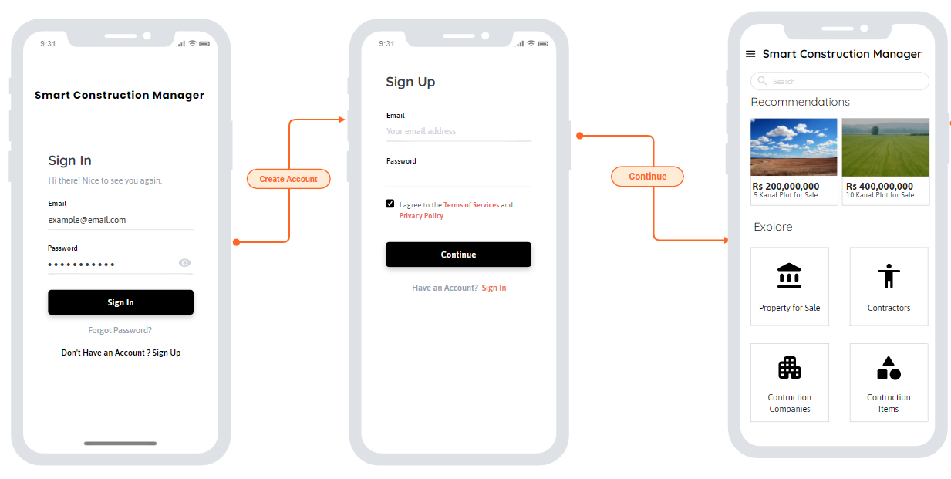

Figure 7: Mobile Home

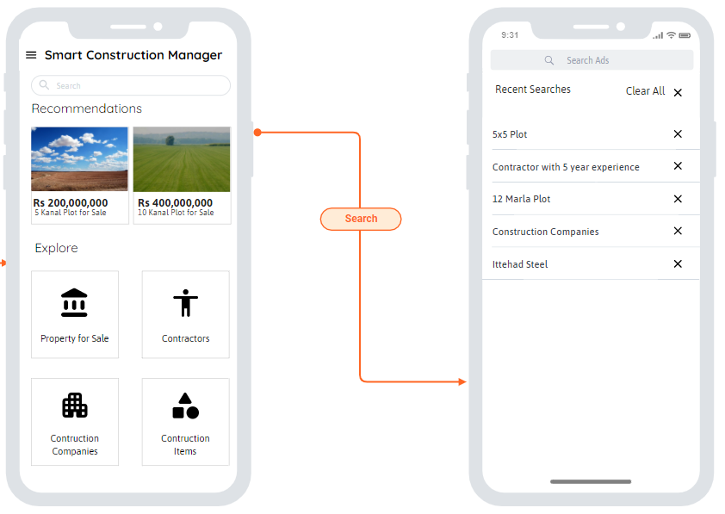

Figure 8: Mobile Search

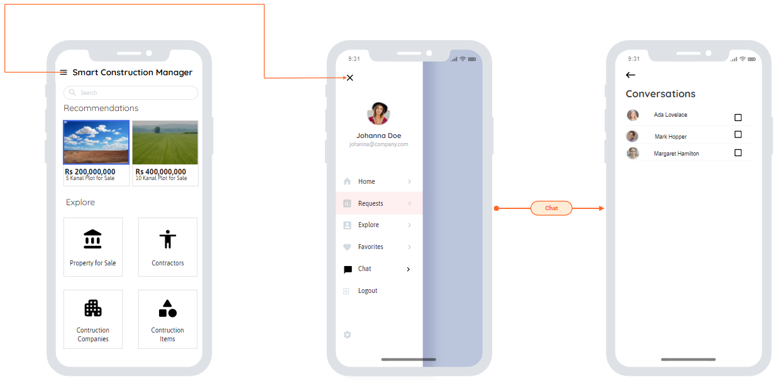

Figure 9: Mobile Chat

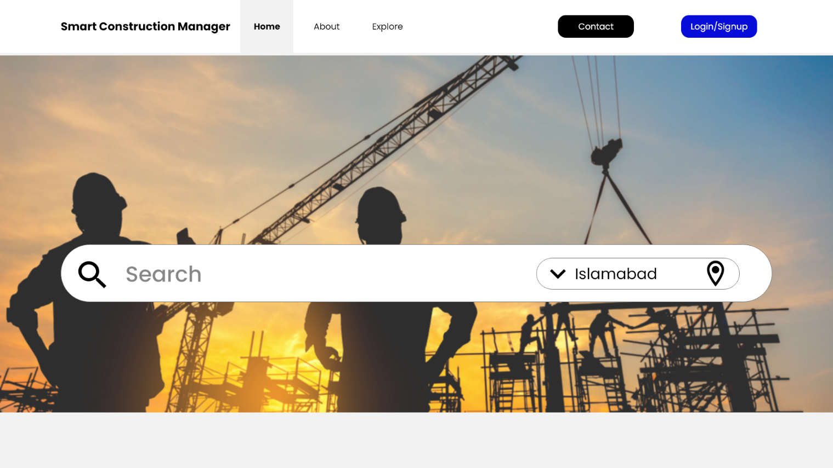

Figure 10: Web Home Interface

## Software Interfaces

The application uses MongoDB Database Management System to store public posts.

The application uses React JS for front end designing in web.

The application uses Express JS for back end development.

The application uses React Native for Mobile Development.

The application stores project data in JSON format to enable easy integration with 3rd party applications.

## Hardware Interfaces

The application requires Android Mobile device with at least Android 6.0, an IOS device with minimum IOS 9 or any desktop computer capable of running a Web Browser.

## Communication Interfaces

The application requires active internet connection which can be achieved in several ways. The application user must have working email or phone number in order to fully take advantage of the application.

# Project Gantt Chart

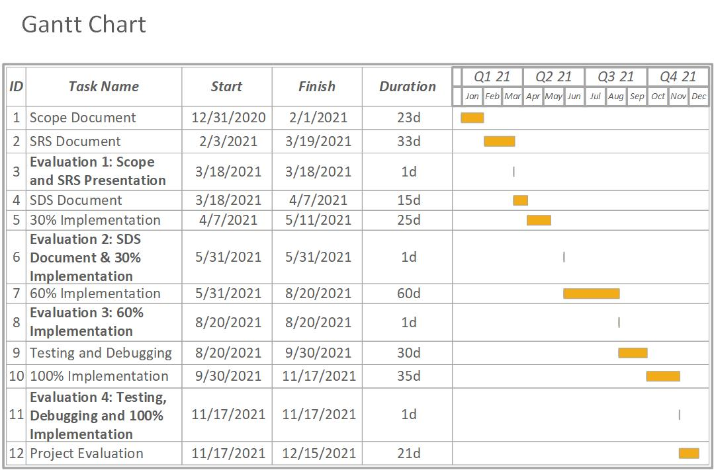

Figure 11: Gantt Chart for Targeted Project

# Conclusion

Smart Construction Manager garners the needs and s in each and every detail in the SRS document. Each Mentioned in the form of use cases is carefully analyzed from both Patron & Clients Perspective. The careful analysis of s provides Users with a sophisticated system ensuring ease in the process of construction and other commodities and forming invariably an efficient system. So, the document shows how we are planning to take our project in coming year. We will be implementing each part of our project according to the Gantt chart mentioned above and are fully motivated to complete the project.