AgroSaathi: An Integrated Smart Farming Assistant
for Crop Recommendation, Disease Diagnosis,
and Crop Growth Planning
Talha Patrawala, Bhavesh Raghunath Harad,
Kunal H. Vinod Jadhav, and Shubham Dashrath Dombale
Department of Computer Engineering, Vidyalankar Institute of Technology,
Mumbai, India

Abstract. AgroSaathi is an integrated smart farming assistant that combines crop recommendation, image-based plant disease diagnosis, crop growth planning, weather-based advisories, multilingual interaction, and a crop marketplace within a single mobile application. The system architecture separates a Flutter mobile client from Firebase persistence services and a Python FastAPI backend. The disease diagnosis module uses a convolutional neural network trained on the PlantVillage dataset across 38 classes and deployed as a quantized TensorFlow Lite model. The crop recommendation component combines a Random Forest classifier with a local deterministic agronomic scoring engine that provides fallback functionality. Crop growth plans are generated through an Ollama-hosted Qwen 2.5 3B language model with deterministic fallback templates. Weather data are obtained through the OpenWeatherMap API with GPS-based location and district-level fallback values. The application supports English, Hindi, and Marathi interfaces and includes a Firestore-backed marketplace with bidding and PDF invoice generation. Evaluation was performed through module-wise software tests and end-to-end application workflow validation. This paper reports verified implementation details and identifies limitations including the absence of field-image evaluation and formal agronomic validation of AI-generated advice.
Keywords: Smart farming, Precision agriculture, Plant disease detection, PlantVillage, TensorFlow Lite, Crop recommendation, Random Forest, Mobile application, Agricultural decision support.
1 Introduction
Agricultural decision-making involves a chain of related activities rather than one isolated prediction. A farmer may need to choose a suitable crop, assess the health of a plant from visual symptoms, plan irrigation and fertilizer operations, monitor local weather, and ultimately find a buyer for the harvested produce. In many digital workflows these activities are separated across different applications and information sources. The resulting fragmentation can make it difficult to move from a prediction to a practical action.
Machine learning and deep learning have created useful tools for agricultural diagnosis and recommendation. Image-based plant disease recognition is particularly attractive because a leaf photograph can be acquired with a commodity smartphone. The PlantVillage benchmark established a widely used setting for multiclass plant disease classification and demonstrated the effectiveness of deep convolutional models, while also exposing the difference between controlled laboratory images and field conditions [1]. This distinction motivates careful evaluation and conservative claims when a model is deployed beyond its training domain.
AgroSaathi addresses the integration problem by bringing crop recommendation, disease diagnosis, crop growth planning, weather advisories, farmer notifications, and crop selling into a single mobile platform. The design emphasizes a practical separation between the user interface, cloud persistence, model inference, and external services. The system also implements fallback paths for critical services so that the application can continue to provide useful functionality when a remote service is unavailable.
The disease-classification component deploys a convolutional neural network model trained on the PlantVillage dataset. Deep residual networks introduced residual learning through shortcut connections that allow deeper networks to optimize effectively [2]. In AgroSaathi, the trained model is exported to TensorFlow Lite and deployed as a quantized inference artifact so that the disease detector can be integrated with a resource-constrained backend service.
The main contributions of this work are: (1) an integrated mobile architecture connecting agricultural recommendation, plant disease recognition, growth planning, weather services, notifications, and a produce marketplace; (2) a 38-class PlantVillage-based disease diagnosis pipeline using TensorFlow Lite deployment with quantization; (3) a crop recommendation module combining a serialized Random Forest classifier with a local deterministic agronomic scoring fallback; (4) a structured crop growth planning workflow using an Ollama-hosted language model with deterministic fallback templates; and (5) a module-wise and end-to-end evaluation strategy that separates functional validation from predictive-model evaluation.
2 Related Work
Mohanty, Hughes, and Salathé used deep convolutional neural networks for image-based plant disease identification and reported results across 38 classes in the PlantVillage dataset [1]. Their study remains important for two reasons. First, it established a reproducible benchmark for multiclass crop-health classification. Second, it showed that model performance on curated images can differ substantially from performance on images collected under realistic field conditions. AgroSaathi uses the same benchmark setting for controlled model evaluation and does not claim field generalization because no field-image study was conducted.
Transfer learning is frequently used when training image classifiers with limited task-specific data. VGG-style networks established the value of deep convolutional feature extraction [3], whereas ResNet introduced residual blocks that allow deeper networks to preserve useful representations through shortcut connections [2]. A review of plant-disease classification literature reports extensive use of VGG16, ResNet50, MobileNet variants, DenseNet, and other transfer-learning architectures [4]. The AgroSaathi disease model was selected from a project training workflow that compared candidate architectures on the PlantVillage dataset.
For structured agricultural recommendation, Random Forest is a natural baseline because it combines multiple decision trees and can model nonlinear relationships without requiring strong distributional assumptions [5]. AgroSaathi uses a serialized Random Forest classifier as part of its crop recommendation backend and supplements it with an application-side agronomic scoring engine to support continued operation when remote inference is not available.
The distinguishing aspect of AgroSaathi is the system-level integration of these functions. Rather than optimizing a single image-classification benchmark, the project connects prediction outputs to crop planning, weather context, notification schedules, and a marketplace workflow. This changes the evaluation emphasis from a single model score to a layered assessment of predictive accuracy, software integration, service availability, and end-to-end behavior.
3 Proposed Method and System Architecture
3.1 Problem Formulation
For disease diagnosis, an RGB image I is mapped to one of K disease classes. The system computes class probabilities p(y = k | I) and selects the class with the highest probability. The PlantVillage-based configuration used by AgroSaathi contains K = 38 classes covering 14 plant species. The confidence shown to the user is derived from the predicted probability of the selected class.
ŷ = arg max_k p(y = k | I) (1)
For crop recommendation, the backend Random Forest model is trained on agricultural feature variables. The model outputs one of 22 crop classes using probability-based ranking. In parallel, the Flutter application implements a deterministic agronomic scoring function that ranks a local crop catalog of 14 crops according to soil compatibility, seasonal alignment, water availability, and an optional soil-pH adjustment.
S(c) = S₀ + Δ_soil + Δ_season + Δ_water + Δ_pH (2)
For a recommended crop c, the application estimates revenue and profit from catalog values scaled by farm size. These values are explicitly treated as illustrative estimates rather than authoritative market prices.
Profit = (Yield × Price) − Cost (3)
3.2 System Overview
AgroSaathi is organized into four interacting layers, as illustrated in Fig. 1. The first layer is the Flutter mobile client, which manages onboarding, phone-based authentication, crop setup, disease-image capture, recommendation results, growth-plan screens, marketplace interactions, profile management, localization across three languages, and local push notifications. The second layer is Firebase, which provides phone OTP authentication, Cloud Firestore persistence for user profiles, crop profiles, recommendations, growth plans, marketplace listings, bids, and notifications, as well as Firebase Storage for marketplace listing images. The third layer is the FastAPI backend, which exposes REST endpoints for disease inference, crop recommendation, growth-plan generation, disease-remedy generation, health checks, and request monitoring. The fourth layer contains intelligence services including TensorFlow Lite for disease inference, a serialized Random Forest model for crop classification, an Ollama-hosted Qwen 2.5 3B language model for growth plan and remedy generation, and the OpenWeatherMap API for weather data.
The principal workflow proceeds as follows: farmer input is collected in the Flutter client; the client either reads or writes data to Firebase or sends an inference request to FastAPI; the backend executes the appropriate model or decision procedure; the structured result is returned to the application; and selected outputs are persisted for subsequent planning, reminders, or marketplace actions.
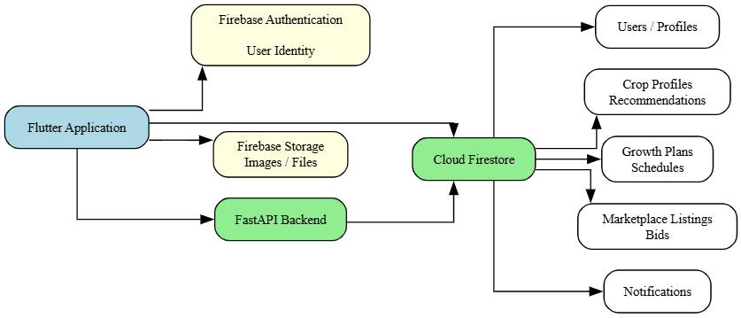
Fig. 1. Firebase data architecture showing the Flutter application's connections to Firebase Authentication, Firebase Storage, Cloud Firestore collections, and the FastAPI backend.
3.3 Key Components and Algorithms
Disease Detection Pipeline. The disease detection pipeline, illustrated in Fig. 2, accepts an uploaded leaf image through the FastAPI /predict-disease endpoint. The backend corrects EXIF orientation using PIL ImageOps, converts the image to RGB, and resizes it to match the TFLite model's input dimensions. The image tensor is passed to the TensorFlow Lite interpreter. If the model output is quantized, the backend dequantizes using the stored scale and zero-point parameters. A softmax transformation is applied when the output is not already normalized. The predicted class index is mapped to a disease label using the class_indices.json file containing 38 disease-to-index mappings. The inference response contains the predicted disease label and a confidence percentage.
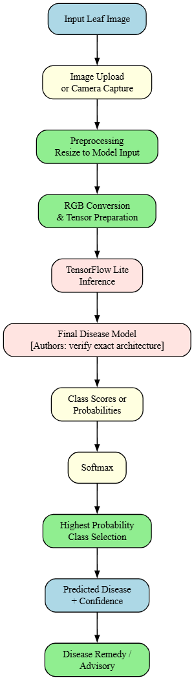
Fig. 2. Plant disease detection pipeline from leaf image input through preprocessing, TensorFlow Lite inference, softmax classification, to predicted disease label with confidence score and remedy advisory.
Crop Recommendation Pipeline. The crop recommendation pipeline, illustrated in Fig. 3, contains two complementary paths. The primary path uses a serialized Random Forest classifier (model.pkl) with 100 estimators and 22 output crop classes. The backend maps categorical application inputs (soil type, season, water availability) to integer encodings and uses predict_proba to obtain class probability distributions. The top-ranked crops are enriched with illustrative economic metadata including estimated yield, revenue, cost, and profit scaled by farm size. The fallback path is a deterministic agronomic scoring engine implemented in the Flutter application. This engine maintains a catalog of 14 crops with localized names (English, Hindi, Marathi), ideal soil types, seasonal preferences, water requirements, and economic parameters. It scores each crop against the farmer's inputs and returns up to five ranked candidates.
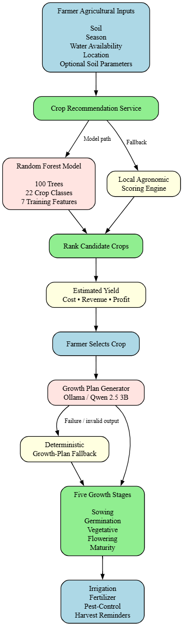
Fig. 3. Crop recommendation to growth planning pipeline showing the dual-path architecture with Random Forest model inference and local agronomic scoring fallback, followed by growth plan generation via Ollama/Qwen 2.5 3B with deterministic fallback.
Growth Plan Generation. The growth planner uses an Ollama-hosted Qwen 2.5 3B language model to generate structured five-stage crop plans covering sowing, germination, vegetative growth, flowering, and maturity. The backend sends a system prompt requesting JSON output with specific fields for each stage: duration in days, irrigation frequency, and pest risks. A normalization and validation function cleans the language model output, standardizes stage names, ensures all five stages are present, and validates fertilizer plan entries. Generated plans are cached in memory for subsequent requests with identical parameters. When the language model is unavailable or produces invalid output, a deterministic fallback template provides default stage durations, irrigation frequencies, and pest risk lists. The Flutter application converts the plan into actionable schedules and uses flutter_local_notifications to schedule device push notifications for irrigation, fertilizer, and pest-control reminders.
Disease Remedy Advisory. After disease detection, the user can request treatment guidance through the /disease-remedy endpoint. The backend queries the Ollama Qwen 2.5 3B model with a system prompt requesting structured JSON output containing severity assessment, organic remedies, chemical treatments, preventive measures, and summary advice. When the language model is unavailable, a hardcoded fallback provides general agronomic remedy guidance including neem oil application, copper oxychloride treatment, and crop rotation advice.
Weather Advisory. The weather subsystem in the Flutter application queries the OpenWeatherMap API using the device's GPS coordinates obtained through the Geolocator package. The raw meteorological data (temperature, humidity, wind speed, cloud cover, weather condition) are transformed into an agricultural advisory. For example, rain conditions generate advisories to delay pesticide spraying. The service maintains fallback weather data for five Maharashtra districts (Pune, Nashik, Nagpur, Kolhapur, Aurangabad) to ensure continued functionality when GPS or network access is unavailable.
Marketplace and Bidding. The marketplace module allows farmers to create crop listings with images uploaded to Firebase Storage and geolocation data. Buyers can browse listings, place bids, and negotiate. Farmers can accept, decline, or counter bids. All marketplace data is persisted in Cloud Firestore using a listings collection with a bids subcollection. The application supports PDF invoice generation using the pdf and printing Flutter packages when a transaction is completed.
Multilingual Support. The application implements localization for English, Hindi, and Marathi through a custom translation service backed by a comprehensive string dictionary. All user-facing labels, navigation items, crop names, and advisory texts are available in all three languages. The user can switch languages at runtime using a language selector in the application toolbar.
3.4 Implementation Details
The mobile application is implemented in Flutter (Dart SDK ≥ 3.5.0) targeting Android SDK 24–36. Firebase Authentication provides phone OTP-based identity management. Cloud Firestore stores user profiles, crop profiles, recommendations, growth plans, marketplace listings with bids, and notification records. Firebase Storage handles marketplace listing images. The application uses Google Fonts for typography, google_maps_flutter for location display in marketplace listings, and geoflutterfire_plus for geospatial queries.
The Python backend uses FastAPI (≥ 0.100.0) with uvicorn as the ASGI server, deployed on Render. TensorFlow Lite (tflite-runtime 2.14.0) provides disease model inference. The disease model is loaded preferentially from plant_disease_model_quantized.tflite, with fallback to the unquantized model and then a generic model.tflite. scikit-learn (≥ 1.2.0) loads the serialized Random Forest from model.pkl. Pillow handles image preprocessing. The backend implements CORS with permissive origin settings, request logging with an in-memory ring buffer of 100 entries, and an HTML-based monitoring dashboard for backend diagnostics.
Table 1. AgroSaathi functional modules and implementation technologies.
Module | Primary Implementation | Output / Role
Disease diagnosis | CNN + TensorFlow Lite | 38-class disease label and confidence
Disease remedy | Ollama Qwen 2.5 3B + fallback | Severity, remedies, prevention
Crop recommendation | Random Forest + local scoring | Ranked crop recommendations
Growth planning | Ollama Qwen 2.5 3B + fallback | Five-stage crop plan and schedules
Weather advisory | OpenWeatherMap API + fallback | Weather conditions and advisories
Marketplace | Flutter + Cloud Firestore | Listings, bids, invoices
Localization | Custom translation service | English, Hindi, Marathi
Authentication | Firebase Phone Auth (OTP) | User identity management
Persistence | Firebase Auth + Cloud Firestore | User and application records
Monitoring | FastAPI request logs/dashboard | Backend diagnostics and status
4 Experimental Setup
4.1 Datasets and Testbed
The disease-detection model was trained using the PlantVillage dataset in its multiclass plant-disease setting. The project uses 38 classes covering diseases and healthy-leaf categories for 14 plant species: Apple, Blueberry, Cherry, Corn (maize), Grape, Orange, Peach, Pepper bell, Potato, Raspberry, Soybean, Squash, Strawberry, and Tomato. The original PlantVillage study reports 54,306 images across these 38 classes [1]. The present application uses this dataset as the controlled evaluation environment and does not include real photographs from farmer fields in the evaluation.
For crop recommendation, the serialized Random Forest model (model.pkl) contains 22 crop classes and was trained on seven features: nitrogen (N), phosphorus (P), potassium (K), temperature, humidity, soil pH, and rainfall. The original training notebook is maintained separately. The repository confirms the model structure through the predict_proba interface but does not contain the original tabular dataset.
The Flutter application contains a local crop catalog with 14 crops including detailed agronomic metadata: wheat, rice, cotton, maize, chickpea, pigeon pea, sugarcane, onion, tomato, soybean, grapes, pomegranate, watermelon, and banana. Each catalog entry includes localized names, ideal soil types, seasonal preferences, water requirements, estimated yield per acre, base price per quintal, cultivation cost, and risk level.
Table 2. Verified dataset and model configuration.
Component | Verified Information
Plant disease dataset | PlantVillage; 38 classes; 14 plant species
Disease model deployment | TFLite quantized model; class_indices.json mapping
Crop recommendation model | Random Forest; 100 estimators; 22 classes; 7 training features
Local crop catalog | 14 crops with multilingual names and economics
Weather fallback data | 5 Maharashtra districts with agricultural advisories
Field imagery evaluation | Not conducted
Marketplace concurrency test | Not conducted
4.2 Metrics
For the disease classification task, the appropriate evaluation metrics are classification accuracy, precision, recall, and F1-score. For a multiclass task, both macro-averaged and weighted-averaged values should be reported. However, the exact numerical classification results from the model training are maintained in a separate training record not included in the project repository. The repository contains the deployable model artifacts but not the complete training evaluation logs.
Accuracy = correct predictions / total predictions (4)
F1 = 2 × precision × recall / (precision + recall) (5)
For the application itself, module-level functional correctness and end-to-end workflow success are separate measures from predictive model accuracy. The project includes Flutter unit tests that verify localization across three languages, representative crop recommendation scenarios, data-model serialization, and weather advisory generation logic.
4.3 Experimental Protocol
Evaluation was performed in two stages. First, individual modules were tested independently to verify expected input-output behavior through Flutter unit tests. Second, integrated end-to-end workflows were executed to confirm that the mobile client, backend services, cloud persistence, and AI components could exchange data correctly. The marketplace was not evaluated under multiple concurrent bidders, and the AI growth planner was not evaluated with a formal agronomic correctness or hallucination benchmark.
5 Results and Discussion
5.1 Disease Classification Deployment
The project deploys a convolutional neural network trained on the 38-class PlantVillage dataset as a quantized TensorFlow Lite model (plant_disease_model_quantized.tflite, approximately 15 MB). The backend demonstrates the complete deployment path from image upload through EXIF correction, RGB conversion, resizing to model input dimensions, tensor preparation, TFLite interpreter invocation, output dequantization when necessary, softmax normalization, and class-label mapping. The unquantized model (plant_disease_model.tflite, approximately 60 MB) is also available as a fallback.
The inference pipeline handles both quantized and floating-point model outputs transparently. The backend checks whether the output tensor sums to approximately 1.0 to determine if softmax has already been applied by the model, and applies softmax only when necessary. This approach accommodates different model export configurations.
The exact numerical classification results (test accuracy, precision, recall, F1-score) from the model training workflow are maintained in a separate training record. The project repository contains the deployable model artifacts and the complete inference pipeline but not the training evaluation logs. Therefore, this paper reports the verified deployment configuration without claiming specific accuracy percentages that have not been independently confirmed from the training record.
5.2 Crop Recommendation Results
The crop recommendation component contains two functional layers. The serialized Random Forest classifier (model.pkl, approximately 3.5 MB) provides learned multiclass prediction over 22 crop classes using 100 estimators. The backend maps application-level categorical inputs (soil type, season, water availability) to integer encodings for model input. It uses predict_proba to obtain probability distributions and selects the top three candidates ranked by confidence score.
A discrepancy exists between the model's training schema and the current backend adapter. The Random Forest was trained on seven features (N, P, K, temperature, humidity, pH, rainfall), but the backend currently constructs a three-feature input vector from the mapped soil type, season, and water availability values. This means the model receives fewer features than it was trained on. The local agronomic scoring engine in the Flutter application therefore serves as an important complementary path rather than merely a fallback.
The local agronomic scoring engine scores 14 crops against the farmer's soil type, season, water availability, and optional pH input. Scoring weights include soil compatibility (approximately 35%), seasonal alignment (approximately 35%), water availability match (approximately 25%), and pH adjustment (approximately 5%). The engine returns up to five ranked candidates with estimated yield, revenue, cost, and profit calculations scaled by farm size. These economic figures are illustrative estimates from the application's crop catalog and should not be treated as real-time market measurements.
Table 3. Crop recommendation model configuration.
Property | Verified Value
Algorithm | Random Forest Classifier
Number of estimators | 100
Number of output classes | 22
Training features | N, P, K, temperature, humidity, pH, rainfall (7 features)
Backend input mapping | Soil type, season, water availability (3 integer-encoded)
Local catalog crops | 14 (wheat, rice, cotton, maize, chickpea, pigeon pea, sugarcane, onion, tomato, soybean, grapes, pomegranate, watermelon, banana)
Economic values | Illustrative application estimates
Standalone field study | Not conducted
5.3 Application-Level and End-to-End Evaluation
Module-wise testing verifies that individual application services behave as expected. The project includes Flutter unit tests that exercise: (a) localization across English, Hindi, and Marathi, verifying that translation keys produce correct localized strings; (b) representative crop recommendation scenarios, verifying that Rabi-season inputs on black soil produce wheat or chickpea recommendations with suitability scores above 70; (c) data-model serialization, verifying that CropModel objects survive toMap/fromMap conversion; and (d) weather advisory generation, verifying that rain conditions produce appropriate agricultural advisories.
End-to-end validation connects the user interface with the backend, cloud persistence, and AI services. In a representative workflow, a user creates a crop context with soil type, season, water availability, district, and farm size; requests a recommendation; selects a crop and generates a growth plan; captures a leaf image for disease diagnosis; and continues to marketplace or notification functions. The purpose of this stage is to verify interoperability and state propagation rather than to estimate model accuracy.
Table 4. Module-wise and end-to-end validation status.
Test Area | Status | Interpretation
Localization | Implemented and tested | English, Hindi, Marathi labels verified
Crop recommendation UI flow | Implemented and tested | Representative scenarios pass application checks
Data-model serialization | Implemented and tested | Model objects survive map conversion
Weather advisory | Implemented and tested | Rain condition generates expected advisory
Disease inference | Implemented | TFLite request-response path available
End-to-end workflow | Performed | Integrated application flow validated
Concurrent marketplace bidding | Not performed | No concurrency claim
Field-user study | Not performed | No usability/generalization claim
6 Case Study and Application Workflow
A representative AgroSaathi workflow, illustrated in Fig. 4, begins when a farmer completes the crop-setup form with soil type, season, water availability, district, and farm size. The application requests ranked crop recommendations through either the backend Random Forest model or the local agronomic scoring engine. The recommendation result includes suitability score, water requirement, risk level, estimated yield, estimated revenue, estimated cost, and estimated profit. These economic values are explicitly illustrative and are intended to help users compare options rather than to represent current market quotations.
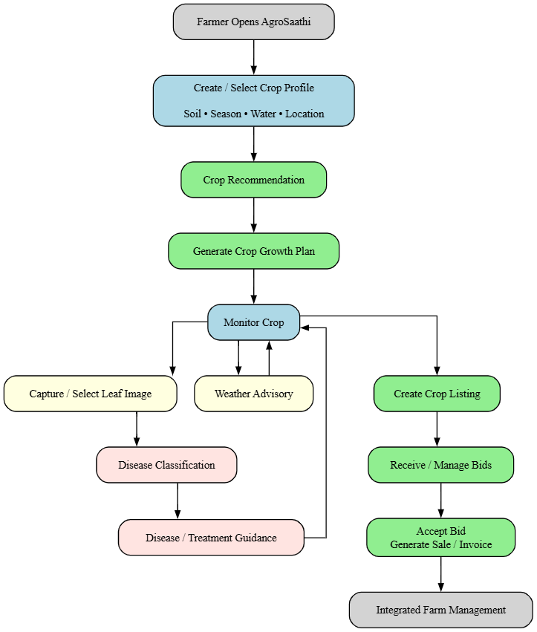
Fig. 4. End-to-end farmer workflow from crop profile setup to recommendation, growth plan generation, disease diagnosis, weather advisory, and marketplace operations.
After selecting a crop, the farmer can request a growth plan. The backend queries the Ollama-hosted Qwen 2.5 3B model, which produces a structured five-stage plan. The application converts this plan into irrigation, fertilizer, and pest-control schedules with scheduled local push notifications. The plan is stored in Cloud Firestore so that the farmer can track progress and receive reminders.
During cultivation, the farmer can capture or select a leaf image. The image is uploaded to the /predict-disease endpoint, preprocessed, passed through the quantized TensorFlow Lite model, and mapped to one of the 38 supported disease classes. The result shown to the user contains a predicted disease label and confidence percentage. The farmer can then request treatment guidance through the /disease-remedy endpoint, which queries the language model for organic remedies, chemical treatments, and preventive measures. Because the project did not perform a formal agronomic validation of generated advice, such text should be treated as decision support rather than as a substitute for professional field diagnosis.
The marketplace module allows the farmer to publish a crop listing with images and geolocation, receive bids from buyers, view buyer information, and accept a selected offer. Cloud Firestore provides persistence through a listings collection with a bids subcollection. PDF invoice generation completes the transaction workflow. This illustrates the broader system objective: transforming isolated predictions into a connected farm-management experience.
7 Backend Monitoring and Service Architecture
The FastAPI backend implements a comprehensive request logging and monitoring system, illustrated in Fig. 5. Every API request is recorded in an in-memory ring buffer with a capacity of 100 entries. Each log entry captures the endpoint, HTTP method, timestamp, client IP address, request body, Ollama attempt status and duration, response source (model inference, fallback, cache, or error), HTTP response status, and total request duration in milliseconds. The monitoring dashboard is served as an HTML page with real-time log viewing capabilities.
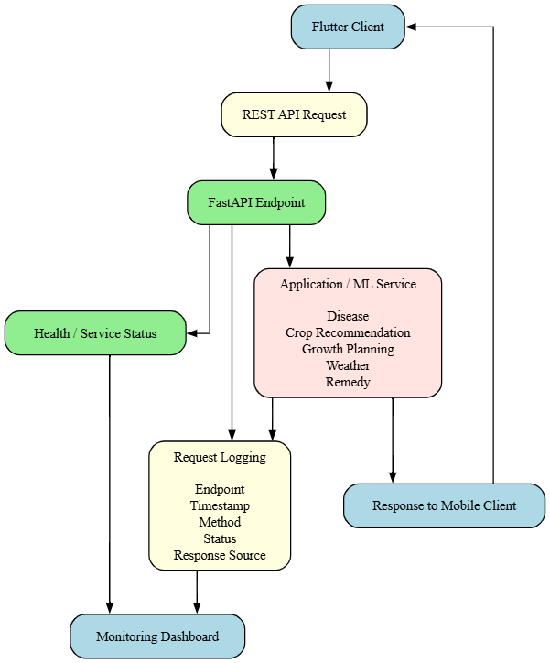
Fig. 5. Backend request monitoring architecture showing the flow from Flutter client through FastAPI endpoints to ML/AI services, with request logging for diagnostics and a monitoring dashboard.
The health check endpoint (/health) reports the loaded status of both the disease model and the recommendation model, the configured Ollama model and host, and provides a link to the monitoring dashboard. An Ollama status endpoint (/api/ollama-status) queries the language model server's /api/tags endpoint to verify service availability. These monitoring features support operational visibility during development and deployment on the Render hosting platform.
8 Threats to Validity and Limitations
The first limitation is dataset domain shift. PlantVillage images are controlled benchmark images captured under laboratory conditions and do not represent the full variation encountered in field photography with commodity smartphones [1]. AgroSaathi therefore makes no claim that disease model performance generalizes to arbitrary field photographs. A field-image evaluation would be necessary to support such a claim.
The second limitation is the incomplete availability of training evaluation records. The project repository contains deployable model artifacts (TFLite models, serialized Random Forest) and the complete application code, but not the original disease-model training notebook or evaluation logs. Consequently, exact classification metrics (accuracy, precision, recall, F1-score) cannot be independently reported in this paper. The final submission should import these values from the authoritative training record.
The third limitation concerns the crop recommendation feature-schema discrepancy. The serialized Random Forest model was trained on seven features (N, P, K, temperature, humidity, pH, rainfall), but the current backend adapter maps only three application-level categorical inputs (soil type, season, water availability) to integer encodings. This means the model receives a reduced input representation. The local agronomic scoring engine provides a complementary recommendation path and should be evaluated independently.
The fourth limitation is the absence of concurrent marketplace testing. The current project validates marketplace behavior functionally but does not establish correctness under simultaneous bidders or high transaction load.
The fifth limitation is the absence of formal evaluation for AI-generated content. The growth planner and disease remedy services use the Ollama-hosted Qwen 2.5 3B model, but neither has been evaluated for agronomic correctness, consistency, latency distributions, or hallucination rate. The deterministic fallback templates provide baseline functionality but do not address the quality of AI-generated plans.
The sixth limitation is economic-data validity. Revenue, price, yield, and cultivation-cost values in the application are illustrative estimates from the crop catalog. They should be refreshed from authoritative local data sources before being treated as decision-grade financial information.
Finally, the project does not contain a formal field-user study. Consequently, conclusions about usability, farmer acceptance, behavioral change, or agricultural impact should not be stated as empirical findings.
9 Conclusion and Future Work
This paper presented AgroSaathi, an integrated smart farming assistant that combines crop recommendation, plant disease diagnosis, crop growth planning, weather advisories, disease remedy guidance, multilingual interaction, local push notifications, and a produce marketplace within a single mobile application. The system separates the Flutter user interface from Firebase persistence and FastAPI-based intelligence services, while TensorFlow Lite enables deployable disease inference and a Random Forest model supports structured crop recommendation.
The primary contribution of the present work is system integration and deployment-oriented engineering rather than a new classification architecture. The disease classifier is deployed as a quantized TensorFlow Lite model trained on the 38-class PlantVillage dataset. The crop recommendation combines a learned Random Forest model with a deterministic agronomic scoring engine for robustness. Growth planning and disease remedy services use an Ollama-hosted Qwen 2.5 3B language model with deterministic fallback behavior. The weather subsystem integrates OpenWeatherMap with GPS-based location and district-level fallback data. The evaluation strategy combines module-wise software tests with end-to-end workflow validation, while explicitly avoiding unsupported claims about field performance or farmer impact.
Future work should focus on five areas. First, the model evaluation should be made fully reproducible by publishing the dataset split, training configuration, class-wise metrics, and model-conversion details. Second, the disease model should be evaluated on field-collected smartphone images to quantify domain shift and calibration. Third, the crop recommendation backend should reconcile its feature-schema discrepancy to utilize all seven trained features. Fourth, the AI-generated growth plans and disease remedies should be evaluated for agronomic correctness and hallucination rate. Fifth, the marketplace module should be tested under concurrent transaction loads, and a formal field-user study should be conducted to assess usability, farmer acceptance, and agricultural impact.
Acknowledgments
The authors thank Dr. Prakash J. Parmar for guidance and supervision during the design and implementation of AgroSaathi.
Disclosure of Interests
The authors have no competing interests to declare that are relevant to the content of this article.
References
1. Mohanty, S.P., Hughes, D.P., Salathé, M.: Using deep learning for image-based plant disease detection. Frontiers in Plant Science 7, Art. no. 1419 (2016). https://doi.org/10.3389/fpls.2016.01419
2. He, K., Zhang, X., Ren, S., Sun, J.: Deep residual learning for image recognition. In: Proc. IEEE Conference on Computer Vision and Pattern Recognition (CVPR), Las Vegas, NV, USA, pp. 770–778 (2016)
3. Simonyan, K., Zisserman, A.: Very deep convolutional networks for large-scale image recognition. In: Proc. International Conference on Learning Representations (ICLR) (2015)
4. Richter, D.J., et al.: A systematic review of the current state of transfer learning accelerated CNN-based plant leaf disease classification. arXiv preprint (2025)
5. Breiman, L.: Random forests. Machine Learning 45, 5–32 (2001)
6. TensorFlow: TensorFlow Lite documentation. https://www.tensorflow.org/lite, last accessed 2025/01/15
7. Flutter: Flutter framework documentation. https://flutter.dev, last accessed 2025/01/15

