|  |
| --- |
| **LAST SURPRISE** |
| Hamstronaut |
|  |
| Version #0.1  All work Copyright © 2021 by Last Surprise  All rights reserved. |
| **Shimron Khan**  **Salick Talhah** |
| **Maxwell Bojarzin**  **Joseph Malibiran**  **Tyler McMillan**  **Amber Thompson** |

|  |
| --- |
| January 11th 2021 |

## Table of Contents

Table of Contents

Version History

Game Overview

Game Play Mechanics

Camera

Controls (Subject to change if necessary)

Saving and Loading

Interface Sketch

Menu and Screen Descriptions

Game World

Levels

Game Progression

Characters

Enemies

Weapons

Items (AKA Pickups)

Abilities

Script

Scoring

Sound Index

Story Index

Future Features

## 

## Version History

**v0.1**

Jan 28 – Added Savefiles and scripts, Coding consistency.

Jan 29 – Added Minimap/ Start player functionality.

Jan 30 – Added SaveFilesManage, SaveLoadSystem, Minimap setting, Added Assets and more player functionality.

Jan 31 – Added SaveGame and LoadGame functions.

Feb 1 – Added Main Menu, SimplyPausing Script, Platforms.

Feb 2 – Added Checkpoint, Minimap setting, Main Menu functionality, update level.

Feb 3 – Added Pause UI, Gameplay UI, Health Bar, Player Camera, Inventory Menu, Audio, Collectibles.

Feb 4 – Added Desktop Control, Assets for level Creation, Fix movement issues.

Feb 5 – Fix bugs.

Feb6 – Added Minimap, Player controller, enemy animated, Player movements, Seed counter, Polishing UI.

Feb 7 – Fixing bugs and polishing level.

## Game Overview

*A 3D Platformer with hovering and shooting mechanics.*

## Game Play Mechanics

*platforming and shooting*

## Camera

*The game will feature a third-person perspective view camera in a fixed angle that will smoothly follow the player character.*

## Controls (Subject to change if necessary)

*WebGL controls.*

* *WASD to move.*
* *Space bar to Jump.*
* *Click to use any UI.*
* *Click to Attack.*

*mobile touch controls.*

* *left joystick to move.*
* *A to jump.*
* *X to shoot.*
* *Y and B to switch ammo type.*
* *(Possible aiming with another joystick on the right)*

## Saving and Loading

*Your progress is saved based on player input. And when you load a game you start at the last checkpoint you were on. The player will have the option to save when pause is pressed.*

## Background pattern Description automatically generated with medium confidenceInterface Sketch (WebGL Version)

## Interface Sketch (Mobile Version)

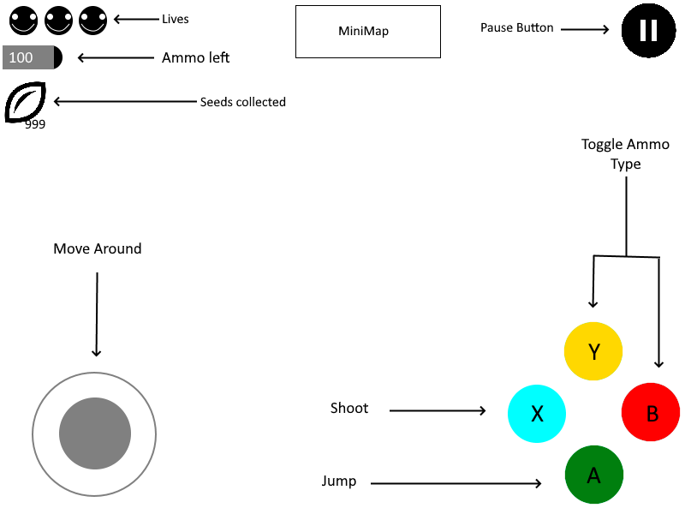

## Menu and Screen Descriptions

* **Menu Screen:** Start screen with menu buttons where you can Start a new game, Load the previous saved game, Instructions, Option and quit.
* **Instructions:** demonstrate how the game is played can press the back button to go back to the title screen.
* **Option:** The player will be able to adjust Volume or Controls.
* **Game Over:** Menu Screen when player losses. Menu buttons allow player to retry level, quit game, or go back to menu.
* **Start Screen:** Greets the player and prompts them to tap the screen. Once tapped the game goes to the menu screen.
* **Pause Screen:** Pauses game. Allows player to quit or save and go back to main menu.

## Game World

This is the year 43, 020, 001, 000. Long after humans eradicated itself during a nuclear war, Animals evolved into beings of great intelligence. Marco and Polo are very talented Space Engineer hamsters who have been sent to Orbitus. A space satellite made to explore the possibilities of creating artificial planets. Since the great star (AKA the sun) is nearing the end of its life cycle. However, while the experiments were underway, aliens from Pluto known as the Plutorions break in and attempt to take Polo away to perform experiments on him. Now it’s Marco’s job along with his nifty power suit to prevent that from happening.

## Levels

**Orbitus:** The player controls Marco and has to get to the end of the level and defeat Pluton (AKA the Boss) to prevent Polo from being taken, from the alien invaders known as the Plutorions.

## Game Progression

Just reach the end of the level and beat the boss to win.

## Characters

* ***Marco****: A Hamster Astronaut named (The Character your playing as)*
* **Polo:** Marco’s best friend who was kidnapped by aliens for experimental purposes

## Enemies

The Aliens are known as the Plutorions their weaknesses will differ depending on the planet/level the player is on they all shoot at the player. Some are Stationary but others may move around.

* **Plutorion Grey**: The basic Enemy with no real weaknesses just shoot them.
* **Plutorion White:** An Enemy with the ability to fly.
* **Plutorion Red:** An Enemy impervious to explosives.
* **Plutorion Purple:** An Enemy impervious to freezing.
* **Pluton:** The Boss shoots at the player while summoning weaker versions of previous enemies to attack the player as well.

## Weapons

Marco uses a power suit to explore space. It can fire various types of projectiles.

***Projectiles***

* **Lazer:** weak projectile that can be used as much as the player wants.
* **Nitrogen Bullets:** A freezing weapon that can hurt and stop enemies in their tracks.
* **Explosive Bullets:** bullets that blow up on impact and can hurt others that are nearby.

## Items (AKA Pickups)

* ***Seeds:*** *Replenishes life.*
* ***Bullets:*** *fills ammo supply*

## Abilities

* Jumping.
* Hovering for a short period of time by holding the jump button.
* shooting different types of projectiles.

## Dynamics

The interaction between the player and the game for the WebGL version is by Keyboard (WASD) to move and mouse (to interact with UI and attack) but for Mobile version will be Joystick, touchscreen, and buttons. The complexity will be to overcome the smart Alien enemies which will have different abilities. The gameplay data displayed during the game will be health, Minimap, collected Item, Pause button. By the Pause button, the player will be able to save, go back to main menu and quit. On the Main Menu Screen the player will have the instruction screen with a brief story and the control type. Also, an option where the player can adjust the volume.

## Aesthetics

The game atmosphere is in a Space Station, the feeling of the game will be more technological, sparse and geometric. It will have a fun and serious mood. All the gathered assets will create a coherent and cohesive theme. Since we are in a Space atmosphere, the color of the surrounding will vary depending on where you are in the station. The background sound will be ambient and mostly spaceship electrical sounds. Each movement will have a different sound effect, such as player attack, enemies attack, jump and even running. The goal is for Marcos to save his friend Polo who was captured by Aliens. The fun will be overcoming the obstacles and the different effects the game provides and exploring the world.

## Script

Using C# in Unity.

## Scoring

* Number of different Seeds collected.
* Number of Aliens Killed.

## Sound Index

**MUSIC**

* Title Screen Music.
* Level Music.
* Game Over music/Jingle.

***SFX***

* Laser shooting sounds for player and enemies.
* Explosion sounds.
* Freezing sounds.
* Impact sounds for player and enemies.

## Story Index

*Marco is a Hamster astronaut, who is trying to rescue his Friend Polo, who was kidnapped by aliens, to use in their experiments, and it is up to Marco to stop them.*

## Future Features

* more enemy types.
* multiple levels.
* a boss for every levels.