

Name:

Talha Abid

Roll No:

192400002

Submission Date:

28 April, 2022

Submitted To:

Numra Khalid

Subject:

Software Quality Engineering

Objective:

Assignment 2

State Transition Testing

Reservation system

***Reservation system possible scenarios in figure.***

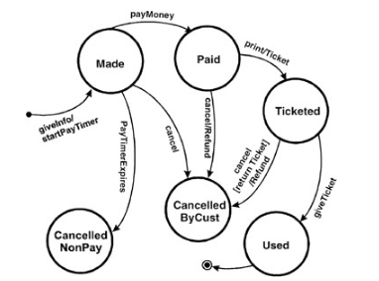

______________________

***Arranging In Table Form***

|  |  |  |  |  |  |  |
| --- | --- | --- | --- | --- | --- | --- |
| Info Gather | Made plan | Payment | Ticketed | Used | - | - |
| Info gather | Made plan | Pay Time Expires | - | - | Canceled | - |
| Info gather | Made plan | - | - | - | Canceled  No-pay | - |
| Info gather | Made plan | Done payment | ticketed | - | Cancelled | Refund |
| Info gather | Made plan | Done payment | - | - | Cancelled | Refund |

_____________________

***Creating Test Cases***

Information in the state-transition diagrams can easily be used to create test cases. Four different levels of coverage can be defined:

***Test Case:***

Create a set of test cases such that all states are "visited" at least once under test. The set of three test cases shown below meets this requirement. Generally this is a weak level of test coverage.

***Test Case:***

Create a set of test cases such that all events are triggered at least once under test. Note that the test cases that cover each event can be the same as those that cover each state. Again, this is a weak level of coverage.

***Test Case:***

Create a set of test cases such that all paths are executed at least once under test. While this level is the most preferred because of its level of coverage, it may not be feasible. If the state-transition diagram has loops, then the number of possible paths may be infinite

***Test Case:***

Create a set of test cases such that all transitions are exercised at least once under test. This level of testing provides a good level of coverage without generating large numbers of tests. This level is generally the one recommended.

_____________________