EduVault
Online Learning Resource Repository
Deliverable 2 — Iteration 1 / Sprint 1 Report
Subject: Software Engineering
Department of Artificial Intelligence
National University of Computer and Emerging Sciences, Islamabad
Date of Submission: 11th March 2026
Project Team
Talha Afzal — 24i-0027
Abdul Hadi — 24i-2599
Umair Saeed — 24i-0088

1. Project Introduction
EduVault is a web-based Online Learning Resource Repository designed to provide students and teachers at FAST-NUCES with a centralized, organized platform for uploading, browsing, and downloading academic materials. The platform addresses the common problem of learning resources being scattered across messaging apps, emails, and cloud drives by consolidating them into a single structured system.

Sprint 1 focuses on the Core Resource Management module, covering user registration, login, resource upload, resource viewing, and resource download. These features form the foundation of the entire platform.

2. Sprint 1 Backlog

2.1 Module Name
Core Resource Management

2.2 User Stories
The following table lists the primary user stories selected for Sprint 1 along with their priority and actor:

ID | User Story | Actor | Priority
US-01 | As a new user, I want to register with my university email so that I can access the EduVault platform. | Student / Teacher | High
US-02 | As a registered user, I want to log in with my credentials so that I can access my account securely. | Student / Teacher | High
US-03 | As a logged-in user, I want to upload a learning resource (PDF, document, or link) so that others can access it. | Student / Teacher | High
US-04 | As a user, I want to view a list of uploaded resources so that I can browse available materials. | Student / Teacher | High
US-05 | As a user, I want to download a resource so that I can study it offline. | Student / Teacher | High
US-06 | As a user, I want to log out of my account so that my session is ended securely. | Student / Teacher | Medium

2.3 Sub User Stories
Each primary user story is broken down into granular sub user stories as listed below:

Sub-Story ID | Sub User Story | Actor
US-01.1 | As a new user, I want to enter my full name during registration so that my profile is identifiable. | Student / Teacher
US-01.2 | As a new user, I want to provide a university email (@nu.edu.pk) so that domain restriction is enforced. | Student / Teacher
US-01.3 | As a new user, I want to select my role (Student/Teacher) so that the system can assign appropriate permissions. | Student / Teacher
US-01.4 | As a new user, I want to set and confirm a password during signup so that my account is secure. | Student / Teacher
US-02.1 | As a user, I want to enter my registered email and password so that I can authenticate myself. | Student / Teacher
US-02.2 | As a user, I want to see an error message if my credentials are wrong so that I know login failed. | Student / Teacher
US-02.3 | As a user, I want a 'Forgot Password' option so that I can recover access to my account. | Student / Teacher
US-03.1 | As a user, I want to enter a resource title and description so that others understand what I am sharing. | Student / Teacher
US-03.2 | As a user, I want to select a subject from a dropdown so that the resource is categorized correctly. | Student / Teacher
US-03.3 | As a user, I want to drag-and-drop or browse a file (PDF, DOC, PPT) so that it is uploaded to the system. | Student / Teacher
US-03.4 | As a user, I want to see a progress bar during upload so that I know the status of my submission. | Student / Teacher
US-04.1 | As a user, I want to see resource cards with title, subject, and uploader name so that I can quickly identify materials. | Student / Teacher
US-04.2 | As a user, I want to click on a resource card to view its details so that I can decide whether to download it. | Student / Teacher
US-05.1 | As a user, I want to click a Download button on a resource detail page so that the file is saved to my device. | Student / Teacher
US-05.2 | As a user, I want to see upload metadata (uploader name, date, subject) so that I can assess resource credibility. | Student / Teacher
US-06.1 | As a user, I want to click a Logout button so that my session is terminated and I am redirected to the login page. | Student / Teacher

3. Structured Specifications
Four structured specifications are provided below for the key user stories of Sprint 1.

3.1 Structured Specification — US-01: User Registration
Use Case ID | US-01
Use Case Name | User Registration
Actor | Student / Teacher (New User)
Description | A new user registers on EduVault using their university email address to gain access to the platform.
Pre-conditions | The user has a valid university email ending in @nu.edu.pk. The user does not already have an account.
Post-conditions | A new user account is created in the system. The user is redirected to the login page.
Main Flow | 1. User navigates to the Sign Up page. 2. User enters full name, university email, password, confirm password, and selects a role. 3. User agrees to Terms and Conditions. 4. User clicks Sign Up. 5. System validates email domain (@nu.edu.pk). 6. System hashes password and creates account. 7. User is redirected to Login page.
Alternative Flow | AF1: If email domain is not @nu.edu.pk, system displays 'University email required' error. AF2: If passwords do not match, system shows 'Passwords do not match' error. AF3: If email already exists, system shows 'Account already exists' error.
Non-functional | Password must be stored using bcrypt hashing. Domain restriction enforced server-side.

3.2 Structured Specification — US-02: User Login
Use Case ID | US-02
Use Case Name | User Login
Actor | Registered Student / Teacher
Description | A registered user logs into EduVault using their email and password to access the platform features.
Pre-conditions | The user must have a registered account on EduVault.
Post-conditions | User is authenticated and redirected to the home/dashboard page with a valid session.
Main Flow | 1. User navigates to the Login page. 2. User enters their university email and password. 3. User clicks Login. 4. System validates credentials against the database. 5. On success, session is created and user is redirected to the dashboard.
Alternative Flow | AF1: If credentials are incorrect, system displays 'Invalid email or password'. AF2: If user clicks Forgot Password, system initiates password reset flow. AF3: If account is not verified, system prompts email verification.
Non-functional | Login must complete within 2 seconds under normal load. Session tokens must expire after 24 hours of inactivity.

3.3 Structured Specification — US-03: Upload Learning Resource
Use Case ID | US-03
Use Case Name | Upload Learning Resource
Actor | Logged-in Student / Teacher
Description | A logged-in user uploads a learning resource (PDF, document, or reference link) to EduVault.
Pre-conditions | User is authenticated. File size does not exceed 50 MB.
Post-conditions | Resource is stored securely. It appears in the resource listing under the selected subject.
Main Flow | 1. User navigates to the Upload Resource page. 2. User fills in resource title and description. 3. User selects a subject from the dropdown. 4. User enters topic/chapter name. 5. User drags-and-drops or browses for a file. 6. User clicks Upload. 7. System shows a progress bar during upload. 8. On completion, system confirms upload and redirects to resource listing.
Alternative Flow | AF1: If file exceeds 50 MB, system displays 'File too large' error. AF2: If unsupported format is uploaded, system shows 'Unsupported file type' error. AF3: If required fields are empty, system highlights missing fields.
Non-functional | Upload must complete within 5 seconds for files up to 50 MB. Files must be stored securely with access control.

3.4 Structured Specification — US-05: Download Resource
Use Case ID | US-05
Use Case Name | Download Learning Resource
Actor | Logged-in Student / Teacher
Description | A logged-in user downloads an existing learning resource from EduVault to their local device.
Pre-conditions | User is authenticated. The resource exists and is approved in the system.
Post-conditions | File is downloaded to the user's device. Download count for the resource is incremented.
Main Flow | 1. User browses or searches for a resource. 2. User clicks on a resource card to open its detail page. 3. User views resource metadata (title, uploader, date, subject). 4. User clicks the Download button. 5. System initiates file download to the user's device.
Alternative Flow | AF1: If the file no longer exists on the server, system shows 'Resource unavailable' error. AF2: If user is not logged in, system redirects to login page.
Non-functional | Download must initiate within 3 seconds. The system must log all download activity for audit purposes.

4. Non-Functional Requirements Specification
The following non-functional requirements have been identified for the EduVault system. They are specified in natural language to ensure clarity for all stakeholders:

ID | Requirement | Description | Priority | Applicable Module
NFR-01 | Domain Restricted Authentication | Only users with @nu.edu.pk email can register and log in. | High | Registration / Login module
NFR-02 | Security | User passwords must be stored in encrypted format using bcrypt or equivalent hashing. | High | Authentication module
NFR-03 | Usability | The interface must be intuitive enough that a non-technical user can upload or download a resource within 3 clicks. | Medium | All UI pages
NFR-04 | Scalability | The system must support up to 500 concurrent users without performance degradation during initial release. | Medium | Backend / Database
NFR-05 | Performance | File upload and download response time must not exceed 5 seconds for files up to 50 MB. | Medium | Upload / Download module

4.1 NFR Natural Language Description
NFR-01: Domain Restricted Authentication
The system shall only permit users who possess a valid university email address (ending in @nu.edu.pk) to register and log in. Any attempt to register with an external email domain must be rejected with an appropriate error message. This restriction must be enforced on the server side and cannot be bypassed through client-side manipulation.

NFR-02: Security
All user passwords must be stored in a hashed and salted format using a strong cryptographic algorithm such as bcrypt. Under no circumstances shall plain-text passwords be stored in the database. Communication between the client and server must use HTTPS to protect data in transit.

NFR-03: Usability
The system must provide a clean and intuitive user interface that allows a first-time, non-technical user to successfully upload or download a resource within three user interactions. Error messages must be descriptive and actionable so that users can self-correct without requiring technical support.

NFR-04: Scalability
The backend architecture must be designed to support a growing user base. During the initial release, the system must handle a minimum of 500 concurrent users without significant performance degradation (i.e., response time should not exceed 3 seconds for standard operations). The database schema and file storage mechanism should allow horizontal scaling if user numbers increase significantly.

NFR-05: Performance
File uploads and downloads of up to 50 MB must complete within 5 seconds under normal network conditions. API response times for standard read operations (e.g., fetching resource listings) must not exceed 2 seconds. A visible progress indicator must be shown to the user during file uploads to ensure transparency.

Figma Shareable Link:
https://www.figma.com/make/wIVIcDiNSylbZxWfIvA46T/Website-Builder?t=3nSxBmtYOuJcbQjN-1&preview-route=%2Fdashboard

6. Iteration 1 Implementation Screenshots
The following section contains screenshots of the implemented features for Sprint 1. Screenshots demonstrate the working state of each implemented module.

6.1 Registration Page
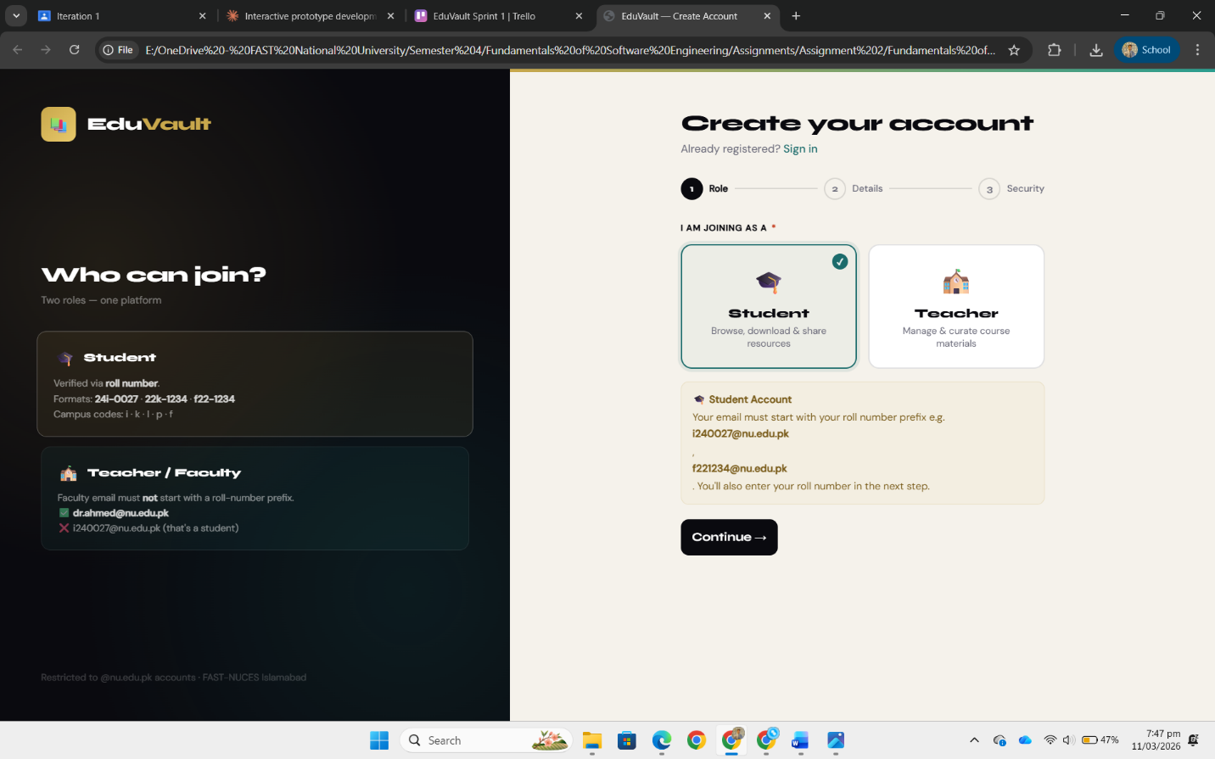
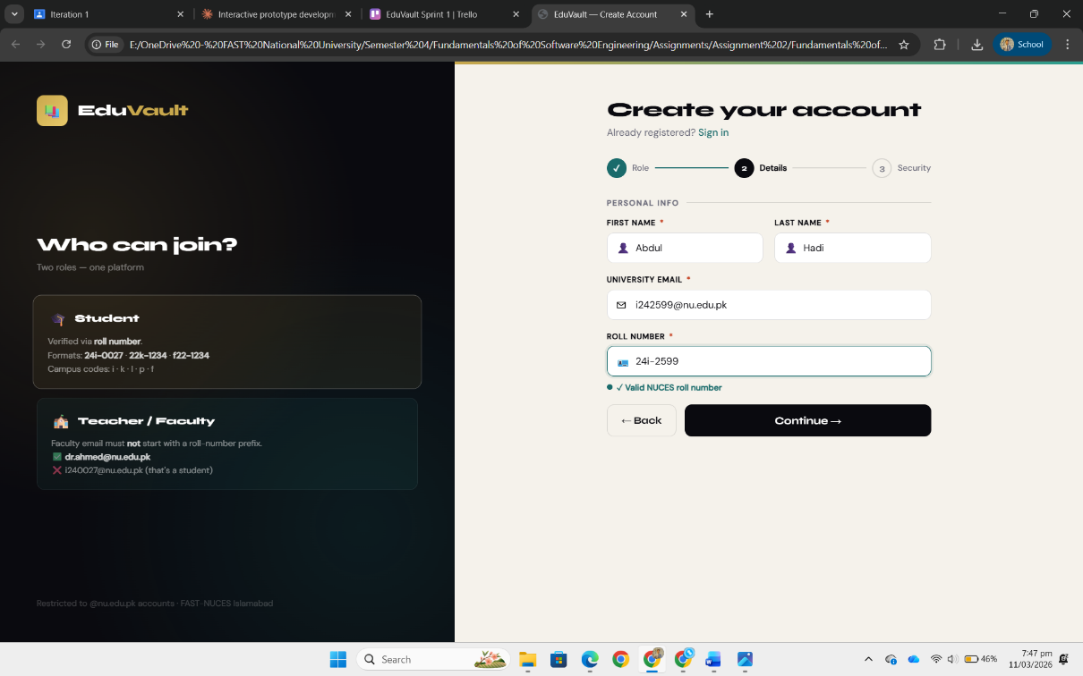
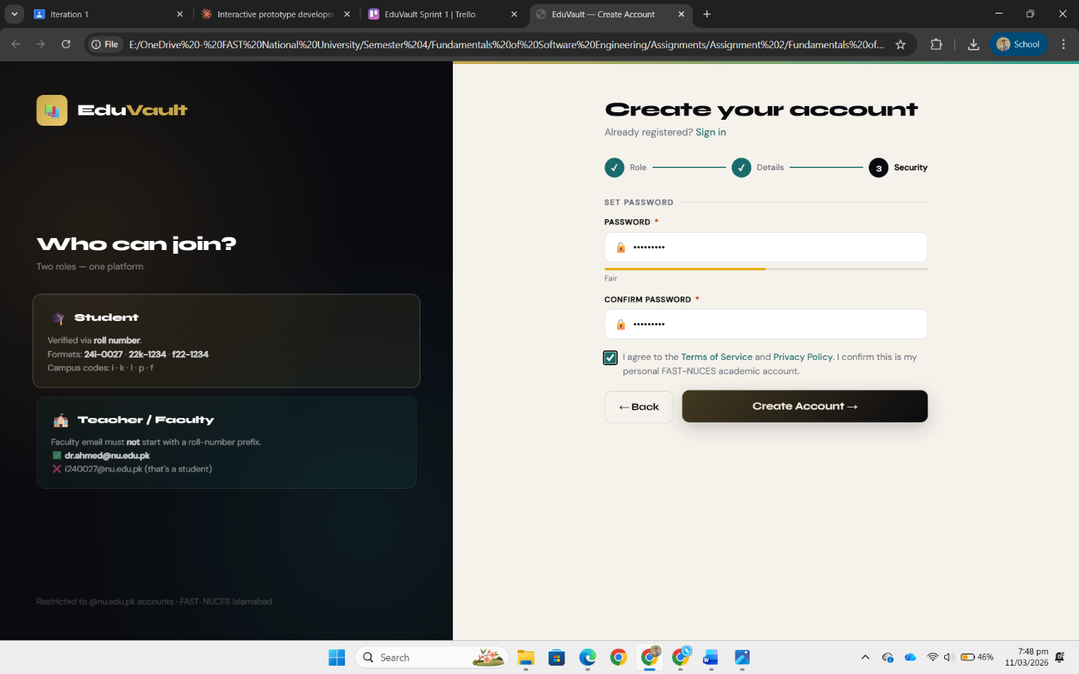

6.2 Login Page
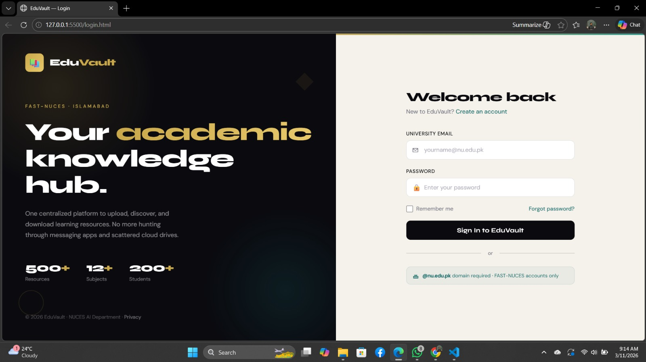

6.3 Upload Resource Page
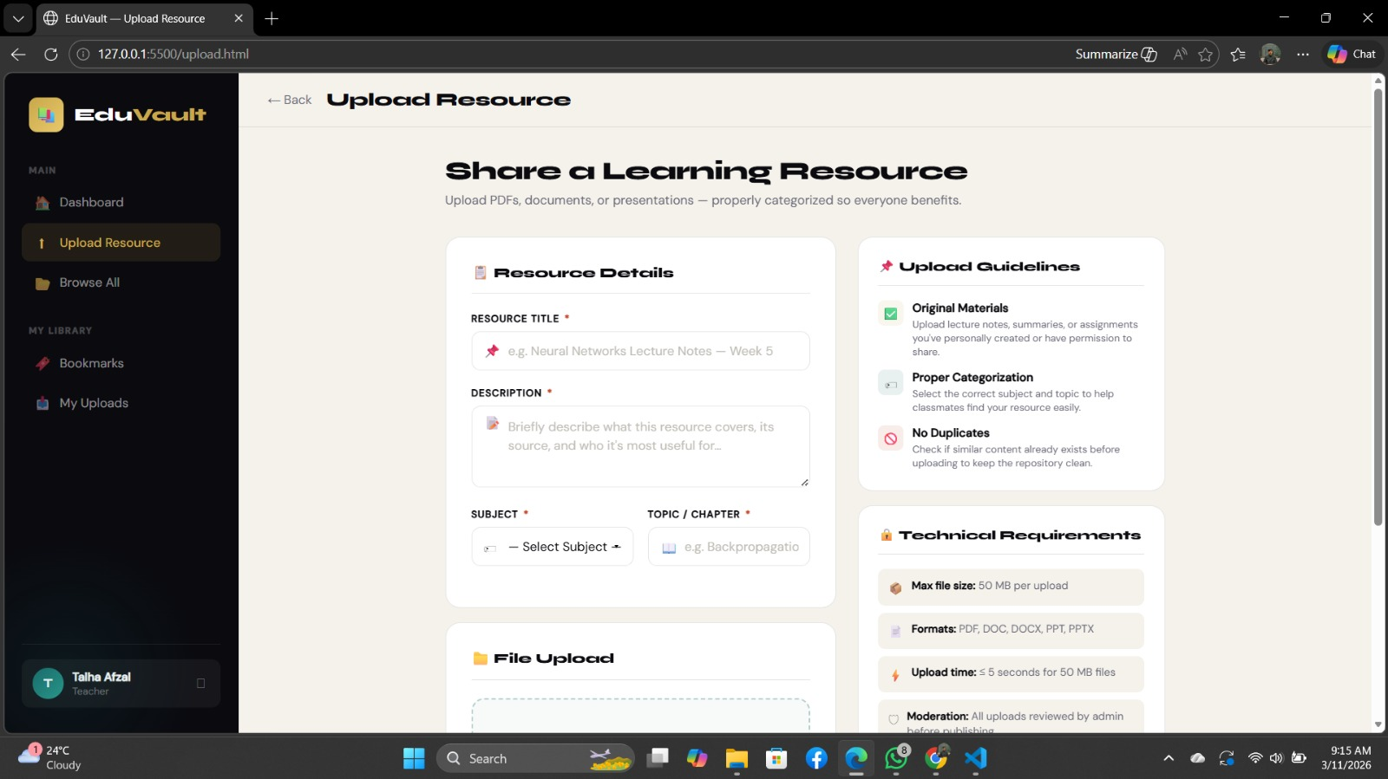
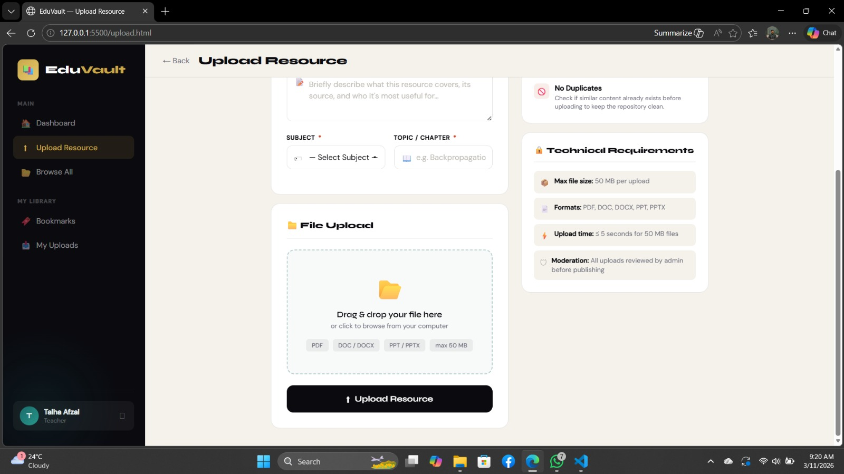

6.4 Resource Listing / Browse Page
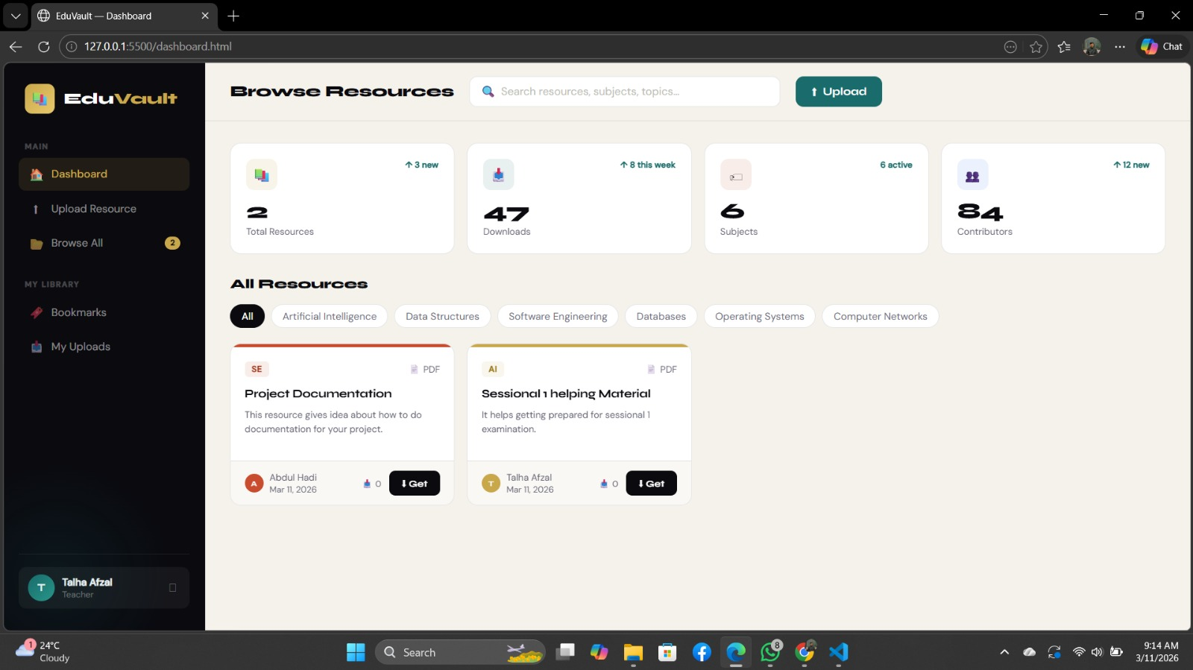
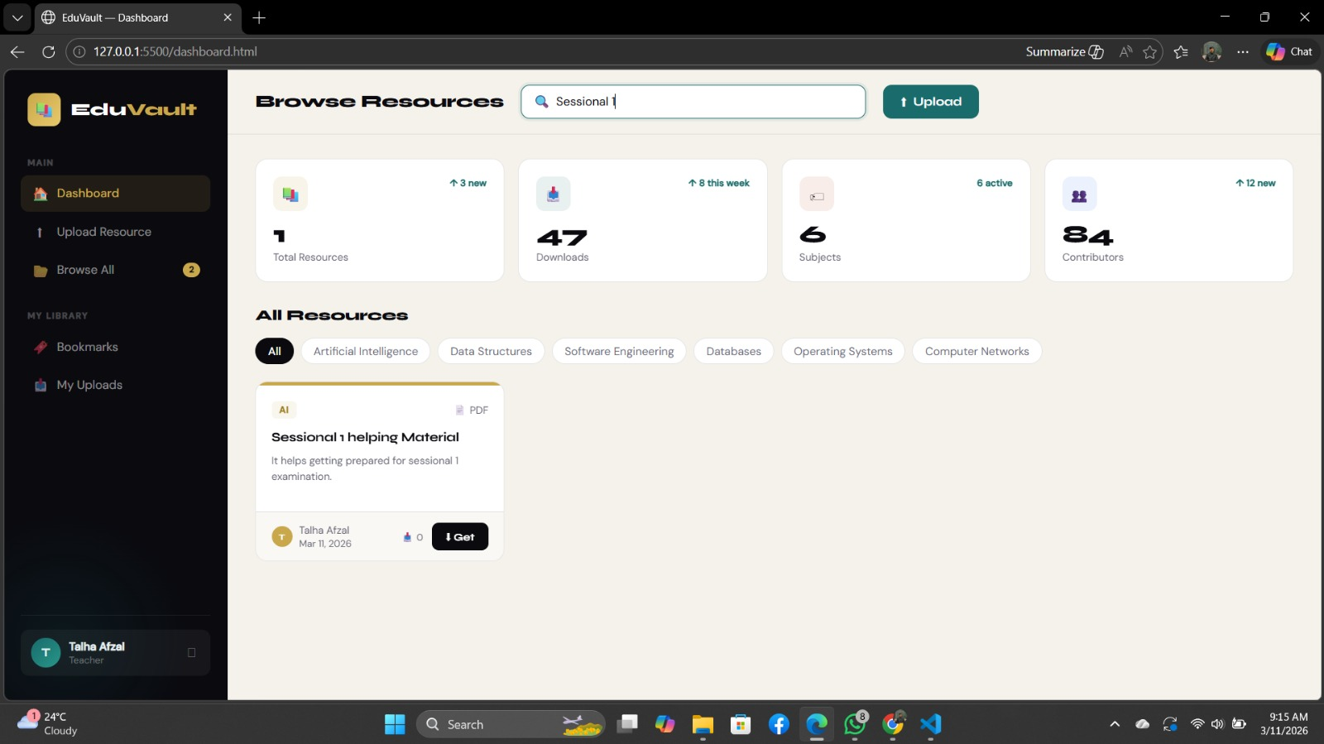

6.5 Resource Detail & Download Page
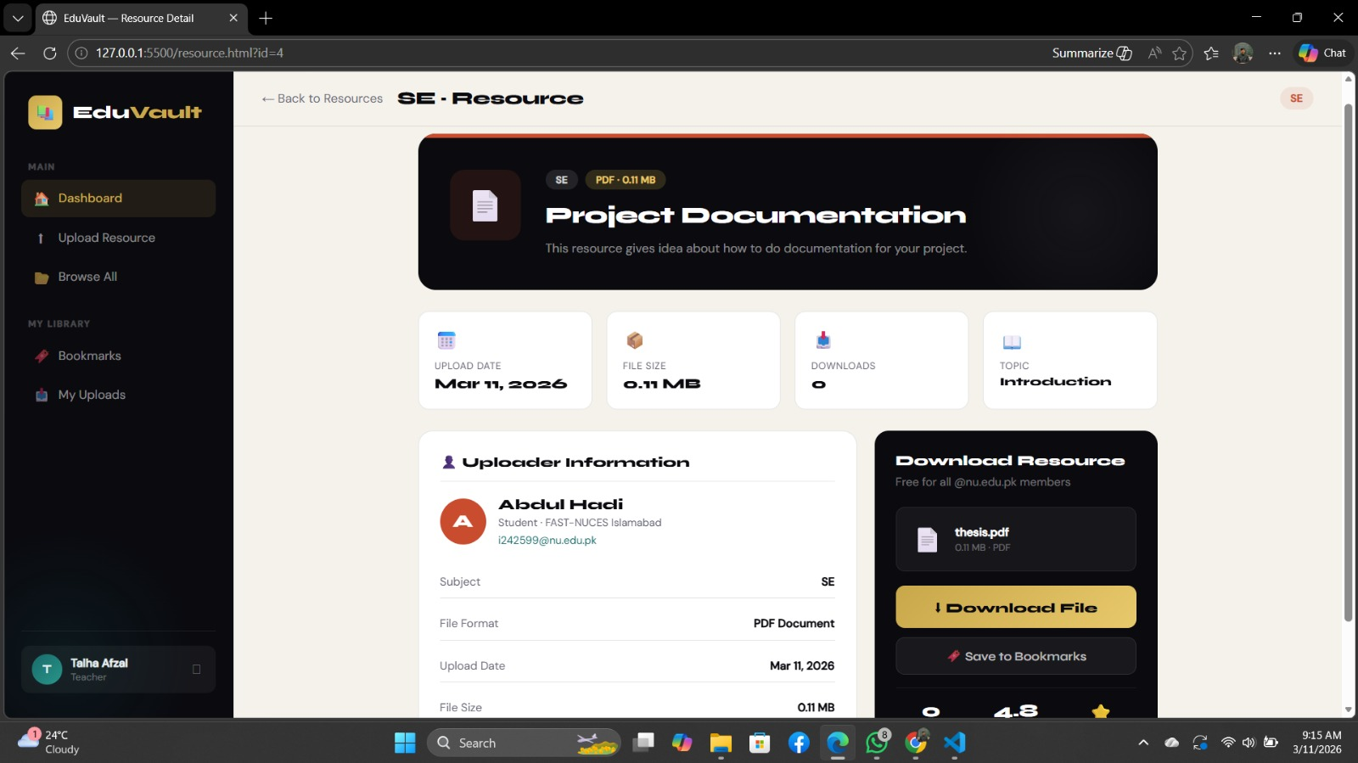
Trello Screen Shots

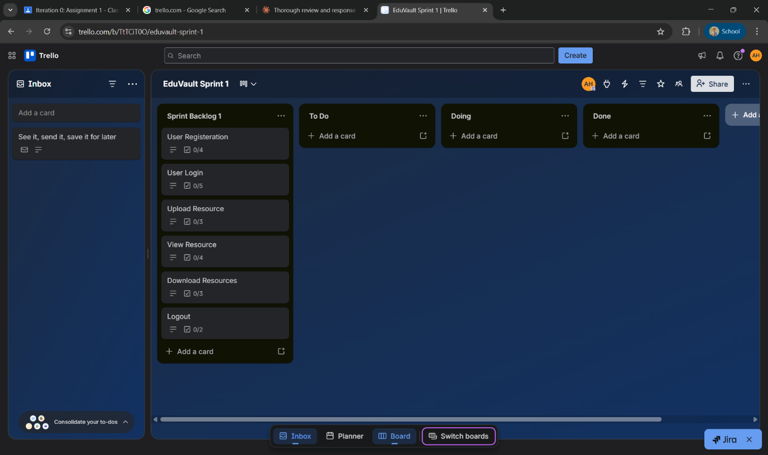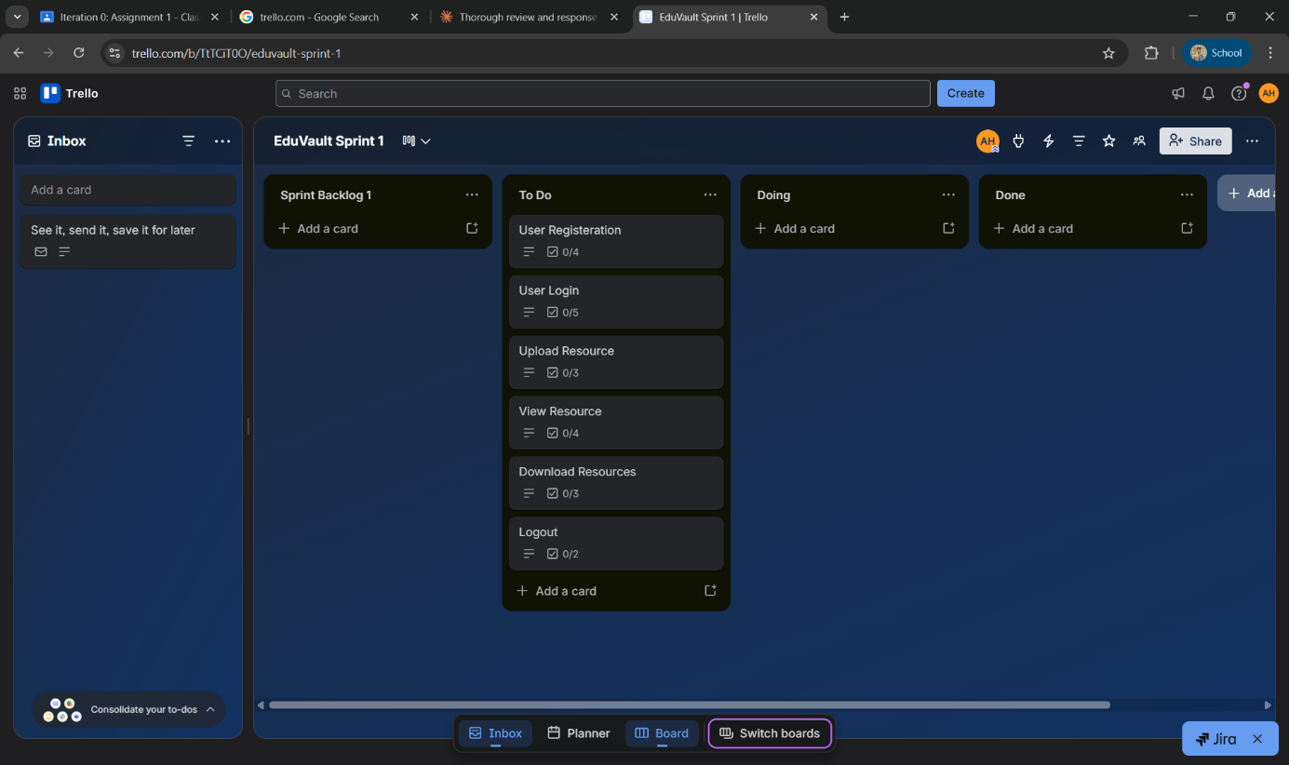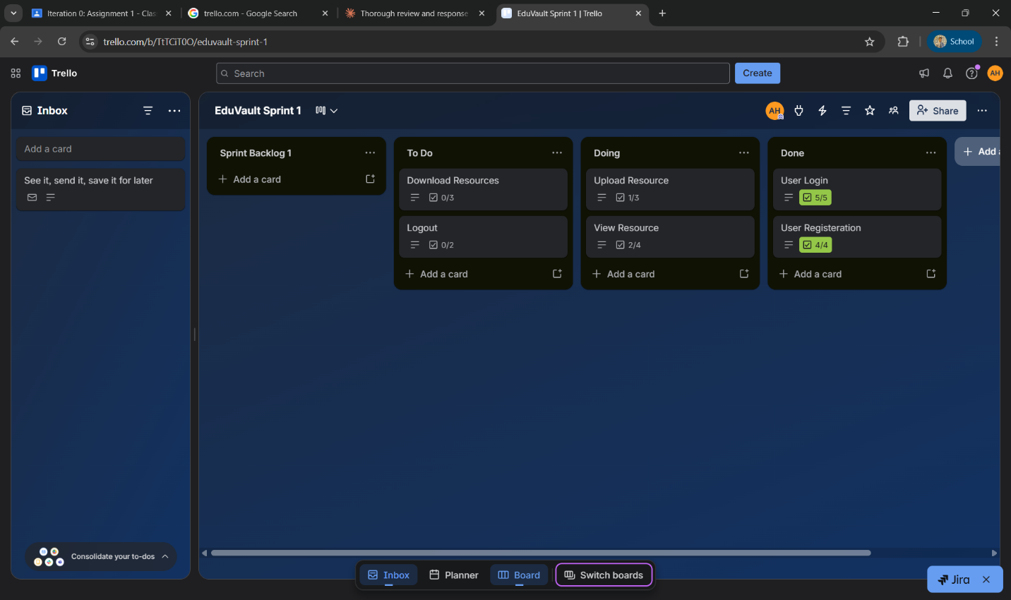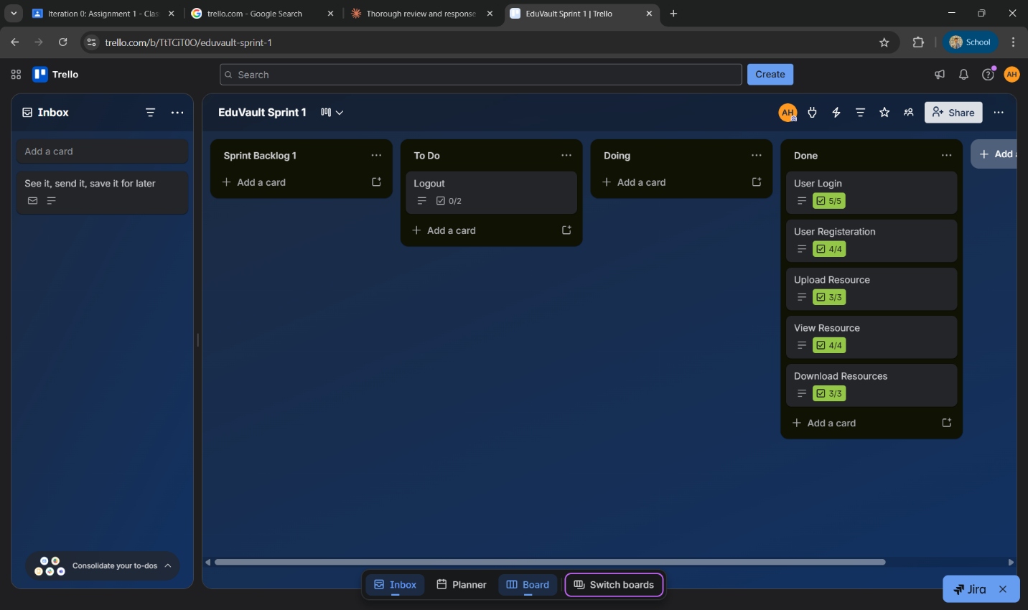

7. Functional Requirements Specification (FRS)
The following Functional Requirements Specification (FRS) defines the formal, verifiable, and unambiguous requirements for the EduVault system. Each requirement satisfies the properties of clarity, testability, feasibility, and independence as required by good software engineering practice.

FR-ID | Requirement Name | Description | Priority | Related US
FR-01 | User Registration | The system shall allow a new user to register using a valid @nu.edu.pk email, full name, password, and role (Student/Teacher). The system shall reject any registration attempt using a non-university email domain. | High | US-01
FR-02 | User Login | The system shall allow a registered user to log in using their university email and password. Upon successful authentication, the system shall create a session and redirect the user to the dashboard. Incorrect credentials shall result in an error message. | High | US-02
FR-03 | Resource Upload | The system shall allow an authenticated user to upload learning resources in PDF, DOC, or PPT format. The user shall provide a title, description, subject, and topic. File size must not exceed 50 MB. A progress indicator shall be displayed during upload. | High | US-03
FR-04 | Resource Listing | The system shall display all approved resources as cards showing the title, subject, uploader name, and upload date. An authenticated user shall be able to click a resource card to view its full detail page. | High | US-04
FR-05 | Resource Download | The system shall allow an authenticated user to download any approved resource to their device by clicking the Download button on a resource detail page. The download count for the resource shall be incremented upon each successful download. | High | US-05
FR-06 | Secure Logout | The system shall allow an authenticated user to log out by clicking the Logout button. Upon logout, the session token shall be invalidated and the user shall be redirected to the login page. | Medium | US-06
FR-07 | Input Validation | The system shall validate all user input fields (registration, login, and upload forms). Empty required fields, invalid email formats, mismatched passwords, and unsupported file types shall each produce a specific, descriptive error message visible to the user. | High | US-01, US-02, US-03
FR-08 | Session Management | The system shall maintain an authenticated user session after login. Sessions shall expire automatically after 24 hours of inactivity. Protected routes (upload, browse, download) shall be inaccessible to unauthenticated users and shall redirect to the login page. | High | US-02, US-06

8. Software Development Process Model

8.1 Selected Model: Agile (Scrum Framework)
The selected software development process model for EduVault is Agile, specifically implemented through the Scrum Framework. Agile is an iterative and incremental software development methodology that prioritizes flexibility, continuous delivery, and collaboration between team members and stakeholders. The Scrum framework operationalizes Agile through time-boxed iterations called Sprints, each delivering a potentially shippable increment of the product.

8.2 Justification
Incremental Delivery Aligns with Project Structure: EduVault is planned across three clearly defined iterations, each delivering a functional module. Agile Scrum’s Sprint model maps directly to this structure, allowing the team to build and validate one module at a time (Core Resource Management → Organization & Search → Quality Control & Interaction) rather than attempting to design and build the entire system upfront.
Evolving Requirements: As an academic platform targeting real student and teacher users, EduVault’s requirements may evolve as feedback is gathered. Agile’s iterative nature accommodates these changes gracefully, whereas a rigid model such as Waterfall would make late-stage changes costly and difficult to integrate.
Small Team Collaboration: With a team of three members, Scrum’s lightweight ceremonies (daily stand-ups, sprint planning, retrospectives) are well-suited for maintaining transparency and coordination without the overhead of heavy documentation-driven models like the Waterfall or Spiral model.
Early Risk Mitigation: By delivering working software at the end of each sprint, the team can identify technical risks (e.g., file storage integration, authentication issues) early rather than discovering them at the end of a long development cycle. This reduces overall project risk significantly compared to a Waterfall approach.
Academic Deadline Compatibility: The course structure with defined deliverable deadlines (Iteration 1, 2, 3) naturally mirrors a Scrum sprint cadence. Each deliverable deadline serves as a sprint review milestone, making Agile Scrum the most compatible model for this academic project context.

8.3 Why Not Other Models?
Model | Limitation for EduVault | Why Agile is Better
Waterfall | All requirements must be defined upfront; inflexible to change; no working product until the very end. | Agile delivers a working module every sprint and welcomes changing requirements.
Spiral | Designed for high-risk, large-scale systems with formal risk analysis cycles; overkill for a small academic project. | Agile is lightweight, simpler to execute, and suitable for small team academic projects.
Incremental | Lacks formal feedback loops and retrospectives; less structured team coordination compared to Scrum. | Agile Scrum adds sprint ceremonies and a defined backlog that enforces accountability and planning discipline.

9. Work Division
The following table outlines the responsibilities undertaken by each team member during Sprint 1:

Member Name | Roll Number | Responsibilities
Talha Afzal | 24i-0027 | UI/UX Design, Frontend Development (Login, Signup pages), Integration
Abdul Hadi | 24i-2599 | Backend Development, Database Schema Design, API Development
Umair Saeed | 24i-0088 | Testing, Deployment Setup, Upload & Download Feature Implementation

All team members collaborated on requirement review, user story writing, and testing of completed features. Regular stand-up meetings were held throughout the sprint to track progress and address blockers.

