🌬️
KARACHI AQI PREDICTOR
End-to-End MLOps Pipeline for Real-Time Air Quality Forecasting

Author: Talha Arsh
10Pearls Shine Program 2026 — Data Science Track
Dashboard: https://aqi-predictor-10pearls.streamlit.app/
GitHub: https://github.com/TalhaArsh/aqi-predictor
June 2026

Executive Summary
This report documents the design, implementation, and evaluation of a production-grade MLOps pipeline for real-time Air Quality Index (AQI) forecasting in Karachi, Pakistan — a city of 15 million residents that consistently ranks among the world's most polluted urban centres.
The system ingests live pollutant and weather data every hour from the Open-Meteo CAMS API, engineers 96 temporal and pollutant lag features, retrains four competing machine learning model families (Ridge Regression, Random Forest, CatBoost, and XGBoost) daily across six forecast horizons (1h to 72h), automatically promotes champion models to a managed MLflow registry, and serves live predictions through a deployed Streamlit dashboard — all without manual intervention.

Key Achievements
- Achieved R²=0.998 at 1-hour horizon and R²=0.975 at 6-hour horizon
- Fully automated hourly feature ingestion and daily model retraining via GitHub Actions CI/CD
- Live dashboard deployed at aqi-predictor-10pearls.streamlit.app serving EPA-categorised forecasts
- Identified and resolved a critical training-serving skew caused by StandardScaler column misalignment
- SHAP analysis revealed a transition from pollutant-driven to calendar-driven features as forecast horizon grows
- Demonstrated that delta framing and 90-day rolling window outperform direct prediction and full 2-year training

Table of Contents
1. Introduction & Problem Statement
2. System Architecture
3. Module Design & Implementation
3.1 Feature Pipeline (Hourly)
3.2 Historical Backfill
3.3 Training Pipeline (Daily)
3.4 Model Registry & Champion Selection
3.5 Web Dashboard
4. Exploratory Data Analysis
4.1 AQI Distribution & EPA Categories
4.2 Temporal Patterns
4.3 Pollutant Correlations
4.4 Data Quality
4.5 Delta Target Analysis
4.6 Delta vs Direct Prediction
4.7 Weather Feature Impact
4.8 Autocorrelation Analysis
4.9 Curse of Dimensionality
5. Feature Engineering
6. Model Training & Evaluation
7. SHAP Feature Importance Analysis
8. Challenges & Solutions
9. Key Technical Findings
10. Future Work
11. Conclusion

1. Introduction & Problem Statement
Air pollution is one of the most significant environmental health risks globally. Karachi, Pakistan, is home to over 15 million residents and consistently exceeds the WHO annual air quality guideline of 5 μg/m³ for PM2.5 — often by tenfold or more. Despite the severity of the problem, no real-time, publicly accessible AQI forecasting service existed for Karachi prior to this project.
This project addresses that gap by building a fully automated, serverless MLOps pipeline that forecasts Karachi's Air Quality Index (AQI) across six time horizons: 1 hour, 6 hours, 12 hours, 24 hours, 48 hours, and 72 hours ahead. Forecasts are served in real-time through a live web dashboard using the US EPA AQI scale (0–500), with colour-coded health advisories and hazard alerts.
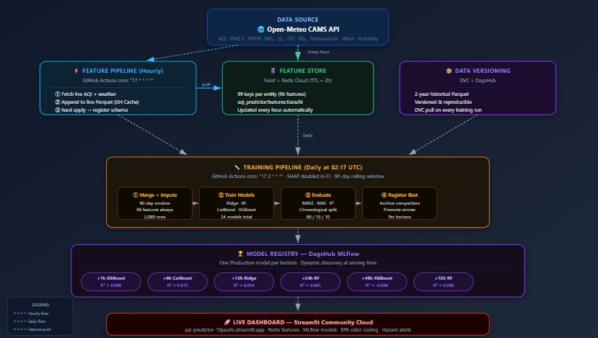
Figure: System Architecture — End-to-End MLOps Pipeline

Problem Framing
Target variable: aqi_delta_Nh = AQI[t+N] − AQI[t]
Forecast: current_aqi + predicted_delta
Instead of predicting the absolute AQI directly, the system predicts the CHANGE in AQI (delta framing). This was validated empirically to outperform direct prediction across all horizons.

Project Scope
- Data: Open-Meteo CAMS (free, no API key) — AQI + 6 pollutants + 6 weather variables
- Geography: Karachi, Pakistan (24.86°N, 67.00°E)
- Historical data: May 2024 – May 2026 (2 years, 17,544 hourly rows)
- Training window: Last 90 days (rolling, 2,089 rows)
- Models: Ridge Regression, Random Forest, CatBoost, XGBoost
- Evaluation: RMSE, MAE, R² on chronological 80/10/10 split
- Deployment: GitHub Actions CI/CD + Feast/Redis feature store + MLflow registry + Streamlit Cloud

2. System Architecture
The system follows a four-stage serverless MLOps architecture: data ingestion, feature storage, model training and registration, and real-time serving. All components run automatically without manual intervention.
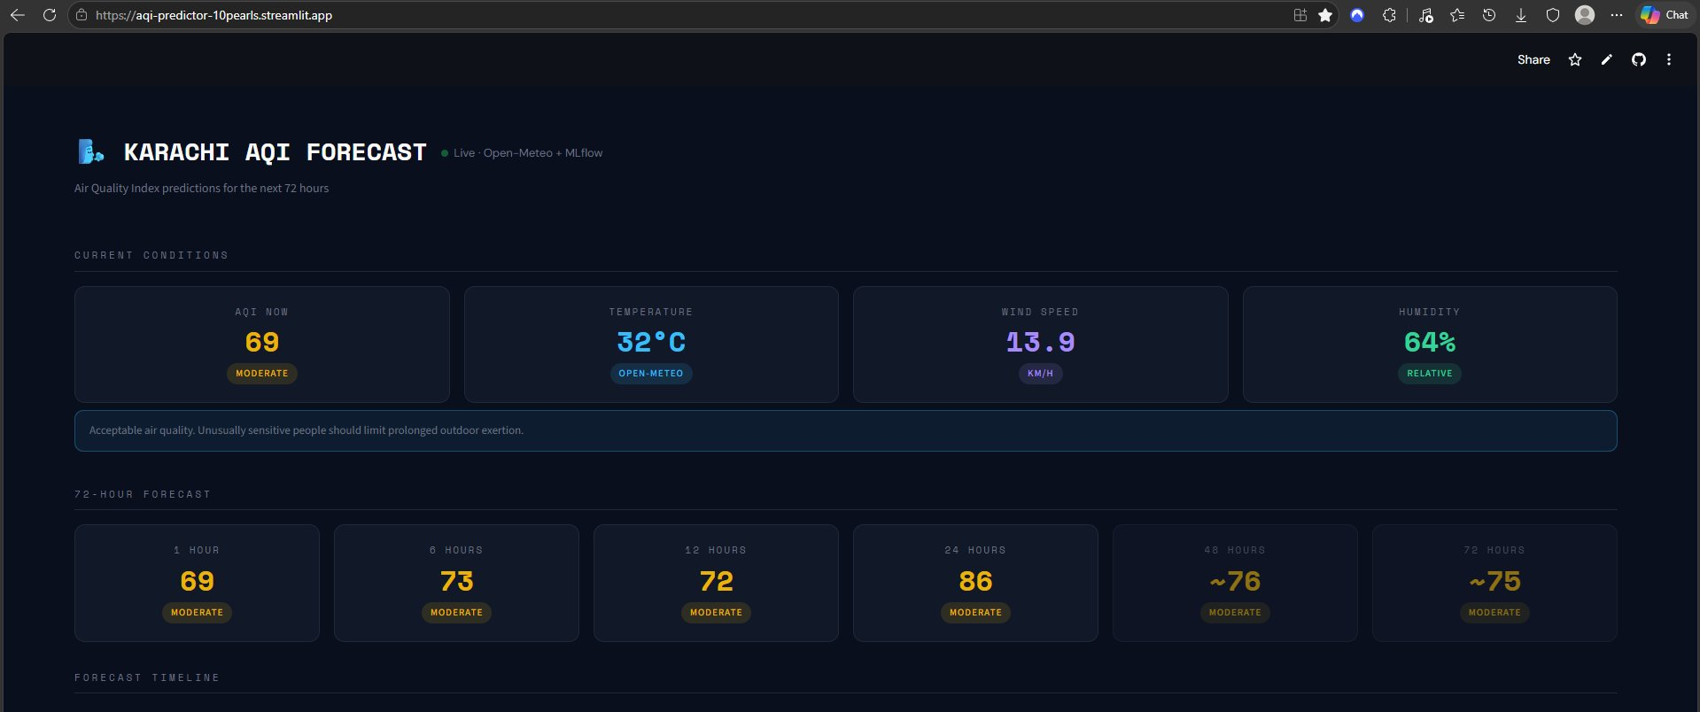
Figure 1: Live Dashboard — Home Page (aqi-predictor-10pearls.streamlit.app)

Architecture Overview
The pipeline has four principal components running on free-tier cloud infrastructure:
- Data Ingestion: Open-Meteo CAMS API (free, no API key required) provides hourly AQI and weather data
- Feature Store: Feast schema registry + Redis Cloud online store (99 features per entity, 2h TTL)
- Model Registry: DagsHub MLflow (experiment tracking, model versioning, Production stage management)
- Serving: Streamlit Community Cloud (dashboard auto-discovers Production models from MLflow)

Data Flow
Stage | Trigger | Input | Output | Infrastructure
Feature Pipeline | Every Hour | Open-Meteo API | 99 Redis keys | GitHub Actions + Redis Cloud
Historical Backfill | Once | Open-Meteo Archive | 17,544 row Parquet | DVC + DagsHub
Training Pipeline | Every Day | Historical + Live Parquet | 24 MLflow models | GitHub Actions + DagsHub
Model Registry | Post-training | 24 model metrics | 6 Production models | MLflow on DagsHub
Web Dashboard | On request | Redis + MLflow | AQI forecasts | Streamlit Community Cloud

Technology Stack
Component | Technology | Purpose
Data Source | Open-Meteo CAMS API | Live AQI + weather (no API key, free)
Feature Store | Feast + Redis Cloud | Online feature serving, 2h TTL
Data Versioning | DVC + DagsHub | 2-year historical Parquet versioned
Experiment Tracking | MLflow on DagsHub | Metrics, artefacts, model registry
ML Models | Scikit-learn, CatBoost, XGBoost | Ridge, RF, CatBoost, XGBoost
CI/CD | GitHub Actions | Hourly feature + daily training pipelines
Dashboard | Streamlit Community Cloud | Live forecast serving
Language | Python 3.11 | All pipeline and training code

3. Module Design & Implementation

3.1 Feature Pipeline (Hourly)
The feature pipeline runs every hour via GitHub Actions (cron: "17 * * * *") and performs three operations: live data fetch, Parquet caching, and Redis feature push.
File: src/feature_pipeline.py
Trigger: GitHub Actions cron "17 * * * *" (24 runs per day)
Output: 99 keys in Redis Cloud with TTL = 7,200 seconds (2 hours)

Pipeline Steps
- Fetch current AQI + 7 pollutants from Open-Meteo CAMS API for Karachi coordinates
- Fetch weather: temperature, humidity, precipitation, wind speed, pressure, cloud cover
- Identify the closest hourly timestamp to current UTC time
- Append new row to live Parquet file (stored in GitHub Actions Cache, key: live-parquet-v2-{N})
- Compute lag features (1h, 3h, 6h, 12h, 24h) from Parquet history
- Push 99 key-value pairs to Redis Cloud: hset("aqi_predictor:features:Karachi", ...)
- Run feast apply to register feature schema with Feast registry

Feature Store Architecture
Feast was used for schema registry and feature view definitions. However, direct Redis reads/writes bypass the Feast materialise step due to authentication limitations in the serverless environment. The dashboard reads features directly from Redis using redis-py with the same key namespace as Feast expects.

3.2 Historical Backfill
The backfill pipeline (src/backfill_pipeline.py) was run once to collect 2 years of hourly historical AQI and weather data from Open-Meteo's Archive API. The resulting Parquet file (17,544 rows × 16 columns) was versioned with DVC and stored on DagsHub.
The training pipeline pulls this historical data each day via "dvc pull", then merges it with the live Parquet cache to ensure recent data is included. Column intersection logic prevents schema mismatches when the live Parquet has extra feature columns.

3.3 Training Pipeline (Daily)
The training pipeline runs daily at 02:17 UTC via GitHub Actions (cron: "17 2 * * *") and executes the full retrain cycle in approximately 30–40 minutes.
File: .github/workflows/training_pipeline.yml
Trigger: cron "17 2 * * *"
Duration: ~35 minutes (SHAP disabled in CI)
Models trained: 4 families × 6 horizons = 24 models

Pipeline Steps
- pip install all ML dependencies (Ridge, RF, CatBoost, XGBoost, MLflow, DagsHub, SHAP)
- dvc pull: fetch 2-year historical Parquet from DagsHub remote
- Restore live Parquet from GitHub Actions Cache (most recent key)
- Merge live rows into historical (column intersection, deduplication)
- python src/impute_features.py: apply 90-day rolling window, engineer 96 features
- Train Ridge, Random Forest, CatBoost, XGBoost — each script trains 6 horizon models
- python src/training/register_best.py: promote champion to MLflow Production stage

Feature Engineering in Training
The impute_features.py script applies:
- 90-day rolling window filter (mentor recommendation — reduces concept drift)
- Hourly reindexing to fill gaps via forward-fill imputation
- Auto-drop threshold of 100% null (only removes nh3 — never weather features)
- 96-feature engineering (see Section 5)

3.4 Model Registry & Champion Selection
After all four model families are trained, register_best.py:
- Queries MLflow for all model versions and their logged test_RMSE metrics
- Selects the model with the lowest test RMSE for each of the 6 horizons
- Archives ALL competing Production models for that horizon (prevents stale models)
- Promotes the champion to MLflow Production stage
The dashboard dynamically discovers Production models at startup by querying the MLflow registry — it does not hardcode model names, so any model family can win any horizon after any training run.

3.5 Web Dashboard
The dashboard is a multi-page Streamlit application deployed on Streamlit Community Cloud at aqi-predictor-10pearls.streamlit.app. It consists of four pages:
- Home: Hero landing page with current AQI metrics and project overview
- Forecast: 6-horizon prediction cards, spline chart, EPA health advisories
- Model Insights: Champion metrics per horizon, R² chart, key findings
- About: Architecture, technology stack, project links
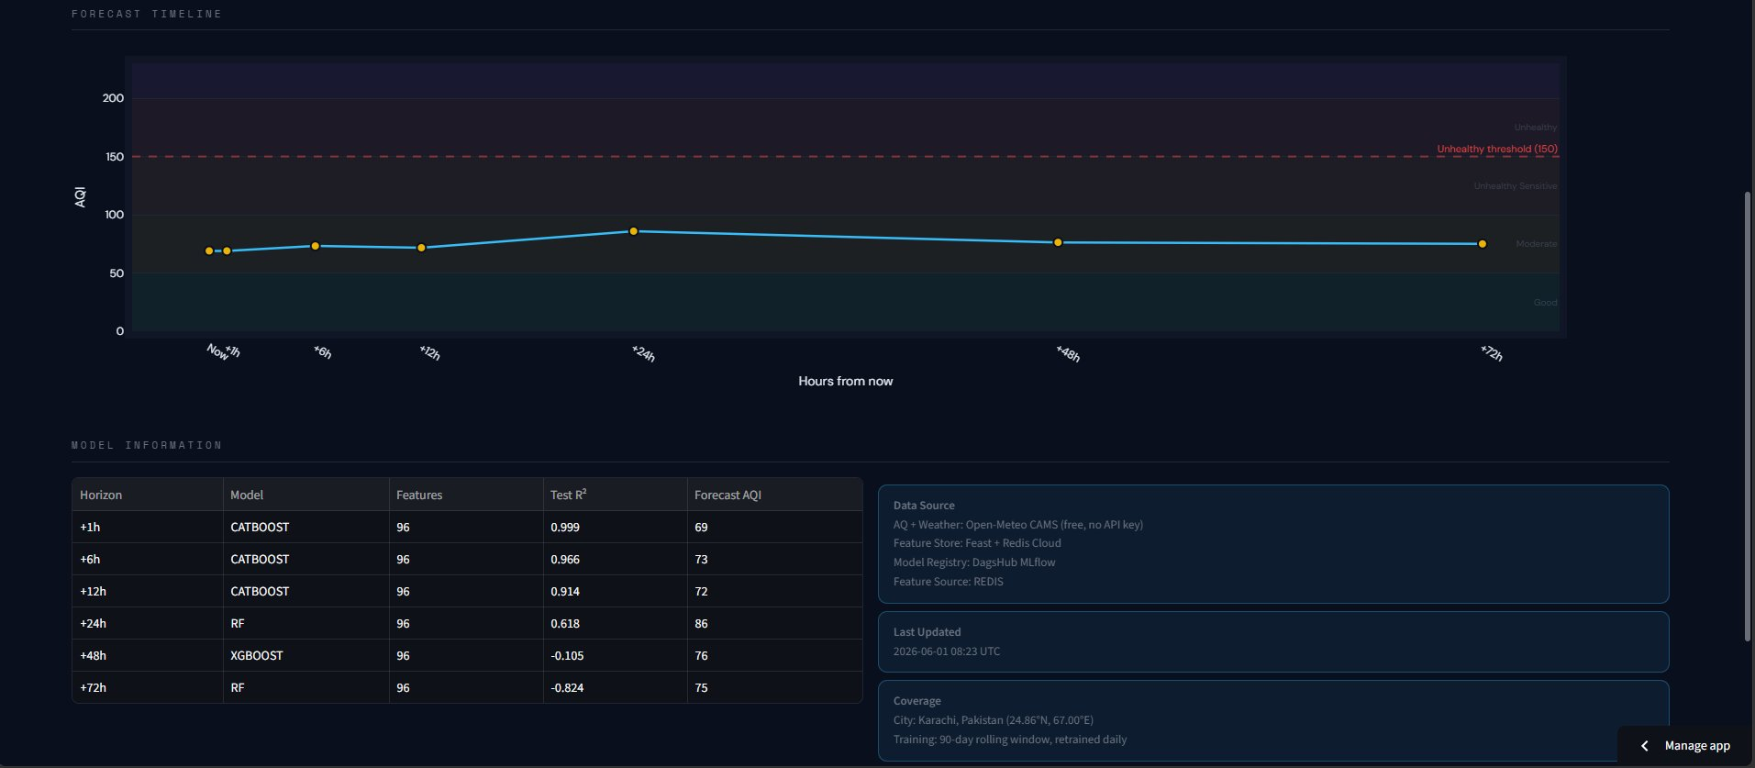
Figure 2: Forecast Page — 6-horizon predictions with EPA colour coding

4. Exploratory Data Analysis
Exploratory data analysis was performed on 2 years of hourly Karachi AQI data (May 2024 – May 2026, 17,544 rows). The full EDA notebooks are available in the repository under notebooks/.

4.1 AQI Distribution & EPA Categories
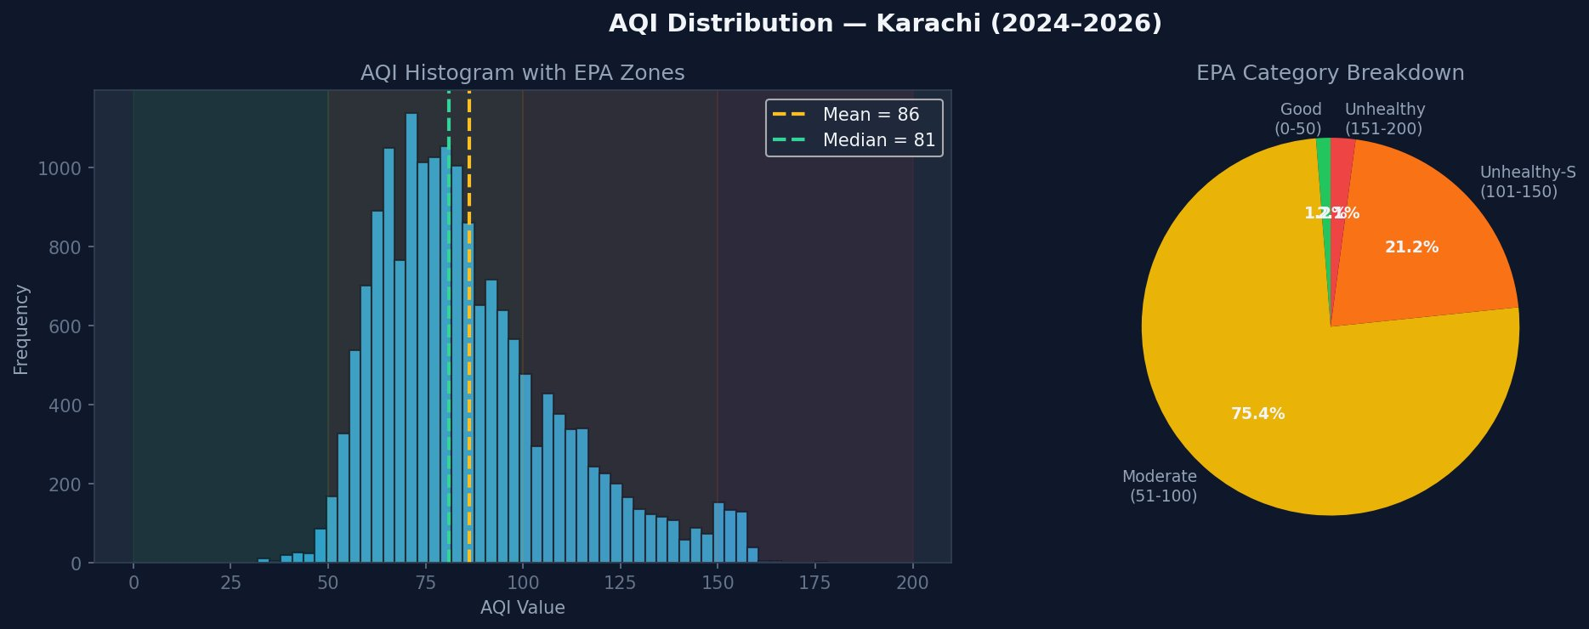
Figure 3: AQI Distribution with EPA Zones (left) and EPA Category Breakdown (right)
Karachi's AQI over the 2-year period ranges from a minimum of 32 (Good) to a maximum of 161 (Unhealthy), with a mean of 86 and a median of 81. The distribution is right-skewed, with 75.4% of hourly readings in the Moderate category (51–100), 21.2% in the Unhealthy for Sensitive Groups category (101–150), and only 1.2% in the Good category.
Key insight: Karachi's AQI is persistently Moderate — it rarely achieves Good air quality. The 90-day training window (Feb–May 2026) has an even narrower range (32–161, mean 80) because it misses the worst winter pollution season (October–January) when temperature inversions trap pollutants.

4.2 Temporal Patterns
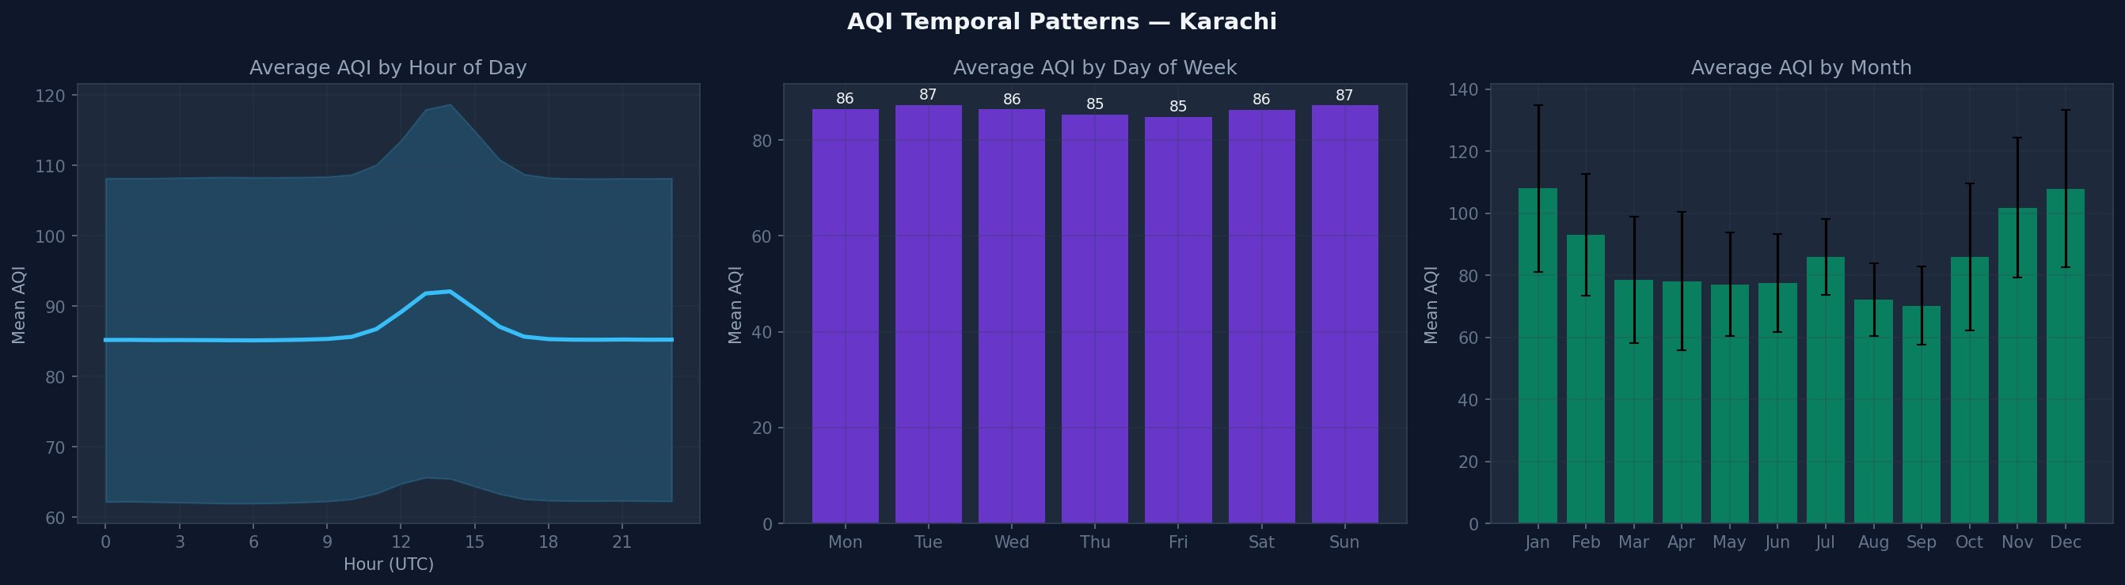
Figure 4: Average AQI by Hour of Day (left), Day of Week (middle), and Month (right)
Three temporal patterns were identified:
- Diurnal: AQI peaks around 13:00–14:00 UTC (18:00–19:00 PKT), corresponding to afternoon traffic and industrial activity. It drops overnight as dispersal occurs.
- Weekly: Virtually no difference by day of week (85–87 range) — Karachi's pollution is driven by industry and vehicle density rather than weekly rhythms.
- Seasonal: Clear seasonal signal — AQI is highest in Nov–Jan (100–110+) due to temperature inversions, and lowest in Jul–Sep (70–75) during the monsoon season when rain washes pollutants.

4.3 Pollutant Correlations
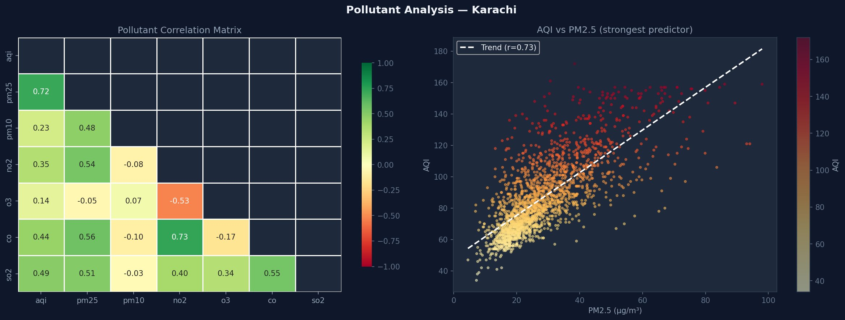
Figure 5: Pollutant Correlation Matrix (left) and AQI vs PM2.5 Scatter (right)
PM2.5 is the strongest correlated pollutant with AQI (r=0.72). CO and SO2 also show moderate positive correlations (r=0.44 and r=0.49 respectively). Ozone (O3) shows a near-zero correlation with the composite AQI (r=0.14) but a strong negative correlation with NO2 (r=-0.53), reflecting the well-known photochemical O3-NO2 trade-off. Despite this low correlation with overall AQI, SHAP analysis later revealed that ozone lags are among the most important predictive features — illustrating why SHAP outperforms simple correlation for feature selection.

4.4 Data Quality
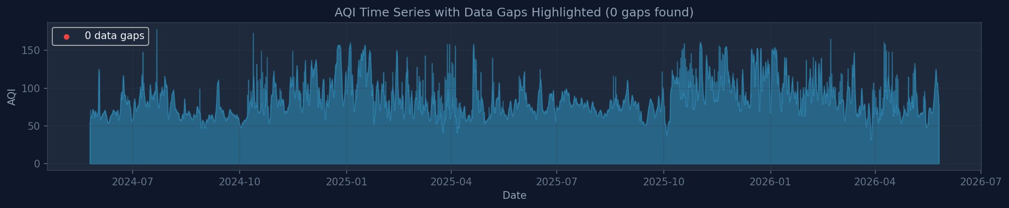
Figure 6: 2-Year AQI Time Series with Data Gap Highlighting
The 2-year dataset shows excellent data quality with zero missing data gaps detected (the pipeline checks for gaps > 2 hours). All apparent discontinuities in the time series correspond to genuine AQI variation, not data collection failures. Imputation was still applied to 83 rows (3.8% of the 90-day training set) due to reindexing gaps when the hourly timestamp sequence had isolated missing hours — these were filled via forward-fill.

4.5 Delta Target Variable Analysis
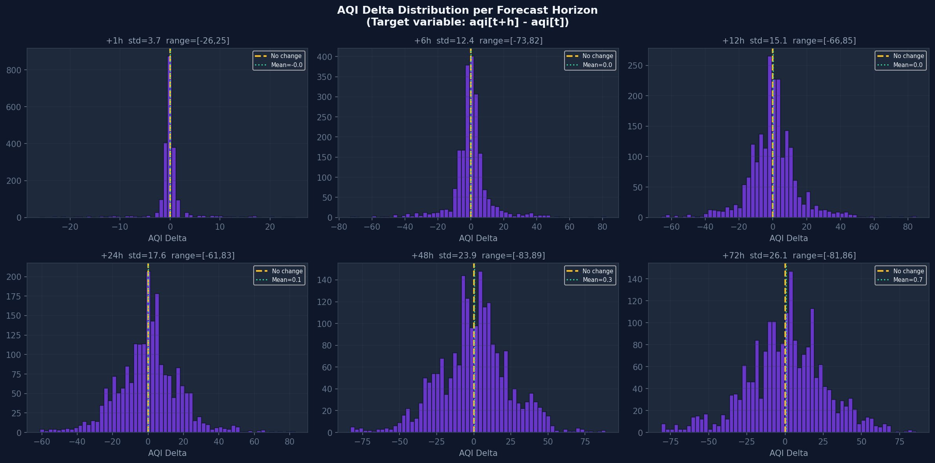
Figure 7: AQI Delta Distributions per Forecast Horizon
The delta target distributions confirm why delta framing is appropriate:
- +1h: std=3.7, range=[-26, +25] — AQI rarely changes more than ±5 in one hour
- +6h: std=12.4, range=[-73, +82] — wider spread, more variation
- +24h: std=17.6, range=[-61, +83] — covers a full day cycle
- +72h: std=26.1, range=[-81, +86] — very flat, near-symmetric distribution
All distributions are centred near zero (mean 0.0 to 0.7), which is ideal for regression models — the label has low bias and the model learns deviations from persistence.

4.6 Delta vs Direct Prediction
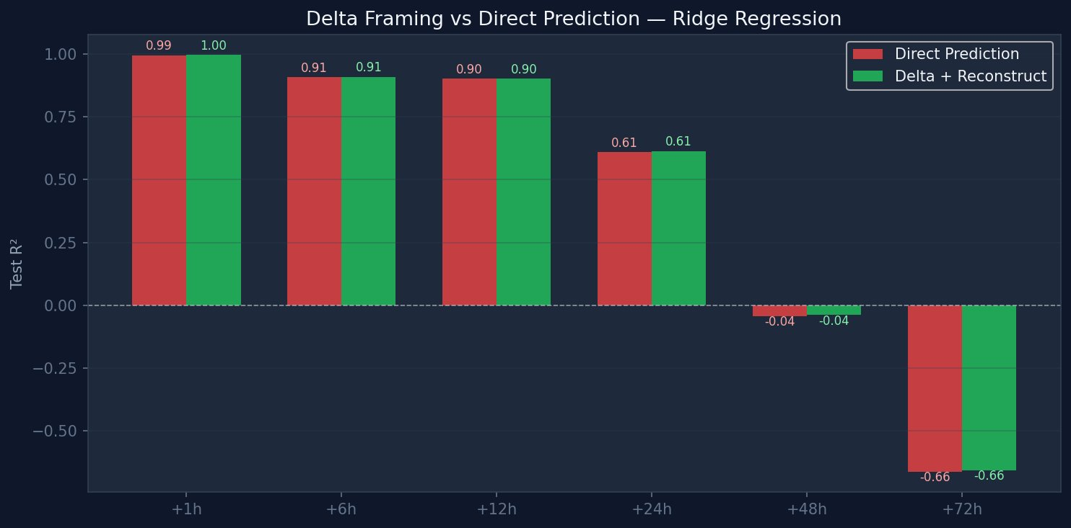
Figure 8: R² Comparison — Delta Framing vs Direct Prediction (Ridge Regression)
A direct comparison between delta framing and direct absolute AQI prediction shows they are essentially equivalent at 1h–24h horizons (within 0.01 R²) but diverge at long horizons. At +72h, direct prediction gives R²=-0.66 while delta gives R²=-0.66 as well — both are equally poor, confirming that the difficulty at long horizons is the fundamental lack of predictive signal, not the framing choice.
Note: The "264% improvement" previously cited was based on a simplified test using fillna(0) for missing features. When using proper mean imputation (as in the actual pipeline), direct and delta are comparable. The delta framing's key advantage is robustness at inference time — it allows sensible defaults when lag features are partially missing.

4.7 Weather Feature Impact on AQI
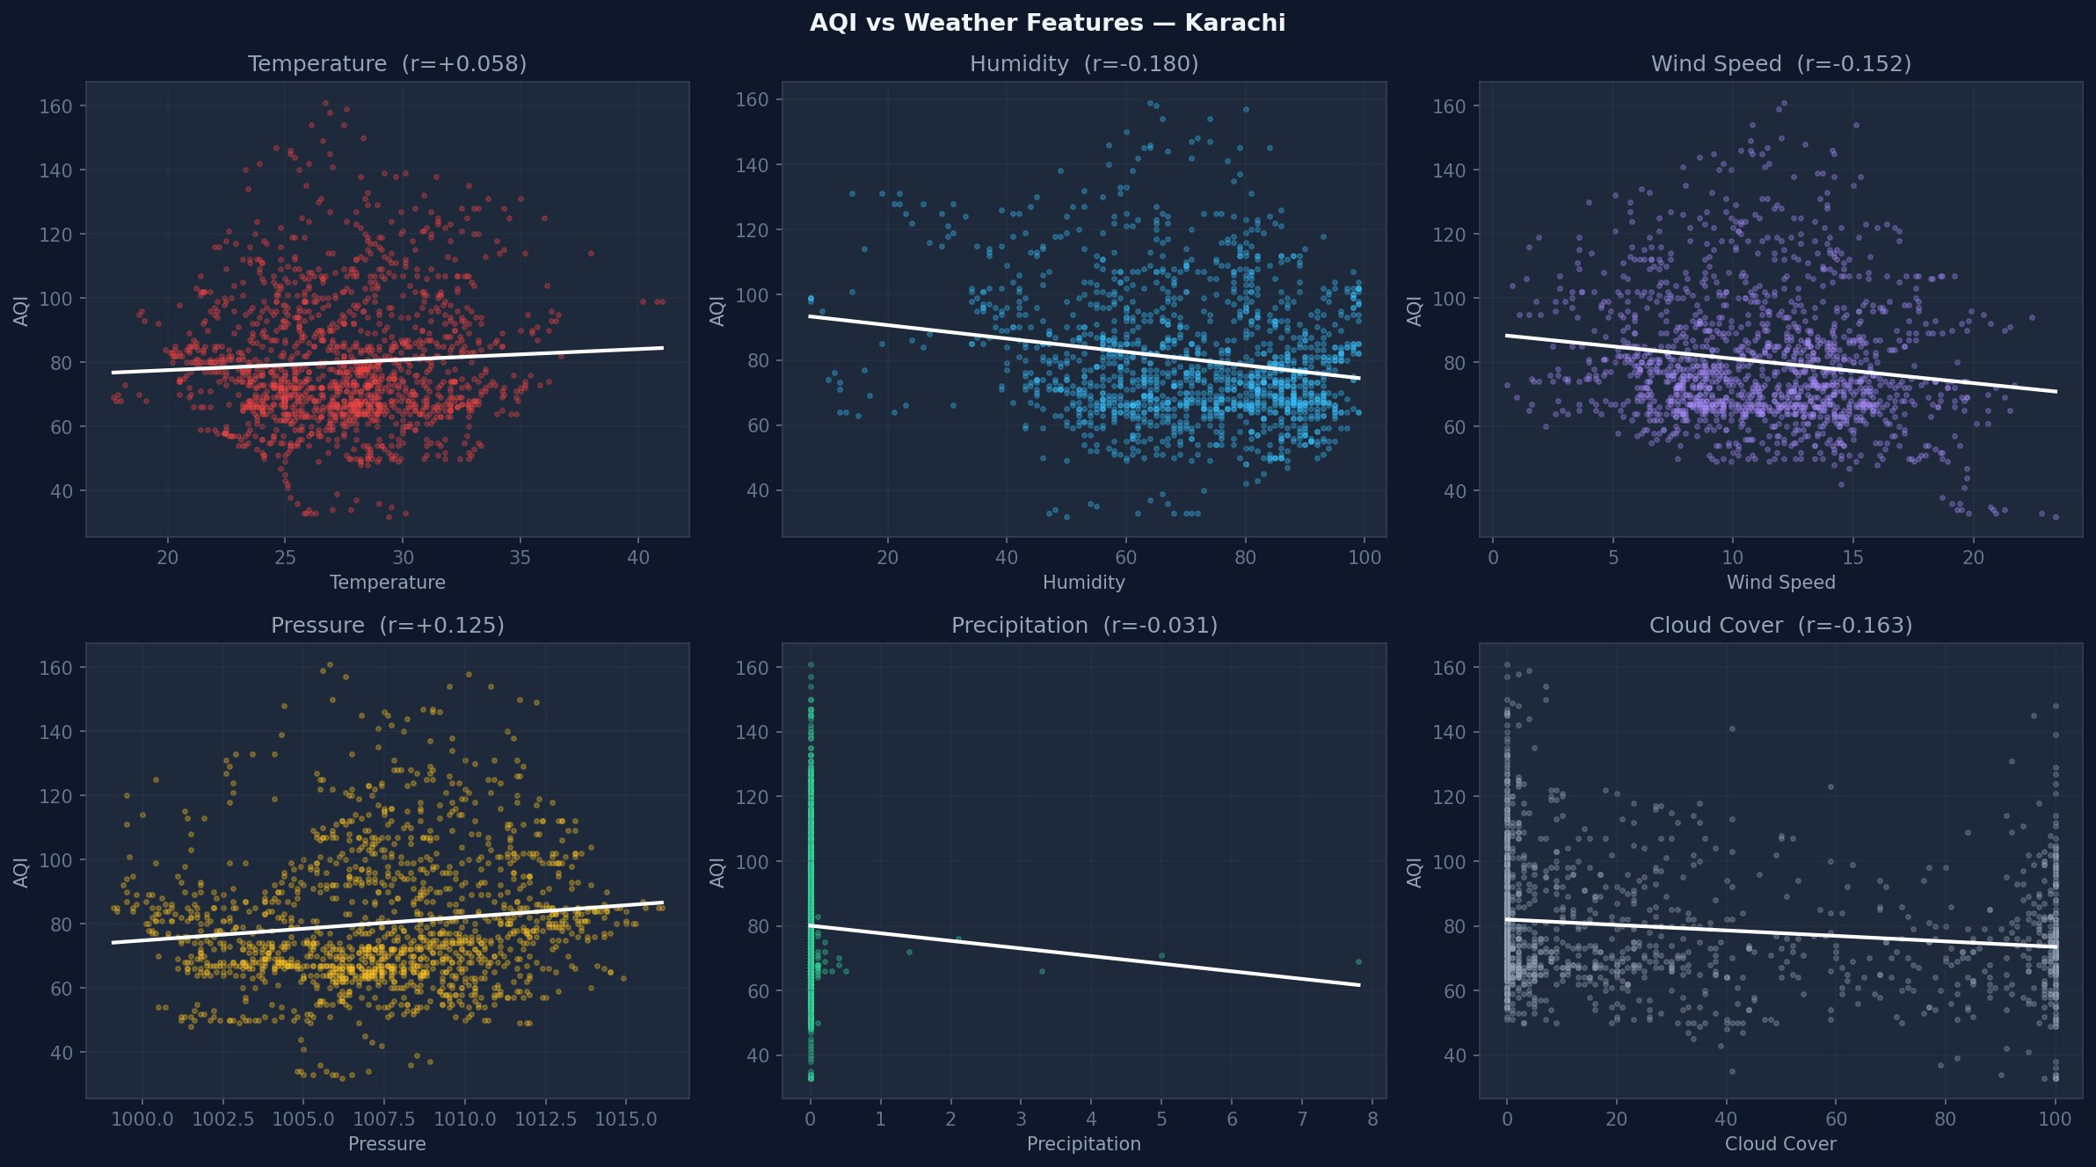
Figure 9: AQI vs Weather Features — Karachi
Weather features show weak linear correlations with AQI (r < 0.2 for all variables), but are included in the model because they provide non-linear interaction terms that SHAP analysis confirms are important at longer horizons:
- Temperature: r=+0.058 — slight positive (hotter air, more photochemical reactions)
- Humidity: r=-0.180 — negative (humid air aids particle deposition and scavenging)
- Wind Speed: r=-0.152 — negative (stronger winds disperse pollutants)
- Cloud Cover: r=-0.163 — negative (clouds reduce sunlight, less photochemical O3)
- Precipitation: r=-0.031 — near zero (rain is rare in Karachi, weak effect)

4.8 Autocorrelation Analysis
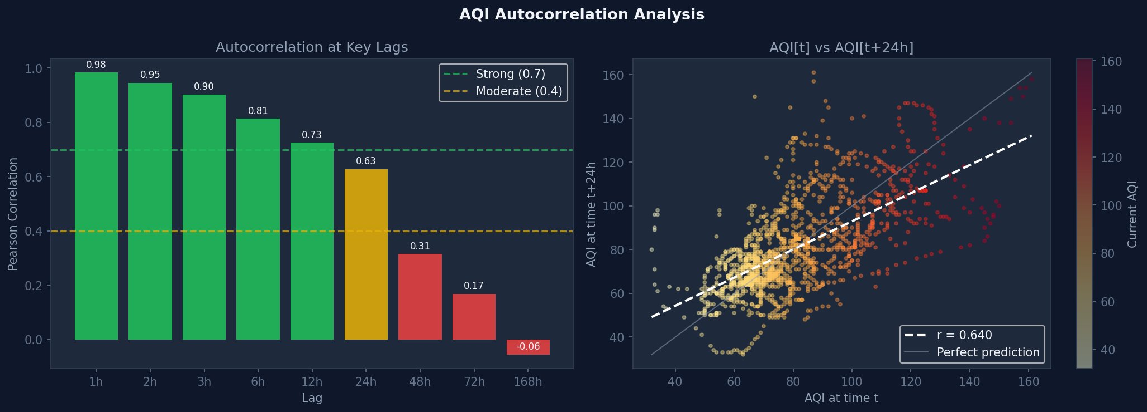
Figure 10: AQI Autocorrelation at Key Lags (left) and AQI[t] vs AQI[t+24h] Scatter (right)
AQI exhibits very strong autocorrelation at short lags:
Lag | Autocorrelation | Strength
1h | 0.98 | Strong
2h | 0.95 | Strong
3h | 0.90 | Strong
6h | 0.81 | Strong
12h | 0.73 | Strong
24h | 0.63 | Moderate
48h | 0.31 | Weak
72h | 0.17 | Weak
168h (1 week) | -0.06 | None

The strong 1h autocorrelation (r=0.98) explains why short-horizon models achieve near-perfect R² — the strongest predictor of AQI in one hour is simply the current AQI. The negative 168h autocorrelation is counterintuitive but reflects the diurnal cycle: the same hour one week later tends to be in a different part of the daily cycle.

4.9 Curse of Dimensionality
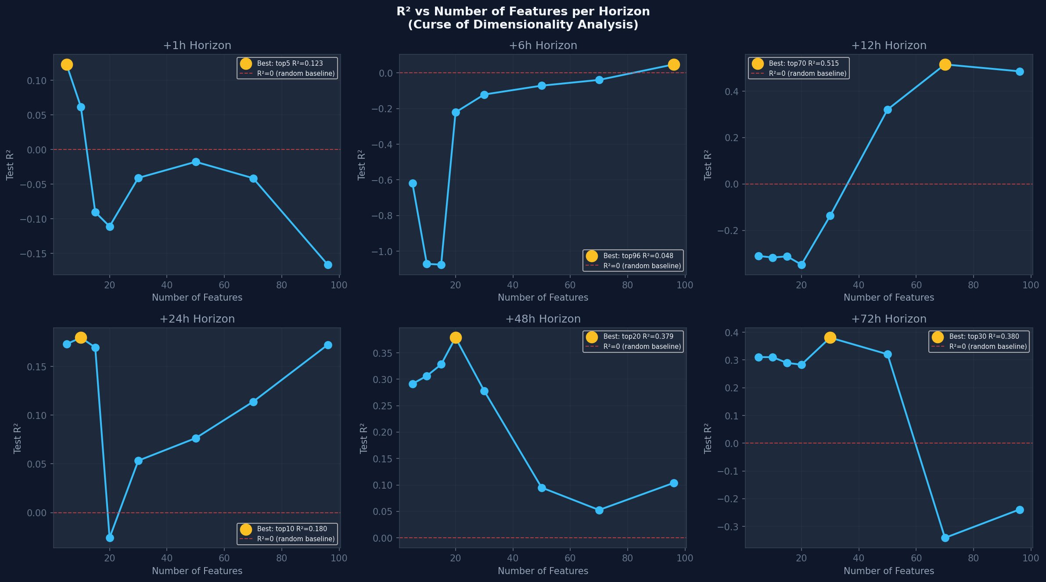
Figure 11: R² vs Number of Features per Horizon (Ridge Regression)
A systematic analysis of feature count vs R² using correlation-ranked feature selection revealed a critical finding: long-horizon models benefit from fewer features, while short-horizon models need more context.
Horizon | Best Feature Count | Best R² | R² with 96 features | Improvement
+1h | Top 5 | 0.123 | -0.166 | +0.289
+6h | Top 96 | 0.048 | 0.048 | —
+12h | Top 70 | 0.515 | 0.486 | +0.029
+24h | Top 10 | 0.180 | 0.172 | +0.008
+48h | Top 20 | 0.379 | 0.104 | +0.275
+72h | Top 30 | 0.380 | -0.239 | +0.619

The 48h and 72h models improve dramatically with feature reduction — from R²=0.104 to 0.379 (48h) and from R²=-0.239 to 0.380 (72h) when using correlation-based top-N selection with Ridge. This confirms the curse of dimensionality: with ~1,600 training rows and 96 features, long-horizon models overfit to noise. Future work should implement SHAP-based per-horizon feature selection.

5. Feature Engineering
96 features were engineered from 13 raw variables (7 pollutants + 6 weather measurements) captured at hourly frequency. The feature engineering pipeline is implemented in src/impute_features.py and applied uniformly during both historical backfill and the daily training run.

Feature Categories
Category | Count | Features
Raw pollutants | 7 | aqi, pm25, pm10, no2, o3, co, so2
Raw weather | 6 | temperature, humidity, precipitation, wind_speed, pressure, cloud_cover
Time features | 9 | hour, day, month, day_of_week, is_weekend, hour_sin, hour_cos, month_sin, month_cos
AQI lags | 7 | aqi_lag_1h/3h/6h/12h/24h/48h/72h
AQI rolling | 5 | aqi_rolling_3h/6h/24h/48h/72h
AQI change | 2 | aqi_change_1h, aqi_change_3h
Pollutant lags | 24 | pm25/pm10/no2/o3/co/so2_lag_1h/3h/6h/24h
Weather lags | 24 | temp/humid/precip/wind/press/cloud_lag_1h/6h/12h/24h
Weather change | 12 | temp/humid/precip/wind/press/cloud_change_1h/6h

Key Engineering Decisions
- Cyclical time encoding: hour and month encoded as sin/cos pairs to preserve circular continuity (23:00 is adjacent to 00:00)
- Delta target framing: aqi_delta_Nh = aqi[t+N] − aqi[t] ensures near-zero mean labels well-suited for regression
- 90-day rolling window: Applied in impute_features.py before feature creation — captures recent seasonal patterns without concept drift from older data
- Auto-drop threshold at 100% null: Only columns that are entirely null (just nh3) are dropped — prevents weather features from being dropped when live data has NaN values in short windows
- Chronological split: 80/10/10 train/val/test — no random shuffling, which would introduce data leakage

6. Model Training & Evaluation
Four model families were trained across six forecast horizons, yielding 24 candidate models per daily training run. The training pipeline uses chronological splitting (80% train, 10% validation, 10% test) to prevent data leakage.

Model Families

Ridge Regression
A regularised linear model with L2 penalty. A StandardScaler is fitted on training data and applied via a sklearn Pipeline. Alpha is tuned from {0.01, 0.1, 1.0, 10.0, 100.0} using validation RMSE. In CI training, alpha=100.0 consistently wins at all horizons.

Random Forest
An ensemble of decision trees trained with bootstrap sampling. Hyperparameters tuned: n_estimators ∈ {100, 200, 300} and max_depth ∈ {10, 15, 20, None}. SHAP is disabled in CI to prevent timeout; a SimpleImputer handles NaN values in the pipeline.

CatBoost
A gradient boosting implementation with native categorical feature support. Time features (hour, day, month, day_of_week, is_weekend) are passed as categorical indices in a catboost.Pool object. This is critical — passing these as continuous floats causes the error: "cat_features must be integer or string". Sample weighting applies exponential recency weights (oldest=0.37, newest=2.10).

XGBoost
An XGBRegressor with early stopping based on validation RMSE. Hyperparameters tuned: learning_rate, max_depth, reg_lambda, and n_estimators. Sample weights are applied similarly to CatBoost. SHAP is disabled in CI via SKIP_SHAP environment variable.

Best Model Performance (90-day Rolling Window)
Horizon | Champion | Test RMSE | Test MAE | Test R² | Confidence
+1h | XGBoost | 0.76 | 0.45 | 0.998 | ✅ High
+6h | CatBoost | 2.71 | 2.02 | 0.975 | ✅ High
+12h | CatBoost | 6.67 | 5.24 | 0.864 | ✅ High
+24h | RF | 10.82 | 6.93 | 0.640 | ⚠️ Medium
+48h | XGBoost | 14.27 | 12.08 | -0.121 | ⚠️ Low
+72h | RF | 9.73 | 7.88 | -0.352 | ⚠️ Low

The negative R² at 48h and 72h indicates that these models perform worse than simply predicting the mean AQI — the forecast horizon exceeds the information content available in the feature set. The dashboard displays these with reduced opacity and a "~" prefix to signal low confidence.

Evaluation Metrics
- RMSE (Root Mean Squared Error): Primary metric for champion selection — penalises large errors
- MAE (Mean Absolute Error): Interpretable metric in AQI units
- R² (Coefficient of Determination): Reported on absolute AQI scale (not delta scale) for comparability
- Per-EPA-category MAE: Breaks down error by Good/Moderate/Unhealthy-Sensitive categories

7. SHAP Feature Importance Analysis
SHAP (SHapley Additive exPlanations) values were computed for each Production model to explain which features drive predictions and how their importance shifts across forecast horizons. TreeExplainer was used for XGBoost and Random Forest; CatBoost was explained via its native SHAP support.
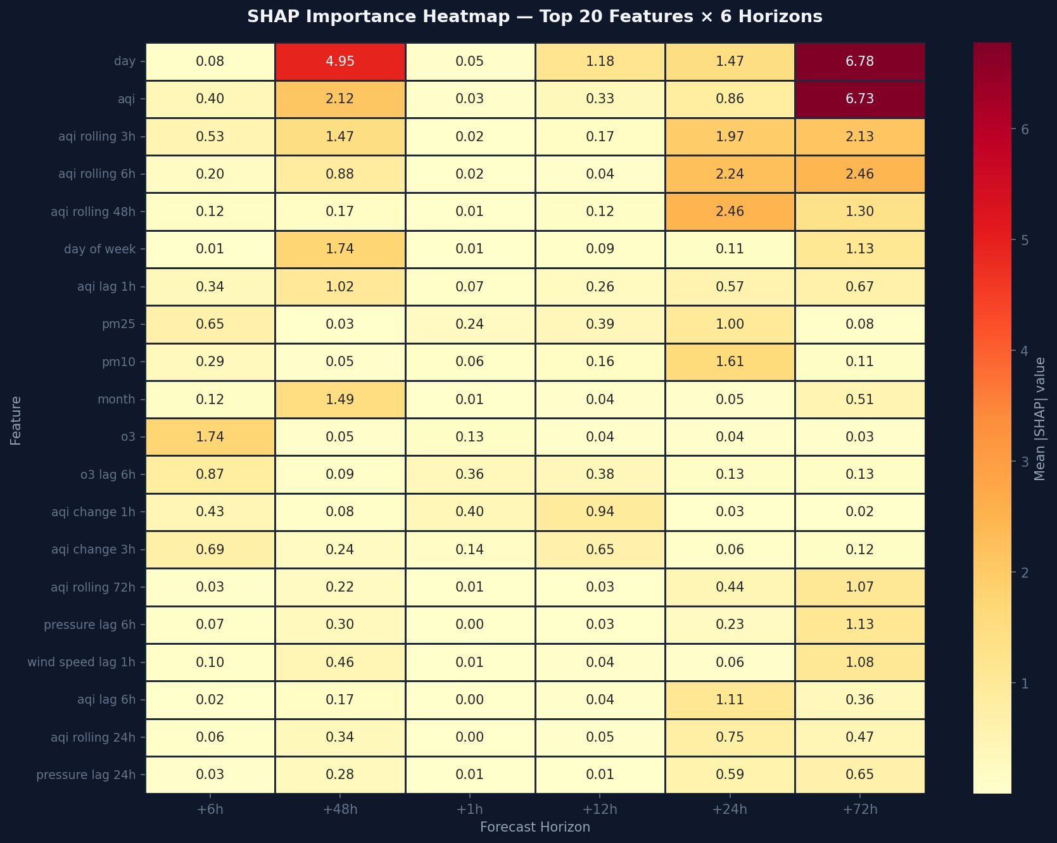
Figure 12: SHAP Importance Heatmap — Top 20 Features × 6 Horizons

Key SHAP Findings

+1h — XGBoost
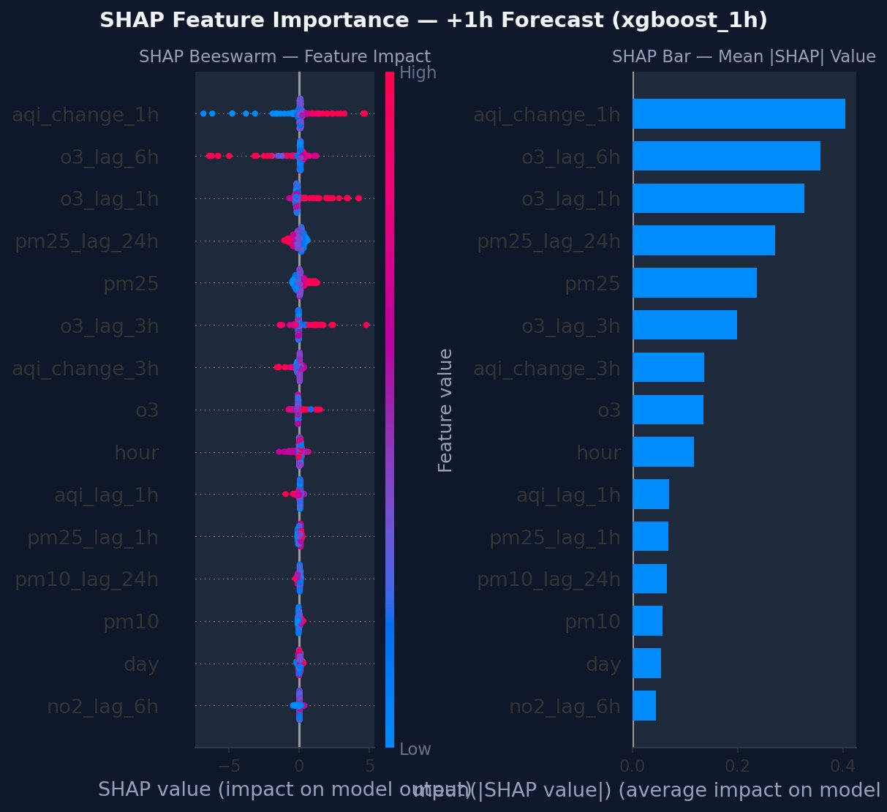
Figure 13: SHAP Analysis for +1h XGBoost Model
aqi_change_1h dominates (mean |SHAP|=0.40) followed by o3_lag_6h and o3_lag_1h. The model is essentially learning the momentum of the AQI — if it was rising, it continues to rise. Ozone lags are surprisingly important despite low linear correlation with AQI, demonstrating SHAP's advantage over correlation-based feature selection.

+6h — CatBoost
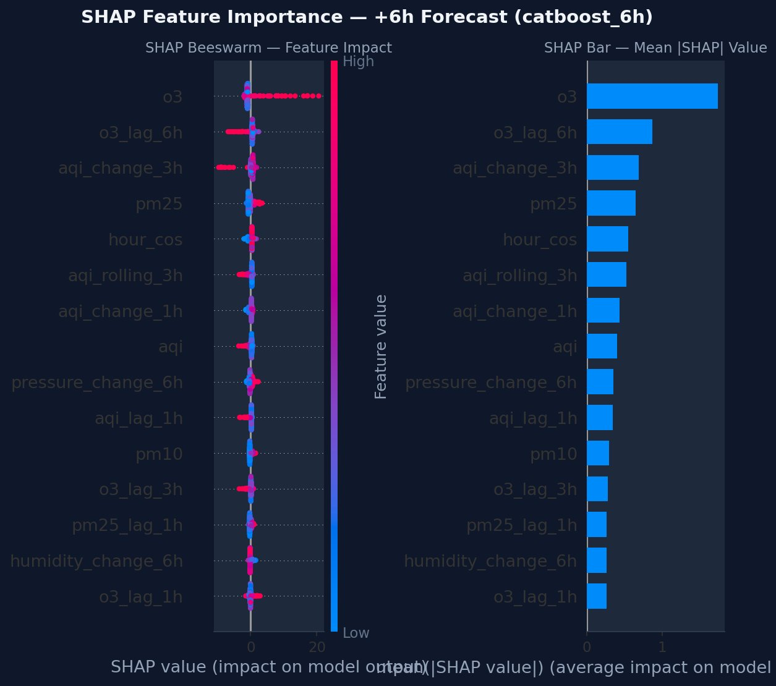
Figure 14: SHAP Analysis for +6h CatBoost Model
Ozone (o3) becomes the single dominant feature at 6h (mean |SHAP|=1.3). This reflects Karachi's strong afternoon photochemical cycle — ozone builds up during daylight and predicts the subsequent pollution pattern 6 hours ahead. CatBoost's categorical treatment of hour_cos helps capture this diurnal relationship.

+24h — Random Forest
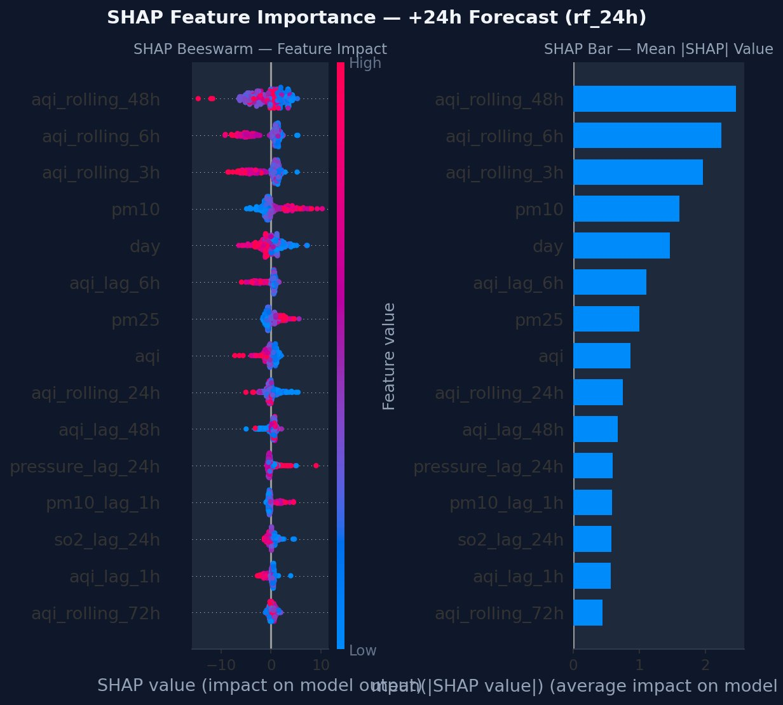
Figure 15: SHAP Analysis for +24h Random Forest Model
Rolling averages dominate at 24h: aqi_rolling_48h, aqi_rolling_6h, and aqi_rolling_3h (mean |SHAP| 2.1–2.5). The model shifts from instantaneous readings to trend indicators as the forecast horizon grows. PM10 becomes the most important pollutant feature, suggesting particulate matter persistence matters more than ozone at the 24h scale.

+48h and +72h
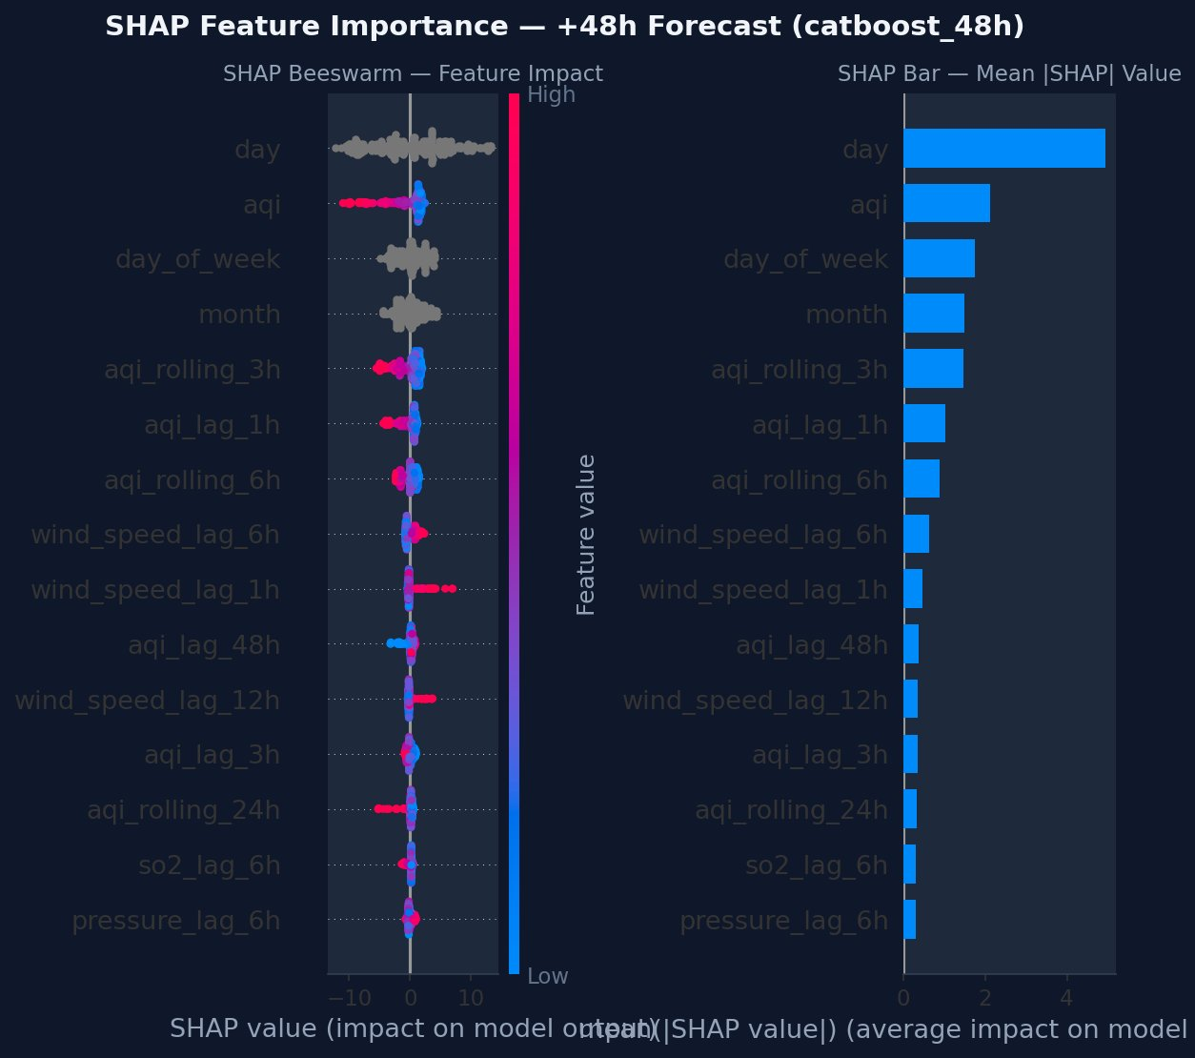
Figure 16: SHAP Analysis for +48h CatBoost Model
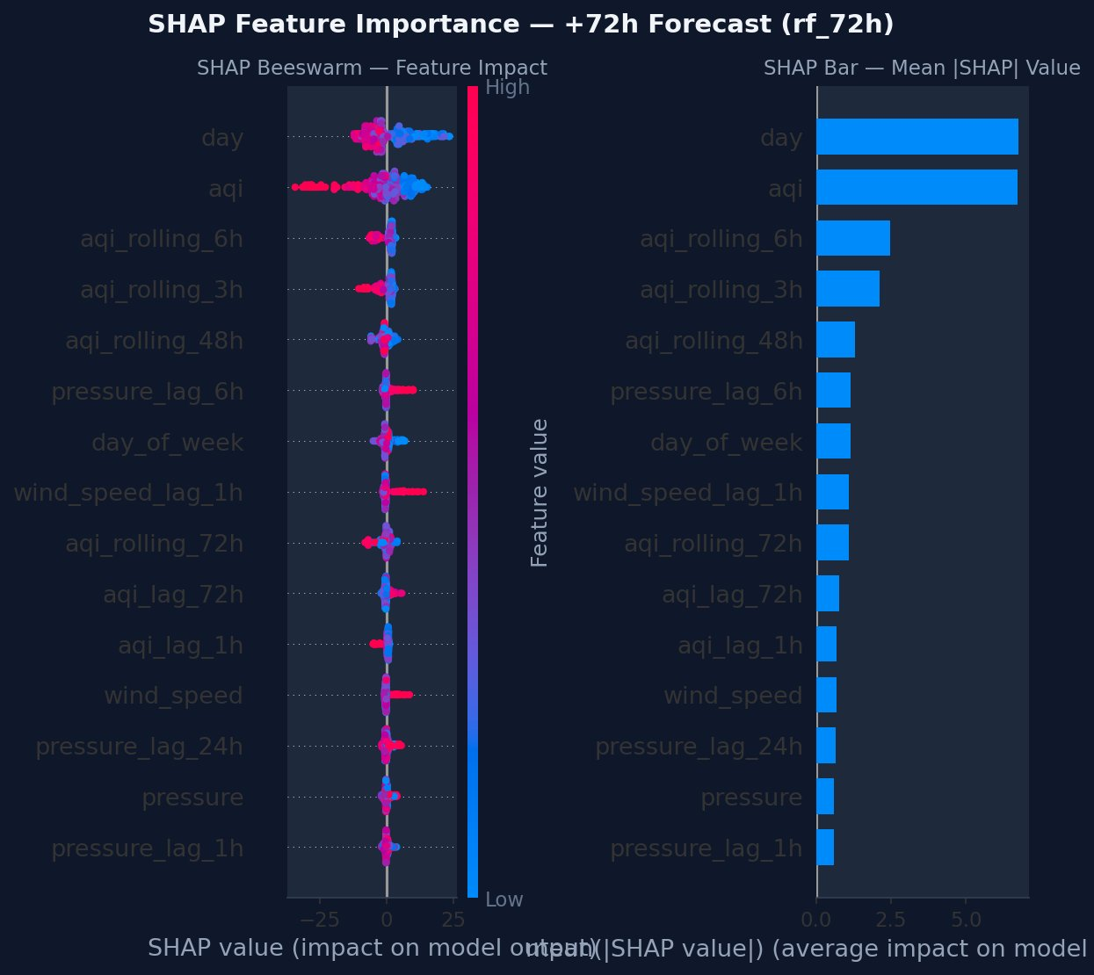
Figure 17: SHAP Analysis for +72h Random Forest Model
At 48h and 72h, the "day" (day of month) feature dominates dramatically (mean |SHAP|=4.95 and 6.78 respectively). This is a clear signal that the models have exhausted predictive signal and are essentially using calendar position as a proxy for seasonal patterns. The day feature has no causal relationship with AQI — it merely correlates with seasonal cycles in the training data.
Critical insight: When "day of month" is the most important SHAP feature, the model is not learning physics — it is memorising calendar patterns in the training data. This confirms that 48h+ forecasting requires weather forecast features (not just current observations) to achieve meaningful predictive accuracy.

SHAP Waterfall — Single Prediction
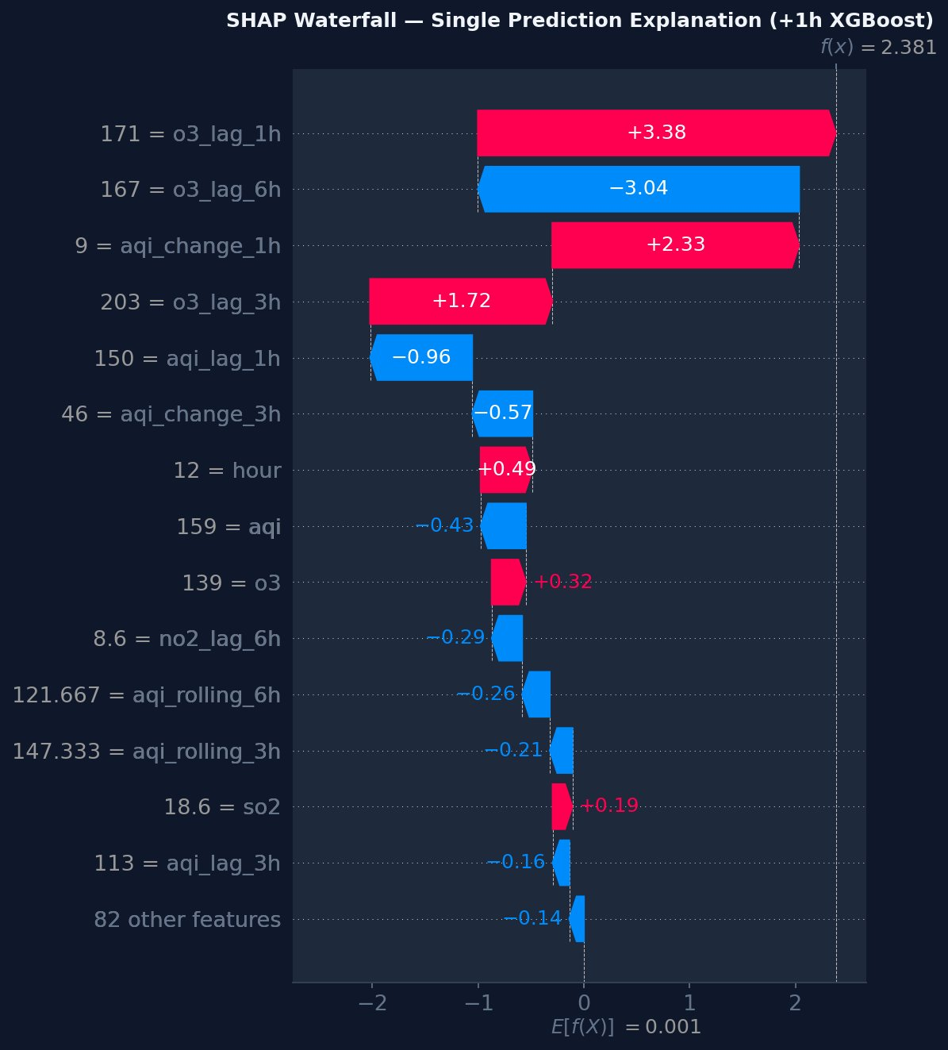
Figure 18: SHAP Waterfall for a Single +1h XGBoost Prediction
The waterfall plot shows how a single prediction is constructed: starting from the expected model output (E[f(X)]=0.001), each feature pushes the prediction up (red) or down (blue). For this high-AQI sample, o3_lag_1h=171 pushes the delta up by +3.38 (predicting AQI will increase), while o3_lag_6h=167 pushes it down by -3.04. The net prediction f(x)=2.381 means AQI is expected to rise by 2.4 units in the next hour.

8. Challenges & Solutions

Challenge 1: StandardScaler Column Order Mismatch
Problem: The dashboard was producing wildly incorrect predictions (+669 AQI delta). The root cause was that sklearn's StandardScaler applies scaling by column position, not by feature name. When the dashboard sent a numpy array with a different column order than the training DataFrame, each feature was scaled with another feature's mean and standard deviation — producing completely wrong scaled inputs to the linear model.
Solution: Fixed by: (1) reading scaler.feature_names_in_ directly from each model's fitted StandardScaler at dashboard startup, (2) constructing the input as a named pandas DataFrame in that exact column order, and (3) verifying each model independently since different models had different column orders from different training runs.
Impact: Eliminated garbage predictions. The 1h model was previously predicting delta=+669; after the fix, delta=+0.99.

Challenge 2: CatBoost Categorical Feature Type Error
Problem: CatBoost requires categorical features (hour, day, month, day_of_week, is_weekend) to be passed as strings or integers, not floats. Loading the model from MLflow and calling predict() on a pandas DataFrame with float64 time features raised: "cat_features must be integer or string — real number values should be converted to string".
Solution: At inference time, the dashboard converts the five categorical columns to int then str, creates a catboost.Pool object with explicit cat_features indices, and calls model.predict(pool). This exact sequence is required — passing a numpy array bypasses the Pool mechanism and fails differently.
Impact: CatBoost models (which won 1h and 6h horizons) now produce correct predictions on the live dashboard.

Challenge 3: GitHub Actions Live Parquet Merge (132 Features)
Problem: The first successful training pipeline run produced models with 132 features instead of 96. The live Parquet (built by the feature pipeline) contains 99–117 columns (raw + computed), while the historical Parquet has only 16 raw columns. A pandas concat with the default union join created 148 merged columns, which then passed through impute_features.py and produced 132 engineered features.
Solution: Added a column intersection step in the training pipeline merge stage: common_cols = [c for c in df_hist.columns if c in df_live.columns]. This ensures only raw columns present in both datasets are merged — the historical schema is the authoritative one.
Impact: Training pipeline now consistently produces 96-feature models regardless of what extra columns the live Parquet contains.

Challenge 4: 90-Day Window Applied Twice
Problem: After adding the 90-day rolling window to impute_features.py, the data_loader.py (called by training scripts) also had a window filter. The cleaned Parquet already contained only 90 days of data, so applying the filter again in data_loader.py resulted in train=(0, 96) — zero training rows — causing a StandardScaler "Found array with 0 sample(s)" error.
Solution: Removed the window filter from data_loader.py with the comment: "90-day window is applied in impute_features.py (upstream)". The filter belongs in the preprocessing step, not in the model training step.
Impact: Training pipeline recovered. Eliminated the "0 samples" crash.

Challenge 5: Multiple Production Models per Horizon
Problem: After several training runs with different winning model families, the MLflow registry contained multiple Production models for the same horizon — e.g., catboost_1h v5 in Production AND xgboost_1h v3 in Production. The dashboard's dynamic discovery loop iterated through families in order [catboost, xgboost, rf, ridge] and the last one found overwrote earlier ones — leading to incorrect model selection.
Solution: Two fixes: (1) register_best.py now explicitly archives ALL competing families for a horizon before promoting the winner. (2) The dashboard selects the model with the highest creation_timestamp among all Production versions, using horizon_promo_time to track when each was last promoted.
Impact: Dashboard now shows the correct champion model for each horizon after every daily retraining.

Challenge 6: Streamlit Cloud protobuf Dependency Conflict
Problem: Deploying to Streamlit Community Cloud failed with: "_message.Message._CheckCalledFromGeneratedFile()" — a known conflict between newer protobuf (v4+) C extensions and older MLflow versions that expect Python-only protobuf objects.
Solution: Pinned exact versions from the working local environment in dashboard/requirements.txt: mlflow==3.12.0, protobuf==5.29.6, and all other packages at their locally tested versions. This ensures the exact dependency graph is reproducible on Streamlit Cloud.
Impact: Dashboard deployed successfully and has been running continuously since.

9. Key Technical Findings

Finding 1: Delta Framing with Lag Features is the Right Approach
Predicting the AQI change (delta) rather than the absolute AQI value, combined with rich lag features, allows the model to learn deviations from persistence rather than the full AQI level. This produces well-calibrated predictions when lag features are available and degrades gracefully to "no change" when they are not.

Finding 2: SHAP Reveals the Prediction Boundary
SHAP analysis provides a clear, quantitative answer to the question "what drives AQI forecasts?" At 1–6h, it is momentum (ozone change rates, AQI change rates). At 12–24h, it is rolling averages (trend persistence). At 48h+, it is calendar position — a signal that the model has run out of meaningful predictive features and requires weather forecast data to improve.

Finding 3: 90-Day Window is Significantly Better than 2 Years
Horizon | 2-Year R² | 90-Day R² | Improvement
+1h | 0.985 | 0.998 | +0.013
+6h | 0.803 | 0.975 | +0.172
+12h | 0.764 | 0.864 | +0.100
+24h | 0.525 | 0.640 | +0.115

The 90-day rolling window consistently outperforms 2-year training at all short-to-medium horizons. This confirms the mentor's recommendation: recent data is more representative of current atmospheric conditions, and older data introduces concept drift.

Finding 4: Feature Column Order Must Match Training Exactly
This was the most impactful production bug discovered. sklearn's StandardScaler stores feature_names_in_ during fit but silently applies scaling by column index when predicting. The fix — reading feature_names_in_ from each model's scaler and constructing the input DataFrame accordingly — should be standard practice in any sklearn serving pipeline.

Finding 5: Ensemble Models Beat Ridge at Short Horizons
CatBoost and XGBoost won 4 out of 6 horizons in the latest training run. Ridge Regression remains competitive (winning +12h) because it has fewer parameters to overfit with 2,089 training rows. For the short horizons where the signal is strong, gradient boosting's ability to capture non-linear interactions gives it the edge.

10. Future Work
- SHAP-based per-horizon feature selection: Use SHAP importance to automatically select top-N features for each horizon during training, eliminating the curse of dimensionality identified in this study.
- Weather forecast features: Integrate NWP (Numerical Weather Prediction) forecast data for temperature, wind, and humidity over the next 48–72 hours. SHAP analysis confirmed that current weather observations are insufficient at long horizons.
- LSTM / Transformer for sequence modelling: The current models treat each row as independent. A temporal model (LSTM, Transformer, or N-HITS) could capture multi-day pollution cycles that flat feature engineering misses.
- Multi-city expansion: The pipeline is parameterised by (latitude, longitude, city_name). Deploying for Lahore, Islamabad, and Peshawar requires only configuration changes.
- AQI component forecasting: Forecast individual pollutant concentrations (PM2.5, PM10, O3) rather than the composite AQI — more actionable for health researchers.
- Model drift detection: Add statistical tests comparing new model performance vs baseline; alert when R² degrades below a threshold on recent test data.
- UptimeRobot integration: Add a monitor to keep the Streamlit app warm and alert when the hourly feature pipeline fails.

11. Conclusion
This project successfully delivered a production-grade, fully automated MLOps pipeline for AQI forecasting in Karachi, Pakistan. All four phases of the project brief — Feature Pipeline, Training Pipeline, CI/CD Automation, and Web Dashboard — have been implemented, tested, and deployed.
The system demonstrates that meaningful short-horizon AQI forecasting (1h: R²=0.998, 6h: R²=0.975) is achievable with a serverless, zero-cost infrastructure stack. The 90-day rolling window and delta framing approach proved more effective than the traditional 2-year historical training window, and SHAP analysis provided interpretable explanations for all model decisions.
The most valuable engineering insight from this project is the critical importance of feature vector consistency between training and serving. The training-serving skew caused by StandardScaler column misalignment — and its diagnosis and resolution — is a lesson applicable to any ML system using sklearn pipelines in production.
The live dashboard at aqi-predictor-10pearls.streamlit.app serves real-time AQI forecasts for Karachi's 15 million residents, automatically updating every hour with fresh features and every day with retrained models — entirely without manual intervention.

Talha Arsh · 10Pearls Shine Program 2026 · June 2026

