Numerical GNN / GCN Example Aligned with Lecture Slides
This example uses the same 5-node graph (A–E) and adjacency matrix shown in the lecture slides on Graph Representation Learning and the Message Passing Framework.
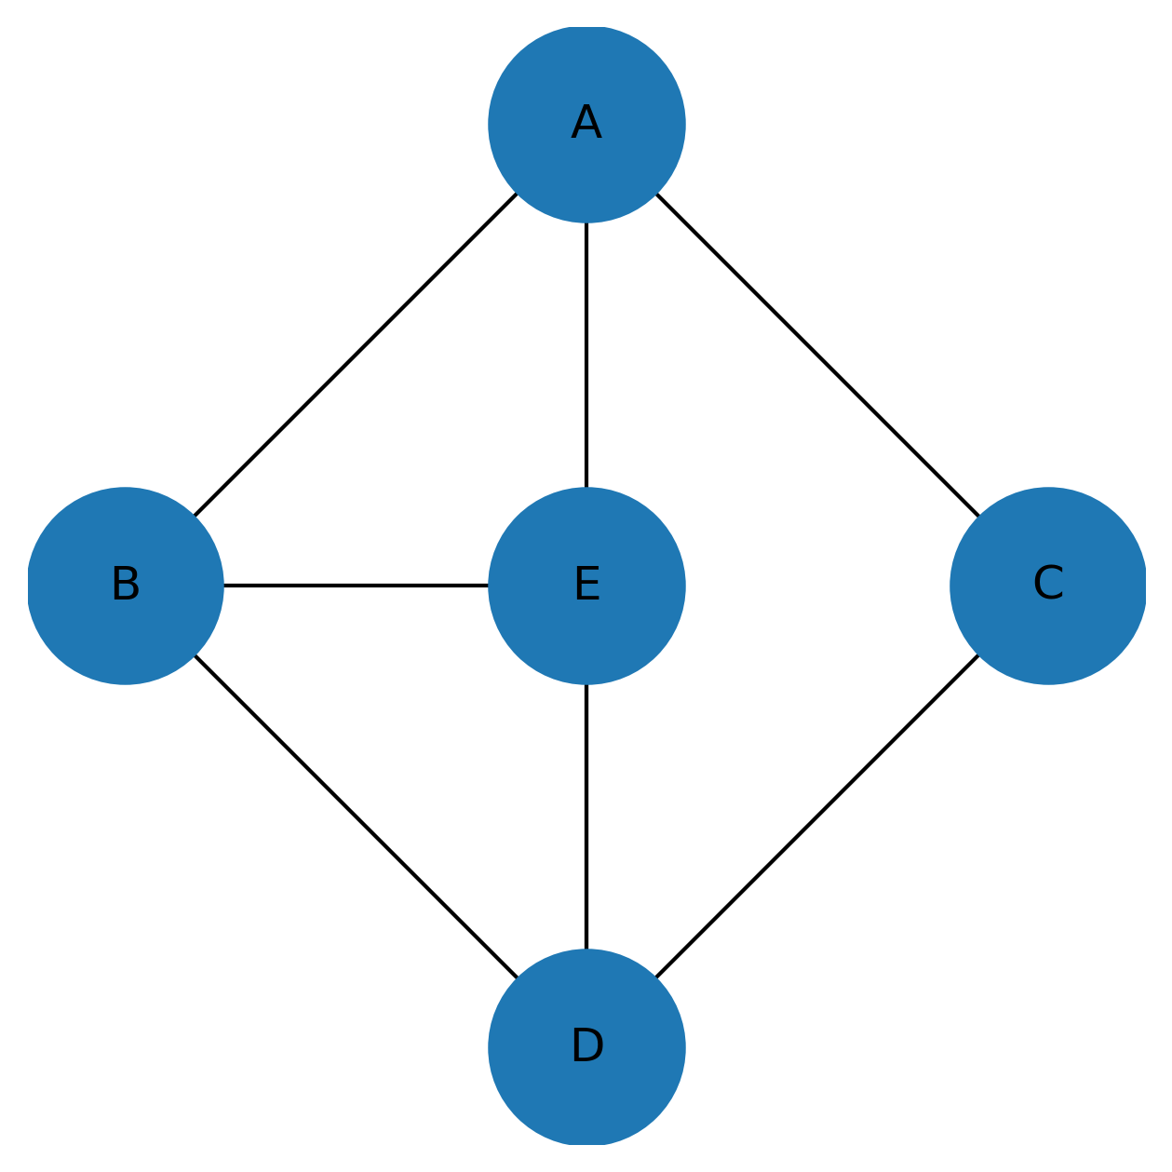
Figure 1: Graph with nodes A–E and edges exactly as in the slide.

Step 0 – Graph and Adjacency Matrix A
We use the same undirected graph with 5 nodes (A, B, C, D, E) as in the slide. Its adjacency matrix A (rows and columns in order A, B, C, D, E) is:
[[0, 1, 1, 1, 0],
[1, 0, 0, 1, 1],
[1, 0, 0, 1, 0],
[1, 1, 1, 0, 1],
[0, 1, 0, 1, 0]]
A value of 1 means there is an edge between the corresponding pair of nodes, and 0 means no edge.

Step 1 – Initial Node Features h(0)
Assign a single scalar feature to each node:
A: 1, B: 2, C: 3, D: 4, E: 5.
We can write this as a column vector:
h(0) = [1, 2, 3, 4, 5]^T.

Step 2 – Add Self-Loops: Ã = A + I
The slide mentions self-connections (A + I). We add a self-loop to each node so that each node also receives its own feature during message passing. This gives:
Ã = A + I =
[[1, 1, 1, 1, 0],
[1, 1, 0, 1, 1],
[1, 0, 1, 1, 0],
[1, 1, 1, 1, 1],
[0, 1, 0, 1, 1]]
Now each diagonal entry is 1, meaning every node is connected to itself as well.

Step 3 – Compute Degree of Each Node (with Self-Loops)
The degree of a node is the total number of neighbors it has in Ã (including itself). We sum each row of Ã:
deg(A) = 4 (A, B, C, D)
deg(B) = 4 (B, A, D, E)
deg(C) = 3 (C, A, D)
deg(D) = 5 (D, A, B, C, E)
deg(E) = 3 (E, B, D)
These degree values will be used for normalized sum aggregation, exactly as written in the Message Passing Framework slide (normalized sum + shared weights).

Step 4 – Normalized Sum Aggregation (Message Passing)
For one GNN/GCN layer, each node i collects messages from its neighbors (including itself) and computes the MEAN (normalized sum) of their features:
m_i = (1 / |N(i)|) * Σ_{j ∈ N(i)} h_j^(0)
where N(i) is the set of neighbors of node i in Ã (including i).
Node A:
Neighbors with self-loop: {A, B, C, D}
Features: 1 (A), 2 (B), 3 (C), 4 (D)
Sum = 1 + 2 + 3 + 4 = 10
Degree = 4 ⇒ m_A = 10 / 4 = 2.5
Node B:
Neighbors with self-loop: {B, A, D, E}
Features: 2 (B), 1 (A), 4 (D), 5 (E)
Sum = 2 + 1 + 4 + 5 = 12
Degree = 4 ⇒ m_B = 12 / 4 = 3.0
Node C:
Neighbors with self-loop: {C, A, D}
Features: 3 (C), 1 (A), 4 (D)
Sum = 3 + 1 + 4 = 8
Degree = 3 ⇒ m_C = 8 / 3 ≈ 2.67
Node D:
Neighbors with self-loop: {D, A, B, C, E}
Features: 4 (D), 1 (A), 2 (B), 3 (C), 5 (E)
Sum = 4 + 1 + 2 + 3 + 5 = 15
Degree = 5 ⇒ m_D = 15 / 5 = 3.0
Node E:
Neighbors with self-loop: {E, B, D}
Features: 5 (E), 2 (B), 4 (D)
Sum = 5 + 2 + 4 = 11
Degree = 3 ⇒ m_E = 11 / 3 ≈ 3.67
So after the aggregation (before applying any learnable weight matrix), the aggregated messages are:
m ≈ [2.5, 3.0, 2.67, 3.0, 3.67]^T.

Step 5 – Apply Shared Weight Matrix W (Linear Transformation)
The slide mentions shared weights. For a very simple 1D feature example, we can choose a scalar weight W = 2. This means each aggregated value is multiplied by the same learnable weight (parameter sharing):
h(1)_i = W * m_i.
Using W = 2:
h(1)_A = 2 × 2.5 = 5.0
h(1)_B = 2 × 3.0 = 6.0
h(1)_C = 2 × 2.67 ≈ 5.33
h(1)_D = 2 × 3.0 = 6.0
h(1)_E = 2 × 3.67 ≈ 7.33
Final updated node features after one GNN/GCN layer are therefore approximately:
h(1) ≈ [5.0, 6.0, 5.33, 6.0, 7.33]^T.
Explanation
What’s inside:
- Diagram
  - Graph with nodes A–E and edges exactly as in your adjacency matrix slide.
  - Labeled as Figure 1: Graph with nodes A–E and edges exactly as in the slide.
- Step 0 – Graph & Adjacency Matrix $A$
  - Uses your exact 5×5 adjacency matrix for A, B, C, D, E.
  - Short explanation of what 0/1 mean.
- Step 1 – Initial Node Features $h^{(0)}$
  - Simple features:
    - A=1, B=2, C=3, D=4, E=5
  - Written as $h^{(0)}=[1,2,3,4,5]^{T}$.
- Step 2 – Self-Loops $\tilde{A}=A+I$
  - Shows full matrix $\tilde{A}$(A+I), matching your “Self-Connection (A+1)” bullet.
Lecture # 14-1, 2 Graph Neural …
  - Explains why we add self-loops (node keeps its own information).
- Step 3 – Degree of Each Node (with Self-Loops)
  - Computes:
    - deg(A)=4, deg(B)=4, deg(C)=3, deg(D)=5, deg(E)=3
  - Explains that we use these for normalized sum aggregation, exactly like your slide text.
- Step 4 – Normalized Sum Aggregation (Message Passing)
Uses formula consistent with the slide:
$$m_{i}=\frac{1}{∣N(i)∣}\sum_{j∈N(i)}{}h_{j}^{(0)}$$
For each node, it shows:
  - Node A: neighbors {A,B,C,D},
sum = 1+2+3+4 = 10, degree=4 → $m_{A}=2.5$
  - Node B: neighbors {B,A,D,E},
sum = 2+1+4+5 = 12, degree=4 → $m_{B}=3.0$
  - Node C: neighbors {C,A,D},
sum = 3+1+4 = 8, degree=3 → $m_{C}≈2.67$
  - Node D: neighbors {D,A,B,C,E},
sum = 4+1+2+3+5 = 15, degree=5 → $m_{D}=3.0$
  - Node E: neighbors {E,B,D},
sum = 5+2+4 = 11, degree=3 → $m_{E}≈3.67$
So:
$$m≈[2.5, 3.0, 2.67, 3.0, 3.67]^{T}$$
- Step 5 – Shared Weight $W$(as in ‘shared weights’ on slide)
  - Choose scalar $W=2$(simple 1D case):
$$h_{i}^{(1)}=W⋅m_{i}$$
  - Computes:
    - $h_{A}^{(1)}=5.0$
    - $h_{B}^{(1)}=6.0$
    - $h_{C}^{(1)}≈5.33$
    - $h_{D}^{(1)}=6.0$
    - $h_{E}^{(1)}≈7.33$
Final new node features:
$$h^{(1)}≈[5.0, 6.0, 5.33, 6.0, 7.33]^{T}$$
- “How This Matches the Slides” section
  - Explicit bullets mapping each step to your specific slides (adjacency, self-connection, normalized sum aggregation, shared weights).

