Numerical Example of GNN/GCN with Step-by-Step Explanation
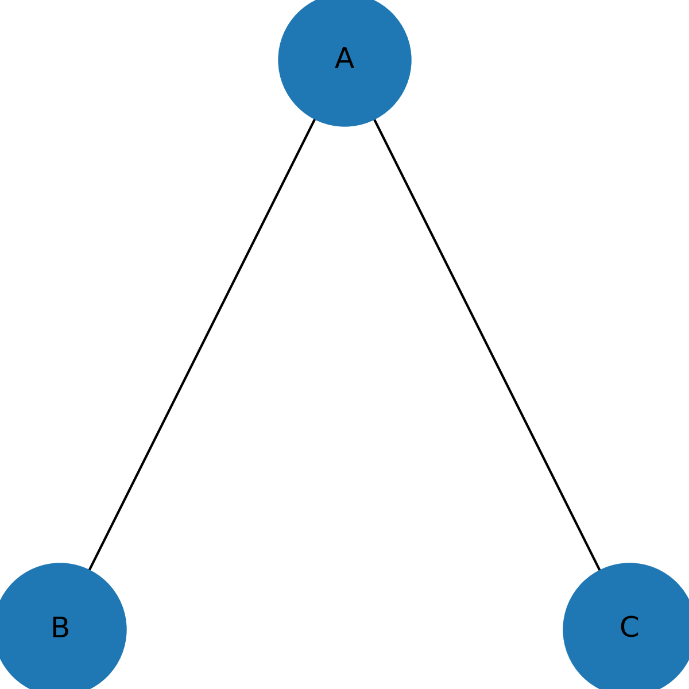

⭐ Numerical Example for GNN / GCN

Graph Convolutional Network (1 Layer)
We use a tiny graph of 3 nodes.

STEP 0 — Define the Graph

Node Features
Each node has one feature:
Node | Feature $h^{(0)}$
A | 1
B | 2
C | 3

Adjacency Matrix (no self-loops)
$$A=\begin{matrix}0 & 1 & 1 \\ 1 & 0 & 0 \\ 1 & 0 & 0\end{matrix}$$

Explanation
- "1" means the nodes are connected
- A is connected to B and C
- B only to A
- C only to A
This is the raw graph structure.

STEP 1 — Add Self-Loops
$$\tilde{A}=A+I=\begin{matrix}1 & 1 & 1 \\ 1 & 1 & 0 \\ 1 & 0 & 1\end{matrix}$$

Explanation
GCN requires that each node also sends a message to itself (self-connection).
Self-loops stabilize training and preserve the node’s original feature.
Adding identity matrix (I) does exactly this.

STEP 2 — Compute Degree Matrix
Degree = number of connections in each row of $\tilde{A}$:
- deg(A) = 3
- deg(B) = 2
- deg(C) = 2
$$\tilde{D}=\begin{matrix}3 & 0 & 0 \\ 0 & 2 & 0 \\ 0 & 0 & 2\end{matrix}$$

Explanation
Degree matrix tells how many neighbors each node has.
GCN uses degree values to normalize the messages so that nodes with many neighbors do not overpower those with fewer neighbors.

STEP 3 — Compute Normalized Adjacency $\hat{A}$
GCN uses this formula:
$$\hat{A}={\tilde{D}}^{-1/2} \tilde{A} {\tilde{D}}^{-1/2}$$

Compute $D^{-1/2}$
$$3^{-1/2}=0.577,2^{-1/2}=0.707$$

$${\tilde{D}}^{-1/2}=\begin{matrix}0.577 & 0 & 0 \\ 0 & 0.707 & 0 \\ 0 & 0 & 0.707\end{matrix}$$

Normalize:
$$\hat{A}=\begin{matrix}0.333 & 0.408 & 0.408 \\ 0.408 & 0.5 & 0 \\ 0.408 & 0 & 0.5\end{matrix}$$

Explanation
This step does message normalization:
- Prevents exploding messages
- Ensures equal influence from neighbors
- Makes GCN invariant to graph size
The matrix $\hat{A}$tells how much of each neighbor’s feature is sent.

STEP 4 — Choose Weight Matrix W
Let:
$$W=[2]$$

Explanation
This is a learnable parameter.
Just like CNN learns filters, GCN learns weights.
Here W = 2 simply means:
“After aggregating neighbors, multiply the result by 2.”
For teaching, keeping W simple is ideal.

STEP 5 — Perform Message Passing & Update Node Features
GCN Update Rule:
$$H^{(1)}=\hat{A}H^{(0)}W$$
Where:
$$H^{(0)}= \begin{aligned}1 \\ 2 \\ 3\end{aligned}$$

Step 5a — Aggregate neighbor features: $\hat{A}H^{(0)}$

Node A:
$$0.333(1)+0.408(2)+0.408(3) \\ =0.333+0.816+1.224=2.373$$
📌 Meaning:
A mixes its own feature (1), plus contributions from B and C, weighted by normalized adjacency.

Node B:
$$0.408(1)+0.5(2)+0(3) \\ =0.408+1=1.408$$
📌 Meaning:
B gets information from itself and A (C not connected).

Node C:
$$0.408(1)+0(2)+0.5(3) \\ =0.408+1.5=1.908$$
📌 Meaning:
C only communicates with itself and A.

Step 5b — Multiply by weight W = 2
$$H^{(1)}=\begin{aligned}2.373×2 \\ 1.408×2 \\ 1.908×2\end{aligned} =\begin{aligned}4.746 \\ 2.816 \\ 3.816\end{aligned}$$

🎉 FINAL OUTPUT — Updated Node Features After GCN Layer
Node | Updated Feature
A | 4.746
B | 2.816
C | 3.816

